H2o Fit Coaching New Client Questionnaire
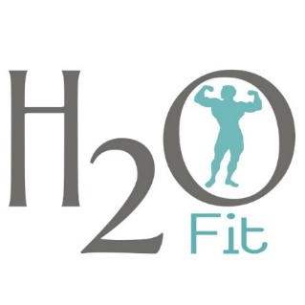
For your plan to be the best fit for you, please be as specific as possible. Your answers are what I use to create your training and nutrition plans, so broad answers make it harder to personalize things.

PERSONAL INFORMATION
Name* Age* Height *

What is your main goal? (Lose weight, build muscle, body recomposition, improve strength, increase energy, health and wellness, athletic performance, etc.)*

What do you weigh now and what do you want to weigh? (It’s okay if you do not have a goal number in mind. I like to focus more on body composition improvement through measurements and pictures instead of the scale.) *

Do you have any “stubborn” body parts you would like to focus on? You can’t spot-reduce fat, but I’ll make a mental note of these areas and use progress photos, measurements, and training adjustments to help improve them over time.*

TRAINING BACKGROUND
Regular activity level outside of the gym (What does your day-to-day movement look like? Do you have an active job or mostly sit throughout the day? Include things like walking, sports, yard work, or recreational hobbies.) *

Do you currently have a consistent exercise routine? (If yes, describe what you’ve been doing types of workouts, frequency, intensity, and how long you’ve followed it. If not, no problem we’ll start fresh and build consistency from the ground up.)*

How many days per week can you realistically commit to lifting weights?*

How many days per week can you realistically commit to cardio?*

How much time do you realistically have available for each workout session? (Please be honest about your schedule whether it’s 30 minutes or 90 minutes. The goal is to make your program fit your life, not the other way around.)*

How many years of weight training experience do you have?*

How many years of cardiovascular or endurance training experience do you have?*

What types of workouts do you enjoy most? (Examples: traditional strength training, circuit training, bodybuilding, CrossFit, powerlifting, functional fitness, group classes, yoga, pilates, or outdoor workouts.)*

What styles of workouts do you dislike or have trouble staying consistent with?*

How would you rate your training experience level? (Beginner 0–6 months or Intermediate 6–24 months or Advanced 2+ years.)*

Are there specific lifts or movements you love or feel confident performing? (Examples: squats, deadlifts, lunges, bench press, hip thrusts, pull-ups, etc.)*

Are there movements you dislike, struggle with, or can’t perform due to injury or mobility issues? (Be specific if pain or discomfort occurs in certain lifts or positions.)*

Do you currently track strength or performance progress (PRs, weights, times, distances, etc.)?

Are you currently following a structured training program or split? (If yes, describe it and include how it’s going so far.)*

Do you have access to a gym? If not, what equipment do you have at home? (Examples: dumbbells, kettlebells, resistance bands, treadmill, stationary bike, barbell setup, bench, TRX, etc.)*

NUTRITION & LIFESTYLE
Do you have any dietary restrictions or health concerns that could affect your nutrition plan? (Include food intolerances, allergies, digestive issues, religious/ethical preferences, or anything else I should know.)*

Do you follow a specific way of eating? (Examples: low-carb, intermittent fasting, holistic, flexible dieting, paleo, plant-based, carnivore, or intuitive eating.)*

What supplements, vitamins, prescription medications, or performance-enhancing compounds (if any) are you currently using? (Include dosage or frequency if relevant.)*

Walk me through a typical day of eating - include meal times, food choices, snacks, and beverages. (Be specific about portion sizes, and how consistent you are during the week vs weekends. If you currently track calories or macros, please include those also.)*

What foods do you dislike or want excluded from your meal plan? (Please list any foods that upset your stomach or you simply don’t enjoy. This ensures your plan is something you’ll actually want to follow.)*

What foods or meals do you love and want to keep in your plan if possible? (List comfort foods, weekly staples, family meals, or go-to snacks you’d like incorporated if they fit your goals.)*

How many ounces of water do you typically drink per day?

Do you ever experience digestive issues like bloating, constipation, acid reflux, or irregularity? (If so, describe when it tends to occur - after meals, certain foods, etc.).*

How would you rate your overall nutrition habits and consistency on a scale from 1–10? (1 = very inconsistent, 10 = extremely consistent)*

On a scale of 1–10, how would you rate your daily stress level? (What are your biggest sources of stress?)*

HEALTH & RECOVERY
Do you have any health concerns, injuries, surgeries, or physical limitations that could affect your training? (Include both past and present issues — even minor ones like knee pain, back tightness, shoulder impingement, or joint discomfort. This helps me program safely and effectively.)*

On a scale of 1–10, how would you rate your daily stress level? (What are your biggest sources of stress? Work, family, time management, health, etc.)*

How many hours of sleep do you get per night on average? (Do you feel rested when you wake up, or do you struggle with sleep quality, restlessness, or waking up during the night?)*

Do you feel like you recover well from your workouts, or do you often feel sore, fatigued, or under-recovered?*

Do you have a strong support system encouraging your fitness goals? (Include your spouse, family, friends, or coworkers who help you stay accountable.)*

MINDSET & ACCOUNTABILITY
What’s your preferred coaching style?*
☐ Tough love – Push me hard, hold me accountable, keep me disciplined.
☐ Encouraging – More supportive and flexible, focusing on motivation and consistency.
☐ A balance of both – I want structure, but I also want encouragement along the way.

What do you feel has held you back from reaching your goals in the past? (Think about past diets, training phases, or lifestyle challenges - consistency, time management, mindset, emotional eating, stress, etc.)*

Have you worked with a coach before? (If yes, what did you like or dislike about that experience? What worked and what didn’t?)*

Have you ever followed a structured diet or training plan? (If yes, describe what helped you make progress and what caused you to fall off track.)*

Do you ever emotionally eat? (If so, when does it usually happen - stress, boredom, social settings, nighttime, or after tough days?)*

What motivates you most - internal goals, external accountability, competition, or transformation?*

When do you want to start your plan? (Include any upcoming vacations, work trips, or life events that could affect the start date.)*

Is there anything else I should know about your unique situation, lifestyle, or challenges?*

PROGRESS TRACKING – Pictures
Progress tracking is one of the most important parts of your transformation journey. It allows both of us to see the full picture of your progress, not just what the scale says. Weight can fluctuate from day to day based on things like hydration, sleep, stress, and hormone levels, so we use multiple indicators to measure real results.
Every four weeks, I will ask for new progress photos from the front, side, and back. These images are one of the most powerful tools we have for assessing change. They reveal improvements in posture, muscle tone, and body composition that may not always be visible in a mirror or reflected on the scale.
Your photos are completely private and kept only in your personal coaching file. They will never be shared or posted anywhere without your written permission. I take your privacy seriously, and you can trust that these are used only for your progress and program development. If you are not comfortable sending photos right away, that is perfectly fine. We can use measurements and feedback until you feel ready.
When taking progress photos, try to be as consistent as possible each time so we can accurately compare your results.

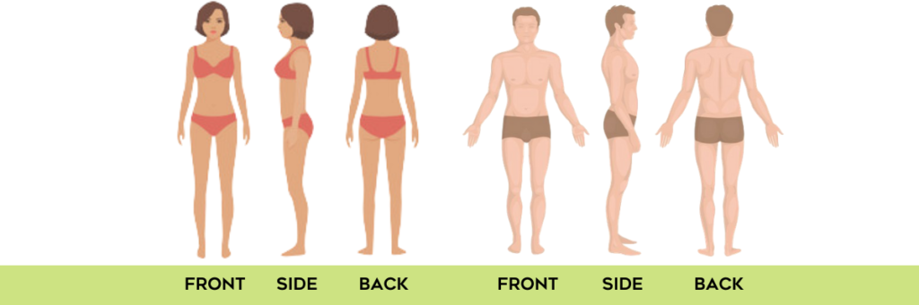

• Wear the same or similar clothing for each check-in, something fitted but comfortable so your shape is visible.
• Stand tall and relaxed with your arms naturally by your sides. Do not flex, twist, or suck in your stomach.
• Take each photo from the same distance and height every time, ideally chest-level and about five to six feet away.
• Include your entire body from head to toe.
Please send updated photos every four weeks by text or email. I will use them to make detailed comparisons, evaluate your progress, and adjust your nutrition or training plan as needed.

PROGRESS TRACKING – Measurements
In addition to photos, body measurements are another reliable way to see progress over time. Sometimes your weight might not change much, but your measurements tell a very different story. A smaller waist, tighter arms, and leaner thighs can all show that you are losing fat and building muscle simultaneously.
Please take these measurements before starting your plan and then re-measure every two weeks.
Neck Chest Waist Hips Right Thigh Left Thigh Right Calf Left Calf Right Arm Left Arm Right Forearm Left Forearm
For best accuracy, take measurements first thing in the morning before eating or training. Keep the tape snug but not tight against your skin. Write them down immediately after measuring and save them in one place so we can compare them over time.

COMMUNICATION
You can reach out to me anytime with questions, updates, or small wins. I truly enjoy hearing how you are doing, whether it is about your training, nutrition, mindset, or personal victories. I love updates because the more feedback you give me, the more I can fine-tune your plan to keep you moving forward.
You are always encouraged to send food photos, training clips, progress pictures, or quick notes about how you are feeling. Every message you send helps me adjust your plan more accurately and gives me valuable insight into your consistency, energy, and recovery.
I strive to be as responsive as possible. My typical reply hours are Monday through Friday between 7:30 AM and 5:30 PM. I reserve evenings and weekends for family time, but I will always follow up when I can. If anything urgent comes up related to your coaching plan, you can contact me directly at 985 714 5793.
Communication and accountability are what make coaching successful. The more consistent we are with staying in touch, the more successful your journey will be. Together, we will make every week count and continue building progress that lasts for the long term.

I look forward to hearing from you soon! Thank you so much,
Chance Waters
https://h2ofitcoaching.com/

