*Get the most out of your*

*Pool Table investment.*



“Specialist in Organizing Tavern/Bar Pool Programs”

(Southwest Pool League was est. spring 2007 in Las Vegas as the LVPPA).

Leagues, Tournaments and Light Maintenance.

A Pool League designed by League players for League players.



The Southwest Pool League.

We have been running and organizing Tavern/Bar pool leagues since 2007.

The first league was the LVPPA (Las Vegas Pool Players Association) from 2007 - 2016.

After 9 years of the LVPPA, in 2016, we merged the LVPPA with Southern Nevada 9 Ball.

In 2024, after 8+ years the league was sold, I retired and moved back to the Dallas area. However, I have found that after just a few months of retirement I am bored and miss running leagues.

The Southwest Poll League format was designed and developed in 1974 by the Las Vegas Tavern Owners Association and Andy Mercer. The league was operating years before leagues like APA, TAP, BCAPL or USAPL were even a thought, and Southern Nevada 9 Ball is still active today under new management.

What is the Southwest Pool League’s goal?

We’re not looking to the largest league in North Texas. We have done the large 150 to 200 teams per season leagues and honestly, I’m not interested in that responsibility again. Ideally, we would like to have 2 or 3 total divisions (1 division on 2 or 3 different nights each week) preferably at one establishment. We’re looking to have some fun, meet some local pool players & introduce our unique league format to the North Dallas area.

Our format is geared more toward the local player / local pool hall. We are however a BCAPL sanctioned league so our players are qualified to play in the BCAPL World Championships each February in Las Vegas as long as they meet the BCAPL requirements.

What are the differences between the Southwest Pool League and other Dallas leagues?

Frankly there quite a few. For starters the format of the Southwest Pool League offers the opportunity for bars and pool halls to make more money and serve more customers than the other leagues that are currently operating in the Dallas area. If you have pool leagues in your bar you are probable well aware that league players tend to spend very little money as a whole, mostly on just water and sodas. Unfortunately, they are oblivious to the fact that the wear and tear on the tables is considerable not to mention rent, electric etc. While we can’t promise our players will spend more money than other league players, our format is more “compact” and offers the opportunity for the bar to make more by being able to serve more non-league people during league times. As an example, I will use the bar I play out of on Tuesday nights. There are 12 teams playing on Tuesday, 4 teams in one league and 10 teams in another league.

That’s a total of 60 players that take up 12 out of 14 tables for 4 hours or more. In the Southwest pool league, we are able to play the same 60 players on only 6 tables not 12 so this frees up 8 tables for either:

#1) non-league customers, that do drink and do eat to rent the tables by the hour.

OR

#2) you could add another 8-team pool division (40 players) on 4 of the 8 leftover tables and that would be a total of 100 players on 10 tables and you’d still have 4 tables for non-league customers to play, eat & drink.

Your bar may not have 14 tables, so as a guide, we play 2 teams and 10 players on 1 table not 2

(usually, the same number of people and teams on ½ as many tables as most other leagues).



A few of the Other Southwest Pool League Differences

#1 our league format – We play a Round Robin Format. The Round Robin format is each member of a team will play each member of the other team 1 game in a rotation. In most leagues, in Dallas, the players only play

1 person from the other team and that is either a race to a ball count or game count. The player that plays last

in these formats, more often than not, won’t even come to the bar until they play at 8:30 or later. Then they

play their games and leave, contributing nothing to the bar or if they do play first, some play and leave early.

In Round Robin format all players need to be at the match close to 7 and stay until the match is over because

players play one game in each of the 5 rounds. For example, the player that plays first that night plays the next to last game of the match so they must be there all match.

#2 our player fees – Because the Southwest Pool League’s weekly player fees are less than most and we pay back cash as prizes the players would have more free money to spend at the bar. In addition, at the end of each session there is a league party. This is where we give out the player and team awards.

#3 our player awards – Our player awards are not “top heavy” meaning the top few players and teams do not win everything. Most existing Dallas leagues really don’t offer any real player awards other than trips to the National Tournament’s for a few teams and individual players. We don’t give away trips to Las Vegas or Orlando. The truth is, most players can’t afford to take off work for a week or 10 days to go to these tournaments even if they do win a “paid” trip. The players that can afford to take off and play a tournament like the APA national championships are going to go anyway. What we do is pay cash for many different categories including League Playoff Champions, Division Champions, Division Top Shooters, Team Top Shooters and cash for each game the players win during the season. There is an awards schedule in this mailing so you can let your players compare.

What do we need to get started?

All we need is a commitment of a night of play and a minimum of 3 tables and up to 6 (the more the better) available to the league on the night of play you desire. In a perfect world, if we were able to get 4 to 6 tables dedicated on Monday and/or Wednesday night starting at 6:30 that would allow us to have 1 or 2 divisions per night (depending on division size) and 30 or 60 players each night per division.

Once we have the confirmation from a venue on night and number of tables,

we will be able to advertise and begin recruiting teams for the division.

In Closing…

What we offer your establishment is a pool league that is fun, easy & different. One with a completely different format, a format that has been tested for over 50 years and would be EXCLUSIVE to your pool hall each night.

One that rewards your league players/customers and is tailored to and named after your pool hall/bar.

Our league is very player friendly with a personal touch… Me or Carmella will always be at the matches each week so we can mediate any problems or protests in person and as they happen making the transition to a different league for the players much easier. Also, this will make submitting score sheets and weekly fees easier than what your captains are used. There won’t be weekly invoices and there’s no need for Zelle or other app.

On the following pages you will find some league information you may find helpful.



The Southwest Pool League Player Awards (rewards)

The Southwest Pool League is designed more for the “local” type players. Players that like to hang out with their friends, play some pool, have a couple drinks and maybe a bite to eat. Unlike other leagues we don’t play for a chance to go to Orlando or Las Vegas for the national tournaments.

While it is great that 20 - 25% of a league’s teams may win a trip to go to these events the problem is that there is 75 – 80% of players that are rewarded with pretty much nothing for their participation and support.

That doesn’t happen in the Southwest Pool League. If you play 1 week and win 1 game you will get something back at the end of the season. How we reward the players that support us is described below.

Individual and Team Awards by Division – All Ties Split.

Awards are based on minimum of 6 teams per division. Awards will be adjusted if less teams.

Playoff Procedures & Guidelines

Top 4 places in each division qualify for the playoffs.

The Southwest Pool League “League” Championship playoffs will start the week after each session ends. Four (4) teams per division (night) and type of game go into the playoffs.

If more than one (1) division per night in the same game, the two divisions combine and two (2) teams from each division go to the playoffs. There is NO weekly fees for the post season playoffs

4 Player “Triple Play” Divisions – (Except “Open”)

“Triple Play” – Each player plays 2 Games 8 Ball, 2 Games 9 Ball & 2 Games 10 Ball each night.

All Divisions are $15.00 per player / per week. We pay $10 towards table costs per match.

*Players receive $1.00 per* ***regular season game*** *they win. (Paid at the end of season party.)*

Division Top Shooter - $200 / Division Top Shooter R/U - $100 / 3rd - $50.

Each Team’s Top Shooters receive – 1st $50 and R/U $25.

**6 & 7 Team Divisions**.

Division Winners (Per Team) 1st $250 / 2nd $200 / 3rd – $150 / 4th – $100.

Playoff Winners (Per Team) 1st – $400 / 2nd – $200 / 3rd – $100 / 4th – $50.

**8 & 9 Team Divisions**.

Division Winners (Per Team) 1st $250 / 2nd $200 / 3rd – $150 / 4th – $100.

Playoff Winners (Per Team) 1st – $500 / 2nd – $250 / 3rd – $100 / 4th – $50.

**10 & 11 Team Divisions**.

Division Winners (Per Team) 1st $250 / 2nd $200 / 3rd – $150 / 4th – $100.

Playoff Winners (Per Team) 1st – $600 / 2nd – $300 / 3rd – $200 / 4th – $100.

**12 Team Divisions**.

Division Winners (Per Team) 1st $250 / 2nd $200 / 3rd – $150 / 4th – $100.

Playoff Winners (Per Team) 1st – $700 / 2nd – $350 / 3rd – $200 / 4th – $100.



5 Player “Triple Play” Divisions – (Except “Open”)

“Triple Play” – Each player plays 2 Games 8 Ball, 2 Games 9 Ball & 2 Games 10 Ball.

All Divisions are $15.00 per player / per week. We pay $10 towards table costs per match.

Players receive $1.50 per **regular season game** they win. (Paid at the end of season party.)

Division Top Shooter - $200 / Division Top Shooter R/U - $100 / 3rd - $50.

Each Team’s Top Shooters receive – 1st $50 and R/U $25.

**6 & 7 Team Divisions**.

Division Winners (Per Team) 1st $200 / 2nd $150 / 3rd – $100 / 4th – $50.

Playoff Winners (Per Team) 1st – $500 / 2nd – $250 / 3rd – $150 / 4th – $75.

**8 & 9 Team Divisions**.

Division Winners (Per Team) 1st $250 / 2nd $200 / 3rd – $150 / 4th – $100.

Playoff Winners (Per Team) 1st – $600 / 2nd – $300 / 3rd – $150 / 4th – $100.

**10 & 11 Team Divisions**.

Division Winners (Per Team) 1st $300 / 2nd $250 / 3rd – $200 / 4th – $150.

Playoff Winners (Per Team) 1st – $700 / 2nd – $350 / 3rd – $200 / 4th – $100.

**12 Team Divisions**.

Division Winners (Per Team) 1st $350 / 2nd $300 / 3rd – $250 / 4th – $200.

Playoff Winners (Per Team) 1st – $800 / 2nd – $400 / 3rd – $250 / 4th – $125.

5 Player 8, 9, & 10 Ball Divisions – (Except “Open”)

All Divisions are $15.00 per player / per week. We pay $10 towards table costs per match.

Players receive $1.50 per **regular season game** they win. (Paid at the end of season party.)

Division Top Shooter - $200 / Division Top Shooter R/U - $100 / 3rd - $50.

Each Team’s Top Shooters receive – 1st $50 and R/U $25.

**6 & 7 Team Divisions**.

Division Winners (Per Team) 1st $200 / 2nd $150 / 3rd – $100 / 4th – $50.

Playoff Winners (Per Team) 1st – $500 / 2nd – $250 / 3rd – $150 / 4th – $75.

**8 & 9 Team Divisions**.

Division Winners (Per Team) 1st $250 / 2nd $200 / 3rd – $150 / 4th – $100.

Playoff Winners (Per Team) 1st – $700 / 2nd – $350 / 3rd – $200 / 4th – $100.

**10 & 11 Team Divisions**.

Division Winners (Per Team) 1st $300 / 2nd $250 / 3rd – $200 / 4th – $150.

Playoff Winners (Per Team) 1st – $900 / 2nd – $450 / 3rd – $250 / 4th – $125.

**12 Team Divisions**.

Division Winners (Per Team) 1st $350 / 2nd $300 / 3rd – $250 / 4th – $200.

Playoff Winners (Per Team) 1st – $1100 / 2nd – $550 / 3rd – $300 / 4th – $150.



“Open” Divisions – 10 Ball & “Triple Play”.

All Divisions are $17.00 per player / per week. We pay $10 towards table costs per match.

Players receive $2.00 per **regular season game** they win. (Paid at the end of season party.)

Division Top Shooter - $200 / Division Top Shooter R/U - $100 / 3rd - $50.

Each Team’s Top Shooters receive – 1st $50 and R/U $25.

**6 & 7 Team Divisions**.

Division Winners (Per Team) 1st $200 / 2nd $150 / 3rd – $100 / 4th – $50.

Playoff Winners (Per Team) 1st – $800 / 2nd – $400 / 3rd – $200 / 4th – $100.

**8 & 9 Team Divisions**.

Division Winners (Per Team) 1st $250 / 2nd $200 / 3rd – $150 / 4th – $100.

Playoff Winners (Per Team) 1st – $900 / 2nd – $450 / 3rd – $250 / 4th – $125.

**10 & 11 Team Divisions**.

Division Winners (Per Team) 1st $300 / 2nd $250 / 3rd – $200/ 4th – $150.

Playoff Winners (Per Team) 1st – $1200 / 2nd – $600 / 3rd – $300 / 4th – $150

**12 Team Divisions**.

Division Winners (Per Team) 1st $500 / 2nd $400 / 3rd – $300 / 4th – $200.

Playoff Winners (Per Team) 1st – $1500 / 2nd – $750 / 3rd – $375 / 4th – $200.

There is an end of season league tournament the Saturday the week after playoffs end (if venue allows).

The tournament will be a handicapped R3 Hot Race – 9 Ball with a $10.00 buy in and $500 added.



A SAMPLE LEAGUE POSTER

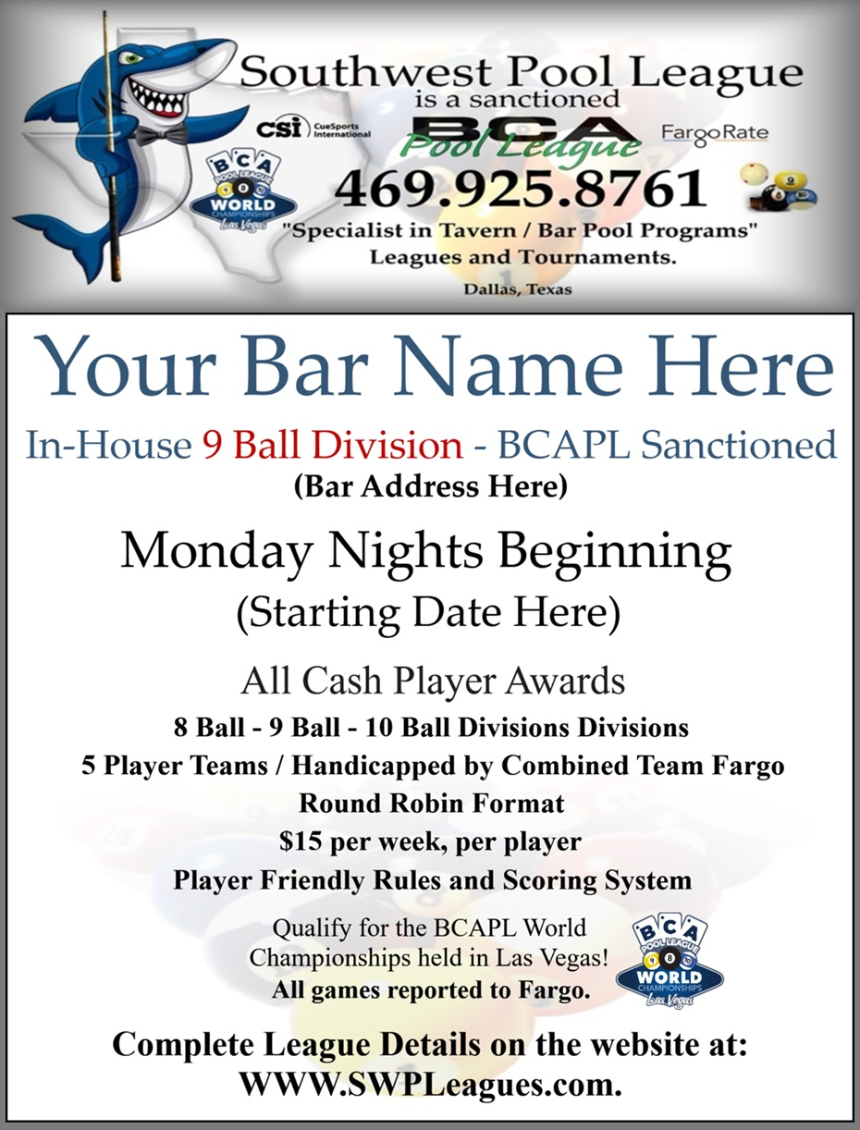



Thank you for your time and I look forward to meeting with you

and answering any questions you may have about elevating the pool program at your establishment.



Southwest Pool League Contact Information

Jim Thompson – 469.925.8761

Website: WWW.SWPLeagues.com

Facebook: Facebook.com/sw.pool.league

_______________________________

Jim Thompson / Southwest Pool League

