# **2025 Grand Lodge Sessions**

We are excited to announce that the Grand Lodge Sessions will be held in The Villages, Florida at the Waterfront Inn. We have secured an incredible room rate of just $114.00 per night. This rate will be available from May 16-26.

Breakfast will be available onsite from the restaurant for a charge of $17.00 per person each day. The hotel will need notified the night prior if you are going to purchase breakfast.

There are many restaurants located around the Hotel facility giving us much more choice in dining during the week.

The Wednesday night Banquet will include Tea, Coffee, and water. It is a served 3 course dinner, with salad, entrée is choice of Chicken Francaise or Burbon Glazed Salmon, with baked potato and vegetable side, and completes with a cheesecake dessert.

Installation of Officers will be on Thursday Night.

**Register Early**! The first person to register will get a special Gift. All registrations will be entered into a contest for some great door prizes.

## Reminder:

To attend the Department Council, you must be a member of a Canton with dues card.

To attend the Grand Encampment, you must be a member of the Royal Purple Degree with dues card, you do NOT need to be a Past Patriarch.

To attend the Rebekah Assembly, you have to be a member of a Rebekah Lodge with dues card, you do NOT need to be a Past Nobel Grand.

To attend the Grand Lodge Session, you must be a 3rd degree member with dues card, you do NOT need to be a Past Grand.

Everyone should try and attend sessions so that you know what is going on in the Jurisdiction. The Grand Bodies run the Order FOR all members.

*Please see the attached registration form and hotel information*.

~ Registration Form ~

Name:___________________________________________

Title:____________________________________________

(Highest current or past title)

Address:__________________________________________

City:________________ State:___________ Zip:__________

Phone:_______________ Email:_______________________

Emergency Contact:______________ Phone_____________

Please check which Meeting(s) you will attend

* Department Council
* Grand Encampment
* Grand Lodge
* Rebekah Assembly

Make checks payable to:

Grand Lodge of Florida

Mail with form to:

Grand Lodge of Florida

205 Alanhurst Way

Sun City Center, FL 33573

Registration

**Before May 1 $15.00 __________**

**After May 1 $25.00 ___________**

Wednesday, May 21

6:00 p.m. Banquet **$55.00 _______**

(P*lease circle your choice)*

Chicken Française

Burbon Glazed Salmon

Total meal

and registration $__________

~ Hotel Reservations ~

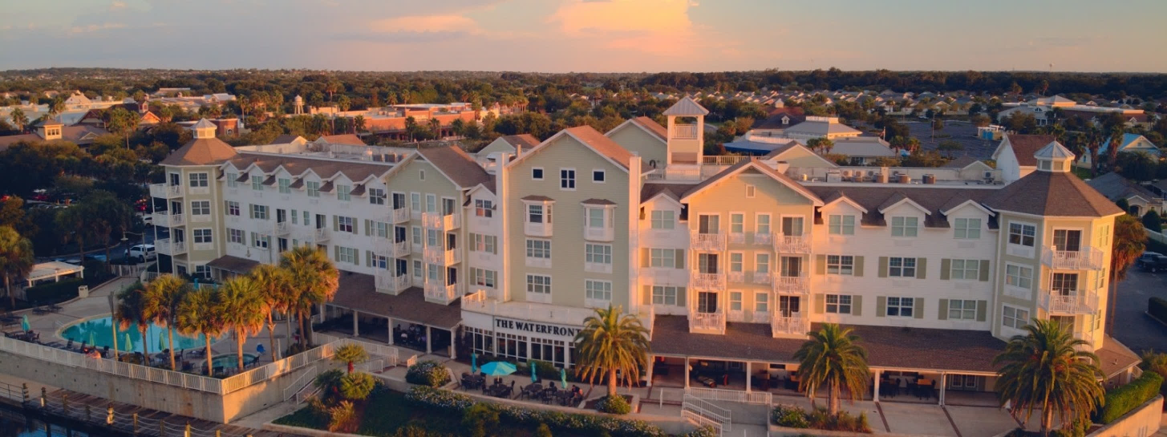

The Waterfront Inn

1105 Lake Shore Dr

The Villages, FL 32162

Please make your reservations directly with the hotel

By Phone: 352-753-7535 Dial “0” and mention the Independent Order of Odd Fellows

or

Online booking at <https://reservations.travelclick.com/15005?groupID=4593327>

Room rate is $114.00 per night plus applicable taxes.

*~ Check in is at 4:00 pm ~ Check out 11:00 am ~*

Special pricing is only good for 3 days prior to 3 days after Sessions

**CUT OFF FOR GROUP RATE IS APRIL 10, 2025**

After this date you will be required to pay full price for your room, no exceptions we do not have control of this.