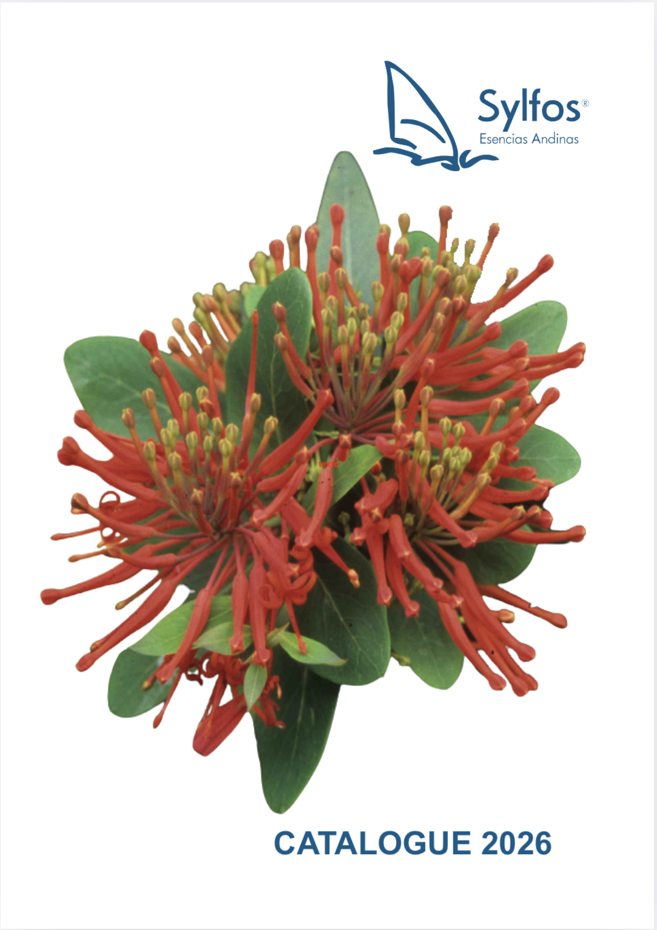





It was during his own initiatory journey that Vincent Belbèze was led to prepare elixirs. He first worked with flowers from his region in Chile, then across the entire continent. This research gave rise to the Sylfos range of Andean Flowers. He then went on to create other 'shamanic' elixirs related to the 'power animals' of Native American traditions. This work in the subtle world opened the doors to another type of elixir, which he nicknamed 'messengers' and which we are delighted to offer you in France.



Sylfos compounds

LUZ - LIGHT Releases oppression of the heart on both a physical and emotional level. Promotes muscle relaxation. Helps keep your feet on the ground and calms emotions. Brings "light" into a dark or even depressive phase. Allows you to regain clarity and objectivity, especially when faced with an overload of negative or even manipulative information.

PROTECTION This elixir creates a protective shield on a physical and psychological level while cleansing the energy field. It promotes grounding and a feeling of stability. It can be carried in your pocket or placed under your pillow at night.
Thanks to its components: mineral and flower essences, particularly orchids, which act on all levels, it is best suited to our current reality.

MATER To reconnect with the emotional pattern of the "Inner Mother". Helps to clarify the maternal lineage, both ascending and descending. Provides physical and psychological support and sensitivity in the relationship with the mother and develops mother/child union and reconciliation. Enables a healthy relationship with the nurturing aspect for both men and women, thereby increasing creativity.

PATER To reconnect with the emotional pattern of the "Inner Father". Helps to clarify the paternal lineage, both ascending and descending. Provides physical and psychological support in the relationship with the father and develops union and reconciliation between father and child. Enables a healthy relationship with authority and relationships for both men and women.

LIBERTAD -FREEDOM / LETTING GO: For those who wish to overcome various addictions. It aids in psychophysical detoxification, particularly when substances harmful to health have been consumed excessively. It restores order where compulsive and self-destructive behaviours existed and helps those who wish to change their behaviour in the least traumatic way possible. It can be used in conjunction with other detoxification treatments.

Available in 15 ml and 30 ml bottles.

Sylfos environmental elixirs

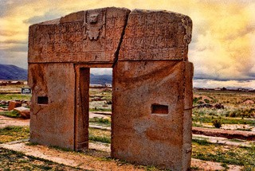
PUERTA DEL SOL / GATE OF THE SUN / INTI PUNKU
An elixir to accompany the process of spiritual initiation and the awakening of Kundalini energies. Helps us rediscover our supersensitive faculties. It allows us to reach or envisage our summit, an inner crowning glory, towards ourselves and nature.


VOLCANO LLAIMA
An elixir that catalyses awareness of our spiritual journey. The only knowledge that truly matters is that which lies within. It allows us to become aware of and enter into an intimate relationship with the life that is in all things.
Improves emotional grounding and stability.


These three elixirs accompany us on our path of evolution. They can be taken separately or in sequence. Women should start with Yin, then Yang, then Unity, while men should start with Yang, then Yin, then Unity.

YIN: to connect with our feminine side. The elixir supports and strengthens yin energy (receptivity, empathy, etc.) on an emotional level, in both men and women.

YANG: to connect with our masculine side. The elixir supports and strengthens yang energy (action, assertiveness, etc.) on an emotional level, in both men and women.

Yin Yang UNITE: Balances the two polarities. It completes the process by allowing these two fundamental aspects of our personalities to be reintegrated.

The 24 Andean flower essences

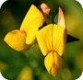
- Alfalfa Chilota¬Lotus uliginosus

Understanding¬Communication¬Relief
For introverted people. Brings understanding of events and human behaviour. Allows you to tune into the energies of the universe and achieve a state of harmony, balance and healing. Allows you to focus, direct, feel and work with energies, rebalancing them in order to focus on what is fundamental and not get bogged down in details. Helps treat insomnia.

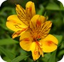
- Amancay¬Alstroemeria aurea

Releases old beliefs and unresolved conflicts.
Enhances communication between the right and left sides of the brain. Helps to overcome excessive protective instincts. Helps to free oneself from restrictive beliefs about one's intuitive abilities. Removes energy blockages caused by unresolved situations and/or conflicts. Has a powerful effect on the third eye, allowing us to visualise subtle energies and release muscular tension and stress, particularly in children. Connects to divine energy; excellent for meditation. As with "Chesnut Bud", we learn from our mistakes. Allows us to open up to the present moment and integrate higher realities. Promotes detachment. Great purifier.

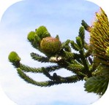
- Araucaria¬Araucaria araucana

Compassion¬Connection to the Earth¬Energy
Essentially allows connection to the Earth and perception of the cycles of time and space. Excellent energiser through its action on the root chakra, promotes greater openness to compassion. Reveals our presence and poise, awakens our desire to live and enjoy life. Physically promotes straightening of the spine, thereby improving posture.

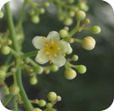
- Arbol del Peru¬Schinus molle

Flexibility¬Communication
Elixir of communication without prejudice, based on opening the heart. Recommended in all situations where communication must be harmonious and fluid, allowing individuals to develop within the norms of respect. Allows us to let go of archaic and negative positions, ideas, concepts, models and old moulds that no longer serve us.


- AVE del PARAISO / Bird of Paradise - Strelitzia reginae

Acceptance - Creativity
Eliminates creative blocks. Enables acceptance of life's circumstances and the creation of a new future, through personal acceptance and acceptance of others. Stabilises the ego and works on possessiveness and selfishness, helping us to discover our inner beauty by opening ourselves up to a sensitivity that is far removed from the material world. Enables us to accept what is difficult for us, what hurts us, what we find unfair, painful or excessive, silencing the fictitious desires that do not belong to us.

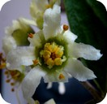
- Boldo¬ Boldea fragans

Reconciliation and healing of our emotions and our image.
When we lose our joie de vivre and/or interest in life. For difficulties in accepting our feelings, our emotions or those directed towards us. When we question our "inner self", when the joy of living is replaced by bitterness. When we feel guilt and/or a need to know who we really are. When we no longer have any desire or interest in who we are. For the fear of missing out and when we are unable to let go. To heal emotional wounds and erase negative experiences. When it is difficult to "digest" our emotions, "Boldo" mobilises our will and energy to heal us and reconcile us with our inner selves. It is also very useful as a complement to treatment for all types of addiction.

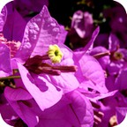
- Bougainvillea - Bougainvillea glabra

Spiritual love - Protection - Forgiveness - Learning.
When we live in fear or in states of perfectionism or remorse, this elixir allows us to enjoy the abundance of love revealed in creation. It also helps to unite emotions with the mind and eliminates feelings of guilt and fear of suffering reprisals. It allows us to connect with the forces of love. It encourages us to appreciate the pleasures of life and to help others feel good, with pleasure, even in difficult situations. This elixir promotes deep breathing and develops feelings of peace and tranquillity. It reduces local pain, even chronic pain, and helps combat fatigue. It is especially appreciated in situations of addiction and learning disorders.

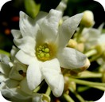
- Canelo Drymis chilensis

Peace and well-being
Allows us to access a state of deep peace and serenity. It brings us confidence and tranquillity after turbulent times. This elixir leads us to seek well-being and comfort, transforming dense, low-vibration energies into vital energies. This is the Master Plant of the Mapuche Indians, which helps us face our inner reality, healing the difficult episodes that cause us to act rigidly. It allows us to develop a more flexible approach to our own reality.

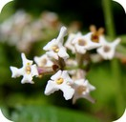
- Cedron Aloysia citriodorata

Self-confidence¬Perseverance.
Promotes self-confidence by stimulating sociability, caution, understanding and compassion. Increases our magnetism and develops empathy. Cedron brings balance, humility and affability. It reassures troubled minds. It allows us to rest without feeling guilty. Ideal for people seeking recognition. It helps resolve traumas accumulated in previous incarnations so that we can integrate them into our conscious relationship with the world, while respecting our choices and our ideal way of life.

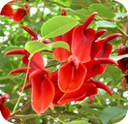
- Ceibo Eritrina cresta-galli - National Flower of the Argentine Republic

Communication-Inner Path.
Ideal for communication, mainly within couples, increasing passion, allowing desire to flow more freely and releasing blockages. Helps people who feel diminished and seek to dominate their relationships. Allows us to reconnect with our Inner Being and follow the true path of honesty and solidarity. Recommended for heart problems and/or problems related to blood circulation.

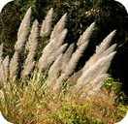
- Cola de zorro - Cortadeira araucana

Emotional balance
It allows us to eliminate feelings of misery and approach Divine Love, that fire of transmutation that burns away what prevents us from rising above our emotions and feelings of misery. It produces relaxation that promotes restorative rest, giving us the opportunity to face the new day with more optimism. It restores our hope that "anything is possible" and allows us to transmute our feelings through the healthy influx of love it generates within us. It frees us from bitterness and frustration. On a physical level, it acts on heart problems, loss of a loved one, great pain caused by shock, emotional excesses, heart disease, arrhythmias and hypertension. It acts as a balancer in cases of hyper/hypotension. It also allows relaxation of the head area, releasing tension in the jaws (bruxism), among other things.

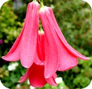
- Copihue Lapageria rosea - National flower of Chile
Inner joy
To achieve inner joy, challenge yourself by gaining a better understanding of your "higher self". For people who complain and live in a state of pessimism, constant self-reproach, or even depression. This elixir is recommended for people who develop "pretext" illnesses and who believe they are inferior to others, wavering before even starting a new task.

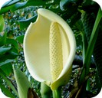
- Costilla de adan - Monstera deliciosa

Expression¬Eliminate self-limitation¬ Seize opportunities.
Freedom from inhibition. Re-inspires expansiveness and promotes balanced exuberance. Ideal for people who have accepted the paradigm of limitation and can now enjoy opportunities and pleasure. Recommended for those who are stuck in the idea that they "can't": now they can change their own definitions. Freedom from restrictions imposed by the psychic and spiritual heart, leading to greater flexibility in physical expression. Stimulates circulation and the heart meridian. Strengthens the heart and vigour (useful in cases of cardiac degeneration). A valuable aid in the treatment of impotence and frigidity. Has a balancing effect.

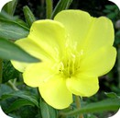
- Dondiego de la noche - Oenothera affinis

Awareness and soothing of painful emotions.
Works directly on painful situations experienced in early childhood, through the suffering experienced by the mother. Works on cellular information to rediscover the feeling of survival. Balances emotions with feelings, allowing us to rediscover the power of boldness within us, encouraging us to overcome fears that belong to an ancestral heritage and cause us suffering. Allows us to create bonds and healthy, balanced emotional relationships. Reconciles us with the maternal image.


- Flor de un dia -Tigridia pavonea

Awakening the inner warrior¬Emerging from one's cocoon.
Awakens our inner warrior, allowing us to feel strong and protected, enabling us to emerge from our cocoon of pseudo-protection. Gently shows us the enormous possibilities that lie ahead, distancing us from fear and sadness. Awakens the energy needed to be present and balanced in our daily lives. For people who avoid facing reality, leaving things unfinished, who devalue themselves, feel sadness, fear and panic, trying to go unnoticed in life.

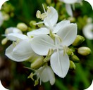
- Libertia - Libertia chilensis

Protection - Fear of death - Divinity - Acceptance of our incarnation from

the essence of the mental body and soul.
Connects us to our inner child, in a state of original purity. Heals this inner child who has suffered, allowing us to erase deeply rooted fear, the fear of life. Reconciles us with our desire for incarnation and accompanies us. Elixir of change in the face of the dispersion we are currently experiencing. Promotes a global "macro" vision, the interaction of man between the microcosm and the macrocosm. Allows us to recognise that all systems, cosmic, telluric and of Light, focus their energies for our own complete safety. Promotes interdimensional communication, allowing us to understand the "relativity" of time and space (which do not exist). Recommended for meditation, providing a state of spiritual peace, increasing clairvoyance and clear hearing. Allows us to erase the fear of physical death, for the person who is in this process and for their loved ones, through the understanding of our own essence: "that we have always had within us the divine spark that connects us to the Whole".

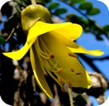
- Mayú - Sophora macrocarpa

Communication - Emotional stabiliser - Acceptance.
Allows us to verbalise our emotions. Recommended for excitable people, as it stabilises emotions and mitigates excesses. Useful for working on frustration. In this process of awareness, it allows us to achieve a state of inner tranquillity and mental clarity. Allows us to 'translate emotions through a message'. Recommended for caustic and ironic people. A great stabiliser of emotions, it allows us to focus our attention on a particular point, giving us a very useful sense of tranquillity and security (e.g. during exams). Physically, it acts on the entire digestive system, the liver and elimination. Very useful for treating diabetes and ulcers (especially mouth and stomach ulcers).

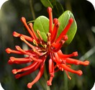
- Notro - Embothrium coccineum

Transmutation of violence
A plant revered by the Pehuenche people, through which they confirm the opening of their 8th chakra, allowing them constant spiritualisation and a perfect connection with Mother Nature, through which they do nothing that could harm living beings. Balances energy, softening violence, making instinct more subtle, elevating it, sanctifying it. Useful for aggressive and ironic temperaments. Balances vital energy and more particularly excess yang. The colour of the flower shows us an illuminated, purified and refined root chakra. Transmutes instinct, violence, hatred and aggression, which can lead the individual to a state of depression.

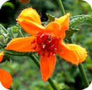
- Ortiga Brava - Loasa chilensis

Changes - Power
Recommended when we feel stuck and stagnant and there is a retention of vital energy, when we persist in maintaining deep structures of life and existence, unable to adapt to necessary changes. To balance our relationships with power or domination in our world, especially when we are afraid of lacking the strength to do so.

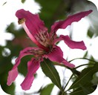
- Palo borracho - Chorisia speciosa

Letting go - Self-acceptance.
For people who hide behind a closed, rigid, unfriendly face, both in their outward appearance and in their manner. In fact, they are gentle and pleasant people, but shame and rejection of their own bodies cause them to adopt this attitude. To work on self-acceptance, develop self-confidence beyond outward appearance. Similarly, this elixir helps to increase faith in a different future.

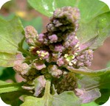
- Quinoa - Chenopodium quinoa

Balance-Self-acceptance
Brings powerful energy of self-acceptance, opening us up to compassion for others. Brings understanding in the union of the human and mineral kingdoms. Can cause a deep opening of the heart, developing a sense of balance between the upper and lower chakras. Promotes the body's ability to work with gold in all its forms. Very interesting for therapists and healers.

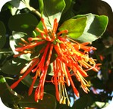
- Quintral - Tristerix tetrandrus

Ancestral fears - Hope and understanding.
Fluidises the energy of the spine and corrects posture. Leads the individual to a plane of physical consciousness, reconnecting them with the reality of the Earth Goddess. Acts on the ancestral fears of our cellular heritage by connecting to the archetypes of fear. Helps express the emotions linked to these fears which, if left untreated, can turn into a degenerative process. Brings awareness, allowing control to be regained over these processes. Very useful for therapies for degenerative and autoimmune diseases.

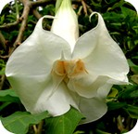
- Toloache - Datura arborea

Connection with angelic energies - Fear of death
Helps overcome fear at any age, especially in older people. Gives us the courage to understand and accept with compassion the departure of a loved one and to accept the natural process of the end of life, without interfering with our attachments, the abandonment of the physical body and the passage of the soul to a higher state. Allows us to connect with angelic energies and increase our level of perception.

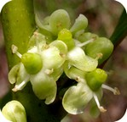
- Yerba mate Ilex paraguariensis

Mental balance-Presence.
This elixir brings peace and allows us to focus on the "here and now", without interference with our current life and state of health. It helps us break unwanted telepathic ties with people in the present or from past lives. Its action improves memory and visualisation and develops attention and presence.
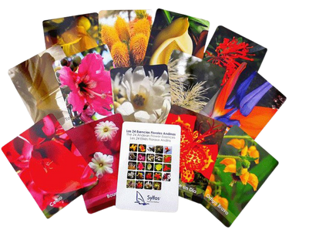
Set of Diagnostic Cards for the 24 Andean Flower Elixirs

Wild Flowers of the Americas
Flower Essences

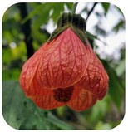
- - ABUTILON Abutilon dictum

Understanding and Appreciation of Experience
Allows the expression of grief. Activates deep memories. Enhances creativity. Cleanses the grief that obscures our original roots, allowing for a better understanding of our true task in life. Helps calm the fearless, so that this dynamic does not cause disruption. When there is a slowdown in momentum due to indecision, helps with decision-making.

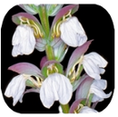
- - ACANTO/ SPINY ACANTUS Acanthus spinosus

Overcoming Life's Trials and Tribulations
Shows us triumph over adversity by reminding us that those who walk the path of initiation must be prepared to face trials of all kinds: physical, emotional, mental and spiritual. Recommended when a person says that their life is "a valley of tears" and believes that pain and the denial of pleasure are a valid path to achieving joy in "another world". An elixir of rebirth and the dissolution of pain that brings perseverance, protection and confidence to overcome life's trials and teaches us that invention, ingenious combinations and the acquisition of knowledge are sterile when not fertilised by feeling.

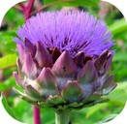
- – ALCACHOFA / ARTICHOKE Cynara scolynus

Confidence
To face the fears that arise when we are alone with ourselves and feel insecure. Provides the strength needed to perceive the ingrained patterns that keep us stuck in the past. We can thus open ourselves to new times and new knowledge. When we can only count on ourselves, Artichoke helps us connect with higher beings.

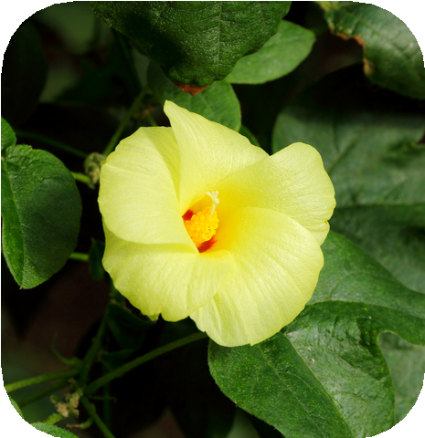
- - ALGODÓN CRIOLLO / COTTON Gossypium barbadense

Paternal image, sensitivity
For those who, because they did not receive enough love in their childhood, do not know how to love themselves. It promotes the search for and reunion with the inner child, to heal its wounds; it also improves intuition. Cotton invigorates the etheric body, integrates it and distributes it equally with the physical body.

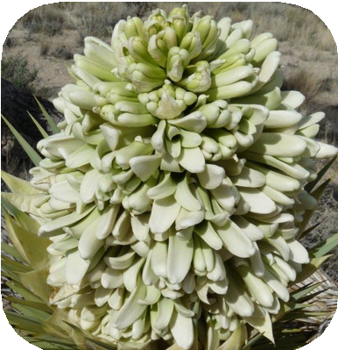
- - ÁRBOL de JOSUÉ / TREE of JOSUÉ Yucca brevifolia Liberation from inherited patterns - Generational karma Liberation from inherited patterns - Generational karma
Heal your generational tree, free yourself from patterns inherited generation after generation, without denying your origins. Allows you to integrate your heritage and lineage without being a slave to family traditions. Useful in cases of inability to free oneself from dysfunctional family or cultural patterns, such as persistence in negativity and self-sabotage.

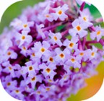
- - ÁRBOL DE MARIPOSAS/ BUTTERFLY TREE Buddleja davidii

Spiritual help. Ego
For those who need to make a change in their lives and recognise that they need spiritual help. Recommended for people who are unable to move forward because of pride or who react negatively to change. Helps to shape our ideas, increases creativity and clarity of thought and reasoning.

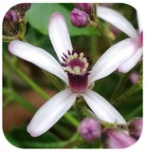
- - ÁRBOL SANTO Melia azedarach

Understanding - Compassion
This is the very essence of charity, love and giving. It brings change and understanding, and helps us to understand the processes of giving and receiving from the bottom of our hearts.
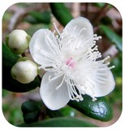
- -ARRAYAN / CHILEAN MYRTLE Luma apiculata

Taking charge
Enables you to take responsibility for life situations in a welcoming manner. It will be particularly helpful for people who tend to be rigid, compulsive or sexist. It may be useful for people who engage in self-sabotaging or even self-destructive behaviour.

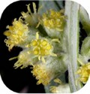
- -ARTEMISIA / MUGWORT Artemisia douglasiana

Harmonises the forces of the unconscious
For those who have a very active psychic life and/or feel that the world is against them. Helps regulate altered states of consciousness. Harmonises the forces of the unconscious

; teaches us not to be overwhelmed when we manage to open up new fields of knowledge. Its archetype is that of progress, metamorphosis and the lunar aspect, referring above all to change and its active characteristic.
- - ASTER Symphyotrichum Novae-angliaiae

Recovery of the awareness of wholeness
Dissolves concepts in the mental body, eliminating harmful ideas that we believe to be our own, but which in reality do not belong to us. Its elixir allows us to free ourselves from collective and individual thought patterns. Decongests emotional crystallisations, particularly the need to possess.

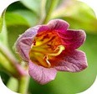
- - BELLADONNA Atropa belladonna

Opening the heart - Internal and external spiritual cleansing.
Helps to free oneself from negative thought forms. Allows us to see the reasons why we put obstacles in our lives and discover how to overcome them. To look at life again through the "eyes of love" and be able to recognise our own beauty as well as that of our environment. Helps overcome shyness, boosts self-confidence and thus confirms our projection on this earthly plane. Eliminates the illusions in our lives, allowing us to see clearly and free ourselves from what hurts us: habits, behaviours, thoughts, relationships and careers that crush our soul. This greater understanding can relieve karma.
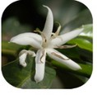
- -COFFEE Coffea arabica

Clarity, renewal
Improves mental acuity and aids in quick decision-making. Allows us to free ourselves from customs and patterns of behaviour and/or thinking that are no longer constructive for our current path. Ideal for people who are indecisive and/or get lost in over-analysis.
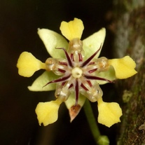
13 – COCOA Theobroma Cacao AVAILABLE JUNE 2026
Opens the heart - Emotional protection - Tenderness
An elixir of the heart and tenderness, Cacao helps to reopen the emotional space after emotional wounds. It brings gentleness, inner security and the ability to receive love. Ideal for rediscovering warmth, sensitivity and self-love.


- - CAÑA DE AZUCAR / SUGAR CANE / Saccharum officinarum

Sweetness of life - Balance
Those who know how to give... know how to receive. That is one of the lessons of this elixir. For those who have hardened themselves to face adversity... but remain tender inside, like the plant itself.


- - CARDO / THISTLE Cirsium vulgare

Courage - Moving forward
An elixir of courage that helps us find our true value in adverse times and enables us to respond with positive action. When we are in the grip of fear, especially of unknown origin, which hinders our functioning. Allows us to gradually discover our inner strength so that we can regain security, confidence and courage, and shed the dark cloak that prevents us from seeing the Light.
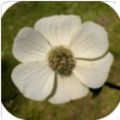
- - CORNEJO / PACIFIC DOGWOOD Cornus nuttallii

Release from emotional pain - Too much sorrow.
When there is or has been too much pain or abuse, the elixir will help to deal with past traumas. It will promote the release of resentment. And it will help "hardened" people who lack confidence because of this abuse. These may be people who are inflexible and inflexible in their bodies, rigid, even restrained or clumsy. Its great help will be to find the right path to forgiveness.

- - CORONA del INCA / POINSETTIA Euphorbia pulcherrima

Love and Hope
This elixir helps to overcome the barriers of love, enabling us to open up to others, to humanity as a whole, allowing us to find our place in humanity. It will be very useful for rebuilding interpersonal relationships within a group or within a couple.

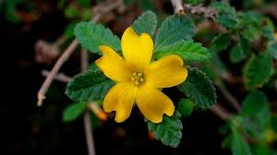
18 - DAMIANA Turnera diffusa​ AVAILABLE JUNE 2026
Sexuality — Physical vitality — Emotional connection
Damiana awakens joie de vivre, desire and connection to the body. It supports vital energy, natural sensuality and emotional momentum. An elixir for rediscovering pleasure, motivation and inner harmony.

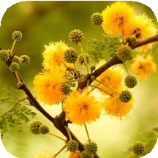
- - ESPINILLO Vachelia caven
Intuition – Clarity – Confidence
Elixir recommended for those who doubt their own opinions and depend on the judgement of others. Helps reconnect with intuition blocked by a lack of development or past events. Promotes inner clarity and self-confidence without losing empathy for others. It allows you to act from inner wisdom, balancing assertiveness and respect.

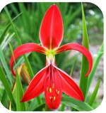
- -FLOR DE LIS / AZTEC LILY / Spekelia formossissima

Truth and Concentration - Psychic Protection
This elixir is intended for those who have difficulty concentrating, who are easily distracted and lose track of what they are doing. It also helps those whose mental or energetic state predisposes them to illness by clearing contradictory information stored at the cellular level. It promotes concentration by allowing the body, mind and soul to focus on a specific goal, helping to overcome distractions and enhance mental clarity.

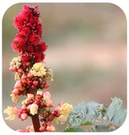
- - HIGUERILLA / CASTOR BEAN Ricinus comunis

Spiritual growth - Surrendering free will
To transcend one's many personal desires and find balance when surrendering free will. Provides the clarity needed to be drawn to "renunciation" and be able to follow the dictates of the higher Self. In the etheric body, it fills the small gaps created by an excess of uncontrollable desires. It balances the heart.
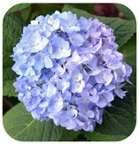
- - HORTENSIA Hydrangea macrophylla

Self-confidence - Energy - Purification - Responsibility
Elixir recommended for people who suffer from anxiety in relationships. They often lack clarity of thought, lack self-confidence but are very demanding and never satisfied. They may have a paranoid tendency. They hide their insecurities through addictions, can be manipulative and hypochondriacal. HORTENSIA is a great purifier and energiser and is highly recommended for detoxification work.

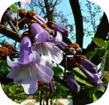
23 - JACARANDÁ Jacaranda mimosifolia

Learning - Achievement
This elixir elevates our talents so that we can better express them and fulfil our life's mission. It supports hyperactive and scattered individuals, helping them to focus their efforts. It promotes the completion of ongoing projects and the management of mental dispersion. It is also beneficial for those with learning difficulties.
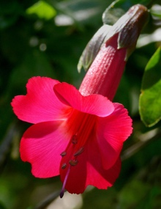
24 – KANTUTA / CANTUTA Cantua buxifolia. AVAILABLE JUNE 2026
Identity - Belonging - Lineage
A sacred flower of the Andes, Cantuta promotes emotional reconciliation and openness of the heart. It soothes relational wounds and restores inner peace. An elixir of gentleness, forgiveness and conscious love.

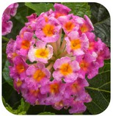
- - LANTANA Lantana montevidensis

Sensitivity - Brightness - Karma
Lantana helps overcome blockages in motivation, clarity and direction by bringing to light unconscious issues inherited from ancestral trauma and past lives. It acts as a powerful karma cleanser, capable of confronting the dark aspects of the subconscious, and facilitates the release of feelings of guilt. With its clear, bright and positive energy, lantana dissolves stagnant and negative energies, as well as unwanted psychic attachments.


- - LINO / LINUM usitatissimum

Clarity - Discernment
To balance emotional stress and release rigid attitudes, outbursts of anger and fixations. Brings clarity and discernment and allows one to recognise one's own inner strengths, which promotes protection of the self. Helps to assimilate information and improves memory.
It is an excellent cleanser of the meridians, which is appreciated in acupuncture.

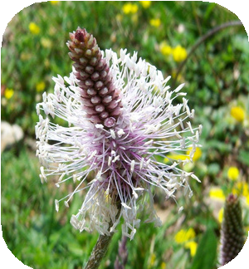
- - PLANTAIN Plantago major

To increase self-esteem and self-acceptance.
To free ourselves from mental blocks (bitterness, resentment, negative thoughts) and let go of negativity, as it is only an obstacle to well-being.

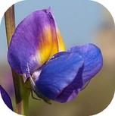
- - LUPINO - TARWI / ANDEAN LUPIN Lupinus mutabilis

Openness - Generosity
Stimulates generosity, openness and solidarity. It helps with the autonomous development of personality. To relax and navigate the river of life with security and confidence. Accompanies childbirth.

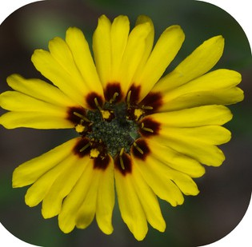
- - MADIA Madia elegans

Concentration, precise thinking
The soul must learn to expand and contract in order to concentrate better. The ability to focus energy allows for clear and productive thinking. Without this, the person becomes scattered and easily distracted. MADIA helps those who live too much in space and lack presence in the present moment.

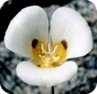
- - MARIPOSA LILY Calochortus leichtlinii

Feminine image
For people who have or have had problems with their mother. For a lack of feminine image in both men and women. For men who do not like women, for problems of abuse. Useful in cases of eating disorders such as bulimia or anorexia. Also for problems of sterility, infertility or pregnancy.
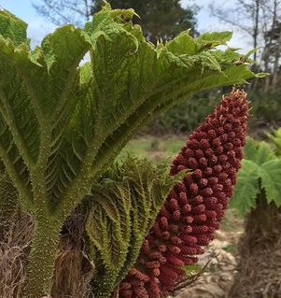
31 – NALCA Gunnera tinctoria. AVAILABLE JUNE 2026
Regaining personal territory - Strength
Nalca helps to release old emotional burdens and regain inner lightness. It supports the processes of emotional purification and renewal. An elixir to let go of the past and move forward with clarity.


- - OJOS AZULES / Baby-Blue-Eyes Nemophila menziesii

Confidence - Emotional support - Masculine image
For those who feel unsure of themselves and are unable to trust in the goodness of others or the world; for those who did not receive sufficient emotional support during childhood and may lack a healthy relationship with their father or the image of the father as a positive force of protection and guidance. The elixir helps restore childlike trust and the original innocence of the soul.
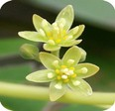
- - PALTO / AVOCADO Persea americana

Stabilises emotional fluctuations.
Useful for those who have difficulty experiencing pleasure. Helps restore confidence in oneself and others; aids in developing telepathic abilities, intuition, and the ability to see the workings of subtle energies; also develops a keen sense of touch. Supports concentration and memory, particularly when preparing for exams and cultivating a love of learning. Restructures the skin and hair.
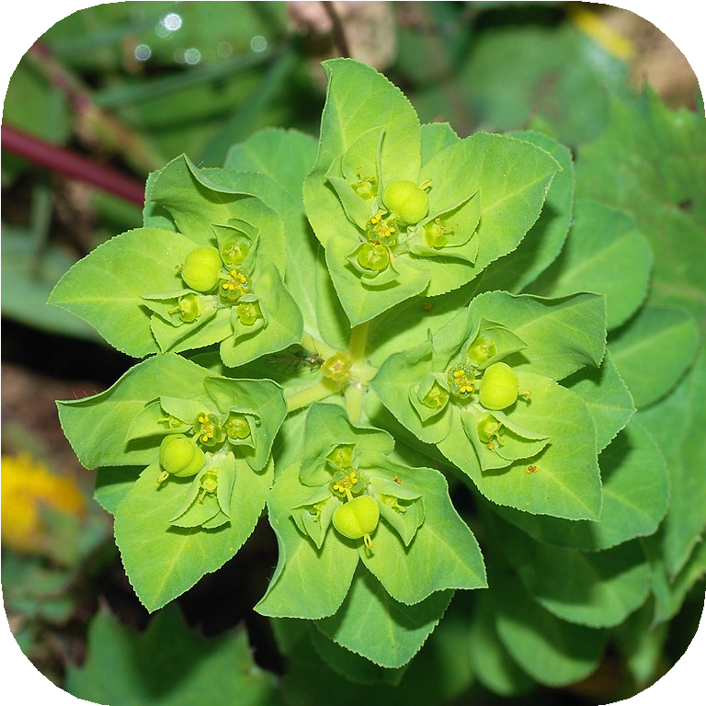
- - PICHOGA / CHILEAN EUPHORBIA Euphorbia chilensis

Acceptance of the shadow
To face, recognise and accept the shadow. The first step to healing is to know and accept reality. Provides the humility and strength necessary to begin this process, which immediately alleviates feelings of guilt, tension and negativity in general. It is a catalyst for transformation to begin a journey of real healing from our true origin.

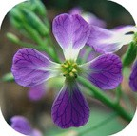
35 - RABANO Raphanus raphanistrum

Life force - Father figure
To heal wounds in the relationship with the father or the masculine image. To overcome feelings of insecurity, self-pity, destructive self-criticism, self-punishment, feelings of ugliness or impurity. For fear of exclusion, of speaking, of feeling unworthy of paternal love, the elixir increases life force, Yang energy and opens the lower energy centres.

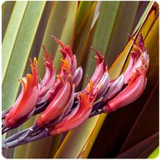
36 - PITA (Phormium tenax)

Enthusiasm – Energy – Action
This is the flower essence of enthusiasm, recommended for active, direct and motivated people who are prone to impatience, irritability and exhaustion. It supports those who live in anticipation of what is to come and seek constant action, helping them to regain their energy and zest for life. Particularly useful for hyperactive children or people who quickly lose interest in new experiences.

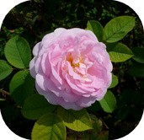
- - ROSA REINA de DINAMARCA / Rose KOENING VAN DAENMARK Rosa alba

Letting go of emotional wounds
Allows you to let go of emotional wounds. Guides you towards the possibility of giving and receiving love, thus freeing your heart. Balances the activities of the right and left hemispheres of the brain.

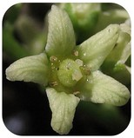
- - POISON OAK Toxicodendron diversiloba

Confidence - Sexuality - Grounding
For people who lack self-confidence because they do not recognise the boundaries between themselves and others. They tend to put up a barrier between themselves and their intimate contacts, for fear of rejection and/or possible physical pain, particularly in their sexual relationships. They are afraid of losing their identity and being absorbed by their environment or in social gatherings, by others. The elixir helps them learn to let go without fear and to trust others. It brings security and self-confidence, and the ability to set healthy boundaries. It facilitates the acceptance of sexuality as something natural.

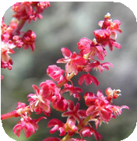
- - ROMACILLA / SHEEP SORREL Rumex acetosella

Forgiveness, Compassion, Karma Cleanser
Allows you to face emotionally challenging situations while keeping a cool head. Useful in cases of emotional fatigue. Also helps during meditation and aligns the spiritual and emotional bodies, calming the mind. Allows you to cleanse old karma, erasing the pain we have acquired as our 'right' to be oppressed. To untangle karmic knots. Illusions and imperfections are released, opening up the possibility for forgiveness, understanding and letting go.

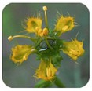
- - RUDA / RUE Ruta graveolens

Self-determination – Power – Individuality
This elixir supports self-realisation, authenticity, inner strength, independence, freedom and self-esteem. It is particularly useful in moments of invasive negative thoughts, when one feels discouraged, lost, or overwhelmed by fears and obsessive thoughts. It helps to overcome doubt and negativity and to regain clarity, personal will, and empathy.

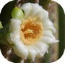
- - SAGUARO Carnegiea giganta

Represents power and authority.
For people in conflict with authority figures. These people find it difficult to distinguish the positive aspects of authority and do not allow themselves to be commanded. They live in constant struggle with the world. It is a vital elixir for those who are coming of age and have broken with their social circle. It brings awareness of the ancient and the sacred in the sense of tradition and lineage.

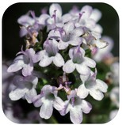
- - TOMILLO / THYME Thymus vulgares

Presence - The elixir of time
The Elixir of Time helps to relieve the pressure associated with lack of time, promoting relaxation and efficiency. It stimulates concentration, energy and adaptation to change, particularly seasonal change. It strengthens presence in the present moment and supports the connection with dreams and the subconscious. Its action is both invigorating and balancing on an energetic level.

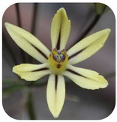
- - TRITELEIA / PRETTY FACE Triteleia ixioides

Acceptance of physical appearance
This elixir is for those who are obsessed with their appearance, seeking perfection out of fear of rejection. It also helps people with physical deformities, fear of ageing or low self-confidence. It promotes self-acceptance, harmony between inner and outer beauty, and self-esteem. Its energetic action affects the base, solar plexus and heart chakras.

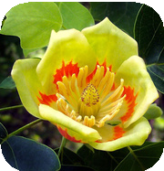
- - TULIPERO / TULIP TREE Liriodendron tulipifera

Spiritual reconnection
This is spiritual "nourishment," especially for those who feel restless and dissatisfied or who have addictive tendencies. The elixir will enable us to find positive outlets and achieve our new goals with energy.

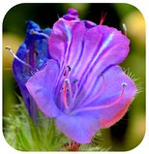
- - VIBORERA Echium bonariense

Relaxation - Transmutation
For serious, dry people with no sense of humour. Brings relaxation and releases accumulated tension; lightens the mind, emotions and body by connecting us with higher planes of consciousness. Useful for hyper-sensitive or internally weak people, as well as those suffering from mental turmoil. Provides protection, but above all a capacity for transmutation, as well as gentleness and understanding towards ourselves and, consequently, towards others.

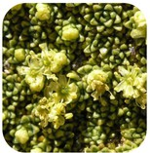
- - YARETA Azorella compacta

Opening the heart - Healing emotional trauma
Yareta helps to reopen hearts closed by great loss, rejection or lack of affection that may have created coldness or hardness. The elixir allows us to recognise pain so that we can open our hearts and love again. It helps us to let go and trust in "self-love", strengthening confidence and awareness.

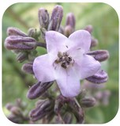
- - YERBA SANTA Eriodictyon californium

Liberation - Openness - Awareness
This flower essence helps to release repressed trauma and emotional impurities, particularly in cases of deep grief, such as the loss of a loved one. It gradually restores the heart, making it more spacious and luminous, allowing the soul to regain its balance and experience the world with a renewed emotional presence. Used in massage, it promotes deep relaxation. It also harmonises the action of other essences, soothing painful emotions and facilitating their treatment by compensating for the effects of more powerful essences.

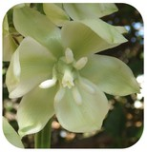
- - YUCCA Yucca elata

Personality - Action - Harmony
This elixir helps those who find it difficult to change their behaviour, who fear new challenges, or who are unbalanced, depressed, isolated, or ill. It promotes spiritual healing and strengthens inner unity, while relieving stress related to social or cultural maladjustment. It also supports the search for one's own destiny, harmonious cooperation with others, and the sincere expression of affection.

Presentation
In individual bottles of 15 or 30 ml.

Andean Shamanic Animal Elixirs
According to indigenous peoples, it appears that we have two souls: when we are born, one soul occupies our body and the other settles in the powers of Nature: in a river, on a mountain, in the lightning of a storm and, especially, in animals. From there, this second soul observes us, nourishes us and advises us throughout our lives, giving us the special gifts of the animal in which it dwells.


- – CONDOR – The Inca King

Vision - Rebirth
The Condor seeks the highest altitudes in order to communicate with the gods. It leads us towards initiation, transforming us into people who seek meaning and purpose in our lives.
To re-establish contact with the spirit. So that our ideas can become reality. From the heights, it impels us to see life's challenges with a new vision, knowing that solutions are not always within our reach. It teaches us not to rely solely on intellectual solutions, but awakens our intelligence and wisdom. It develops the world of the Spirit, giving us a new vision and purifying us. It is the symbol of the master who transmutes his faults into virtues.
- - PUMA "The Guardian of the Temples"


Leadership – Ego control – Power
The Puma forces its young to take on a great responsibility: to become leaders. This is a fundamental skill, that of leading without even insisting that others follow us.
To develop the ability to take charge when others cannot or will not. It promotes useful action and offers us the help we need to manifest our dreams and visions. It helps us to centre ourselves in situations of distraction or agitation. It helps us to realise what we need to do and accompanies us in facing our fears, thus developing our self-confidence. It is a balancer of power, intention and strength, allowing us to improve our self-esteem and free ourselves from guilt. It allows us to use the power of leadership without the invasion of the ego.
The Puma is the guardian and companion of our journey towards evolution.


- – SERPIENTE / SNAKE

Transmutation – Life Force – Regeneration.
The power of the Serpent is very strong, but you must not fear its energy. A symbol of medicine and chemistry, it represents the healing powers that live within us. It will accompany the changes of skin that we need regularly, as well as the major transformations that involve letting go of the old in order to access the new. The Serpent helps us develop a balanced sexuality. It is a true "shamanic teacher". It facilitates initiation into the deepest realms of the psyche and provides us with great help in accompanying transformations and evolution at the deepest levels, so that we can integrate our experiences of archetypal energies, such as Death and Resurrection or Rebirth.

The Serpent: for exploring the mysteries of life, as it develops our creative power and allows us to break free from the hypnotic state in which we live, capturing the negativity that is rooted within us.

- - LLAMA / LAMA

Protection – Strengthens the feminine side – Comfort from the unconscious.
Protective elixir that helps us confront and cleanse the negative energies that surround us. A very gentle and warm elixir that accompanies growth processes and helps us bear sorrow. Comforts the unconscious mind. Supports lucidity, eliminating the illusions of materialism. Guardian of "yin", of the wisdom that cares for the community and the species. Useful for people who are energetically sensitive and who cannot or do not know how to control this gift.


5- RANA / FROG

Emotional healing – Strength to face change. Renewal.
Frogs sing to invoke rain. The Power of Water, symbol of the heart and emotions. Love, encounters, the power of desire, dreams and artistic creativity.
The Frog, to understand the needs of others in a healthy way and make them our own. To channel creative flow and express it through art. It facilitates the daily experience of the world as if it were a miracle. It helps us to act fully and with the confidence of knowing that life is a miraculous and transformative process. It gives us the strength and security to face profound emotional and spiritual changes. It helps us develop the tranquillity and security necessary to face the constant changes and transformations in our lives.


- - PICAFLOR / HUMMINGBIRD

Joy – Life Force.
The gentle beating of its wings makes us feel the healing energy vibration of flowers, but also of all essences in general. The hummingbird teaches us to go through life more lightly when we feel overwhelmed by our worries and problems.
Its wing beats and its ability to move in all directions teach us not to remain stuck in situations or waiting for the future to bring us an unlikely solution.

The hummingbird invites us to revisit our past with the aim of making a fresh start, with a different outlook, and also invites us to feed on the nectar of life, the nectar that sustains its own life and enables the development of the plant kingdom through the pollination it carries out.

- – MARIPOSA / BUTTERFLY Transformation, hope, creativity

This elixir is truly one of transformation, to go from caterpillar to butterfly, transforming insecurities, lack of confidence and doubts into security, self-esteem and hope. It is recommended for growing from our weaknesses. It facilitates contact with the world of ideas, communication and exchange, to express our creativity and accompany the different cycles and changes in our lives.

- – SALMÓN / SALMON

Knowledge of Life – Confidence – Freedom.
To cultivate knowledge of life as a journey towards the Divine. Salmon helps us find meaning and spiritual purpose in our lives, as well as discover and deepen the experience of our spiritual journey. Salmon helps us move forward with perseverance towards our destiny, without fear of the unknown. It opens the doors to the spiritual mystery of life.


- – PINGÜINO / PINGOUIN

Agility – Playfulness – Community spirit.
This elixir teaches us how to move forward, to break out of a stuck situation, letting go of mild depression or fear, especially in people who tend to be constantly preoccupied.
It will be of great help to overworked people who fear that if they stop working, everything will fall apart.
This is an elixir for the long nights of the soul. It also helps us to work on patience and resilience, and brings groups of people together. It also helps us to understand feminine energy within the masculine. The penguin will be useful for assuming and developing harmonious fatherhood.


- – PUDU

Compassion – Sensitivity – Inner child.
Kindness and gentleness allow us to heal wounds (our own and those of others) and touch even the hardest of hearts. The elixir helps us to get in touch with our inner being, our childlike soul, and restores our ability to be curious and amazed by an ever-fascinating world. In this way, it is an antidote to gloom. It allows us to discover playfulness where we are preoccupied with our concerns, but also to love others as they are, without trying to change them. It allows us to develop real compassion and sensitivity.


11 - DIATOMACEOUS EARTH ELIXIR
They are one of the first manifestations of life: a protein that, thanks to a silica coating, was able to protect itself from decay. The elixir is used when the initial role has been "forgotten", both in terms of our life purpose and at the cellular level. Diatom Elixir acts as a reminder of our original mission so that we can truly act in accordance with our divine star and the path of our soul.


12 - PATAGONIAN DOLPHIN ELIXIR
He is a Master who accompanies us on our spiritual journey. He allows us to see the path we have travelled. He confronts us with reality, removing our illusions. When we are sincerely committed to fulfilment and resolution, he allows us to balance the duality that is the cause of our instability. (As in the case of Madre Divina (Divine Mother), it is not recommended to take this elixir before we are truly aware of our progress.)

The Elixirs of the "MESSENGERS"

At the beginning of the 20th century, Rudolf Steiner, a German scientist and philosopher, studied all forms of esoteric sciences. He had a deep love and understanding for angels. Steiner understood that the purpose of angels was to be spiritual instructors who help humanity reach a higher level of spirituality and inner development. He said that the more we evolve as spiritual beings, the more we connect with the angelic realms. He believed, for example, that the archangel Michael was the master angel of our New Age, and that he would help humanity emerge from the state of chaos and lack of spirit in which it was immersed, so that it could move towards an era of greater light and spiritual awareness.
A significant part of Steiner's writings describe how angels communicate with us. He says that they do so through images. According to Steiner, we need to develop our imagination and intuition in order to decipher what angels wish to reveal to us. In fact, the work we can do with angels allows us to free ourselves from our negativity and open our mental patterns regarding physical reality. This helps us develop our intuitive thinking and increase our creative capacity. Meditating on angelic matters allows us to clear negative thought patterns so that we are open to receiving heavenly messages.

Bibliography: Ambika Wauters - El Oráculo de los Angeles

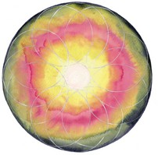
MADRE DIVINA / DIVINE MOTHER
- Creating the conditions for evolution
- Acceptance of the constraints of karma
- Strengthens the realisation of evolution
- Spiritual perfection
The Divine Mother is ONE, but appears before us in different aspects. She has many powers, personalities and emanations that act on her behalf in the universe.
The Divine Mother harbours absolute Power and calls upon all truths that must manifest themselves, giving them a dynamic form.
Main qualities of the Divine Mother:
- The STRENGTH of her Energy, Passion and Will;
- The WISDOM of her Tranquillity, her Understanding and her Compassion;
- The HARMONY of her Ardor, her Gentleness and her seductive Grace;
- ORDER imparted by intimate knowledge, meticulous work and the pursuit of perfection.


GABRIEL Purity
Spiritual quality: Purifies the being, bringing its qualities into greater harmony with the Purity of the spirit.

Qualities and characteristics: Purity, Harmony, Kindness, Clarity, Calm, Consolation.

Imbalances:
- For people who have suffered abuse or attacks on their integrity, who have suffered physical or psychological attacks.
- For people who live with negative feelings related to a past experience, as well as those who tend to feel sorry for others and/or take on other people's problems and compromise themselves in the process.
- For people who tend to carry the weight of the world on their shoulders and suffer from low self-esteem.
- Difficulty sleeping.

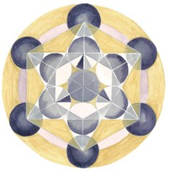
METATRON Divine creation
Spiritual quality: Prepares us to completely reprogram our lives in the Great Light, restructuring our being in this Light. Brings us great changes and invites us to evolve. Cleanses deeply rooted patterns.

Qualities and characteristics: Better understanding; Creativity; Masculine divinity; Mental divinity; Workers of the universe; Helps to build form; Programming and reprogramming.

Imbalances:
- Deep-rooted genetic patterns that keep us stuck in the past, which is no longer useful to us and prevents us from moving forward. Lack of vision and understanding of the meaning of life.
- Problems related to masculinity;
- For people who are stuck in the past and always dreaming of the future;
- For people who are unable to be in the present;
- Problems related to DNA and when there are attacks on the body with the appearance of significant ailments.
- For people who have problems using technology.

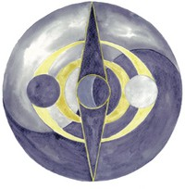
MICHAEL Truth
Spiritual quality: Allows us to cut off our thoughts related to the being who has come: to accept as the only truth that which is not. Helps us maintain our individuality in truth, in order to increase the integrity of the being.

Qualities and characteristics: Integrity; Truth; Power of Truth in order to be full of Strength and apply it in the right direction; Strength, vigour and power; Courage to face obstacles, even the most significant ones; Protection in action; Restoration of faith.
Actions:
- Helps people to be honest with themselves; for two who find it difficult to tell the truth and who do not want to act in accordance with what they say;
- For people who lack a sense of their own worth, who do not value themselves and do not value their time or energy;
- Excellent for people who betray themselves or others, as well as those who abuse their abilities or strengths, who are addicted to alcohol, nicotine or drugs in general (narcotics or medication) as well as food;
- Helps to break down barriers to personal development and see through the illusions of everyday life by creating space for oneself to see and experience life as it is.


RAFAEL Healing
Spiritual quality: Restores integrity by healing and regenerating the being, bringing it back to a state of true balance, harmony and grace.

Qualities and characteristics: Integrity, Healing; Restorative, Unity, Deep inner perfection.

Actions:
- Restoration and regeneration; Healing, Reformation and Unification;
- Returns us to integrity and helps us heal the past;
- Helps restore or heal relationships between two people (for this work, the best result will be if both people take the same elixir);

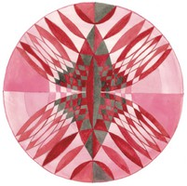
URIEL Selfless service
Spiritual quality: Aligns the person with the principle of greater service to the entire Universe. The being and the universe are as separate as a drop in the ocean.

Qualities and characteristics: Giving; Receiving; Service; Discernment; Peace; Recognition of the Divine in all things.

Actions
  - Magnifies our courage to follow our life path, combining the aspects of love, wisdom and power in each person.
  - Helps us so that we can give our gifts and knowledge to humanity and opens us up to serve and receive by opening ourselves to the world;
  - Help us so that we may reconnect with our lives and connect with the universal source.

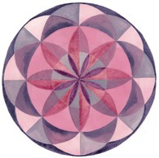
ZADKIEL Forgiveness
Spiritual quality: Allows us to forgive ourselves and others, and to reprogram dense energies into greater Light through the power of transmutation. Forgiveness in love in action.

Qualities and characteristics: Forgiveness, Mercy; Compassion; Love; Transmutation; Transformation.

Actions
  - Helps us to forget ourselves, to rise above and let go of the weight of resentment;
  - Helps us to open up and increase our own spiritual abilities, as well as to let go of anger; - Helps us to take responsibility for our own actions, thoughts and feelings, and to be more open towards ourselves and others.

The Butterfly Elixirs of the Americas

Butterflies, symbols of transformation...

"A civilisation can be judged by the way it treats its animals."
M. Gandhi, 1869-1948

For us, butterflies represent one of the greatest symbols of the animal world. This creature knows exactly when it is time to leave its calm and confined environment, its protective cocoon of light, to enter the world.

We must recognise that our own cocoon of thoughts and fears, in which we are currently confined, is also very safe and extremely familiar to us. We are afraid of what we might find outside.

Butterfly Elixirs can help us discover our level of readiness.


The four stages of butterfly evolution parallel our realities of developing thought towards manifestation in the outer, material world.

The egg stage corresponds to the idea, concept or desire we have just formed.

The larval stage is where we make the decision to learn more about the previous idea. You begin to lay the foundations for your idea to become a reality.

The cocoon stage corresponds to the moment when you think you can do, or do what you thought you could do. It is the stage in which he imagines with the idea that it can be achieved, he plays with the image, with the illusion, with the possibility. Of course, amid so much happiness, there are also fears, doubts, thoughts of failure or inability. There may still be time to back out. To start, to navigate through doubts and fears, but, inexorably, to arrive...

The butterfly stage. It materialises in the physical world and begins to realise the idea or image it had in its imagination. It is confronted with its fears, doubts, feelings of inadequacy in the best of cases, but the Butterfly Essences help it to discover strength in vulnerability, confidence in fear, experience in inadequacy.

You can take flight, a peaceful and graceful flight, because we understand that transformation is a natural act that we should not fear. Transformation is our path to perfect evolution.

Butterflies are also directly linked to our inner self, the self that has accompanied us since the beginning of evolution. They can therefore be our companions on the path to the future, so that, based on past experience, we can understand the messages needed to build the future.

Set No. 1


- - AFRODITA Speyeria aphrodite (Mexico) Aphrodite

Self-esteem – Communication – Beauty
An elixir to increase charisma. It allows us to discover, appreciate and enhance both inner and outer beauty. To enjoy our ability to attract others, but in a positive and constructive way.


- - ALMIRANTE ROJO Vanessa atalanta (Guatemala) Vulcan

Authority – Firmness
An elixir that allows us to assert ourselves in our own beliefs and life goals. It allows us to let go of the fear of not being able to do what the world (and ourselves) expects of us. It allows us to assert our authority and helps in resolving blockages related to the father figure or when there are conflicts with the father.


- - DAMASCUS ARGAN Phoebis argante (Peru) Apricot argan

Harmonious sexuality
This elixir enhances the pleasant aspects and pleasure of physical love by increasing sexual energy. It allows us to experience the act of love as a total celebration of the creation of the universe.


- - ARTEMIS MANCHADO Limenitis arthemis astyanax (Canada) Admiral

Manifestation
This elixir connects the root chakra with the crown chakra, opening the doors to the 8th, 9th and 10th chakras. It allows for MANIFESTATION. In addition, it protects us from negativity by raising our vibration level.


- - CAPITAN SALPICADO DE PLATA Hesperia comma (Canada) Comma

Enjoyment and faith in life
This elixir gives us faith in the future by helping us recognise the positive aspects that await us. It helps us have happy and joyful dreams, develop good plans, and find the time and energy to play and enjoy life to the fullest.
It will be useful in situations of nightmares, especially in children.


- - CAPITAN VIOLETA Nyctelius nyctelius (Argentina) Euripus

Spiritual awakening – Initiation
This elixir is a catalyst for transformation, allowing you to experience the rites of spiritual initiation. It will thus promote the emergence of your leadership or healing abilities. It is especially recommended when this process takes too long and/or is painful.


- - CAPUCCINO Siproeta stelenes (Peru) Malachite

Strength - Goals
An elixir to remove obstacles in our path to growth. It allows us to overcome the excuses we give ourselves for not doing what we should do because we think our goals are too distant or too difficult to achieve.
This elixir allows us to clear the path we must follow, giving us the strength and security we need to continue our evolution without hiding behind false pretexts.


- - CERANUS AZUL Hemiargus ceraunus (Peru) Blue Anole

Healing – Evolution
This elixir is a true vibrational healer that raises the body's physical vibrations so that it can cope with evolution and development without suffering from the health disorders that often accompany these processes of change. Accelerates healing processes during crises of evolution.


- - COBRE AZULADO Lycaena heteronea (Canada) Blue Copper

Letting go – Unconditional love – Fulfilment
In moments of intense or even overwhelming tension, this elixir helps to release negative tensions and restore lightness and joy. It helps us understand that there is nothing more important than the love and joy we feel for the people and goals we have. We can rejoice in this broader scheme of things and let our passion flow, regardless of what that may mean or imply.


- - CYNA Zizula cyna (Argentina) Zizula

Expression - Healing
This elixir gives us the security and protection to express what needs to be expressed, with the aim of facilitating healing on all levels. It works mainly on the throat chakra. It helps us understand that it is important to find someone we can confide our thoughts and emotions to, which will facilitate healing.


- - DOCTOR AZUL Rhetus dysonii (Peru) Blue Doctor Healing – Cleansing – Creativity
A particularly healing elixir that brings calm and tranquillity and helps clear blockages in the upper chakras. This allows high energies to flow freely to the second chakra, which increases creativity. It will be useful for improving creative visualisation.


- - DUENDE DE HIELO Callophrys irus (Canada) Frosty Imp

Protection
This is a major protective elixir, which repels negative energies and thoughts that other people direct towards us. It gathers these thoughts together as if in a net and sends them to a higher vibrational level for transmutation.


- - FILODICE Colias philodice (Guatemala) Clover Coliade

Letting go – Trust – Respect
This elixir lifts us up and brings us inspiration. It helps us understand that everything has a spiritual basis and that we should not be afraid, because we are part of Creation. It allows us to refrain from judging ourselves and others. It helps us break out of our ruts so that transformation and healing can occur.


- - ICARO Polymmatus icarus (Canada) Blue Argus

Self-worth – Positive creativity.
It is particularly suited to people who believe that others are more talented, have more to offer and give, are more elegant, more creative, and better off than they are. These people may realise that they have been subjected to negative programming, which the elixir will help them to clarify, allowing them to develop their true talents, without comparison and without false compassion.


- - MACAON Papilio machaon (Mexico) Machaon

Objectivity – Decision
This elixir helps us deal with resentment caused by situations created by others, where we find ourselves against our will and for which we must take responsibility.
It helps us to remain calm and objective so that we are not affected.

- - PAPILIO DE LAS ESPECIAS Papilio troilus (Mexico) Spice butterfly

Renewal – Love – Sexuality
Erotic love and passion to find your partner. Renewal of your love life when things get stuck. This elixir rekindles the fire in a romantic and creative relationship and erases the distance imposed by time. Renewal of love based on experience and respect.


- - PIERIS BLANCA Pieris brassicae (Chile) Cabbage white butterfly

Relationship karma
The fundamental elixir in the range, which allows us to see others through the lens of our own past. By rediscovering it, we can heal our old karma.
This elixir helps to break the vicious circle of unresolved situations in our karma, thereby facilitating our evolution.


- - PRUNA Satyrium pruni (Canada) Plum tree moth

Emergency remedy
This is another fundamental elixir for dealing with all crisis and emergency situations. It helps to soften trauma by suspending emotional pain. It allows us to refocus so that we can accept and receive the necessary help, both on a physical level and on higher planes.
It is recommended in all crisis and trauma situations, particularly when lower impulses arise (e.g. suicidal tendencies).


- - VERDE PEQUEÑA Callophrys rubi (Canada) Green Hairstreak, Green Argus

Abundance - prosperity
Helps achieve prosperity and abundance. This elixir allows this energy to come to us instead of believing that we must pursue it, thinking that it is trying to escape us.
This elixir allows us to be open and confident in the energies that govern our development, without bitterness or resentment.

- - XERCES AZUL Glaucopsyche xerces (Mexico) Blue Xerces

Karma cleansing
Another fundamental elixir in the range. It allows us to free ourselves from negative thought forms and implants inherited from previous lives.
It allows cleansing at the soul level, in order to face the reality of our mission in this incarnation.

Set No. 2


21- MACULADA / TIRCIS Parage aegeria

Soothing, Cleansing
This elixir promotes the shamanic extraction of negative energies that cause depression and despair in our lives. It repairs the etheric body.


- - AGUA-MARINA LISTADA / STRIPED AQUAMARINE Oenomaus ortygnus

Letting go – Renewal – Abundance
This elixir allows us to let go of the old so that the new can enter.
It allows us to let go of what no longer serves us and hinders our progress. It clears the way for abundance, growth and expansion of our Being to enter.


- – SABANERA/ ANARTIA Anartia jatrophae

Love and Trust – Healing
This elixir allows us to understand and put into practice the love and passion that the Creator has for all His creations. It allows Divine intervention to enter into all healing processes, both physical and mental.


- - ARES DE METAL / ARES METALLIQUE Emesis ares(Mexico)

Value – Renewal
An elixir to initiate a new paradigm, opening us up to spiritual strength and courage. It will allow us to act beyond what we already know, thus discovering new energies that we can then recognise as our own and appropriate to the process we have begun.


- – BATTUS Battus philenor

Faith in life
This elixir is very special because it carries our prayers to the Creator so that they may be blessed and returned to us in manifest form. Faith and trust in life, without the intervention of our mind. We learn to savour the "Nectar of Life" that is present everywhere.


26- CAPITAN DION/ CAPTAIN DION Euphyes macquirei

Changes – Skill
An elixir for moments when we feel that a new door is opening in our lives, but we don't know how to act. This elixir is also useful for people who try to force a new situation instead of waiting for the right moment to act.


- - COBRE BRONCEADO / AMERICAN BROWN Lycaena hyllus

Creativity – Change – Cellular Memory
This elixir regulates the electrical circulation in the body, which is particularly useful in times of necessary change that we do not know how to deal with. It helps the energy flow in the building channels, so that we can achieve the necessary goals instead of remaining on the sidelines.


- – PURPLE COPPER Lycaena helle

Prosperity - Responsibility
This elixir helps us understand that our prosperity and abundance depend solely on ourselves. We cannot rely on anyone but ourselves; we must look within and connect with our own prosperity. We often tend to think and believe that our well-being depends on factors outside ourselves and therefore beyond our control. In fact, this elixir helps us understand that these movements, these flows of prosperity, depend solely on our deepest thoughts, feelings and beliefs. The more we act to elevate and increase our positive beliefs, the more we will see that these energetic movements we initiate are beginning to bear fruit.


- – DAIRA/ DAIRA Eurema daira

New horizon – Strength and courage
An elixir for people who feel trapped by circumstances (when there is a problem with a family member, a break-up or job loss, etc.). It will open up a new vision for us so that we can walk freely, without fear, guilt or feeling betrayed by others. It will also bring us strength, joy and energy on this new path.


- - DUENDE DE LOS PINOS/ PINE SPRITE Callophrys niphon

Union – Courage – Strength
This elixir helps us to mend or break destructive relationships, taking into account whether the existing union is good or necessary or, on the contrary, destructive. It helps us to overcome the anxiety of an emotional break-up.


- - MARCA DE LA PREGUNTA/ POLYGON OF THE QUESTION
Polygonia interrogationis

Knowledge – Humility – Mission
This elixir is very important because it allows us to know clearly what question to ask. Often, clearly formulating the question opens the door to answers. The elixir helps us to go beyond the answers we think we already have....


- - MEXICANO AZUL/ MEXICAN BLUE Myscelia ethusa

Being yourself - Understanding
To understand families with problems, cultural patterns and the impact this has on our lives, and on our own lives in particular. By breaking with the cultural and social expectations of others, we can then let go of repetitive patterns of dysfunction. This elixir enables this break, thus clarifying the transition to a new way of thinking and acting, with respect, but without servility.


- - MORFO BLANCO/ WHITE MORPHO Morpho polyphemus

Ego control - Recognition
This elixir allows us to accept praise and recognition from others, as they value and acknowledge our contributions.
It also allows us, in a healthy and objective way, to open up our ability to praise, value, recognise and demonstrate these feelings to others.


- - OJO DE MACHO/ OCELLATED BUTTERFLY Junonia coenia

Vision - Awareness - Evolution
This elixir allows us to transform negativity so that we can see the truth. It allows us to see the situation more clearly, helping us to see and get straight to the heart of the problem. It helps us to see our highest goals clearly and teaches us to define the concrete steps we need to take to achieve them.


- - PAFIA PLATEADA / SPANISH TOBACCO Argynnis paphia

Angelic connection
This elixir helps us understand that angels are always with us and accompany us. It helps us access angelic dimensions, allowing us to be attentive and act under the guidance of our angelic guides.


- - PELOS DE ENEBRO/ MITOURA Callophrys gryneus

Transmutation - Evolution
This elixir works on all the chakras, but mainly on the root and heart chakras, in order to eliminate feelings of hatred and resentment. It transmutes these emotions so that we can confidently and safely bring about the changes we need.


- - PRIMAVERA AZULADA/ SPRING BLUE Celastrina ladon

Communication - Faith in the future
This Elixir works by opening the throat chakra to allow for better self-expression. It allows us to discover our origins in this system or another, and gives us access to the abundance, blessings and help we need for our spiritual development. It allows us to let go of fear and worry.


- - PÚRPURA GRANDE/ LARGE PURPLE Atlides halesus

Evolution – Awareness
This elixir teaches us that everything happens for the development and growth of our Spirit, and that we can let go in order to evolve freely and naturally. Even when we consciously work to open our spirituality, things still happen beneath the surface. In order to make the quantum leap, we must be attentive to simple experiences that do not seem to have a spiritual reflection.


- - VESTA CRECIENTE/ MOON BUTTERFLY Phyciodes vesta

Finding your centre – Self-worth
This elixir is there to help us focus on what is really necessary and allows us to simplify the way we act, distancing ourselves from the daily hustle and bustle that we have made our own. It allows us to value our duties, our actions and ourselves in order to truly be ourselves.


- – BLUE MAZARINA Cyaniris semiargus

Consciousness – Cause and Effect
This elixir helps us to be more conscious, not only of what we think, but also of who we are connected to for the cause of what we think.
It helps us to better understand that thoughts are like objects and that we can see the result of anyone's thoughts, as well as the belief systems that exist.
In this way, we can choose a model for ourselves in order to obtain what we desire and thus raise our vibration so that it coincides with what we need.

ANDEAN ORCHID ELIXIRS

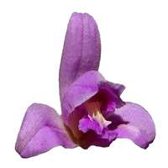 | 1 - ORCHID OF HARMONY (Bletia purpúrea)  BALANCE, STABILITY  The Orchid of Harmony helps to restore balance and centring, acting immediately in situations of imbalance or emergency. It promotes presence in the moment and aligns the body in all its dimensions. Its action is beneficial for adults, children and animals alike. It also supports the creative work of therapists such as acupuncturists and chiropractors.  Corresponding gemstone or metal: Citrine
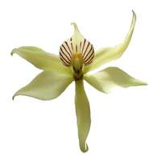 | 2 - AURORA ORCHID (Epidendrum fragrans)  EMOTIONAL PURIFICATION  This elixir strengthens the feeling of purity and promotes internal cleansing processes. This orchid purifies the subtle levels of the aura and releases stagnant emotional energies. It brings a feeling of freedom and relief, facilitates self-forgiveness, and helps restore inner love and overcome blockages related to the past.  Corresponding gemstone or metal: Axinite
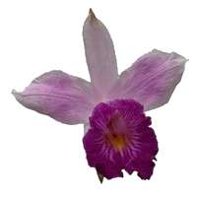 | 3 - ORCHID OF KNOWLEDGE (7th chakra) (Arundina graminifolia)  TRANSFORMATION, SECURITY  An elixir of transformation that connects emotions, feelings and knowledge to promote self-understanding. This orchid brings peace and balance in times of crisis and supports listening to personal values. It stimulates inner strength to accompany change and remain true to oneself, and promotes confidence, courage, tolerance, freedom and dignity in everyday life.  Corresponding gemstone or metal: Gold
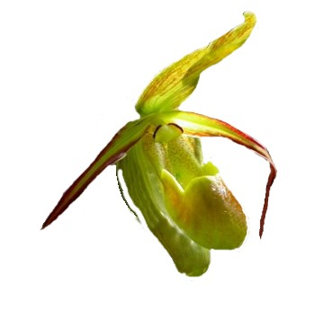 | 4 - ORCHID OF BALANCE (Phragmipedium longifolium)  PEACE, BALANCE, PURITY  An elixir of peace and balance that transforms emotions through love. This orchid brings mental clarity, calm, strength, hope and joy to move forward. It facilitates purification and change in personal development and helps to understand and release emotions to regain inner harmony.  Corresponding gemstone or metal: Chrysoberyl
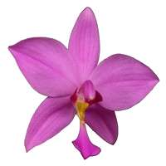 | 5 - ORCHID OF INTUITION (7th chakra) (Spathoglottis plicata)  LIGHT, INTUITION, FEMININITY  This elixir balances and harmonises the energies of the inner feminine. It strengthens self-esteem, supports the development of intuition and promotes connection to the feminine dimension in both women and men. An elixir that accompanies inner work on profound themes.  Corresponding gemstone or metal: Cross stone (chiastolite)
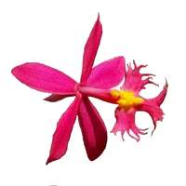 | 6 – ORCHID OF YOUTH (Epidendrum ibaguense)  JOY, ENERGY BALANCE  This elixir supports those who feel a deep desire to return to their roots. It raises energy vibrations, stimulates inner renewal and helps to rediscover the simple, spontaneous joy of childhood. An elixir that promotes vitality, lightness and connection to life.  Corresponding gemstone or metal: Platinum
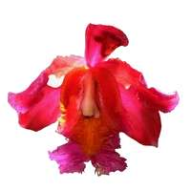 | 7 - ORCHID OF LIGHT (Sobralia dichotoma)  KEEP YOUR FEET ON THE GROUND  This elixir helps to anchor light and remain stable while serving as an energy channel. It promotes a benevolent connection to the earth and the embodiment of peace. It supports spiritual practices and sacred movements by facilitating the flow of energy. It allows new frequencies to be harmoniously integrated and calms overexcitement.  Corresponding gemstone or metal: Andean opal
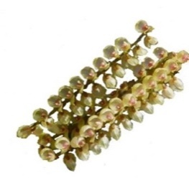 | 8 - MEDITATION ORCHID (Pleurothallis revoluta)  MEDITATION  A very high-frequency elixir that opens channels to higher dimensions, supporting ascension energy and deepening meditation. It facilitates the fulfilment of the highest conscious and unconscious desires and promotes profound and lasting inner transformations.  Corresponding gemstone or metal: Sunstone
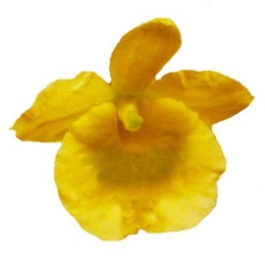 | 9 - ORCHID OF PEACE (Dendrobium agregatum)  EMOTIONAL BALANCE, SELF-AWARENESS  An elixir of peace that brings emotional balance, calm, joy and strength to move forward. It helps to clear away what prevents joy in life, promotes inner protection and develops sensitivity, connection and trust in inner wisdom. An elixir that provides support in times of emotional overload or imbalance.  Corresponding gemstone or metal: Native copper
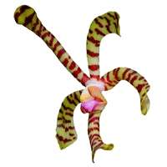 | 10 - ORCHID OF PROTECTION (Arachgnis flos aeris)  PROTECTION, FAITH, COURAGE  This elixir generates a protective field that prevents any negative influence. It acts as a benevolent guardian surrounding our subtle being. Strengthens faith, courage and inner confidence and is recommended in moments of vulnerability or energetic fragility.  Corresponding gemstone or metal: Amber
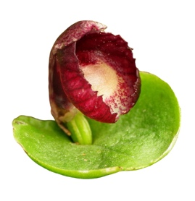 | 11 - RED HELMET ORCHID (Corybas dilatatus)  SENSITIVITY, RESPECT, SELF-CONTROL  For rebellious, selfish people who have problems with authority due to a poor relationship with their own father. This essence helps to create bonds with children, with sensitivity and respect. Often, these people can have an explosive temper or a reckless attitude.  Corresponding gemstone or metal: Ruby
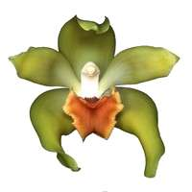 | 12 - ORCHID OF ETERNAL WISDOM (Lycaste longipetala)  DISCOVER THE PURPOSE OF YOUR SPIRIT  This elixir opens the wisdom chakra and strengthens the perception of ancient knowledge. It reminds us of the profound truths about our identity and essence and helps us determine our soul's purpose in this earthly experience. It supports our connection to wisdom and inner guidance.  Corresponding gemstone or metal: Labradorite
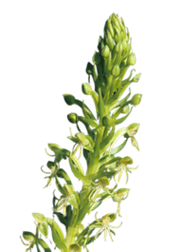 | 13 - ORCHID of STABILITY (Habenella petalodes)  HARMONY, STABILITY, GROUNDING  A broad-spectrum elixir that promotes balance in our environment. It anchors and stabilises the upper chakras to move forward serenely and restores harmony and balance, even in stressful or emergency situations. It quickly aligns the different energy bodies.  Corresponding gemstone or metal: None
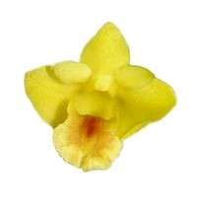 | 14 - ORCHID OF VALOUR (Dendrobium anceps)  LEARNING, UNDERSTANDING, FLEXIBILITY  A learning elixir that reveals how fear and pride affect the joy of living. It connects to the inner self and brings mental clarity to transform defensive attitudes and promotes flexibility, conscious expression and a positive approach to conflict. This elixir supports the joy of living and helps to overcome dissatisfaction and isolation.  Corresponding gemstone or metal: Rhodonite
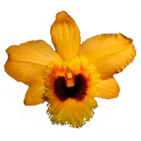 | 15 - ORCHID OF TRANSFORMATION (Dendrobium fimbriatum)  TRANSFORMATION OF BLOCKAGES, CLARITY, INNER HARMONY  An elixir that transforms blockages and harmonises emotions through mental clarity, opening communication with the inner light and promoting inner peace. It helps to release past conflicts and uncover hidden feelings, supports the resolution of karmic conflicts and prepares for inner regression.  Corresponding gemstone or metal: Lapis lazuli
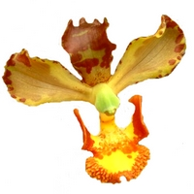 | 16 - UNION ORCHID (Cyrtopodium puntatum)  UNION, INTEGRATION OF SEXUALITY  An elixir that promotes the integration and harmonisation of sexuality. It acts as a vibrational catalyst to elevate union and connection and represents love as an instrument of peace and harmony, supporting energetic elevation and inner transformation.  Corresponding gemstone or metal: Rose quartz
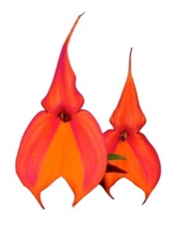 | 17 - WAKANKI ORCHID (Masdevallia veitchiana)  REALISATION, EVOLUTION  This is the Elixir of the feminine principle, embodying divine light and helping us perceive our cosmic purpose. It encourages letting go of difficult emotions and circumstances in life. This Elixir stimulates inner energy flow, supports the process of personal evolution, strengthens alignment with the higher intentions of the Universe, and transcends dualities.  Corresponding gemstone or metal: Aquamarine
Composition: Mineral water, cognac, solar infusion of flowers (0.5%) - Alcohol 20% vol. Glass bottle with dropper cap.

Precautions for use: Store in a cool place, away from electromagnetic radiation. Do not expose to sunlight.

Note: flower essences are completely safe and have no adverse effects or contraindications. Flower essences are not medicines and are not a substitute for medical treatment.

ESSENCES FROM ANDES GEMSTONES AND METALS

The range of 17 Andean gem and metal essences
To complement emotional therapeutic treatments and combine with Andean Orchid Essences.

 | 1 – AGUA MARINA / AQUAMARINE  COMMUNICATION, TENDERNESS  Facilitates communication between people, speech, singing, and the expression of truth. Helps develop paranormal perception and extra-lucidity, and amplifies maternal instinct.
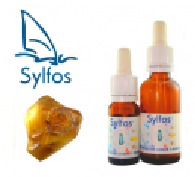 | 2 – AMBAR / AMBER  SELF-CONFIDENCE, VITAL FORCE  Wisdom of the heart. Activates the etheric body, acts on the solar plexus and the heart centre. Amber brings us a dose of "inner sunshine" for our body and soul. Its vibration strengthens self-confidence, activates self-healing powers and amplifies life force. Helps the person to take action in developing their consciousness.
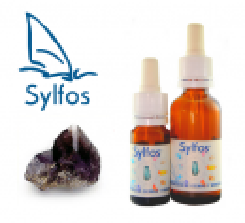 | 3 – AXINITE  POWER, BALANCE, EVOLUTION  It is the very elixir of evolution, as it facilitates breaking with the past, thus offering the possibility of a second birth. It acts on deep memories and allows the DNA chain to be opened in order to modify these memories. Promotes channelling and circulation between the root chakra and the crown chakra.
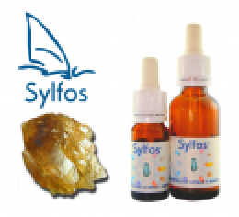 | 4 – CITRINO / CITRINE  ENTHUSIASM, CREATIVITY, ABUNDANCE  It helps us overcome and illuminate our fears, insecurities and feelings of inferiority, thereby strengthening our personal power. It is a solar stone with powerful magnetism that transforms darkness into light. It promotes creativity and attracts abundance. Its vibration provokes enthusiasm and dynamism. Clarification of thought patterns to manifest what one desires by attuning to the power of creative light. Recommended for invigorating the body and mind. Very useful for exams and intellectual work.
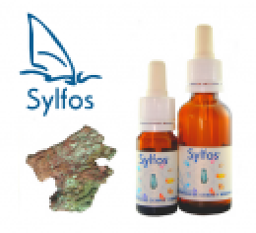 | 5 – NATIVE COPPER  ENERGY, SELF-ESTEEM  It is an emotional balancer, associated with the sex chakra. It brings a lot of energy to the body and mind and is beneficial in cases of exhaustion and low libido. It strengthens self-esteem. Used in combination with azurite or amethyst, it is a tool for meditation on the energy bodies.
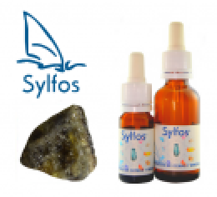 | 6 – CHRYSOBERYL  ELEVATION OF THE SPIRIT, AUTONOMY  Strengthens the body's self-healing powers. Promotes strategic thinking and planning. Helps to raise awareness of thought patterns, behaviour and social organisation. Helps with fears, inhibitions and nightmares. It gives us strength, authority and leadership qualities. Promotes self-discipline, self-control, ambition and independence.
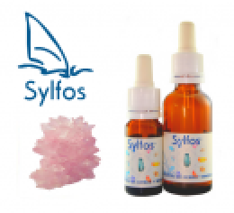 | 7 – CUARZO ROSA / ROSE QUARTZ  CALMING  Helps heal the deepest emotional wounds, heartbreak and romantic trauma. Sensitises hardened hearts to the joys of love, compensates for emotional deficiencies and trauma experienced during childhood, particularly those related to domestic or sexual violence. Provides security for children and adolescents, especially during puberty.  It allows us to become aware of the love we have for ourselves, helps us to love ourselves, to accept ourselves as we are, and induces a physical change that allows us to move closer to a more positive image of ourselves. It gives us more self-confidence and soothes the greatest pains.
 | 8 – LABRADORITE  PROTECTION, INTUITION  It could be compared to a shield combined with a sponge: it absorbs negative energies, problems and the pain of others, dissolves them and protects us. It allows for restructuring at all levels of the aura's energy body, plugging energy leaks in the etheric body.  Its light acts as an inner light: a brilliant mind in the service of good, a privileged relationship with higher cosmic forces, universal knowledge. A gem of great intuition, it promotes premonitory dreams, develops clairvoyant qualities and helps to perceive the aura.
 | 9 - LAPIS LAZULI  INITIATION, CREATIVITY, PURIFICATION  Improves authentic communication, facilitating the expression of your truth. Recommended for shy and introverted people, as it allows you to reconnect with your Higher Self in order to find the strength necessary to "step outside yourself" and overcome the limitations imposed by the ego.  It supports the process of transformation, inviting you to let go of old fears and open yourself up to evolutionary changes by being more receptive to cosmic influences. It helps you remember your dreams and understand their messages. It stimulates introspection, clairvoyance and inner discipline.
 | 10 – OPALO ANDINO / ANDEAN OPAL  CALM, ENTHUSIASM  It allows us to be receptive to new impressions. It encourages openness to others and promotes community life. It gives us the ability to be enthusiastic. It releases feelings and helps to release repressed sadness by allowing us to cry. It gives us a serene mood and a pleasant outlook on life. It helps to combat discouragement and develop a childlike curiosity that allows us to see the world as a place of adventure. It releases feelings of oppression in the chest and is useful for strengthening the immune system.
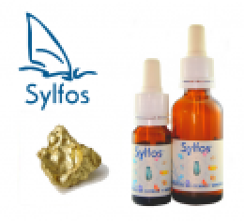 | 11 – ORO / GOLD  EGO BALANCER, GENEROSITY  Stabilises the ego, very useful in cases of frustration in life. The richness of this elixir lies in the intelligence and spirituality it brings. It clarifies the mind and promotes closeness to the supreme being. It acts on extrasensory abilities.
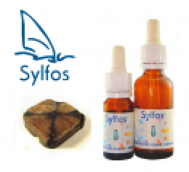 | 12– PIEDRA CRUZ / CROSS STONE (Chiastolite)  OBJECTIVITY, CENTRING  To act in accordance with our identity and fulfil our life's mission. Promotes a sense of reality and objectivity, dispelling illusions. It calms nervous, fearful temperaments and those who suffer from feelings of guilt. It helps us return to our centre, stabilising and supporting us, especially when we are afraid of losing control. It strengthens our analytical abilities, makes us more aware, helps us not to remain attached to things and allows us to come out of our shell.
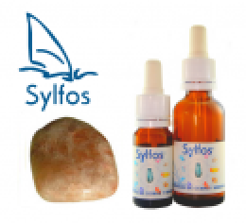 | 13 – PIEDFRA SOL / SUNSTONE  CHARISMA, ACTION, OPENNESS  Helps us discover our centre and bring it to life. Allows us to assert ourselves positively and let our own strengths shine through. With this essence, we can once again believe in joy and divine goodness.  It brings us joie de vivre, puts us in a good mood, helps combat depression and dispels feelings of disadvantage. It strengthens our self-esteem and self-confidence. It promotes optimism and the need to take action. It stimulates self-healing powers and ensures harmonious cooperation between all organs.
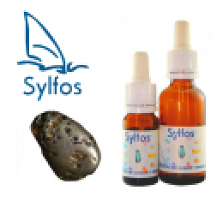 | 14 – PLATINO / PLATINUM  POWER, INITIATIVE, ACTION  Helps you take control of yourself and regain the initiative when you have given up. Helps combat fatalism and passivity. Helps you rediscover your inner strength and the will to fight adversity by setting yourself new, more ambitious and determined goals.
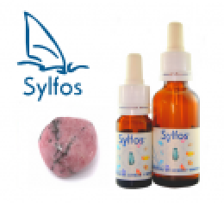 | 15 – RODONITE  CALM, GENTLENESS, TOLERANCE  Helps you to forgive and is therefore useful for people who hurt each other. Helps you to understand that arguments are often due to a lack of self-esteem and that the faults of the other person that trigger the argument are not really the cause. Promotes mutual understanding, strengthens bonds of friendship and helps to resolve conflicts constructively. Helps to overcome states of confusion, fear and panic and provides first aid in cases of trauma. Helps you to remain calm in extreme or dangerous situations.
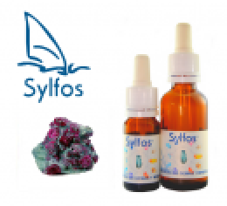 | 16 – RUBI / RUBY  STRENGTH, COURAGE, REALISATION  Encourages joyful engagement in social tasks. Stimulates thought and action, makes one active, courageous, impulsive and spontaneous. Brings intensity and dynamism. Rebalances hyperactivity and encourages an active sex life. Brings movement into our lives, with passion as its driving force. It is the gemstone of joie de vivre, and is therefore very useful in cases of self-destruction.
 | 17 – RESCATE MINERAL / MINERAL REMEDY  EMERGENCY SITUATIONS  In crisis or emergency situations, it brings calm and tranquillity in cases of serious mental or physical disorders. It helps to harmoniously restore the senses and structure of the being. It is also very beneficial in the phase preceding death, bringing calm and understanding, saving us if necessary or preparing us to leave our body. It will be useful for people accompanying a terminally ill patient. In general, it is used in the same way as Dr Bach's flower emergency remedies.


My Notes


www.sylfos.com
www.sylfos.eu

info@sylfos.eu

