* Marram Classic
* Marram Pitchfork
* Marram Animals

Combined Rules Book and How to Play on Board Game Arena

Videos on the web

Details on how to play, and tips for improving your game can be found on YouTube

**The Classic Game - Rules and How to Play on BGA**

**Game overview**

MARЯAM™ Classic is a strategic tile game for 2-4 players, suitable for ages 8 and up. Players take turns that comprise two moves, either laying tiles, or flipping certain already-laid tiles. Players claim ownership of tile features, such as snakes, worms, patches of grass and sand, by placing welly boots on the feature during the move. Points are scored when tiles are laid that complete features which have welly boots on them.

In the short game, play stops when one player has achieved a score of 80 or more (2-player game), 60 points (3-player game) or 50 points (4-player game). The winner is the player with the highest score.

In the long game all tiles are laid. The winner is the player with the most points, after additional points have been added for uncompleted features.

The short game on BGA can be completed by experienced players in about 15-25 minutes, and the long game in 40-50 minutes. Add 50% to these times for inexperienced players.

**Game pieces**

**Tiles**

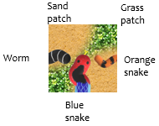Each player is given 3 tiles each drawn at random from the stock of 95 tiles, with a starter tile already on the playing area.

Most tiles show 1, 2 or 3 segments of two types of snakes or one type of worm, on a background of grass and sand patches.

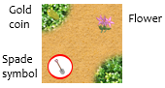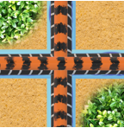Some tiles only show the grass and sand patterns. Some tiles have flowers or coins on them. Tiles that can be flipped have a spade symbol on them with a coloured ring.

A “Beastly” tile has all three types of beast (blue snake, orange snake and worm) on them. These can extend any type of beast. If, for example, the top edge is joined to a blue snake, then the bottom edge can only be matched to a blue snake.

The reverse of these tiles shows the same combination of beast segments, but with a different pattern of grass and sand. The sand and grass pattern on the reverse is a mirror image, but on tiles with the spade symbol, the reverse shows grass swapped for sand, and sand for grass.

**Welly boots and spade cards**

Each player has a colour and receives a stock of 7 welly boots of that colour. In a 2-player game, each player also receives 4 spade cards, in a 3-player game 3 cards and in the 4-player game 2 cards.

**Game play**

The playing order is automatically generated, and the current player can see in the top panel both sides of the three tiles selected. The player can also see other players’ tiles, their stock of welly boots and spade cards.

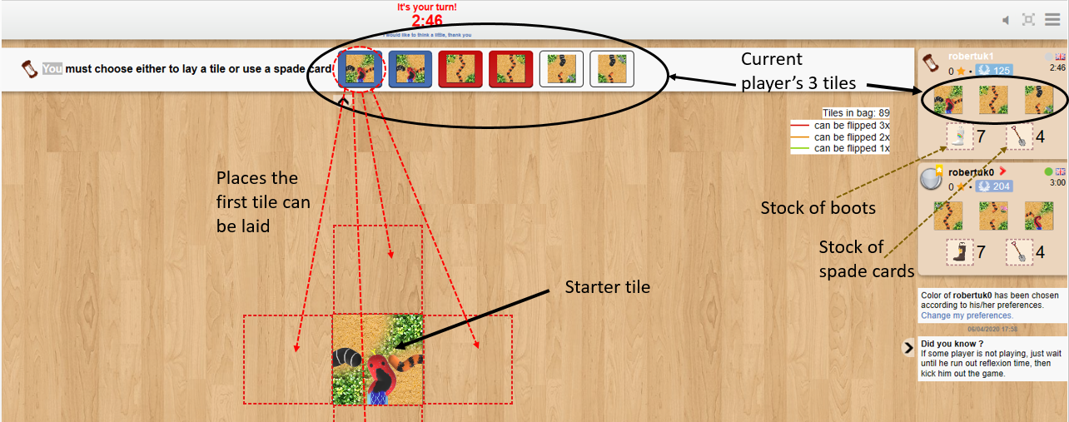

**Each player’s turn comprises two moves:**

**First move –**

* The player either lays a tile to join those already laid, or, optionally flips a tile. The player’s spade card stock is reduced if the tile is flipped. The starter tile does not have a spade symbol so the very first move in a game is always a tile placement
* The player has the option to place a welly boot on a patch (grass or sand), or on a beast, or to pass on the option. The welly boot can only be placed on the tile just laid or flipped
* The player scores points for any completed feature and welly boots on these features are automatically returned to the player’s or opponents’ stock
* Now the player has either one less tile or one less spade card.

**Second move –**

* The player again either lays a tile from the player’s remaining stock, or, again optionally, clicks on a spade symbol on a tile already played
* Then, again, the player can opt to place a welly boot, or to pass
* Again, the player scores points for any completed feature and the welly boots on these features are automatically returned to the player’s or opponents’ stock
* Finally, the player’s stock of tiles is replenished from the unused stock of tiles. The player’s stock of spade cards is not replenished.

During the course of normal play, a player will have 3 tiles at the start of a turn but a reducing number of spade cards if these have been used. Towards the end of the game, the tile stock may become exhausted and the player will start a turn with less than 3 tiles.

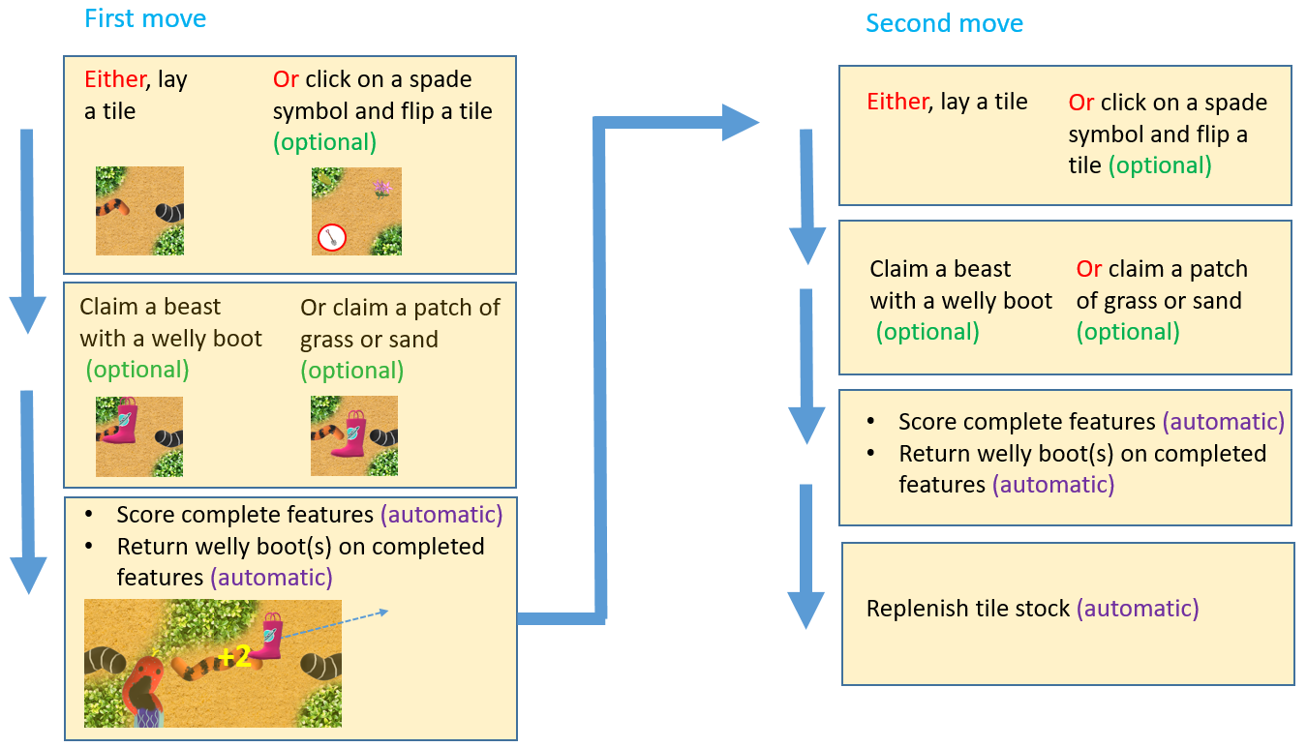

On BGA, these moves are made as follows:

**Laying a tile:**

Clicking on one of the two sides of the tile shows highlights on the playing area of places where that side of the tile cay be laid. The player clicks any of these highlighted areas to lay the tile, and then clicks again on the tile in place to re-orient it to fit. The tile placed must match patch for patch and snake for snake where the tile adjoins another. To confirm the selection the player clicks the “confirm” button, or to try another tile, or the reverse side of the current tile, the player can click on the “cancel” button.

**Flipping a tile:**

Some tiles that are already laid have a spade symbol. These may be flipped if the spade symbol has a coloured outer ring. The player reverses by clicking on the spade symbol. After the tile is flipped, the player reorients the tile to fit grass and sand patches. The player has the option to cancel or confirm the move.

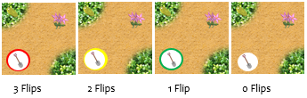A player may not use two spade cards in any one turn to flip the same tile twice No particular tile may be flipped more than 3 times in a game. Tiles that can be flipped have a red circle to show it can still be flipped 3 times, amber twice, green once and a tile with no coloured circle cannot be flipped again.

Any welly boot that was occupying the tile at the time of flipping is retired from the game.

**Placing a welly boot on a tile:**

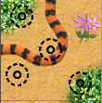All places a welly boot can be laid are marked with a black roundel on a tile when it is laid. However, not all of these places will be available, for example, if a beast or patch is controlled by another welly boot, or if the player does not have any welly boots in stock. By clicking on the roundel, the player’s boot is transferred to the tile, and the player may then “confirm” the boot placement, or “pass”, in which case the boot placement attempt is cancelled. If a player does not wish to lay a boot on a tile, then the player takes the “pass” option.

**Scoring after each move**

During the course of the game, players score points for completed features only if they have placed a welly boot at some stage (including the current move) on the feature and have a majority of welly boots on the completed feature. If several players have equal highest numbers of welly boots on the completed feature then they will all score all of the points associated with the feature.

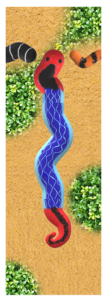**Completing snakes and worms**

Completed beasts have the following characteristics:

* A regular **blue snake** is complete if it has a head, at least one body length and a tail. A player with the majority of welly boots controlling the snake gets 3 points for each head, tail or body length. The snake shown on the right will score 9 points

**+9**

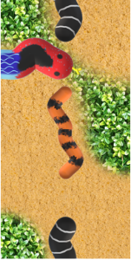

**+2**

* 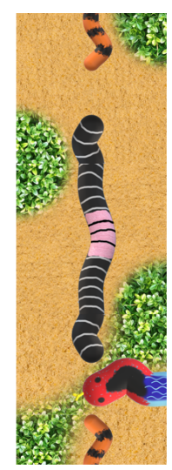The **orange snake** head and tail are the same. The orange snake is completed if it has, at a minimum, a head and a tail. A completed snake will score 1 point for each head, tail or body length. The snake shown right will score 2 points
* Unlike the snakes, **worms** have a pink saddle. They also have the same head and tail. A worm is complete if it has, at a minimum, a head, a saddle and a tail. The regular worm may also have other body lengths, but only one saddle. A completed worm will score 2 points each for the head, saddle, each additional body length, and the tail, so the worm shown on the right will score 6 points

**+6**

* It is possible to create **freak snakes and worms**. Freak blue snakes might have two heads or two tails, or no body length (just a head and a tail), and worms might be missing a saddle or might have more than one saddle. Some freaks do not have a head or a tail, just a circle of body lengths. In each case, the player controlling the beast scores just 3 points for the entire beast.

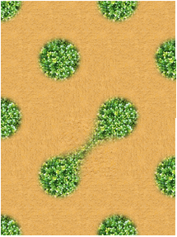**Completing patches**

A complete grass patch is one that is surrounded completely by sand, and a completed sand patch is surrounded by grass. Completed patches have bulges, some grass patches will have coins and some sand patches have flowers. The simplest complete patch looks like a circle and this has one complete bulge. The next simplest looks like a dumbbell, and this has 2 complete bulges. Circle and the dumbbell grass patches are shown in the picture on the right.

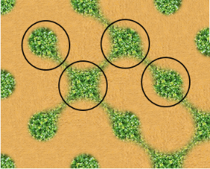Completed bulges happen when 4 tiles are laid in a square formation. The shape of the completed bulges varies from almost circles to crosses. 4 completed grass bulge examples are shown in the picture to the left (along with a completed double sand patch). Quite often snakes or worms will look as if they are slithering across a patch, breaking it up. These are ignored when determining the size and extent of the patch.

A completed grass or sand patch is worth 5 points for every complete bulge, and, if these are in the patch, 5 points for each gold coin, 4 points for each flower and 3 points for each silver coin.

**Notes and rules on selecting and laying tiles**

* The player can choose from any of the tiles in the personal tile stock to lay on any one move
* The player can choose which side of the tile to lay face up, which differ only in their depiction of patches
* The player must lay the tile to nestle against other tile(s) so that each of the adjoining edges match, snake for snake type, worm for worm, and patch for patch. If an adjoining edge has no snake or worm, it must adjoin a matching edge without a snake or a worm
* There is no limit to the body length that a beast might attain
* Each tile that is laid may complete previously incomplete beasts and grass patches. But it can also start one, two or three incomplete beasts, extend one to three existing incomplete beasts, or join two or four existing incomplete beasts
* By placing a tile the player might cause the completion of a freak beast (see above). This is permitted, but freak beasts score fewer points than regular beasts
* On any turn it is possible that there are limited or no opportunities to lay tiles:
  + An important rule to remember is that the player has the option to play a spade card, but is never required to do so, but if there is only one place to lay a tile and a player opts not to play a spade card, then the player must lay that tile
  + If there is nowhere that any of the player’s tiles can be played, and the player has opted not to use a spade card, then all of the player’s tiles are taken out of the game, and the player automatically receives fresh tiles, and play the fresh tile(s) on the same turn. If there are no tiles left for the refreshment, the player forfeits the rest of the turn unless opting to play a spade card
  + If all players have no tiles, and have consecutively passed the option to play any remaining spade cards, then the game moves immediately into the end-game phase (see below).

**Notes on placing welly boots**

* The player is allowed place a welly boot on a feature that has been completed on the player’s turn (and consequently claim points) if no player (including him/herself) already has a welly boot on any part of the feature
* A player cannot place a welly boot on a feature on which there is already a welly boot
* If a player has no welly boots in stock, then no welly boot can be laid. Welly boots are laid before any are returned for completed features
* Welly boots cannot be moved once played, they stay on the tile until a feature it is associated with is completed, at which point it is returned to the player’s stock
* Welly boots placed on tiles with a spade symbol are at risk of being captured if a spade card is played!

**Notes on using spade cards**

* In some instances, a player might complete two patches when flipping a tile during a spade card move. The player may place a welly boot on only one of the completed features assuming there are no welly boots already in the feature
* The player may flip a tile in a previously completed patch. The player is still entitled to place a welly boot in the now-altered patch as long as no other player has a welly boot in it
* A flipped tile might complete a snake that looks the same as a snake that had already been completed before the flip, but the body length that is used to make the snake is no longer the same, and the player can put a boot on the snake that enjoyed the transplant!

**End of the game**

In the short 2-player game, the game is over when one player scores 80 points or more as long as there are still tiles to be played or as the last tile has just been played by the winner. The winning score is 60 points for a 3-player game or 50 points for a 4-player game.

If all the tiles have been played and no player has achieved a knock out at the end of the last player’s turn, then unfinished features are counted and the player with the most points is the winner. In the long game, all tiles are played, and unfinished features are counted.

**Notes on scoring the short game**

* If more than one player achieves a winning score as a result of points scored in a player’s move, then the player with the highest score after that move is the winner
* If two or more players are tied with the highest score after a player’s move, then the result is a tie.

**End-game scoring**

If no player has reached the winning total, the last tile has been placed, and no player wishes to play a spade card then end-game scoring commences. Scores are tallied for incomplete beasts, grass and sand patches, where players have a majority or equal majority of welly boots on the feature.

* For each incomplete beast, (i.e. snake and worm), just one point is scored for each segment (head, tail, saddle or body length)
* For each incomplete patch of grass or sand, two points are awarded for each complete bulge in the patch and one points for each coin or flower found in the patch.

The winner is the player with the highest score after all scoring features have been tallied and scores recorded. If scores are tied after the end game, then the result is a tie.

**Marram “Pitchfork” - Rules and How to Play on BGA**

**Overview**

**“Pitchfork”** is a variant of Marram “Classic” and is a strategic tile placement game for 2, 3 or 4 players, suitable for ages 10 and up. Players take turns that comprise two moves, either laying tiles, or flipping certain already-laid tiles. Players can claim ownership of tile features, such as snakes, worms, patches of grass and sand by placing welly boots and pitchforks on tile features during the moves. Points are scored for completing features.

In the short game, play stops when one player has achieved a score of 120 or more (2-player game), 80 points (3-player game) or 60 points (4-player game). The winner is the player with the highest score.

In the long game all tiles are laid. The winner is the player with the most points, after additional points have been added for uncompleted features.

The short game on BGA can be completed by experienced players in about 15-25 minutes, and the long game in 60 minutes. Add 50% to these times for inexperienced players.

Major Differences between “Pitchfork” and “Classic”

* Most completed snakes and worms disappear from the playing area
* Welly boots can only be placed in patches
* Snakes and worms can only be claimed by pitchforks
* Players only receive 5 welly boots in the long game, and only 3 in the short game, but get 5 pitchforks
* Players receive many more spade cards
* Tiles without snakes on them gain the ability to be flipped
* Only one flip is allowed per tile
* Bulges, coins and flowers are worth less points

**Game pieces**

**Tiles**

Each player is given 3 tiles each drawn at random from the stock of 95 tiles, with a starter tile already on the playing area.

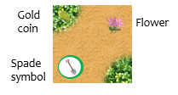Most tiles show 1, 2 or 3 segments of two types of snakes, or one type of worm, on a background of grass and sand patches.

Some tiles only show the grass and sand patterns. Some tiles have flowers or coins on them. Tiles that can be flipped have a spade symbol on them with a green coloured ring.



A “Beastly” tile has all three types of beast (blue snake, orange snake and worm) on them. These can extend any type of beast. If, for example, the top edge is joined to a blue snake, then the bottom edge can only be matched to a blue snake.

The reverse of these tiles shows the same combination of beast segments, but with a different pattern of grass and sand. The sand and grass pattern on the reverse is a mirror image, but on tiles with the spade symbol, the reverse shows grass swapped for sand, and sand for grass.

**Welly boots, pitchforks and spade cards**

**Long game**

****Each player has a colour and receives a stock of 5 welly boots and 5 pitchforks of that colour. In a 2-player game, each player also receives 10 spade cards, in a 3-player game 7 cards and in the 4-player game 5 cards.

**Short Game**

Some resources are reduced in the short game. Each player still receives 5 pitchforks, but a player receives a stock of only 3 welly boots rather than 5. The number of spade cards is also reduced to 8 in the 2-player game, 5 in the 3-player and 4 in the 4-player game.

**Game play**

The playing order is automatically generated, and the current player can see in the top panel both sides of the three tiles selected. The player can also see other players’ tiles, their stock of welly boots and spade cards.

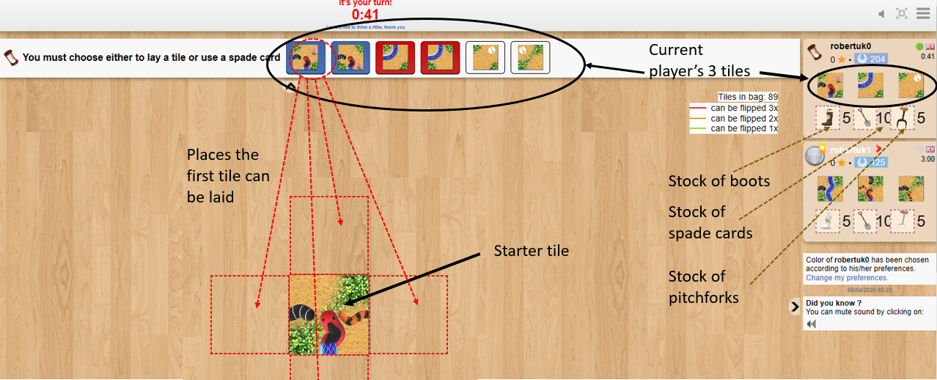

**Each player’s turn comprises two moves:**

**First move –**

* The player either lays a tile to join those already laid, or, optionally flips a tile. The player’s spade card stock is reduced if the tile is flipped. The starter tile does not have a spade symbol so the very first move in a game is always a tile placement
* The player has the option to place a welly boot on a patch (grass or sand), or a pitchfork on a beast, or to pass on the option. The welly boot or pitchfork can only be placed on the tile just laid or flipped
* The player scores points for any completed feature and welly boots or pitchforks on these features are automatically returned to the player’s or opponents’ stock
* Now the player has either one less tile or one less spade card.

**Second move –**

* The player again either lays a tile from the remaining player’s stock, or, again optionally, clicks on a spade symbol on a tile already played
* Then, again, the player can opt to place a welly boot, pitchfork, or to pass
* Again, the player scores points for any completed feature and the welly boots or pitchforks on these features are automatically returned to the player’s or opponents’ stock
* Finally, the player’s stock of tiles is replenished from the unused stock of tiles. The player’s stock of spade cards is not replenished.

During the course of normal play, a player will have 3 tiles at the start of a turn but a reducing number of spade cards if these have been used. Towards the end of the game, the tile stock may become exhausted and the player will start a turn with less than 3 tiles.

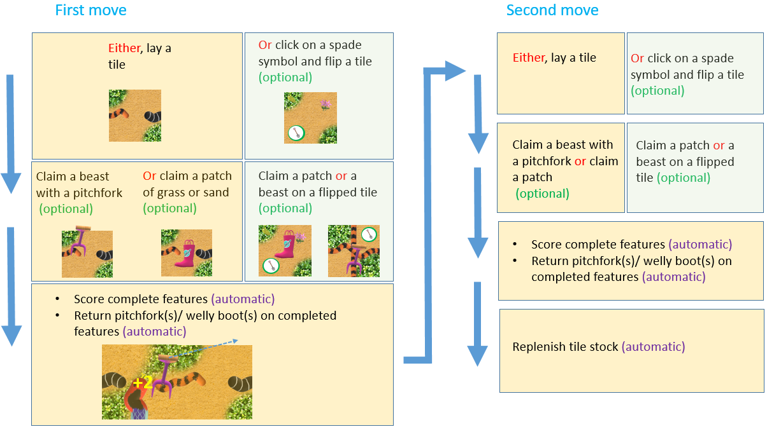

On BGA, these moves are made as follows:

**Laying a tile:**

Clicking on one of the two sides of the tile shows highlights on the playing area of places where that side of the tile cay be laid. The player clicks any of these highlighted areas to lay the tile, and then clicks again on the tile in place to re-orient it to fit. The tile placed must match patch for patch and snake for snake where the tile adjoins another. To confirm the selection the player clicks the “confirm” button, or to try another tile, or the reverse side of the current tile, the player can click on the “cancel” button.

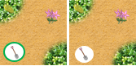**Flipping a tile:**

Some tiles that are already laid have a spade symbol. These may be flipped if the spade symbol has a green coloured outer ring. The player reverses by clicking on the spade symbol. After the tile is flipped, the player reorients the tile to fit grass and sand patches. The player has the option to cancel or confirm the move. A tile can only be flipped once during a game.

Any welly boot that was occupying the tile at the time of flipping is retired from the game.

**Placing a welly boot or pitchfork on a tile:**

****All places a welly boot or pitchfork can be laid are marked with a black roundel on a tile when it is laid. However, not all of these places will be available, for example, if a beast or patch is controlled by another welly boot or pitchfork, or if the player does not have any welly boots or pitchforks in stock. By clicking on the roundel, the player’s boot is transferred to the tile, and the player may then “confirm” the boot or pitchfork placement, or “pass”, in which case the boot/ pitchfork placement attempt is cancelled. If a player does not wish to lay a boot/ pitchfork on a tile, then the player takes the “pass” option.

**Completing snakes and worms**

Completed beasts have the following characteristics:

* A regular **blue snake** is complete if it has a head, at least one body length and a tail. A player with the majority of pitchforks controlling the snake gets 3 points for each head, tail or body length. The snake shown on the right will score 9 points.

**+9**

* The **orange snake** head and tail are the same. The orange snake is completed if it has, at a minimum, a head and a tail. A completed snake will score 1 point for each head, tail or body length. The snake shown right will score 2 points.



**+2**

* Unlike the snakes, **worms** have a pink saddle. They also have the same head and tail. A worm is complete if it has, at a minimum, a head, a saddle and a tail. The regular worm may also have other body lengths, but only one saddle. A completed worm will score 2 points each for the head, saddle, each additional body length, and the tail, so the worm shown on the right will score 6 points.



**+6**

* It is possible to create **freak snakes and worms**. Freak blue snakes might have two heads or two tails, or no body length (just a head and a tail), and worms might be missing a saddle or might have more than one saddle. Some freaks do not have a head or a tail, just a circle of body lengths. In each case, the player controlling the beast scores just 3 points for the entire beast.

**Completing patches**

A complete grass patch is one that is surrounded completely by sand, and a completed sand patch is surrounded by grass. Completed patches have bulges, some grass patches will have coins and some sand patches have flowers. The simplest complete patch looks like a circle and this has one complete bulge. The next simplest looks like a dumbbell, and this has 2 complete bulges. Circle and the dumbbell grass patches are shown in the picture on the right.

Completed bulges happen when 4 tiles are laid in a square formation. The shape of the completed bulges varies from “almost circles” to “crosses”. 4 completed grass bulge examples are shown in the picture to the left (along with a completed double sand patch). Quite often snakes or worms will look as if they are slithering across a patch, breaking it up. You must ignore the beasts when you determine the size and extent of the patch. Just look at the grass or sand patterns.

A completed grass or sand patch is worth 3 points for every complete bulge, and, if these are in the patch, 4 points for each gold coin, 3 points for each flower and 2 points for each silver coin.

**Removal of completed beasts**

When a beast is completed, its beastly segments, (heads, tails, body lengths, saddles) are automatically removed from the tiles that contain the segments. The only exception is that a completed blue snake (or completed blue snake freak beast, if it has a head) will remain if there is no other blue snake head already laid on the play area. In other words, there is always one blue snake head at all times on the play area. Once a further blue snake head is laid, the completed blue snake will then be removed. If a second blue snake is completed while an earlier complete snake is still on the play area, then the earlier snake is the one that is removed.

A tile that that has lost all of its beastly segments automatically gains the ability to be flipped with a spade card, unless a welly boot is on the tile when the last beast segment is removed. The grass and sand patterns on of the newly flippable tile are now swapped on the reverse of the tile, rather than mirrored as before.

Flippable tiles that have beast elements, (1 worm tile and 2 orange snake tiles have this quality) lose the ability to be flipped if one of the beast elements is removed, and regain the ability to be flipped once all beast elements have been removed unless there is a welly boot on the tile when the last segment is removed.

**Notes and rules on selecting and laying tiles**

* The player can choose from any of the tiles in the personal tile stock to lay on any one move
* The player can choose which side of the tile to lay face up, which differ only in their depiction of patches
* The player must lay the tile to nestle against other tile(s) so that each of the adjoining edges match, snake for snake type, worm for worm, and patch for patch. If an adjoining edge has no snake or worm, it must adjoin a matching edge without a snake or a worm
* There is no limit to the body length that a beast might attain
* Each tile that is laid may complete previously incomplete beasts and grass patches. But it can also start one, two or three incomplete beasts, extend one to three existing incomplete beasts, or join two or four existing incomplete beasts
* By placing a tile the player might cause the completion of a freak beast (see above). This is permitted, but freak beasts score fewer points than regular beasts
* On any turn it is possible that there are limited or no opportunities to lay tiles:
  + An important rule to remember is that the player has the option to play a spade card, but is never required to do so, but if there is only one place to lay a tile and a player opts not to play a spade card, then the player must lay that tile
  + If there is nowhere that any of the player’s tiles can be played, and the player has opted not to use a spade card, then all of the player’s tiles are taken out of the game, and the player automatically receives fresh tiles, and play the fresh tile(s) on the same turn. If there are no tiles left for the refreshment, the player forfeits the rest of the turn unless opting to play a spade card
  + If all players have no tiles, and have consecutively passed the option to play any remaining spade cards, then the game moves immediately into the end-game phase (see below).

**Notes on using spade cards**

* In some instances, a player might complete two patches when flipping a tile. The player may place a welly boot on only one of the completed features assuming there are no welly boots already on the feature
* The player may flip a tile in a previously completed patch. The player is still entitled to place a welly boot in the now-altered patch as long as no other player has a welly boot in it.

**Notes on placing welly boots and pitchforks**

* The player is allowed place a welly boot or pitchfork on the newly laid tile on any feature as long as the feature does not already has a welly boot(s) or pitchfork(s) on it. As a result, no tile can have more than one boot or pitchfork on it
* If a player has no tiles left to lay, then pitchforks and welly boots in stock can only be used on tiles that are being flipped
* If the feature is completed as a result of laying the tile, and there was no welly boot or pitchfork on it, then the player may claim the completed feature by placing a boot or pitchfork on the completed feature, and consequently claim points)
* If a player has no welly boots in stock, then no welly boot can be laid, and the same rule applies for pitchforks. Welly boots and pitchforks must be laid before any are returned for completed features
* Welly boots and pitchforks cannot be moved once played, they stay on the tile until a feature it is associated with is completed, at which point it is returned to the player’s stock
* Welly boots and pitchforks placed on tiles with a spade symbol with a coloured ring are at risk of being captured if a spade option is taken. Laying a pitchfork on a snake or worm tile with a coloured ring might not prove very fruitful unless the snake or worm can be completed on the players turn.

**End of the game**

In the short game, the 2-player game is over when one player scores 120 points or more as long as there are still tiles to be played or as the last tile has just been played by the winner. The winning score is 80 points for a 3-player game or 60 points for a 4-player game.

If all the tiles have been played and no player has achieved a victory score at the end of the last player’s turn, then the end-game scoring rules apply (see below). After unfinished features are counted and the player with the most points is the winner.

In the long game, all tiles are played, and unfinished features are counted, as detailed below.

**Notes on scoring the short game completed before the last tile has been laid**

* If more than one player achieves a winning score as a result of points scored in a player’s move, and the end-game situation has not been reached, then the player with the highest score after that move is the winner
* If two or more players are tied with the highest score after a player’s move, then the result is a tie.

**End-game scoring**

If no player has reached the winning total, the last tile has been placed, and no player wishes to, or can, play a spade card then end-game scoring commences. Scores are tallied for incomplete beasts, grass and sand patches, where players have a majority or equal majority of welly boots or pitchforks on the feature.

* For each incomplete beast, just one point is scored for each segment (head, tail, saddle or body length)
* For each incomplete patch of grass or sand, two points are awarded for each complete bulge in the patch and one points for each coin or flower found in the patch.

The winner is the player with the highest score after all scoring features have been tallied and scores recorded. If scores are tied after the end game, then the result is a tie.

**Videos on the web**

Details on how to play, and tips for improving your game can be found on YouTube.

**Marram “Animals” - Rules and How to Play on BGA**

**Overview**

**“Animals”** is a variant of Marram “Classic” and is a strategic tile placement game for 2, 3 or 4 players, suitable for ages 10 and up. Players take turns that comprise two moves, either laying tiles, or flipping certain already-laid tiles. Players can claim ownership of tile features, such as snakes, worms, patches of grass and sand by placing welly boots and pitchforks on tile features during the moves. Points are scored for completing features. The winner is the player with the most points, after additional points have been added for uncompleted features after all tiles have been laid and other play options exhausted.

In the middle of the game a fly appears on the play area, hop about almost at random, before being eaten by a blue snake. Later on, a frog appears and then suffers a similar fate. Both animals might also escape if they last 30 hops without being eaten. Players score points by predicting how many hops are taken before the fly or frog meet their end.

The game takes about 60 minutes to play. Add 50% to this time for inexperienced players.

Major Differences between “Animals” and “Classic”

* Most completed snakes and worms disappear from the playing area
* Welly boots can only be placed in patches
* Snakes and worms can only be claimed by pitchforks
* Players only receive 5 welly boots but get 5 pitchforks
* Players receive many more spade cards
* Tiles without snakes on them gain the ability to be flipped
* Only one flip is allowed per tile
* Bulges, coins and flowers are worth less points

Differences between “Animals” and “Pitchfork”

* The only difference between the Pitchfork long game and Animals, is the introduction of the fly and frog
* There is no short game in “Animals”.

**Game pieces**

**Tiles**

Each player is given 3 tiles each drawn at random from the stock of 95 tiles, with a starter tile already on the playing area.

Most tiles show 1, 2 or 3 segments of two types of snakes, or one type of worm, on a background of grass and sand patches.

Some tiles only show the grass and sand patterns. Some tiles have flowers or coins on them. Tiles that can be flipped have a spade symbol on them with a green coloured ring.



A “Beastly” tile has all three types of beast (blue snake, orange snake and worm) on them. These can extend any type of beast. If, for example, the top edge is joined to a blue snake, then the bottom edge can only be matched to a blue snake.

The reverse of these tiles shows the same combination of beast segments, but with a different pattern of grass and sand. The sand and grass pattern on the reverse is a mirror image, but on tiles with the spade symbol, the reverse shows grass swapped for sand, and sand for grass.

**Welly boots, pitchforks and spade cards**

Each player has a colour and receives a stock of 5 welly boots and 5 pitchforks of that colour. In a 2-player game, each player also receives 10 spade cards, in a 3-player game 7 cards and in the 4-player game 5 cards.

**Game play**

The playing order is automatically generated, and the current player can see in the top panel both sides of the three tiles selected. The player can also see other players’ tiles, their stock of welly boots and spade cards.



**Each player’s turn comprises two moves:**

**First move –**

* The player either lays a tile to join those already laid, or, optionally flips a tile. The player’s spade card stock is reduced if the tile is flipped. The starter tile does not have a spade symbol so the very first move in a game is always a tile placement
* The player has the option to place a welly boot on a patch (grass or sand), or a pitchfork on a beast, or to pass on the option. The welly boot or pitchfork can only be placed on the tile just laid or flipped
* The player scores points for any completed feature and welly boots or pitchforks on these features are automatically returned to the player’s or opponents’ stock
* Now the player has either one less tile or one less spade card.

**Second move –**

* The player again either lays a tile from the remaining player’s stock, or, again optionally, clicks on a spade symbol on a tile already played
* Then, again, the player can opt to place a welly boot, pitchfork, or to pass
* Again, the player scores points for any completed feature and the welly boots or pitchforks on these features are automatically returned to the player’s or opponents’ stock
* Finally, the player’s stock of tiles is replenished from the unused stock of tiles. The player’s stock of spade cards is not replenished.

During the course of normal play, a player will have 3 tiles at the start of a turn but a reducing number of spade cards if these have been used. Towards the end of the game, the tile stock may become exhausted and the player will start a turn with less than 3 tiles.



On BGA, these moves are made as follows:

**Laying a tile:**

Clicking on one of the two sides of the tile shows highlights on the playing area of places where that side of the tile cay be laid. The player clicks any of these highlighted areas to lay the tile, and then clicks again on the tile in place to re-orient it to fit. The tile placed must match patch for patch and snake for snake where the tile adjoins another. To confirm the selection the player clicks the “confirm” button, or to try another tile, or the reverse side of the current tile, the player can click on the “cancel” button.

**Flipping a tile:**

Some tiles that are already laid have a spade symbol. These may be flipped if the spade symbol has a green coloured outer ring. The player reverses by clicking on the spade symbol. After the tile is flipped, the player reorients the tile to fit grass and sand patches. The player has the option to cancel or confirm the move. A tile can only be flipped once during a game.

Any welly boot that was occupying the tile at the time of flipping is retired from the game.

**Placing a welly boot or pitchfork on a tile:**

****All places a welly boot or pitchfork can be laid are marked with a black roundel on a tile when it is laid. However, not all of these places will be available, for example, if a beast or patch is controlled by another welly boot or pitchfork, or if the player does not have any welly boots or pitchforks in stock. By clicking on the roundel, the player’s boot is transferred to the tile, and the player may then “confirm” the boot or pitchfork placement, or “pass”, in which case the boot/ pitchfork placement attempt is cancelled. If a player does not wish to lay a boot/ pitchfork on a tile, then the player takes the “pass” option.

**Completing snakes and worms**

Completed beasts have the following characteristics:

* A regular **blue snake** is complete if it has a head, at least one body length and a tail. A player with the majority of pitchforks controlling the snake gets 3 points for each head, tail or body length. The snake shown on the right will score 9 points.

**+9**

* The **orange snake** head and tail are the same. The orange snake is completed if it has, at a minimum, a head and a tail. A completed snake will score 1 point for each head, tail or body length. The snake shown right will score 2 points.



**+2**

* Unlike the snakes, **worms** have a pink saddle. They also have the same head and tail. A worm is complete if it has, at a minimum, a head, a saddle and a tail. The regular worm may also have other body lengths, but only one saddle. A completed worm will score 2 points each for the head, saddle, each additional body length, and the tail, so the worm shown on the right will score 6 points.



**+6**

* It is possible to create **freak snakes and worms**. Freak blue snakes might have two heads or two tails, or no body length (just a head and a tail), and worms might be missing a saddle or might have more than one saddle. Some freaks do not have a head or a tail, just a circle of body lengths. In each case, the player controlling the beast scores just 3 points for the entire beast.

**Completing patches**

A complete grass patch is one that is surrounded completely by sand, and a completed sand patch is surrounded by grass. Completed patches have bulges, some grass patches will have coins and some sand patches have flowers. The simplest complete patch looks like a circle and this has one complete bulge. The next simplest looks like a dumbbell, and this has 2 complete bulges. Circle and the dumbbell grass patches are shown in the picture on the right.

Completed bulges happen when 4 tiles are laid in a square formation. The shape of the completed bulges varies from “almost circles” to “crosses”. 4 completed grass bulge examples are shown in the picture to the left (along with a completed double sand patch). Quite often snakes or worms will look as if they are slithering across a patch, breaking it up. You must ignore the beasts when you determine the size and extent of the patch. Just look at the grass or sand patterns.

A completed grass or sand patch is worth 3 points for every complete bulge, and, if these are in the patch, 4 points for each gold coin, 3 points for each flower and 2 points for each silver coin.

**Removal of completed beasts**

When a beast is completed, its beastly segments, (heads, tails, body lengths, saddles) are automatically removed from the tiles that contain the segments. The only exception is that a completed blue snake (or completed blue snake freak beast, if it has a head) will remain if there is no other blue snake head already laid on the play area. In other words, there is always one blue snake head at all times on the play area. Once a further blue snake head is laid, the completed blue snake will then be removed. If a second blue snake is completed while an earlier complete snake is still on the play area, then the earlier snake is the one that is removed.

A tile that that has lost all of its beastly segments automatically gains the ability to be flipped with a spade card, unless a welly boot is on the tile when the last beast segment is removed. The grass and sand patterns on of the newly flippable tile are now swapped on the reverse of the tile, rather than mirrored as before.

Flippable tiles that have beast elements, (1 worm tile and 2 orange snake tiles have this quality) lose the ability to be flipped if one of the beast elements is removed, and regain the ability to be flipped once all beast elements have been removed unless there is a welly boot on the tile when the last segment is removed.

**The Fly and the Frog**

The Fly and the Frog appear only in the long game. Once 20 tiles have been laid, the Fly is automatically introduced to the play area on a tile that is as far from all blue snake heads as possible. Players then guess how many hops the Fly will take before being eaten by the snake. The Fly is eaten if it lands on a tile with a blue snake head. 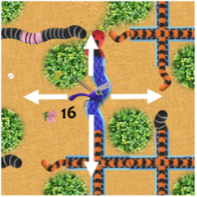After 30 tiles have been laid, a Frog appears in a similar manner, and is also eaten if it hops onto a tile with a blue snake head. If either the Fly or the Frog survive 30 hops, then they escape.

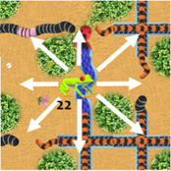The Fly and the Frog hop in a random fashion every time a player makes a move, so twice each player’s turn. The Fly can only hop on to tiles that have one edge directly in contact with the tile on which the Fly starts the hop.

The Frog may also hop on to tiles that are diagonally placed to the one where the hop starts. The Fly and Frog are both only half as likely to hop onto the tile that they have just hopped from.

Before the Fly or Frog start hopping, all players guess the expected number of hops that each beast will take before being eaten, or whether they will escape. The count of hops includes the fatal one, but ignoring the hop that took place introducing the Fly or Frog to the play area. Players take turns to state their guesses (a number between 1 and 30, or escape), starting from the current player, in the normal order of play. The player who has stated a number that is closest to the actual number of hops receives 12 points for the Fly and 12 points for the Frog with an additional bonus of 12 points if the guess was correct. Players who chose the escape option cannot share in the points, if the fly or frog is captured. If two players are tied, on either side of the correct number of hops, then the 12 points are shared out according to the number of players tied for closest. In the case of escape, if no player has opted to choose escape as their guess, then no points are awarded, even to the player with the highest guess. If a player chose the escape option, then that player receives 12 points with no additional bonus. If more than one player opted to choose the escape option, then the point available are equally shared between the players.

**Notes and rules on selecting and laying tiles**

* The player can choose from any of the tiles in the personal tile stock to lay on any one move
* The player can choose which side of the tile to lay face up, which differ only in their depiction of patches
* The player must lay the tile to nestle against other tile(s) so that each of the adjoining edges match, snake for snake type, worm for worm, and patch for patch. If an adjoining edge has no snake or worm, it must adjoin a matching edge without a snake or a worm
* There is no limit to the body length that a beast might attain
* Each tile that is laid may complete previously incomplete beasts and grass patches. But it can also start one, two or three incomplete beasts, extend one to three existing incomplete beasts, or join two or four existing incomplete beasts
* By placing a tile the player might cause the completion of a freak beast (see above). This is permitted, but freak beasts score fewer points than regular beasts
* On any turn it is possible that there are limited or no opportunities to lay tiles:
  + An important rule to remember is that the player has the option to play a spade card, but is never required to do so, but if there is only one place to lay a tile and a player opts not to play a spade card, then the player must lay that tile
  + If there is nowhere that any of the player’s tiles can be played, and the player has opted not to use a spade card, then all of the player’s tiles are taken out of the game, and the player automatically receives fresh tiles, and play the fresh tile(s) on the same turn. If there are no tiles left for the refreshment, the player forfeits the rest of the turn unless opting to play a spade card
  + If all players have no tiles, and have consecutively passed the option to play any remaining spade cards, then the game moves immediately into the end-game phase (see below).

**Notes on using spade cards**

* In some instances, a player might complete two patches when flipping a tile. The player may place a welly boot on only one of the completed features assuming there are no welly boots already on the feature
* The player may flip a tile in a previously completed patch. The player is still entitled to place a welly boot in the now-altered patch as long as no other player has a welly boot in it

**Notes on placing welly boots and pitchforks**

* The player is allowed place a welly boot or pitchfork on the newly laid tile on any feature as long as the feature does not already has a welly boot(s) or pitchfork(s) on it. As a result, no tile can have more than one boot or pitchfork on it
* If a player has no tiles left to lay, then pitchforks and welly boots in stock can only be used on tiles that are being flipped
* If the feature is completed as a result of laying the tile, and there was no welly boot or pitchfork on it, then the player may claim the completed feature by placing a boot or pitchfork on the completed feature, and consequently claim points)
* If a player has no welly boots in stock, then no welly boot can be laid, and the same rule applies for pitchforks. Welly boots and pitchforks must be laid before any are returned for completed features
* Welly boots and pitchforks cannot be moved once played, they stay on the tile until a feature it is associated with is completed, at which point it is returned to the player’s stock
* Welly boots and pitchforks placed on tiles with a spade symbol with a coloured ring are at risk of being captured if a spade option is taken. Laying a pitchfork on a snake or worm tile with a coloured ring might not prove very fruitful unless the snake or worm can be completed on the players turn.

**End of the game**

The end of the game is reached when all tiles have been played and players have either used all of their spade cards or elected to pass. End-game scoring then commences. Scores are tallied for incomplete beasts, grass and sand patches, where players have a majority or equal majority of welly boots or pitchforks on the feature.

* For each incomplete beast, just one point is scored for each segment (head, tail, saddle or body length)
* For each incomplete patch of grass or sand, two points are awarded for each complete bulge in the patch and one points for each coin or flower found in the patch.

The winner is the player with the highest score after all scoring features have been tallied and scores recorded. If scores are tied after the end game, then the result is a tie.