Overview
The aim of the game is to place all of your animals into grazing fields, where they are tended by 4 Maasai warriors and 7 boys.
For the 2-player long game, you start with 20 zebu, which are looked after by warriors, and 20 each of goats and sheep which are looked after by boys. In the 2-player short game, you have 14 of each type of animal. In the 3-player long game, you have 14 of each type of animal, and in the short game 10.
The grazing fields comprise land parcels and enclosures that the players create and extend by laying shields in the playing area. There are 3 types of land:
- Red on which zebu graze
- Green on which sheep graze and
- Yellow on which goats graze.
A land enclosure is created when the land of one colour is totally surrounded by land of other colours. Fenced enclosures, called bomas, can be created when a player lays a shield that creates that possibility.
Animals are added to land enclosures if the player has claimed the enclosure with a warrior or boy, who stay with the animals throughout the game. Animals are added to fenced enclosures when a warrior build the enclosure. Once the enclosure is built, the warrior can be released for other duties.
After an initial phase, called the hexagon, players start with 13 shields and lay 2 at a time in turn and can carry out actions such as moving warriors or boys, claiming land or building bomas when each tile is laid. When both players have only one shield remaining, the players restock to 13 shields and play continues.
Game Assets
Shields
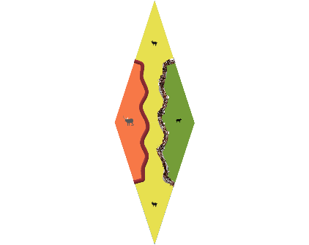
There are 39 narrow shields. Narrow shields, such as the one of the left, have various features: 3 land patches, (coloured red for zebu, yellow for goat and green for sheep) with each land patch showing a black dot where animals might be placed, a stretch of fence1 foundation (which the BGA game are shown as dashed line in black) and a stretch of fence2 foundation (dashed line in brown). Land patches of the same colour that are separated only by a fence foundation can be viewed as a larger land parcel. All narrow shields have two animal placement symbols in the top-to-bottom land patch.
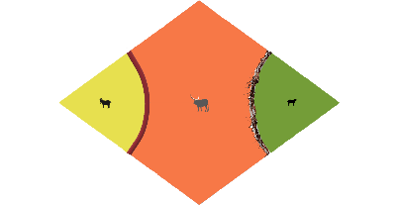
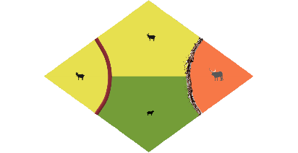
There are 63 wide shields. Wide shields have either 3 land patches (27 shields) or 4 patches (36 shields), and single lengths of the two fence foundations. Again, adjoining land patches of the same colour on a shield are considered part of the same land parcel.
Land Glossary
Land Patch – a single area of land on a shield.
Land Parcel – a larger area of adjoining land of the same colour covering one or more shields, which is not yet enclosed by land of a different colour
Land Enclosure – a land parcel or patch which is surrounded by land of a different colour

Warriors and boys
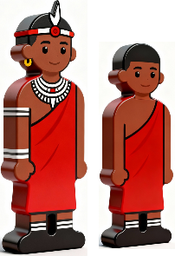
Players have a stock of 4 warriors and 7 boys at the start of the game. Their allegiance to their player is denoted by the colour of their tunic.
A player can optionally place warriors or boys on shields laid during the player’s turn. Only one warrior or boy can occupy a shield. Warriors can only go on red land patches. Boys can only go on green or yellow land patches. Warriors also construct bomas (secure animals grazing enclosures). Warriors or boys can optionally be moved between land patches or parcels during a player’s turn.

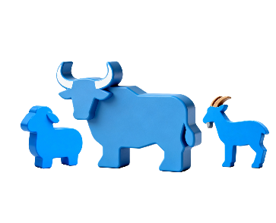
Animals
Players are given a stock of animals at the start of the game: 20 zebu, 20 goats and 20 sheep for the 2-player full game, or 14 of each for the 2-player short game. For the 3-player long game, players are given 14 of each, and for the short game 10 of each. The animals are coloured the same as the warrior’s tunics, and these animals are kept initially in stock. The idea of the game is to place all animals successfully in completed enclosures (either land enclosures or bomas) where they can graze.
Round 1
13 shields are randomly distributed to each player (8 wide and 5 narrow); 4 warriors and 7 boys. Players also receive their animals which are placed in stock.
Players aim to complete enclosures. There are three types of enclosure:
- land enclosures, where animals placed must be tended to by a warrior, who looks after zebu, or a boy in the case of sheep or goats, and
- secure fenced bomas, in which animals can be placed safely without the continuing need for a warrior or boy to tend them. However, bomas are constructed by warriors who stay with the boma until the end of the round in which they commenced the construction.
After an initial phase, called the hexagon, players take turn to lay 2 shields to join shields that are already on the playing area. When a shield is laid, a player can optionally place a warrior or boy on any land patch on the shield, or if a boma shape is completed, can instead place a warrior on the fence foundation. By laying shields and placing warriors or boys, players attempt to:
- claim land patches and parcels that are not controlled by other players,
- complete land enclosures, placing animals according to the colour of the land in the enclosure or boma, red for zebu, green for sheep and yellow for goats.
- construct bomas, placing warriors to construct them, and animals according to the colour of the land within the boma.
By laying shields without placing warriors, boys or animals, players might aim to
- expand land patches and parcels that the player already controls
- join land patches and parcels
- create blocks where players cannot place shields
After players have laid 12 shields, (i.e. players have 1 shield left,) round 1 is complete, and warriors who were constructing bomas can return to the player’s stock.

Rounds 2 - 4
At the start of rounds 2, 3 and 4, players replenish their shield stock to 8 wide and 5 narrow shields. Then play continues in the same player order.
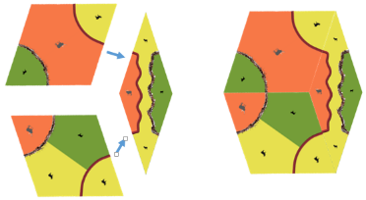
Initial Phase – creating the Hexagon
Order of play is determined randomly. One 3-patch wide, one 4-patch wide and one narrow shield are drawn at random from the undistributed stock of shields and placed automatically in the shape of a hexagon. Shields that only have one colour of land patches are not included in the choice of shields for the hexagon.
Each player can now optionally place warriors or boys on the 3 shields that comprise the hexagon.
The rules are as following:
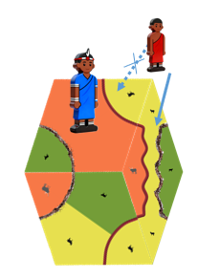
For the 2-player game:
Player 2 plays first followed by player 1. Player 2 can optionally lay one warrior or boy on a land patch on any of the 3 shields. Player 1 then may lay a warrior or boy on either of the two other shields, but not to claim a land parcel already claimed by player 2.
For the 3-player game, the order of play is player 2, followed by player 3 and then player 1. Player 1 may not place a warrior or boy on any tile occupied by either player 2 or player 3.
On the right, player 2 (blue) has placed a warrior to claim the red land on the top left shield. By extension, the red land claimed also extends to encompass the red land patch on the narrow shield.
Player 1 can then optionally lay a warrior or boy on either of the two other shields in the hexagon and on any feature on the shield that has also not been claimed. On the right, player 1 (red) might want to place a warrior on the top wide shield but cannot place it on the yellow land on that shield, because player 2 already laid a warrior on it. Similarly, player 1 cannot place a warrior the red land parcel on the narrow shield because player 2 already claims that land parcel. Player 1 is not restricted in placing a warrior or boy on any feature on the lower wide shield but chooses instead to place a boy on the yellow land patch on the narrow shield, which, by extension, is a large yellow land parcel that extends over all 3 shields.
If a land patch or parcel is enclosed by differently coloured land, and a player has a boy or warrior on it, then animals is placed with the boy or warrior, one animal for each land patch that forms part of the land enclosure or boma. For example, had player 2 instead opted to place a boy on the green patch on the lower wide shield, then, because the green patch is enclosed (surrounded by land of a different colour), then a sheep can be placed on the green land alongside the boy. In a normal game, a land parcel that consists of just one land patch is not usually claimed.
In the 3-player game player 1 may place a warrior or boy in the hexagon only on the lower left wide shield and cannot place it on the claimed yellow land parcel.

Regular play
The regular game now starts with player 1 followed by player 2, and then in the 3-player game, player 3.
Each player’s turn comprises 2 sequences of moves, and each sequence of moves comprises a series of actions, some mandatory but most are optional. At the end of the game, a player may only have one shield, in which case, only the first sequence of move actions is carried out, including placing the last shield.
Sequence of moves
First action, a player may optionally remove warriors, boys, and animals in the playing area.
- Abandoning one or more claimed land patches or parcels by removing warriors or boys that are claiming them. The player may not return to the land enclosure once it is abandoned.
- Abandoning one or more land enclosures by removing the warriors, boys and animals in the land enclosures. Again, the player may not return to the land enclosure once it is abandoned.
- Abandoning one or more bomas under construction, by removing the warrior constructing it, along with the animals placed in the boma. If by doing so, an enclosure claimed by either player is no longer an enclosure but is instead reclassified as a land parcel, then the animals within the former enclosure are returned to the player, with the controlling warrior or boy remaining in place.
Second action: The player must place a shield chosen by the player from the player’s stock of shields to join to shields already on the playing area, matching fence1 to fence1 or fence2 to fence2. The player clicks on a shield from the player’s stock and then on the white circle on the shield in the playing area that the player wants to join to. The player can reorient the shield as, in many cases, the shield can fit one of two ways.
Third action: After each shield is placed, the player may optionally place a warrior or boy on the shield just laid, warriors can be placed on red land, and boys on green or yellow land. By laying the shield, a player might complete a land enclosure, then animals are placed on the land patches on the shields that make up the completed land enclosure, according to the rules for doing so (see below). It is also possible for a player to construct a boma and can place animals in accordance with the rules for doing so (see below). A player cannot lay a shield, and both construct a boma and place a warrior or boy on a land patch on the shield.
This sequence of actions is now repeated for the second move of the player’s turn.
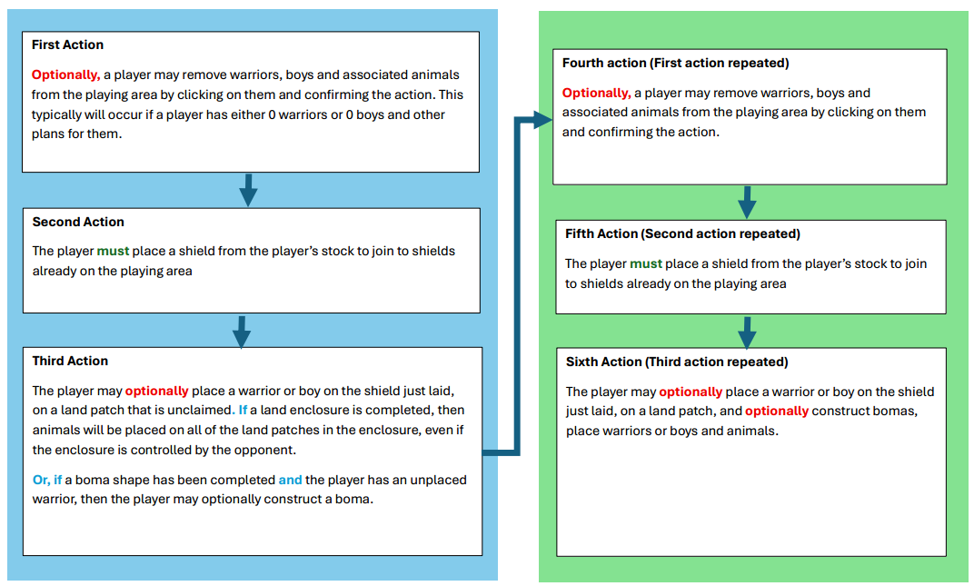
All elements of a players turn can be reversed until the sixth action is completed at which time the moves are locked in and play moves to the opponent.
After each player has taken 6 turns, (i.e. placed 12 shields) the player’s stock of shields has reduced to 1. Once all players are reduced to 1 shield, players replenish their shield stocks back to 13 (8 wide and 5 narrow), receive back warriors that were constructing bomas in that round and continue playing in a new round.
Completing Land Enclosures
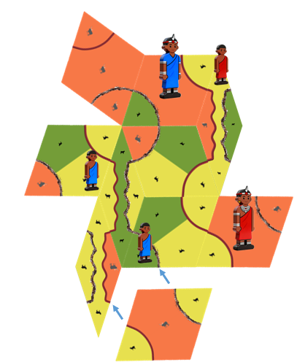
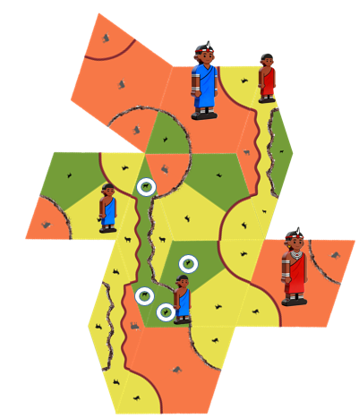
Players completing land enclosures that they occupy can place animals in the land enclosure up to the number of animals indicated by the animal symbols on the land patches. In the example on the left, the blue player controls a green land parcel with a boy, and on the next turn, can enclose the green land parcel by laying a shield with a different coloured land patch adjoining the green land parcel. When the shield is laid, it completes a green land enclosure and, because the blue player controls the enclosure, the player can place up to 4 sheep where indicated with the blue circles. The boy stays to oversee the sheep flock in this land enclosure.
Characteristics of completed land enclosures
Completed land enclosures have the following characteristics:
- The land enclosure comprises all one colour of land
- The land enclosure extends across fence foundations that join land patches of the same colour on the same shield. But if the boma is built from these foundations then the land enclosure may be split. (see below)
- A land enclosure does not terminate at the edge of shields placed in the playing area, it must be surrounded by different coloured land or a constructed boma fence. In the example above (right) the red player will need to place at least 4 more shields to enclose the yellow land parcel, and at least 3 to enclose the red land parcel.
Shared land enclosures
A player can only have one warrior or boy controlling an incomplete land patch, parcel or land enclosure. If, through either player’s action, the player ends up with more than one warrior or boy in a parcel or enclosure, then the player’s excess warrior or boy is removed automatically and take back to stock.
If a player lays a shield that joins two or more land parcels, claimed by more than one player, then all of those warriors and boys will be removed from the parcels. The player who has laid the shield has the option to claim the enlarged land parcel in the normal way, by placing a warrior or boy on the land patch that joined the land parcels on the shield the player has laid and may place animals if the enlarged land parcel is, by laying the shield, now enclosed.
However, if the player has joined parcels, all of which are controlled by a single opponent, then that opponent will receive back the excess warriors or boys, leaving one still controlling the enlarged parcel, and the opponent will retain control.
Constructing Bomas
Bomas are worth constructing because a player who constructs it can place animals in it, without the need to have a warrior permanently looking after them.
A boma can be constructed by the player who has laid a shield that joins fence foundation lengths so that the fence foundations completely surround an area of land. Unlike a land enclosure, the encircled boma land does not have to be all of one colour.
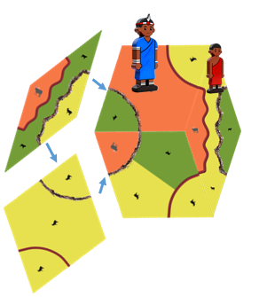
A warrior is required to construct the boma and will stay constructing the bomas and protecting the animals in the boma until the end of the round, at which point the warrior is returned to the player’s stock. If the player has no warriors in stock - for example, because they are all tending zebu or constructing other bomas – then the player cannot construct the boma.
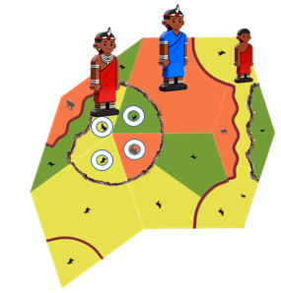
In the diagram on the left, the red player lays a wide shield to extend the yellow land parcel, and then, a second narrow shield to create a circle of a fence foundations. The player then places a warrior in the surrounded area, instructing the warrior to construct the boma.
After placing the warrior, the player removes any of the opponent’s animals (if any) that are within the boma returning these to the opponent and places the player’s own animals onto all land patches in the boma. In the example on the right, 1 zebu, 2 goats and 1 sheep. The warrior remains with the boma, tending to the animals at the same time as constructing the boma. At the end of a round, the bomas are deemed constructed, and the warriors can return to the player’s stock.
If the act of constructing a boma has cut an opponent’s land parcel or land enclosure into two or more pieces, and the warrior or boy tending the animals is outside of the boma the warrior or boy will now only be claiming a smaller land parcel, with the constructed fence creating a new boundary. Some animals are now unprotected and are returned to either the player’s or opponent’s animal stock.
It is also possible that the constructing the boma has now completed a land enclosure for the player or an opponent who were controlling a land parcel. Populating these new land enclosures with animals happens after the animals are added to the boma. The benefits and penalties of cutting up land parcels and land enclosures will not accrue at all unless the boma is constructed.
It is also possible that, in constructing the boma, either the player or the opponent may have a warrior or boy inside the boma, and animals being cared for both inside and outside of the boma. The player receives back all the animals, including those outside of the boma.
Small constructed bomas use 3, 4 or 5 shields. Larger bomas are very hard to construct and require at least 10 shields. All larger bomas encircle smaller boma shapes. If a large boma is constructed then the player can replace opponent’s animals and warriors or boys contained within, but not those in any inner bomas (either under construction or completed), as well as placing the player’s own animals on any empty or vacated land patches or parcels within the large boma. A large boma might surround an area with one or more missing shields, or areas where no shield can be laid. If a player subsequently lays shields in these spaces, animals can be placed on them by the player controlling the large boma. Hence the opponent of a player who has completed a large boma, should never place shields inside such a boma.
It is also possible that by laying one shield, two bomas are capable of being constructed. The player may choose only one of the two to construct.
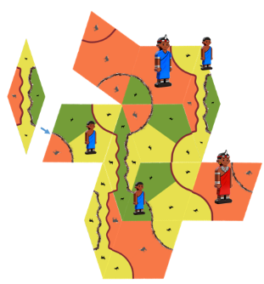
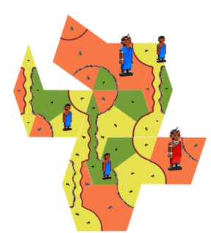
Creating blocks
It is possible to place a shield such that the adjoining space is not large enough to place additional shield. An example is shown on the right. Red frustrates blue’s plans for both zebu and goat enclosures by laying a narrow shield such that the gap shown by the arrow cannot be filled with any shield.

Additional notes and rules on selecting and laying shields
- The player chooses two from any of the shields in the personal shield stock to lay on any one turn
- In the last round of the game, players may be left with only one shield to be placed, and will play that shield in an abbreviated turn
- The shield must be laid so that a complete edge of the shield rests up against the complete edge of another shield
- The player must lay the shield to rest against other shield(s) so that fence1 joins fence1 and/or fence2 joins fence2, for all joined edges
- Shields must not exceed the angle and space available to it – for example, a wide shield cannot be forced into a narrow gap between two shields
- There is no limit to the size of any land enclosure, boma, or length of fence
- It is always possible to lay two shields in a turn, and players must follow this rule, even if the outcome for the player is negative
- Many shields have two or more land patches the same colour separated by a fence foundation. These patches form part of the same land parcel as long as the boma fence is not under construction or constructed.

Additional note on placing warriors and boys
- Other than in the hexagon phase of the game, players can only place a warrior or boy on the shield the player has laid
- A warrior of boy cannot claim an abandoned completed land enclosure and a warrior cannot claim an abandoned constructed boma.
Additional notes on placing animals in enclosures
- If a player does not have enough animals to populate a newly claimed enclosure, then the program automatically chooses which spots to place the animals, preferring the middle land patch of a shield in preference to the edge patches.
Additional notes on constructing bomas
- A player cannot claim a land patch on a shield that is laid and decide also to construct a boma.
- If a player cannot, or decides not, to construct a boma after laying a shield that provides that opportunity, then land parcels in the vicinity of the boma shape are unaffected. It is as if the bomas did not exist.
End of game
Play stops when all of any one player’s animals have left the holding pen and are in the playing area grazing. That player is the winner.
If the players have played all of the rounds and have laid all the shields and have not placed all of their animals, then the winner is the player with the most zebu in the playing area. If both players have placed the same number of zebus, then the winner is the player tending the most goats and sheep combined. If this still produces a tie, then the game is tied.
Additional notes on the end of game
- The game state is evaluated after the laying of a shield. If a player lays a shield and confirms the placement, and, in doing so, the player has enclosed a land parcel claimed by the opponent, and the opponent has now placed all their animals in the playing area, then the opponent is the winner. The player does not have the chance to claim any feature because the game is over.
- Similarly, if the player lays a shield that encloses a land parcel they already claim and also a land parcel claimed by one or more opponents, and, by doing so, all of the player’s and all the opponent’s animals are in the fields, then the game is considered a tie.
- It is technically possible that, in the 3-player game, then two or more of them may end up in a tie.

