Final Technical Document
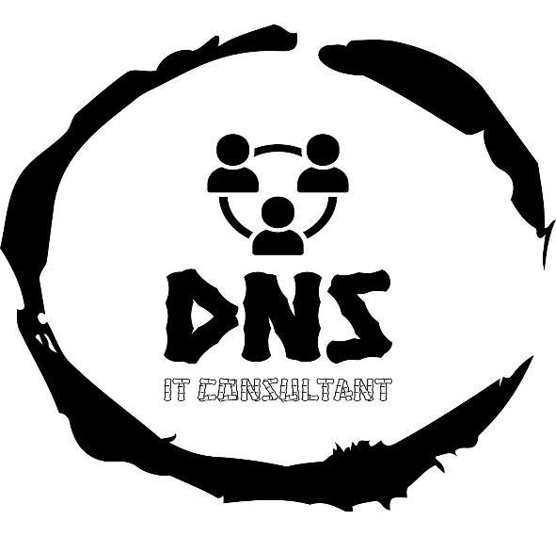

Group 8 (Sec - 005)

Deepak Khanal
Perez Rincon, Daniel Felipe
Sagar Shrestha
Ngima Tenzing Sherpa

CNET 227
March 30, 2024
To: Prof Nathan Kumarasamy

Table of Contents

Old network 3-4

New network 5-7

IP Subnetting 07-09

Network Design and Implementation 09- 96

Troubleshutting 108-109

References 99

So, this was the Old network topology design of our Client
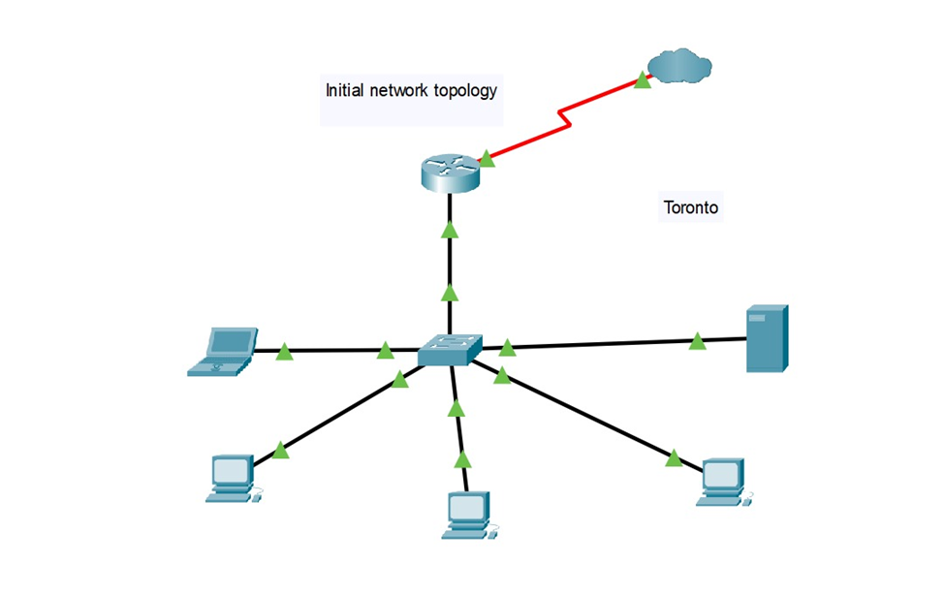
Analysis of the Original Network Design
Limited Scalability:
The original network design lacks the necessary architectural elements to support horizontal scaling or accommodate an expanding infrastructure. Its reliance on a monolithic configuration, comprising a single server, router, and switch, constrains flexibility and adaptability. The absence of modular components and scalable protocols inhibits the seamless integration of additional locations or the incorporation of advanced networking technologies. Consequently, as network demands increase, the system is ill-prepared to efficiently allocate resources or handle heightened traffic volumes, impeding organizational growth and agility.

Security Concerns:
The absence of a comprehensive security framework in the original network exposes critical vulnerabilities to various threat vectors. The limited hardware resources and potentially lax security configurations render the network susceptible to exploitation by malicious actors. Inadequate access controls, encryption protocols, and intrusion detection mechanisms heighten the risk of unauthorized access, data breaches, and service disruptions. Given the agency's handling of sensitive customer data, the absence of robust security measures poses a significant liability, necessitating immediate remediation to safeguard confidentiality, integrity, and availability.
Operational Inefficiencies:
The original network architecture engenders operational inefficiencies, particularly in terms of communication and data-sharing capabilities. With a single-server paradigm devoid of specialized services or distributed computing resources, intra-office data exchange is hampered by bandwidth constraints and latency issues. This limitation impedes real-time collaboration, necessitating manual interventions and inefficient workflows to synchronize information across departments. To mitigate these inefficiencies, a redesign focusing on scalable distributed architectures, optimized protocols, and streamlined data transmission mechanisms is imperative to enhance operational fluidity and workforce productivity.

So, this is the New network connection we came up with for the client
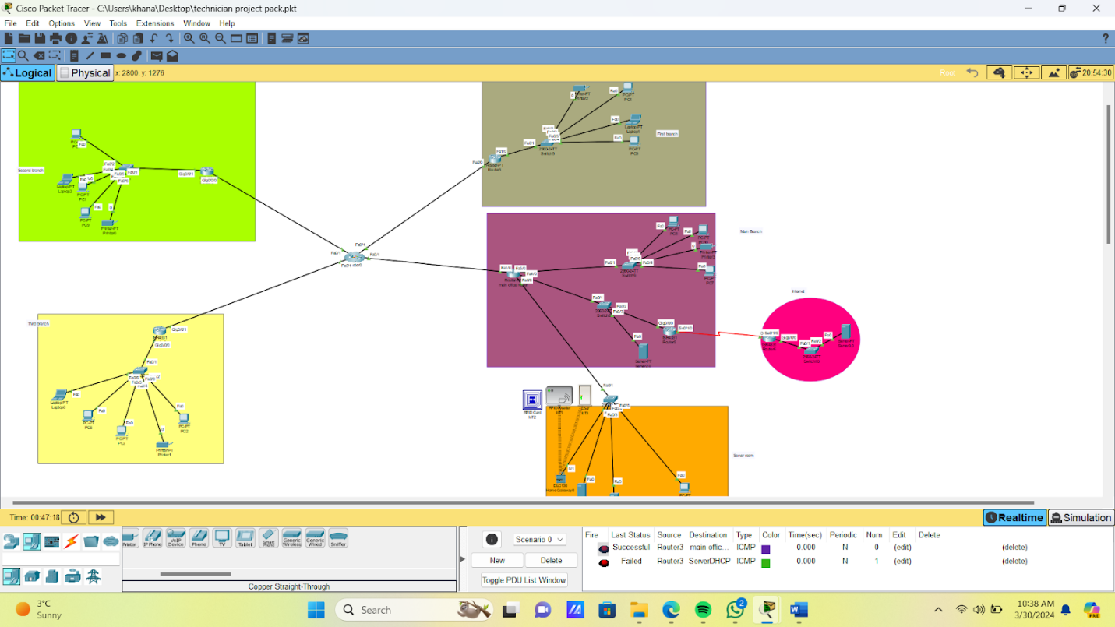
Updated Network Overview
Expansion to Four Branches:
Network Architecture: The agency has expanded its operations to include four locations, interconnected via a Wide Area Network (WAN). Each branch is equipped with a Local Area Network (LAN) setup, establishing seamless communication and data-sharing capabilities across all sites.
Infrastructure Enhancement: High-capacity WAN links connect each branch to the main office in Toronto, ensuring consistent network performance and reliability. This setup enables efficient data transmission and resource access across the distributed network environment.
OSPF for Dynamic Routing:
Routing Protocol: The network employs OSPF (Open Shortest Path First) for dynamic routing management. OSPF automatically calculates the shortest path for data packets, optimizing network speed and efficiency by dynamically adapting to changes in network topology.
Scalability and Flexibility: OSPF offers scalability and flexibility, allowing for the seamless addition of new branches or adjustments to network topologies without requiring extensive manual reconfiguration. This dynamic routing protocol supports the network's expansion and evolution over time.
Enhanced Security with Firewalls:
Perimeter Security: Firewalls are strategically deployed at each branch and the Toronto headquarters to fortify the network's perimeter. These firewalls inspect incoming and outgoing traffic, implementing access control policies to mitigate unauthorized access attempts and potential threats.
Internal Segmentation: In addition to external threat mitigation, firewalls are utilized for internal network segmentation, safeguarding sensitive data and critical resources from potential internal breaches. This segmentation enhances overall network security posture and data confidentiality.
Centralized IP Address Management:
DHCP Configuration: A centralized DHCP server, likely hosted in Toronto, dynamically assigns IP addresses to all PCs and network devices across the agency. This centralized management simplifies network administration tasks and ensures seamless connectivity for all devices.
Consistent Connectivity: DHCP automates the assignment of IP configurations, including subnet masks, default gateway addresses, and DNS settings. This ensures consistent connectivity and reduces the likelihood of configuration errors, enhancing the user experience.
Operational and Strategic Benefits:
Improved Network Management: Centralized DHCP and OSPF routing streamline network administration processes, enabling efficient management of the expanding network infrastructure.
Robust Security Posture: The implementation of firewalls across the network enhances security by protecting against external threats and internal vulnerabilities, ensuring the confidentiality and integrity of sensitive information.
Scalability for Future Growth: The updated network design provides a scalable foundation capable of accommodating future expansions or increases in network traffic as the agency grows.
Enhanced User Experience: Reliable connectivity, strengthened security measures, and efficient data-sharing capabilities contribute to improved productivity and customer service quality across all branches, enhancing the overall user experience.

Network Addressing and Subnetting Plan
The utilization of a /27 subnet mask for each location, including the main office and the branches, is a strategic choice that aligns with the scale and operational needs of "Around The World" travel agency. This subnetting approach offers a tailored balance between the number of available IP addresses and the efficient use of IP space, fitting for a small but expanding agency.
Given the /27 subnet mask, each subnet provides 32 addresses in total, of which 30 are usable for hosts, as the first address is reserved for the network identifier, and the last address is reserved for the network broadcast. This setup is indeed sufficient for a small travel agency with a limited number of devices, allowing for future growth within each location without immediately exhausting the available IP range.
Toronto Headquarters (Main Office):
- Subnet: 10.58.0.0/27
- Subnet Mask: 255.255.255.224
- Usable IP Range: 10.58.0.1 to 10.58.0.30
- Supports Toronto's network needs, including critical servers, workstations, and operational devices, within a secure and efficiently managed subnet.

Vancouver Branch: (Branch 1)
- Subnet: 10.58.0.32/27
- Subnet Mask: 255.255.255.224
- Usable IP Range: 10.58.0.33 to 10.58.0.62
- Tailored to Vancouver's branch operations, this configuration facilitates connectivity for PCs, network printers, and other essential office devices.
Calgary Branch: (Branch 2)
- Subnet: 10.58.0.64/27
- Subnet Mask: 255.255.255.224
- Usable IP Range: 10.58.0.65 to 10.58.0.94
- Calgary's subnet is designated for seamless internal communication and access to centralized resources, accommodating various networked devices.
Montreal Branch: (Branch 3)
- Subnet: 10.58.0.96/27
- Subnet Mask: 255.255.255.224
- Usable IP Range: 10.58.0.97 to 10.58.0.126
- This setup ensures Montreal's branch network is optimized for performance and security, supporting a similar device ecosystem as the other locations.
WAN Interface Configuration for Inter-Location Connectivity:
The WAN interfaces for connecting each branch and the Toronto headquarters are configured with IP addresses within a separate subnet (192.168.58.0/24), ensuring clear delineation and secure inter-site communications.
- Toronto Router WAN Interface: 192.168.58.1
- Vancouver Router WAN Interface: 192.168.58.2
- Calgary Router WAN Interface: 192.168.58.3
- Montreal Router WAN Interface: 192.168.58.4
- Subnet Mask for WAN Links: 255.255.255.0
This subnetting strategy not only supports the agency's current operational needs but also incorporates foresight into network planning, providing a scalable foundation for the travel agency’s network. It allows for efficient IP management and simplifies the addition of devices as each branch grows.
Hardware Requirements
- Edge Servers: 4 units for central and branch data processing and services.
- Assembled PCs: 80 units for staff use across all locations.
- Cisco ISR 4331 Routers: 6 units to ensure WAN connectivity across sites.
- Multi-Layer Switches: 4 units (Cisco 3560) for core network functions in the main data center.
- Access Switches: 7 units (Cisco 2960) for local area connectivity in all offices.
- Printers: 4 network printers for office documentation needs.
- Wi-Fi Access Points: 15 units to provide wireless connectivity across all locations.
- IoT Devices: 30 units for operational efficiency, including smart thermostats, security cameras, etc.
- PoS Systems: 21 units for transaction processing in customer service areas.
- Wires and Cables: Sufficient quantities for networking infrastructure setup and connections.
Software Requirements
- Operating Systems:
- Windows Server 2022 Standard for servers.
- Windows 11 Pro for all PCs.
- Productivity and Collaboration Tools:
  - Microsoft 365 Business Standard subscriptions for staff.
  - Office 365 Business Apps for enterprise use.
- Security Software:
  - Antivirus and Security Software licenses for all PCs and servers.
- Network Management Tools:
  - Network Management Software for centralized control and monitoring.
- Development and Operational Tools:
  - Custom software development tools and platforms as needed.

Services and Subscriptions
- Internet Connectivity:
- High-Speed Internet Service with sufficient bandwidth to support all operational needs, including cloud services and VoIP.
- Cloud Services:
  - Cloud Storage and Backup Services for data redundancy and disaster recovery.
- Public IP Address Leases:
  - At least 3 public IP addresses for accessible services like mail and web servers.
- Maintenance and Support:
  - Service agreements for critical hardware and software, ensuring prompt technical support and updates
Network Design and Implementation
We Configured the server and here is the server after configuration
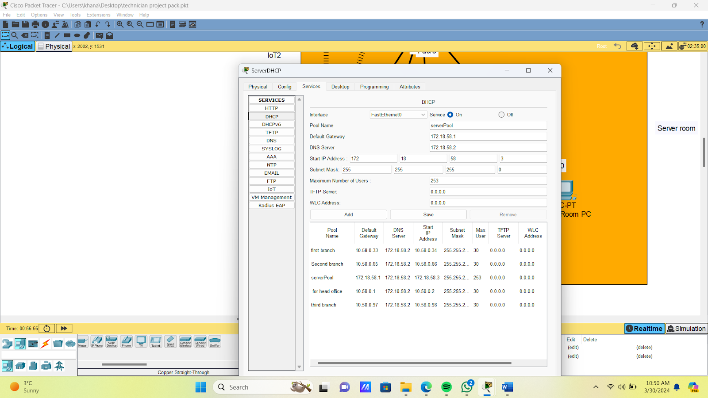
Adding one extra DHCP server in server room for redundancy
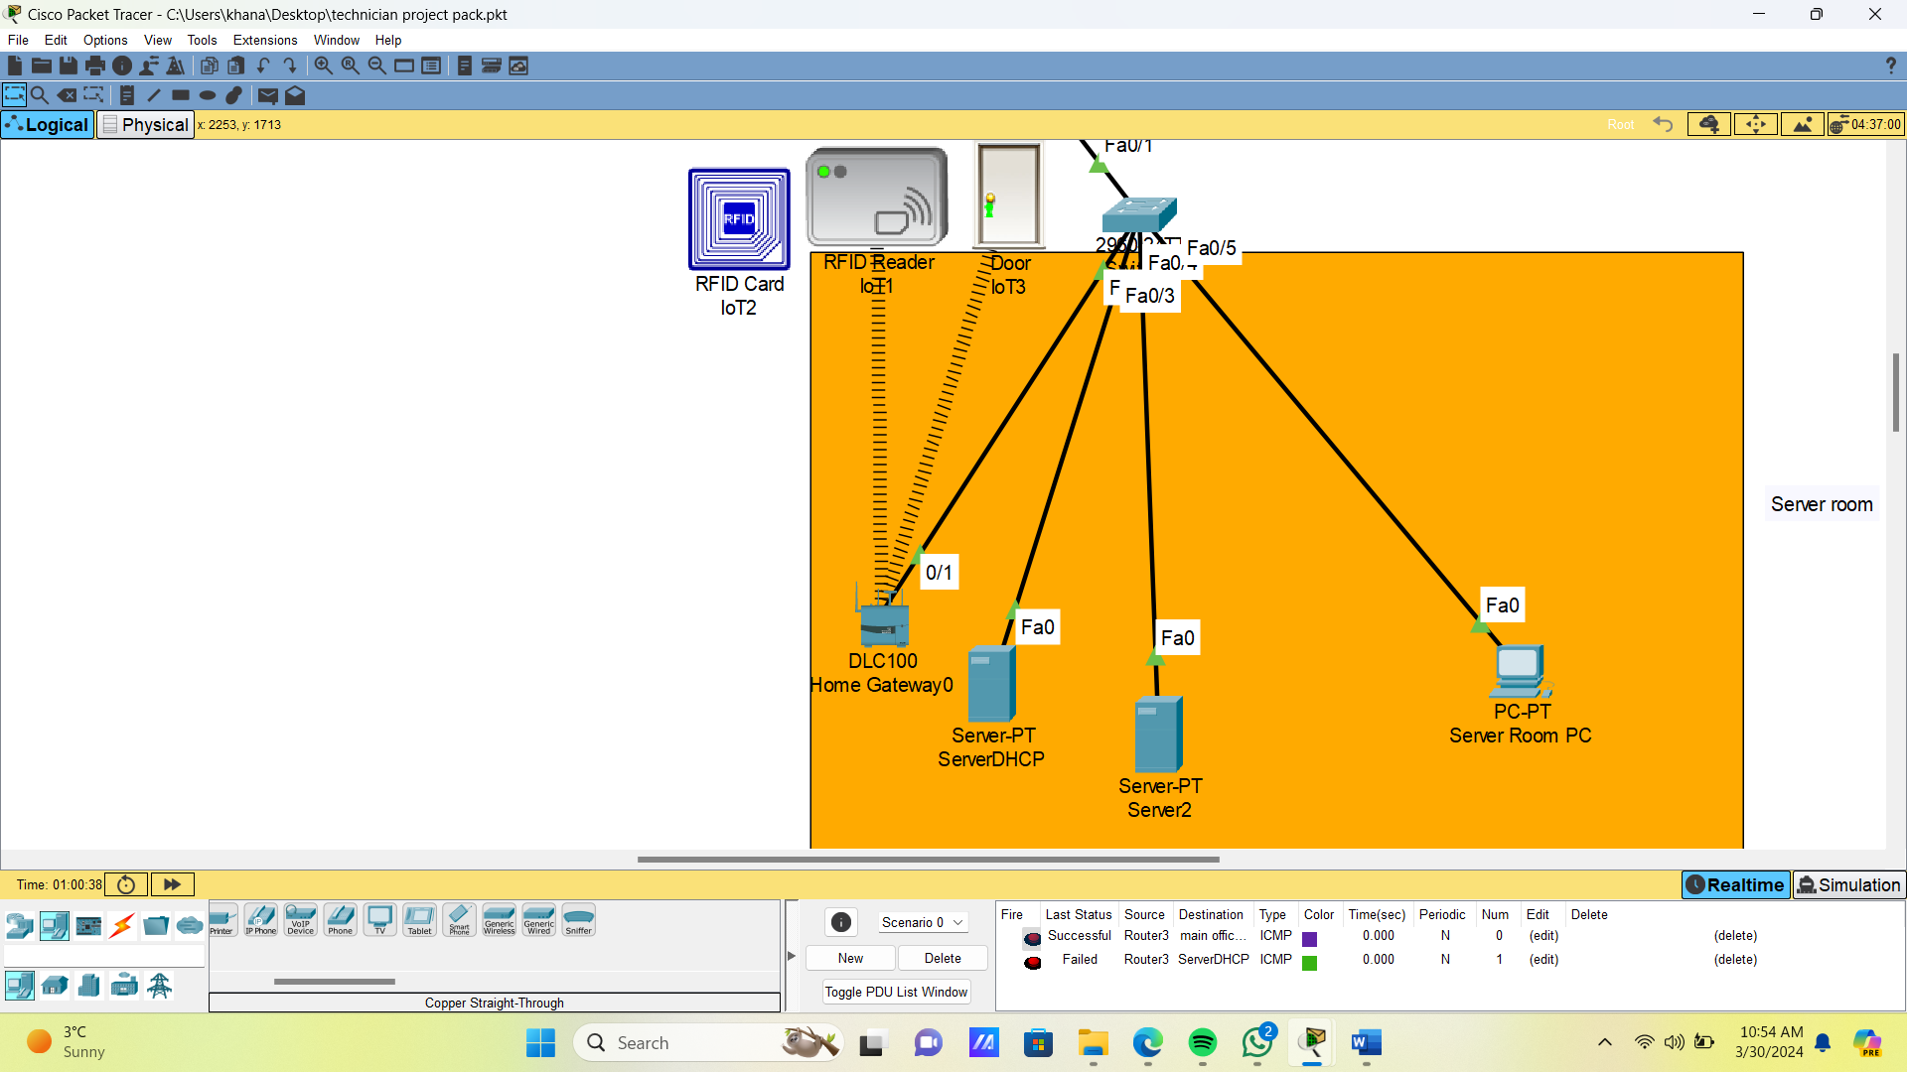
Configuring routers with ip helper command
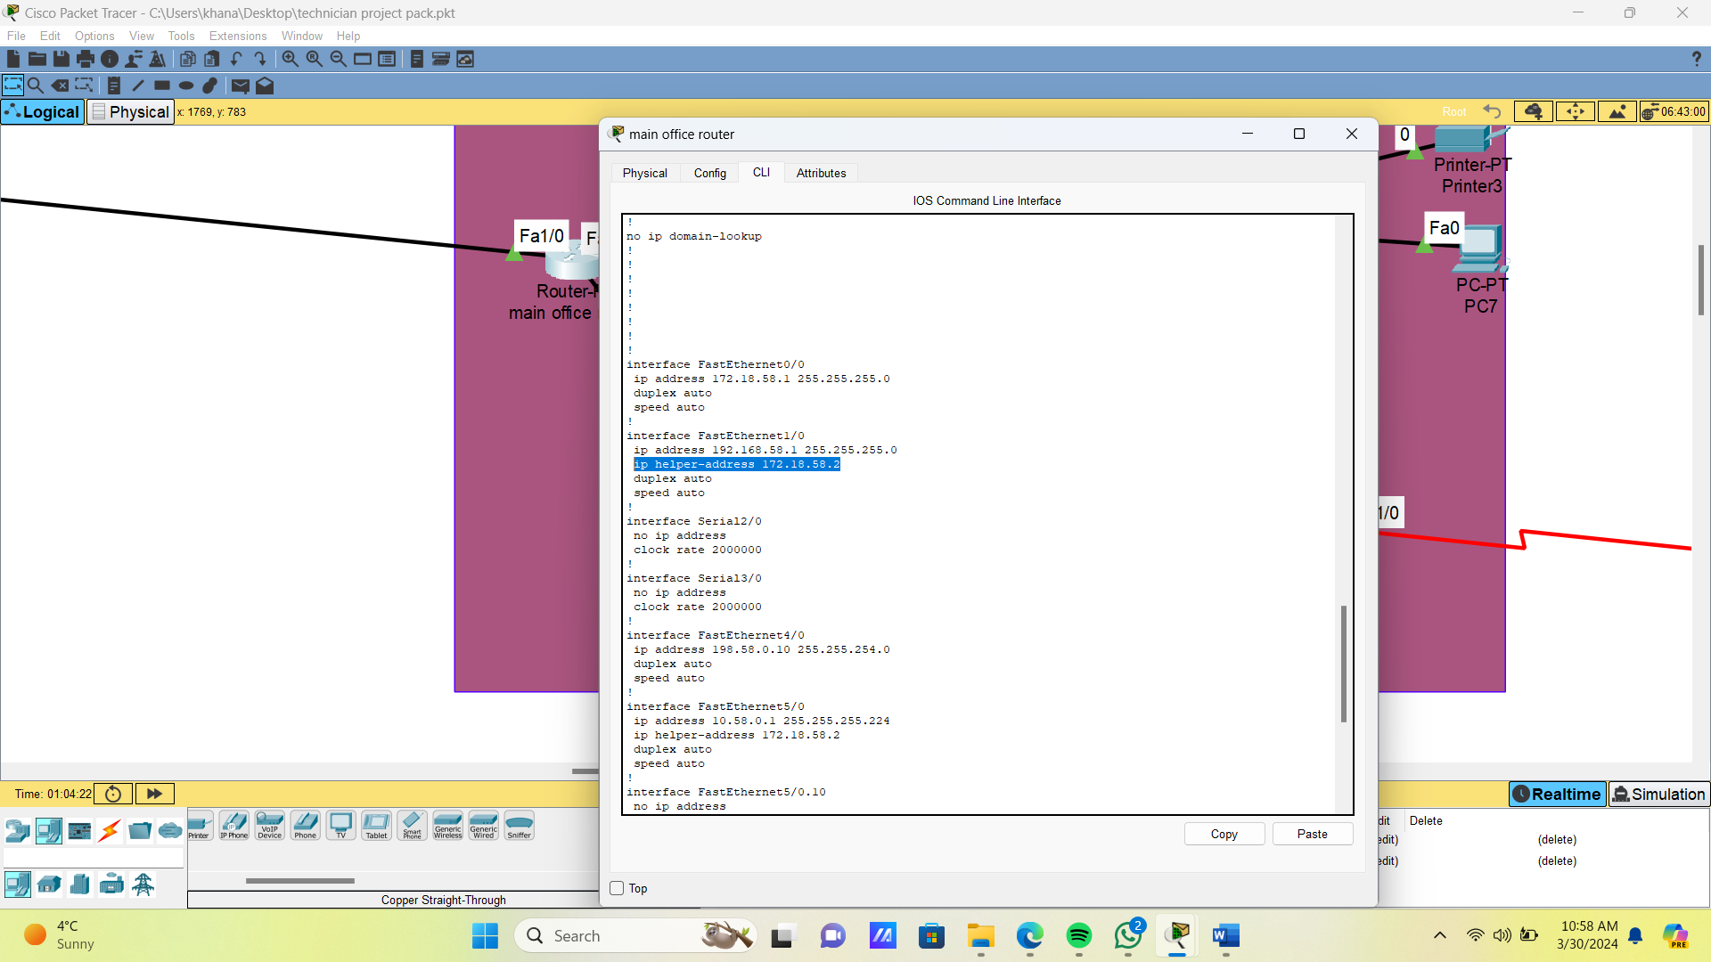
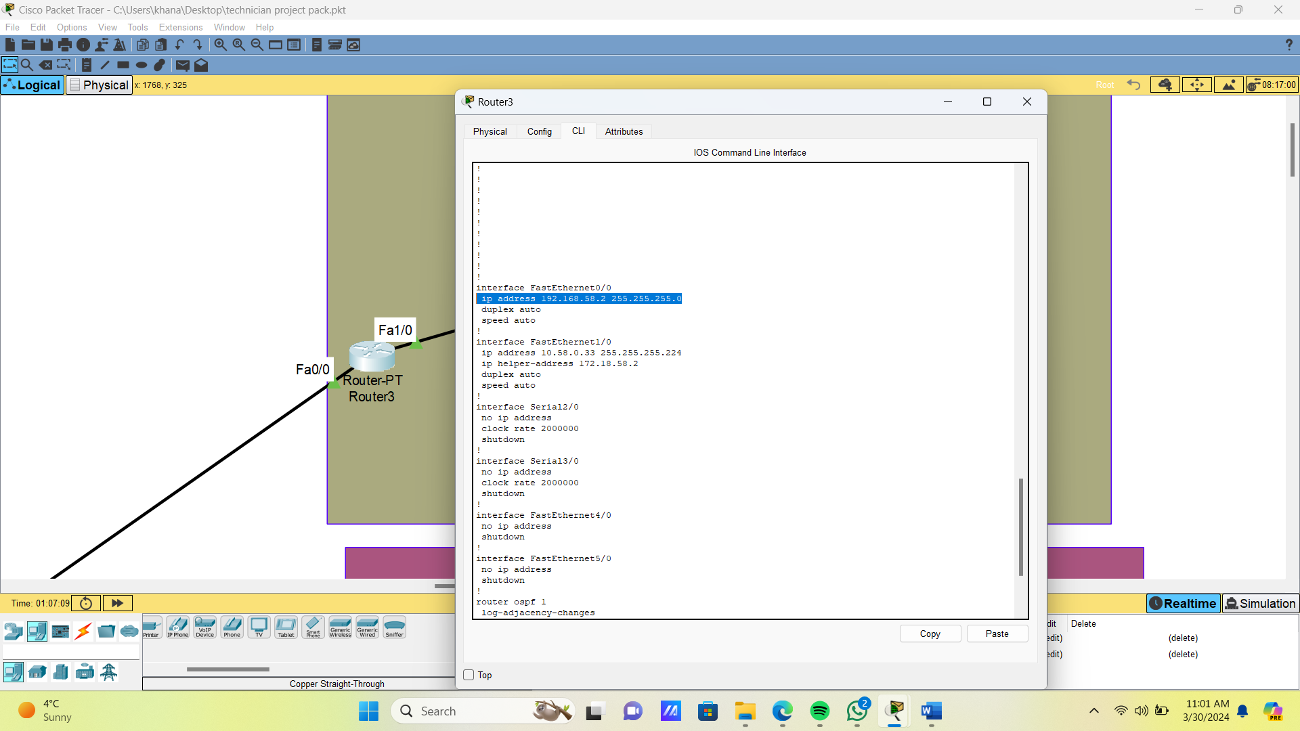
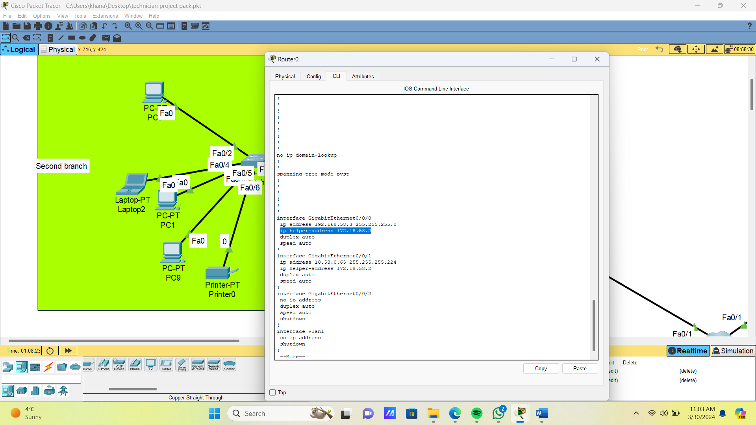
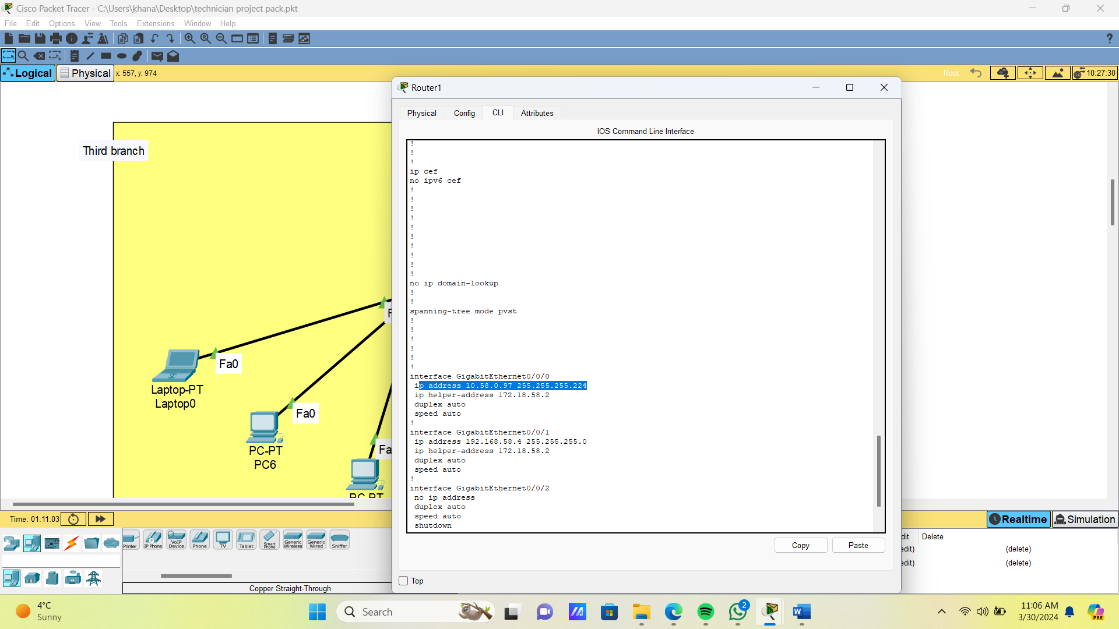

Configuring routers with ospf
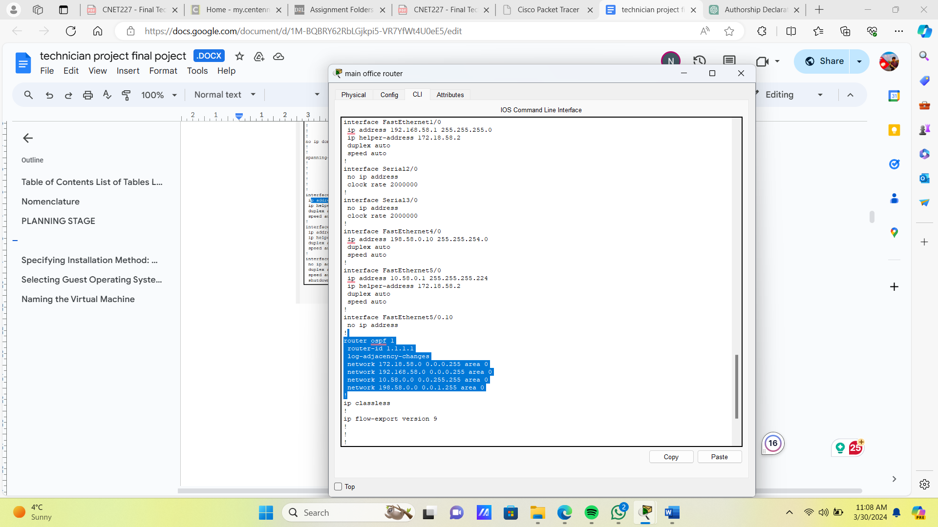
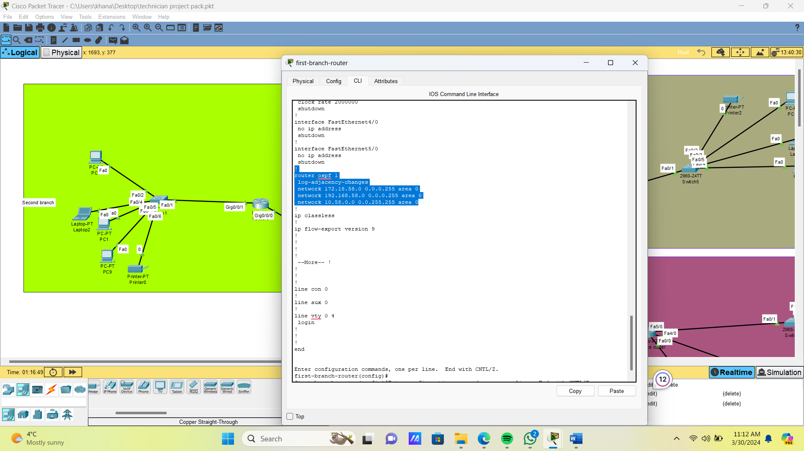
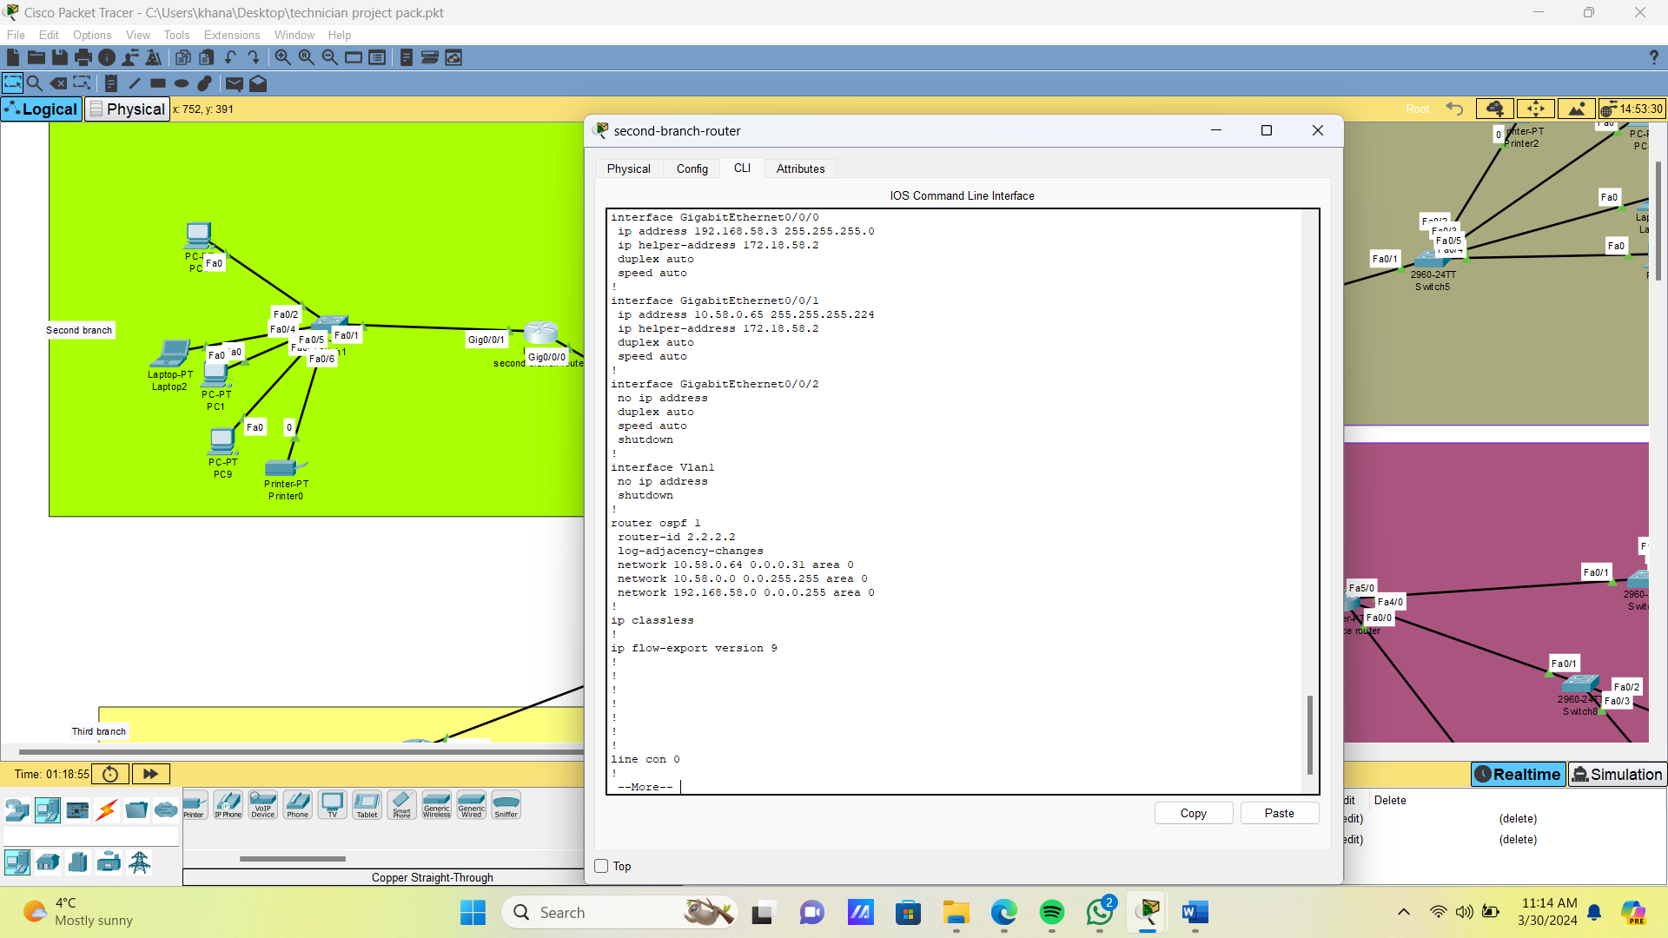
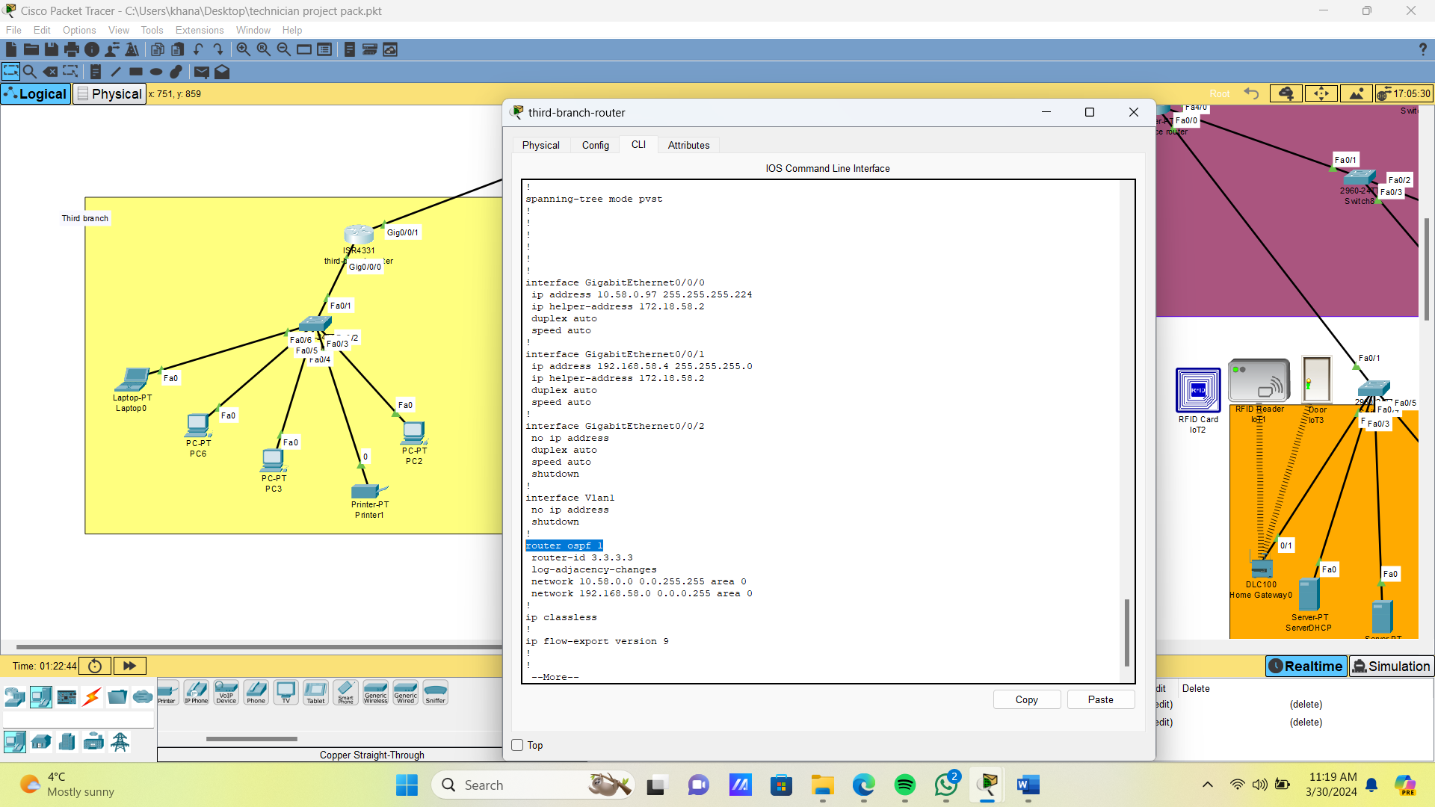

All PCs requesting for IP address and getting through DHCP server configured earlier successfully
server room pc:
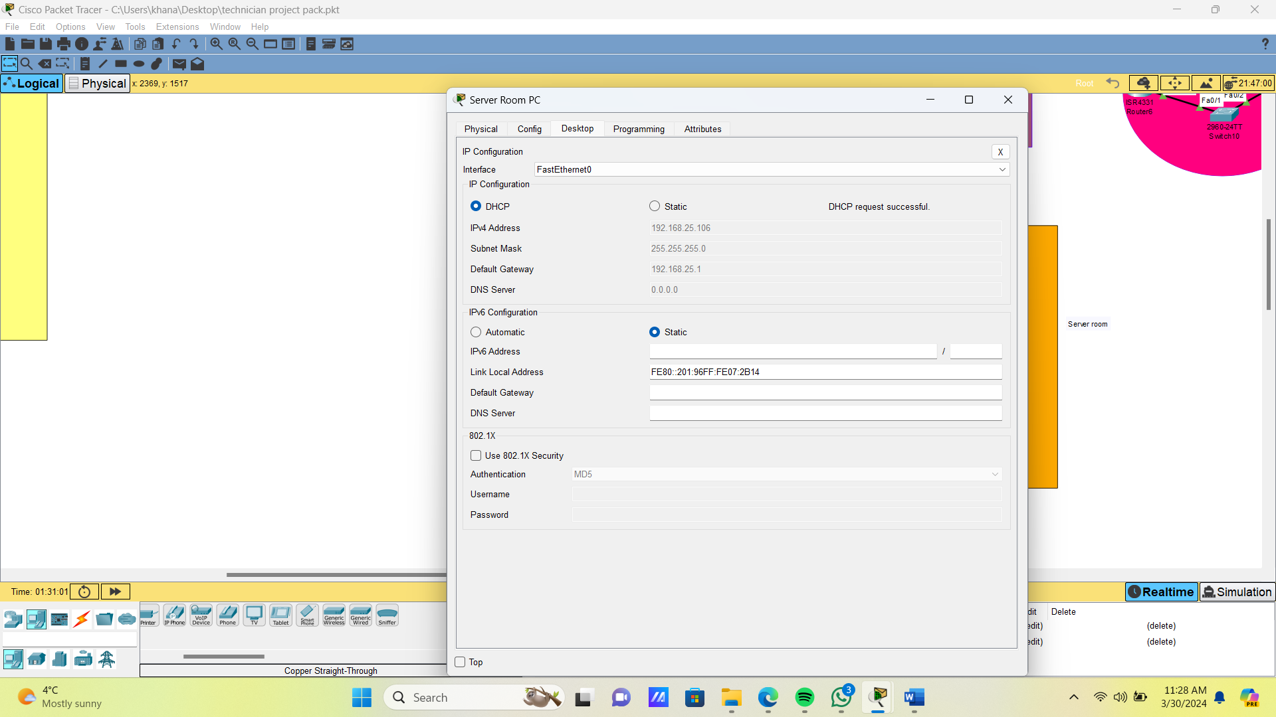
The main branch pcs
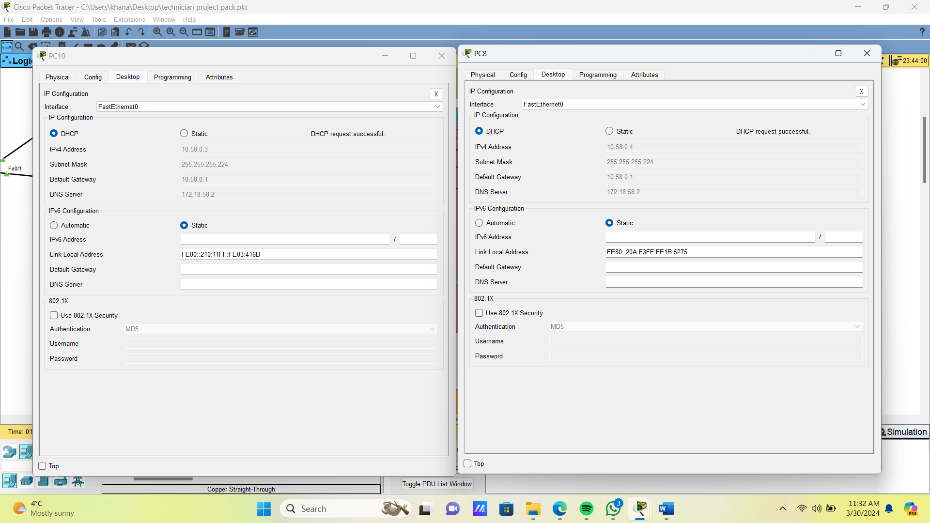

First branch pcs
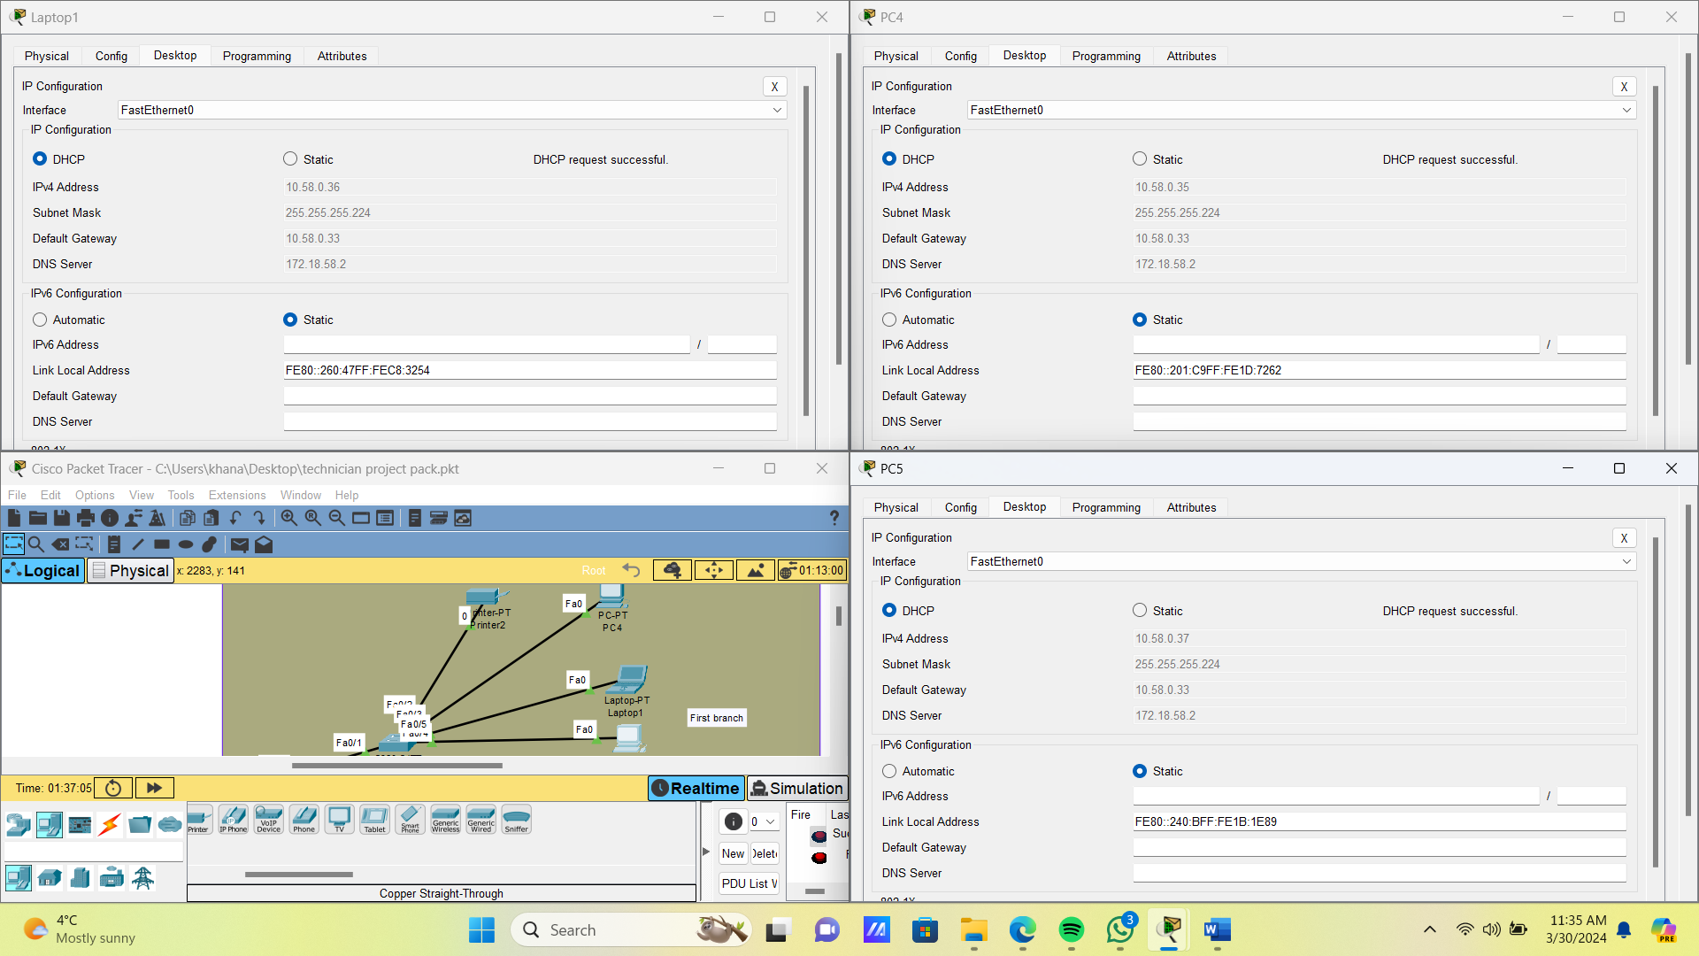

second branch:
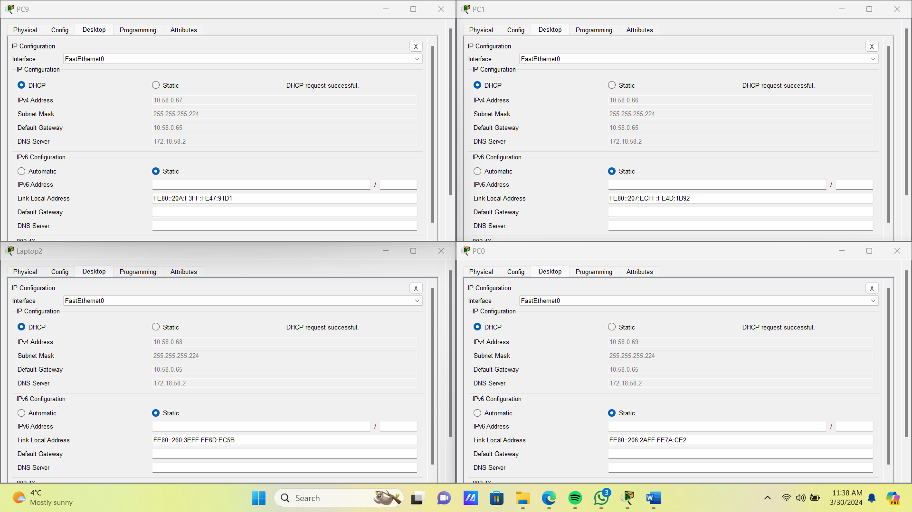

Third branch:
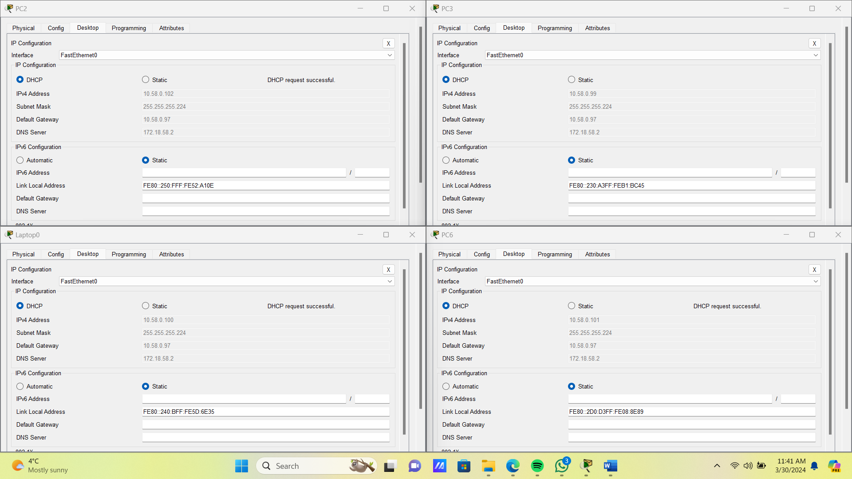

configuring RFID reader installed on server room:
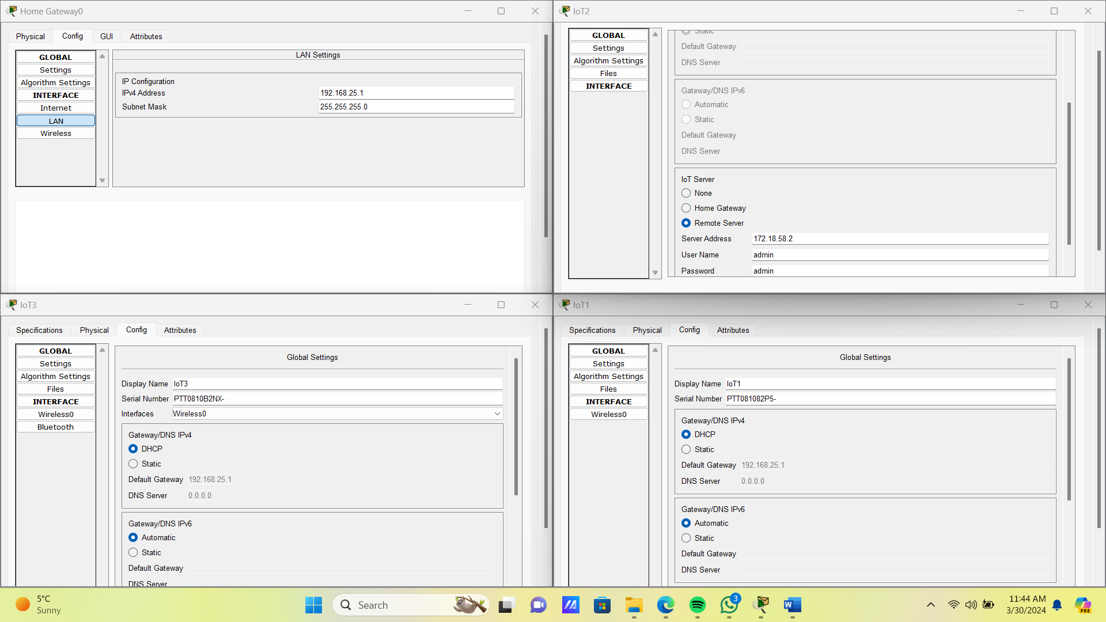
we arranged 4 multilayer switches connected in mesh topology for redundancy
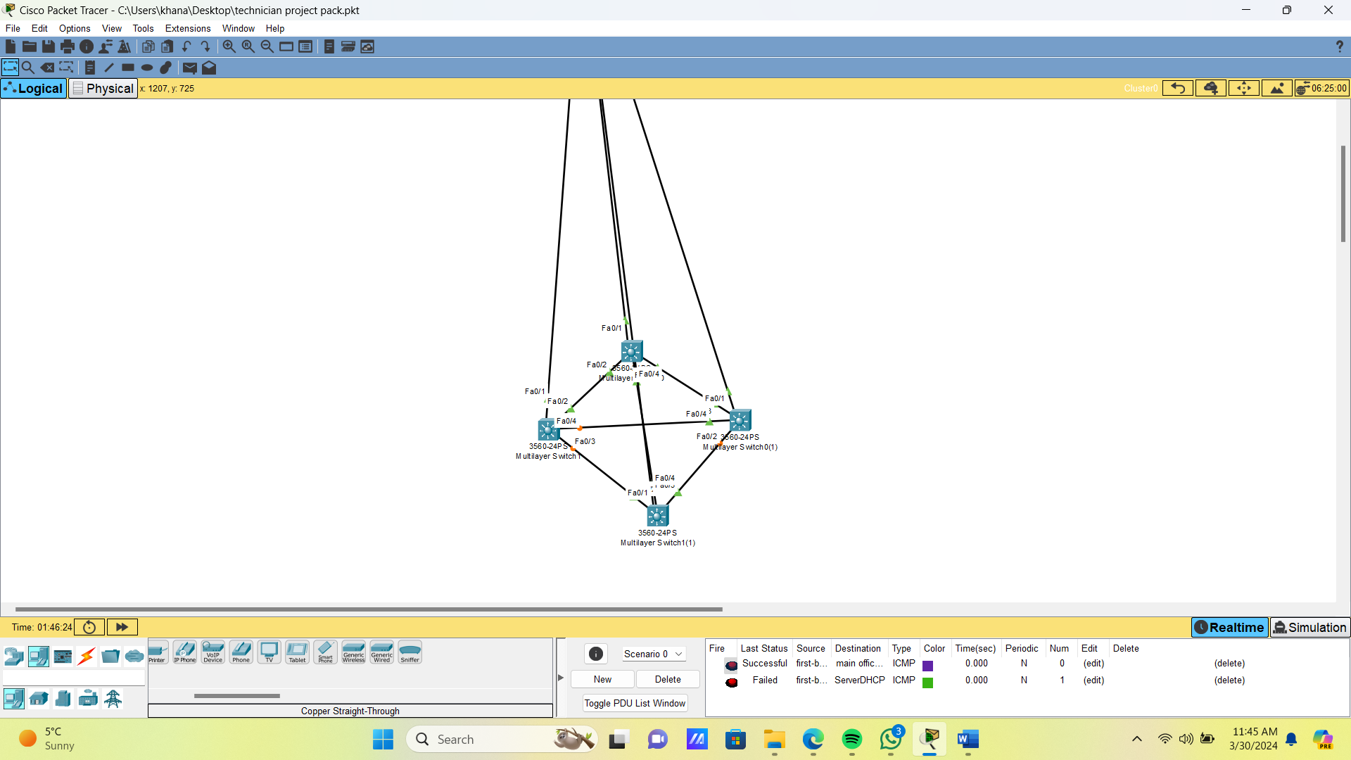

Testing the connectivity
pinging from the second branch to the main branch
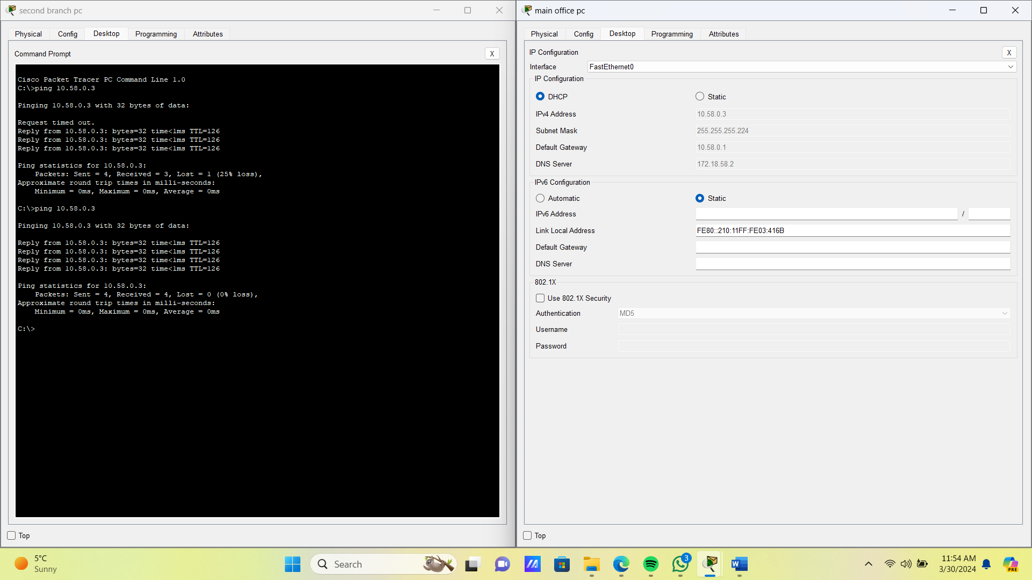

pinging from 3rd branch to 1st branch
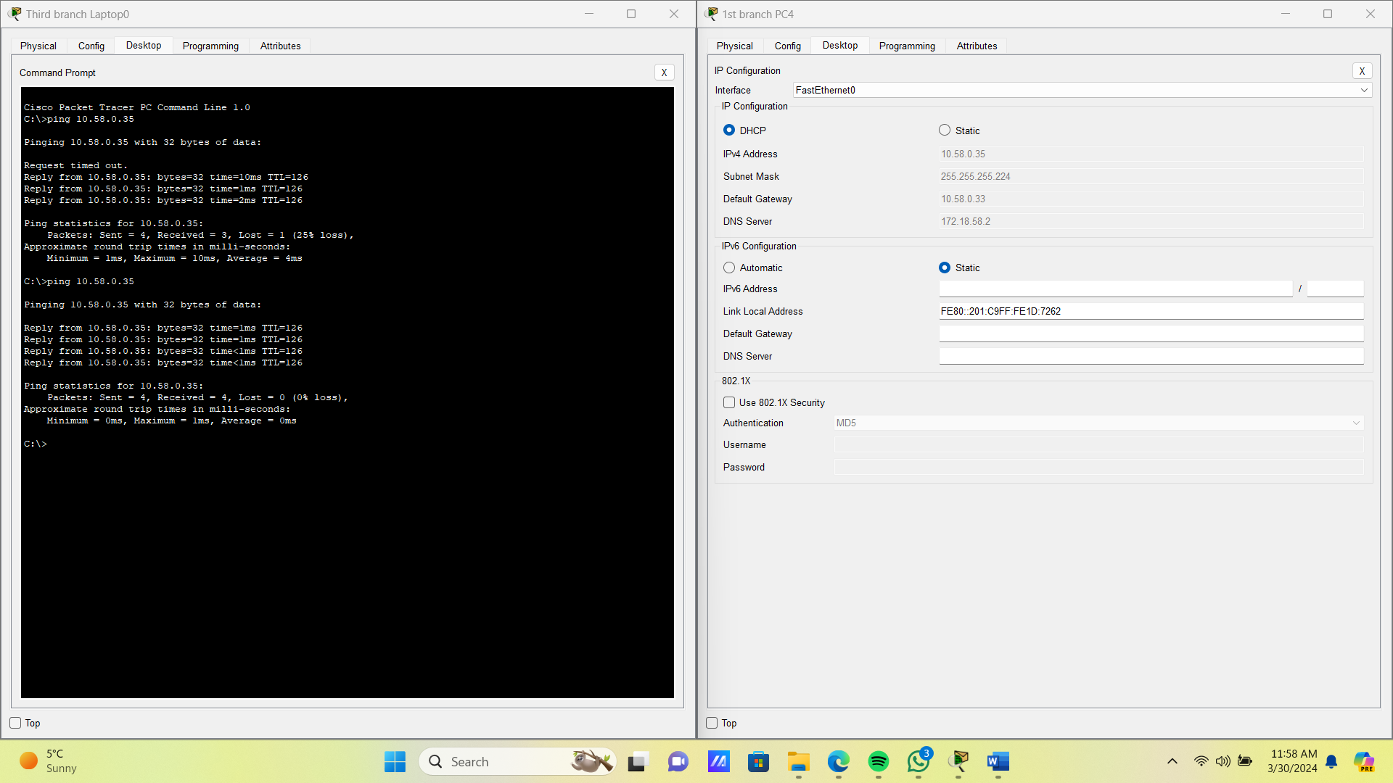
VM installation
Planning Your Virtual Machine: Lay out the specifications and requirements for your virtual machine, including operating system, resources allocation, and intended usage.
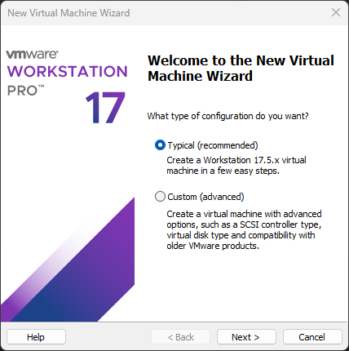

Specifying Installation Method: Determine how you'll install the operating system: from a disc, disc image (ISO), or a previously installed virtual machine.

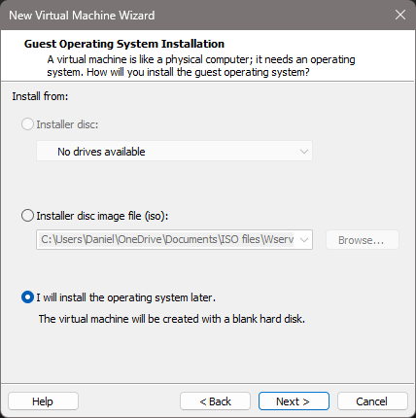

Selecting Guest Operating System: Choose the operating system you want to install on the virtual machine. Ensure compatibility with VMware Workstation.
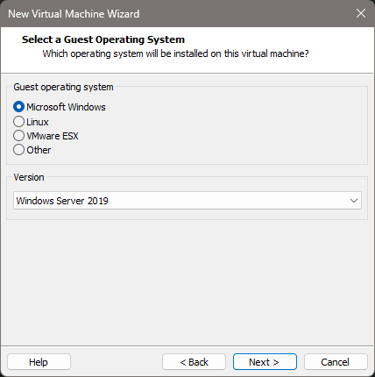

Naming the Virtual Machine
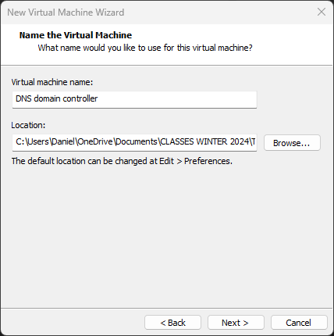

Selecting ISO file to install OS in the Virtual machine
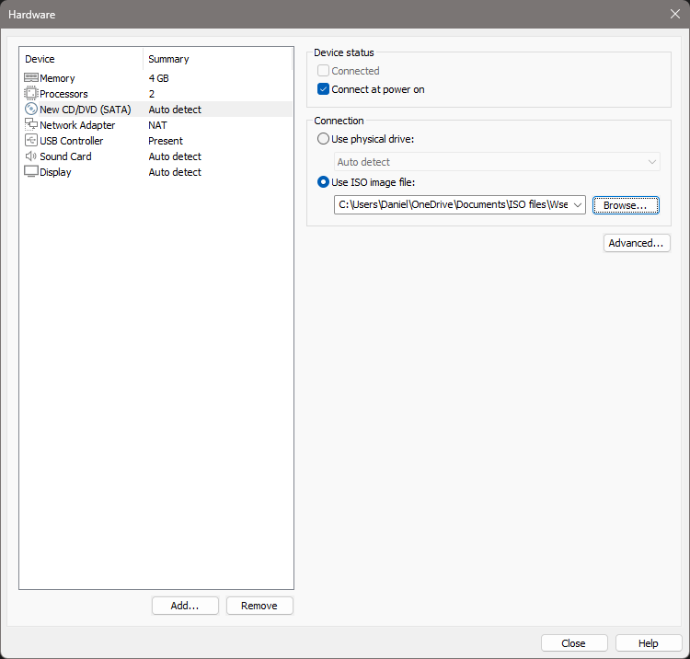

Adding up the Network Adaptor which allows the device to communicate over the local area network(LAN), connecting to the internet or to other computers.

INSTALLING WINDOWS SERVER 2019 IN THE VM

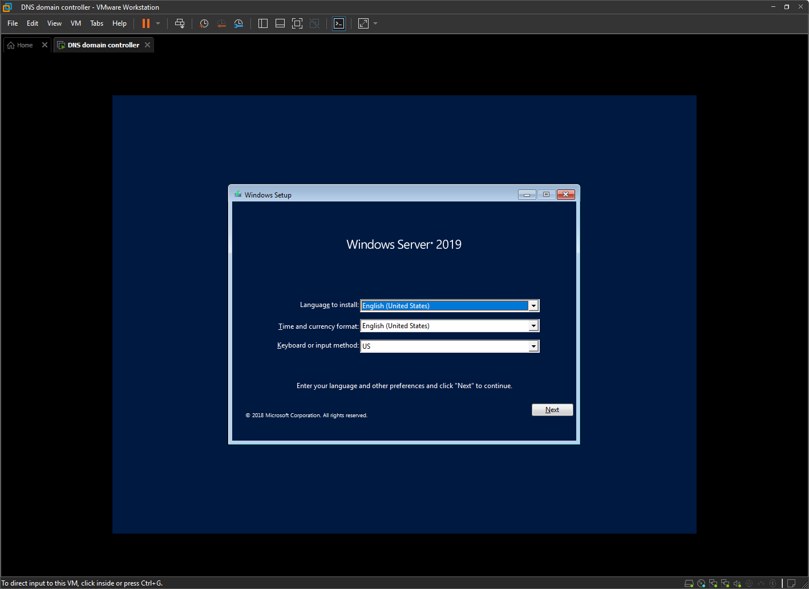
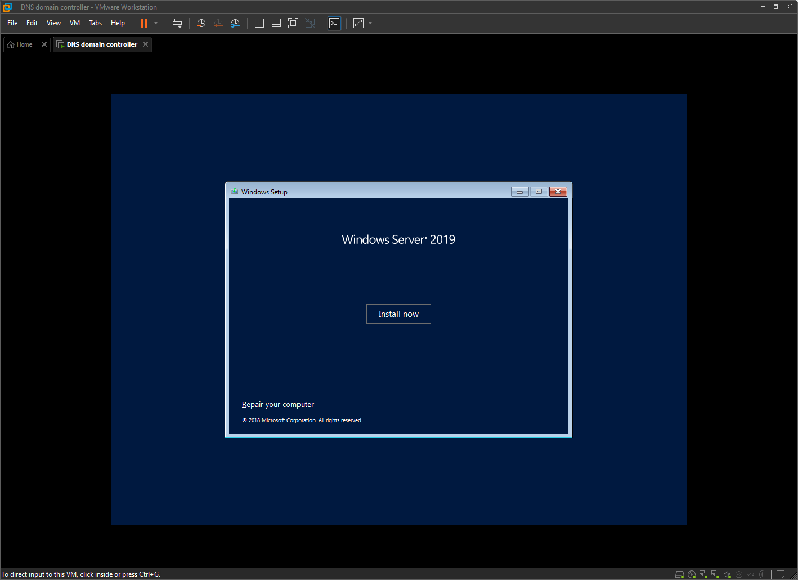
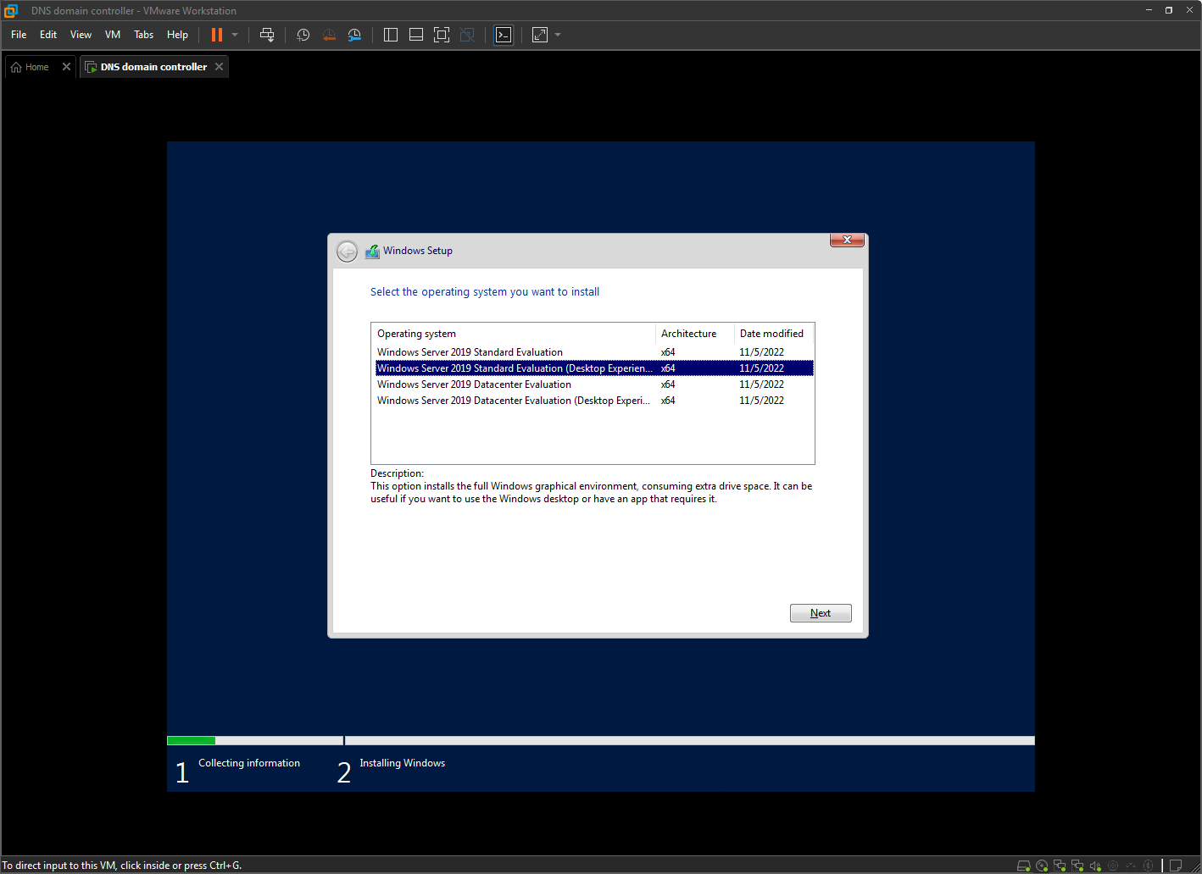
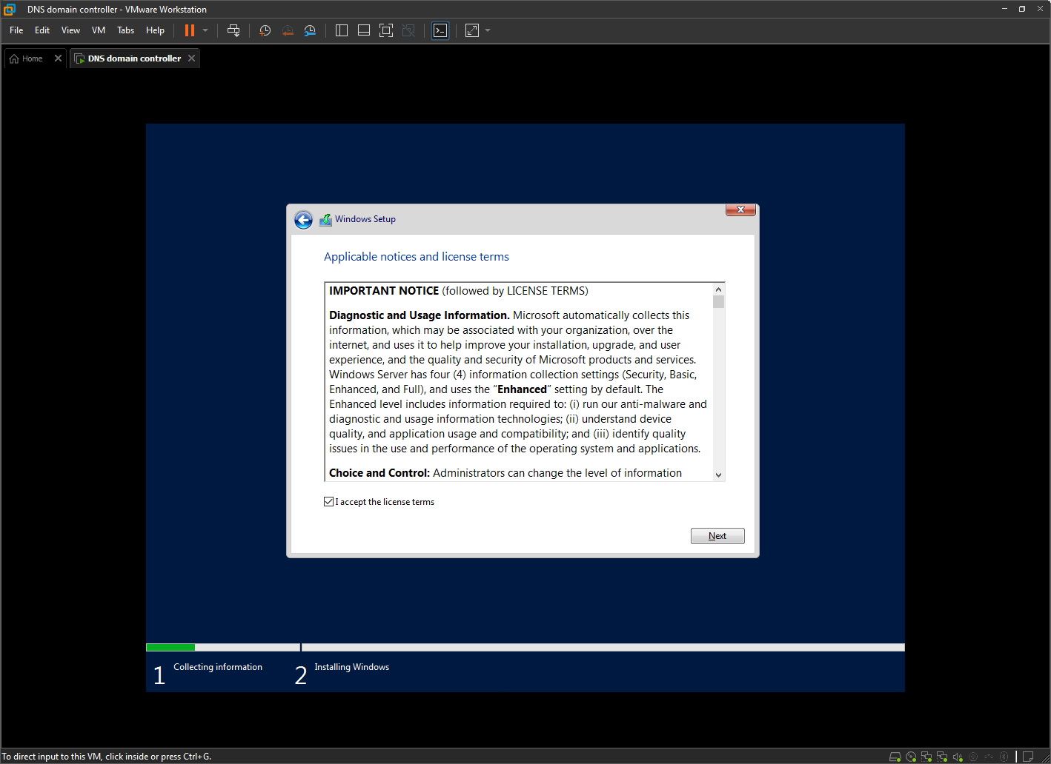
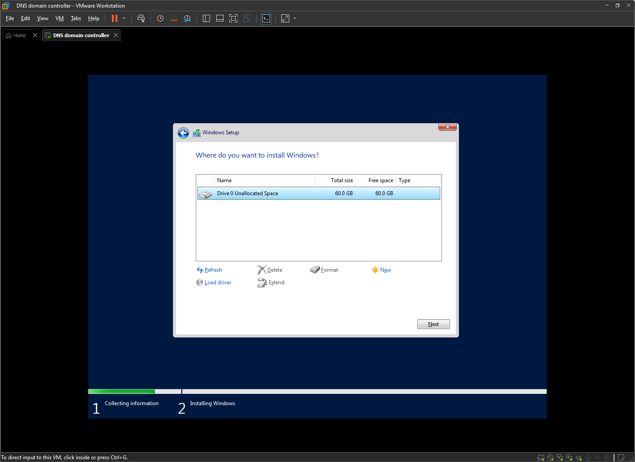
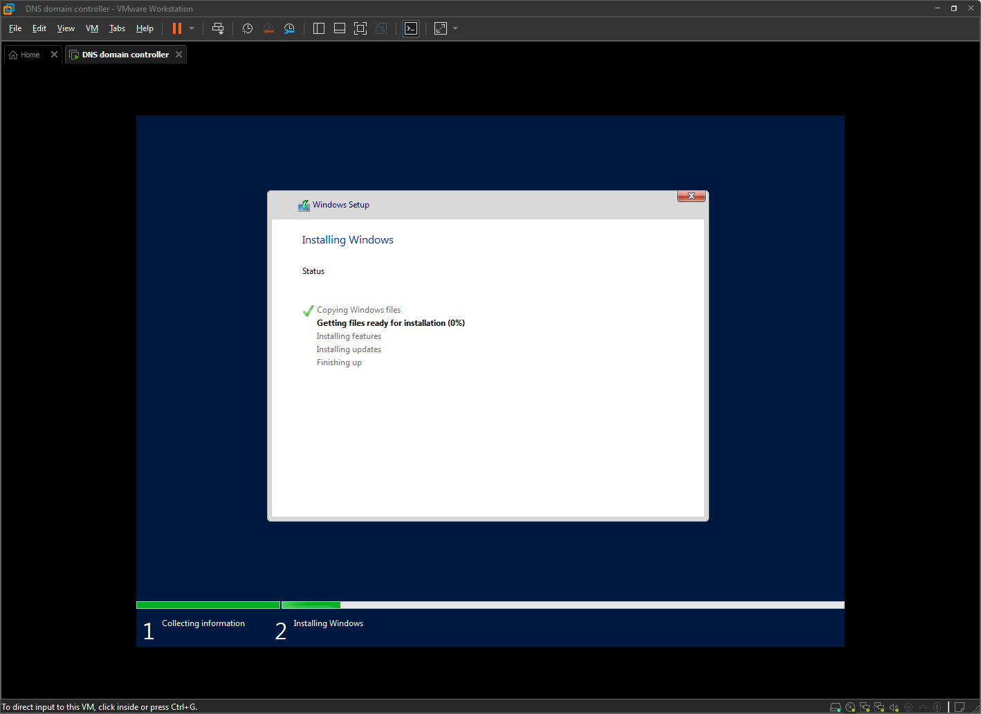

Setting up User name and Password for securing pc
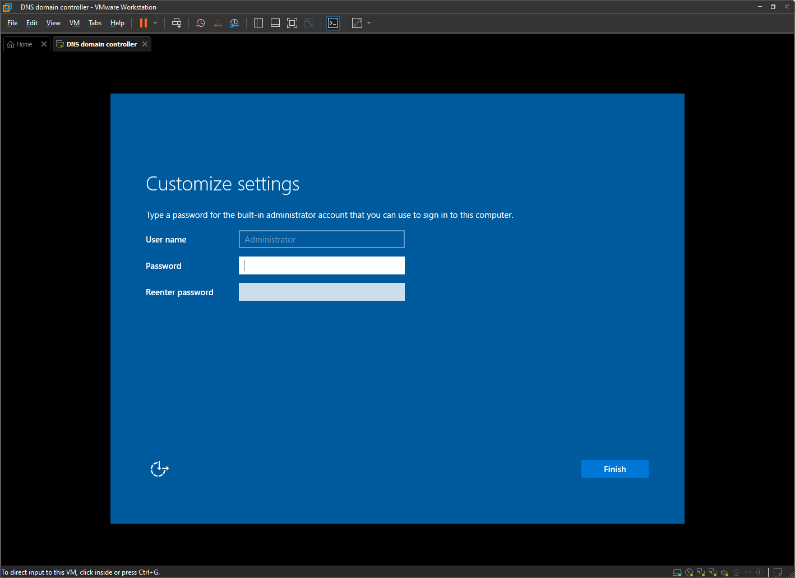

Ready for Use: Your VMware virtual machine is now ready for use! Enjoy the benefits of virtualization for development, testing, or any other purpose you require.
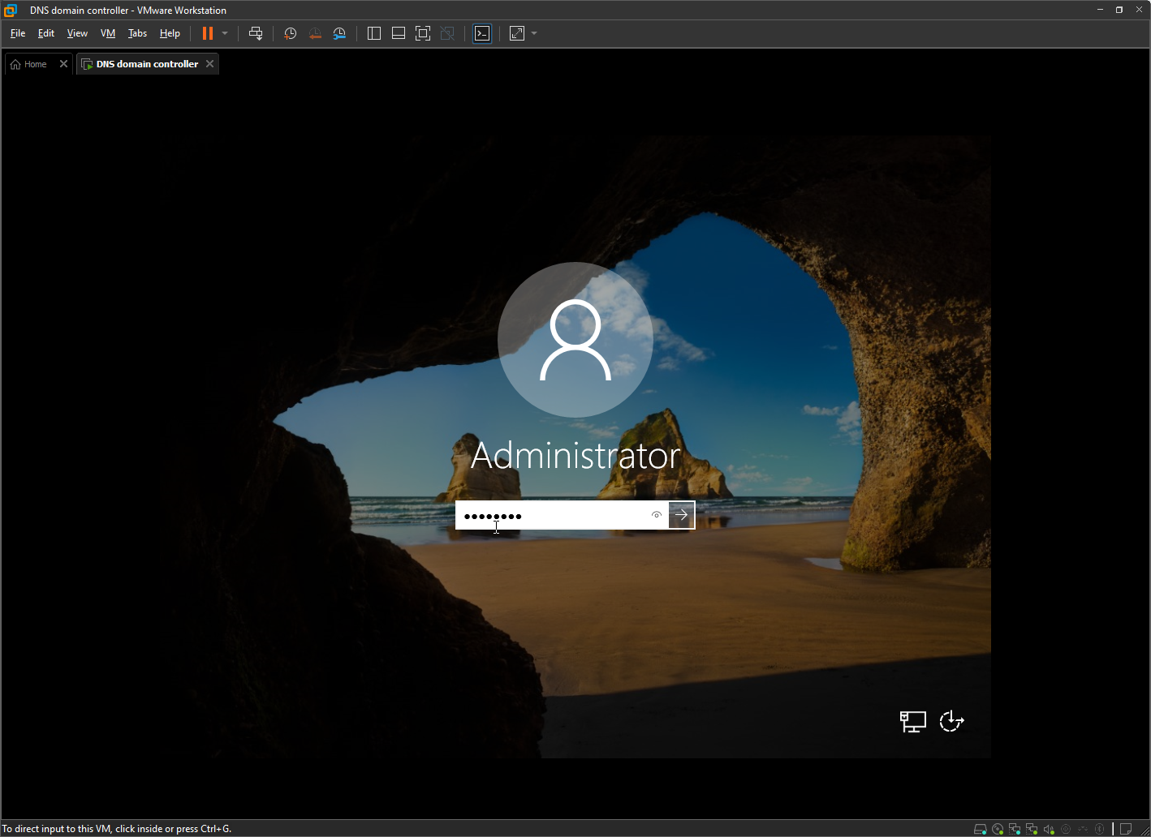

INSTALLING VMWARE TOOLS

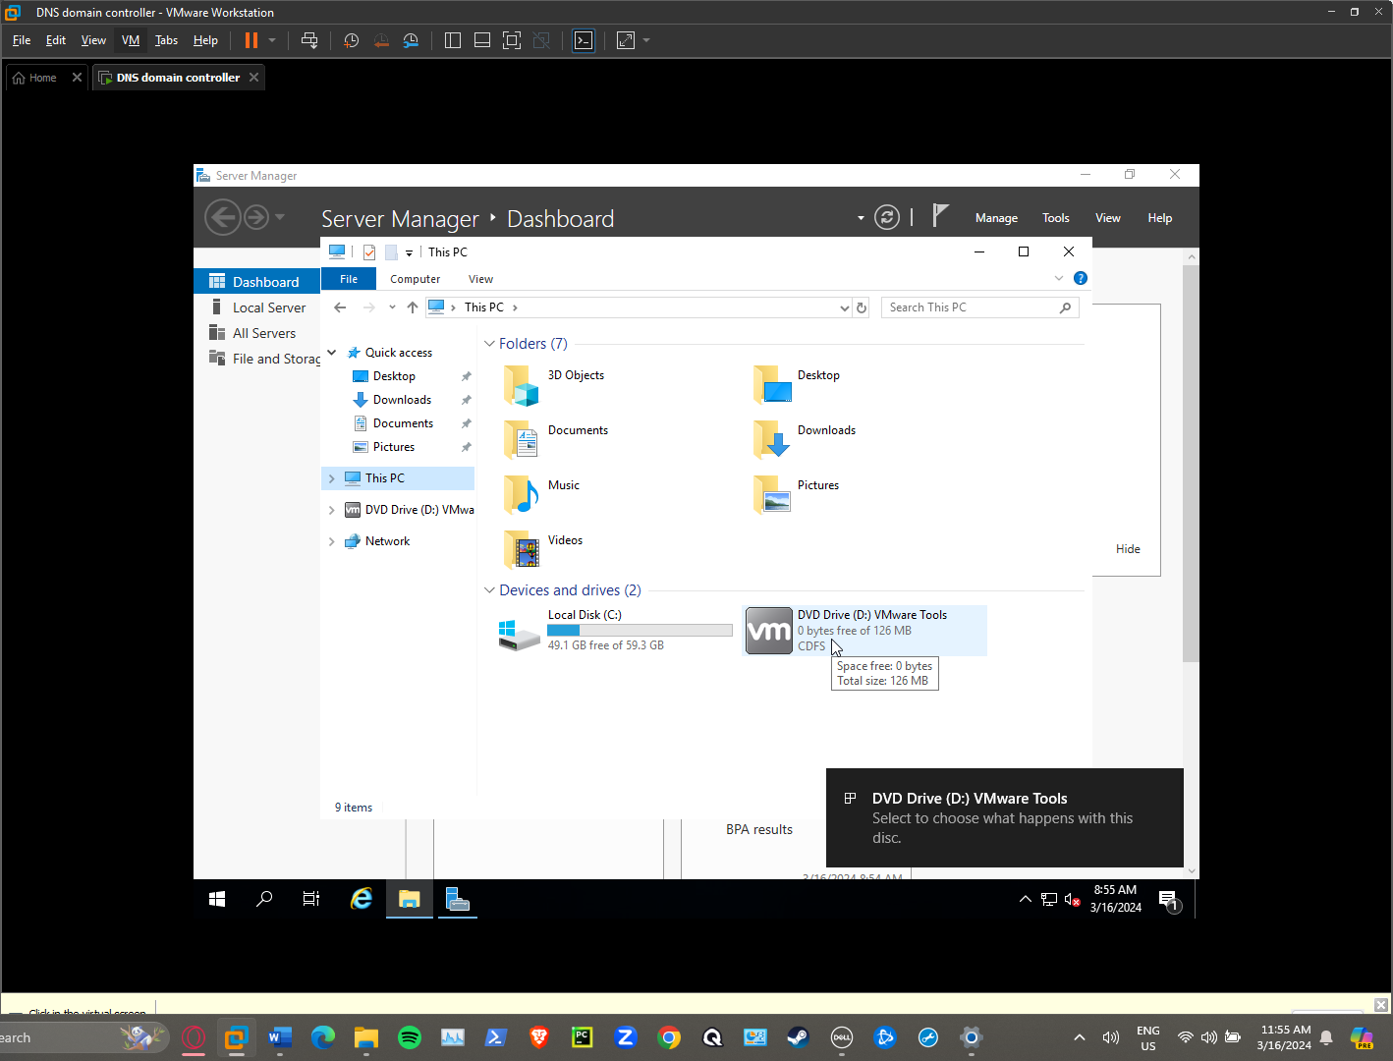
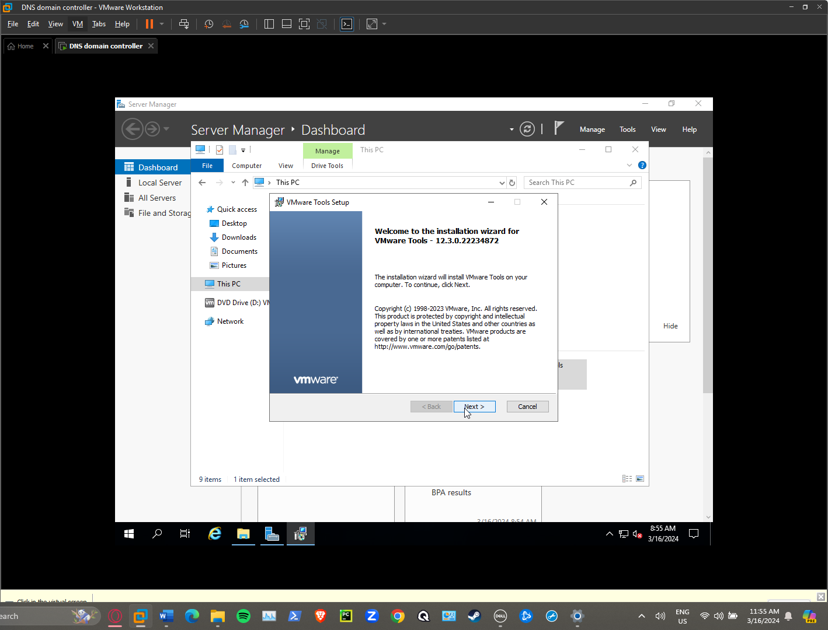

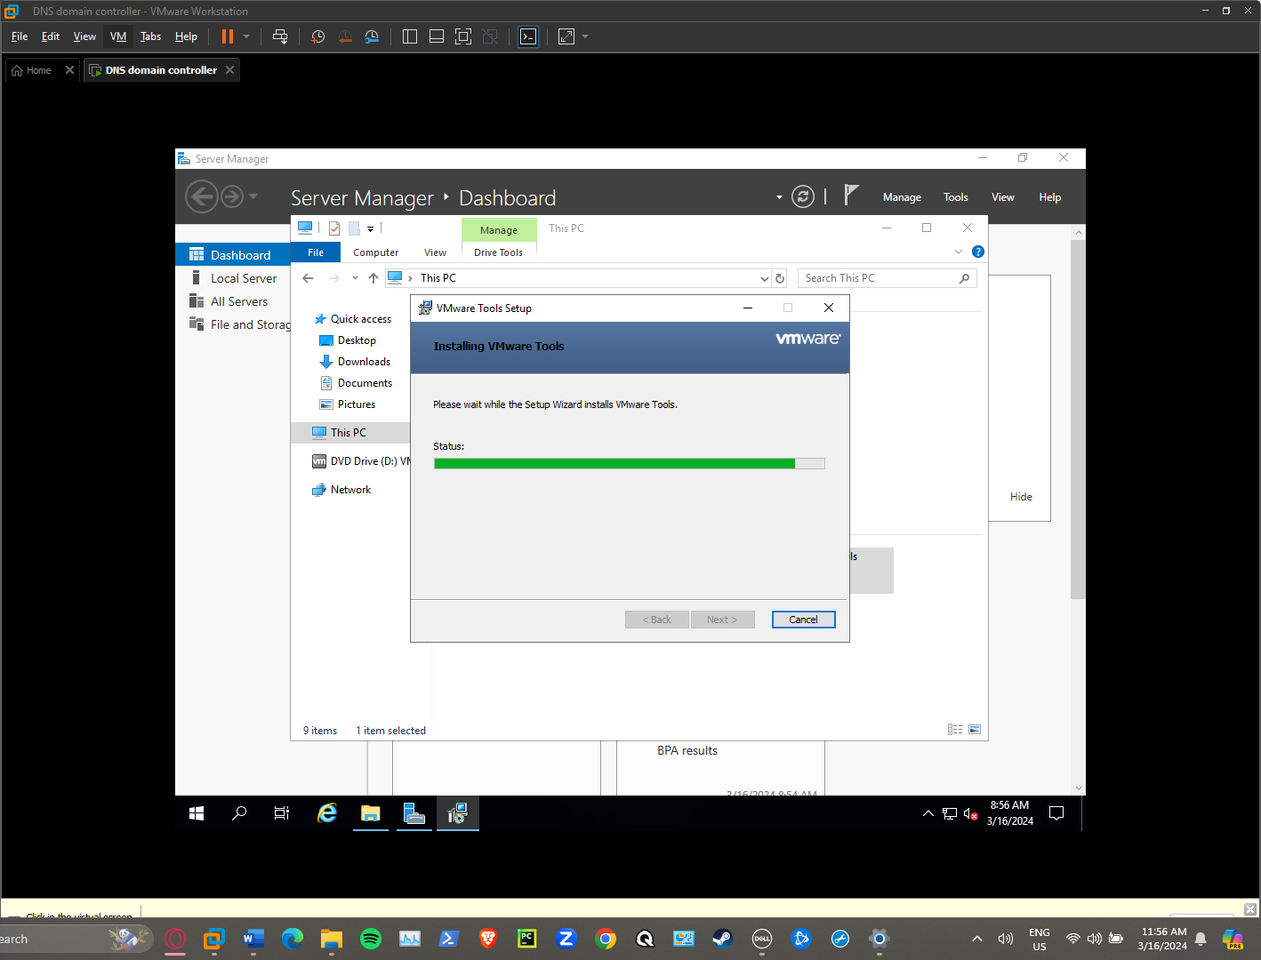

INSTALLING ACTIVE DIRECTORY AND DNS

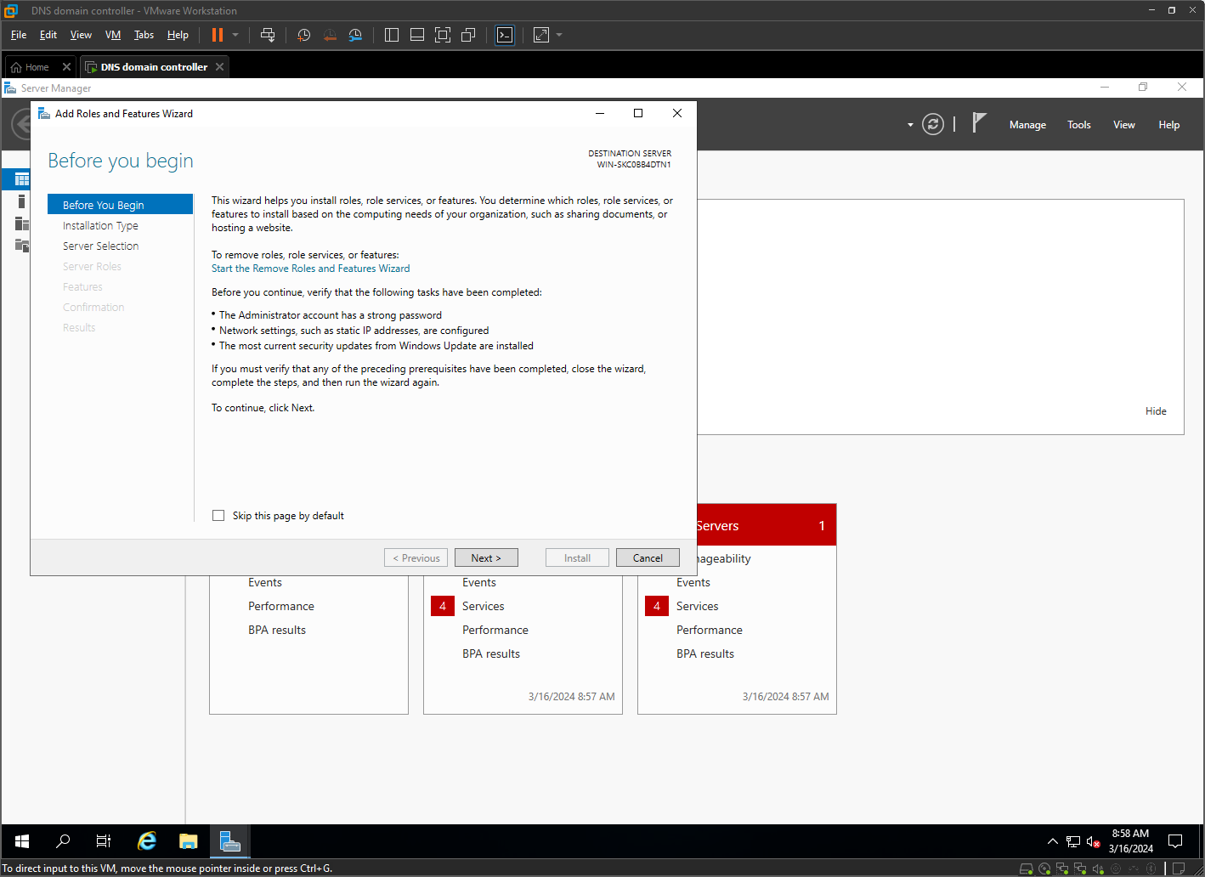

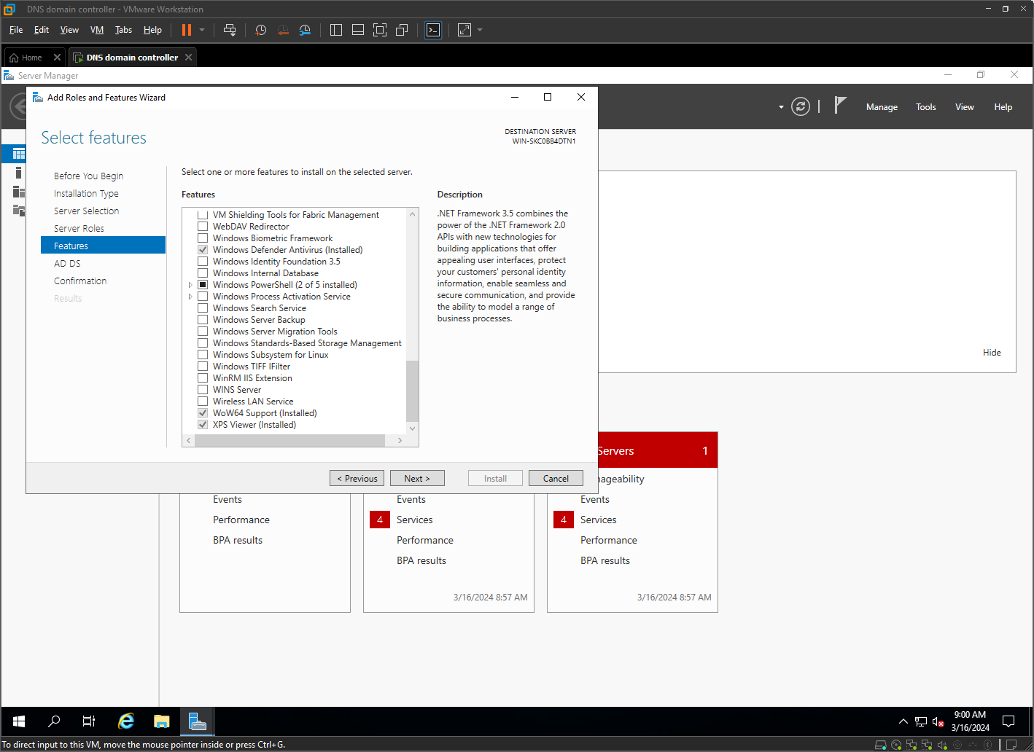

PROMOTING SERVER TO DOMAIN CONTROLLER AND CREATING NEW FOREST

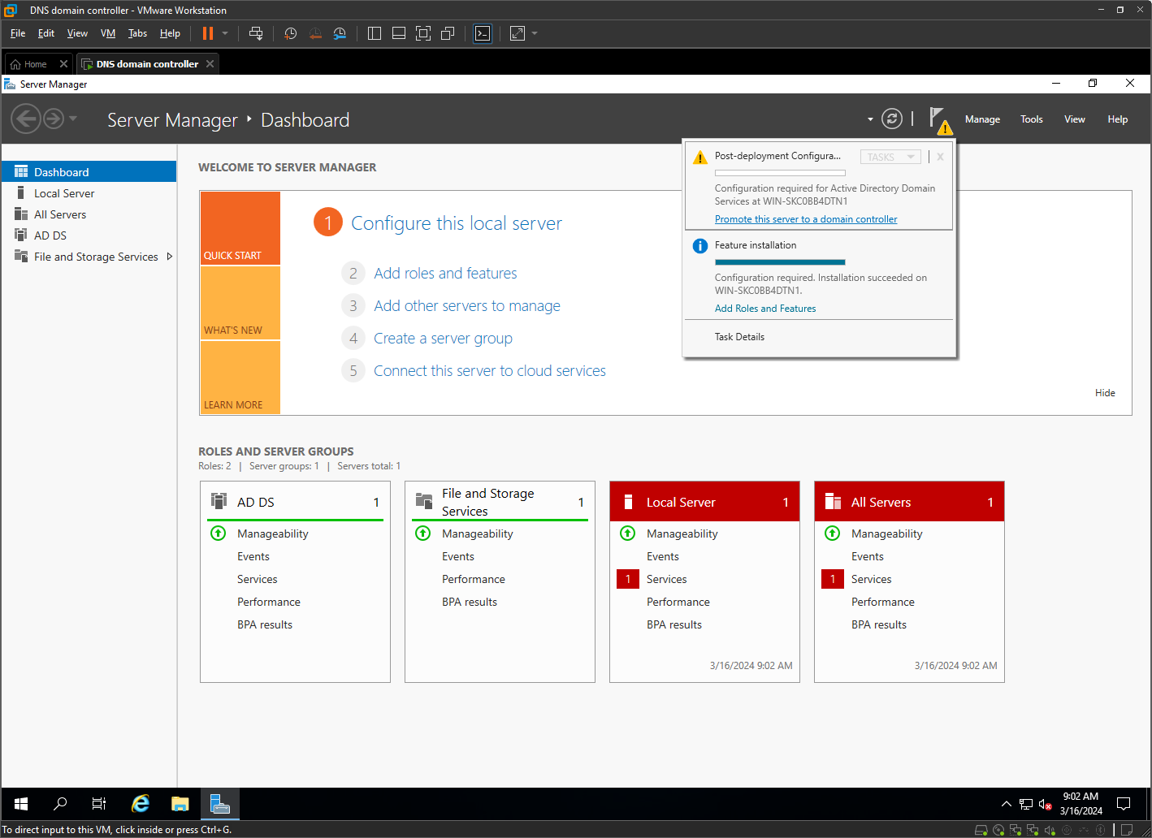

Setting up the path ways to set up server as DNS
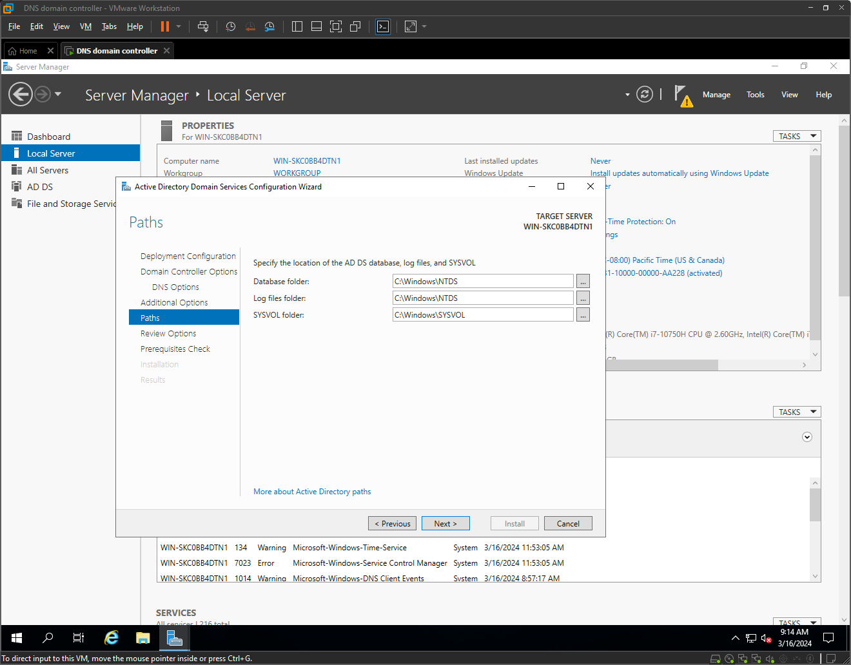

Installation in progress
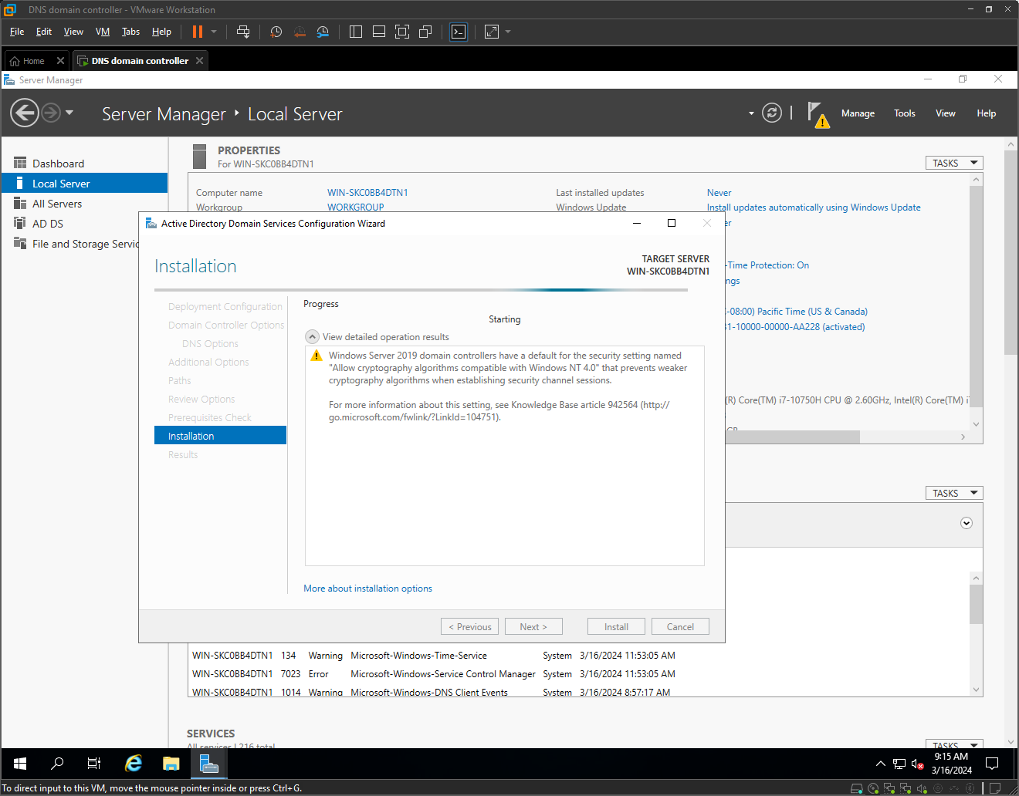

Server was successfully configured as domain controller
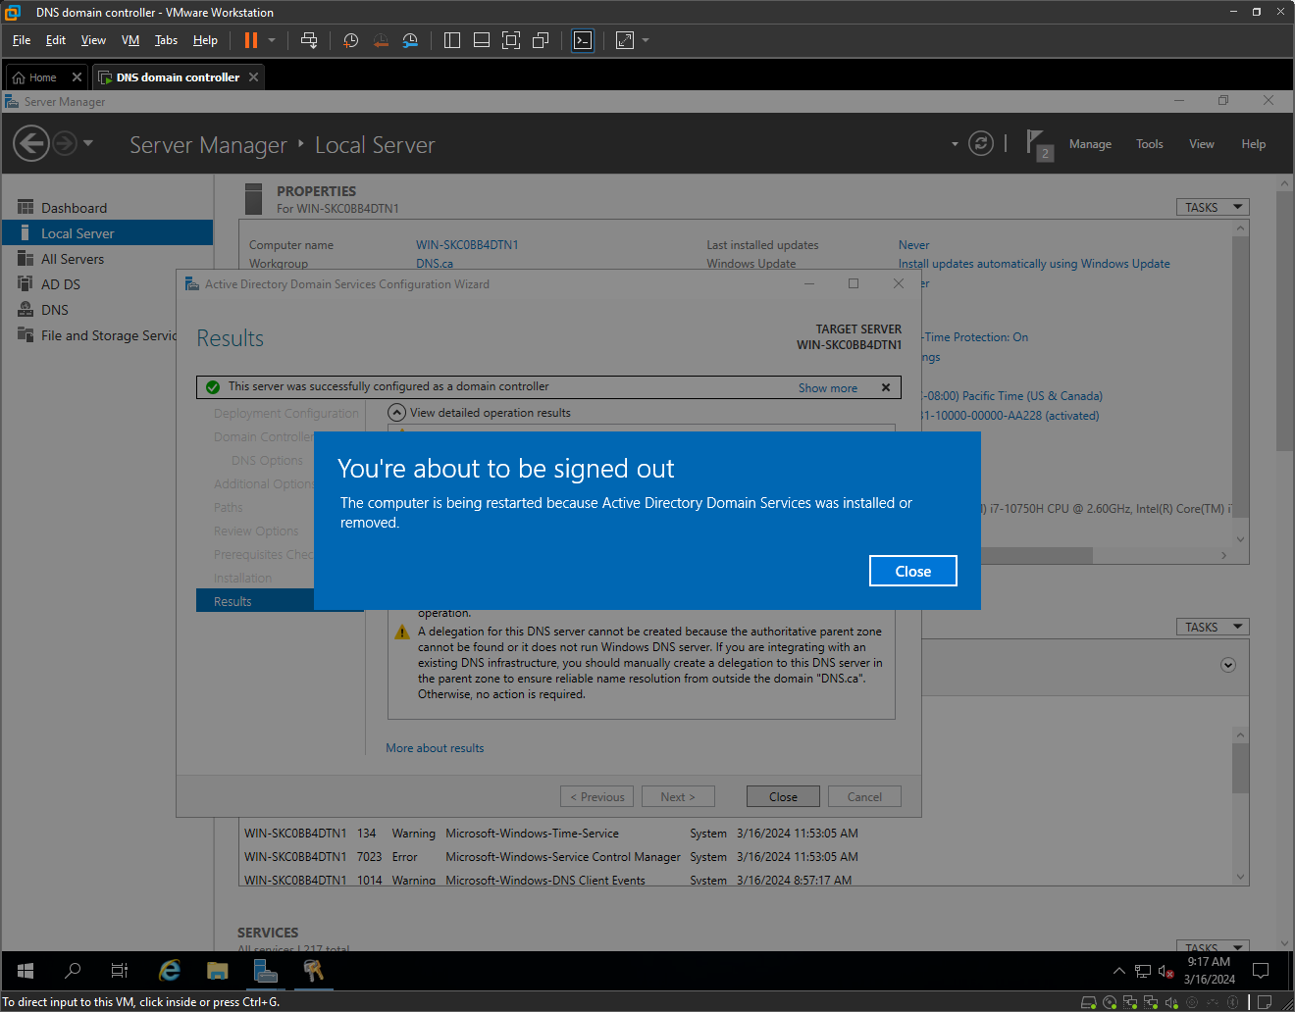

Here is our Server as DNS
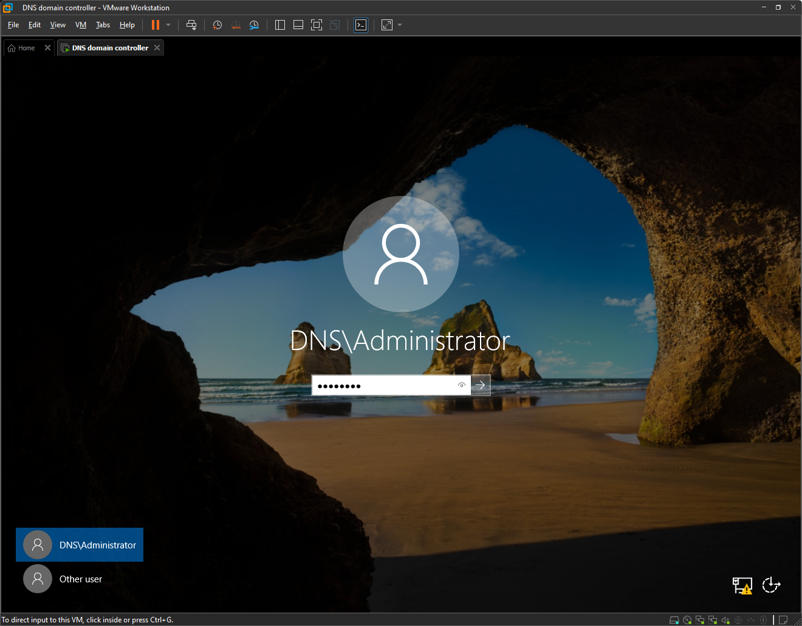

INSTALLATION OF DHCP TO THE SERVER

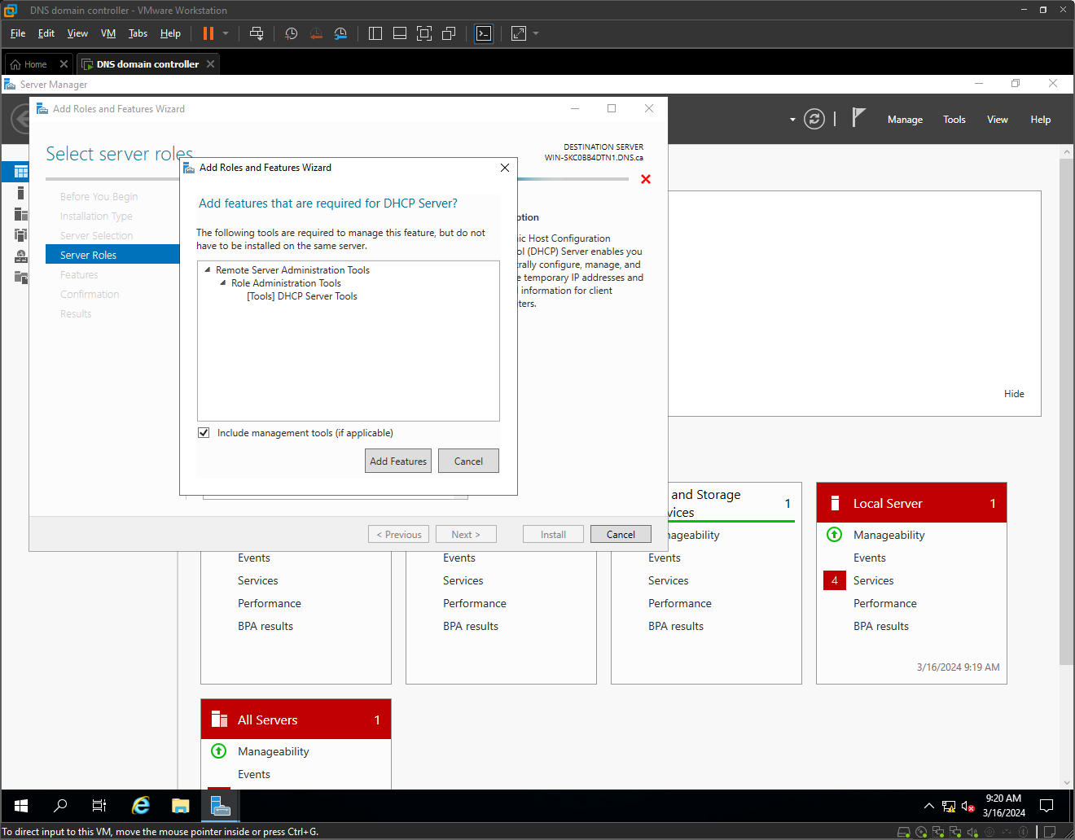

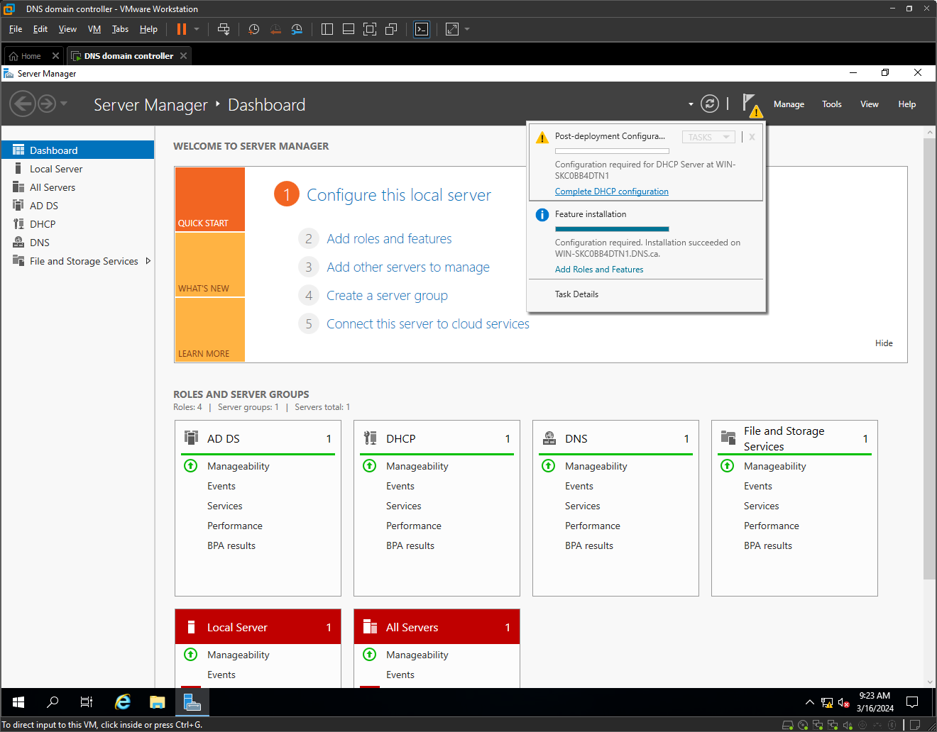

RENAMING SERVER

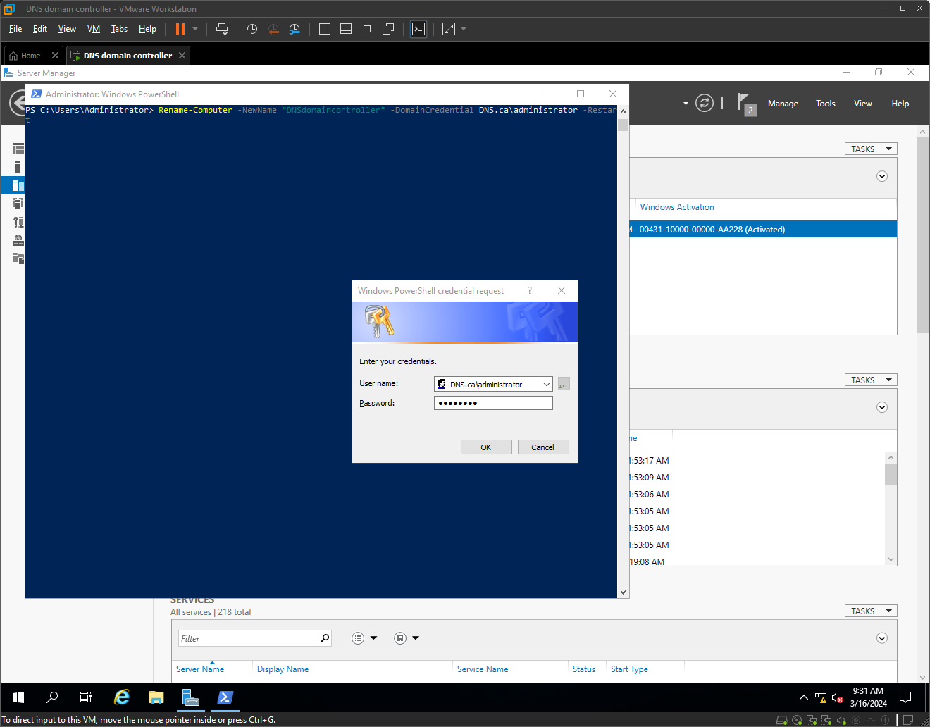

CREATING OUs FOR THE BRANCHES AND USER GROUPS FOR THE USERS
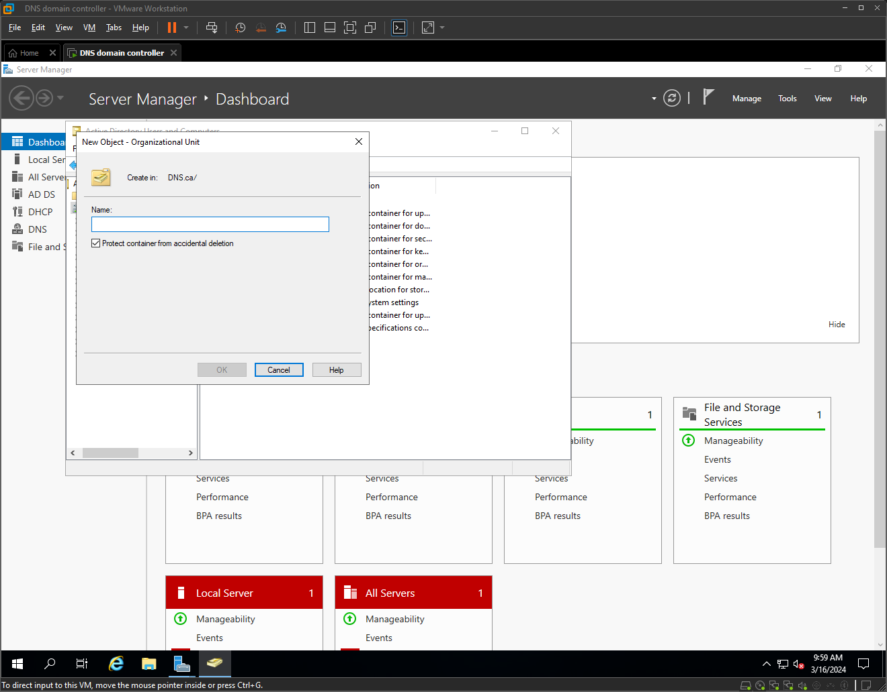
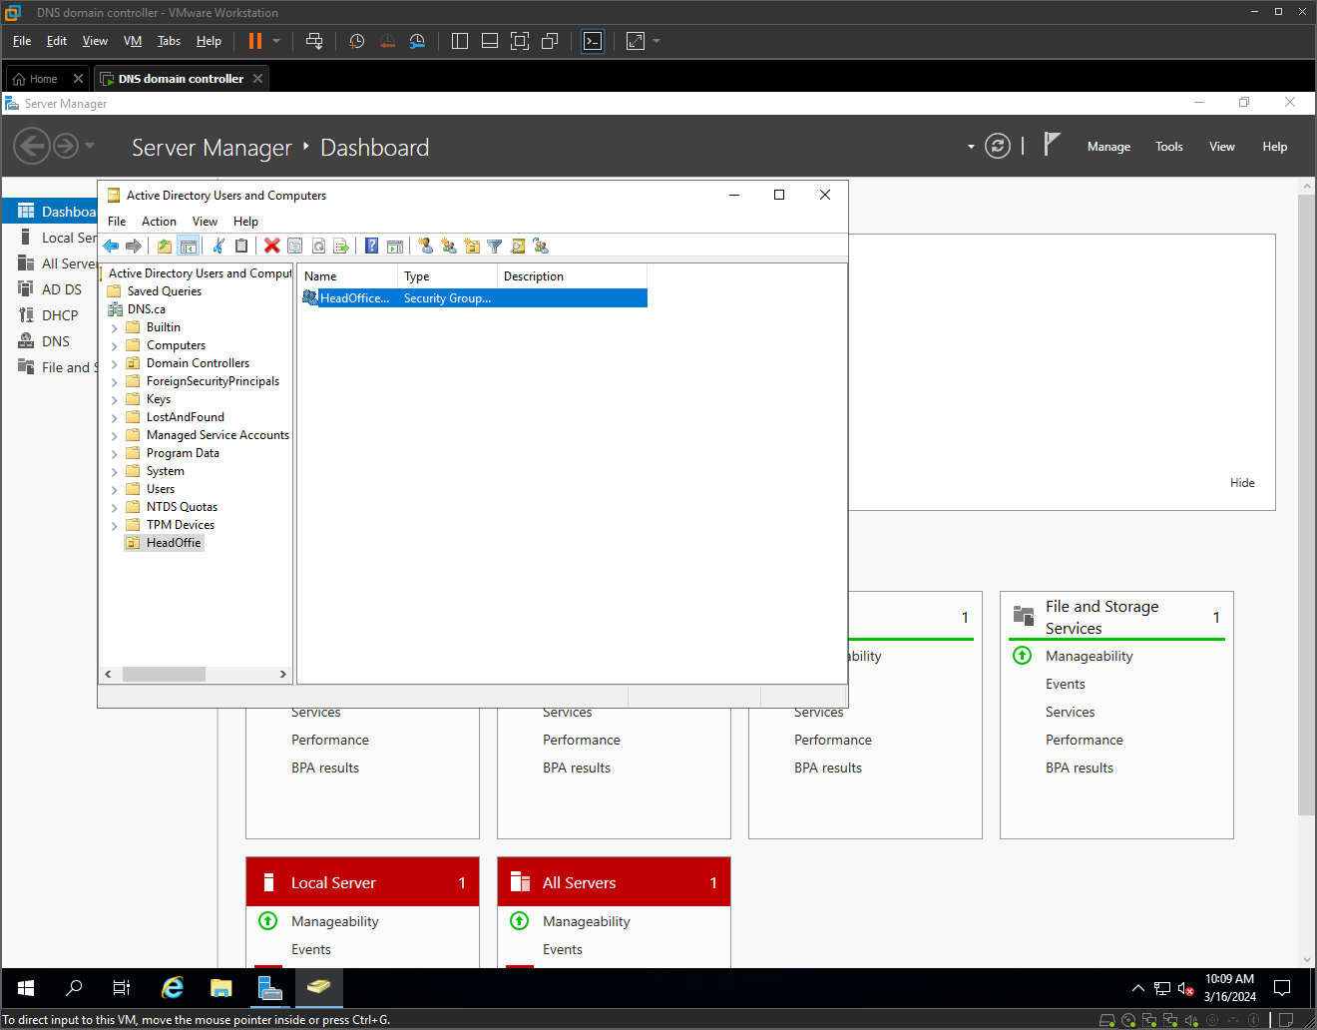
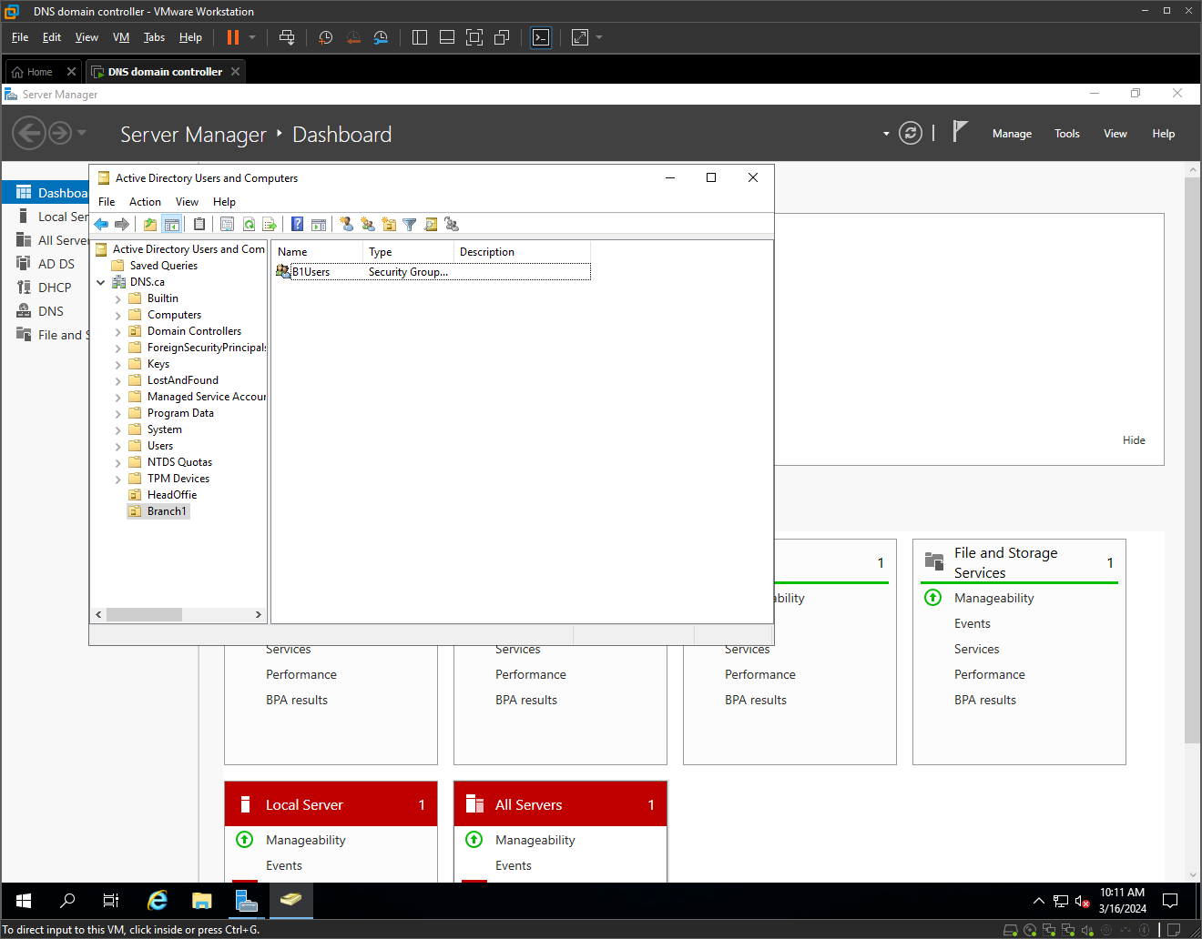
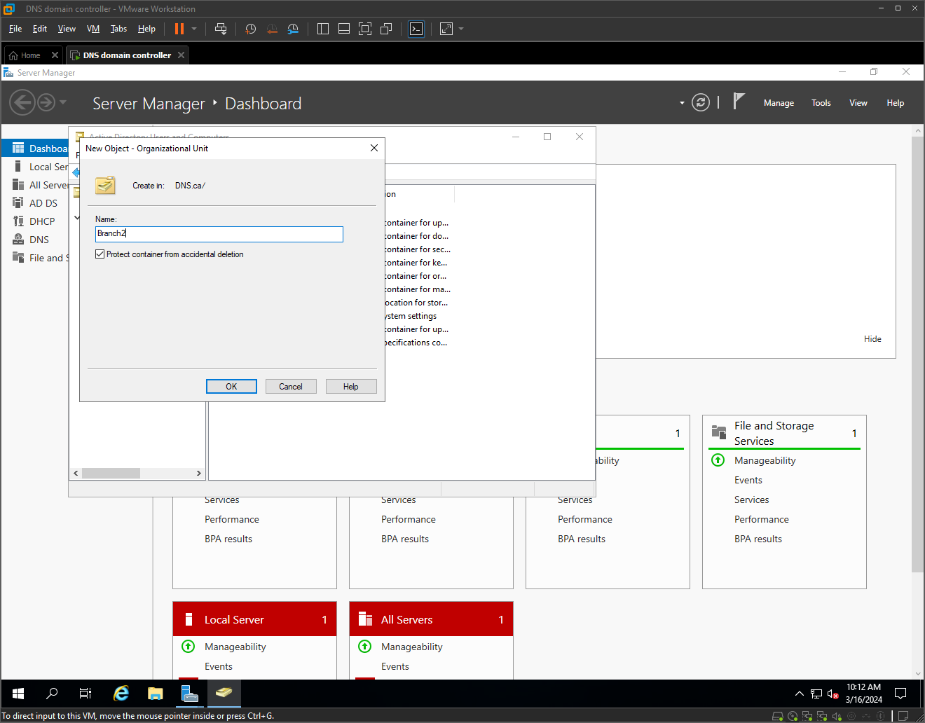
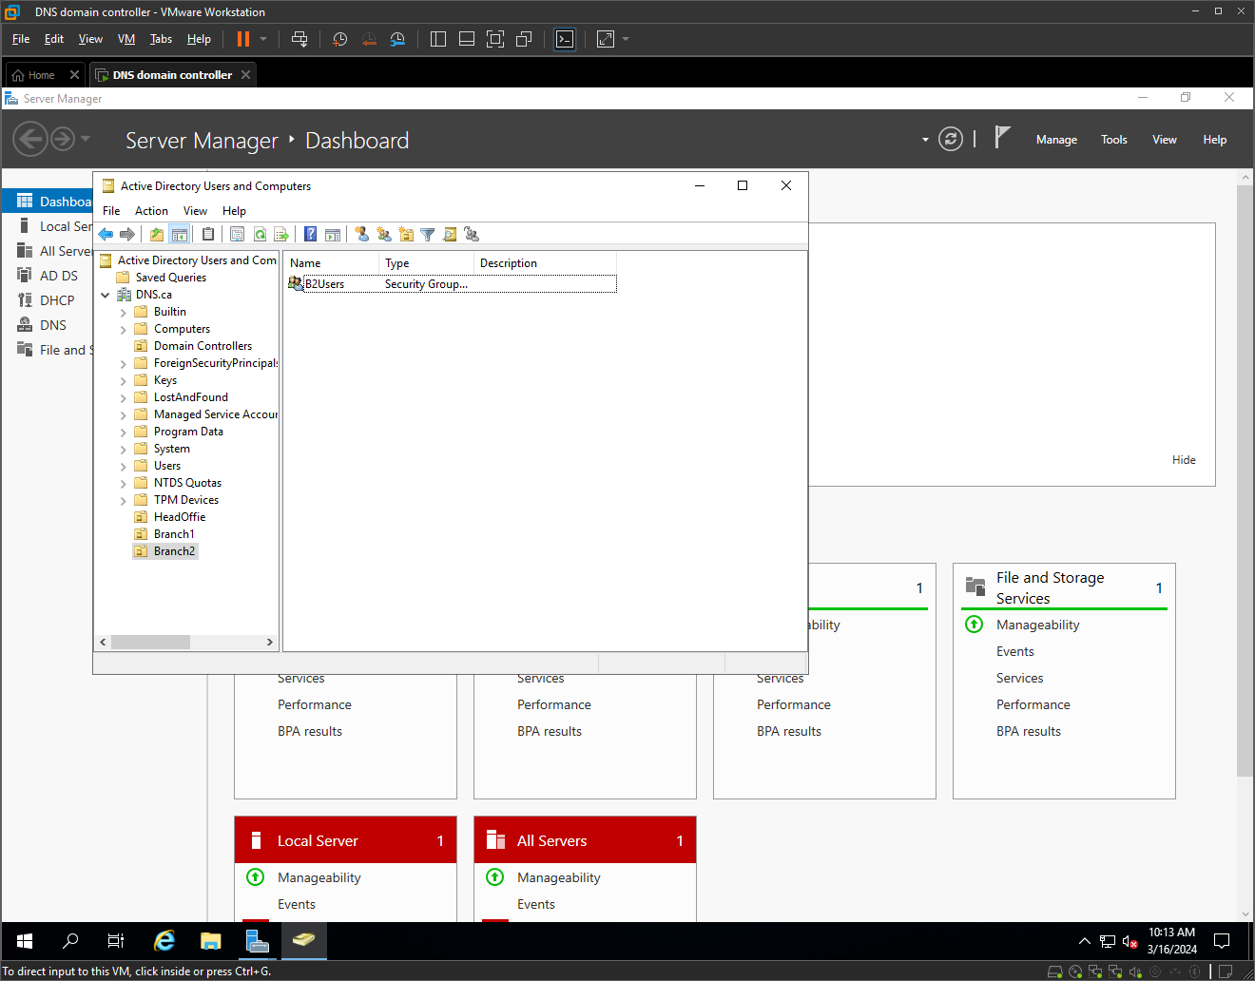
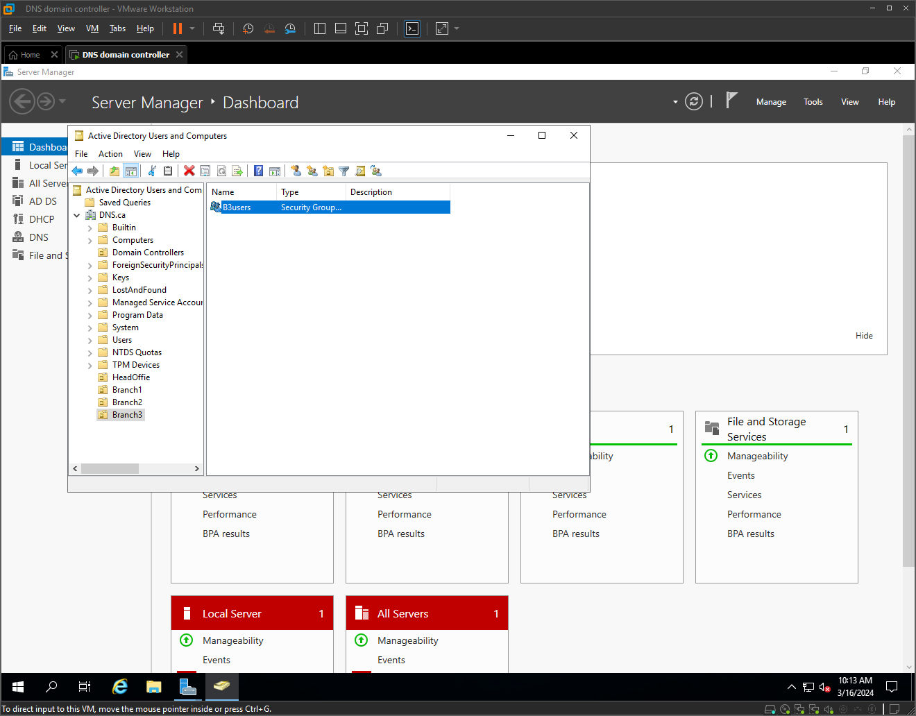

Configuring DHCP
Adding 4 different network cards to the domain controller to simulate the different subnets of each branch.
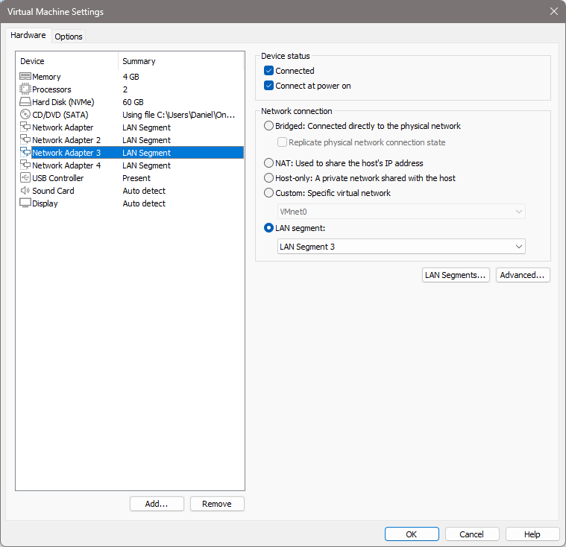

Assigning a static IP address of each of the subnets.

Head Office:
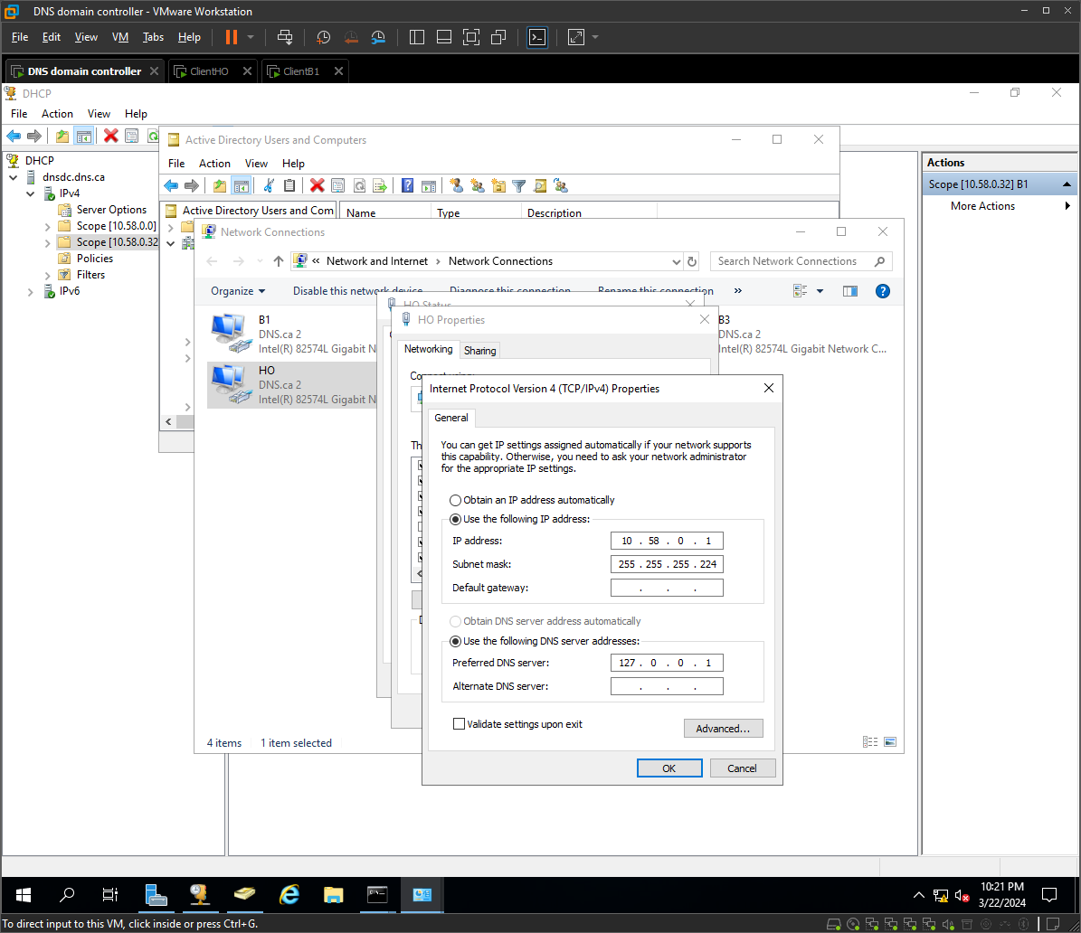

Branch 1:
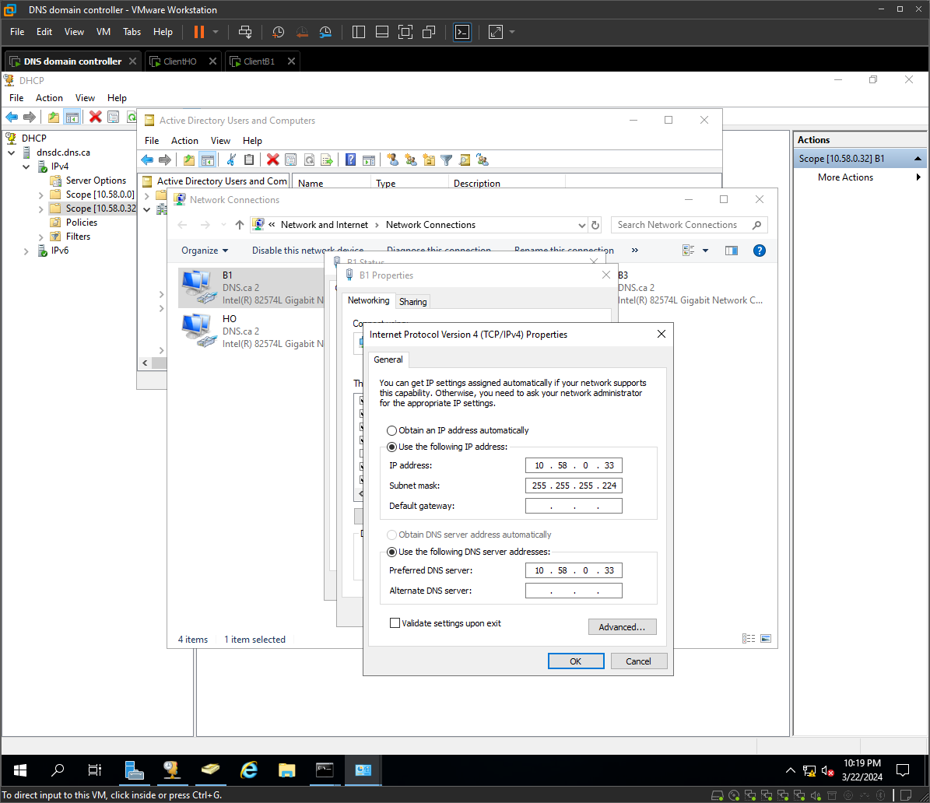

Branch 2:
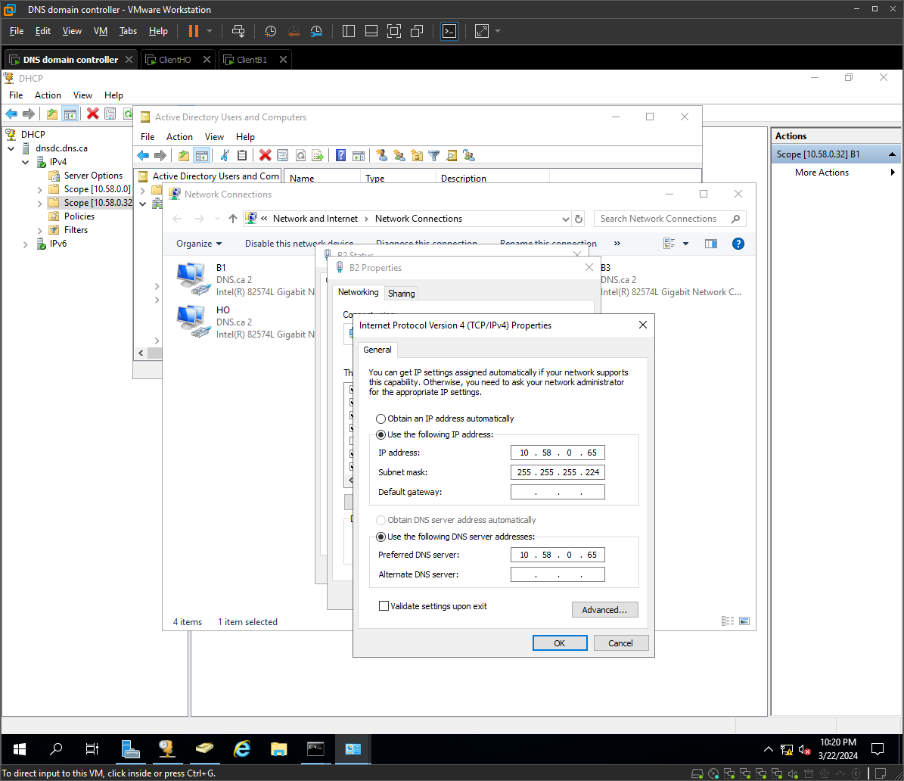

Branch 3:
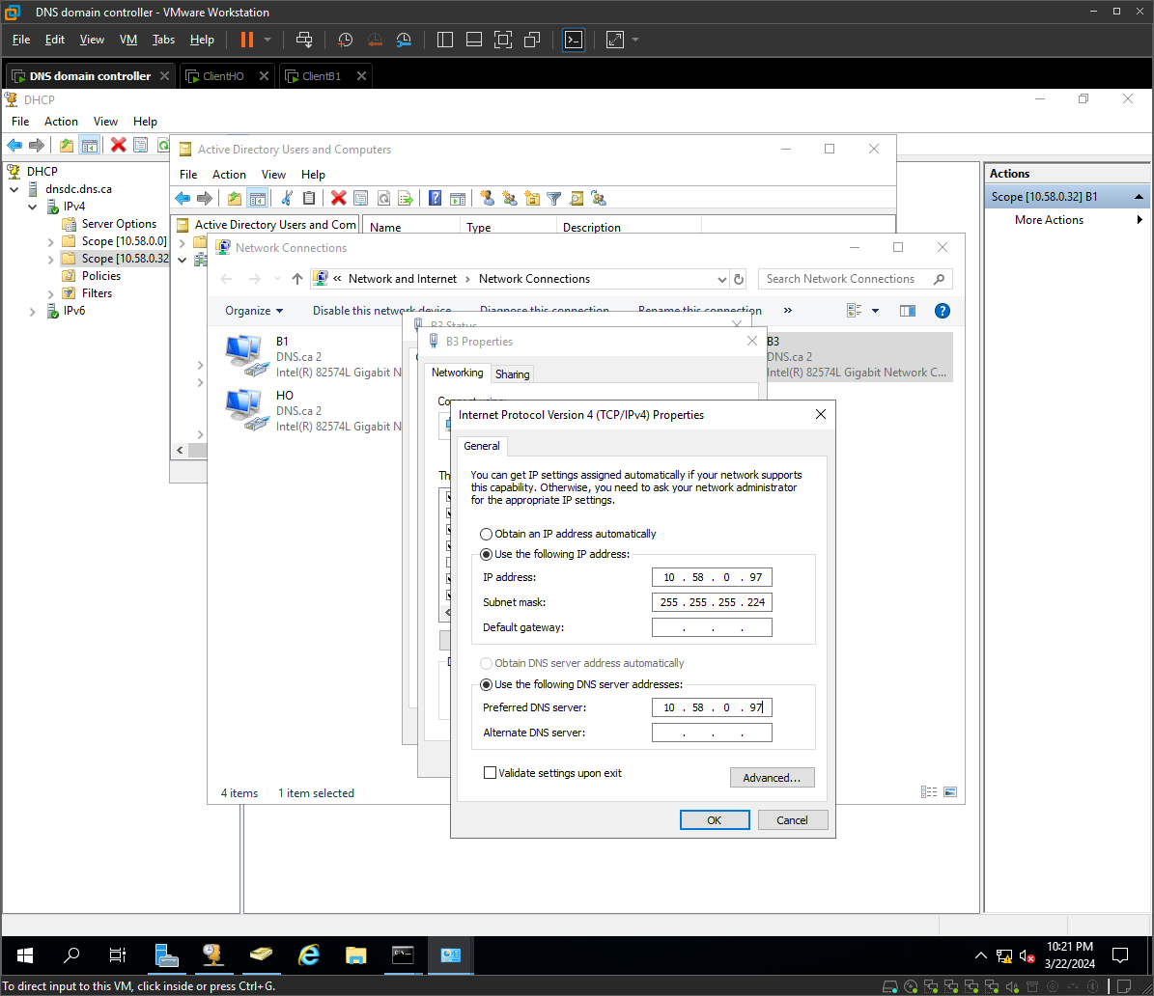

Now create a Scope for each subnet (branch). Head office and Branch 1 was already created to check everything worked well.
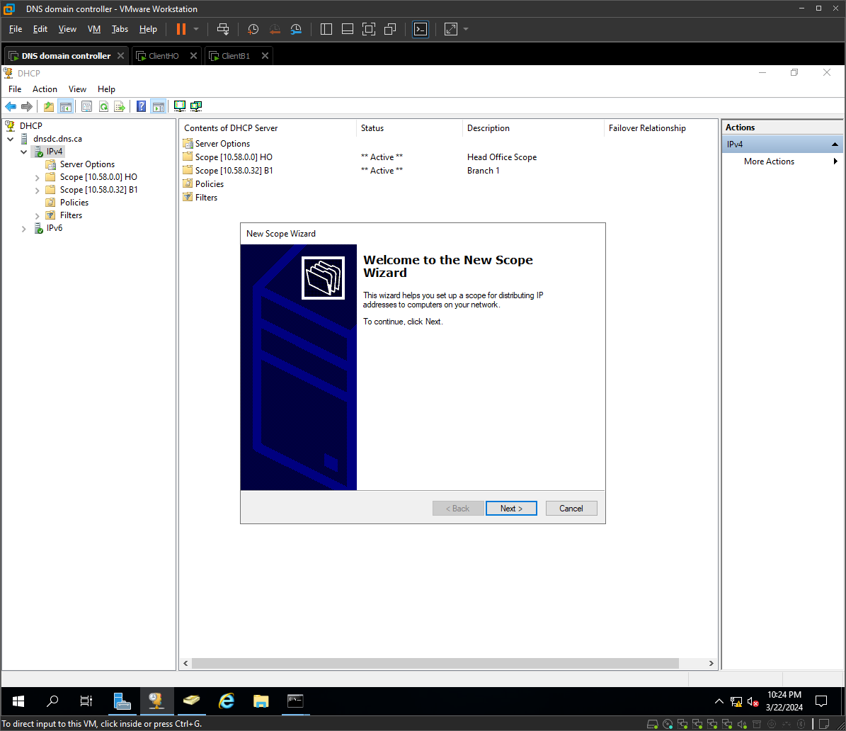
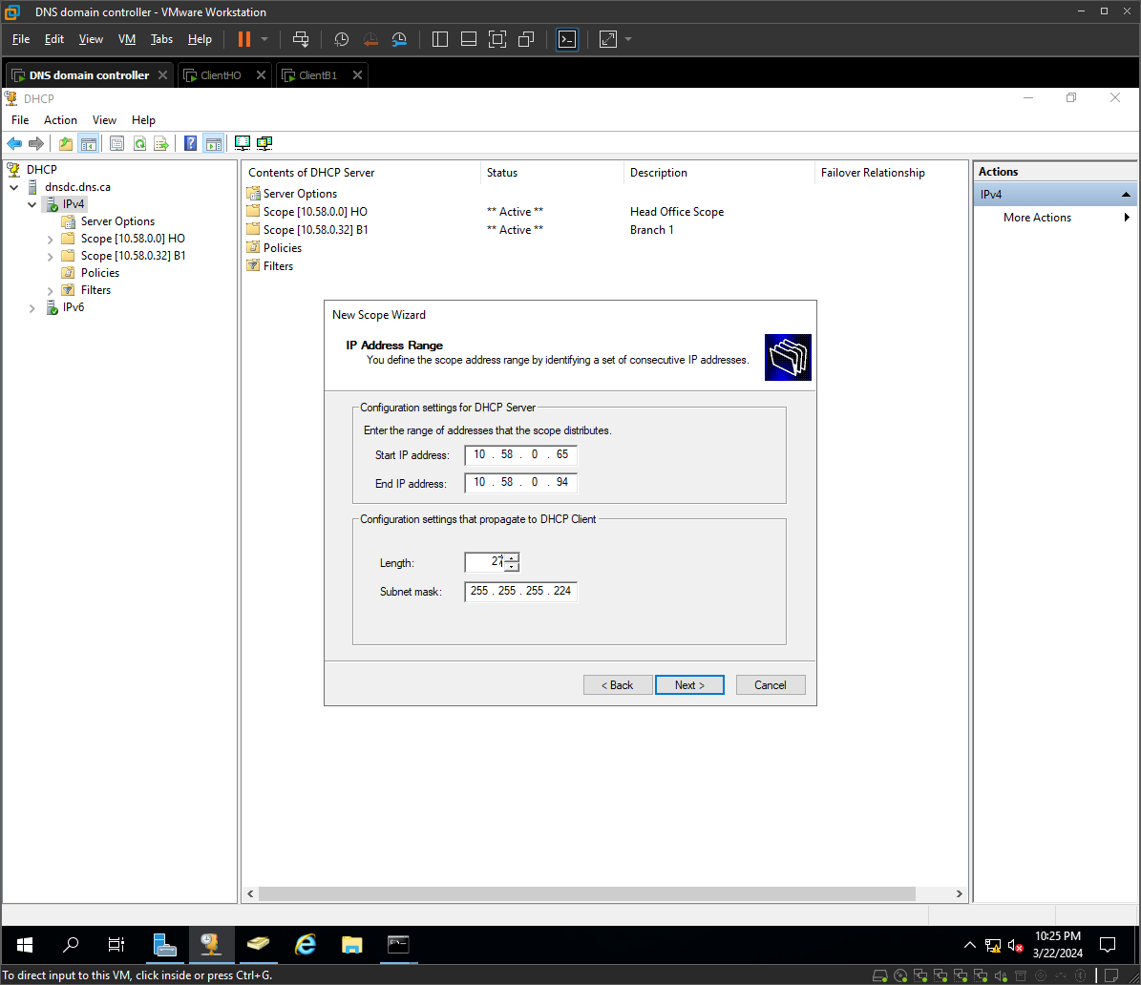

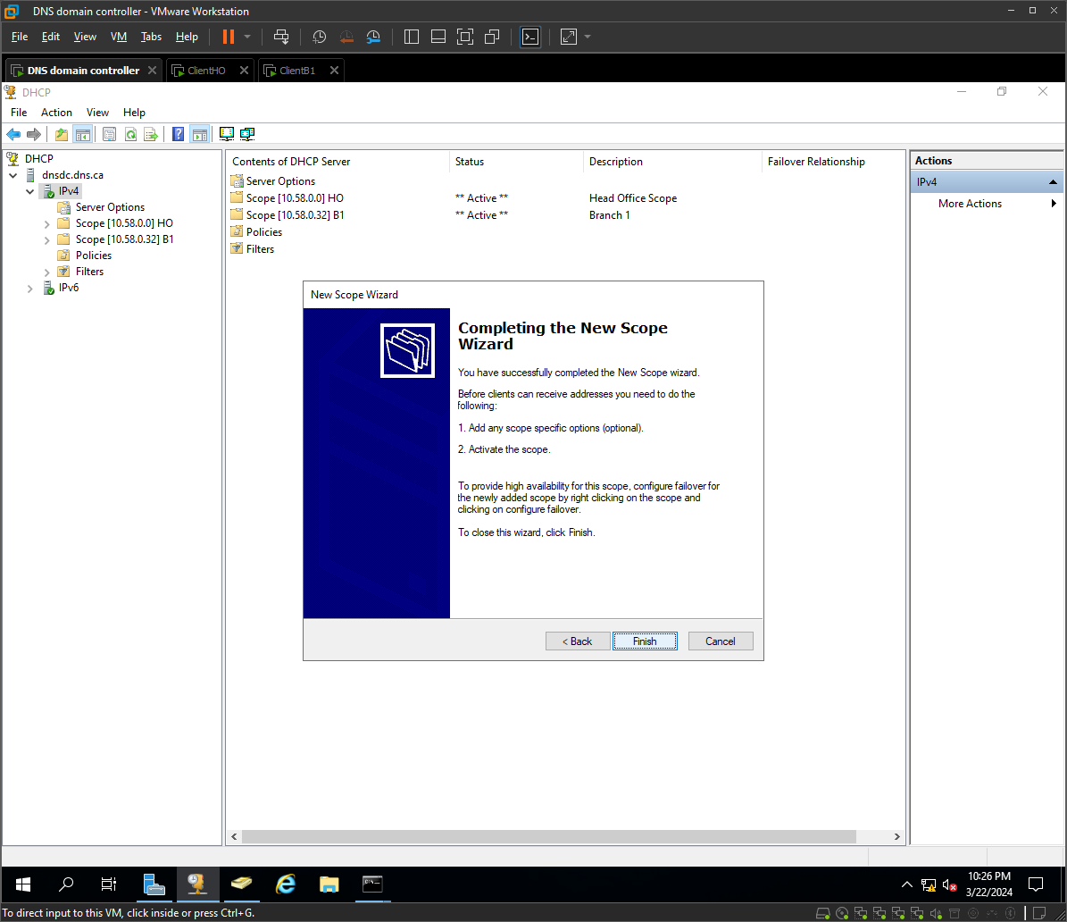

I created 4 client VMs with windows 10 to test the configurations
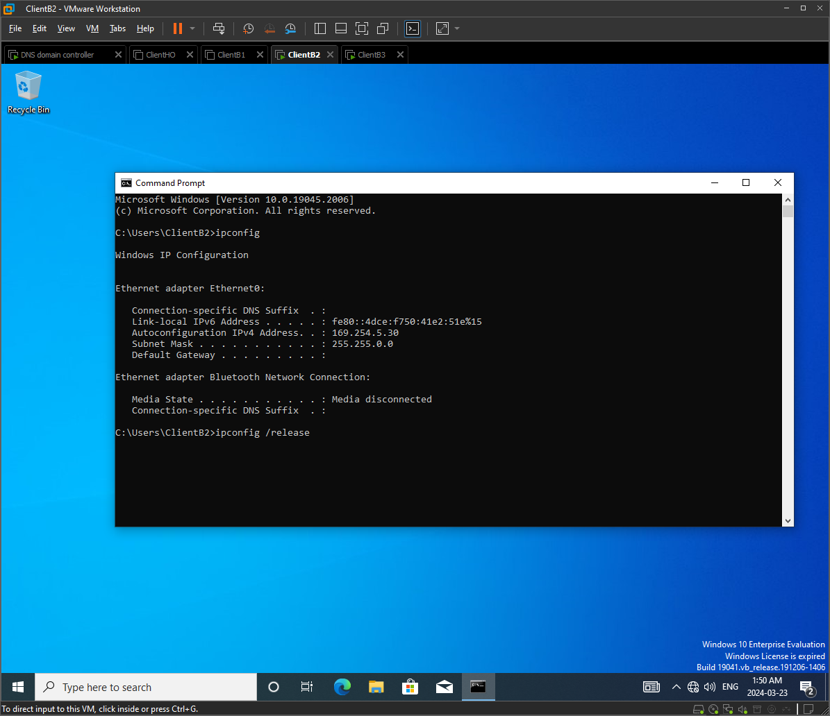
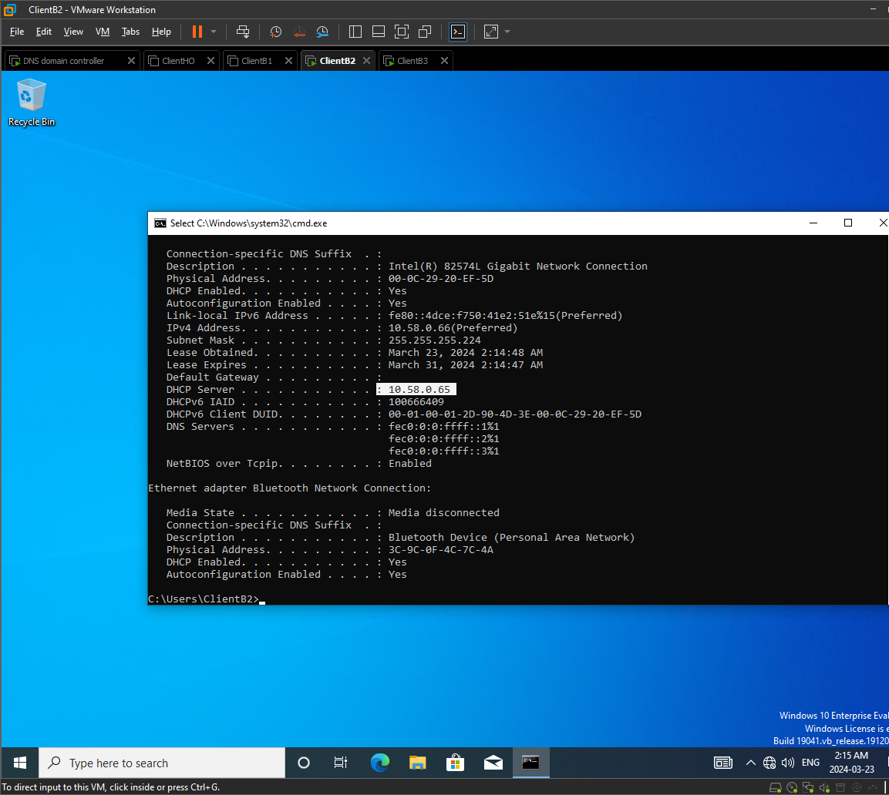
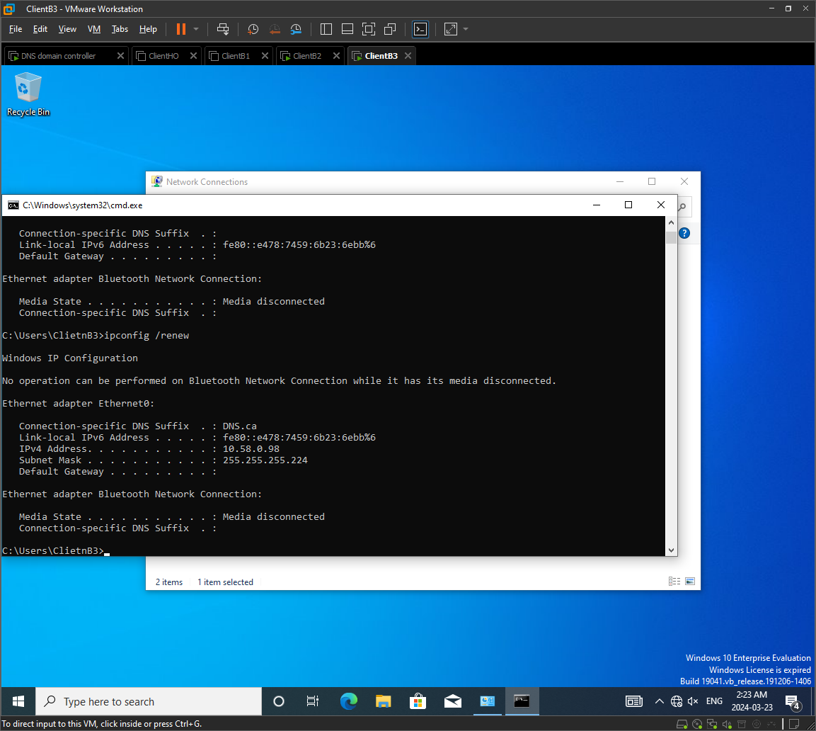

RENAME CLIENTS AND ADD THEM TO THE DOMAIN

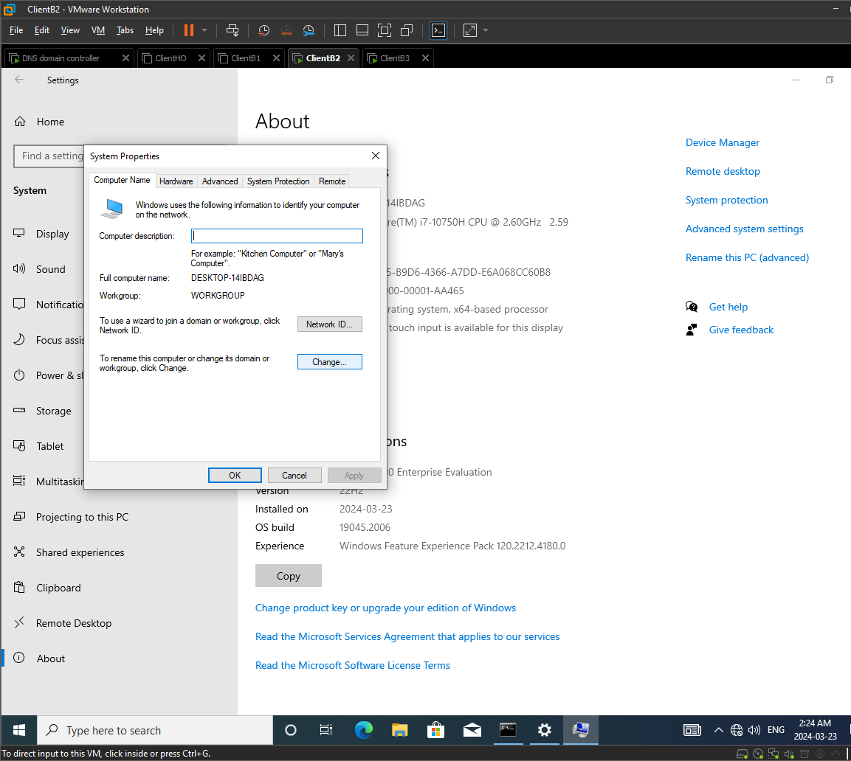
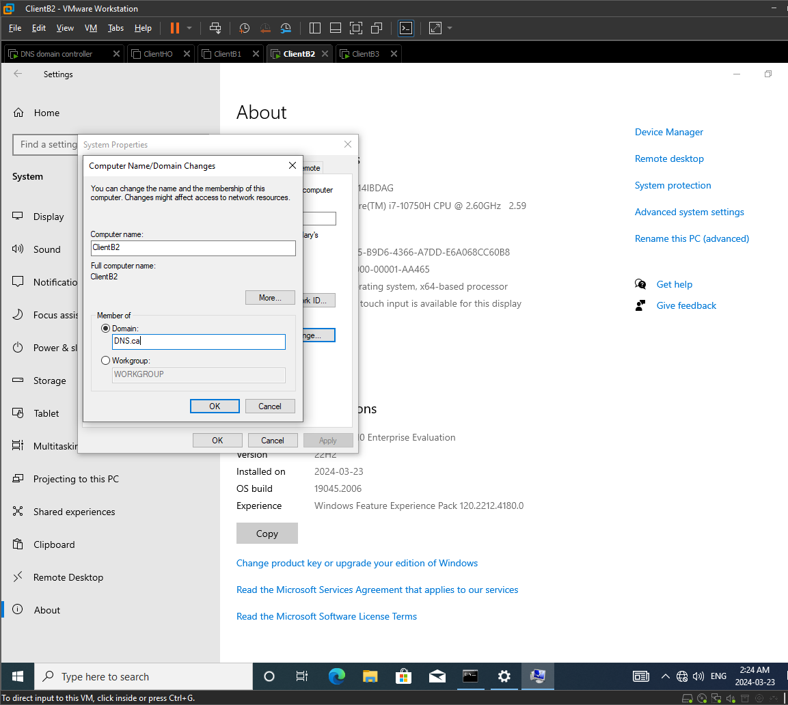
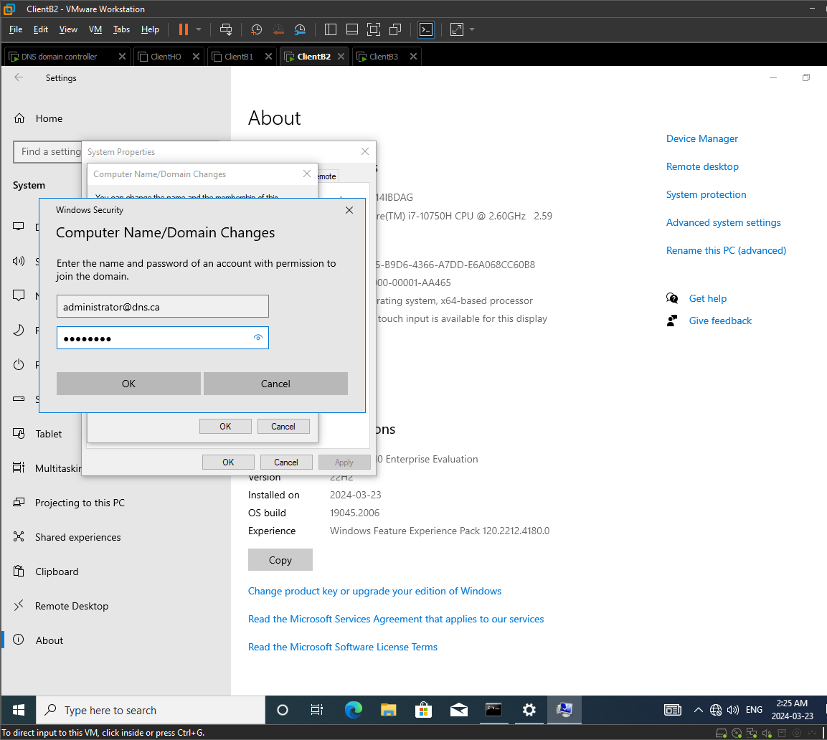
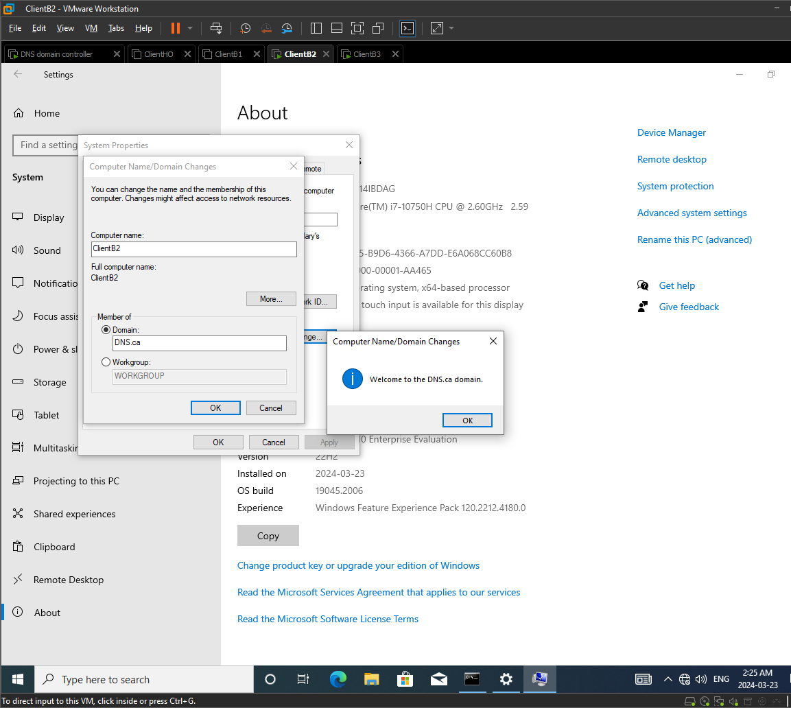
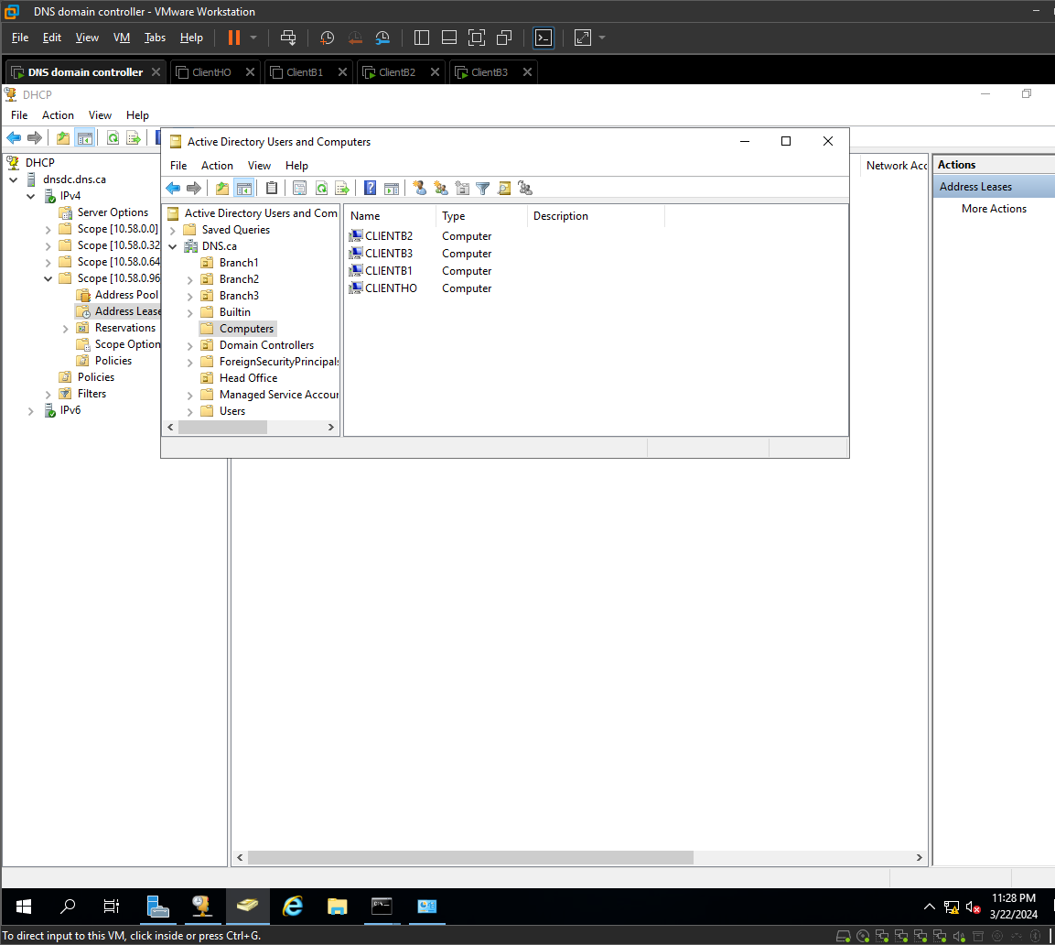

MOVING EACH COMPUTER TO THE RESPECTIVE OU:
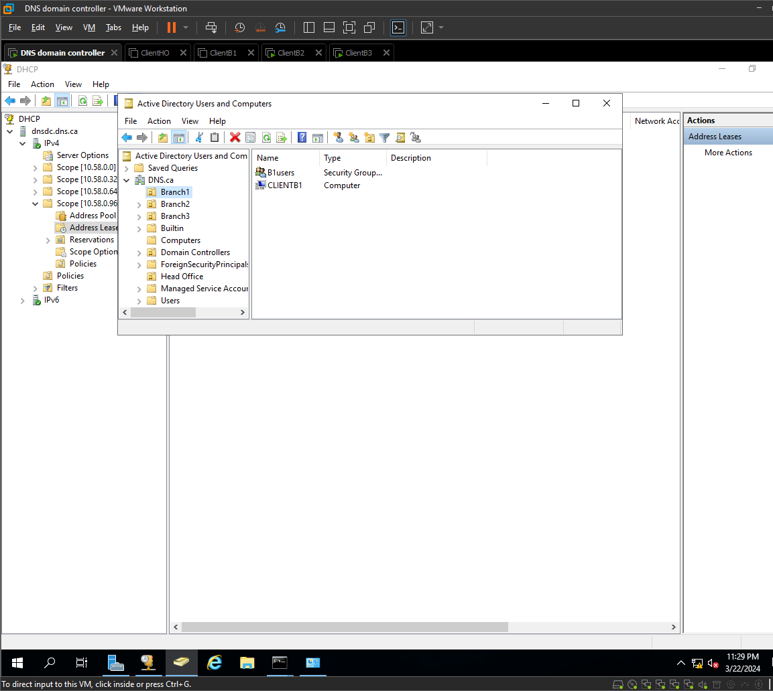
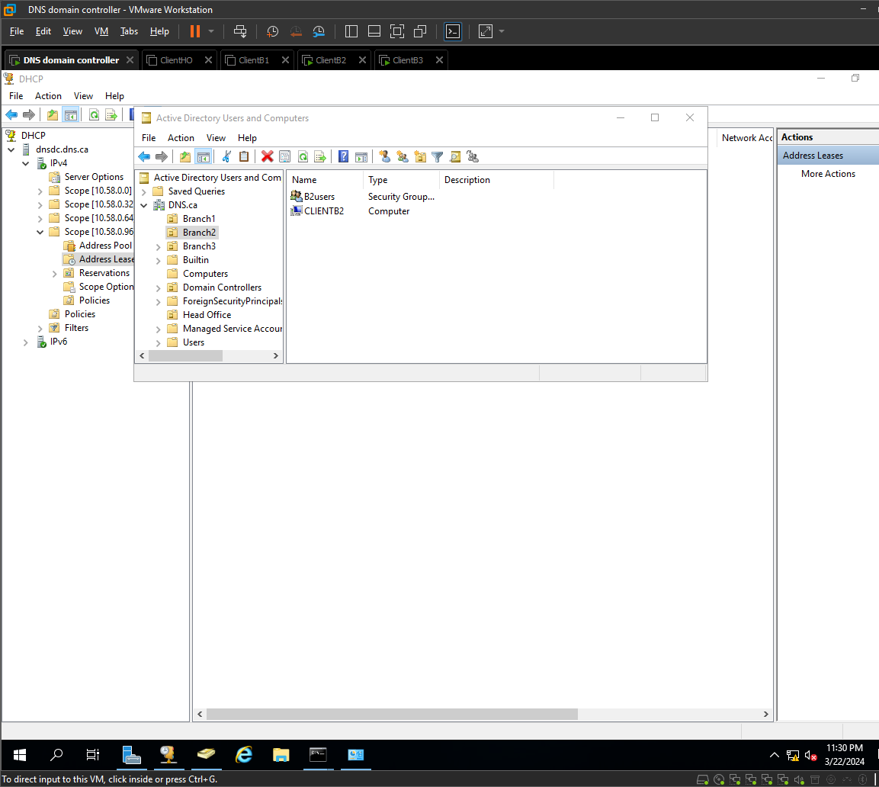
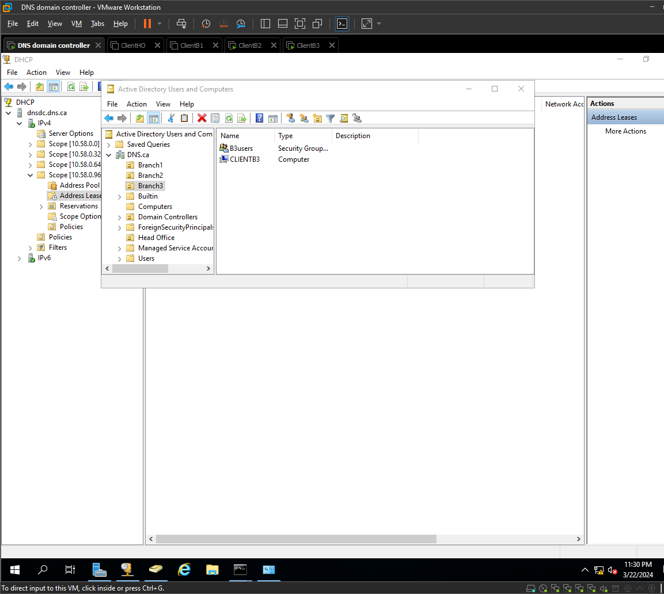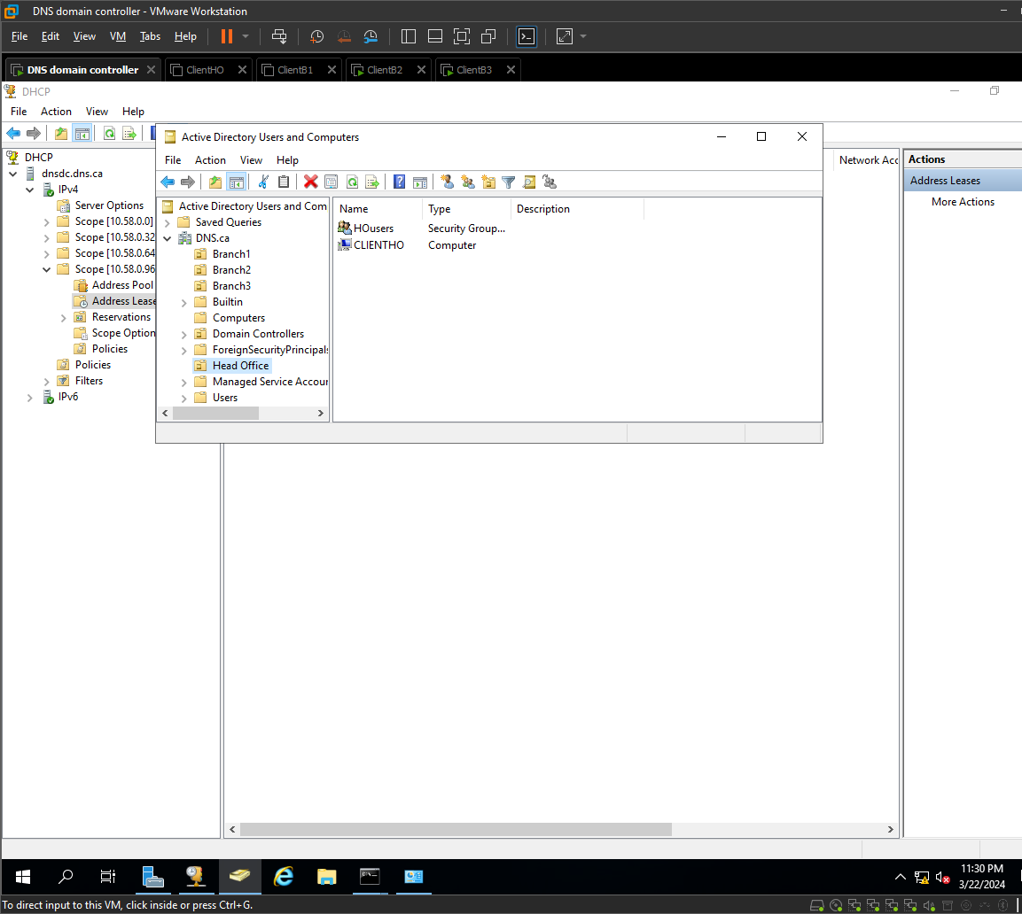

USER CREATION:

For user creation I am going to use a PowerShell script for efficiency
This is the script:
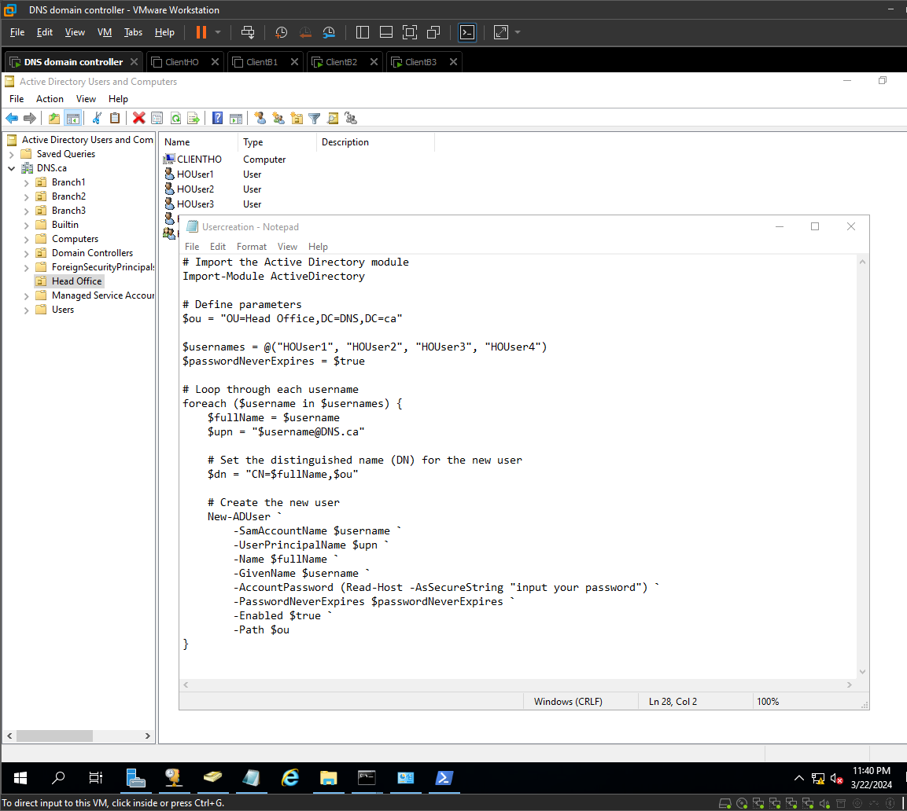
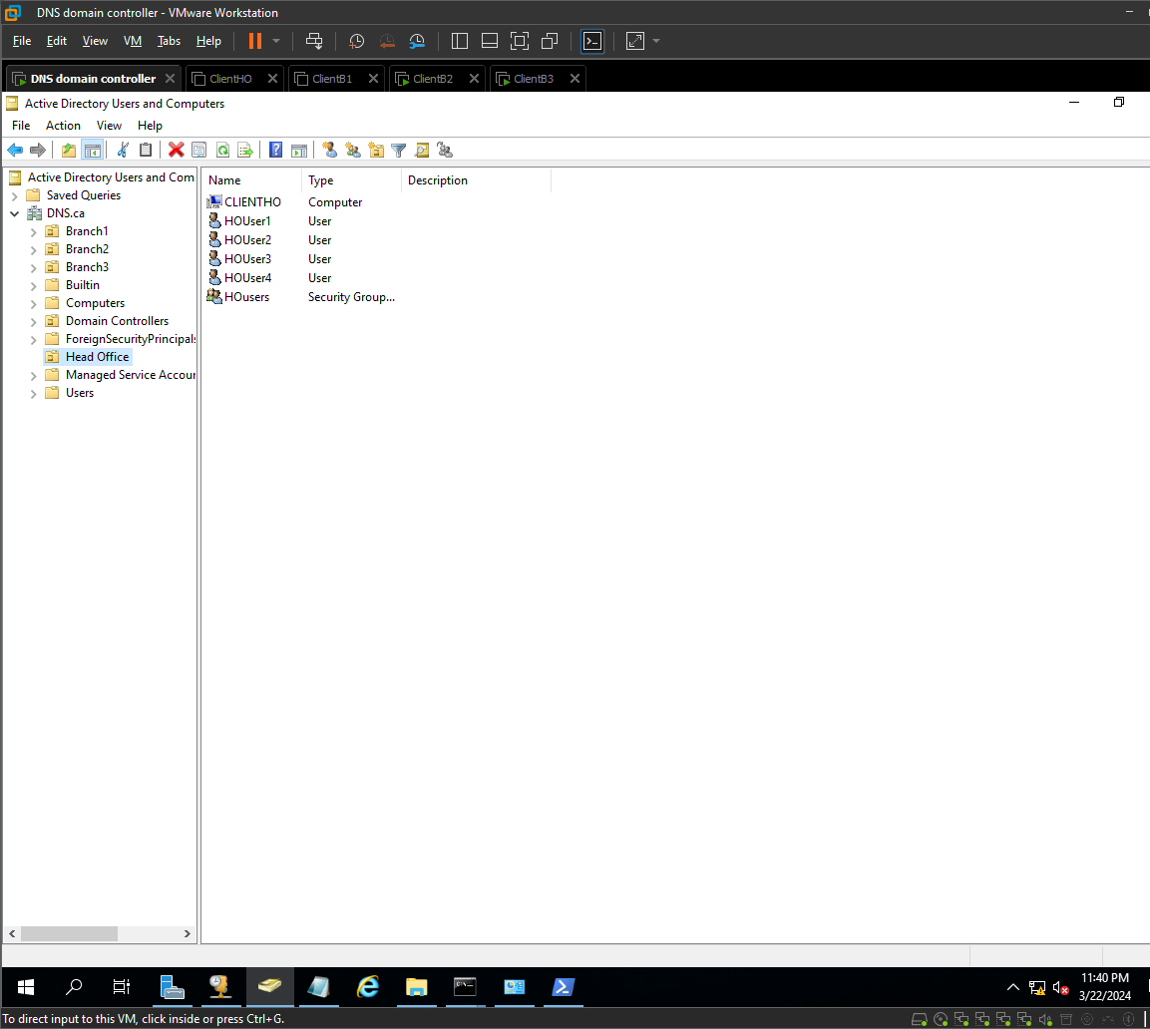

Repeat for each branch
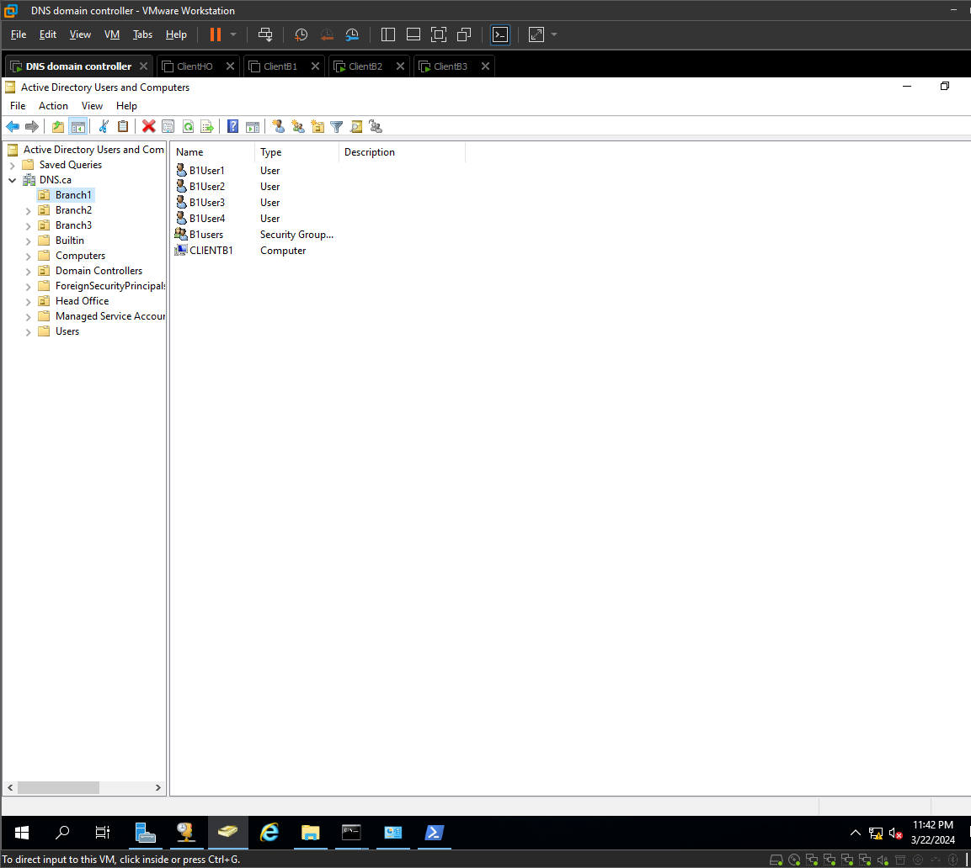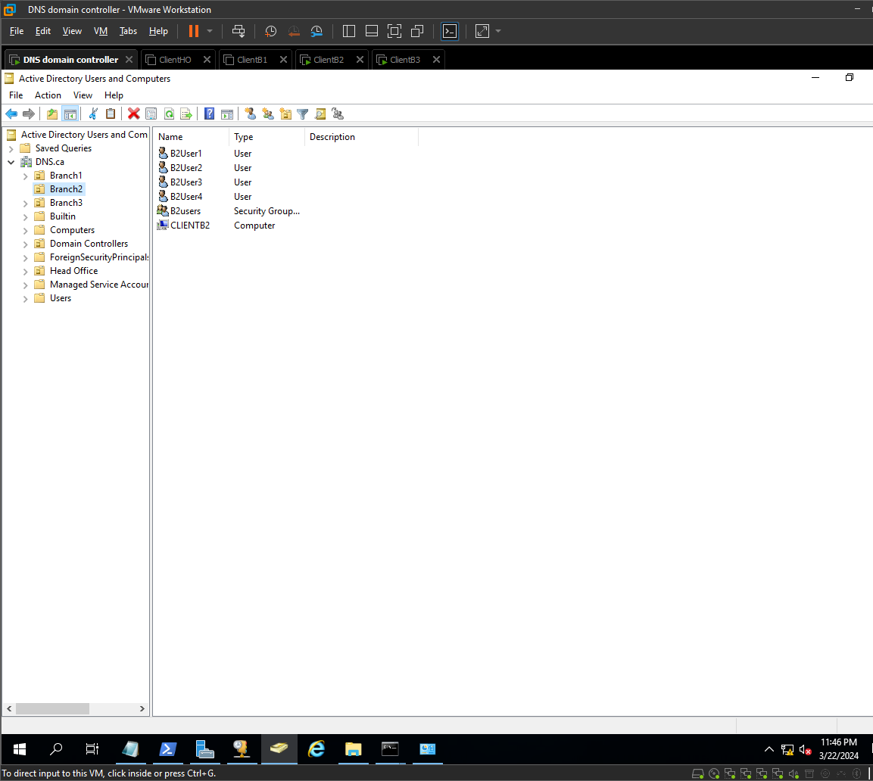
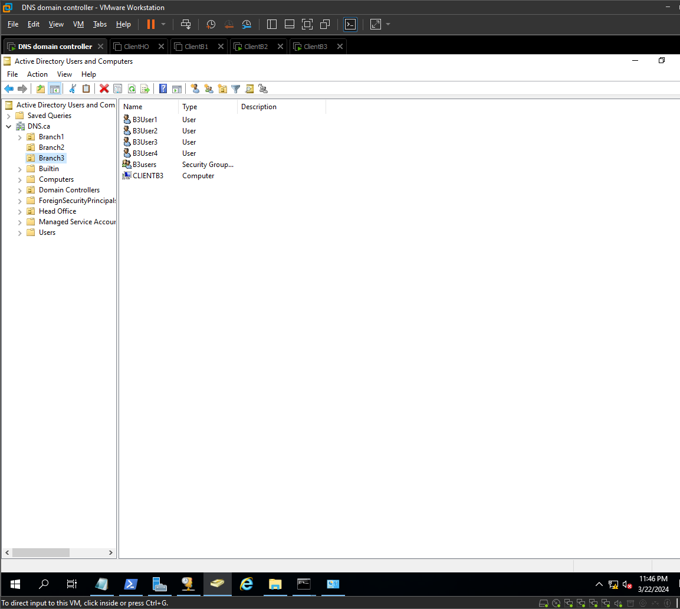

Join all the users to their groups

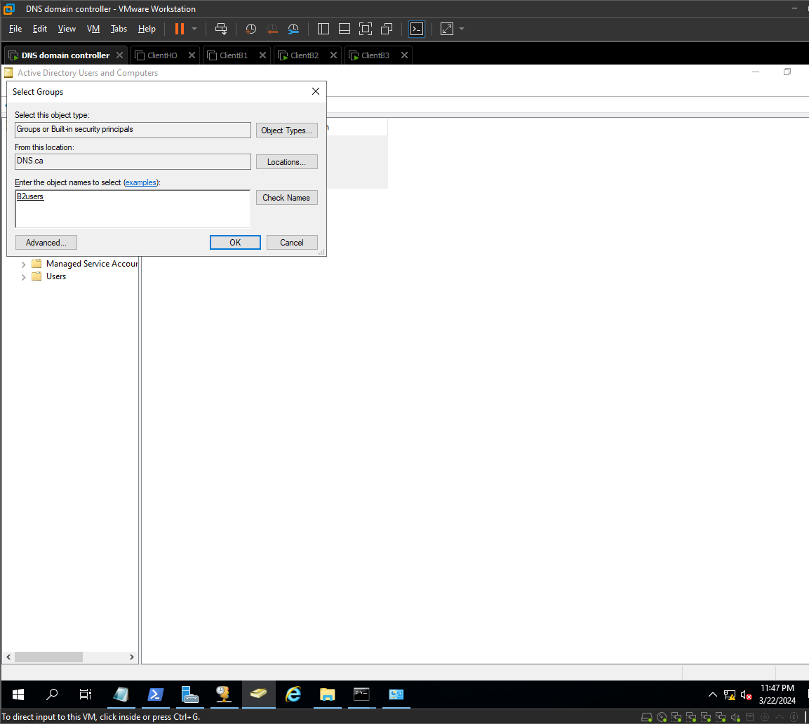
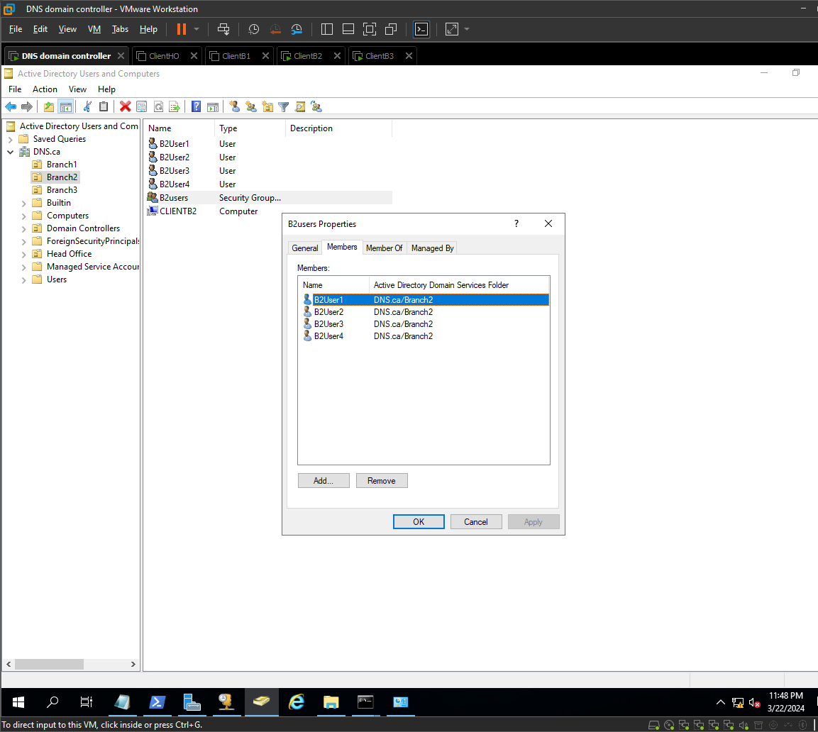
repeat for each branch

CHECK THE USERS WORK LOGGING IN FROM A CLIENT

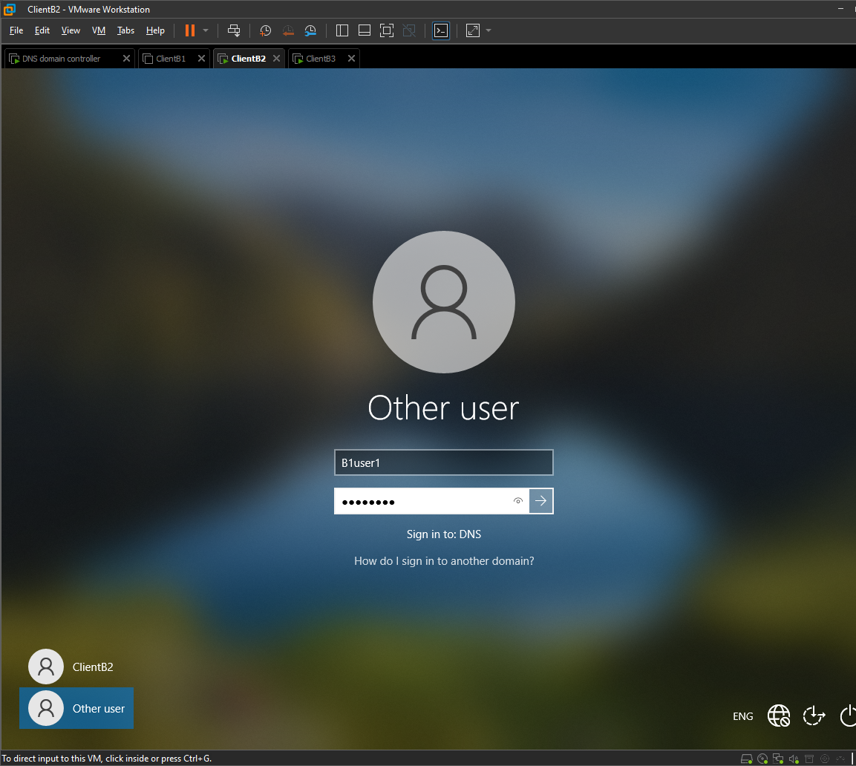

Shown User in the windows Menu

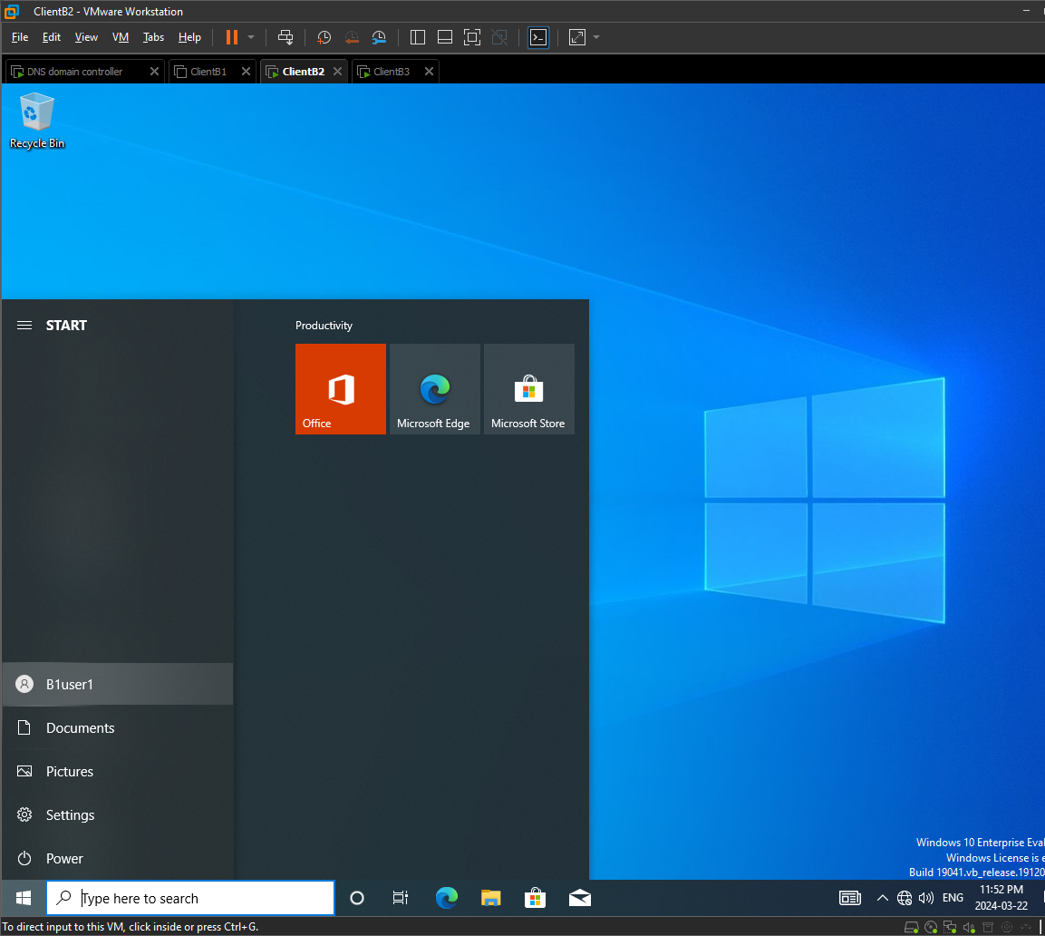

CREATING USER FOR EACH BRANCH:

1ST BRANCH (USER1)
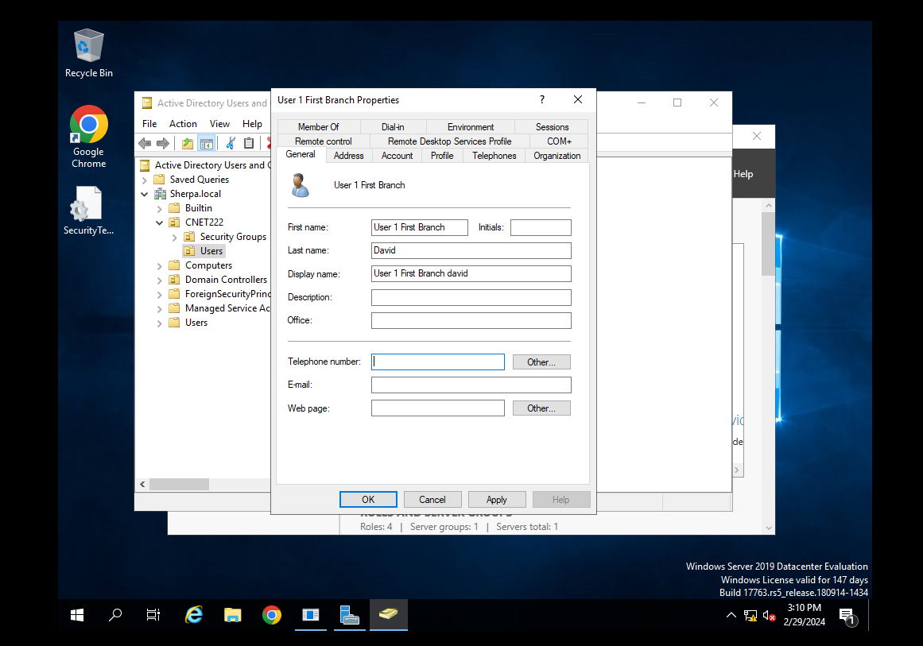

BRANCH 1 (USER 2)
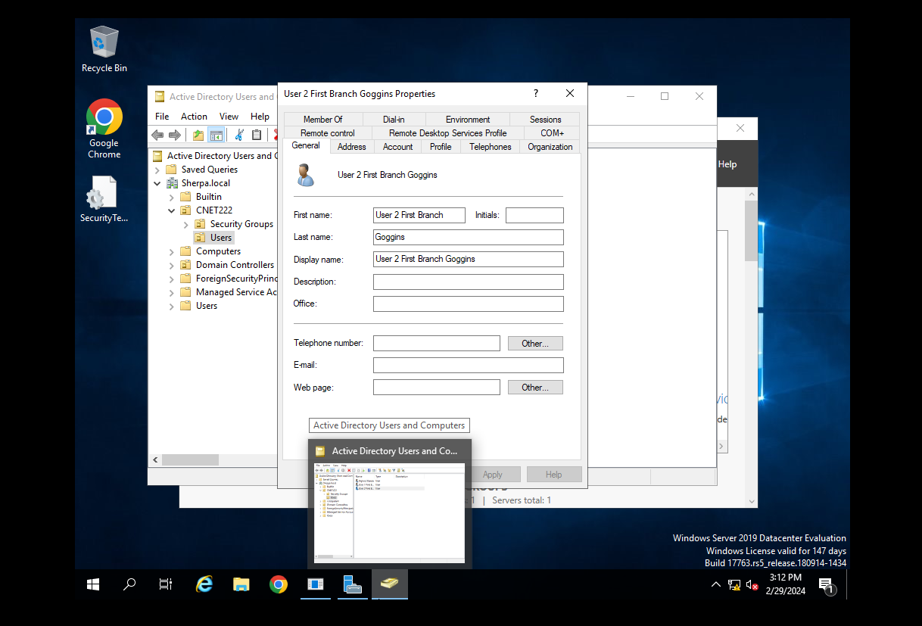

BRANCH 2 (USER 1)
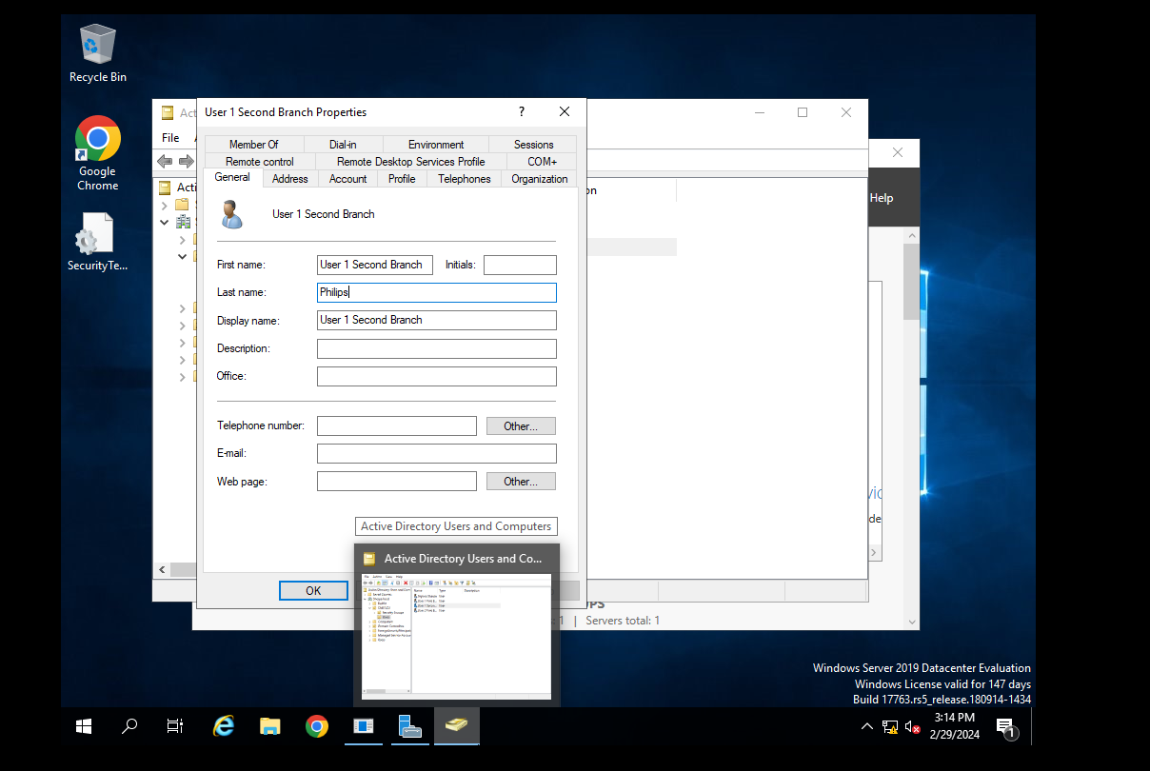

BRANCH 2 (USER 2)

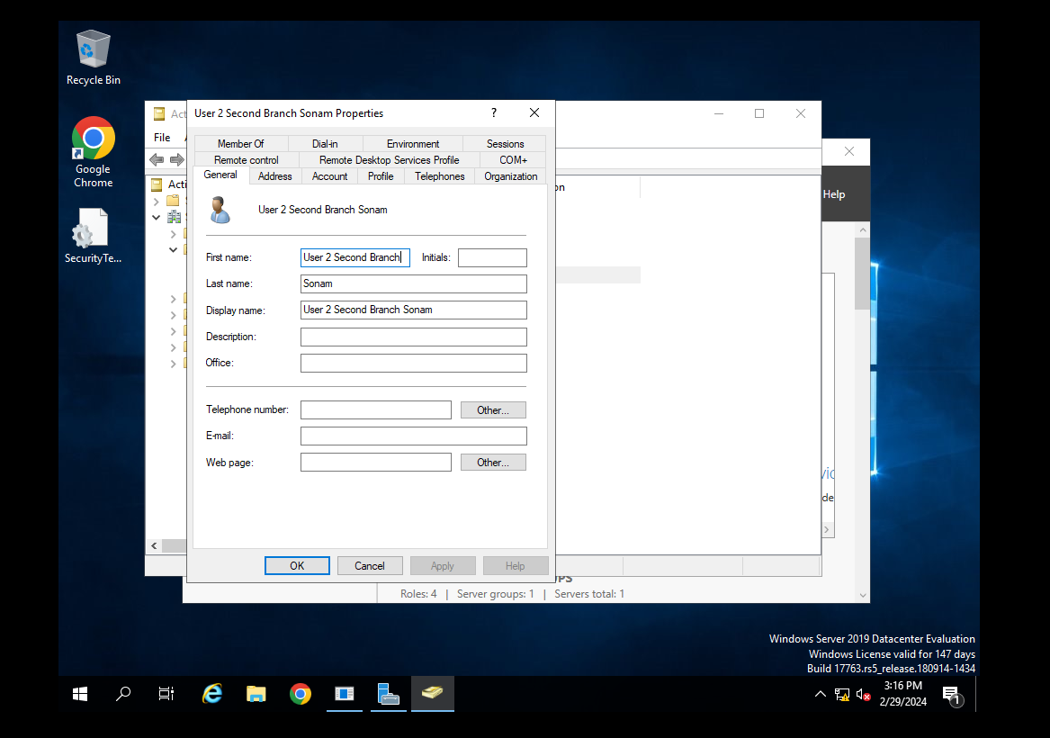

BRANCH 3(USER 1)
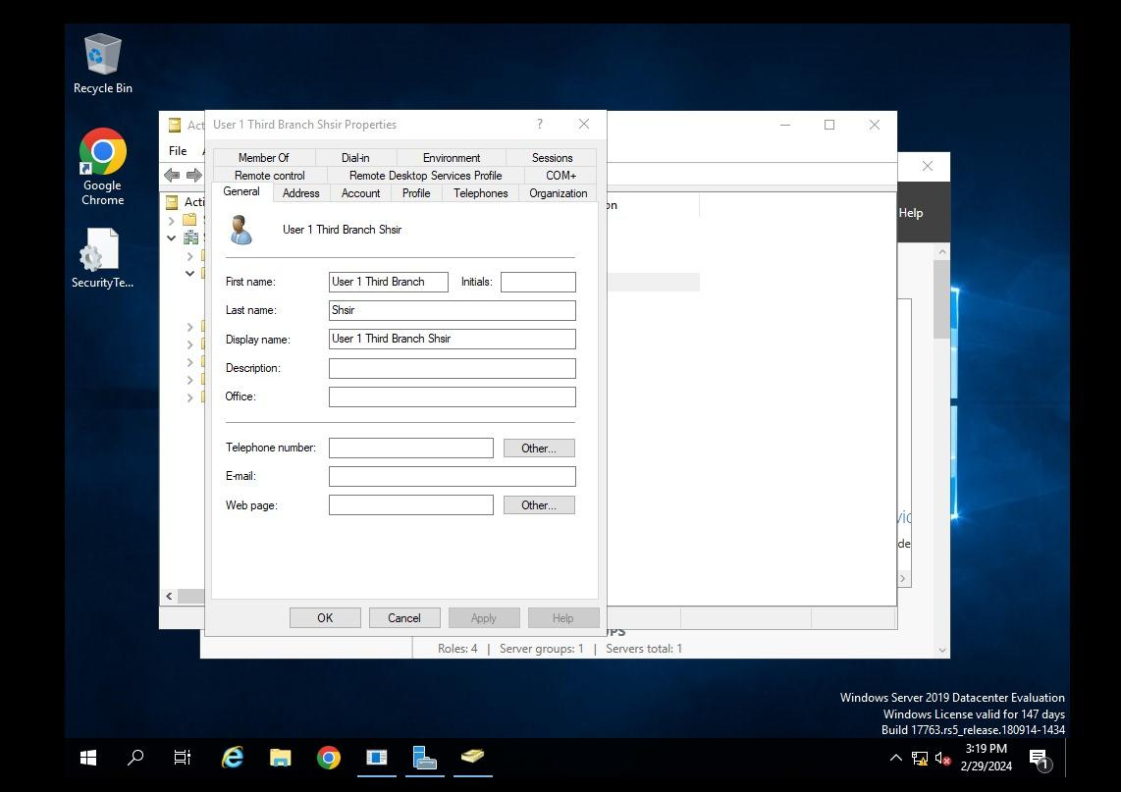

BRANCH 3 (USER 2)
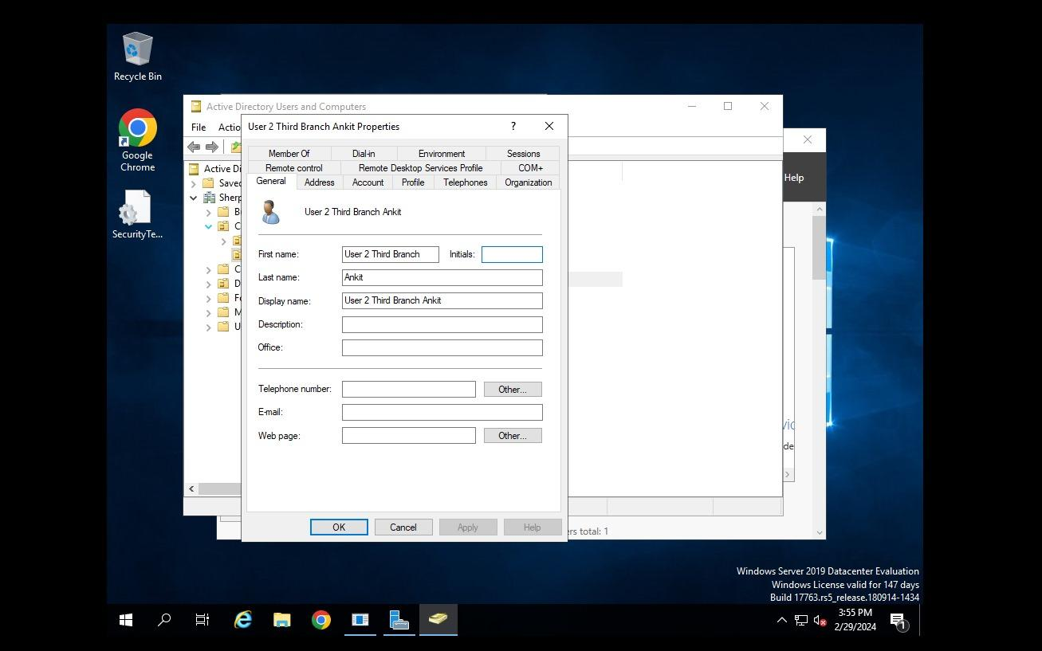

MAIN BRANCH USERS:
1)
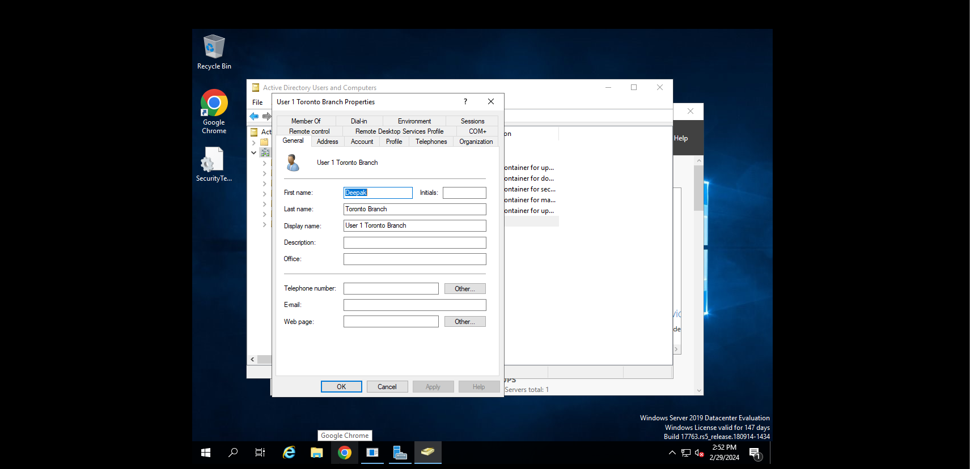
2)
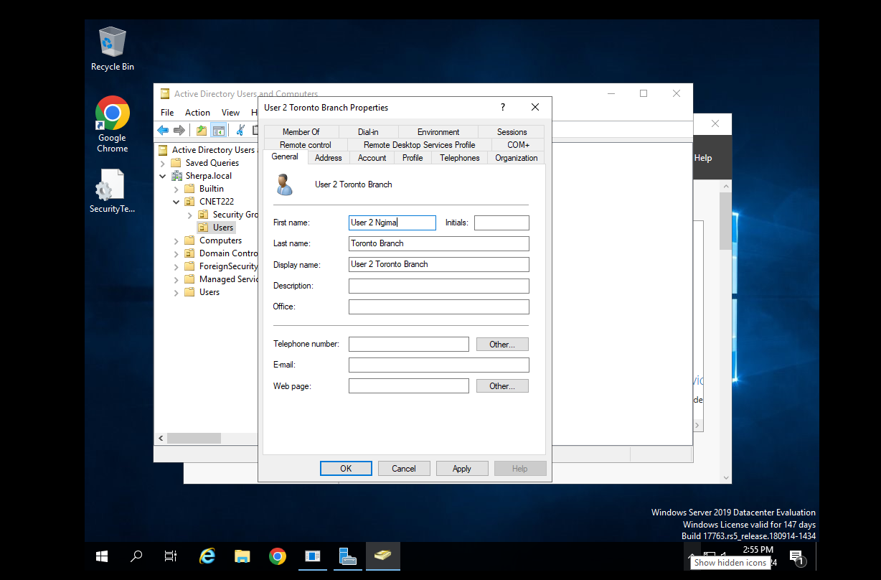
3)
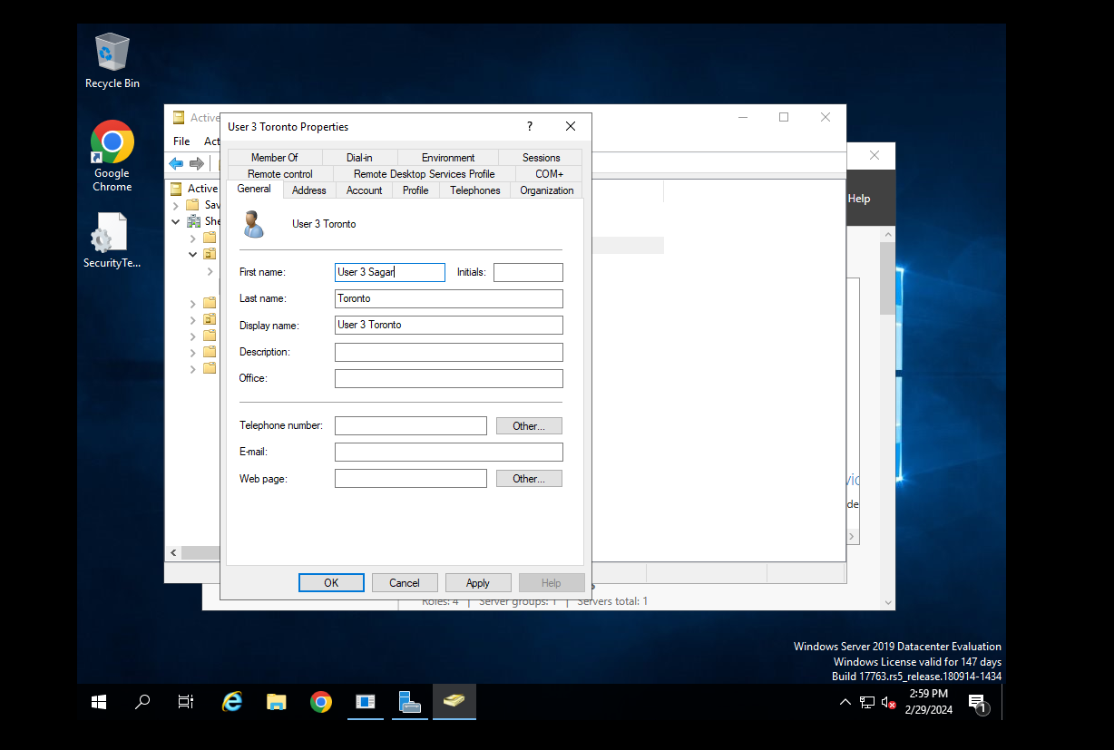

WE ALSO CREATED WEBPAGE FOR OUR CLIENT FOR THEIR BUSINESS

HTML
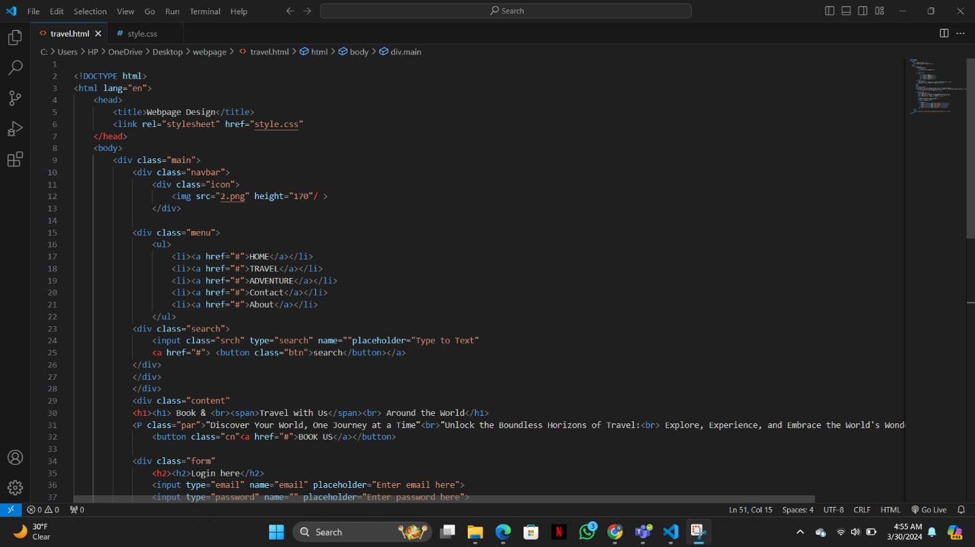
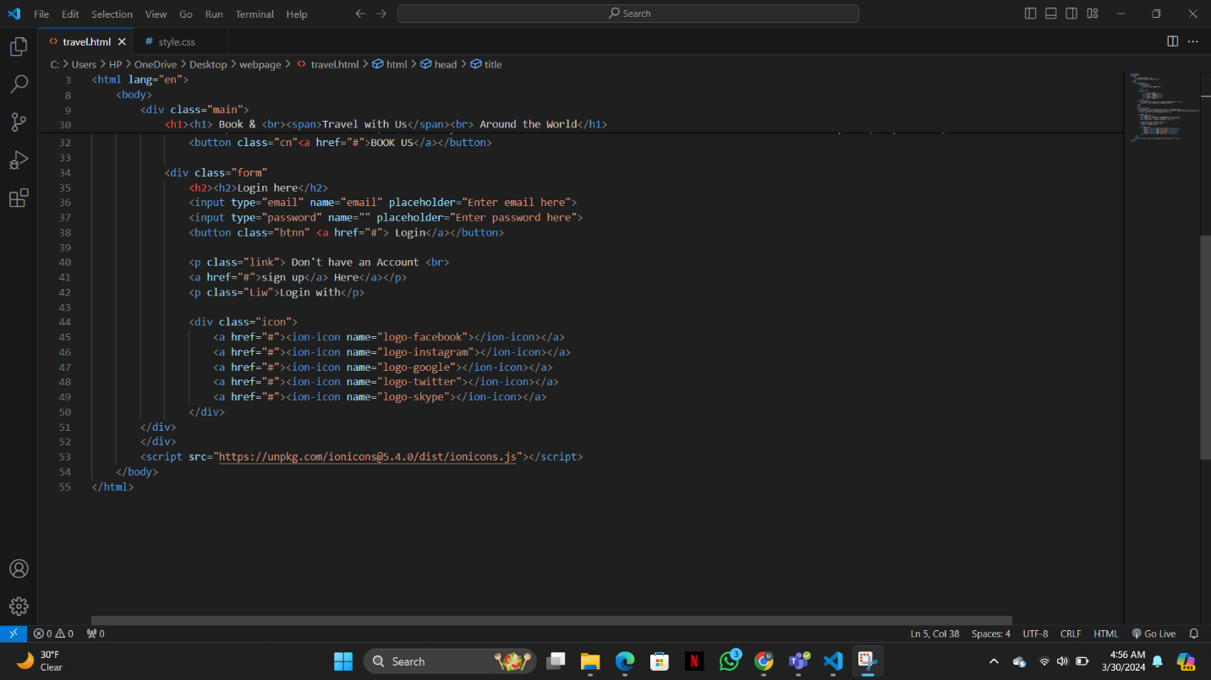

CSS
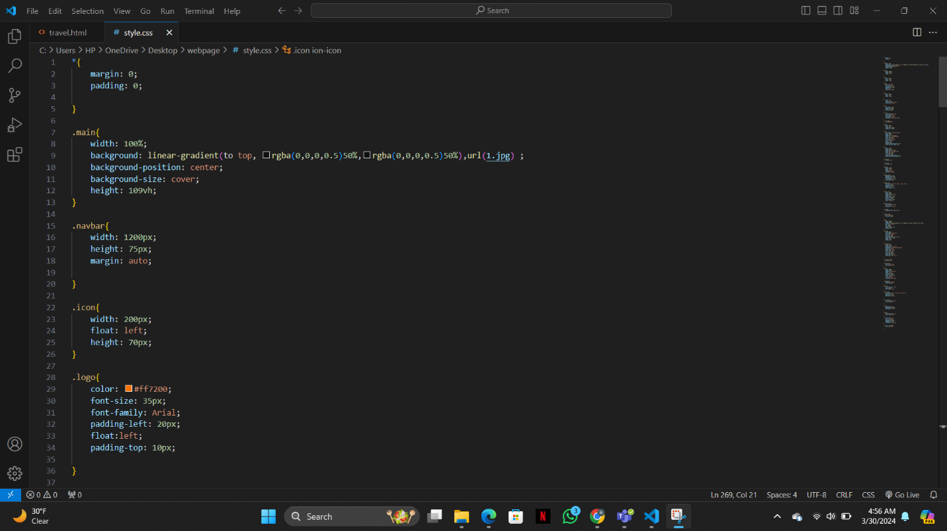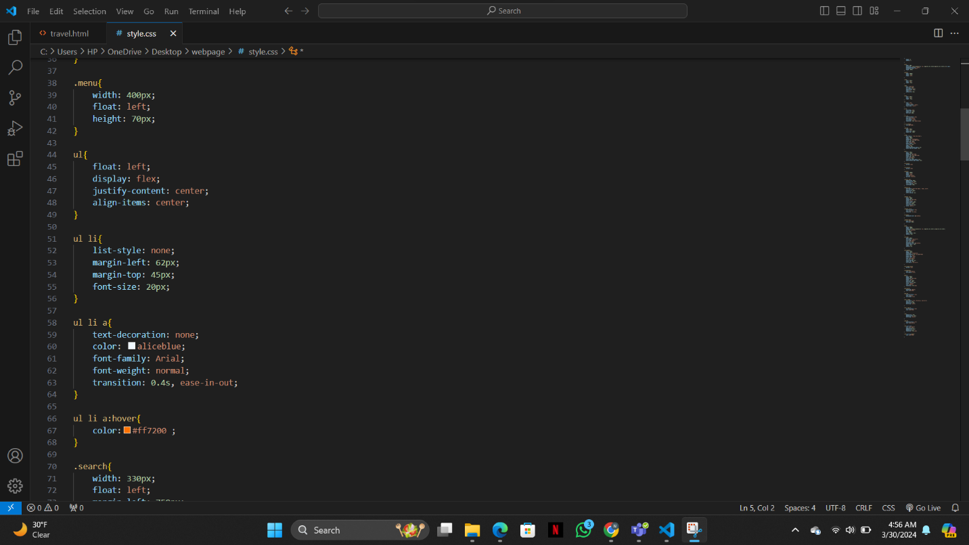

WEBPAGE FOR OUR CLIENT

Welcome to "Travel Around the World"! Your Gateway to Global Exploration

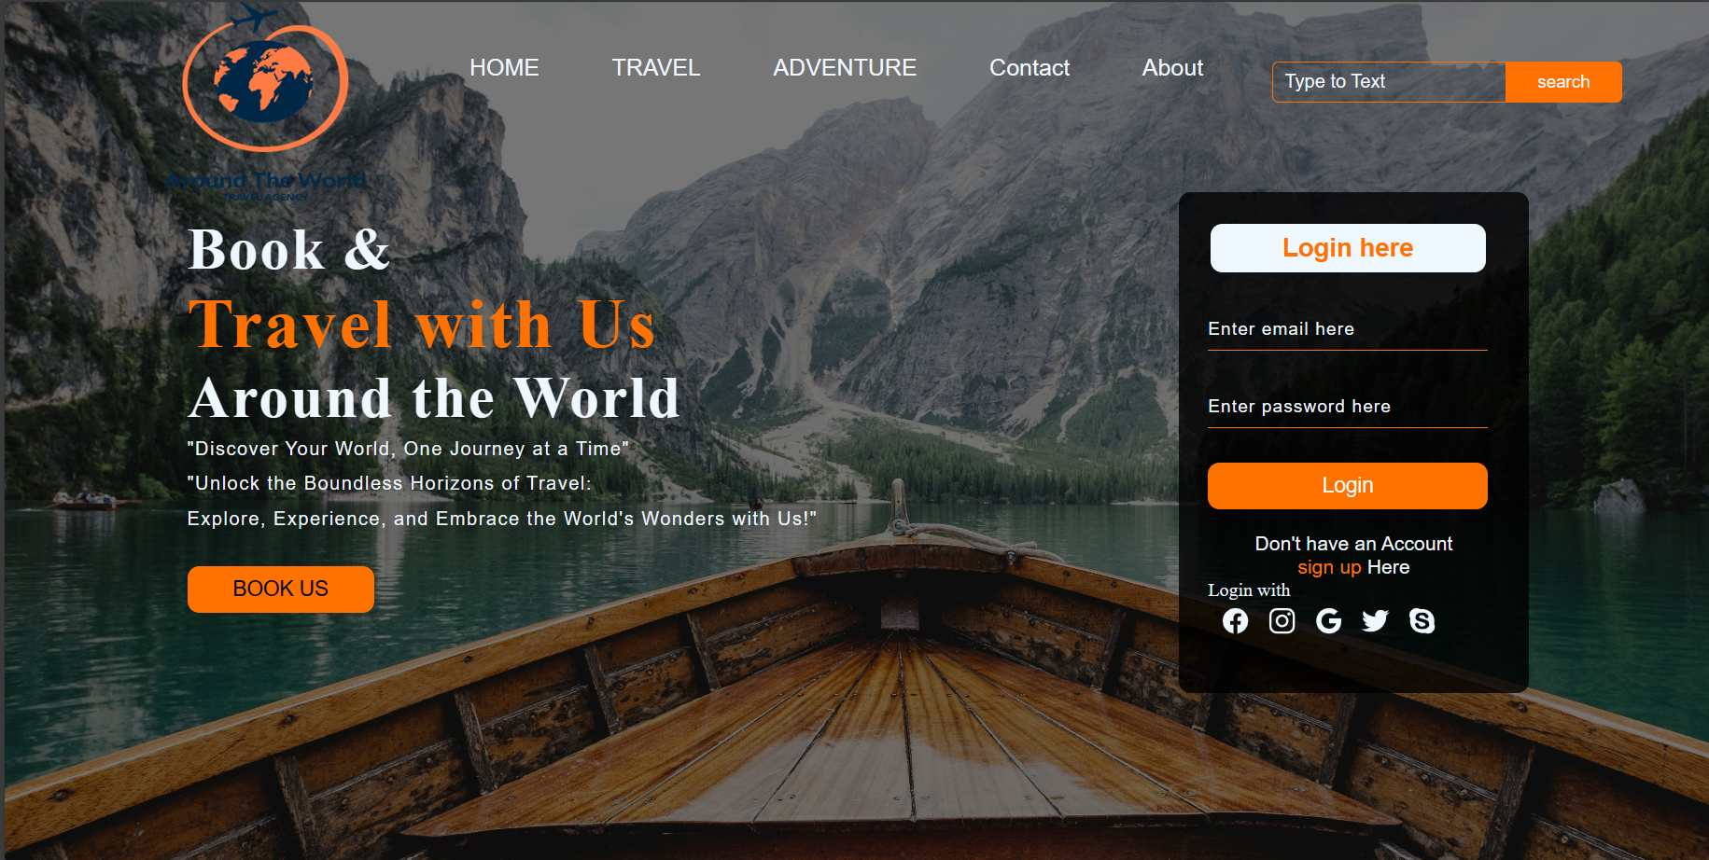

Embark on a journey of discovery with "Travel Around the World," your premier destination for bespoke travel experiences. As a distinguished travel agency, we specialize in curating unforgettable adventures that transcend boundaries and immerse you in the diverse tapestry of cultures, landscapes, and wonders our planet has to offer.
At "Travel Around the World," we understand that every traveler is unique, with distinct passions, preferences, and dreams. Whether you seek the adrenaline rush of an epic adventure, the tranquility of a secluded retreat, or the cultural enrichment of a historical odyssey, our dedicated team of travel experts is committed to crafting personalized itineraries tailored to your desires.
Our unwavering commitment to excellence ensures that every aspect of your journey is meticulously planned and flawlessly executed, leaving you free to savor each moment without the burden of logistics. From luxurious accommodations to immersive excursions, from gourmet dining to seamless transportation, we leave no detail overlooked in our quest to provide you with unparalleled travel experiences.
Join us as we embark on a voyage of discovery, where the world is our playground and every destination holds the promise of adventure. Let "Travel Around the World" be your compass as you chart a course to new horizons and create memories that will last a lifetime. Your extraordinary journey begins here.



Troubleshooting Process

During the critical phase of implementing the network upgrade for "Around The World" travel agency, two significant challenges were encountered: ip address clash due to incorrect subnetting and a persistent reloading issue within the Packet Tracer simulation.

Packet Tracer Reloading Issue
Symptom: Packet Tracer simulations of the upgraded network topology failed to reload properly, preventing validation of the new OSPF configurations and VLAN setups.
Initial Diagnosis: Corrupted simulation files or compatibility issues with the latest Packet Tracer version used for the upgrade simulation.

Packet Tracer Reloading Issue Resolution Steps
- File Integrity Check: Checked the integrity of the Packet Tracer simulation files. Found no corruption but noted that files were last saved with an older version.
- Version Compatibility: Updated Packet Tracer to the latest version to ensure compatibility with simulation files.
- Simulation Reconfiguration: Encountered version-specific features that were not backward compatible. Adjusted the OSPF and VLAN configurations to align with the updated Packet Tracer's functionalities.
- Testing and Validation: Successfully reloaded the simulation, conducted comprehensive testing of the network configurations, and validated the operational efficiency of the OSPF routes and VLAN segmentation.

IP Address Clash Due to Incorrect Subnetting

In the midst of deploying the network upgrade for "Around The World" travel agency, the team faces an unforeseen challenge. The branches in Calgary and Montreal began reporting intermittent network outages and connectivity issues. Initial observations pointed towards an IP address clash, a situation that immediately raised concerns about the subnetting scheme implemented during the upgrade.

Incident Details
Symptom: Devices in the Calgary and Montreal branches experienced frequent disconnects and failed to access network resources consistently. This erratic behavior disrupted operations and raised urgent calls for a solution.
Diagnosis: A quick review of the IP addressing scheme revealed that the Calgary and Montreal branches were inadvertently assigned overlapping IP address ranges. Specifically, both locations were using the 10.58.0.64/27 subnet, leading to IP address clashes as devices attempted to join the network.

Troubleshooting and Resolution Process
- Immediate Isolation: To mitigate the impact, network access for the affected branches was temporarily restricted. This step was necessary to prevent further IP address conflicts and to stabilize the network for unaffected areas.
- Subnet Re-evaluation: The network design documents were revisited, with a particular focus on the subnet allocation for each branch. It was determined that a clerical error during the documentation phase led to the incorrect assignment of the same subnet to both Calgary and Montreal branches.
- Corrective Subnetting: A new subnetting scheme was devised to ensure unique IP address ranges for each branch. The Calgary branch was reassigned to use the 10.58.0.64/27 subnet, while the Montreal branch was allocated a new subnet, 10.58.0.96/27. This adjustment ensured no overlap between the IP address ranges of the branches.
- Implementation of Changes: Network configurations were updated across the routers and switches to reflect the new subnetting scheme. DHCP scopes were also adjusted to match the updated subnets, ensuring that devices would receive IP addresses within the correct range.
- Testing and Monitoring: Following the implementation of the subnet corrections, extensive testing was conducted. Devices in both Calgary and Montreal branches were monitored as they obtained new IP addresses from the DHCP server, confirming the absence of further IP clashes.
- Documentation Update: Network design documents were thoroughly updated to reflect the corrected subnetting scheme. This step was crucial to prevent recurrence of similar issues and to ensure accurate reference materials for future network modifications.

Lessons Learned
- Importance of Accurate Documentation: This incident highlighted the critical role that precise documentation plays in network design and implementation. Any discrepancies can lead to significant issues down the line.
- Proactive Monitoring: Implementing monitoring tools that can detect IP conflicts in real-time would serve as an early warning system, allowing for quicker resolution of such issues.
- Regular Review and Audit: Periodic reviews and audits of network configurations and addressing schemes can preempt potential conflicts, ensuring the network's stability and reliability.

References:
Cisco. (n.d.). Buy. Retrieved from https://www.cisco.com/c/en_ca/buy.html

Cisco. (n.d.). Cisco Partner Locator. Retrieved from https://locatr.cloudapps.cisco.com/WWChannels/LOCATR/openBasicSearch.do

Best Buy Canada. (n.d.). Best Buy Business. Retrieved from https://www.bestbuy.ca/en-ca/about/best-buy-business/bltfad9143fefc09dc6

