Operation Heroes Support Application

Name:
Address
Street:
Town:
State:
Date of Birth:

Email:

Home Phone: Cell Phone:

Shirt Size: Small Medium Large X-:Large XX-Large XXX-Large XXXX-Large

Branch of Service: Rank: Service Dates:

Duty Summary:

Treatment Facility / Hospital:

Summary of Injuries or Physical Limitations:

Special needs or Accommodations / Dietary / Allergies

Medications

Have you ever hunted before: Yes / No

Do you have hunting clothes: Yes / No

If no what is your Shirt Size:

Pant size:

Have you ever completed a hunter safety course: Yes / No Hunter Safety #

Have you ever participated in any other program such as this: Yes / No

If yes, please explain all prior participation:

Emergency Contact: Phone:
Signature: Date:

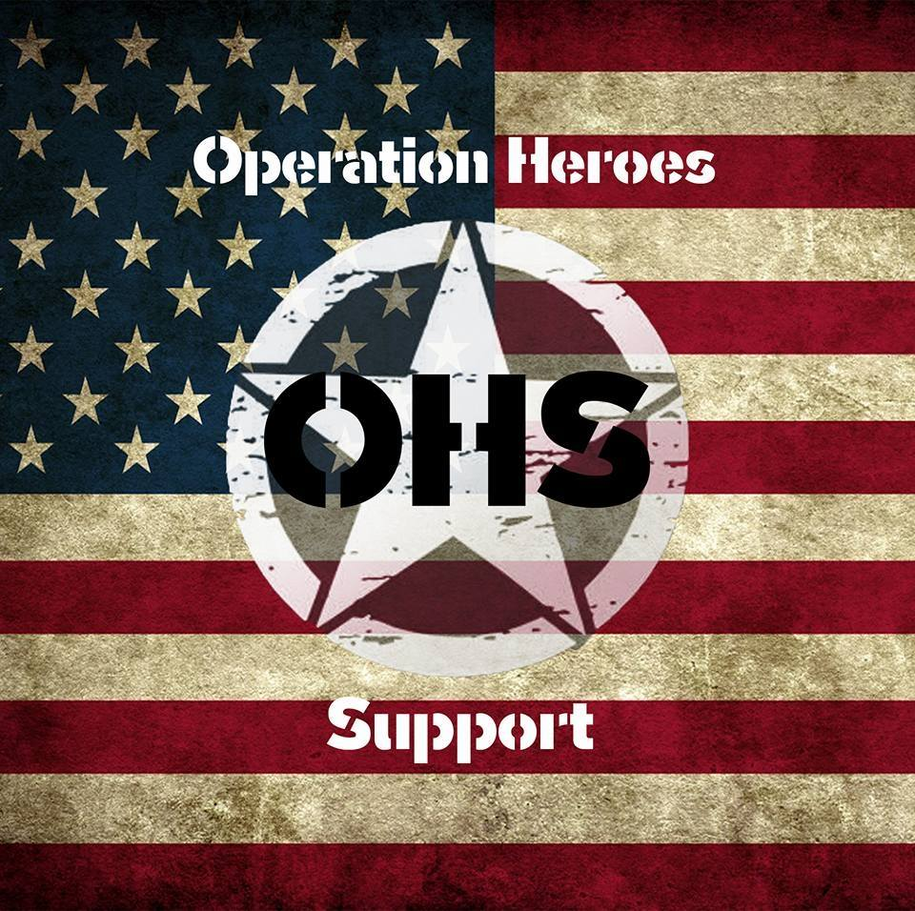
*NOTE: Applying does not guarantee event selection, it acts as a placeholder. Event selection is first come first served, except for our Elk and Hog Hunts. Selection for those events is completed by a board of reviewers. Due to high demand our waiting list is quite long, however we will contact you, please be patient. Thank You

