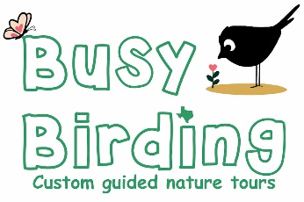
Pre-Trip Survey

- Party Name(s) _________________________________________________
_________________________________________________
Hometown or Visiting From ______________________________________________

- Party Size
To provide a personalized experience, our tours are limited to 10-12 people. Additional guides can be added for larger groups.
_______ Adults
_______ Teens
_______ Kids (Specify ages for <12 y.o.) _________________________________________

- Date(s) ___________________________________________

Preferred Start Time _____________ End Time _____________

- Half-Day : Specify AM or PM

- Full-Day : Morning and afternoon with lunch break (local establishment if available or in field)
- Multiple Days : Cover even more hot spots and habitats
We say half-and full-day instead of a specific number of hours because some like to start earlier, some like to bird later, travel times vary, and often times we’re just having too much fun to stop.

- Birding/naturalist experience of group

- Enjoy the outdoors with friends & family
- Beginning
- Intermediate
- Advanced

- Have you visited our area before? Birding? Nature walks? If so, when and where?
__________________________________________________________________________
___________________________________________________________________________

- Pace
- Stroll : Many stops to look, listen, learn, photograph and/or document birds and other creatures
- Intermediate
- Rapid: Trying to find as many species as possible in each location

- Walking Distance and terrain
- Minimal : Sit and let the birds come to me, and/ or tour by vehicle, golf cart etc.
- Strolling : Less than 3 miles, relatively flat trail, easy creek crossings
- Intermediate : Increased distances, uneven terrain
- Challenging : Large distances, loose surfaces, ridgeline climb/descent

List any concerns regarding distances, mobility, etc.
______________________________________________________________________________
______________________________________________________________________________

- Trip Goals : Check all that apply

- Enjoy the outdoors with friends & family
- Learn more about birds/nature
- Starting a new birding/naturalist hobby
- Sharpen my birding skills
- Other __________________________
- Spend time photographing nature
- Look for specific birds and locations
- Observe birds’ behaviors
- Find as many species as possible
- Skilled birder unfamiliar with this area

- Interests
- Birds
- Butterflies
- Dragonflies
- Plants
- Other ____________

- Mobile Apps
How familiar are you with these?
Bird Specific
- eBird : User / Need help / Interested
- Merlin: User / Need help / Interested

For all creatures
- iNaturalist: User / Need help / Interested
- Seek: User / Need help / Intereste

- Binoculars
Do you have a pair for each person in your party? Yes / No
Type(s) of binoculars ____________________________________________________________________________________________________________________________________________________________
In this case, sharing is no fun. We have some loaner Vortex Triumphs for free. We’ll show you how to adjust them for your eyes and use them in the field.
How many loaner pairs would you need? ____________________________

- May other outside your party with similar abilities and goals to join your tour? Yes / No

- Anything else you want to let us know or need to ask us?
______________________________________________________________________________
______________________________________________________________________________

- How did you learn about Busy-Birding?
______________________________________________________________________________
______________________________________________________________________________

- Do you have a Texas State Parks Pass? Yes / No

- Preferred contact method
- Email me at __________________________________
- Call me at ____________________________________
Preferred days/time to be called _______________________
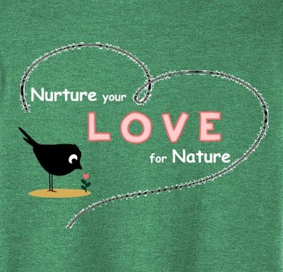
THANK
YOU !

