
八思量简版软件
SeaThinking Simplified Version Software
(DBK2JJ-A1)
用户使用手册
User’s Manual

长沙八思量信息技术有限公司
Changsha BSL Info. Tech. Co., Ltd.

目 录
Catalog
1. 概述Overview 1
1.1. 八思量简版软件简介 1
1.1. A Brief Introduction to the SeaThinking Simplified Version Software 1
1.1.1. 软件简介 Software Introduction 1
1.1.2. Software Function 2
1.1.3. Interface Introduction 4
1.2. About 八思量简版 User’s Manual 5
About SeaThinking Simplified Version User’s Manual 5
1.2.1. Contents Arrangement 5
1.2.2. Other declarations 5
1.3. Instructions of Software Installation 6
2. File Menu 7
2.1.New(N) 8
2.2.Open(O) 8
2.3.Save(S) Save As(A) 10
2.4.Print 11
2.5. Get scanned image (m) 12
2.6.System configs (P) 12
2.6.1. Conventional 14
2.6.2.c 15
2.6.3. working area 17
2.6.4. 自定义快捷键 Custom Keyboard Shortcuts 19
2.6.5. Auto Save 22
2.6.5.Move-Rotate 24
2.6.6.User Management 25
2.6.7.Language 27
2.7.Common Graph Library (此功能已取消) 28
2.8.Recent File List 30
2.9.Exit (X) 31
2.10.Object List window 31
2.11.Object Properties Window 32
3. Edit Menu 36
3.1.Undo (U)/ Recovery (R) 37
3.2.Cut (T), Copy (C) and Paste (P) 37
3.3.Combination/ Separation Combination 38
3.4.Group/ Separation Group 38
3.5. Turn to curve 39
3.6. Turn To a Dashed Line 39
3.7.Offset 39
3.8. Separate text 40
3.8.Ungroup Text 40
3.9 Filling 40
4. Draw Menu 50
4.1. Point (P) 51
4.2. Line (L) 52
4.3. Curve (S) 52
4.4. Rectangle(R) 53
4.5. Circle (C) 54
4.6. Ellipse (E) 56
4.7. Polygon (M) 57
4.8. Text (F) 58
4.8.1. Font Parameters 61
4.8.2. Barcode Font Parameters 66
4.8.3. Variable Text 75
4.9. Draw Picture file 97
4.9.1. Input Bitmap 97
4.9.2. Reversal 99
4.9.3. GrayScal 99
4.9.4. Fixed DPI 99
4.9.5. Outlets 100
4.9.6. Two-way scanning 100
4.9.7. Dotting Time 100
4.9.8. Dot Power Mapping 100
4.9.9. Expand Parameter 101
4.10. Draw Vector File 103
4.11. Draw delay 104
4.12. Draw Input Port 104
4.13. Draw Output Port 105
4.14. Encoder moving distance 106
4.15. Encoder Movement Distance 107
4.16. Helical Line 108
4.17. Graphics picking 109
5. Modify Menu 112
5.1. Array 113
5.2. Transformation 116
5.2.1. Move 117
5.2.2. Rotate 117
5.2.3. Mirror 119
5.2.4. Zoom 121
5.2.5. Tilt 122
5.3. Modeling 123
5.4. prune 124
5.5. Remove intersections 124
5.6. Auto-Connect 125
5.7. Sorting 126
5.8. alignment 126
6. View Menu 128
6.1. Zoom Toolbar 129
6.2. Display ruler /display grid /display guide line 130
6.3. Capture Grid 130
6.4. Capture Guide Line 130
6.5. Capture Objects 130
6.6. System Menu Bar/Toolbar/Status Bar/Interface Window Bar 130
6.7. IO State 130
6.8. Path preview 131
7. Special 132
7.1. Change Text 132
7.2. Serial number text 133
8. Laser 134
8.1. Rotate and Move test（Lite version does not support this feature） 135
8.2. Rotation Angle Marking（Lite version does not support this feature） 139
8.2.1Interface description 139
8.2.2Functional operation 142
8.3. Expansion Axis Marking（Lite version does not support this feature） 142
8.4. Rotate Text Mark（Lite version does not support this feature） 144
8.5 Multi-File Mark 145
8.5.1. File Manage 147
8.5.2. function Option 148
9. Mark parametr 149
9.1. 笔参数管理Pen Parameter Management 149
9.2. Region parameter 157
9.2.1. Configuration Config[default] 157
9.1.3.Mark 172
10. Scanhead Calibration 175
10.1.Direction adjustment 175
10.2. Manual Correction 178
10.2.1.Shape adjustment 181
10.2.2.Zoom 181
10.2.3.等分比例法 Equal Scale Method 182
10.2.4.Save 187
10.3. 九点校正 Nine Point Correction 187
10.3.1开始校正 Start Correction 190
振镜校正 Galvanometer Correction 191
10.3.2标刻校正图形 Marking Correction Graphs 192
10.3.3使用校正文件 Use Correction File 197
10.3.4均匀度校正与高精度调校Uniformity Correction and High Precision Adjustment 200
11. Help 204
11.1. About SEACAD 204
11.2. 重置工作区布局Reset Workspace Layout 204
11.3. 板卡注册 Board Registration 204
11.4. Help documentation 206

概述Overview

八思量简版软件简介

A Brief Introduction to the SeaThinking Simplified Version Software

软件简介 Software Introduction
八思量简版software supports Unicode and can run in several operating systems of the Microsoft Windows series, including Windows 7, Windows 8 and Windows 10. All the following descriptions in this manual are applicable to the currently predominant Microsoft Windows 7 operating system by default.
SeaThinking Simplified software can run on a variety of Microsoft Windows operating system platforms, including Windows 7, Windows 8 and Windows 10. All the following descriptions in this manual are applicable to the currently predominant Microsoft Windows 7 operating system by default.
八思量简版software is an simplified version of SeaCAD 5.X，主要精简了一下不常用的高级功能，增强了软件的稳定性。
SeaThinking simplified version software is an simplified version of SeaCAD 5.X, which mainly simplifies the advanced functions that are not commonly used, and enhances the stability of the software.

八思量简版软件is installed in a green way: extract the installation package into any directory in the hard disk, and then double click the SeaCAD.exe under the directory to run the software. See the following figure.
SeaThinking simplified version software is installed in a green way: extract the installation package into any directory in the hard disk, and then double click the SeaCAD.exe under the directory to run the software. When the software starts, it will automatically detect the marking card device， See the following figure.

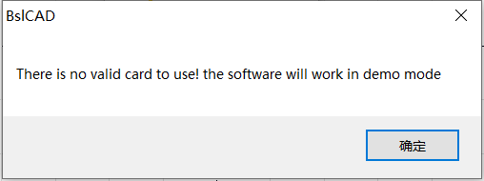
未检测到激光器控制卡，请检查设备与电脑连接线，并让设备重新上电
No laser control board detected. Please check the connection line between the device and the computer and power on the device again

未检测到板卡
No board detected card

长沙八思量信息技术有限公司 http://www.basiliang.com
Changsha SeaThinking Info. Tech. Co., Ltd. http://www.basiliang.com
Fig.1-1 Software Initial

Software Function
Software has the following main functions：
● User can Design their graphics freely pattern .
● Supports multiple document editing, multiple documents, multiple cards, and multiple laser types marking simultaneously.
- Supporting all the fiber lasers, CO² lasers and end-pumped lasers in the market. The parameters, such as the electric current, impulse frequency and duty ratio, can be set and adjusted through the software according to different laser types.
- Support separate red light marking indication.
- Software the Providing use jurisdiction control to prevent the parameters from being modified at random.
- Provide basic IO control function: through port control,enabling your machine easily implementation automation control。
- Provides manual correction, and nine point correction methods to obtain extremely accurate 2D marking effect.
- Provide extended axis function：supporting extended axis to rotate according to the angle，such as rotary marking.
- Support filling operation: provide line and ring filling, can be filled at any angle, cross filling, margin, border, spacing and other adjustable. Support up to four layers of filling combination, each layer can set parameters independently

- Providing the variable text function: fixed text, serial number, date of , time, TCP/IP communication, serial Interface communication, SQL database, etc.
- Supporting 256-layer marking parameters: supporting the parameters of each layer to be set randomly to easily realize multi-parameter marking.
- Supporting image files such as PLT, DXF, BMP, JPG and JPEG.
- Supporting the common 1D/2D barcodes, such as Code39, EAN, PDF417 and DM.
- Provide text input function, support True Type fonts, single line fonts, bar code fonts, and Autonomy add (dot matrix fonts, etc.) fonts.
- Supporting the dynamic file marking. When the text and graphs are marked, the filename is fixed, but the file content will be changed.
- Providing powerful editing function: supporting the arc arrangement of characters, any graph drawing/editing, uncombining/combining, grouping/ungrouping, undoing/redoing, plastic, etc.
- Providing the simulation function: You can preview the marking trajectory of the graph before marking operation
- Supporting secondary development: providing the SDK secondary development library, supporting the user to customize the development, expanding the functions of the existing marking system and meeting the user’s requirements in special applications.
- 提供多达12种的语言支持，满足大部分需求
- Providing up to 12 kinds of language support to meet most needs

Interface Introduction
- Starting initial interface
Starting to run the program, startup interface (Figure 1-2) is displayed, and the program initializes in the background.
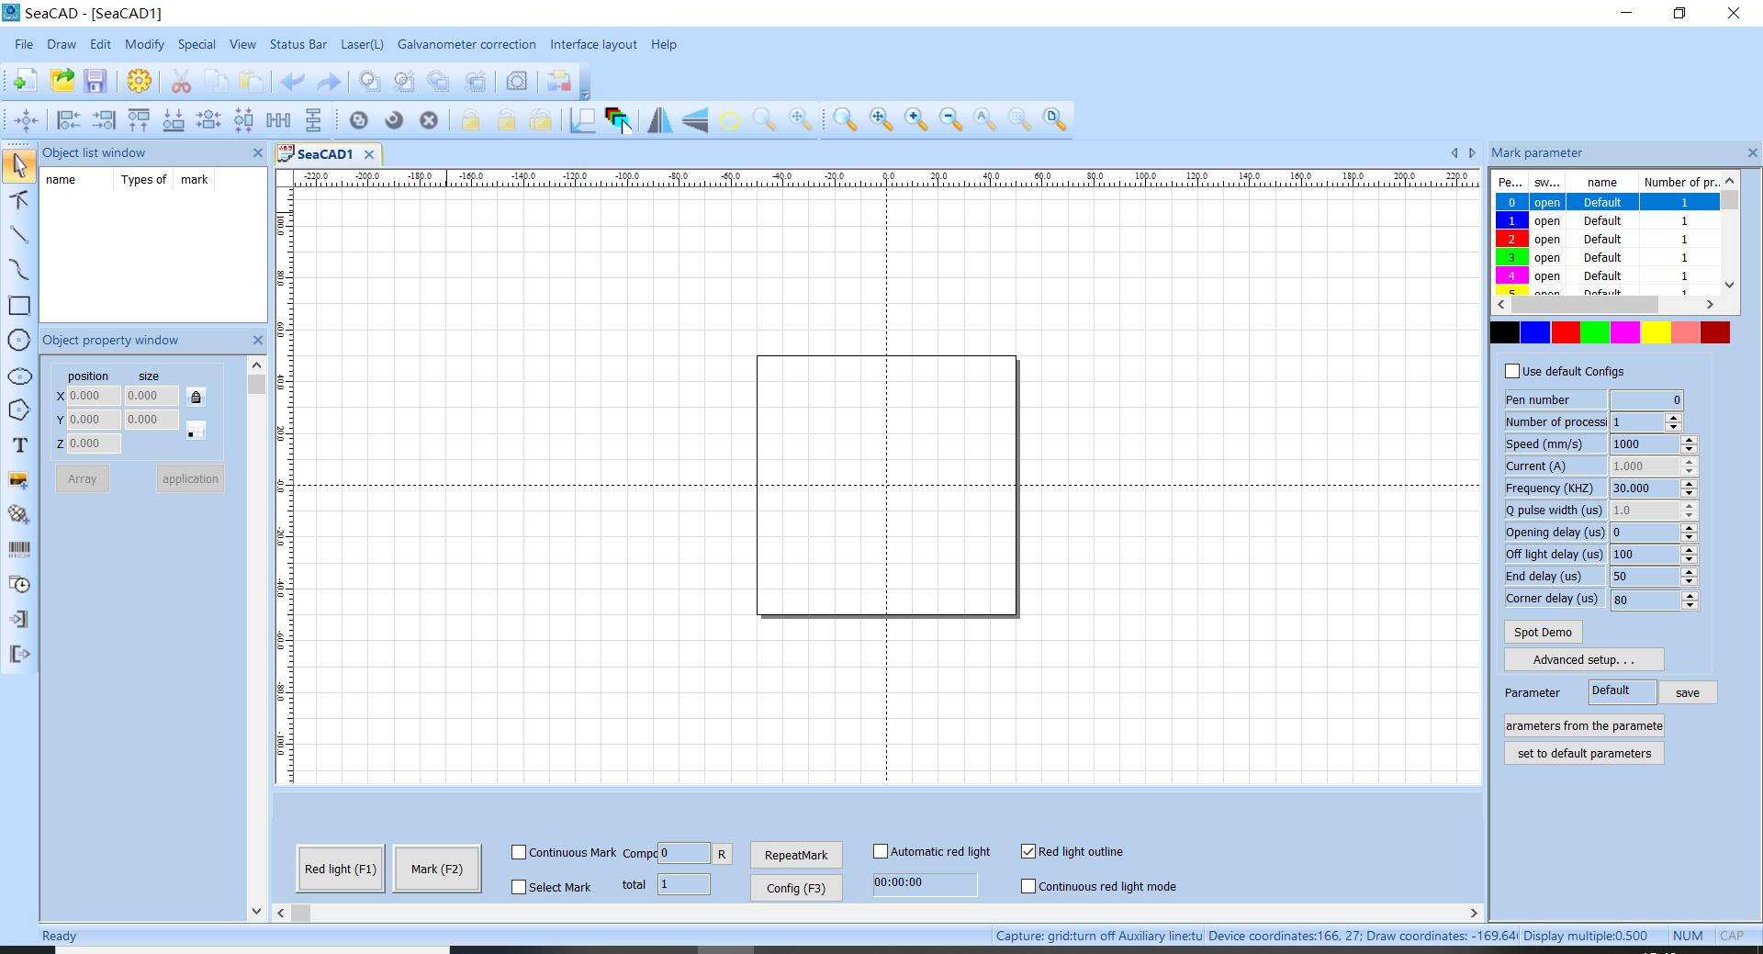
Fig.1-2 Program Starting Interface
- Main interface
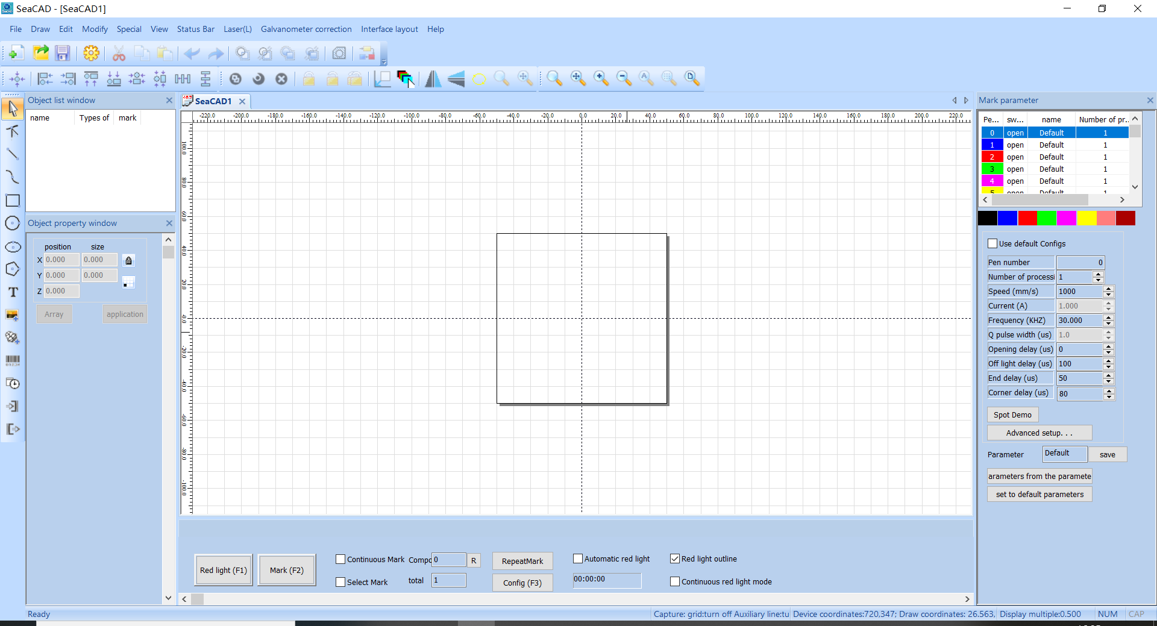
Fig.1-3 Main Program Interface

About 八思量简版 User’s Manual

About SeaThinking Simplified Version User’s Manual

Contents Arrangement
This manual will introduce the usage of 八思量简版软件 according to the order of the menu bar in the main interface, It includes ten main menus, including file, draw, edit, modify, special, status bar, laser, view, galvanometer correction, help, object bar and marking control bar.
This manual will introduce the usage of SeaThinking simplified version software according to the order of the menu bar in the main interface, It includes ten main menus, including file, draw, edit, modify, special, status bar, laser, view, galvanometer galvo, help, object bar and marking control bar.

Other declarations
- Due to the actual operation mode and function settings caused by software upgrade, the contents of this manual may not be updated in time. In case of any inconsistency with this manual, the software shall prevail.
- Other product and company names mentioned herein may be the trademarks of their respective owners.

Instructions of Software Installation
- This software is green software and can run immediately after extracted.
- When the software starts and the reminder of “xxxx.dlll cannot be found” appears, carry out vcredist_x86_2010.exe to install the system patch.

2. File Menu
The File Menu is used for common file operations, such as “New”, “Open” and “Save”, as well as functions like system parameter setting and common graph library maintenance. See Fig. 2-1.
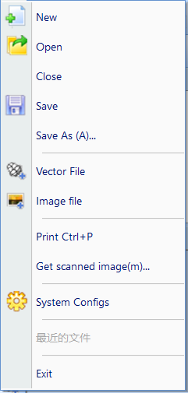
新建 New
打开 Open
关闭 Close
保存 Save
另存为(A)... Save As (A)...
矢量文件 Vector File
图片文件 Image File
打印Ctrl + P Print Ctrl + P
获取扫描图象（m）... Get Scan Image (m)...
系统参数 System Parameter

Fig. 2-1 “File” Menu

2.1.New(N)
“New” Submenu is used for creating a blank workspace to construct objects, and its shortcut key is “Ctrl+ N”.
“New” Submenu corresponding toolbar Icon for . Clicking on this icon will achieve the same operation.

When you move the mouse pointer to the toolbar to create a new icon and pause a little, the system will display a prompt message to briefly explain the function of the icon, and the status bar below the main interface window will display a slightly detailed explanation of the function. If you move the mouse pointer over the new submenu in the menu bar, only a detailed explanation will appear in the status bar, and the prompt will not appear.
[Reminder: in the八思量简版software, each icon in the Toolbar has a function of showing brief prompt information and the Status Bar has a function of displaying detailed explanations. Also, each icon has a corresponding menu item, and both the two ways carry out the same function. The User’s Manual will not mention it again in the following chapters.]
[Reminder Tips: in the SeaThinking simplified version software, each icon in the Toolbar has a function of showing brief prompt information and the Status Bar has a function of displaying detailed explanations. Also, each icon has a corresponding menu item, and both the two ways carry out the same function. The User’s Manual will not mention it again in the following chapters.]

2.2.Open(O)
“Open” Submenu Used to open an .orz file saved on your hard disk, Its shortcut key is Ctrl + O. When the open submenu is selected, system A dialog box will appear to open the file (Fig. 2-2). Ask you to select the file you want to open. When you select a valid .orz file, A preview graphic of the file is displayed below the dialog box.
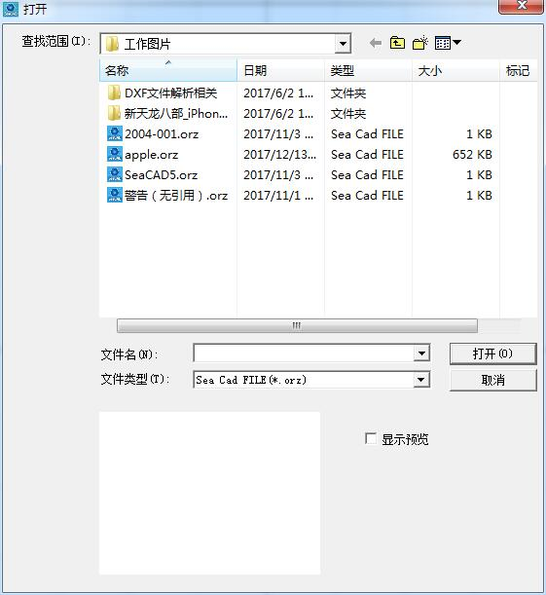
Fig. 2-2 “Open” Dialog Box
Toolbar icon for the open submenu is .
打开 Open
查找范围（I）：Look in (I):
工作图片 Work Images
名称 Name
日期 Date
类型 Type
大小 Size
标记 Marking
警告（无引用）.orz Warning (No Reference).orz
打开 Open
取消 Cancel
显示预览 Display Preview

2.3.Save(S) Save As(A)
The save submenu saves the drawing with the current file name, and the save as submenu saves the drawing with another file name. Both realize the function of saving files.
If the current file already has a file name, the Save command saves the currently drawn drawing with that file name. Otherwise, the save file dialog box will pop up, asking you to choose the path to save the file and provide the file name. No matter whether the current file has a file name or not, the save as command will pop up the Save As dialog box (Figure 2-3), asking you to provide a new file name for saving to avoid the old file being overwritten.
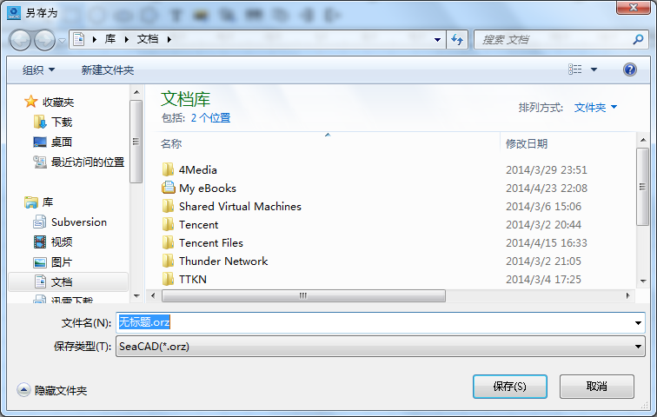
Fig. 2-3 “Save As” Dialog Box
The icon of “Save” in the Toolbar is .
另存为 Save As
库 Library
文档 Documents
收藏夹 Favorites
下载 Downloads
桌面 Desktop
最近访问的位置 Last Visited Location
库 Library
视频 Videos
图片 Images
文档 Documents
文档库 Document Libraries
包括：2个位置 Including: 2 Positions
排列方式：文件夹 Arrangement: Folders
名称 Name
修改日期 Modified Date
文件名（N）：无标题.orz File Name (N): Untitled.orz
保存类型（T）: Save Type (T):
隐藏文件夹 Hide Folders
保存 Save
取消 Cancel

2.4.Print
Print is used to print current image and its shortcut key is “Ctrl+ P”.
The shortcut key for printing is Ctrl + P, which is used to print the current drawing.

2.5. Get scanned image (m)
‘Obtain Scan Image’ submenuis used to get images from specific external devices. Selecting this command will bring up the dialog box shown in Figure 2-4. Requires the selection of an external device (the listed devices are legitimate drivers already installed on your computer). When an external device is selected, the corresponding device image processing dialog box appears. You can select the corresponding image input. (The dialog box varies depending on the device. Please refer to the corresponding device operating instructions.)
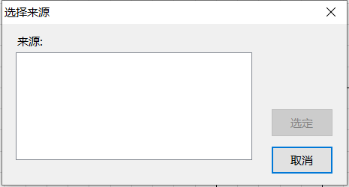
Fig.2-4 Get scanned image

选择来源 Select Source
来源： Source:
选定 Selected
取消 Cancel

2.6.System configs (P)
“System configs” submenu is used to set the system parameters. Select "system parameters" menu and a dialog box as shown in Figure 2-5 will pop up. In this dialog box, you can set general parameters of software, displayed color, parameters related to working range, user management and other parameters.
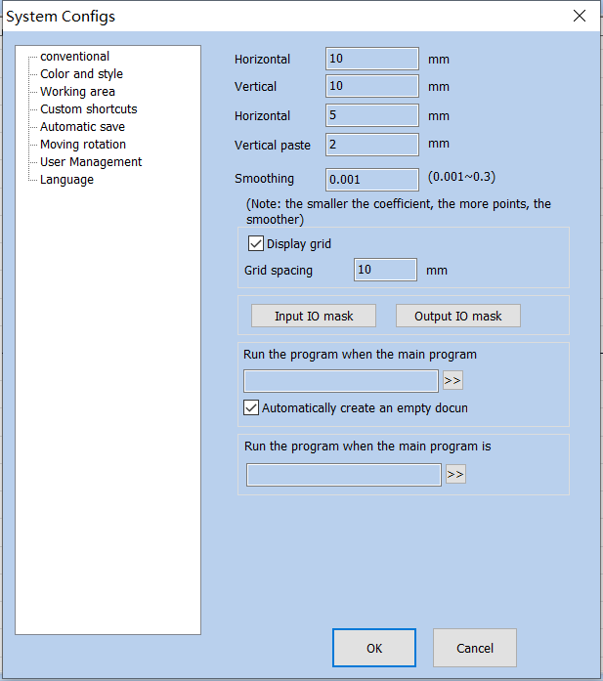
Fig. 2-5 “System configs” Window
The icon of ” System configs” in the Toolbar is .
系统参数 System configs
常规 General
颜色与样式 Color and Style
工作区间 Workspace
自定义快捷键 Custom Keyboard Shortcuts
自动保存 Auto Save
移动旋转 Move-Rotate
用户管理 User Administration
语言 Language
水平对齐间距 Horizontal Alignment Spacing
垂直对齐间距 Vertical Alignment Spacing
水平粘贴偏移 Horizontal Paste Offset
垂直粘贴偏移 Vertical Paste Offset
平滑系数 Smoothing Coefficient
（注：系数越小，点越多，越平滑）
(Note: The smaller the coefficient, the more points, the smoother)
显示网格 Display Grid
网格间距 Grid Spacing
输入IO掩码 Input IO Mask
输出IO掩码 Output IO Mask
当主程序启动时，运行程序 Run the program when the main program starts
程序启动时自动创建一个空文档
Create an empty document automatically when the program starts
当主程序关闭时，运行程序
Run the program when the main program is closed

多卡标刻自动退出窗口 Multi-card marking exits the window automatically
最大设备数 Maximum Number of Devices
确定 OK
关闭 Close

2.6.1. Conventional
In Conventional, mainly set some general parameters
Horizontal paste / vertical paste offset: specifies the offset of the, newly generated object (be pasted object) relative to its original position when you use the copy / paste function. As shown in Figure 2-6:
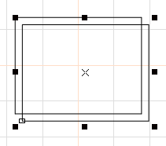
Fig. 2-6 Original Graph and Copied and Pasted Graph
“Smoothing Parameter”: controls the smoothness of the vector diagram generated by the software.
“Grid”: shows or hides the grid.
“Grid spacing ”： Distance between gridlines

“Execute when SeaCAD Starts，Run SeaCAD program”/“Execute when SeaCAD Finish，Execute when SeaCAD Starts，Run SeaCAD program”: start the executable programs provided by the third party to realize some relevant operations.
Open a new file when SeaCAD Starts：a new file named "SeaCAD1" is automatically created after the software is opened.
“Input IO Mask”: sets the input port supported by the current software.
“Output IO Mask”: sets the output port supported by the current software.

2.6.2.c
“Color” is used for setting the color of background, workspace, centerline and grid, etc. Double clicking the color stripe could change the corresponding color. See Fig. 2-7.
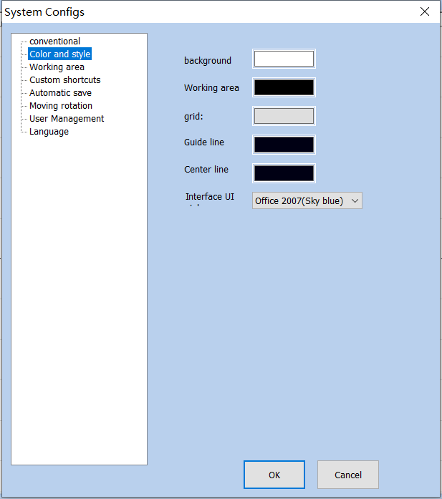
Fig. 2-7 Color Setting

系统参数 System Parameters
常规 Conventional
颜色与样式 Color and Style
工作区间 Workspace
自定义快捷键 Custom Keyboard Shortcuts
自动保存 Auto Save
移动旋转 Move-Rotate
用户管理 User Administration
语言 Language
背景Background
网格： Grid:
辅助线 auxiliary Line
中心线 Center Line
界面UI样式 cc
确定 OK
关闭 Close

2.6.3. working area
“ working area” is used for setting various parameters in the operating area, enabling the user to customize them based on his habits. See Fig. 2-8.
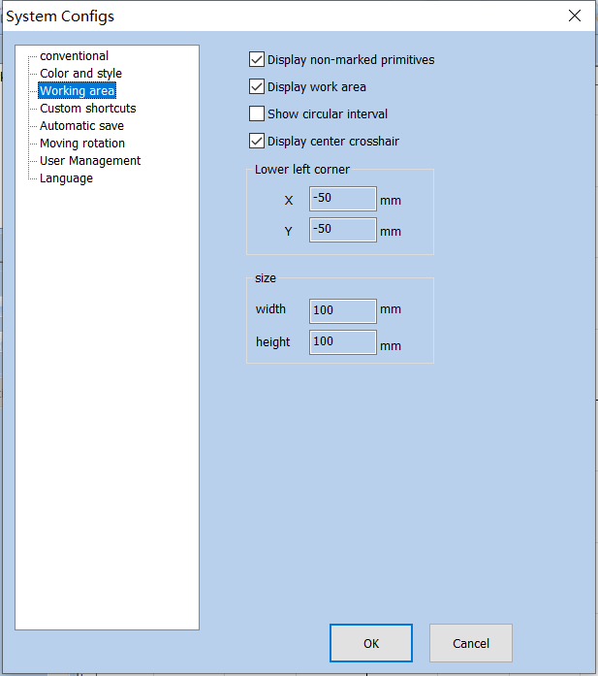
Fig. 2-8 working area Setting

系统参数 System Parameters
常规 General
颜色与样式 Color and Style
工作区间 Workspace
自定义快捷键 Custom Keyboard Shortcuts
自动保存 Auto Save
移动旋转 Move-Rotate
用户管理 User Administration
语言 Language
显示非标刻图元 Display Non-marking Metafile
显示工作区间 Display Workspace
显示圆形区间 Display Circular Interval
显示中心十字线 Display Center Cross Line
左下角 Lower Left Corner
X -50 毫米 X -50mm
Y -50 毫米 Y -50mm
尺寸 Size
宽度 100毫米 Width 100mm
高度 100毫米 Height 100mm
确定 OK
关闭 Close

图

2.6.4. 自定义快捷键 Custom Keyboard Shortcuts
用于设置软件各项功能所对应的快捷按键。
It is used to set the shortcut keys corresponding to various functions of the software.
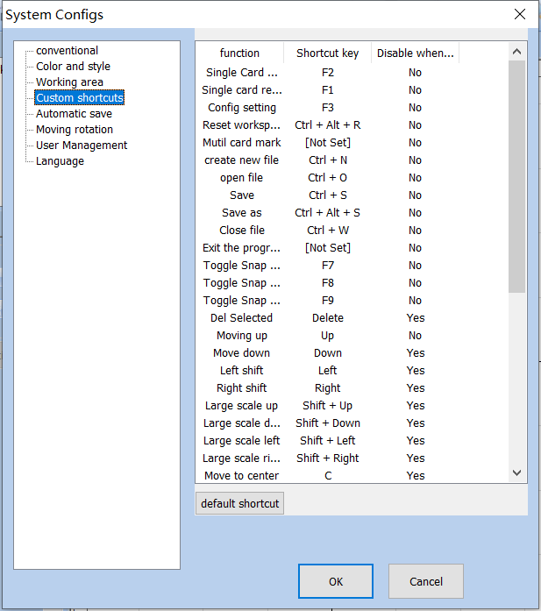
2-9 自定义快捷键Custom Keyboard Shortcuts

系统参数 System Parameters
常规 General
颜色与样式 Color and Style
工作区间 Workspace
自定义快捷键 Custom Keyboard Shortcuts
自动保存 Auto Save
移动旋转 Move-Rotate
用户管理 User Administration
语言 Language

功能  Functions | 快捷键  Keyboard Shortcuts | 编辑文本时禁用  Disable When Editing Text
单卡标刻  Single Card Marking | F2 | No
单卡红光  Single Card Red Light | F1 | No
参数设置  Parameter Settings | F3 | No
重置工作区布局  Reset Workspace Layout | Ctrl + Alt + R | No
多卡标刻  Multi-card Marking | [Not Set] | No
新建文件  New File | Ctrl + N | No
打开文件  Open File | Ctrl + O | No
保存文件  Save File | Ctrl + S | No
文件另存为  Save File As | Ctrl + Alt + S | No
关闭文件  Close File | Ctrl + W | No
退出程序  Exit Program | [Not Set] | No
开关捕捉网络  Toggle Snap Network | F7 | No
开关捕捉辅助线  Toggle Snap Guide Line | F8 | No
开关捕捉对象  Toggle Snap Object | F9 | No
删除选中图元  Delete Selected Metafile | Delete | Yes
图元上移  Metafile Move Up | Up | No
图元下移  Metafile Move Down | Down | Yes
图元左移  Metafile Move Left | Left | Yes
图元右移  Metafile Move Right | Right | Yes
图元大比例上移  Metafile Move Up in Large Scale | Shift + Up | Yes
图元大比例下移  Metafile Move Down in Large Scale | Shift + Down | Yes
图元大比例左移  Metafile Move Left in Large Scale | Shift + Left | Yes
图元大比例右移  Metafile Move Right in Large Scale | Shift + Right | Yes
使用默认配置 Use Default Settings
确定 OK
关闭 Close

2.6.5. Auto Save
“Auto Save” is used for setting the interval time between two automatic saves, so as to efficiently prevent missing file in case of any emergency (such as power failure or dead halt). According to the set interval time, the current data is saved in the file named “autosave.orz’ in SeaCad’s directory. See Fig. 2-9.
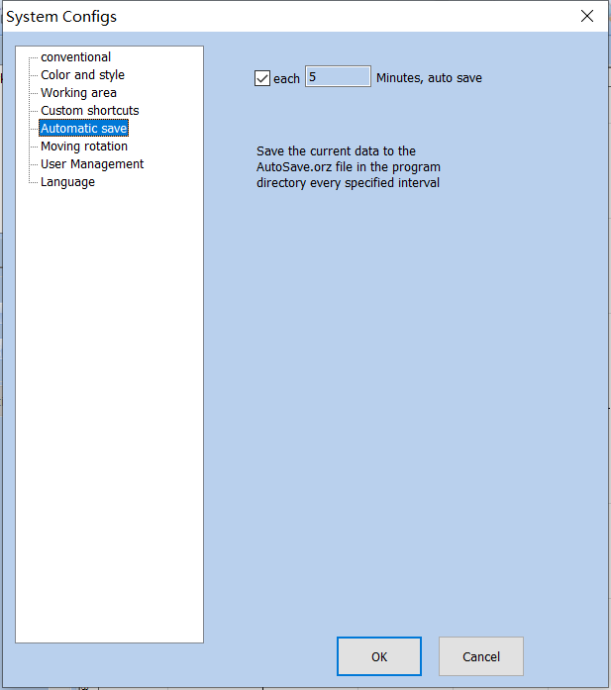
Fig. 2-10 Auto Save Setting

系统参数 System Parameters
常规 General
颜色与样式 Color and Style
工作区间 Workspace
自定义快捷键 Custom Keyboard Shortcuts
自动保存 Auto Save
移动旋转 Move-Rotate
用户管理 User Administration
语言 Language
每5分钟自动保存 Auto Save Every 5 Minutes
每过指定时间间隔将当前数据保存到程序目录下的AutoSave.orz文件中
Save the current data to the AutoSave.orz file in the program directory every specified time interval

2.6.5.Move-Rotate
fine adjustment： refers to the distance that the selected object moves each time when the direction key is pressed, if the direction keys of the keyboard are used for moving the graphs.
Large adjustment: If the distance to be adjusted is long, synchronously pressing direction keys and “shift” key will enable the selected object to move for a distance of Nudge Distance* Large adjustment.
Rotate Angle: refers to the angle the object rotates each time when direction keys and “ctrl” key are pressed together.
Homing method: determines which point of the object should be put on the origin when the “Put to Origin” function is used. SeaThinking simplified version software divides each graph into 9 position points (0-8). “Object’s Origin” can be set by positioning the graph accurately at the user’s will. Fig. 2-9 shows the origin setting based on Position 1. After the graph is drawn in the workspace of the software, click (Put to center) button:
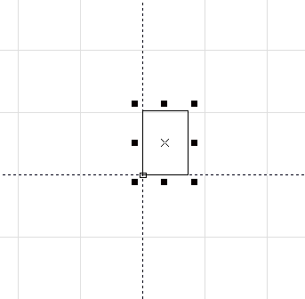
Fig. 2-11 Example of “Homing method”

2.6.6.User Management
- It is used for setting whether the user password shall be input to use the current software, as shown in Fig. 2-11.
When “Enter the Password before Using” is selected, the system is configured with one administrator, one designer and one Draftsman by default, but the user can add operators.
管理者拥有能够使用软件所有功能的权限，切不可以更改权限。
The administrator has the permission to use all functions of the software, and must not change the permission.
其他使用者的权限都可以自行设置。
The permissions of other users can be set by themselves.
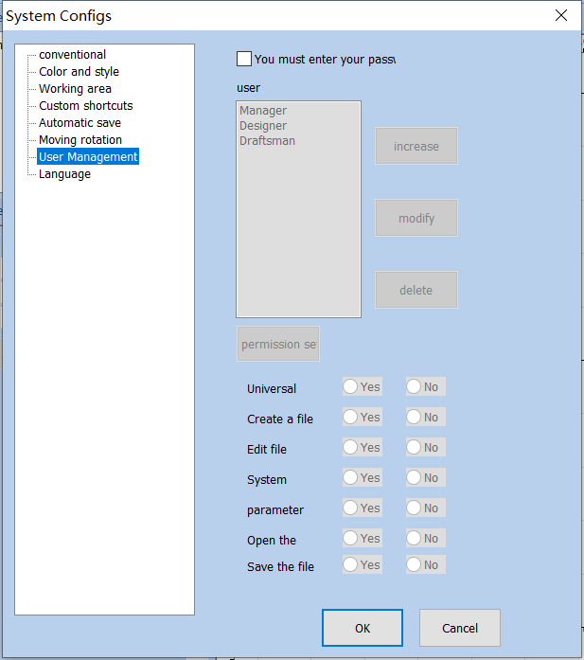
Fig. 2-12 User Management

系统参数 System Parameters
常规 General
颜色与样式 Color and Style
工作区间 Workspace
自定义快捷键 Custom Keyboard Shortcuts
自动保存 Auto Save
移动旋转 Move-Rotate
用户管理 User Administration
语言 Language
使用软件必须输入密码 You must enter the password when you use the software
用户 User
管理者 Administrator
设计者 Designer
增加 Add
修改 Modify
删除 Delete
保存权限设置 Save Permission Settings
通用加工  General Processing | 是  Yes | 否  No
创建文件  Create File | 是  Yes | 否  No
编辑文件  Edit File | 是  Yes | 否  No
系统设置  System Settings | 是  Yes | 否  No
参数设置  Parameter Settings | 是  Yes | 否  No
打开文件  Open File | 是  Yes | 否  No
保存文件  Save File | 是  Yes | 否  No
确定 OK
关闭 Close

2.6.7.Language
- It shows the language package installed in your computer. You can use it to change the language used in the interface of SeaThinking simplified version software. The change will not take effect until the software is restarted next time. It has Chinese simplified, Chinese traditional, English, Korean and other 11 language packages by default.

2.7.Common Graph Library (此功能已取消)
This function can import the graphs frequently used to the common graph library for use at any moment. The specific procedures are as follows:
1. Save the graph library file
First of all, draw or import drawings in your workspace that you want to store in a common library, select that graph, open the “File”/“Common Graph Library” dialog box, then click “New Graph Library” to enter the name of the new graph library in the “New Graph Library” dialog box, and click “OK”. as shown in Fig. 2-13:
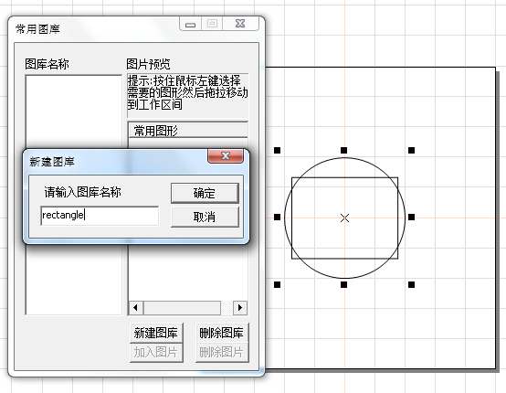
图2-13 “常用图库”对话框
Figure 2-13 “Common Graph Library” Dialog Box

常用图库 Common Graph Library
图库名称 Graph Library Name
图片预览 Image Preview
提示：按住鼠标左键选择需要的图形然后拖拉移动到工作区间
Tip: Hold down the left mouse button to select the desired graphs and drag them to move to the workspace
常用图形 Common Graphs
新建图库 New Graph Library
请输入图库名称 Please Enter the Library Name
确定 OK
取消 Cancel
新建图库 New Graph Library
删除图库 Delete Graph Library
加入图片 Add Image
删除图片 Delete Image
When the graph library is created, add the graph to be saved. Select the graph in the workspace, click “Add Graph” to enter the graph name, and click “OK” to save the graph selected in the work pace in the “Common Graph Library”.

2. Copy the graph from the graph library
If the graph in the graph library is to be copied, open the common graph library and drag the graph to be used to the workspace by pressing the left mouse button.as shown in Fig. 2-14:
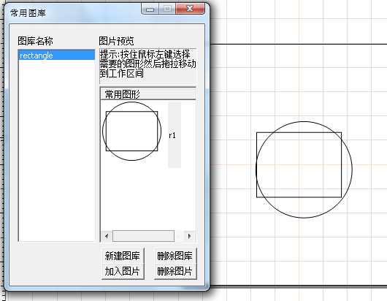
Fig.2-14 Copy the graph from the graph library
常用图库 Common Graph Library
图库名称 Graph Library Name
图片预览 Image Preview
提示：按住鼠标左键选择需要的图形然后拖拉移动到工作区间
Tip: Hold down the left mouse button to select the desired graphs and drag them to move to the workspace
常用图形 Common Graphs
新建图库 New Graph Library
确定 OK
取消 Cancel
新建图库 New Graph Library
删除图库 Delete Graph Library
加入图片 Insert Image
删除图片 Delete Image

2.8.Recent File List
Below “System Parameter”, a list is displayed to show the files recently opened by the user. If the user has never opened/saved any “.orz” file, such a list will not appear.

2.9.Exit (X)
It is used for exiting the 八思量简版 software. If any file is not saved, the system will ask you whether to save it.
It is used for exiting the SeaThinking simplified version software. If any file is not saved, the system will ask you whether to save it.

2.10.Object List window
Object List is in the left side of the main interface of 八思量简版 software, as shown in Fig. 2-14:
Object List is in the left side of the main interface of SeaThinking simplified version software, as shown in Fig. 2-14:
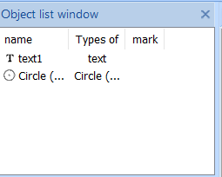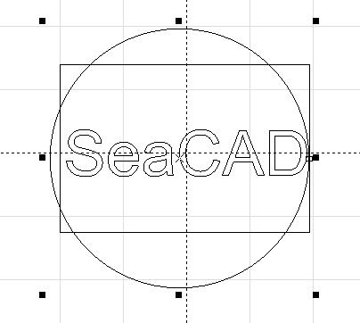
Fig. 2-14 Object List
对象列表窗 Object List Window
名称Name | 类型Type | 标记Marking
矩形1 Rectangle 1 | 矩形Rectangle
文本1 Text 1 | 文本Text
圆（弧）1 Circular (Arc) 1 | 圆（弧）Circular (Arc)
Note: during marking, the system will follow the order in the object list (from top to bottom) to mark the listed objects（3D图元除外）。
Note: during marking, the system will follow the order in the object list (from top to bottom) to mark the listed objects. (Except for 3D metafiles).
The user can rearrange the list by directly dragging the object or through the right key.
The user can double click the object name to rename it.

2.11.Object Properties Window
Object Properties Window is displayed in the left side of the main interface of the software, as shown in Fig. 2-15.
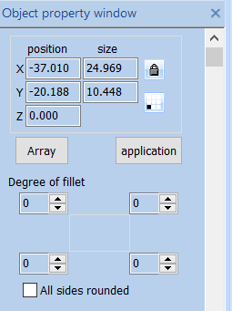
Fig. 2-15 Object Properties Window

对象属性框 Object Property Box
位置 Location
尺寸 Size
阵列 Array
应用 Apply
圆角程度 Fillet Degree
所有边圆角 All Edge Fillet
X Position: Represents the X coordinate of the currently selected object，This coordinate can be specified as the coordinate of the lower left corner of the object，You can also specify coordinates for the center of an object，Through coordinate information button，To set the specific meaning of position coordinates.
Y Position: Represents the Y coordinate of the currently selected object，This coordinate can be specified as the coordinate of the lower left corner of the object，You can also specify coordinates for the center of an object，Through coordinate information button，To set the specific meaning of position coordinates.
Z Position: Said that the current the Z coordinate of the selected object.
X Size: Said that the current the width of the selected object.
Y Size: Said that the current the height of the selected object.
: locks the current length/width ratio of the selected object. If the user changes X and Y Sizes, the system will keep the length/width ratio of the new size unchanged.
Coordinate information Button: specified whether X position and Y position correspond to the coordinates of the left bottom corner or center of the object or other given positions. When the user clicks this button, a dialog box will appear to ask the user to select the position corresponding to the coordinate. The coordinate data displayed currently indicate that X Position and Y Position correspond to the coordinates of the object’s left bottom corner.
Array ：Copy the current object to the specified location, and the operation dialog box is as shown in Figure 2-16:
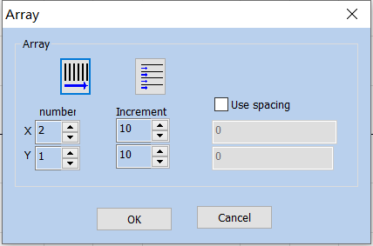
Fig. 2-16 Array Operation Dialog Box

阵列 Array
阵列Array
数目 Quantity
增量 Increment
使用间距方式 Use Spacing Method
确定 OK
关闭 Close

Increment: Refers to the user specified row spacing and column spacing.
Figure 2-17 is the Array Number， X=3、Y=2 object situation
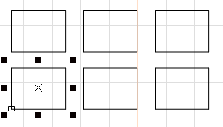
Fig. 2-17 Array Operation Result
: Indicates the array direction is horizontal priority
: Indicates that the array is unidirectional.
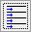: Indicates that the array is a two-way array.

3. Edit Menu
The “Edit” menu carries out the editing operation of a graph, as shown in Fig. 3-1.
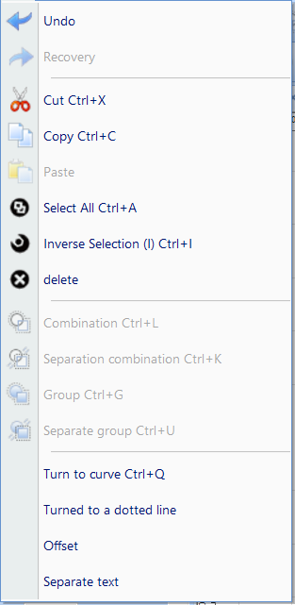
Fig. 3-1 “Edit” Menu

编辑 Edit
绘制 Draw
修改 Modify
查看 View
撤销 Undo
恢复 Redo
剪切 Cut
复制 Copy
粘贴 Paste
全选（A） Select All (A)
反选 Select Invert
删除 Delete
组合 Combine
分离组合 Uncombine
群组 Group
分离群组 Ungroup
转为曲线 To Curve
转为虚线 To Dashed Line
偏移 Offset
分离文本 Ungroup Text

3.1.Undo (U)/ Recovery (R)
During graph editing, if the current operation is not satisfying, “Undo” can be used for undoing current operation and bring the previous operation back; after the current operation is undone, “Redo” can be used for redoing the undone operation. This is one of functions most frequently used in editing.
The icon of the “Undo” menu in the Toolbar is , while the icon of the “Recovery” menu in the Toolbar is . Similar to most software, those two operations have their corresponding shortcut keys, i.e. Ctrl+Z and Ctrl+Y respectively.

3.2.Cut (T), Copy (C) and Paste (P)
“Cut” will delete the selected graph and copy it to the clipboard of the system. Then “Paste” will copy the graph in the clipboard to the current graph. “Copy” will copy the selected graph to the system clipboard and keep the original graph.
The shortcut keys of “Cut”, “Copy” and “Paste” are Ctrl+X, Ctrl+C and Ctrl+V respectively.
The position of the pasted figure and the position deviation from the original figure are determined by the paste displacement in the conventional parameters of the system parameters

3.3.Combination/ Separation Combination

“ Combination” will ignore all the selected objects’ original properties and combine those objects into a new curve object. This combined graph, like other graphs, can be selected, copied, pasted and its properties can be set. For example, when the original graph is a circular or a rectangular, but the graph after “ Combination” operation is dealt with as a curve and will be transformed into a curve after “Separation Combination” operation.
“Separation Combination” Restore combination objects to individual curve objects
“Combination” The toolbar icon corresponding to the menu is,“Separation Combination” The toolbar icon corresponding to the menu is. Their shortcut keys are Ctrl+L and Ctrl+K respectively.

3.4.Group/ Separation Group
“Group” will keep the selected objects’ original properties and make them into a new object, and this new graph, like other graphs, can be selected, copied and pasted, and its properties can be set.
For example, the original graph is circular or rectangular, but the graph after “Group” operation will be dealt with according to the original properties and it will be restored to the original graph, with properties unchanged, after “Separation Group” operation.
“Separation Group” Restore the objects of the group to the state before the collection.
The icon of “Group” in the Toolbar is , while that of “ Separation Group” is. Their shortcut keys are Ctrl+G and Ctrl+U respectively.

3.5. Turn to curve
Remove the attributes of the selected graphic object and turn it into a curve object.

3.6. Turn To a Dashed Line
This function is to transform the vector graph to a dashed graph for marking, as shown in Fig. 3-2:
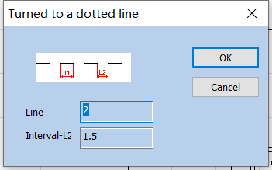
Fig. 3-2 “Turn to a Dashed Line”
The user has to set the length of the short line and the space between lines, and then click “OK” to transform the vector graph into a dashed one.
转为虚线 To Dashed Line
确定 OK
取消 Cancel
线长 Line Length
间隔 Interval

3.7.Offset
点击偏移后会在对象列表窗上面多出一条操作条。
After clicking the offset, an additional operation bar will appear on the top of the object list window.
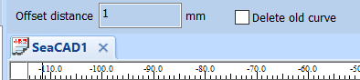
偏移距离 1毫米 Offset Distance 1 mm
删除旧曲线 Delete Old Curve
对象列表窗 Object List Window
SeaCAD1
将绘制的矢量图形按照偏移距离进行偏移操作。功能选项如左图3-3所示：
Offset the drawn vector graphs according to the offset distance. The options are shown in Figure 3-3 on the left:
Offset distance：Refers to the distance between the offset figure and the original figure.
Del Old curve：Whether to keep the original graphics. Unchecked means to keep the original graphics. Check to remove the original graphics and keep only the offset.

3.8. Separate text
Separating character text string into multiple text objects that contain only one character

3.8.Ungroup Text
Ungroup the character text string into several texts, each of which contains only one character.

3.9 Filling
“ Filling ” is used for hatching a given graph. The graph to be hatched must be a closed curve.
The icon of “ Filling” in the Toolbar is . When it is clicked, a dialog box will appear, as shown in Fig. 3-4.
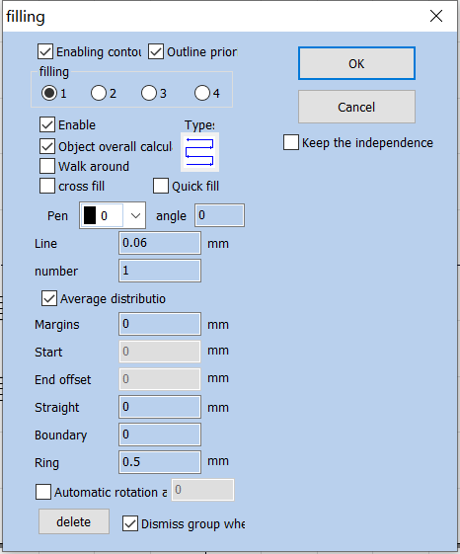
Fig. 3-4 “ Filling” Dialog Box

填充 Hatch
使能轮廓 Enable Contour
轮廓优先 Contour First
填充 Hatch
确定 OK
关闭 Close
保留填充对象的独立 Keep the Independence of Hatch Objects
使能 Enable
类型 Type
对象整体计算 Object Overall Calculation
绕边走一次 Go Around the Edge Once
交叉填充 Cross Hatch
快速填充 Fast Hatch
笔号 Pen Number
角度 Angle
线间距 0.06毫米 Line Spacing 0.06mm
数目 1 Quantity 1
平均分布填充线 Evenly Distributed Hatch Lines
边距 0毫米 Edge Distance 0mm
开始偏移 0毫米 Start Offset 0mm
结束偏移 0毫米 End Offset 0mm
直线缩进 0毫米 Linear Indentation 0mm
边界环数 0 Number of Boundary Rings 0
环间距 0.5毫米 Ring Spacing 0.5mm
自动旋转角度填充 Auto Rotation Angle Hatch
删除 Delete
删除时解散群组 Dismiss Group When Deleting
Enabling Contour: Express whether to show and mark the contour of the original graph, namely, whether the Filling graph keeps the original contour.
Contour prior : Indicates that in the case of enabling contour, the contour is marked first and then the filling line is marked
Filling 1 / Filling 2 / Filling 3 / Filling 4: Four sets of unrelated filling parameters can be used for filling operation at the same time，It can achieve any angle of cross filling and each filling can support processing with five different filling types。（The four types of filling are: one-way filling, bow filling, circular filling, optimized two-way filling and two-way filling. See the following for details.）
Enable: determines whether to permit the validity of the current hatch parameter.
object overall calcul: serves as an optimized option. If it is selected, all the mutually exclusive objects will be calculated as a whole during hatch calculation, which will speed marking up on certain occasions. (If it is selected, the computer’s calculation may slow down), If it is not selected, each independent area will be calculated separately.
For ease of description, we now give a special example to illustrate this feature.
Draw three independent rectangles in the workspace, filling line distance is 1mm, angle is 0
1、Do not check "object overall calculation": the machining order in the object list will be followed during machining ，Mark the filling lines one by one, that is, mark the filling diagram of an object first and mark the next. as shown in Fig. 3-5:

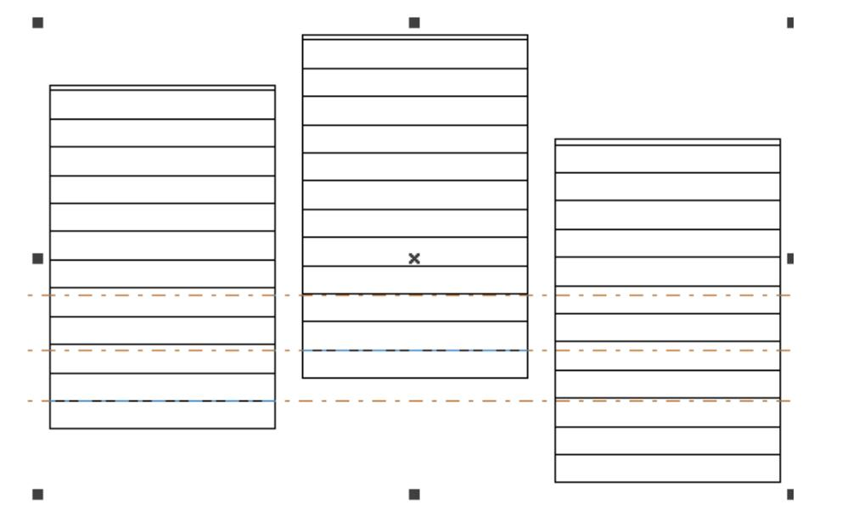
Fig.3-5 Do not check "object overall calculation"
2、Check "object overall calculation": mark all the filling lines in one time during machining, that is, mark the filling lines in the same line of several objects together. as shown in Fig. 3-6:
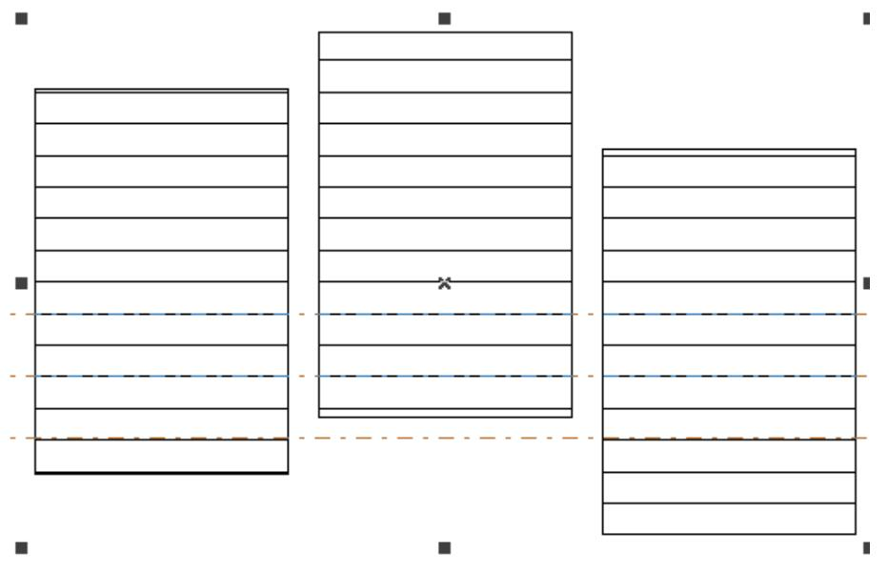
Fig.3-6 Check "object overall calculation"
Type filling：
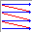Unidirectional filling: Fill lines always fill from left to right. As shown on the left of figure 3-7.
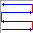Bidirectional filling: Fill lines are filled from left to right, then right to left, and the rest are filled in cycles. As shown on the right of figure 3-7.
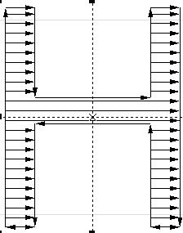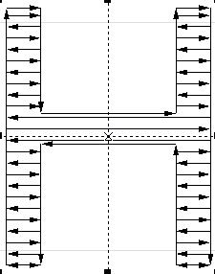
Fig.3-7 Left is Unidirectional filling，Right is Bidirectional filling

 Ring Hatch filling: the hatch lines will be marked from outside to inside of the object contour in a circular and skewing manner. 如图3-8左所示。
Ring filling: filling lines is object outline, from outside to inside cycle offset fill. As shown on the left of Figure 3-8.
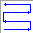 Optimized bidirectional hatch: It is similar to bidirectional hatch, but the ends of hatch lines will connect. 如图3-8右所示。
Bow shaped filling: Similar to a two-way fill, but there are connecting lines between the ends of the fill lines. As shown on the right of Figure 3-8.
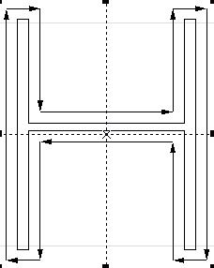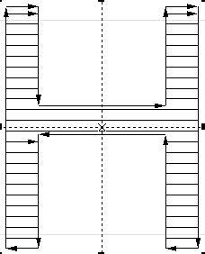
Fig.3-8 Left is Ring filling, Right is Optimized bidirectional filling
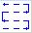 Optimization Gong type hatch: similar with Gong, will jump in null place. 如图3-9所示：
Optimized bow shaped filling: Be similar to bow shaped filling，It will still skip to fill in the blank space of the object. As shown in Figure 3-9:
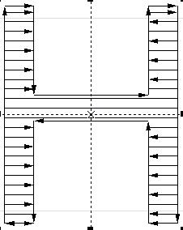
Fig.3-9 Optimized bow shaped filling
Those five types of hatch can be switched over by clicking the button with the mouse and can be set or modified conveniently and rapidly according to the required effects.
Angle: the angle between the hatch line and the X axis. 如图 3-10 所示为填充角度为 45 度时的填充图形。
Angle: Refers to the angle between the filling line and the X axis. As shown in Figure 3-10, it is a filling figure when the filling angle is 45 degrees.
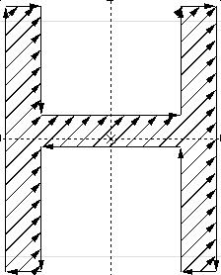
Fig. 3-10 Angle is 45
Line Space: the space between two adjacent hatch lines.
Line margin: All fill calculations, Distance between filling line and profile object
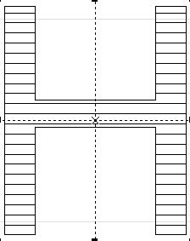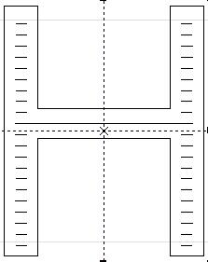
Fig 3-11 Line Space
(the left figure is a fill figure with a fill margin of 0, and the right figure is a fill figure with a fill margin of 1)
Walk around：After filling calculation, add a contour around the periphery of the filling line
Average distrbutio：Solve the problem of uneven distribution of filling lines at the beginning and end of filling objects. Due to the size of the filled object and the setting of the fill line spacing， etc, After filling, there may be uneven distribution of filler lines at the beginning and end of the filled object.To simplify the operation, Without requiring the user to reset the line spacing,It can also achieve the goal of uniform distribution of all filling lines, Add this feature. After selecting this item, The software will automatically adjust the filling line spacing based on the spacing set by the user , To evenly distribute the filling lines
Start Offset: the distance between the first hatch line and the border of the object.
End Offset : the distance between the last hatch line and the border of the object.
Straight: Refers to the reduction of both ends of the fill line. A positive value indicates reduction and a negative value indicates extension. This function is used when the distances between both ends of the fill line and the contour line are expected to be large during marking.
Boundary：Refers to the Before horizontal filling，Advanced ring filling. Due to the function of completely filling with rings, there will be cases where the last ring cannot be filled evenly,So this function is used to solve such problems.
[Note: the line space shall not be too large during text hatching, because a too large line space will cause the filling effect to be invisible.]
Keep the independence：When multiple objects are filled together after checking, they are still multiple objects
Delete : Delete the object's fill line and restore the original content
Dismiss group on wher：Ungroup when you perform a delete operation.
Auto rotate filling: Check this item and set the rotation angle, then the angle of the filling line will be changed automatically according to the setting after each marking
Automatic rotation a
Multi-figure Operation: Default, Intersection, Union, Difference Set As shown in Figure 3-12, the figure combination can be filled with different patterns.
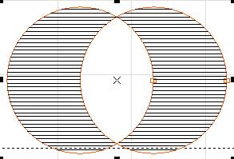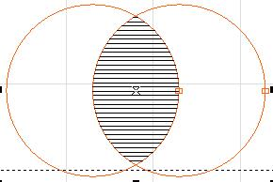
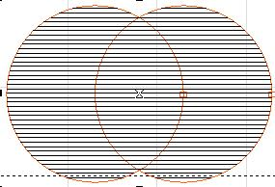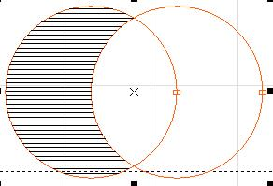
Fig 3-12 The upper left is the default, the upper right is the intersection, the lower left is the union, and the lower right is the difference

4. Draw Menu
The “Draw Menu” is used for drawing various common shapes, including Point, Line, Curve, Polygon, etc. This menu has a corresponding Toolbar, and all related operations can be achieved through the icons in this Toolbar, as shown in Fig. 4-1. When you select a drawing command or the icon in the Toolbar, the Present Command Toolbar on the top of the workspace will be changed to show some options of the current command.
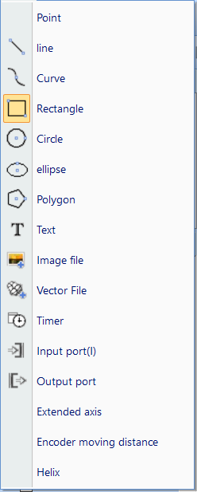
Fig a) “Draw” Menu Fig b) “Draw” Toolbar

Fig c) Select the tools command bar
Fig4-1 “Draw” Operation

绘制 Draw
修改 Modify
查看 View
点 Point
直线 Line
曲线 Curve
矩形 Rectangle
圆 Circle
椭圆 Ellipse
多边形 Polygon
文本 Text
图片文件 Image File
矢量文件 Vector File
延时器 Time-lapser
输入端口 Input Port
输出端口 Output Port
扩展轴 Extended Axis
编码器移动距离 Encoder Movement Distance
螺旋线 Helical Line

4.1. Point (P)
Drawing a point in the workspace is the simplest drawing operation. By selecting the “Point” command in the menu and clicking the left mouse button at an appropriate position in the workspace, you can draw a point at the position. Also you can draw more points by clicking the left mouse button continuously. After drawing, you can click the right mouse button to stop the point drawing command, and then the last point is displayed as the selected object.

4.2. Line (L)
To draw a line, the user can select the command “Line” in the Draw Menu or click the icon , or click and move the left mouse button when the “Line" command is selected.
When the “Line” command is selected, input the coordinates of points directly by clicking the right mouse button, as shown in Fig. 4-2:
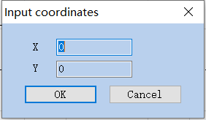
Fig. 4-2 “Input Coordinates”

输入坐标 Input Coordinates
确定 OK
关闭 Close

4.3. Curve (S)
To draw a curve, the user can select the “Curve” command in the Draw Menu or click the icon .
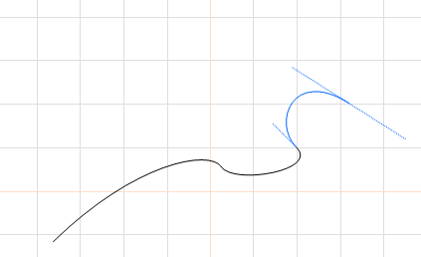
Fig. 4-3 Curve Drawing
When the “Curve” command is selected, the user can draw curves freely by pressing the left mouse button and moving the mouse.
When the “Curve” command is selected, the user can move the mouse cursor to the beginning node of the curve and press the left mouse button to close the current curve automatically.

4.4. Rectangle(R)
To draw a rectangle, the user can select the “Rectangle” command in the Draw Menu or click the icon.
When the “Rectangle” command is selected, the user can press the left mouse button and move it to draw a rectangle.
When the “Rectangle” command is selected, the user can draw a square by pressing the left mouse button and the “Ctrl” key simultaneously and moving the mouse.
When a rectangle is selected, the rectangle properties as shown in Fig. 4-4 will be displayed in the Properties Toolbar.
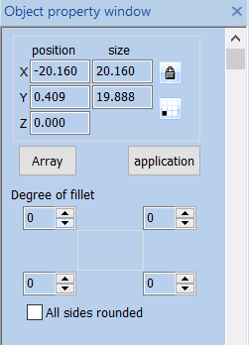
Fig. 4-4 Rectangle Properties Toolbar
对象属性栏 Object Property Bar
位置 Location
尺寸 Size
阵列 Array
应用 Apply
圆角程度 Fillet Degree
所有边圆角 All Edge Fillet
Degree of fillet: It refers to the roundness of the rectangle’s four corners. If the roundness is 100%, the corner turns into an arc.
All Corners Round: When it is activated, the user can modify the roundness of the four corners by just modifying one of them.
NOTE: Whenever the parameters in the Properties Toolbar are modified, it is a must to click the “Apply” button to effect the modification, which applies to the following operations.

4.5. Circle (C)
To draw a circle, the user can select the “Circle” command in the Draw Menu or click the icon.
When the “Circle” command is selected, the user can press the left mouse button and move the mouse to draw a circle.
When a circle is selected, the circle properties as shown in Fig. 4-5 will be displayed in the Properties Toolbar.
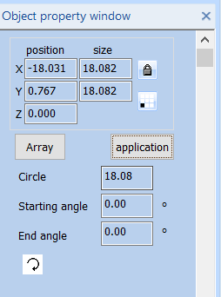
Fig. 4-5 Circle Properties Toolbar
对象属性栏 Object Property Bar
位置 Location
尺寸 Size
阵列 Array
应用 Apply
半径 Eadius
开始角度 Start Angle
Circle Diameter: the diameter of a circle.
Starting Angle: the angle of the starting point of a circle relative to its center.
: It means the current circle is marked clockwise.
: It means the current circle is marked anticlockwise.

4.6. Ellipse (E)
To draw an ellipse, the user can select the “Ellipse” command in the Draw Menu or click the icon.
When the “Ellipse” command is selected, the user can press the left mouse button and move the mouse to draw an ellipse.
When the “Ellipse” command is selected, the users can draw a circle by pressing the left mouse button and the “Ctrl” key simultaneously and moving the mouse.
When an ellipse is selected, the ellipse properties as shown in Fig. 4-6 will be displayed in the Properties Toolbar.
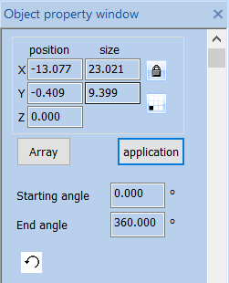
Fig. 4-6 Ellipse Properties Toolbar
对象属性栏 Object Property Bar
位置 Location
尺寸 Size
阵列 Array
应用 Apply
开始角度 Start Angle
结束角度 End Angle
Starting Angle: the angle of the starting point of an ellipse relative to its center.
End Angle: the angle of the ending point of an ellipse relative to its center.
: It means the current ellipse is marked clockwise.
: It means the current ellipse is marked anticlockwise.

4.7. Polygon (M)
To draw a polygon, the user can select the “Polygon” command in the Draw Menu or click the icon .
When the “Polygon” command is selected, the user can press the left mouse button and move the mouse to draw a polygon.
When a polygon is selected, the polygon properties as shown in Fig. 4-7 will be displayed in the Properties Toolbar.
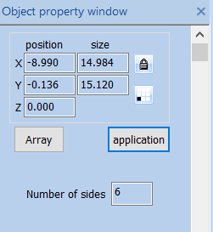
Fig. 4-7 Polygon Properties Toolbar
Edge Num.: It refers to the number of a polygon’s edges with the minimum number of three.
对象属性栏 Object Property Bar
位置 Location
尺寸 Size
阵列 Array
应用 Apply
边数 Number of Edges

4.8. Text (F)
Inputting characters directly in the workspace is supported in SeaCAD, and the fonts include all those supported by the system and many others set in the SeaCAD. To input characters, the user can select the “Text” command in the Draw Menu or click the icon .
When the “Text” command is selected, the user can create text objects by clicking the left mouse button.
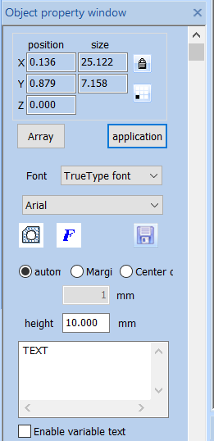
Fig. 4-8 Text Properties Toolbar
位置 Location
尺寸 Size
阵列 Array
应用 Apply
字体 TrueTypez字体 Font TrueTypez Font
自动 Auto
边距 Edge Distance
中心距 Center Distance
1毫米 1mm
高度 10.000毫米 Height 10.000mm
使能变量文本 Enable Variable Text
If you need to modify the text, you can directly modify it in the text edit box.
SeaCAD supports four types of fonts (TrueType fonts, single line fonts, barcode fonts, bitmap fonts) and other fonts that are installed independently.
After selecting the font type, the font list will list all fonts of the current type accordingly, as shown in Figure 4-9 is a TrueType font list.
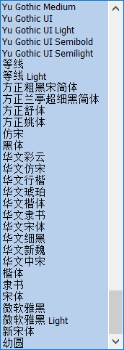
Fig. 4-9 TrueType List
Height: The average height of the font.

字体 TrueTypez字体 Font TrueTypez Font
方正舒体 FZShuTi
方正姚体 FZYaoTi
仿宋 Fangsong
黑体 Black Body
华文彩云 STCaiyun
华文仿宋 STFangsong
华文行楷 STXingkai
华文琥珀 STHupo
华文楷体 STKaiti
华文隶书 STLiti
华文宋体 STSong
华文细黑 STXihei
华文新魏 STXinwei
华文中宋 STZhongsong
楷体 Regular Script
隶书 Clerical Script
宋体 SimSun
微软雅黑 Microsoft YaHei
新宋体 NSimSun
幼圆 Simyou

4.8.1. Font Parameters
点击后系统弹出如图4-10所示对话框。
After clicking , the system pops up the dialog box shown in Figure 4-10.
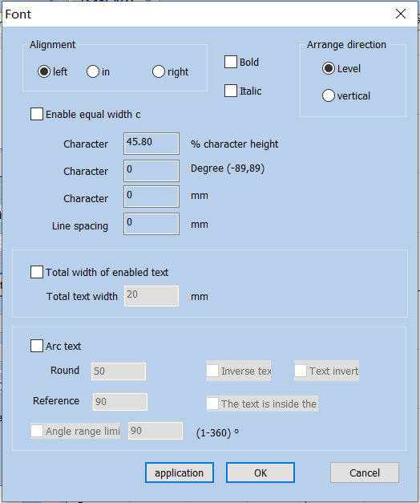
Fig. 4-10 Font Properties
字体 Fonts
对齐方式 Alignment
左 Left
中 Center
右 Right
粗体 Bold
斜体 Italic
排列方向 Sorting Direction
水平 Horizontal
垂直 Vertical
使能等宽字符 Enable the Same Width Character
字符宽度 45.80% 字符高度
Character Width 45.80% Character Height
字符角度 0度（-89,89） Character Angle 0 degree (-89,89)
字符间距 0mm Character Spacing 0mm
行间距 0mm Line Spacing 0mm
使能文本总宽度 Enable Total Text Width
文本总宽度 20mm Total Text Width 20mm
圆弧文本 Circle Text
圆直径 50 Circle Diameter 50
基准角度 90 Base Angle 90
文字反排 Text Reverse
文字倒立 Text Invert
文本位于圆弧内侧 Text Inside the Arc
角度范围控制 90 （1-360） Angle Range Limit 90 (1-360)
应用 Apply
确定 OK
关闭 Close
Alignment: “Left”, “in” and “Right” mean that the current text is aligned to the left/center/right respectively.
Bold: When selected, the current text become bold.
Italic: When selected, the current text become italic
Arrange direction: Horizontal means Horizontal arrangement, Vertical means vertical arrangement.
Enable the Same Width Character: make all characters keep the same width.
Char Width: the average width of characters.
Char Angle: the angle of inclination of characters.
Char Space: the distance between characters.
Line Space: the distance between two rows of characters.
Circle Text: 选择, the text will align according to the user definition circle diameter. As show in figure 4-11.
Arc Text: Select the 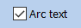 circle text, the text will align according to the user definition circle diameter. As show in figure 4-11.
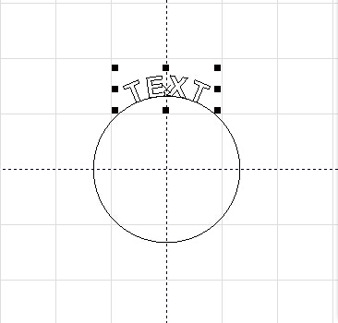
Fig. 4-12 Path Circle Text
Circle Round：diameter of circle text。

Reference Angle: the angle benchmark for text alignment. Starting datum with the leftmost angle of the text. As show in figure 4-12.
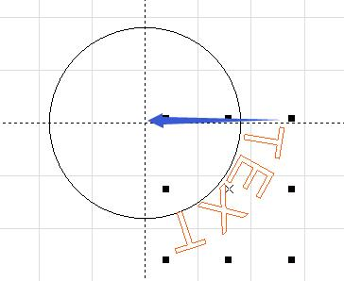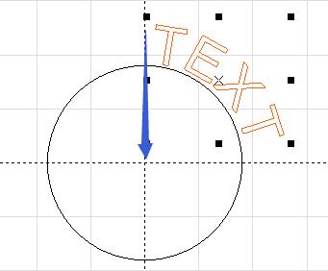
fig 4-12 left side is the reference angle = 0, right is the reference angle = 90
Angle Range Limit: When it is selected, the text will be limited in the angle range limit no matter how many characters are input.as shown in Fig. 4-13:
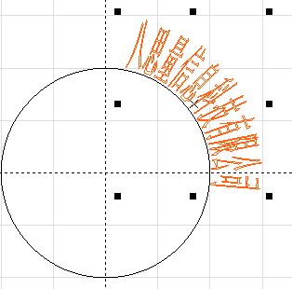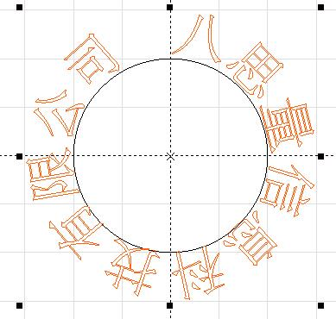
Fig. 4-13 Left one is click Angle Range limit，On the right, there is no check angle range limit。
长沙八思量信息技术有限公司
Changsha SeaThinking Info. Tech. Co., Ltd.

长沙八思量信息技术有限公司
Changsha SeaThinking Info. Tech. Co., Ltd.

Inverse text：Reverse the text.as shown in Fig:
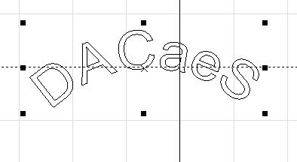
Text handstand: Arrange text upside down. The following picture:
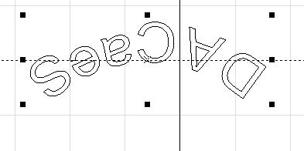
he text is located inside the arc: Place the text on the inside of the arc, following figure
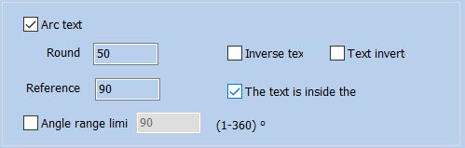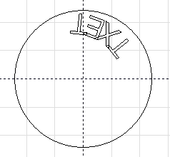
Fig. 4-16 The text is located inside the arc

路径文本 Path Text
基准角度 Base Angle
角度范围 Angle Range
文字反排 Text Reverse
文字顶端对齐 Text Top Alignment
文本位于圆弧内侧 Text Inside the Arc
确定 OK
关闭 Close

4.8.2. Barcode Font Parameters
当在字体里面选择条形码字体后，点击按钮后系统弹出如图4-19所示对话框。
After selecting the barcode font 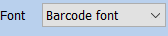 in the fonts, click the button barcode 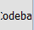 and the system will pop up a dialog box as shown in Figure 4-19.
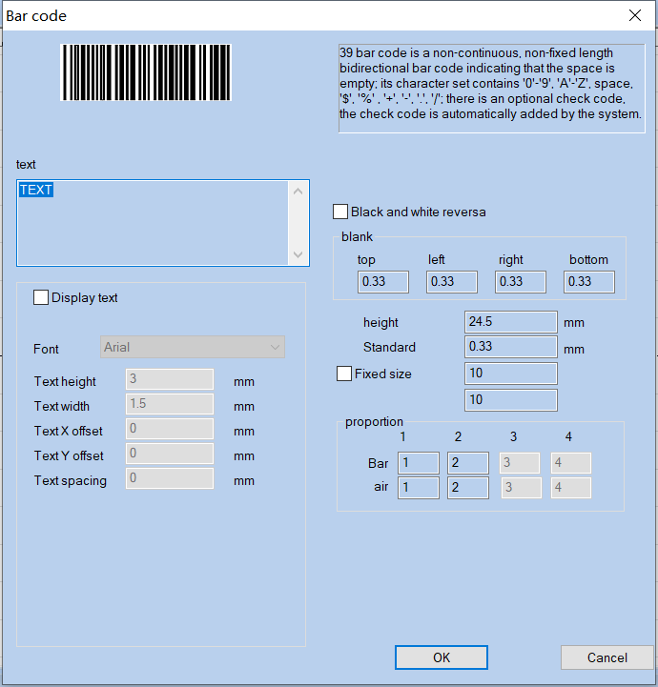
Fig. 4-19 Dialog Box of Barcode Font Parameters
条形码 Barcode
39条码是条空均表示信息的非连续型，非固定长度的双向条码；它的字符集包含‘0’-‘9’，‘A’-‘Z’空格，‘$’，‘%’，‘+’，‘-’，‘.’，‘/’；有可选的校验码，校验码由系统自动加入。
The 39 barcode is a two-way barcode with non-continuous and non-fixed length that represents information by bars and spaces; its character set contains ‘0’-’9’, ’A’-’Z’ spaces, ’$’, ’%’, ’+’, ’-’, ’.’, and ‘/’ ; there are optional check codes, which are automatically added by the system.
文本 Text
显示文本 Display Text
黑白反转 Black and White Invert
空白 Blank
顶部 Top
左边 Left
右边 Right
底部 Bottom
字体 Arial Font Arial
文本高度 2毫米 Text Height 2mm
文本宽度 1.5毫米 Text Width 1.5mm
文本X偏移 0毫米 Text X Offset 0mm
文本Y偏移 0毫米 Text Y Offset 0mm
文本间距 0毫米 Text Spacing 0mm
高度 24.5毫米 Height 24.5mm
标准模块高度 0.33毫米 Standard Module Height 0.33mm
固定尺寸 Fixed Size
比例 Scale
空 Space
条 Bar
确定 OK
关闭 Close
Display Text: determines whether to show a corresponding text for identification under the barcode.
Pen No：Select the pen number for the text, the default is the same as the barcode.
Font: the font of the current text to be displayed.
Text Height: the average height of the text.
Text Width: the average width of the text.
Text X Offset: the coordinates of text offset in the direction of X axis.
Text Y Offset: the coordinates of text offset in the direction of Y axis.
Text spacing: the space between characters.

4.8.2.1. One-Dimensional Barcode
It consists of “strip” and “space” arranged one by one. The barcode information is carried by different widths and positions of bar and space, and the information volume is decided by the width and the precision of barcode. The wider the barcode is, the more bars and spaces are included, and the more information is carried. This kind of barcode technology can store information in only one direction through permutation and combination of bars and the spaces, so it is called one-dimensional barcode. Fig. 4-20 shows the parameter setting in the window when a one-dimensional barcode is selected.
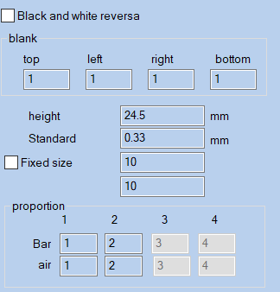
Fig. 4-20 One-dimensional Barcode Parameters
黑白反转 Black and white Invert
空白 Blank
顶部 Top
左边 Left
右边 Right
底部 Bottom
条码高度 16.170毫米 Barcode Height 16.170mm
标准模块宽度 4.53883毫米 Standard Module Width 4.53883mm
比例 Scale
条 Bar
空 Space
Black and White Reversa: determines whether to invert the marking. This function is used for some materials which are light-colored after marking.
Blank：When the barcode is reversed, you can specify the size of the blank area around the barcode.
Barcode Height: the height of the barcode.
Standard Width:Refers to the width of the narrowest strip module, that is, the width of the reference strip module. Commonly a one-dimensional barcode consists of bars and spaces with four types of width respectively, and 1, 2, 3 and 4 refer to 1, 2, 3 and 4 times the width of the unit bar as per the width size of bars and spaces. The width of the narrow bar means the width of one unit bar.
The actual width of Bar 2 is a scale of the narrow bar width multiplied by the width of Bar 2, and the method applies for Bar 3 and 4.
The actual width of Space 1 is a scale of the narrow bar width multiplied by the width of Space 1, and the method applies for Space 2, 3 and 4.
Blank：A limited area with the same reflectivity as the space on the outside or in the middle of the left and right ends of the barcode，The actual width of the blank area is equal to the width of the narrow strip module multiplied by the proportion of the blank.

4.8.2.2. Two-Dimensional Barcode

4.8.2.2.1. PDF417 Barcode
PDF is the acronym of the three words "Portable Data File", meaning "Portable Data File". Figure 4-21 is the demonstration of PDF417 Barcode. Figure 4-21 is the demonstration of PDF417 Barcode.
Bar code Height: the height of the barcode
Module width: Refers to the width of the narrowest bar module.
Error correction：the Error-Checking Level of PDF417 barcode, from 0 to 8.
Lines and Columns: the lines and Columns of PDF417 barcode.
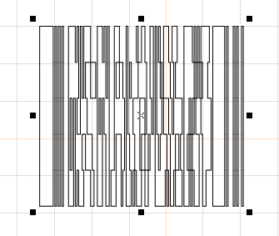
Fig. 4-21 PDF417 Barcode

4.8.2.2.2. DataMatrix Barcode
DataMatrix is a kind of two-dimensional barcode based on Matrix, as shown in Fig. 4-22:
Data Matrix has various fixed size, and users can choose what they want have. If the smallest size is chosen 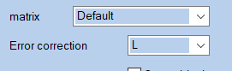，the system will automatically select the smallest frame to fit the all text users
Data Matrix has various fixed size, and users can choose what they want have. If the smallest size is chosen 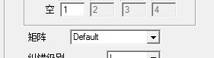，the system will automatically select the smallest frame to fit the all text users
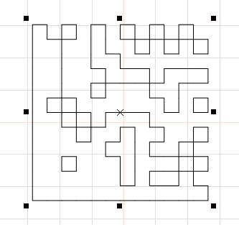
Fig. 4-22 DataMatrix Barcode

4.8.2.2.3. QR-Code
QR-Code Barcode is a kind of two-dimensional barcode and its character set includes all ASCII values, as shown in Fig. 4-23:
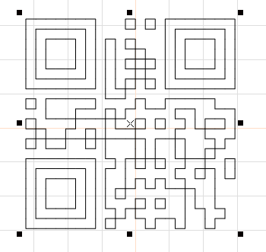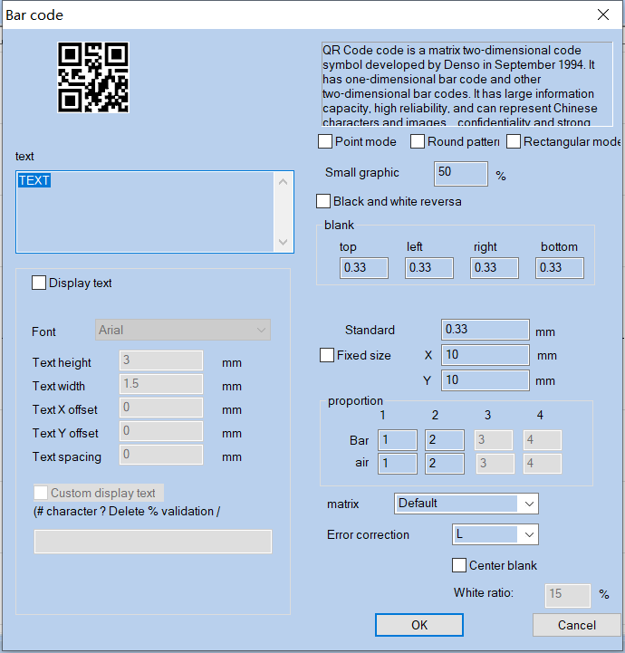
Fig. 4-23 QR-Code Barcode and QR code parameter setting
条形码 Barcode
文本 Text
显示文本 Display Text
笔号 0 Pen Number 0
字体 Arial Font Arial
文本高度 3毫米 Text Height 3mm
文本宽度 1.5毫米 Text Width 1.5mm
文本X偏移 0毫米 Text X Offset 0mm
文本Y偏移 0毫米 Text Y Offset 0mm
文本间距 0毫米 Text Spacing 0mm
自定义显示文本 Custom Display Text
（#字符 ?删除 %效验 /换行） (#Character ?Delete %Validation /Newline)
点模式 Dot Mode
圆模式 Circle Mode
矩形模式 Rectangle Mode
小图形宽度占比50% Small Graph Width Accounts for 50%
黑白反转 Black and White Invert
空白 Blank
顶部 Top
左边 Left
右边 Right
底部 Bottom
标准模块宽度 0.33毫米 Standard Module Width 0.33mm
固定尺寸 Fixed Size
比例 Scale
条 Bar
空 Space
矩阵 默认 Matrix Default
纠错级别 L Error Correction Level L
中心留白 Center Blank
留白比例：15% Blank Scale: 15%
确定 OK
关闭 Close
显示文本：显示文本下的功能同条形码属性的文本功能。
Display Text: The function under the display text is the same as the text function of the barcode properties.
Custom display text：User can use commands to display the text you want to display. #- represents the character that shows the current position,? - represents the character that deletes the current position, %- represents the position number of the character that displays the current position, and -/ is a line-up display character string. For example:
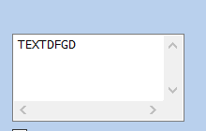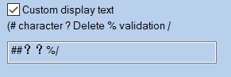
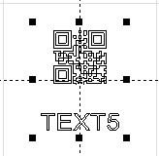
条码 Barcode
自定义显示文本 Custom Display Text
（#字符 ?删除 %效验 /换行） (#Character ?Delete %Validation /Newline)
point Mode, Round Mode, and Rectangle Mode: Select the mode that makes up the two-dimensional code. The examples are as follows (from left to right, point mode, circle Round mode, rectangle mode):
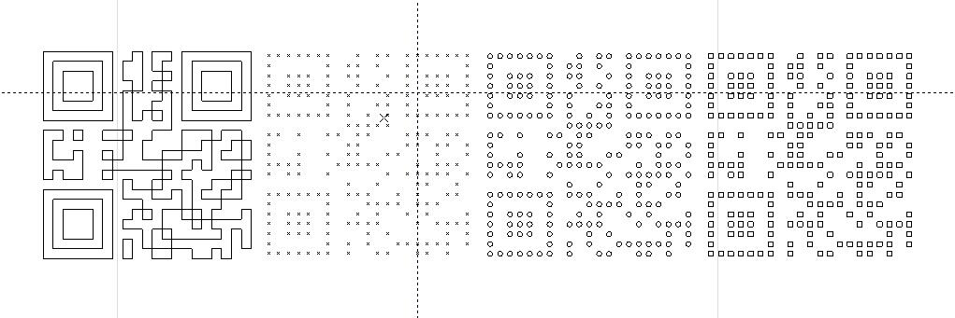
The proportion of graphics width：Set the size of the element which formed two-dimensional code. The adjustment range is from 1 to 100. It is valid only for the circle mode and rectangle mode.
Fixed size：Set the size of the two-dimensional code.
Center blank：An area will be vacated in the center area of the QR code , which will be used to place company LOGO, pictures, etc.

4.8.3. Variable Text
The Enable Variable Text will be available after the Enable Variable Text is selected, and the variable text properties as shown in Fig. 4-24 will be displayed by the system. The “Variable Text” means that a text can be modified dynamically based on the rules given by the user during marking.
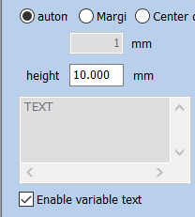
Fig. 4-24 Variable Text Properties

自动 Auto
边距 Edge Distance
中心距 Center Distance
1毫米 1mm
使能变量文本 Enable Variable Text
Auto: Automatically sets the distance between characters.
Margin: It refers to the distance from the right boundary of left character to the left boundary of right character.as shown in Fig. 4-25:
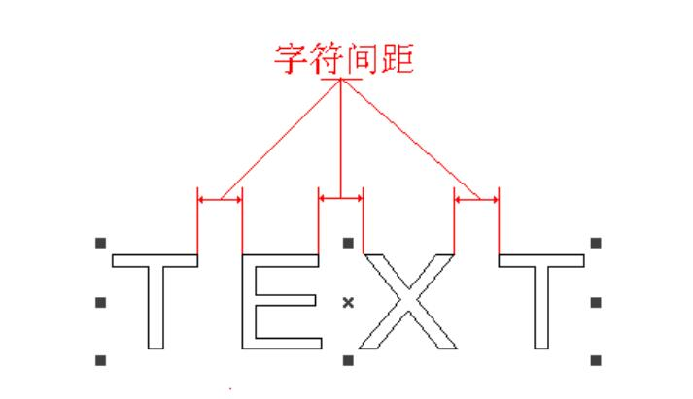
Fig.4-25 Spacing Margin
字符间距 Character Spacing
Center Distance: The calculation of character spacing refers to the distance between the left character center and the right character center. as shown in Fig. 4-26:
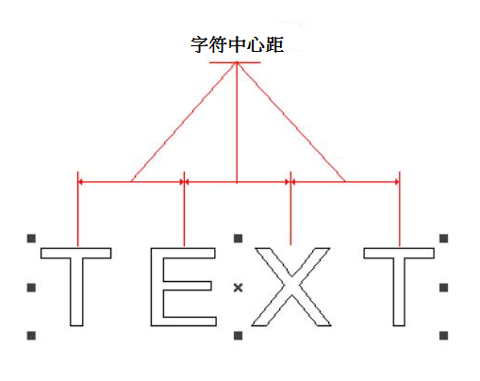
字符中心距 Character Center Distance
Fig.4-26 Center Distance
The user may add various variable text elements as required and sequence the text elements. After the “Add Text Element” is selected, the dialog box as shown in Fig. 4-27 will pop out.
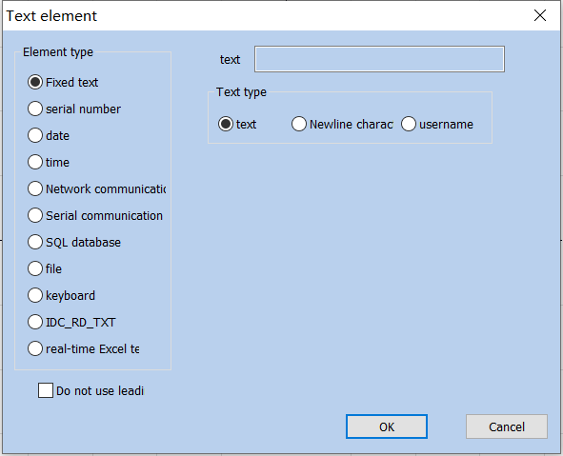
Fig. 4-27 Text Element Dialog Box
文本元素 Text Elements
元素类型 Element Type
固定文本 Fixed Text
序列号 Serial Number
日期 Date
时间 Time
网络通讯 TCP/IP Communication
串口通讯 Serial Communication
SQL数据库 SQL Database
文件 File
键盘 Keyboard
实时TXT文本 Real-time TXT Text
实时Excel文本 Real-time Excel Text
不使用前导零 Leading Zero Before Disuse
文本 Text
文本类型 Text Type
文本 Text
换行符 Newline Character
用户名 Username
Fixed Text: It refers to the invariable element in the text during marking.
Serial Number: It refers to the element changing with the fixed increment during marking.
Date Code: The system will automatically read date information from the computer during marking.
Time: The system will automatically read time information from the computer during marking.
Network Communication: During the processing, the system reads the elements of the text to be processed through the network
Serial Communication: The system will read the text to be marked through the serial port during marking.
SQL Database: The system will automatically read the text to be marked from the connected database during marking.
File: Text to be processed are read directly from the "TXT" "EXCEL" file.
Keyboard: The elements of the text to be processed are entered by the user from the keyboard during processing.

4.8.4.1. Fixed Text Element
It refers to the invariable element during marking.
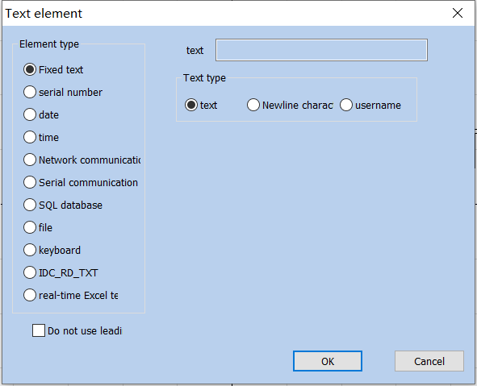
Fig.4-28 Fixed Text Element

文本元素 Text Elements
元素类型 Element Type
固定文本 Fixed Text
序列号 Serial Number
日期 Date
时间 Time
网络通讯 TCP/IP Communication
串口通讯 Serial Communication
SQL数据库 SQL Database
文件 File
键盘 Keyboard
实时TXT文本 Real-time TXT Text
实时Excel文本 Real-time Excel Text
不使用前导零 Leading Zero Before Disuse
文本 Text
文本类型 Text Type
文本 Text
换行符 Newline Character
用户名 Username
Newline character: Applied to the variable text function to solve the problem of multiple lines that require branch marking. When applied, a new line character is added between the two texts, and the software automatically branches the text according to the position of the newline character. If multiple texts need to be split into multiple lines, simply add a line break after the text to be split
Username: When this option is selected, the system automatically replaces the current user name using SeaCAD with a fixed text.

4.8.4.2. Serial Number Element
The serial number element is a text element which changes with the fixed increment during marking.
When the Serial Number is selected, the serial number parameter definition will automatically be displayed in the text element dialog box, as shown in Fig. 4-29.
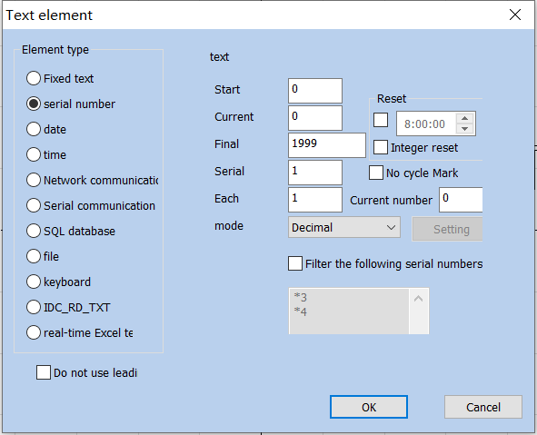
Fig.4-29 Serial Number Element
文本 Text
开始序号 Start Serial Number
当前序号 Current Serial Number
最终序号 Final Serial Number
序号增量 Serial Number Increment
每个标刻数 Number of Every Marking
模式 Mode
复位 Reset
整点复位 Integral Point Reset
不循环打标 Non-Circular Marking
当前标刻数 Number of Current Marking
十进制 Decimal System
设置 Setting
过滤以下序号 Filter the Following Serial Number
确定 OK
关闭 Close
Start SN: the first serial number to be marked at the moment.
Current SN: the serial number to be marked at present.
Final SN: When it comes to the marking of limit serial number, the system will return to the start serial number automatically.
Serial: It refers to the increment of the current serial number. When set as a negative value, the serial number will decrease progressively.
When the increment of the current serial number is 1, and the start serial number is 0000, each number will be added with 1 based on its previous number, for example, 0000, 0001, 0002, 0003 … 9997, 9998, 9999. When it comes to 9999, the system will return to 0000 automatically.
When the increment of the current serial number is 5, and the start serial number is 0000, the serial numbers are: 0000, 0005, 0010, 0015, 0020, 0025…..and so forth.
Each Marks：It means that the serial number will not be changed until the specified number is processed for each serial number. Then, after machining to the specified number, the serial number is changed again to cycle.
Current Marks.: It means that the serial number will not be changed until the specified number is processed for each serial number。Then, after machining to the specified number, the serial number is changed again to cycle.
Mode: the carry mode of the current serial number.
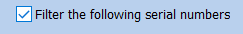: The system will filter out serial numbers whose certain digit is a particular value after it is selected. The means that the serial numbers with 4 as the tail number will be filtered out, and the * can be numbers with any digits.
Reset: You can customize the reset time or reset every point. Every day this time, the serial number of the mark changes to the start sequence number.
：Stop the marking task after you finish the Specified sequence number。

4.8.4.3. Date Code
Date element: The system will automatically read date information from the computer during marking.
When the Date element is selected, the date parameter definition will be displayed in the text element dialog box automatically, as shown in Fig. 4-22.
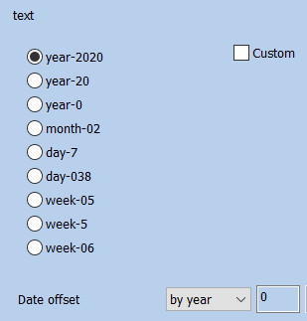
Fig. 4-22 Data element Parameter Definition
文本 Text
自定义 Custom
年-2019 Year-2019
年-19 Year-19
年-9 Year-9
月-12 Month-12
日-5 Date-5
天-339 Day-339
星期-04 Day of Week-04
星期-4 Day of Week-4
周-49 Week of Year-49
日期偏移 Date Offset
按年 Per Annum
确定 OK
关闭 Close
Year-2020: takes the year indicated by the current computer clock as the corresponding text with four characters.
Year-20: takes the year indicated by the current computer clock as the corresponding text with two characters: only the latter two digits are taken.
Month-02: takes the month indicated by the current computer clock as the corresponding text with two characters.
Day-07: takes the date of each month indicated by the current computer clock as the corresponding text with two characters.
Day-038: takes the number of days from January 1 to the date indicated by the current computer clock as the corresponding text with three characters. (001 represents January 1, 002 represents January 2, and so on).
Day of Week-05: takes the day of week indicated by the current computer clock as the corresponding text with two characters.
Week of Year-5: takes the week of year of the date indicated by the current computer clock as the corresponding text with two characters (take the period from January 1 to the first Saturday as the first week).
Date Offset: When the system reads the date indicated by the computer clock, it is necessary to add the set offset-date to obtain the marking date. This function is mainly used for the marking of workpieces with production date and shelf life in food industry and the like.
自定义：自己定义年份的显示内容。
Custom: Define the display content of the year by yourself.

4.8.4.4. Time Element
Time Element is system will automatically read time information from the computer during marking.
When the Time Element is selected, the time parameter definition will automatically be displayed in the text element dialog box, as shown in Fig. 4-23.
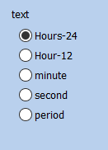
Fig. 4-23 Definition Time Parameter
文本 Text
小时-24 Hour-24
小时-12 Hour-12
分钟 Minute
秒 Second
时间段 Time Section
Hour-24: takes the time in hour indicated by the current computer clock as the corresponding text in the 24-hour time system.
Hour-12: takes the time in hour indicated by the current computer clock as the corresponding text in the 12-hour time system.
Minute: takes the time in minute indicated by the current computer clock as the corresponding text.
Second: takes the time in second indicated by the current computer clock as the corresponding text.
Period: 24 hours of one day are divided into 24 time sections, and the user can define a text for each time section. This function is mainly used for the marking of workpieces requiring the shift information.

4.8.4.5. Network communication
The network communication element is the element that the system automatically reads the text from the network through the computer network interface during the processing
Notice: The network interface in here is the network interface uses in TCP/IP agreement. When the user selected the “TCP/IP communication”, the parameter defines will display automatically in the dialog box, see the figure 4-24:
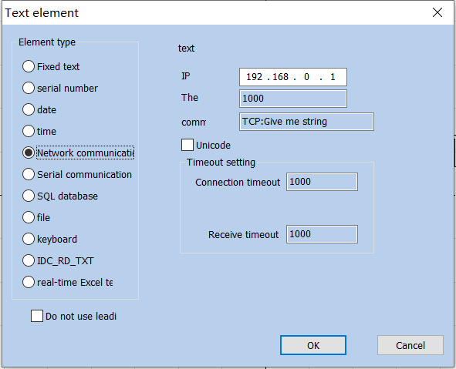
Fig.4-24 Network communication elements
文本元素 Text Elements
元素类型 Element Type
固定文本 Fixed Text
序列号 Serial Number
日期 Date
时间 Time
网络通讯 TCP/IP Communication
串口通讯 Serial Communication
SQL数据库 SQL Database
文件 File
键盘 Keyboard
实时TXT文本 Real-time TXT Text
实时Excel文本 Real-time Excel Text
不使用前导零 Leading Zero Before Disuse
文本 Text
IP地址 IP Address
端口号 Port Number
打标 Marking
超时设置 Timeout Setting
连接超时 Connect Timeout
接收超时 Receive Timeout
确定 OK
关闭 Close
IP Address: select the IP address which from reads the data
Port : select the port the TCP/IP communication used
Command: When the system processes to this text object, the system through the network interface to transmit this order character string to a computer assigned the IP address, request the computer sends the character string needs to process at present, the system will not return until the computer replied, after the response of the computer, the system will process the returns text automatically.
Unicode: After choosing this option, the system to the computer transmission which and the read character is the Unicode form, otherwise is the ASCII form.
Timeout setting: You can set the timeout period for connecting the specified IP address and receiving data.

4.8.4.6. Serial communication
The serial communication element is the element that the system automatically reads the text from the peripheral device through the computer serial port during the processing，When the user selects the serial communication element, the parameter definition of the serial communication element will be automatically displayed in the text element dialog box。As shown in Figure 4-25.
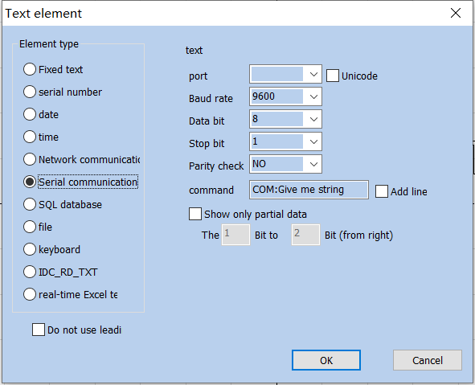
Fig.4-25 Serial communication

文本元素 Text Elements
元素类型 Element Type
固定文本 Fixed Text
序列号 Serial Number
日期 Date
时间 Time
网络通讯 TCP/IP Communication
串口通讯 Serial Communication
SQL数据库 SQL Database
文件 File
键盘 Keyboard
文本 Text
端口号 Port Number
波特率 Baud Rate
数据位 Data Bits
停止位 Stop Bits
奇偶校验 Parity
打标文件 Marking Document
只显示部分数据 Display Part of Data
加换行符 Add Newline
第1位到第2位（右起） 1st to 2nd (From Right)
确定 OK
关闭 Close
Port: the port which computer and peripheral equipment connection used
Baud Rate: Baud Rate which the serial communication used
Data Bits: Data Bits which the serial communication used
Stop Bits: the digits of Stop Bits of which the serial communication used
Parity: select the digits of Parity which the serial communication used
Command: When the system processes this text object, the system will send this command string to the external device through the current serial port，Request the external device to send the current string to be processed,The system will wait for the external device to answer before returning,After the external device answers, the system will automatically process the returned text.
Show only partial data: check to show characters between specified bits

4.8.4.7. File element
TXT: When TXT is selected, the content shown in Figure 4-26 will be displayed. The user is required to set the line number of the associated file and the current text to be processed
Automatic reset: When the processing reaches the end of the text file, the line number is reset to 0, and the processing starts again from the first line.
Read the entire file: When processes to the text document direct read entire Document.
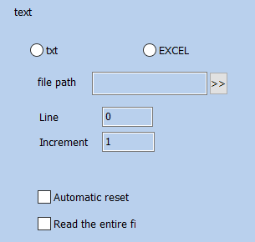
Fig.4-26 TXT

文本 Text
文件名称 File Name
行号 Line Number
增量 Increment
自动复位 Auto Reset
每次读整个文件 Read the Entire File at a Time
EXCEL：When the excel file system is selected, the content shown in Figure 4-27 will be displayed. The user is required to set the file name, field name and line number of the current text to be processed.
Field name: The text of the first row of all columns of form 1 in the excel file table. During processing, the system will automatically take out the text to be processed from the corresponding column.
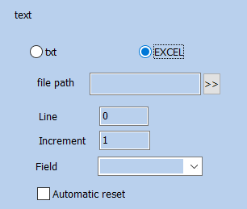
Fig. 4-27 EXCEL

文本 Text
文件名称 File Name
行号 Line Number
增量 Increment
字段名称 Field Name
自动复位 Auto Reset

4.8.4.8. Keyboard
The keyboard element is the text which must process from the keyboard entry by the user, when select the keyboard element, a dialog box as Figure 4-47 shows will be displayed to ask for the user set the keyboard element parameter. Tips In the process of processing, when the system encounters the text of keyboard variables, it will pop up the content in the input dialog box, requiring the user to enter the text to be processed, at this time, the user directly enters the text to be processed manually.
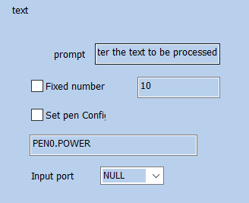
Fig.4-28 Keyboard
文本 Text
提示 Tip
请输入要加工的文本 Please enter the text to be processed
固定字符数 Fixed Character Count
设置笔参数 Set Pen Parameters
输入端口 Input Port
Fixed Number: user must input string with digit equals to this count.
Set Pen Param: The keyboard can be used to directly read the processing parameters of speed, power and frequency, Set pen 0.power to indicate the power of pen 0, pen 1.speed to indicate the speed of pen 1, pen 2.freq to indicate the frequency of pen 2, and set according to this rule.
The keyboard element function uses frequently in this kind of situation when the processing needs the real-time input to the processing content. If the customer present need processes one batch of work pieces, on each work piece is printed with a bar code, when processing needs the user with the bar code scanning gun real-time scans the work piece to read the content on the bar code, then with laser to mark to the work piece assigns in the position, at this time can use the keyboard element function. At the processing time system springs like the figure 4-30 shows the dialog box, the operator with the bar code scanning gun scanning bar code work piece on, the bar code scanning gun inputs the read content to the dialog box inside and closes it automatically, then the system will start to process the content read a moment ago automatically .

4.8.4.9. Advance Function
After selecting advanced functions, the system will pop up a dialog box as shown in Figure 4-29.
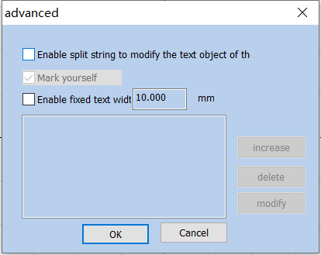
Fig.4-29 Advance Function

高级 Advance
使能分割字符串修改指定名称的文本对象
Text Object that Enables Split Strings to Modify the Specified Name
标刻自己 Mark Self
使能固定文本宽度 10.000mm Enable Fixed Text Width 10.000mm
增加 Add
删除 Delete
修改 Modify
确定 OK
关闭 Close
Mark yourself: In certain situations, when the user needs to split the variable text and then mark them in different positions, and also needs to mark the variable text, this function is applicable. It is conducted by setting the parameters for character splitting and selecting “Mark Self”. During marking, besides the split character, all input variable texts will be marked in corresponding positions.
使能固定文本宽度：设置文本的固定长度，不管内容多少长度是固定的。
Enable Fixed Text Width: Set the fixed length of the text, and the length is fixed no matter how much the content.
Select “Enable Split String to modify text object the”, and click “Add” button to get the dialog box as shown in Fig. 4-30.
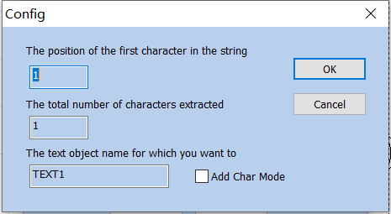
Fig.4-30 Advance Function

参数 Parameters
在字符串中第一个字符的位置 Location of the First Character in String
从字符串中提取的字符总个数
Total Number of Characters Extracted From the String
想要修改字符内容的文本对象名称
The Name of the Text Object that You Want to Modify the Character Content
确定 OK
关闭 Close
The position of the first character in the string: The starting character in text1 text is the number of characters in the string of variable text.
The total number of characters extracted: Extract several characters from the string of variable text from the first character set.
The Name of Text Entity Which You Want to Change: When it is selected, it is necessary to input the name of a fixed text for the character to be split and read.
The text object name for which you want to: Enter the name of the fixed text that you want to modify for the characters read by the partition.
Add Char Mode: when it is selected, the split and read character will be added to the position following the fixed text.
For example:
- Create a new variable text (take a variable serial number text as an example)

- Click “Advance” in the Variable Text Properties Toolbar, and select “Enable Split String to Change Other Text Entity”, as shown in the following figure:
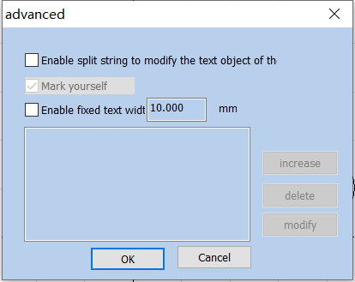
Fig.4-31
高级 Advance
使能分割字符串修改指定名称的文本对象
Text Object that Enables Split Strings to Modify the Specified Name
标刻自己 Mark Self
使能固定文本宽度10.000mm Enable Fixed Text Width 10.000mm
增加 Add
删除 Delete
修改 Modify
确定 OK
关闭 Close
- When “Add” is clicked, the following dialog box will pop out (it means that two characters starting from the first character in the variable text are extracted to replace the content in the fixed text entity with an indicated name) 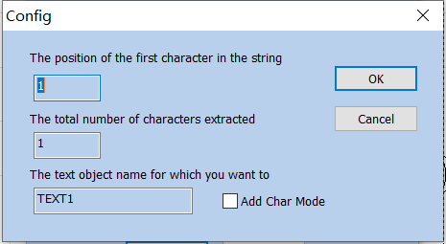
Fig.4-32

参数 Parameters
在字符串中第一个字符的位置 Location of the First Character in String
从字符串中提取的字符总个数
Total Number of Characters Extracted From the String
想要修改字符内容的文本对象名称
The Name of the Text Object that You Want to Modify the Character Content
确定 OK
关闭 Close
- After confirmation, draw a fixed text object, and change the name of the text object to the name set by the above rule

4.9. Draw Picture file

4.9.1. Input Bitmap
To add a bitmap, the user can select the “Bitmap” command in the Draw Menu or click the icon .
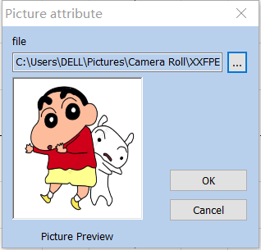
Fig. 4-33 Bitmap Inputting Window

The system will pop up the input dialog box as shown in Figure 4-33 and ask the user to select the bitmap to be input. The currently supported bitmap formats are: Bmp; Jpeg, jpg; Gif; Png; Tiff; Tif; Emf. The system will automatically display the picure of the current file in the preview box, and will also put the center of the current picture on the origin of the coordinates.
After entering the bitmap, the property toolbar displays the bitmap parameters as shown in Figure 4-34.
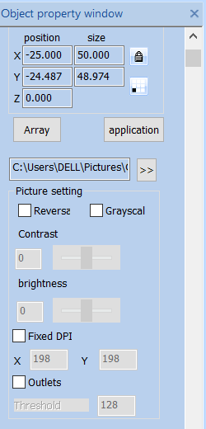
Fig.4-34 Bitmap parameters

4.9.2. Reversal
Reversal: The color value of each point in the current picture is reversed, and the formula adopted is PX new = 255 – PX old, as shown in Figure 4-35.
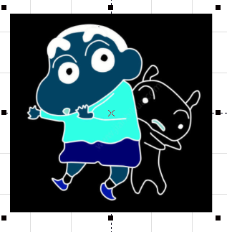
Fig. 4-35 Reversal Image

4.9.3. GrayScal
changes a color image into a 256-level grey scale image, as shown in Fig. 4-36. In the state of gray-scale image, the contrast and brightness of the image can be adjusted to achieve better marking effect.
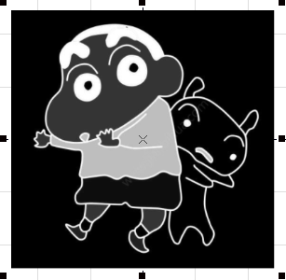
Fig. 4-36 Image gray processing example

4.9.4. Fixed DPI
The concept of DPI is the number of pixels per inch, one inch equals 25.4mm. When the DPI value is higher, the image printing is clearer and the processing time is longer. Otherwise, the more blurred, the processing time is shorter. You can use the default DPI value without fixing the DPI.

4.9.5. Outlets
Outlets: Dot representation is similar to the "halftone pattern" function in Adobe Photoshop. Black and white dichroic images are used to simulate gray-scale images, and black and white dichroic images are used to simulate different gray-scale effects by adjusting the density of points, as shown in figure 4-37.
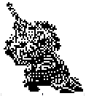
Fig.4-37 Dither Outlets

4.9.6. Two-way scanning
The scanning is bidirectional during the marking of bitmaps. 该方法可以提高一定打标速度。
The scanning is bidirectional during the marking of bitmaps. This method can improve a certain marking speed.

4.9.7. Dotting Time
Dotting Time: The time it takes for the laser to dot each pixel. This value can be modified to adjust the bitmap marking speed under the dotting mode.

4.9.8. Dot Power Mapping
不同像素点映射不同的打点功率。界面中的最大值是设置最大功率，点击最大值，再按复位，则生成新的映射表；同理可以设定最小值，或者设定特定的值。设定之后，按复位键重新生成映射表。效果如图4-38所示。
Different pixel mapping different power，The maximum value in the interface is to set the maximum power. Click the maximum value and then press reset to generate a new mapping table; similarly, you can set the minimum value or set a specific value. After setting, press the reset button to regenerate the mapping table. The effect is shown in Figure 4-38.
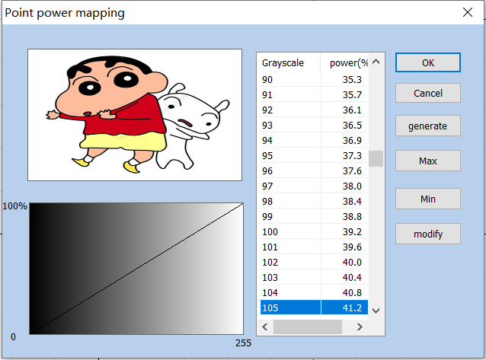
图4-38 点功率映射
Figure 4-38 Dot Power Mapping

功率映射 Power Mapping
灰度 Grey Scale
功率% Power%
确定 OK
取消 Cancel
生成 Generate
最大值 Maximum Value
最小值 Minimum Value
修改 Modify

4.9.9. Expand Parameter
Expand Parameter: Figure 4-39.
Y direction scanning: Set y-scan, the printing direction will be changed to y-scan.
Bitmap scan increment: When there are many image pixels or large image area, printing is time-consuming. You can scan additional lines, skip several lines for printing, but the printing effect will be reduced.
A point below the pixel value: Set the pixel point below which pixels will not be marked.
Point interlaced dislocation: In even rows, the first pixel is removed, and each pixel in the remaining rows moves forward one pixel in turn.
Optimize Mode: calculate the marking speed according to the DPI and frequency to optimize marking speed and result.
加速距离和减速距离：控制打标及其的移动加速参数。
Acceleration Distance and Deceleration Distance: Control the marking and its movement acceleration parameters.
整体偏移和双向偏移：控制打标图片的X，Y两个方向的移动量。
Overall migration and Bi-directional: Control the amount of movement in the X and Y directions of the marking images.
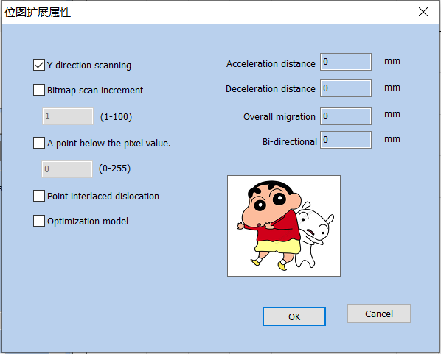
Fig.4-39 Expand Parameter
位图 Bitmap
Y向扫描 Y Direction Scanning
位图扫描行增量 Bitmap Scanning Line Increment
不刻标低于像素值的点 Do Not Mark Points Below the Pixel Value
点隔行错位 Point Interlacing Dislocation
优化模式 Optimization Mode
加速距离 0毫米 Acceleration Distance 0mm
减速距离 0毫米 Deceleration Distance 0mm
整体偏移 0毫米 Overall Offset 0mm
双向偏移 0毫米 Bidirectional Offset 0mm
确定 OK
取消 Cancel
图

4.10. Draw Vector File
To input a vector file, the user can select the “Vector File” command in the Draw Menu or click the icon .
The bitmap formats supported by the current system include AI, PLT and DXF. The Fig. 4-40 shows the result of vector image import.
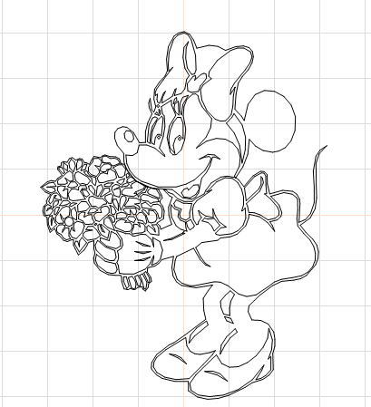
Fig. 4-40 Vector Image Import

4.11. Draw delay
If you want to enter a delayer control object, Choose the time delay command from the draw menu or click the icon.
When the “Delayer” is selected, the delayer property as shown in Fig. 4-41 will be displayed in the Properties Toolbar.
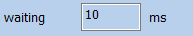
Fig. 4-41 Delayer Property
等待时间 10毫秒 Waiting Time 10 ms
Waiting time: When the marking comes to the current delayer, the system will wait for a scheduled period and then continue to operate.

4.12. Draw Input Port
To input the control object of input port, the user can select the “Input Port” command in the Draw Menu or click the icon .
After the “Input Port” is selected, the input port properties as shown in Fig. 4-42 will be displayed in the Properties Toolbar.
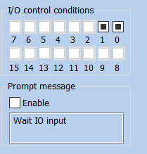
图4-42 输入口参数
Figure 4-42 Input Port Parameters

I/O控制条件 I/O Control Condition
提示消息 Prompting Message
使能 Enable
I/O Control Condition: When the marking comes to the current input port, the system will read the input port and compare the read value with the I/O Control Condition; if the two equal, the system will proceed to the following ports, and otherwise it will read the port again.
Prompt Message: It is given by the system when it reads the port repeatedly and waits for the matching between the port value and the I/O Control Condition.

4.13. Draw Output Port
To draw the control object of output port, the user can select the "Output Port” command in the Draw Menu or click the icon .
After the “Output Port” is selected, the output port property as shown in Fig. 4-43 will be displayed in the Properties Toolbar.
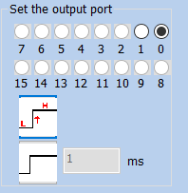
Fig. 4-43 Output Port Parameters
设置输出端口 Set Output Port
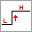The system will provide the port with high-level voltage when the marking comes to the current output port.
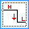The system will provide the port with low-level voltage when the marking comes to the current output port.
 The system will provide the port with a level signal and keep it.
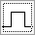 The system will provide the port with a pulse signal and it can set the pulse width.

4.14. Encoder moving distance
在绘制菜单中选择“扩展轴”命令，在对象列表中就会显示“扩展轴”对象，如下图 4-49 所示：
Select the “Extended Axis” command in the draw menu, and the “Extended Axis” object will be displayed in the object list, as shown in Figure 4-49 below:
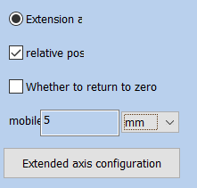
Fig.4-49 Encoder moving distance
扩展轴1 Extended Axis 1
相对位置 Relative Location
是否回零 Whether to Return to Zero
移动 Move
毫米 Millimeter
脉冲 Pulse
度 Degree
扩展轴配置 Extended Axis Configuration

Extended axis correction Zero: Check this to return the motor to zero
Relative position: It means the origin is used as the reference when the motor moves.
Relative position: Indicates whether the motor moves based on the origin or relative position.
Number of moving pulses: how many pulses are sent to the motor, and the number of pulses indicates the motor movement distance.
Unit type：unit of motor movement distance

4.15. Encoder Movement Distance
When the “Encoder Movement Distance” command in the Draw Menu is selected, the “Encoder Movement Distance” will be displayed in the Object List as shown in Fig. 4-50:
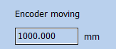
Fig. 4-50 Dialog Box of Encoder Movement Distance
编码器移动距离 1000.000毫米
Encoder Movement Distance 1000.000 mm
“Encoder Movement Distance” is mainly used for detecting the movement distance of flying objects during the process of mark on the fly.

4.16. Helical Line
Helix can be added to the outer frame object, and parameters such as equal pitch, unequal pitch, helix setting from inside to outside, from outside to inside, and minimum radius, minimum helix pitch, maximum helix pitch, pitch variation, outer boundary ring number, inner boundary ring number can be selected
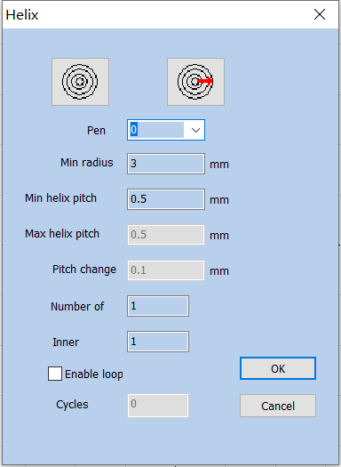
Fig. 4-51 Helical Line Setting Dialog Box
螺旋线 Helix
确定 OK
关闭 Close
笔号 Pen Number
最小半径 3毫米 Minimum Radius 3 mm
最小螺旋线螺距 0.5毫米 Minimum Helix Pitch 0.5mm
最大螺旋线螺距 0.5毫米 Maximum Helix Pitch 0.5mm
螺距变化量 0.1毫米 Pitch Variation 0.1mm
外边界环数 Number of Outer Boundary Rings
内边界环数 Number of Inner Boundary Rings
使能循环 Enabling Cycle
循环次数 Number of Cycles

4.17. Graphics picking
The icon on the top of the Draw Toolbar is used for graph selection.
The depressed state of the icon indicates that the command is selected at that time if no other command is selected, and you can select an object by clicking objects in the workspace with the mouse. The software has the “Auto-snap” function, and you can select an object by clicking the left mouse button if the mouse cursor is near a curve in the workspace.
You can also press the left mouse button and move the mouse to select an object, and there will be a dashed frame in the area where the mouse moves through. Objects wholly included in the dashed frame will be selected.
When the “Select” command is selected, the Select Toolbar will be displayed, and you can realize some particular operations, as shown in Fig. 4-44:

Fig. 4-44 Select Toolbar
It means that the current object is locked and you can’t conduct any editing operations on it. Some lock-like icons will appear around the object at that time.
It means unlocking locked object selected currently.
It means unlocking all the locked objects.
It means placing the selected object to the origin.
It means selecting objects by the pen number. The dialog box as shown in Fig. 4-45 will be displayed after the command is selected.
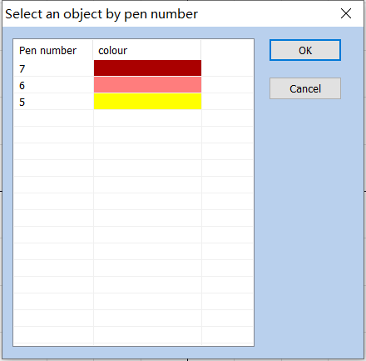
Fig. 4-45 Dialog Box of Selection by Pen Number
按笔号选择对象 Select Objects by Pen Number
笔号 Pen Number
颜色 Colors
确定 OK
取消 Cancel
Indicates that the current selection object will be mirrored horizontally。As shown in figure 4-46 below:
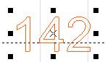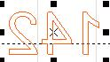
Fig.4-46 Mirrored horizontally

Indicates that the current selection is vertically mirrored：As shown in figure 4-47:
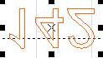
Fig.4-47 Vertically mirrored
Show or hide the current figure’s marking path ：As shown in Figure 4-48:
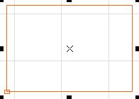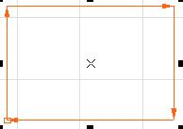
FIg.4-48 Figure’s marking path

5. Modify Menu
Commands in Modify Menu will take easy operations on selected objects, such as, Array, Transformation, Modeling, Prune etc. (Fig. 5-1)
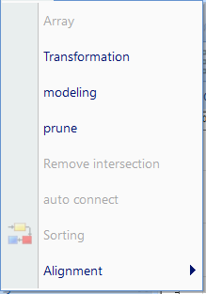
图5-1 修改菜单
Figure 5-1 Modify Menu

修改 Modify
查看 View
阵列 Array
变换 Transformation
造型 Modelling
修剪 Trim
去除交叉点 Break Cross Point
自动连接 Auto-Connect
排序 Resort
对齐 Align
对于3D图元除了变换内的移动和旋转操作外，其他都不支持，移动和旋转操作会同步到3D图元变换信息内，旋转是绕Z轴旋转。
Except for the movement and rotation operations in the transformation of 3D metafiles, other operations are all not supported. The movement and rotation operations will be synchronized to the 3D metafile transformation information, and the rotation is rotated around the Z-axis.

5.1. Array
Click “Array”, we can see the dialog box as shown in Fig. 5-2:
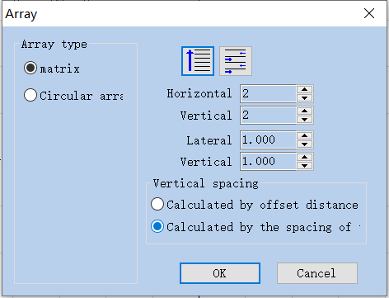
Fig. 5-2 Array Dialog Box
阵列 Array
阵列类型 Array Type
矩阵 Matrix
圆阵 Circular Array
横向数目 Horizontal Number
纵向数目 Vertical Number
横向间距 Horizontal Spacing
纵向间距 Vertical Spacing
间距计算方法 Spacing Calculation Methods
按偏移距离计算 Calculate by Offset Distance
按图形间距计算 Calculate by Graph Spacing
确定 OK
取消 Cancel
Matrix ：Indicates that the pattern will be arranged in a rectangle.
Circle array: The graph according to circle array.
: Indicates that the figures after the array are arranged individually from left to right，At the same time the processing sequence is determined.
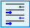：Indicates that the pattern after the array is arranged in two directions from left to right and then from right to left, It also determines the processing sequence.
Horizontal number：Array is the number of arrays in the X direction.
Vertical number：Array is the number of arrays in the Y direction.
Lateral spacing：The distance between the x-direction graphics after the Array.
Vertical spacing：The distance between the x-direction graphics after the Array.
Calculate by Offset Distance: The space of the graphs is calculated by offset distance. (Fig. 5-3 (a))
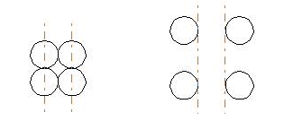
Fig. 5-3 (a) Calculate by Offset Distance (b)
Calculate by Graph offset Distance: The space of the graphs is calculated by graph distance. (Fig. 5-3 (b))
If we select the array type of “Circle”, we can see the dialog box as shown in Fig. 5-4:
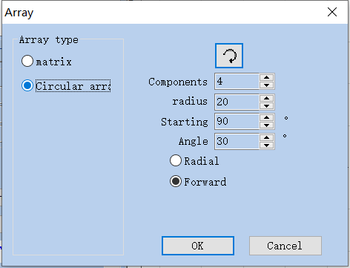
Fig. 5-4 Array Dialog Box (Circle)
阵列类型 Array Type
矩阵 Matrix
圆阵 Circular Array
阵列数目 Array Number
半径 Radius
开始角度 90度 Start Angle 90 degree
角度间距 30度 Angle Spacing 30 degree
向心 Centripetal
正向 Forward Direction
确定 OK
取消 Cancel
：Indicates the arrangement order of the pattern after the array. Whether it is arranged clockwise or anticlockwise also determines the marking order.
Components：Indicates how many identical figures you need to array the selected figures
Radius: Array after the graphics accordance circular arrangement. The radius of the circle.
Start Angle: Decision the initial arrangement angle of the pattern after the array.
Angle spacing: The array angle spacing of the pattern after arraying.

5.2. Transformation
When selected, a parameter setting box will appear as shown in Fig. 5-5.
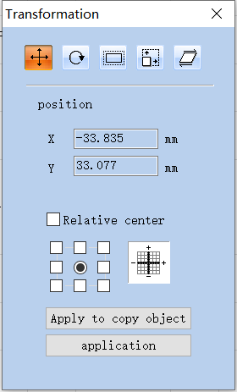
图5-5 变换操作对话框
Figure 5-5 Transformation Operation Dialog Box
变换 Transformation
位置 Location
X -46.340 毫米 X -46.340 mm
Y -46.536 毫米 Y -46.536 mm
相对位置 Relative Location
应用到复制对象 Apply to Copy Object
应用 Apply

5.2.1. Move
: Represents a move transform. The move Transform command can translate the currently selected object.
Position: The coordinates of the currently selected object datum mark.
In absolute coordinates, this function is equivalent to the X and Y functions in the attribute toolbar object label in Chapter 2.
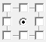Select a datum mark of an object.
Relative centere: use relative coordinates
Apply to Copy Object: This item is used to copy the currently selected object and move it into a new place.
: Activate the modification.
: Move selection to a new location

5.2.2. Rotate
: Rotate your object.
: Represents a rotation transform. The rotation transform command rotates the currently selected object.
When selected, a parameter setting will appear in the Rotation Setting Dialog Box as shown in Fig. 5-6.
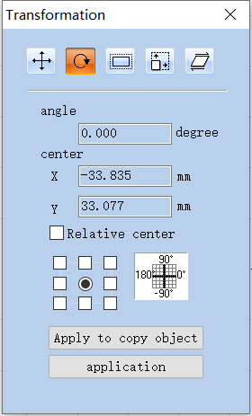
Fig. 5-6 Rotation Setting Box
变换 Transformation
角度 45.000度 Angle 45.000 degree
中心 Center
X -38.164 毫米 X -38.164 mm
Y -41.646 毫米 Y -41.646 mm
相对中心 Relative Center
应用到复制对象 Apply to Copy Object
应用 Apply
Angle: Represents the angle to rotate for the currently selected object.
Center: The coordinates of the currently selected object’s datum mark.

In absolute coordinates, this function is equivalent to the X and Y functions in the attribute toolbar object label in Chapter 2.
Select a datum mark of an object, 3D图元此属性不起作用，默认为绕Z轴旋转。
Select a datum mark of an object, and the property of 3D metafile does not work. It is rotated around the Z-axis by default.
Relative Center: Change the current coordinates into relative coordinates.
: Let the modification of the current object active.
: Move selection to a new location
: This item is used to copy the currently selected object and rotate it into a new place.
Apply to Copy Object: This item is used to copy the currently selected object and rotate it into a new place.

5.2.3. Mirror
: Represents a mirror transform. The mirror Transform command can mirror the currently selected object.
When selecting mirror command, a parameter setting box will appear as shown in Fig. 5-7.
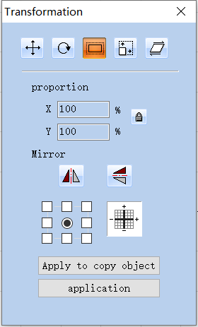
Fig. 5-7 Mirror Setting Box
变换 Transformation
比例 Scale
对象 Object
应用到复制对象 Apply to Copy Object
应用 Apply
Proportion: The zoom ratio of the X/Y size after being mirrored.
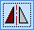: The current object’s horizontal mirror.
: The current object’s vertical mirror.
The vertical mirror and horizontal mirror can be activated at the same time, activate the corresponding mirror functions as per requirements in actual use, and make sure not to press the function that is not required.
: Select a datum mark of an object.

: Move selection to a new location
: This item is used to copy the currently selected object and mirror it into a new place.

5.2.4. Zoom
: Zoom your objects. 缩放变换命令可以将当前选中的对象进行缩放。
Represents a scale transform. The zooming transformation command can zoom the currently selected object.
When selected, a dialog box will appear as Fig. 5-8.
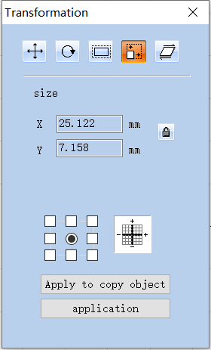
Fig. 5-8 Zoom Setting Box
变换 Transformation
尺寸 Size
X 16.352毫米 X 16.352mm
Y 9.780毫米 Y 9.780mm
应用到复制对象 Apply to Copy Object
应用 Apply
Size: The size after zooming. This function is the same as the Size which is introduced in object label of properties toolbar in Chapter 2.
: Select a datum mark of an object.
: Let the modification of the current object active.
: Move selection to a new location
: This item is used to copy the object and zoom it into a new place.
Apply to Copy Object: This item is used to copy the object and zoom it into a new place.

5.2.5. Tilt
: Lean the currently selected object, 倾斜变换命令可以将当前选中的对象进行倾斜。
: Tilt the currently selected object, and the leaning transformation command can lean the currently selected object.
When selected, a parameter setting box will appear as shown in Fig. 5-9.
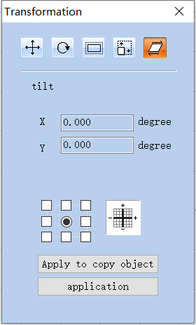
Fig. 5-9 Lean Tilt Setting Box
变换 Transformation
倾斜 Lean
X 0 度 X 0 degree
Y 0 度 Y 0 degree
应用到复制对象 Apply to Copy Object
应用 Apply
Tilt: Represents the slope angle of the currently selected object.
: Select a datum mark of an object.
: Let the modification of the current object active.
Apply to copy object
Apply
: Move selection to a new location
: This item is used to copy the currently selected object and lean it into a new place.

5.3. Modeling
When selected, a parameter setting box will appear as show in Fig. 5-10.
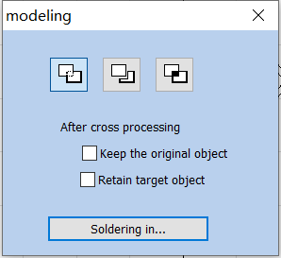
Fig. 5-10 Modeling
: Indicates welding, you can combine two intersecting closed areas into a closed area.
: Indicates trim, you can trim an enclosed area from a drawing contained in another area.
:Indicates cross，You can combine two intersecting closed areas into a closed area, and only the intersecting parts are retained.

5.4. prune
The trimming operation is used to trim the curve in the graph. After the user clicks the trimming command, when the mouse moves to the curve that can be trimmed, the mouse will be scissor shaped, and the curve that can be trimmed will be sky blue, as shown in Figure 5-11. At this time, if you click the left mouse button, the line can be trimmed.
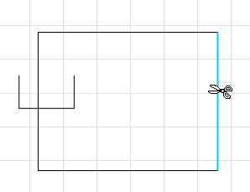
Fig. 5-11 Example of Trim Operation

5.5. Remove intersections
When users click “Break Cross Point”, the following dialog box as shown in Fig. 5-14 will pop-up:
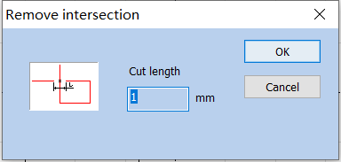
Fig. 5-12 Dialog Box of Remove intersections

Cut length: It means the length of the Crossover line part that we designed, as shown in Fig. 5-12. Take the following Fig. 5-13 for example:
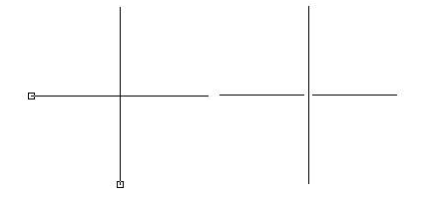
（a）Before removing the intersection (b)After removal of intersections
Fig. 5-13 Example Cut length

5.6. Auto-Connect
When selected, a dialog box will appear as shown in Fig. 5-14.
Automatic connection pitch: If the distance between two curves’ starting and ending points is less than the parameter set, the two curves will be jointed into one.
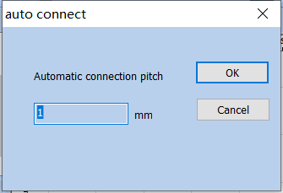
Fig. 5-14 Automatic connection pitch

5.7. Sorting
Select this command in the modify menu or select from the main interface. Draw multiple objects, click Sort, the direction of blue arrow in the working area indicates the current marking order. The sorting icon appears above the main interface, as shown below
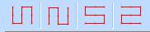
Fig.5-15 Resort Sorting

5.8. alignment
Command “Align” will be available only when more than one object is selected in the workspace. “Align” is used to align the objects users select on the two-dimensional plane. There are several ways to align:
Center point alignment: All objects align center. This way may cause moves on both horizontal and vertical directions.
Align Left: All objects align left.
Align Right: All objects align right.
 Align up: All objects align top.
Align below: All objects align bottom.
Centered vertically alignment: All objects align vertical. These three ways above only support to move objects on horizontal direction.
Centered Horizontal alignment: All objects align horizontal. These three ways above only support to move objects on vertical direction.
图形等距功能：选中对象
图形，点击横向、纵向等距后，图形会按对象列表栏的顺序，之间的距离相等。
Graphic isometric function: Select the object graph, click horizontal and vertical isometric, the graph will be in the order of object list column, and the distance between them will be equal.
Note: The benchmark to align is according to the last object users select, and other objects align behind it. When you use it, first click the first object, then drag to select multiple objects or press "Ctrl" to click multiple objects, all of which are based on the first selected object.

6. View Menu
The View Menu is used for setting every option for view in the software, as shown in Fig. 6-1.
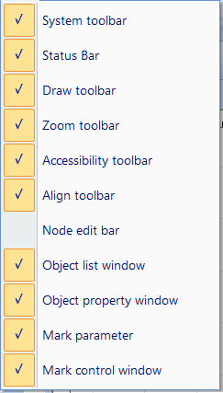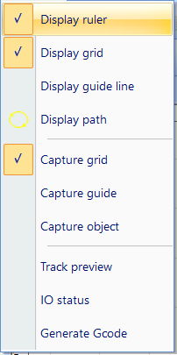
Fig.6-1 View menu and status bar menu
系统工具栏 System Toolbar
状态栏(s) Status Bar(s)
绘图工具栏 Drawing Toolbar
缩放工具栏 Zoom Toolbar
辅助工具栏 Guide Toolbar
对齐工具栏 Alignment Toolbar
节点编辑栏 Node Formula Bar
对象列表窗 Object List Window
对象属性窗 Object Property Window
标刻参数栏 Marking Parameter Bar
标刻控制栏 Marking Control Bar
显示标尺 Display Ruler
显示网络 Display Network
显示辅助线 Display Guide Line
显示路径 Display Path
捕捉网络 Snap Network
捕捉辅助线 Snap Guide Line
捕捉对象 Snap Object
轨迹预览 Path Preview
IO状态 IO State
生成Gcode Generate Gcode

6.1. Zoom Toolbar
The Toolbar of the zoom Menu is , and there are seven types for different requirements.
: Fill the whole view area with the area you specified for observation. You need to use the mouse to select the enlarged rectangular area. If you press the right mouse button directly, the current view will be zoomed out by one time with the current mouse position as the center. If you press the left mouse button directly, the current view will be zoomed in by one time with the current mouse position as the center.
: To move the current view.
: Zoom in.
: Zoom out.
: Fill the whole view area with all the objects.
: Fill the whole view area with only the selected objects.
: Fill the whole view area with the whole workspace.

6.2. Display ruler /display grid /display guide line
Displays horizontal and vertical rulers, grid points, and guides.

6.3. Capture Grid
This item is used for automatically putting the dots you draw on the grid.

6.4. Capture Guide Line
The capture grid capability enables the points you draw to automatically be on the grid points in the workspace.

6.5. Capture Objects
During performing some operations, this item is used for automatically snapping an object’s top, center, nodes, circle center, intersect points, etc.

6.6. System Menu Bar/Toolbar/Status Bar/Interface Window Bar
Software supports many toolbars to achieve different functions. Toolbars can be either displayed or hidden by selecting corresponding options in View Menu; and also the Status Bar can be displayed or hidden, either. When there is a “√” selected in front of the submenu, the corresponding toolbars on Status Bar is visible, and if not, they are hidden.

6.7. IO State
Check the status of current input and output ports. If checked, figure 6-2 will be displayed:
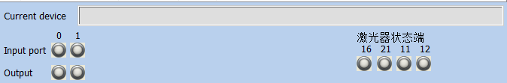
Fig.6-2 IO Status
输入端口 Input Port
输出端口 Output Port

6.8. Path preview
Select this function to see the path of the drawing.

7. Special
特殊菜单在SeaCad 软件中的各种选项，如图 7-1 所示。
Various options of the special menu in SeaCad software are shown in Figure 7-1.
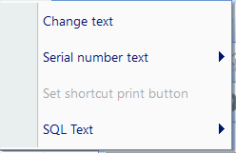
Fig.7-1 Special
改变文本 Change Text
序列号文本 Serial Number Text
设置快捷打印按钮 Set Quick Print Button
SQL数据库文本 SQL Database Text

7.1. Change Text
Click change text, follow dialog window will pop-up, as shown in Fig. 7-2.
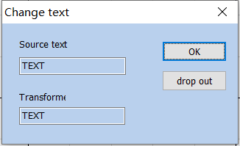
Figure 7-2 Change Text
The content under ‘text’ is to be replaced, the content under ‘change to’ is that after replace.
改变文本 Change Text
源文本 Source Text
变换后的 Transformed
确定 OK
退出 Exit

7.2. Serial number text
All serial numbers under the current file are directly increased or decreased according to their respective increments, or reset to the starting serial number without marking.

8. Laser
“Laser” menu mainly aims at expansion axis control, as shown in Fig. 7-1 below:
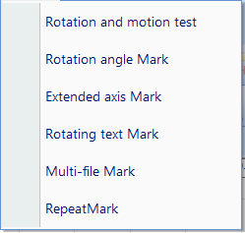
Fig.8-1 Laser
旋转与运动测试 Rotation and Movement Test
旋转角度标刻 Rotation Angle Marking
扩展轴标刻 Extended Axis Marking
旋转文本标刻 Rotate Text Marking
多文件标刻 MultiFile Marking

8.1. Rotate and Move test（Lite version does not support this feature）

The parameters used to set and maintain the extension axis.
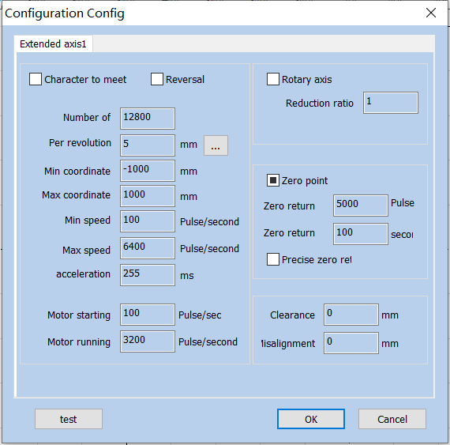
图8-2 旋转配置与检查
Figure 8-2 Rotation Configuration and Test
配置参数 Configuration Parameters
扩展轴1 Extended Axis 1
字符迎着打 Print by Facing to Characters
反转 Invert
旋转轴 Rotation Axis
减速比 Reduction Ratio
每转脉冲数 Pulses per Revolution
每转距离 Distance per Revolution
最小坐标 -1000毫米 Minimum Coordinates -1000 mm
最大坐标 1000毫米 Maximum Coordinates 1000 mm
最小速度 100脉冲/秒 Minimum Speed 100 pulses/second
最大速度 5000脉冲/秒 Maximum Speed 5000 pulses/second
加速时间 100毫秒 Acceleration Time 100 ms
电机启动速度 700 脉冲/秒 Motor Startup Speed 700 pulses/second
电机运行速度 6400 脉冲/秒 Motor Running Speed 6400 pulses/second
零点 Zero
回原点速度 5000脉冲 Return-to-origin Speed 5000 pulses
回原点超时 100秒 Return-to-origin Timeout 100 seconds
精确回零 Accurate Back to Zero
间隙补偿 0.2毫米 Backlash Compensation 0.2 mm
错位补偿 0毫米 Dislocation Compensation 0 mm
测试 Test
确定 OK
关闭 Close
Reversal: It refers to the movement in the opposite direction of the extension axis; when checked, it indicates that the extension axis is reversed.
字符迎着打：改变文本标刻的先后顺序。
Character to meet：Change the sequence of text marking.
Pulses per Round: The pulse (subdivision of driving motor) numbers each round that the expansion axis rotating. It can be set according to the motor parameter.
Distance per revplution：The distance each round that the expansion axis rotating，Click the setting button "..." to calculate a more accurate distance per round.
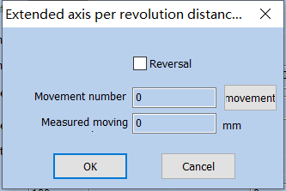
Fig.8-3 Extended axis accuracy setting
扩展轴每转距离计算 Distance Calculation for Extended Axis per Revolution
反向 Reverse
运动转数 Movement Revolutions
运动 Movement
实测移动距离 Actual Movement Distance
确定 OK
关闭 Close
Min Coordinate: The smallest coordinate in which the extended axis can move, in millimeters.
Maximum Coordinate: The maximum coordinate of the extended axis that can be moved, in millimeters.
Min. Coordinate: The minimum speed of the extended axis energy movement, unit pulse / second.
Max. Coordinate: The maximum speed of the extended axis, unit pulse / second.
Acceleration: The time, in milliseconds, required for the extended shaft to accelerate from the minimum speed (starting speed of the motor) to operation.
Go to Start Position After Finished: When it is checked, the expansion axis will go back to the initial position after finishing marking.

Motor starting：Set motor start speed, unit is pulse/s。
Motor running: The rotating speed of motor.
Rotation axis: Select it, it's indicates that current expansion axis is rotation axis.
Reduction ratio：If the motor is directly connected to the shaft, the reduction ratio is 1; if there is a reduction mechanism in the middle, it is the reduction ratio of the reduction mechanism.
Part Diameter: It is used for setting the external wall diameter of round parts and converting graphs in workspace into the accurate rotation angle.
Zero point: Whether the current extension axis has zero signal. When there is no enable zero signal for the extended axis, an absolute coordinate system cannot be established for the extended axis. In this case, it is necessary to adjust the position manually so that each machining is in the same position. Before each machining, the system takes the current extended axis position as the default zero position.
If the zero is selected, the system will automatically look for zero point when employing the expansion axis function. After finding the zero point, an absolute coordinate system will be built for the expansion axis. If the system fails to find the zero point, the expansion function will not be activated properly until the time set for “Zero Time Out” is over.
如无零点信号，则必须将零点的勾选至状态，即不使用零点信号状态。
If there is no zero signal, the zero must be checked to the zero state, that is, the zero signal state is not used.
Zero return: The speed at which the extended axis seeks the zero point signal.
Zero return: Set the time for the extension axis to find the zero point. If the time exceeds this time, the system will prompt "return to zero timeout".
Accurate Zero: When it is selected, it is required to receive three signals before going back to zero; if not selected, only one signal is required for going zero.
Gap Clearance compensation: Used to set the interval compensation between each independent figure. For example, the interval between two figures is set to 10mm. If the mark is 10.1, then the gap compensation bit - (10.1-10) =- 0.1.
Offset compensation：When the graphics are stitched, it may cause mismatch phenomenon. This parameter is used to eliminate the misalignment.
Rotation Test：Test Rotary Axis.
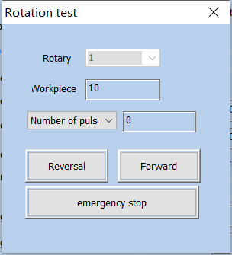
Fig.8-4 Rotate test
旋转测试 Rotation Test
旋转轴 Rotation Axis
工作直径 Working Diameter
脉冲数 Pulses
反转 Invert
正转 Corotation
紧急停止 Emergency Stop

8.2. Rotation Angle Marking（Lite version does not support this feature）

8.2.1Interface description
"Rotation Angle Marking" is to perform rotation marking according to the angle of the rotation axis to process the entire figure.
Click on the "Rotation Angle Marking" menu item under "Laser" to display the following dialog box:
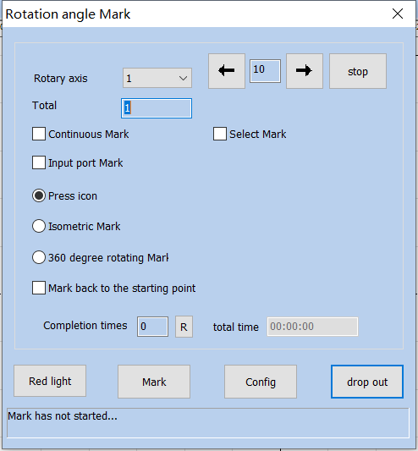
Fig.8-5 Rotate angle mark
旋转角度标刻 Rotation Angle Marking
旋转轴 Rotation Axis
停止 Stop
加工总数 Total Number of Processing
连续加工 Continuous Processing
选择加工 Selective Processing
输入端口打标 Input Port Marking
按图标刻 Marking by Graphs
等角标刻 Equiangular Marking
360度旋转标刻 360 Degree Rotation Marking
每周次数 Times per Week
标刻完返回起始点 Return to Start Position after Marking
完成次数 Number of Completions
总时间 Total Time
红光指示 Red Light Indicator
标刻 Marking
参数 Parameters
退出 Exit
打标未开始…… Marking Not Started......
对话框中，各数据项说明如下：
In the dialog box, the data items are described as follows:

Total Number: The total counts that the marking command should be executed. If checking the “Continuous”, the marking number will not be limited by the total number;
Rotary Axis：Choose which axis to use；
Continuous Mark: If it is checked, it will not be controlled by the total number, and it will perform continuous marking for graphs or text contents displayed in the workspace.
Mark Selected: If it is checked, only those selected graphs will be marked; otherwise, all the graphs will be marked;
Input port marking: Specify an input port and the marking can be triggered through the IO port.
Press icon: After each engraving, rotate the z-axis coordinate value (angle) of the graph. Different graphs can set different rotation angles
Increment mark: Rotate the mark according to the set angle interval.
360 degree rotating mark: Set how many times to mark the figure in a week;
Mark back to the starting point: When this option is checked, the rotation axis will return to the starting point of the marking.
Completion times: The total counts that the marking command has been executed;
R：Reset the marking status and clear marking count；
Total Time： Total time of marking.

8.2.2Functional operation

8.2.2.1 Red light
Click on the "red light " button, you can see the red indicator of the current graphics.

8.2.2.2 Mark
Click "Mark", and the software marks according to the set parameters.

8.2.2.3 Parameters
Click "parameters" to configure the relevant parameters of the rotation axis. (refer to 8.1 for parameter description).

8.2.2.4 ESC drop out
Click "ESE drop out ", the system will save the configured parameters for the next use.
Note: If you click the "X" button in the upper right corner of the dialog, the modified parameters are not saved.

8.3. Expansion Axis Marking（Lite version does not support this feature）

The extended axis marking function is to divide the entity into specified sizes and then splice the marking while rotating. The interface is as follows:
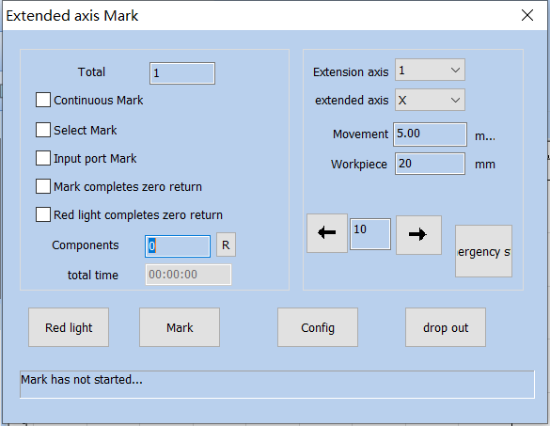
Fig.8-6 Extend axis mark
扩展轴标刻 Extended Axis Marking
加工总数 Total Number of Processing
连续加工 Continuous Processing
选择加工 Selective Processing
输入端口打标 Input Port Marking
标刻完成回零点 Return to Zero After the Completion of Marking
红光完成回零点 Return to Zero After the Completion of Red Light
零件 Part
总时间 Total Time
扩展轴 Extended Axis
扩展轴方向 Extended Axis Direction
运动步长 Movement Step Length
工件直径 Workpiece Diameter
急停 Emergency Stop
红光指示 Red Light Indicator
标刻 Marking
参数 Parameters
退出 Exit
打标未开始…… Marking Not Started......
扩展轴方向：选择旋转轴的使用方向。
Extended Axis Direction: Select the use direction of the rotation axis.
Workpiece：Diameter of Axis.
运动步长：图元分割的大小。
Movement Step Length: The size of the metafile split.

8.4. Rotate Text Mark（Lite version does not support this feature）

Rotate Text Mark is a marking method in which the text is divided by each character and then the individual characters are marked while being rotated.
Click the “Rotation Text Marking” in the “Laser” menu of the menu bar to open the rotation text marking dialog box, as shown in Fig.8-9:
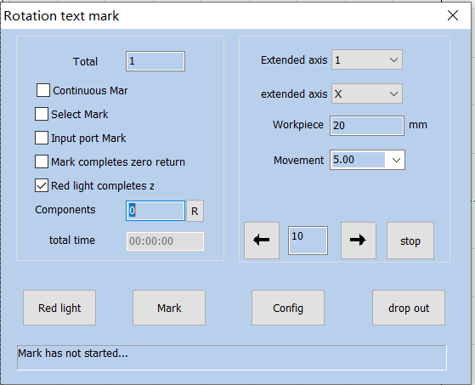
Figure.8-9 Rotate Text Mark
The configuration parameters are the same as those for the Rotary marking.
旋转文本标刻 Rotation Text Marking
加工总数 Total Number of Processing
连续加工 Continuous Processing
选择加工 Selective Processing
输入端口打标 Input Port Marking
标刻完成回零点 Return to Zero After the Completion of Marking
红光完成回零点 Return to Zero After the Completion of Red Light
零件 Part
总时间 Total Time
扩展轴 Extended Axis
扩展轴方向 Extended Axis Direction
工件直径 Workpiece Diameter
运动步长 Movement Step Length
停止 Stop
红光指示 Red Light Indicator
标刻 Marking
参数 Parameters
退出 Exit
打标未开始…… Marking Not Started......

8.5Multi-File Mark
The function of "multi file marking" is used to trigger IO to mark multiple different marking files to avoid frequent changes of marking files. The function menu is: "laser" - > "multi file marking".
The operation interface is as shown in Figure 8-10: the text box on the left displays the file name, and the preview graphic of the selected file appears after the preview graphic is checked on the right border. Double click the file name to open the engraving file in the main interface for editing.
Double-click on the file name and open the marking file on the main screen to edit it.
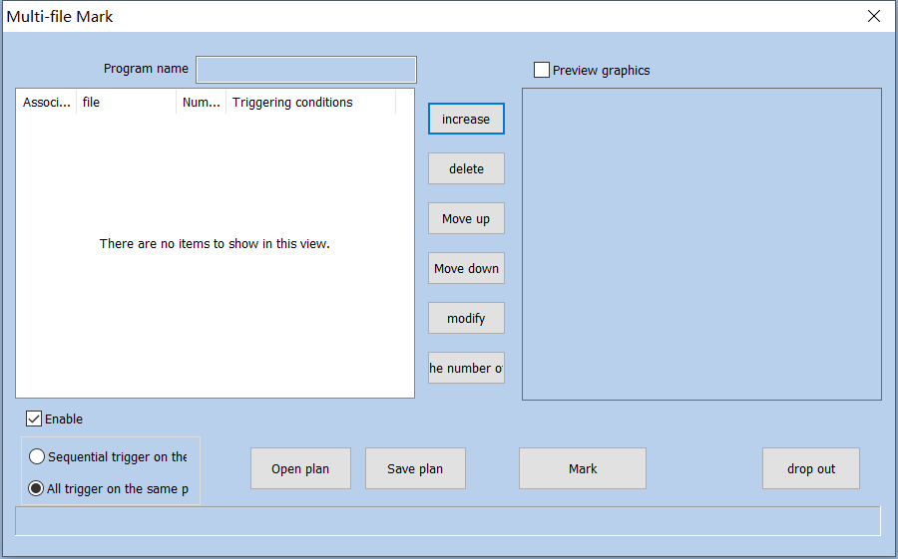
Fig.8-10 Multifile Mark
多文件标刻 MultiFile Marking
方案名称 Solution Name
预览图形 Preview Graph
关联设备 Related Equipment
文件 File
打标 Marking
触发条件 Trigger Condition
增加 Add
删除 Delete
上移 Move Up
下移 Move Down
修改 Modify
次数清零 Frequency Zero
使能有效 Enabling Effective
同端口顺序触发 Trigger in the Same Port Sequence
同端口全部触发 Trigger All on the Same Port
打开方案 Open Solution
保存方案 Save Solution
标刻 Marking
退出 Exit

8.5.1. File Manage
- Add: Add .orz files. The dialog box pops up as Figure 8-38 after click “add” button. Setting I/O control conditional for files, and automatically mark files when board accept the IO signal in mark status.
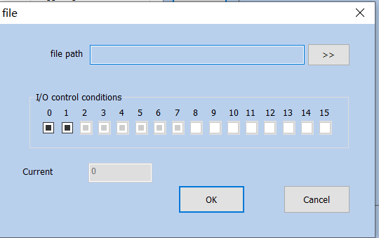
Fig.8-11 File Menu
文件 File
文件名称 File Name
I/O控制条件 I/O Control Condition
当前标刻 Current Marking
确定 OK
关闭 Close
Gray：Gray means not used
Blank：Blank means low level
Black Hook：Black Hook means high level.
- Delete: delete files.
- "Move up", "move down": change the order of files.
- Modify: change file selected and IO control conditional

8.5.2. function Option
Sequential trigger on the：Use a port to mark the preset files in order.
Trigger All on the Same Port: If different documents are the same port, then triggering the port once will mark all documents.
Open plan：Open saved multi-file marking scheme.
Save plan：Save the currently designed multi-document marking content as a scheme.
Mark：After clicking, software will enter the state of waiting for the IO signal to trigger. At this time, the IO signal can be triggered to mark the corresponding document.
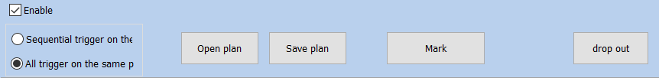
Fig.8-12 Marking Interface
同端口顺序触发 Trigger in the Same Port Sequence
打开方案 Open Solution
保存方案 Save Solution
停止 Stop
退出 Exit
等待IO信号 Wait for IO Signal

9. Mark parametr
Including single-card marking and multi-card marking.

9.1. 笔参数管理Pen Parameter Management

9.1.1. 笔参数列表Pen Parameter List
在SeaCAD中每个文件都有257支笔，对应在加工属性栏中最上面的256支笔，笔号从0到256，其中0号笔是笔模板参数（可以基于该笔号修改其他笔号参数）。
In SeaCAD, there are 257 pens in each file, corresponding to the top 256 pens in the processing property bar, the pen number ranges from 0 to 256, where the pen 0 is the pen template parameter (other pen number parameters can be modified based on the pen number).
如图9-1所示是标刻控制栏。
As shown in Figure 9-1, it is the marking control bar.
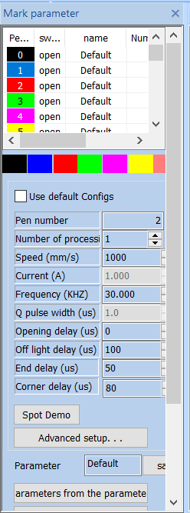
Fig.9-1 Marking tool bar
标刻参数栏 Marking Parameter Bar
笔号 Pen Number
开关 Toggle
名称 Name
加工 Processing
使用默认参数 Use Default Parameters
笔号 Pen Number
加工数目（件） Processing Number (piece)
速度（mm/s） Speed (mm/s)
功率（%） Power (%)
频率（KHZ） Frequency (KHZ)
脉宽（ns） Pulse Width (ns)
开光延时 Light-on Delay
关光延时 Light-off Delay
结束延时 End Delay
拐角延时 Corner Delay
光斑演示 Flare Demonstration
高级设置 Advanced Settings
参数名称 Parameter Name
保存 Save
从参数库选取参数 Select Parameters From Parameter Library
设置成默认参数 Set as Default Parameters
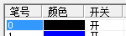表示当前笔要加工，即当加工到的对象对应的为当前笔号时要加工，双击此图标可以更改。
Open indicates that the current pen is to be processed, that is, when the processed object corresponding to the current pen number to be processed, double click this icon to change it.
表示当前笔不加工，即当加工到的对象对应的为当前笔号时不加工。
Turn Off indicates that the current pen is not processed, that is, when the processed object corresponding to the current pen number, it is not processed.

Color: The current pen’s color, which will be displayed when the object is corresponding to the current pen number, 双击颜色条可以更改颜色。
Color: The current pen’s color, which will be displayed when the object is corresponding to the current pen number, double click the color bar to change the color.
参数应用按钮：当用户按参数应用按钮时当前被选择的对象的笔号会被更改为对应的按钮笔号。如图9-2。
Parameter Application Button: When the user presses the parameter application button, the pen number of the currently selected object will be changed to the corresponding button pen number. As shown in Figure 9-2.
图9-2 参数应用按钮
Figure 9-2 Parameter Application Button
当用户在当前列表中按鼠标右键时会弹出如图9-3所示的右键菜单。
When the user presses the right mouse button in the current list, the right button menu as shown in Figure 9-3 will pop up.
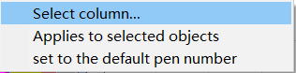
图9-3 右键菜单
Figure 9-3 Right Button Menu
选择列 Select List
应用到选择对象 Apply to the Selected Objects
设置为默认笔号 Set as Default Pen Number

9.1.2. 高级设置 Advanced Settings
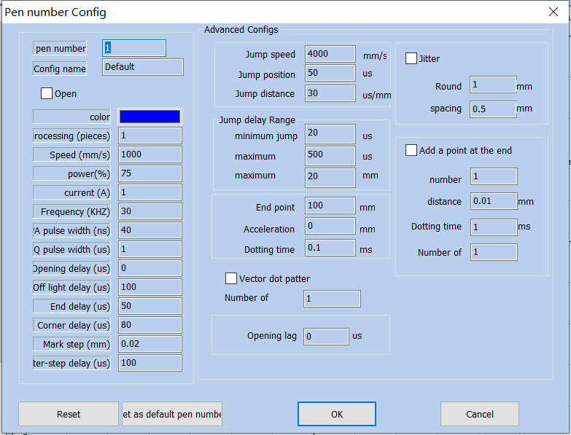
Here we will introduce the specific meaning of each parameter in details.
笔号参数 Pen Number Parameter
当前笔号 Current Pen Number
参数名称 Parameter Name
开启 Start
颜色 Color
加工数目（件） Processing Number (piece)
速度（mm/s） Speed (mm/s)
功率（%） Power (%)
电流（A） Current (A)
频率（KHZ） Frequency (KHZ)
MOPA脉宽（us） MOPA Pulse Width (ns)
Q脉宽（us） Q Pulse Width (ns)
开光延时（us） Light-on Delay (us)
关光延时（us） Light-off Delay (us)
结束延时（us） End Delay (us)
拐角延时（us） Corner Delay (us)
标刻步距（mm） Marking Step Distance (mm)
步间延时（us） Inter Step Delay (us)
高级参数 Advanced Parameters
跳转速度 Jump Speed
跳转位置延时 Jump Position Delay
跳转距离延时 Jump Distance Delay
跳转延时限定 Jump Delay Limit
最小跳转延时 Minimum Jump Delay
最大跳转距离 Maximum Jump Distance
末点补偿 End Point Compensation
加速距离 Acceleration Distance
打点时间 Dotting Time
矢量打点模式 Vector Dotting Mode
每个脉冲点数 Points per Pulse
开光滞后 Light-on Lag
抖动 Dithering
圆直径 Circle Diameter
间距 Spacing
末尾加点 Add Point at the End
数目 Quantity
距离 Distance
打点时间 Dotting Time
打点次数 Dotting Times
重置 Reset
设为默认笔号 Set as Default Pen Number
确定 OK
关闭 Close
基本参数区:
Basic Parameter Area:
Current Pen Number: The set of marking parameters currently used. In SeaCAD, the concept of “pen” is equivalent to a set of given marking parameters.
Processing (pieces): The marking times for each object during one marking are equivalent to the marking quantity in its marking parameters.
Speed: The marking speed of current marking parameters.
Power: This item indicates the power percentage of the current marking parameter, and 100% refers to the maximum power of current laser.
Frequency: The laser’s frequency in the current marking parameter.
Mopa pulse width: The ratio of laser pulse duration to pulse period.
Opening delay: Delay time of laser on at the beginning of marking. Setting the appropriate delay parameter can remove the "match head" at the beginning of marking, but if the delay parameter setting is too large, it will lead to the lack of pen at the beginning. It can be a negative value, which means that the laser light comes out ahead of time.
Off light delay: Delay time for laser off at the end of marking. Setting the appropriate light off delay parameter can remove the non closing phenomenon when the marking is completed, but if the light off delay setting is too large, the end segment will appear "match head". Cannot be negative.
End delay: Generally, it takes a period of response time from the time when the light off command is sent to the time when the laser is completely shut down. Setting an appropriate end delay is to give the laser a sufficient light off response time, so as to achieve the purpose of making the laser carry out the next marking when the laser is completely shut down, and prevent the light from leaking and the phenomenon of point rejection.
Polygon TC: Delay time between each segment during the marking. The proper Polygon TC parameters set can eliminate the circular angle appears during right angle marking, while the too large ones may cause marking time increase and double points at the corner.

Corner delay: Delay time between each segment during marking. If the corner delay is set too much, the marking time will increase, and the corner will have the key phenomenon.
高级参数区:
Advanced Parameter Area:
Jump Speed: Set a jump speed corresponded by the current parameter.
Jump Position: Jump position delay value.
Jump Distance: Jump distance delay value.
After each jump movement, the system will delay some time, and then execute the next command. The actual delay time is calculated by the following formula:
Jump delay = jump position delay + jump distance × jump distance delay;
End Point: Generally, this parameter does not need to be set. Only in high-speed machining, when the delay parameter cannot be adjusted to make the end point in place, this value is set to force the marking of a straight line with the length of the compensation distance of the end point at the end of machining. Negative values are acceptable.
Acceleration Distance: This parameter may be set properly to eliminate the uneven dotting at initial marking segment.
Dotting Time: It indicates light emitting time of each point in case that point objects exist.
Vector Dotting Mode: It indicates to compulsively specify the fixed pulse number given out by the laser during each point marking.
Add Point at the End: It is used to solve the problem of laser end shining. The software will automatically add points at the end of each pen, but will not display it as an object.
number: number of points added at the end.
Distance: Distance between the points added at the end.
Dotting Time: Marking time for each point added at the end.
Dotting Times: Marking times for each point added at the end.

9.2. Region parameter

9.2.1. Configuration Config[default]
See Fig. 9-4 for the field parameter of equipment:
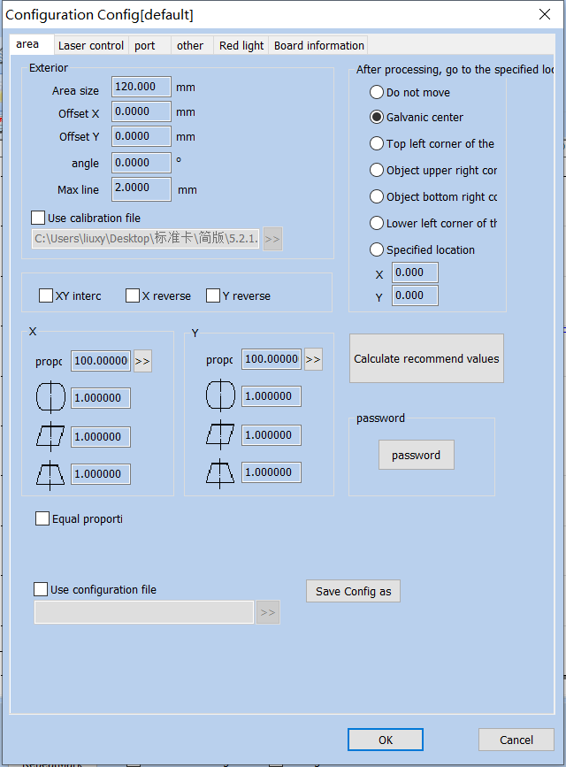
Figure.9-4 Configuration Config[default]
配置参数 [default] Configuration Parameters [default]
区域 Area
激光控制 Laser Control
端口 Port
其它 Others
红光指示 Red Light Indicator
板卡信息 Board Information
外观 Appearance
区域尺寸 Area Size
偏移X Offset X
偏移Y Offset Y
角度 Angle
最大线长 Maximum Line Length
使用校正文件 Use Correction File
XY互换 XY Interchange
X反向 Reverse X
Y反向 Reverse Y
比例 Scale
比例 Scale
等分比例法 Equal Scale Method
使用配置文件 Use Configuration File
计算推荐值 Calculate Recommended Value
密码 Password
密码 Password
参数另存为 Save Parameter As
确定 OK
关闭 Close
Area Size: The actual widest range for marking corresponded by the scanhead.。
Offset X: The offset distance of scanhead center in X direction from field lens center.
Offset Y: The offset distance of scanhead center in Y direction from field lens center.
Angle: Adjust the angle of the galvanometer.
Maximum line length: The maximum length of the line segment that is divided by the figure. It is used to split the line segment beforehand to deliver the data, so as to improve the marking accuracy.
Use the Calibration File: Use the calibration file generated by external calibration program to calibrate the scanhead.
XY Change: Change the axes corresponding to the original galvanometer signal 1 and signal 2.
reverseX/reverseY: The opposite direction of the current scanhead.
indicates the barrel distortion or pincushion distortion calibration coefficient with default of 1.0 (parameter range: 0.875-1.125).
indicates the parallelogram calibration coefficient with default of 1.0 (parameter range: 0.875-1.125).
indicates the trapezium calibration，with default of 1.0 (parameter range: 0.875-1.125).
Scale: It refers to the flex percentage, and the default is 100%. This parameter will be adjusted when the trim size marked is different from the setting size. If the trim size is smaller than the designed one, users can raise this parameter; if the trim size is bigger than the designed one, users can lower this parameter.
Note: If there are some distortions with the laser scanhead, users must firstly adjust the distortions and then the flex percentage.
During scale setting, we may press the button directly, and a dialog box like Fig. 9-5 will be popped up. After we input the set size in software and the actual marking size measured, the software will automatically calculate the flex percentage.
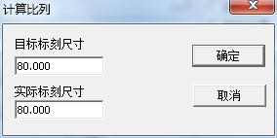
计算比例 Calculation Scale
目标标刻尺寸 Target Marking Size
实际标刻尺寸 Actual Marking Size
确定 OK
取消 Cancel
Fig.9-5 Calculate scale
等分比例法：校正时是否使用等分线计算缩放比例（详见10.2手工校正）。
Equal Scale Method: Whether to use the bisectrices to calculate the zooming scale during correction (see 10.2 manual correction for details).

Go to Specified Position after Marking: After the completion of current marking, move the scanhead to its specified position.
Password: Set the current parameters can only be changed by entering the password。

9.2.2. Laser Parameter
See Fig. 9-6 for the laser parameter of equipment:
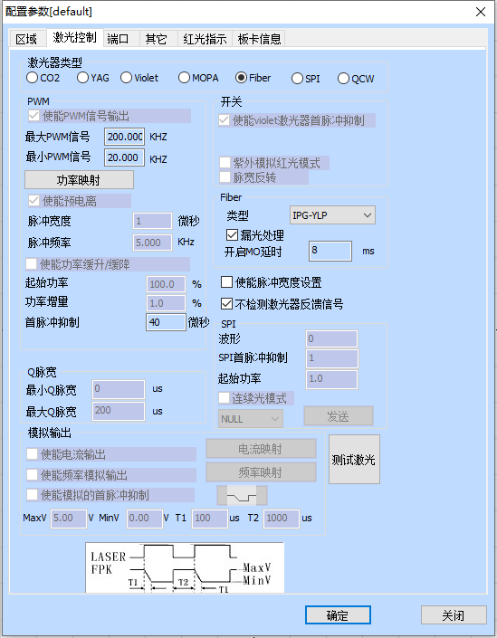
配置参数 [default] Configuration Parameters [default]
区域 Area
激光控制 Laser Control
端口 Port
其它 Others
红光指示 Red Light Indicator
板卡信息 Board Information
激光器类型 Laser Type
使能PWM信号输出 Enable PWM Signal Output
开关 Toggle
使能Violet激光器首脉冲抑制 Enable Violet Laser First Pulse Suppression
最大PWM信号 Maximum PWM Signal
最小PWM信号 Minimum PWM Signal
功率映射 Power Mapping
紫外模拟红光模式 UV Analog Red Light Mode
脉宽反转 Pulse Width Invert
使能预电离 Enable Preionization
脉冲宽度 1微秒 Pulse Width 1 microsecond
脉冲频率 Pulse Frequency
使能功率缓升/缓降 Enable Power Ramp Up/Ramp Down
类型 Type
漏光处理 Light Leakage Treatment
开启MO延时 Start MO Delay
起始功率 Initial Power
功率增量 Power Increment
首脉冲抑制 40微秒 First Pulse Suppression 40 microseconds
使能脉冲宽度设置 Enable Pulse Width Setting
不检测激光器反馈信号 Do not Detect Laser Feedback Signal
波形SPI首脉冲抑制 Waveform SPI First Pulse Suppression
起始功率 Initial Power
连续光模式 Continuous Light Mode
发送 Send
Q脉宽 Q Pulse Width
最小Q脉宽 Minimum Q Pulse Width
最大Q脉宽 Maximum Q Pulse Width
模拟输出 Analog Output
使能电流输出 Enable Current Output
使能频率模拟输出 Enable Frequency Analog Output
使能模拟的首脉冲抑制 Enable Analog First Pulse Suppression
电流映射 Current Mapping
频率映射 Frequency Mapping
测试激光 Test Laser
确定 OK
关闭 Close
Figure.9-6 Laser Control
Please carry out the adjustment as per the actual parameters of laser machine.

9.2.3. Port Parameter
See Fig. 9-7 for the equipment port parameter.
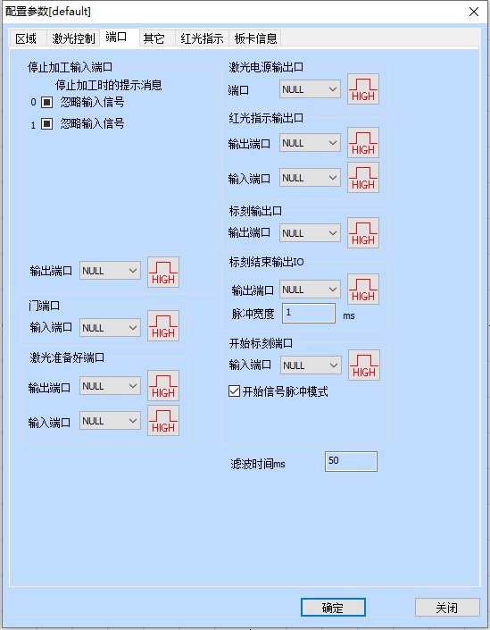
配置参数 [default] Configuration Parameters [default]
区域 Area
激光控制 Laser Control
端口 Port
其它 Others
红光指示 Red Light Indicator
板卡信息 Board Information
停止加工输入端口 Input Port of Stopping Processing
停止加工时的提示信息 Prompt Message When Stopping Processing
忽略输入信号 Ignore Input Signal
忽略输入信号 Ignore Input Signal
激光电源输出口 Output Port for Laser Power Supply
端口 Port
红光指示输出口 Output Port for Red Light Indicator
输出端口 Output Port
输入端口 Input Port
标刻输出口 Marking Output Port
输出端口 Output Port
输出端口 Output Port
门端口 Gate Port
输入端口 Input Port
激光准备好端口 Laser Ready Port
输出端口 Output Port
输入端口 Input Port
标刻结束输出IO Output IO After Finishing Marking
脉冲宽度 Pulse Width
开始标刻端口 Mark Starting Port
输入端口 Input Port
开始信号脉冲模式 Start Signal Pulse Mode
滤波时间 Filter Time
确定 OK
关闭 Close

Figure.9-7 Port
Input Port of Stopping Marking: Certain input port is specified as marking stopping port. During marking process, if the system detects there is a corresponding input signal, the current marking operation will be ended, and prompt the users with error information.
Gate Port: Check the port signals for safety gate opening and closing and make sure the marking will automatically stop in case of safety gate opening (red light indication may continue being used) so as to protect the operators from being burnt.
Laser Power Supply Output Port: This port may be used to control the on-off of laser power supply.
Red Light Pointer Output Port: The system will output high level to the appointed output port during red light pointer.
Mark Output Port: The system will output high level to the appointed output port during marking.
Mark Starting Port: In idle state, the system will start marking automatically if high level is output by the appointed input port.
Start Signal Pulse Mode: Checking this option means the start signal is marked by software in pulse mode, even for continuous level input, the software only reads one pulse. Otherwise the input port marked is of continuous level.

9.1.2.4. Red Light
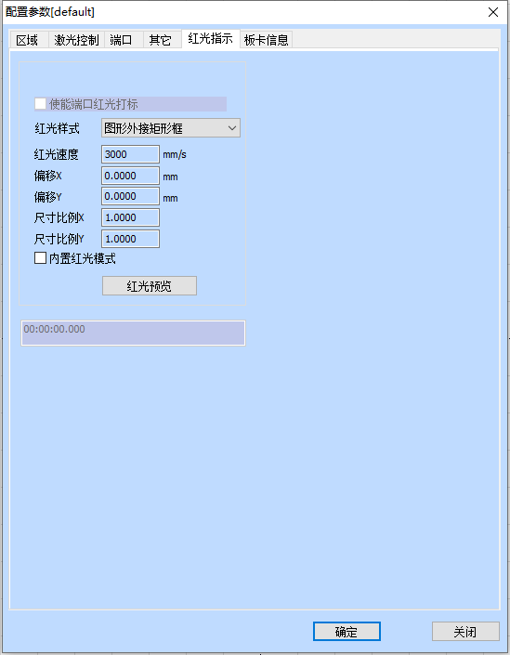
配置参数 [default] Configuration Parameters [default]
区域 Area
激光控制 Laser Control
端口 Port
其它 Others
红光指示 Red Light Indicator
板卡信息 Board Information
使能端口红光打标 Enable Port Red Light Marking
红光样式 Red Light Style
图形外接矩形框 Graphic External Rectangular Box
红光速度 Red Light Speed
偏移X Offset X
偏移Y Offset Y
尺寸比例X Size Scale X
尺寸比例Y Size Scale Y
内置红光模式 Built-in Red Light Mode
红光预览 Red Light Preview
确定 OK
关闭 Close
Figure.9-10 Red Light
Red light style: Used to select the red light to display the bounding rectangle of the figure or the outline of the figure.
Red Light Speed: It indicates the system movement speed in case of red light pointer.
Offset Position: It indicates the system movement offset position in case of red light pointer and may be used to compensate the position error between red light and actual laser.
Size Scale: It refers to the size deviation between red light and laser, by adjusting which the two can completely coincide.

9.1.2.5. Others
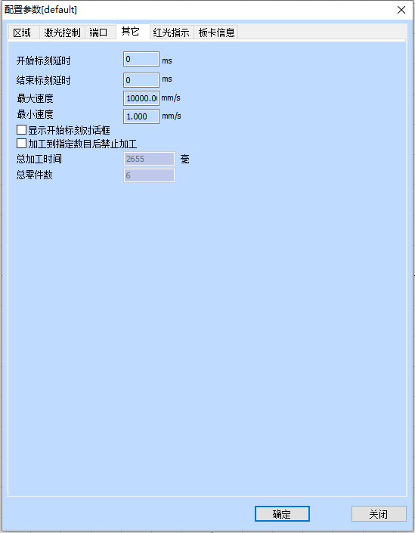
配置参数 [default] Configuration Parameters [default]
区域 Area
激光控制 Laser Control
端口 Port
其它 Others
红光指示 Red Light Indicator
板卡信息 Board Information
开始标刻延时 Delay for Starting Marking
结束标刻延时 Delay for Finishing Marking
最大速度 Maximum Speed
最小速度 Minimum Speed
显示开始标刻对话框 Display the Dialog Box for Starting Marking
加工到指定数目后禁止加工
Forbid Processing after Designated Processing Number is Achieved
总加工时间 2655毫 Total Processing Time 2655 milli
总零件数 Total Parts
确定 OK
关闭 Close
Figure.9-11 Others
Delay for Starting Marking: Start the marking after delay of appointed time at the beginning of each marking.
Delay for Finishing Marking: Finish the marking after delay of appointed time at the end of each marking.
Forbid Marking after Designated Marking Number is Achieved: When the parts number reaches the total marking number designated, the system will pop up a dialog box to prompt that “the current number has exceeded the total marking number, please reset it, and then start marking”.
Display the Dialog Box for Starting Marking: After checking, it will prompt a dialog box of “whether to start marking” for each time selecting marking, as shown in Fig. 9-12.
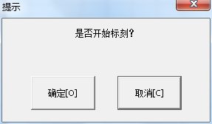
提示 Tip
是否开始标刻？ Do you start marking?
确定 OK
取消 Cancel
Figure.9-12 Start Marking Dialog

9.1.3.Mark
The Marking dialog box is at the bottom of the SeaCAD interface, as shown in Fig.9-13.
红光 Red Light
标刻 Marking
连续加工 Continuous Processing
零件 Part
选择加工 Selective Processing
总数 Total Number
下载至板卡 Download to Board
参数 Parameter
自动红光 Auto Red Light
红光显示轮廓 Red Light Display Outline
连续红光模式 Continuous Red Light Mode
Fig.9-13 Marking Dialog
Red Light: This item is used to mark the frame of the object without laser output and indicate the marking area so that users are convenient to orient the workpiece. This function is available in those laser machines which have red guide light. Key “F1” is the shortcut key of this function.
Mark: To execute marking. Key “F2” is the shortcut key of this function.
Continuous: Mark the current object repeatedly without stop.
Mark Selected: Only those selected objects would be marked.
Part: It indicates the total quantity of parts which have been marked.
Enable display outline: Check this function to display the outline of the figure when displaying red light.
Total Number: It indicates the total parts to be marked, which is ineffective under the mode of Continuous Marking. If the total part number is more than 1, the marking operation will not stop until the number of parts marked is equal to the total part number.
R: Marking parts reset.
Parameter: It is used for equipment setting.
下载至板卡：将当前数据下载至板卡缓存中开始离线打标模式。
Download to Board: Download the current data to the board cache to start offline marking mode.

Enable Continuous Red Light Marking Mode: After selecting this function, returning to the software interface and clicking “Marking”, a dialog box as shown in Fig. 9-14 will appear. It will appear after each marking and red light preview will always exist.
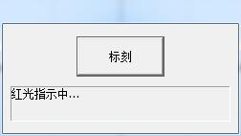
标刻 Marking
红光指示中 Red Light Indicating
Fig.9-14 Continuous Red Light Marking Mode

10. Scanhead Calibration

10.1.Direction adjustment
The direction needs to be adjusted to the same direction as the drawing area before the calibration.
For example, draw a text in the drawing area, as shown below:
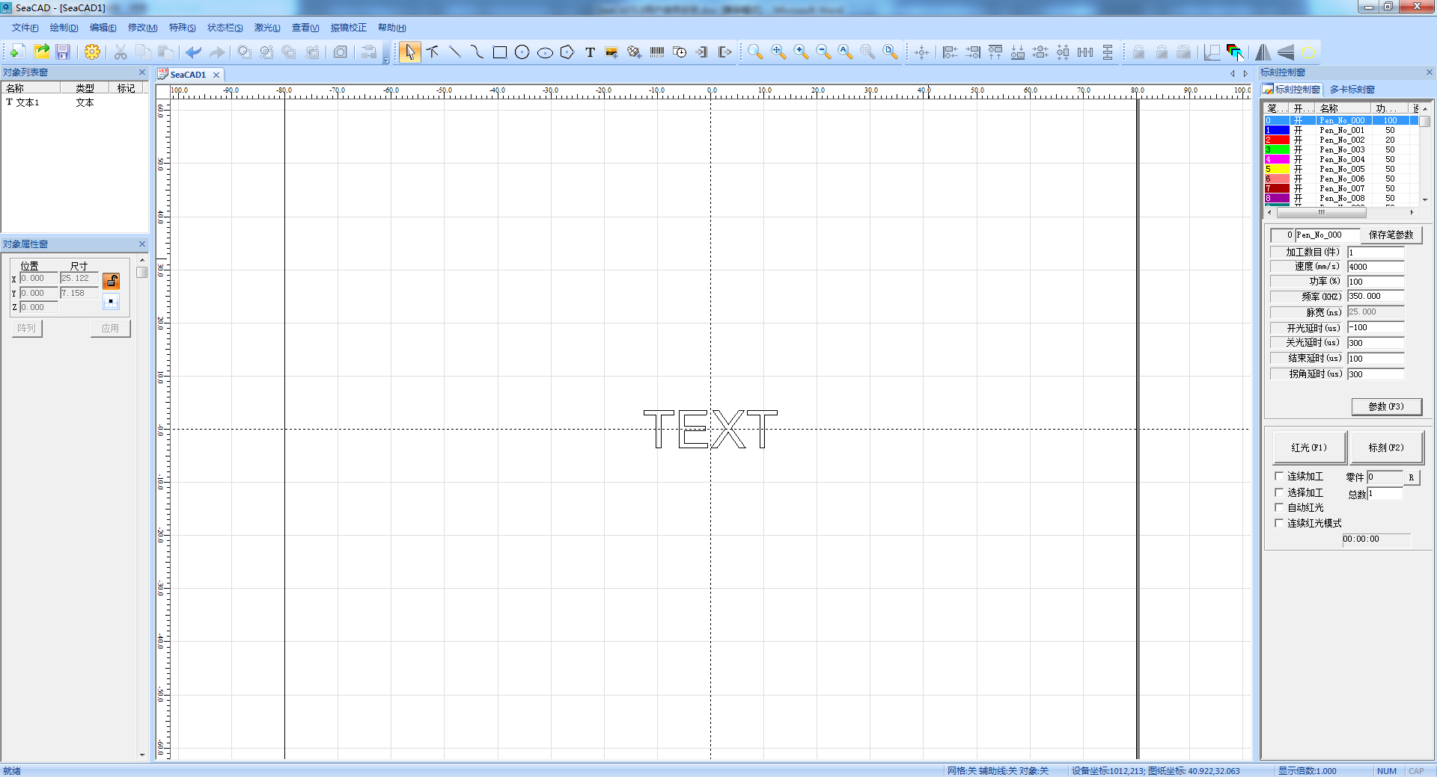
Try to change the three checkmarks in the blue box below and mark until the marked figure matches the drawing area.
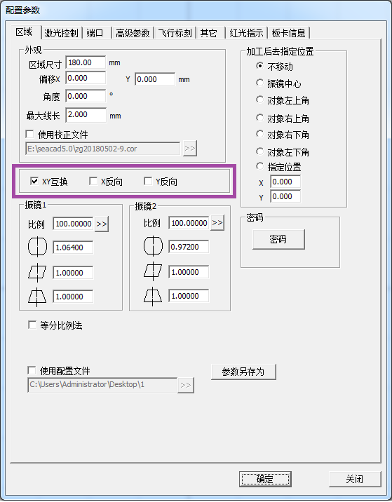
配置参数 Configuration Parameters
区域 Area
激光控制 Laser Control
端口 Port
高级参数 Advanced Parameters
飞行标刻 Flight Marking
其它 Others
红光指示 Red Light Indicator
板卡信息 Board Information
外观 Appearance
区域尺寸 Area Size
偏移X Offset X
角度 Angle
最大线长 Maximum Line Length
使用校正文件 Use Correction File
XY互换 XY Interchange
X反向 Reverse X
Y反向 Reverse Y
加工后去指定位置 Go to the Designated Position After Processing
不移动 Do Not Move
振镜中心 Galvanometer Center
对象左上角 Upper Left Corner of Object
对象右上角 Upper Right Corner of Object
对象右下角 Lower Right Corner of Object
对象左下角 Lower Left Corner of Object
指定位置 Designated Position
振镜1 Galvanometer 1
比例 Scale
振镜2 Galvanometer 2
比例 Scale
等分比例法 Equal Scale Method
密码 Password
密码 Password
使用配置文件 Use Configuration File
参数另存为 Save Parameter As
确定 OK
关闭 Close

10.2. Manual Correction
Manual correction, enter from the right parameter (F3), as shown in the blue box in the figure below. By default, the galvanometer 1 corresponds to x and the galvo mirror 2 corresponds to y. If the xy swap is checked, the galvanometer 1 corresponds to y. Galvo 2 corresponds to x：
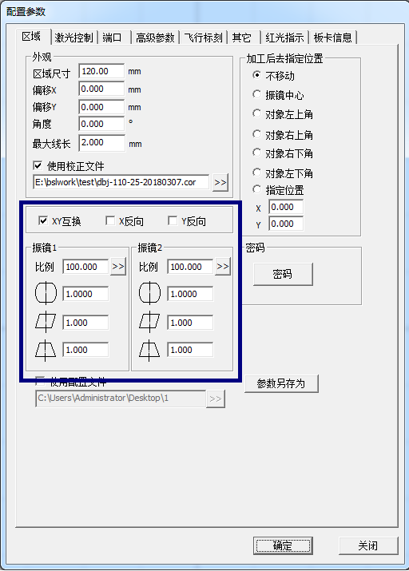
配置参数 Configuration Parameter
区域 Area
激光控制 Laser Control
端口 Port
高级参数 Advanced Parameter
飞行标刻 Flight Marking
其它 Others
红光指示 Red Light Indicator
板卡信息 Board Information
外观 Appearance
区域尺寸 Area Size
偏移X Offset X
偏移Y Offset Y
角度 Angle
最大线长 Maximum Line Length
使用校正文件 Use Correction File
XY互换 XY Interchange
X反向 X Reverse
Y反向 Y Reverse
加工后去指定位置 Go to the Designated Position After Processing
不移动 Do Not Move
振镜中心 Galvanometer Center
对象左上角 Upper Left Corner of Object
对象右上角 Upper Right Corner of Object
对象右下角 Lower Right Corner of Object
对象左下角 Lower Left Corner of Object
指定位置 Designated Position
振镜1 Galvanometer 1
比例 Scale
振镜2 Galvanometer 2
比例 Scale
密码 Password
密码 Password
使用配置文件 Use Configuration File
参数另存为 Save Parameter As
确定 OK
关闭 Close

10.2.1.Shape adjustment
Adjust the curvature, trapezoidal deformation, parallelogram deformation.
Each time you change the curvature, trapezoid, and parallelogram parameters, click "Mark test rectangle" until it is square.

10.2.2.Zoom
According to the marked figure, measure the actual size,Zoom in/out, as shown below:
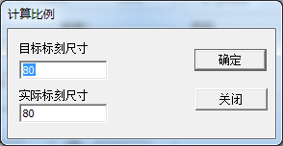
计算比例 Calculation Scale
目标标刻尺寸 Target Marking Size
实际标刻尺寸 Actual Marking Size
确定 OK
关闭 Close

In the first step, click on the “marking X scale line” and the software mark a line in X direction.

10.2.3.等分比例法 Equal Scale Method
对于精度要求比较高的场景，可以使用等分线来提高精度。
For scenes with high precision requirements, you can use bisectrices to improve precision.

注意：在使用等分比例前，应该将图形的弯曲、梯形、倾斜形变都校正目标精度范围。
Note: Before using the equal scale, the bending, trapezoid and tilt deformation of the graph should be calibrated for the target precision range.

勾选 “等分比例法”，出现如下图：
Check the “Equal Scale Method” and the following figure appears:
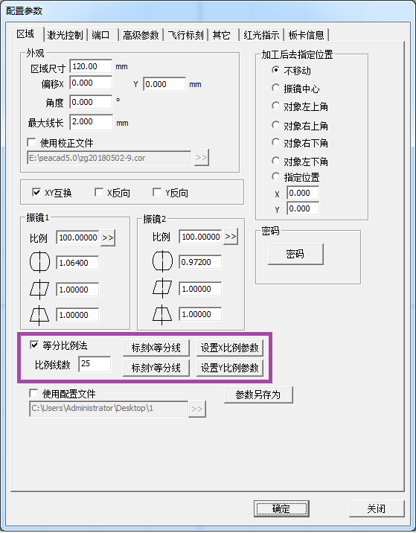
配置参数 Configuration Parameter
区域 Area
激光控制 Laser Control
端口 Port
高级参数 Advanced Parameter
飞行标刻 Flight Marking
其它 Others
红光指示 Red Light Indicator
板卡信息 Board Information
外观 Appearance
区域尺寸 Area Size
偏移X Offset X
角度 Angle
最大线长 Maximum Line Length
使用校正文件 Use Correction File
XY互换 XY Interchange
X反向 X Reverse
Y反向 Y Reverse
加工后去指定位置 Go to Designated Position After Processing
不移动 Do Not Move
振镜中心 Galvanometer Center
对象左上角 Upper Left Corner of Object
对象右上角 Upper Right Corner of Object
对象右下角 Lower Right Corner of Object
对象左下角 Lower Left Corner of Object
指定位置 Designated Position
振镜1 Galvanometer 1
比例 Scale
振镜2 Galvanometer 2
比例 Scale
密码 Password
密码 Password
等分比例法 Equal Scale Method
比例线数 Scale Line Number
标刻X等分线 Mark X Bisectrix
设置X比例参数 Set X Scale Parameter
标刻Y等分线 Mark Y Bisectrix
设置Y比例参数 Set Y Scale Parameter
使用配置文件 Use Configuration File
参数另存为 Save Parameter As
确定 OK
关闭 Close

设置好等分线数，比如若要设置5mm一格，则对于工作区域为120mm的振镜，设定等分数为25。
Set the number of bisectrices. For example, if you want to set 5mm/grid, set the number of bisectrices to 25 for the galvanometer with a working area of 120mm.

点击“标刻X等分线”，测量各等分线到中线的距离，点击“设置X比例参数”，显示等分参数界面。
Click “Mark X Bisectrix”, measure the distance from each bisectrix to the center line, and click “Set X Scale Parameter” to display the equal parameter interface.
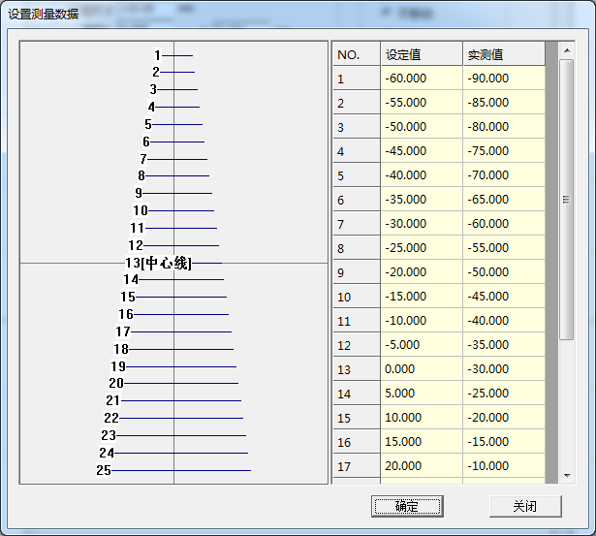
设置测量数据 Set Measurement Data
设定值 Setting Value
实测值 Actual Value
[中心线] [Center Line]
确定 OK
关闭 Close

在等分参数界面中的表格内，将测量值输入实测值列。点击“确定”使数据生效。
Enter the measured value into the actual value column in the table of the equal parameter interface. Click “OK” to make the data effective.

同样操作，设置好Y等分值。
Similarly, set the Y equal value.

10.2.4.Save
Click "Save" to save the parameters using the current file name (or default file name); click "Save Data As" to save the file using another file name.
The saved file can be used for data correction of the marking software.

10.3. 九点校正 Nine Point Correction
用于精度要求比较高的场合。
It is used for occasions with high precision requirements.

校正前的相关参数设置
Relevant Parameter Setting Before Correction

- 在主界面右边标刻参数栏中选择，打开参数设置。快捷键为F3。
- Select in the marking parameter column on the right side of the main interface to open the parameter setting. The shortcut key is F3.

- 确定场镜范围，以120mm为例，把区域尺寸的参数改成120。
- Determine the field lens range, take 120mm as an example, change the parameter of area size to 120.

- 设置好振镜方向，如下图。
- Set the galvanometer direction, as shown below.
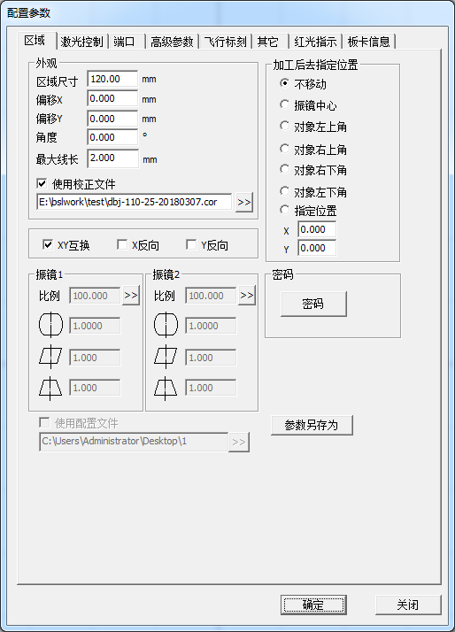
配置参数 Configuration Parameters
区域 Area
激光控制 Laser Control
端口 Port
高级参数 Advanced Parameters
飞行标刻 Flight Marking
其它 Others
红光指示 Red Light Indicator
板卡信息 Board Information
外观 Appearance
区域尺寸 Area Size
偏移X Offset X
偏移Y Offset Y
角度 Angle
最大线长 Maximum Line Length
使用校正文件 Use Correction File
XY互换 XY Interchange
X反向 X Reverse
Y反向 Y Reverse
加工后去指定位置 Go to the Designated Position After Processing
不移动 Do Not Move
振镜中心 Galvanometer Center
对象左上角 Upper Left Corner of Object
对象右上角 Upper Right Corner of Object
对象右下角 Lower Right Corner of Object
对象左下角 Lower Left Corner of Object
指定位置 Designated Position
振镜1 Galvanometer 1
比例 Scale
振镜2 Galvanometer 2
比例 Scale
密码 Password
密码 Password
使用配置文件 Use Configuration File
参数另存为 Save Parameter As
确定 OK
关闭 Close
图9-1 区域参数
Figure 9-1 Area Parameters

10.3.1开始校正 Start Correction

从菜单进入 “九点校正”，进入九点校正操作界面。
Enter "Nine Point Correction" from the menu and enter the nine point correction operation interface.

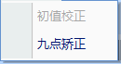
初值校正 Initial Value Correction
九点校正 Nine Point Correction
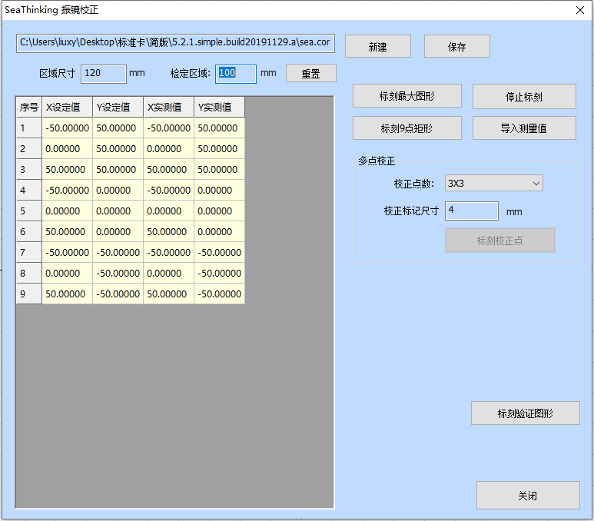

振镜校正 Galvanometer Correction
C:\Users\liuxy\Desktop\标准卡\简版\5.2.1.simple.build20191129.a\sea.cor
C:\Users\liuxy\Desktop\standard card\simplified version\
5.2.1.simple.build20191129.a\sea.cor

区域尺寸 Area Size
检定区域 Verification Area
重置 Reset
序号 Serial Number
X设定值 X Setting Value
Y设定值 Y Setting Value
X实测值 X Actual Value
Y实测值 Y Actual Value
标刻最大图形 Maximum Marking Graph
停止标刻 Stop Marking
标刻9点矩形 Marking 9 Point Rectangle
导入测量值 Import Measured Value
多点校正 Multi-dot Correction
校正点数： Correction Points:
校正标记尺寸 Correct Marking Size
标刻校正点 Marking Correction Point
标刻验证图形 Marking Verification Graph
关闭 Close

10.3.2标刻校正图形 Marking Correction Graphs

新建一个校正文件，然后设置检定区域为100mm，重置。
Create a new correction file, then set the verification area to 100mm, and reset.

点击“标刻9点矩形”，可以标刻出下面的图形（x，y用于说明图形方向，不会实际标刻），注意其中的短线段和左上角的三角形的方向与位置必须跟下图一致，若不一致，则调整主界面的XY互换、X反向、Y反向参数，直到标刻出的图形与上图形状方向相同为止。
Click "Mark Nine Point Rectangle" to mark the following graph (x, y are used to illustrate the direction of the graph, but not the actual marking). Note that the direction and position of the short line segment and the triangle in the upper left corner must be consistent with the figure below. If it is not consistent, then adjust the XY interchange, X reverse and Y reverse parameters of the main interface until the marked graphs are in the same direction as the figure above.
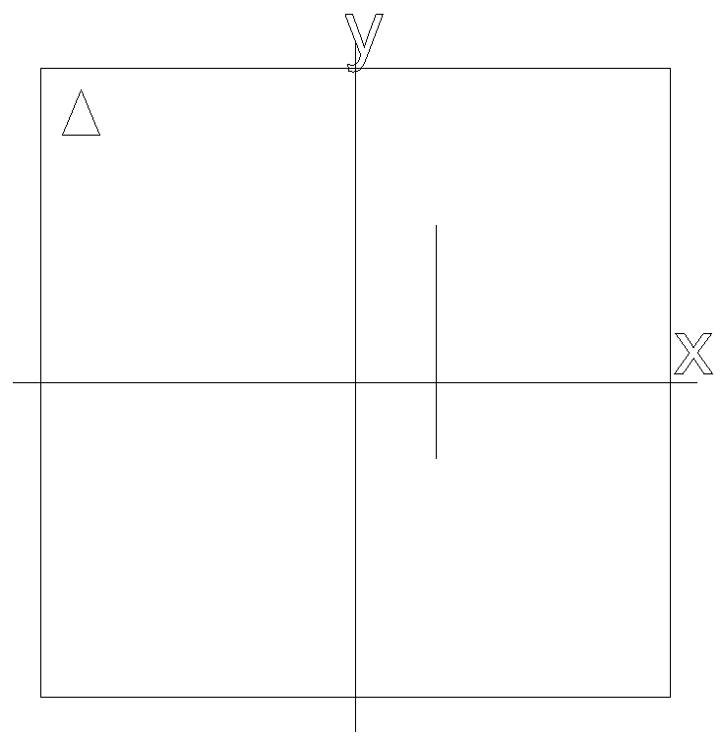
测量点的坐标时，尽可能减少测量误差。依次测量上图中的9个点的坐标值，基于中心点（5号点）进行，顺序号如下图所示：
When measuring the coordinates of points, the measurement error should be reduced as much as possible. Measure the coordinate values of 9 points in the above figure in turn, based on the center point (point 5), and the sequence number is as shown in the following figure:
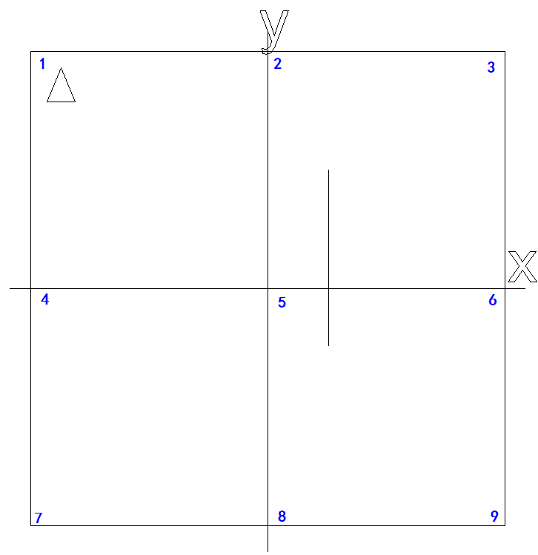
- 以十字中心线（过5号点的直线与坐标轴）为基准，依次测量9个点的坐标值，并记录。测量方法为游标卡尺一边与十字中心线的X轴或者Y轴重合，另外一边与要测量的点重合，这个时候读数就是校正值。或者使用二次元测量。如图9-5取第1点校正值为例：（可以考虑测量3次取平均值的方法会更加精确）
- Take the cross center line (straight line and coordinate axis passing point 5) as the benchmark, measure the coordinate values of 9 points in turn and record. The measurement method is that one side of the vernier caliper coincides with the X-axis or Y-axis of the cross center line, and the other side coincides with the point to be measured. At this time, the reading is the correction value. Or use the quadratic element measurement. As shown in Figure 9-5, take the correction value of point 1 as an example: (it can be considered that the method of measuring for three times to take the average value, which will be more accurate)

- 将测量值填充到数据表中的第4、5列。其中第2、3列为设定的距离，4、5两列为对应的实际标刻距离，注意测量值是有正负的。
- Fill the measured values into columns 4 and 5 of the data table. In which, the columns 2 and 3 are the set distances, and the columns 4 and 5 are the corresponding actual marking distances. Note that the measured values are positive and negative.

- 点击“保存”，保存文件（这里保存为9dot.cor）如图9-9；
- Click “Save” to save the file (here save as 9dot. cor), as shown in Figure 9-9;

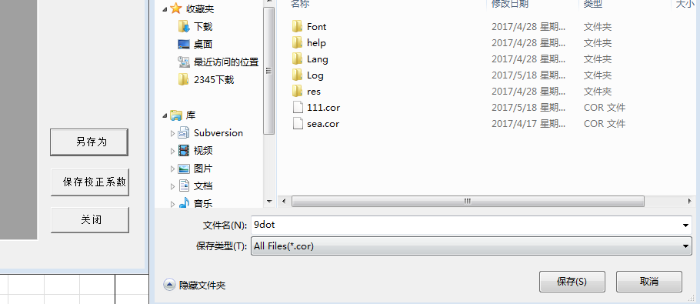
收藏夹 Facorites
下载 Downloads
桌面 Desktop
最近访问的位置 Last Visited Location
2345下载 2345 Downloads
库 Library
视频 Videos
图片 Images
文档 Documents
音乐 Music
名称 Name
修改日期 Modified Date
类型 Type
大小 Size
文件名（N）: File Name (N):
保存类型（T）： Save Type (T):
隐藏文件夹 Hide Folders
保存 Save
取消 Cancel
图9-9 保存校正文件
Figure 9-9 Save Correction File

- 保存后，可以点击“标刻验证图形”，将标刻校正后图形，如下图：
- After saving, you can click the “Marking Verification Graph” to mark the corrected graphs, as shown below:

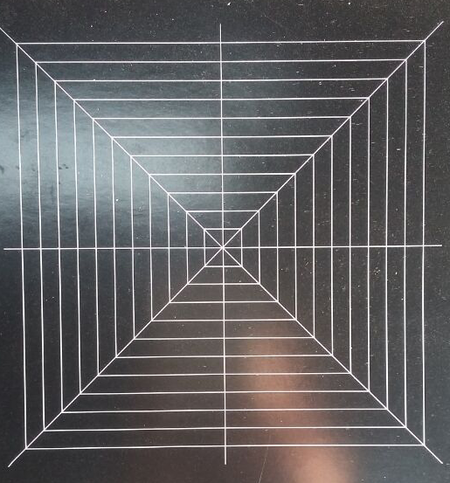

10.3.3使用校正文件 Use Correction File
- 在配置参数里使用校正文件，如下图9-10，勾选使用校正文件，选中对应的9dot.cor文件即可。
- Use the correction file in the configuration parameters, as shown in Figure 9-10 below. Check the use correction file and select the corresponding 9dot.cor file.
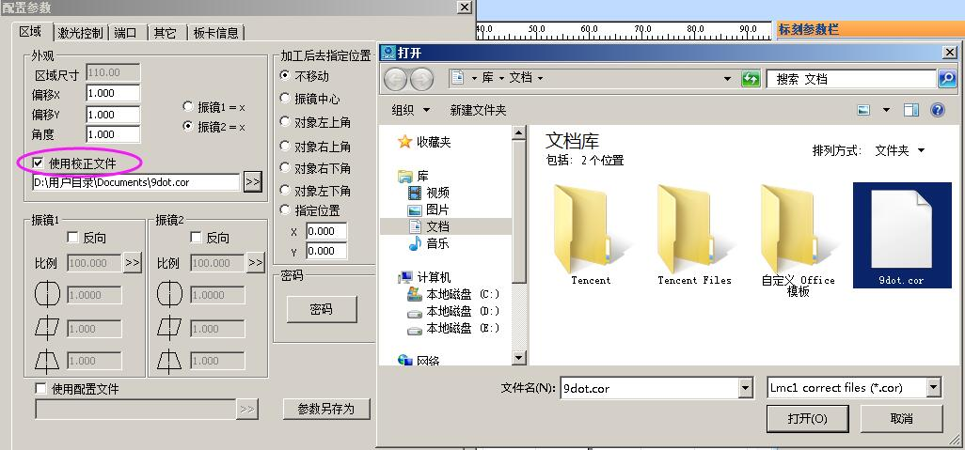
配置参数 Configuration Parameters
区域 Area
激光控制 Laser Control
端口 Port
其它 Others
板卡信息 Board Information
外观 Appearance
区域尺寸 Area Size
偏移X Offset X
偏移Y Offset Y
振镜1 = X Galvanometer 1 = X
振镜2 = X Galvanometer 2 = X
使用校正文件 Use Correction File
D:\用户目录\Documents\9dot.cor D:\user directory\Documents\9dot.cor
振镜1 Galvanometer 1
反向 Reverse
比例 Scale
振镜2 Galvanometer 2
反向 Reverse
比例 Scale
使用配置文件 Use Configuration File
加工后去指定位置 Go to the Designated Position After Processing
不移动 Do Not Move
振镜中心 Galvanometer Center
对象左上角 Upper Left Corner of Object
对象右上角 Upper Right Corner of Object
对象右下角 Lower Right Corner of Object
对象左下角 Lower Left Corner of Object
指定位置 Designated Position
密码 Password
密码 Password
参数另存为 Save Parameter As
标刻参数栏 Marking Parameter Bar
打开 Open
库 Library
文档 Documents
组织 Organization
新建文件夹 New Folder
收藏夹 Facorites
库 Library
视频 Videos
图片 Images
文档 Documents
音乐 Music
计算机 Computer
本地磁盘（C:） Local Disk (C:)
本地磁盘（D:） Local Disk (D:)
本地磁盘（E:） Local Disk (E:)
网络 Network
文档库 Document Library
包括：2个位置 Including: 2 Positions
排列方式：文件夹 Arrangement: Folders
文件名（N）： File Name (N):
打开 Open
取消 Cancel
使用校正文件
Use Correction File

10.3.4均匀度校正与高精度调校Uniformity Correction and High Precision Adjustment

经过区域校正后，一般来说精度可以达到要求，若均匀度不能满足要求，可在x，y方向上增加等分比例校正。
After the area correction, generally speaking, the precision can meet the requirements. If the uniformity can not meet the requirements, you can increase the equal scale correction in the x and y directions.

勾选“等分比例法”，出现如下界面：
Check the “Equal Scale Method” and the following interface appears:

10.3.4.1 X方向比例参数调整 Scale Parameter Adjustment in X Direction

第一步，点击“标刻X比例线”,程序延X轴方向标刻出由短渐长的短线。
Step 1, click "Mark X Scale Line", the program marks the short line from short to long along the X-axis direction.

第二步，点击“设置X比例参数”，进入比例值设置界面。
Step 2, click “Set X Scale Parameter” to enter the scale value setting interface.

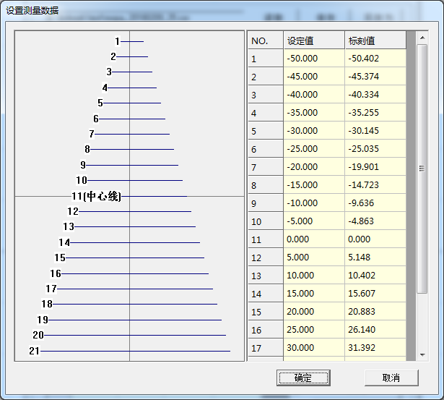
设置测量数据 Set Measurement Data
设定值 Setting Value
标刻值 Marking Value
[中心线] [Center Line]
确定 OK
取消 Cancel

按图中描述的顺序，依次测量短线到中心线之间的距离（mm），并填入右侧表格中，点确定返回主界面。
According to the sequence described in the figure, measure the distance (mm) from the short line to the center line in turn, fill it in the table on the right, and click OK to return to the main interface.

第三步，点击“标刻X测试线”，程序沿X轴向，标刻出一系列由短渐长的等分（对检定区域的大小进行20 等分，比如检定区域为100mm，则相邻等分线之间的标准距离为5mm）短线，测量各短线与中心线之间的距离。如果某个间隔大于标准等分距离，则需要将比例参数距离调大，若小于标准等分距离，则需要将比例参数调小。
Step 3, click “Mark X Test Line”, the program marks a series of equal (20 equal parts for the size of the verification area, for example, if the verification area is 100 mm, the standard distance between adjacent bisectrices is 5 mm) short lines along the X-axis direction, and measures the distance between each short line and the center line. If a certain interval is greater than the standard equal distance, you need to increase the scale parameter distance; if it is smaller than the standard equal distance, you need to decrease the scale parameter.

例如，若测量得到图中线5与线6的间距为4.9，（假定6，7，8，9，10均正确），则此时线5与中心线的距离为29.9。根据图2-13中所填入的数据，此数值位于“6”和“7”之间。根据上述规则，我们需要调整其中较大的“6”中的数据，因4.9小于5，因此需要将原值30.8减小。
For example, if the measured spacing between line 5 and line 6 in the figure is 4.9, (assuming that 6, 7, 8, 9 and 10 are correct), then the distance between line 5 and the center line is 29.9. According to the data filled in Figure 2-13, this value is between “6” and “7”. According to the above rules, we need to adjust the data in the larger “6”, 4.9 is less than 5, so we need to reduce the original value of 30.8.

10.3.4.2 Y方向比例参数调整 Scale Parameter Adjustment in Y Direction

操作步骤与9.2.5.1一样。
The operation steps are the same as 9.2.5.1.

11. Help

11.1. About SEACAD
Click "About SEACAD" to display the software version information.

11.2. 重置工作区布局Reset Workspace Layout

如果软件出现界面显示错误，或者窗口状态异常等问题，可以通过该功能重置成初始状态；
If the software appears the interface display error, or abnormal window state and other problems, you can reset it to the initial state through this function;

如果用户之前有使用我们的标刻软件，在更新版本之前，我们建议客户先重置一次工作区布局以免由于不兼容导致程序在打开的时候出现不可预知的错乱。
If the user has used our marking software before, before updating the version, we recommend that the customer should reset the workspace payout first to avoid unpredictable disorder when the program is opened due to incompatibility.

注意：使用该功能需要手动重启本程序。
Note: To use this function, you need to restart the program manually.

11.3. 板卡注册 Board Registration
客户购买或试用板卡，需要根据销售方的要求进行板卡的注册。
If customers want to purchase or try out the boards, they need to register the boards according to the requirements of the sellers.

作为对客户和销售方的限制，本程序在没有检测到任何的已经正式注册（无使用限制）或者试用期注册（有使用时长限制，具体时长请咨询销售方）的板卡的时候，是不允许客户进行标刻（包括红光）和保存操作的，而且软件也会有30分钟的使用限制，30分钟之后将强制退出程序；
As a restriction on customers and sellers, the program does not allow customers to mark (including red light) and save when it does not detect any board that has been officially registered (without restrictions on use) or registered during the probation period (with restrictions on service time, please consult the sellers for specific time), and the software will also have a 30-minute use restriction. After 30 minutes, the program will be forced to exit;

仅需一张板卡处于正式注册或试用期注册时，软件将会解除所有的限制，但对于没有正式注册或者已经超过试用期的板卡，仍然无法标刻和红光（只能在板卡注册界面查看到相关的板卡）。
When only one board is in the formal registration or probation period registration, the software will release all restrictions, but for the boards that have not been formally registered or have exceeded the probation period, they still cannot be marked and red light (only the relevant boards can be viewed in the board registration interface).

板卡注册方法如下图所示：
The board registration method is shown in the following figure:

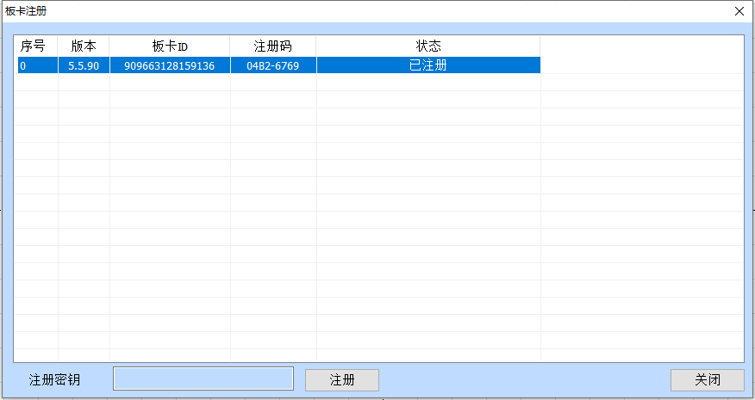
板卡注册 Board Registration
序号 Serial Number
版本 Version
板卡ID Board ID
注册码 Registration Code
状态 State
已注册 Registered
注册密钥 Registration Key
注册 Registration
关闭 Close

- 把注册码发给您的供应商。
- 从供应商那里得到注册密钥。
- 把注册密钥输入到注册密钥对应的位置。
- 点击注册后静待数秒后，弹出注册成功框确定完成注册。
1. Send the registration code to your supplier.
2. Obtain the registration key from the supplier.
3. Enter the registration key to the corresponding location of the registration key.
4. After clicking on the registration and waiting for a few seconds, the registration success box will pop up to confirm the completion of registration.

11.4. Help documentation
Click "Help Documentation" to open the software manual directly.

