Employees Must Wash Hands!

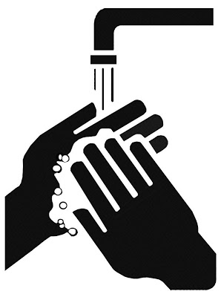

Tom Regan Consulting Food and Alcohol safety training (970) 948-9127

For More Information Call CDPHE (303) 241-4565

6-301.14