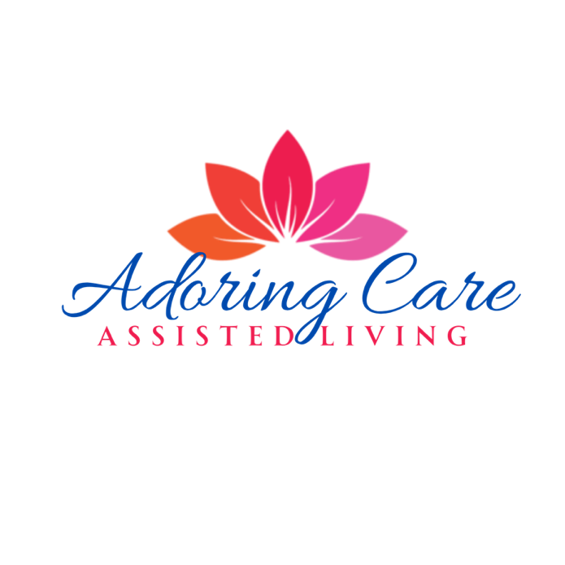
"Where Comfort, Care, and Compassion Come Together"
1111 S. 9th St., Midlothian, TX 76065

Information to Collect for our Waitlist

1. Basic Contact Information:
• Full Name of Potential Resident ____________________________________________________________
• Name and Contact Information of Responsible Party (if applicable) ____________________________________________________________
- Phone Number _______________________________________
- Email Address _______________________________________
• Relationship to the Resident
2. Resident Details:
• Age and Gender _______________________________________
• Current Living Situation _______________________________________
• Desired Move-in Timeline (e.g., immediate, 3–6 months, or flexible) _______________________________________
3. Care Needs:
• General Level of Care Required (e.g., minimal assistance, memory care, mobility support, etc.)
__________________________________________________________________________________________________________________________________________________________
• Special Medical Conditions or Diagnoses
__________________________________________________________________________________________________________________________________________________________
• Known Allergies, Dietary Restrictions, or Preferences
__________________________________________________________________________________________________________________________________________________________
4. Payment Information:
• Acknowledgment of Private Pay Policy

We are delighted that you’re considering Adoring Care Assisted Living as a future home for your loved one. At Adoring Care,
we strive to provide the highest level of personalized care in a warm and welcoming environment. To maintain the quality and level of services we provide, we operate as a private pay home and are unable to accept Medicaid payments. We want to
ensure transparency, so families can make informed decisions that best meet their needs. If you have any questions about this or would like assistance exploring private pay options, we’re happy to help.
5. Preferences and Expectations:
• Specific Amenities or Services They Value Most __________________________________________________________________________________________________
• Any Questions or Concerns About Your Facility ___________________________________________________________________________________________________
6. Follow-Up Preferences:
• Preferred Method of Communication (phone, email, etc.) ________________________________________________________________________________________
• How Often They’d Like to Be Updated on Availability _____________________________________________________________________________________________
We plan to open in August 2025, with our Deposit List opening in June

