
BRIFMA Consulting and Management Studies
Introduction
In a world faced with rapid transformations and increasing challenges there is a dire need for innovative strategic visions, advanced management solutions, and distinguished organizational capabilities. Based on this realization, BRIFMA was established to be an effective partner in the process of development and prosperity, a pivotal contributor facilitating the achievment of our partners’ visions and missions, and forecasting the future with proactive strategies enabling organizations of keeping pace with global advancements.
Who we are
At BRIFMA, we believe that the essence of success lies in a long-term strategic partnership based on trust, transparency, commitment, and insight. We are committed to being your partner on the journey of organizational excellence and achieving global leadership by providing specialized and innovative consulting solutions with tools and strategies that enable you to lead change and shape the future.
Our vision
Innovative management solutions, organizational empowerment and enhancing future readiness in accordance with global best practices.
Our mission
Enabling organizations and individuals to achieve the highest levels of excellence and leadership through innovative solutions that support readiness for the future and empowering organizations according to best practices and international standards.
Our values
- Professionalism: We are committed to the highest standards of quality and professionalism in all our services.
- Innovation: We seek new and creative solutions to address leadership and management challenges.
- Transparency: We are keen to build relationships with our clients.
- Partnership: We believe in the importance of cooperation and integration with our clients to achieve mutual success.
- Continuous improvement: We believe that sustainable development is the key to corporate success.
Our services

Organizational and operational excellence
  - Developing and implementing organizational and operational excellence programs.
  - Implement evaluation processes and provide practical recommendations for improvement and closing gaps.
  - Supporting entities and individuals and preparing the to raise readiness and participate in local national, regional and international excellence programs.
  - Training and qualification in the areas of organizational and operational excellence.
- Preparing the policies, strategies, and tools necessary to achieve the highest levels of excellence, leadership, and organizational efficiency.
Internal and external awards
  - Design, develop, implement and manage internal and external awards.
  - Providing recommendations for improvement processes and bridging gaps arising from internal and external awards
  - Supporting entities and individuals and preparing the participate in local, national, regional and international awards.
  - Training and qualification in the fields of awards in various categories.

Strategic Planning and Performance
  - Developing strategic and operational plans.
  - Organizational performance management systems.
  - Evaluate, analyze and provide recommendations to develop organizational performance.
Developing organizational processes and structures
- Reengineering processes and improving operational efficiency
- Designing organizational structures according to global best practices.
- Develop work policies and procedures to ensure the achievement of objectives.

Building modern management systems
- Design and development of management systems according to international best practices .
- Establish corporate governance systems to ensure compliance and transparency .
Developing ISO and Quality Management Systems
- Design and implement quality management systems in accordance with international standards such as ISO, BS and EU Norms ,
- Providing consultancy to obtain various ISO certificates .
- Training and qualifying work teams to apply quality, excellence and auditing standards.
Improving efficiency and developing services
- Implementing evaluation processes and providing recommendations for service improvement and development processes .
- Developing services and improving customer experience .
- Providing advanced management solutions to deliver services in accordance with the latest global trends.
- Designing,, developing and implementing service management programs.
- Supporting organizations and preparing the necessary files to enhance readiness to participate in service excellence awards and programs.
- Specialized training and qualification in the areas of service management excellence.
- Preparing the necessary policies, strategies and tools to achieve the highest levels of effectiveness and efficiency in service provision .

Why BRIFMA ?
- of A team elite experts and consultants with specialized expereinces in wide scopes and disciplines.
- Adopting scientific methodologies based on the latest research and best international practices
- Achieving tangible results that enable our clients to achieve leadership.
- Continuous commitment alongside our clients to ensure their goals are achieved efficiently.
- Innovative solutions with extensive experience in providing specialized solutions according to international standards.

- Deep understanding of global and governmental trends and the requirements of leadership, excellence and service management.
- Strategic partnerships with local and international entities to ensure the best solutions.
- A sustainable approach that promotes innovation and future readiness.

Our experts have proven track records of success in projects with distinguished organizations.

 |  | 
 | 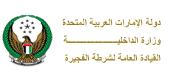 | 
 | 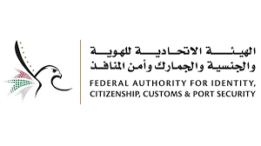 | 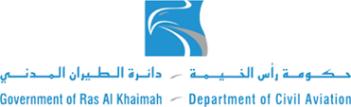
 |  | 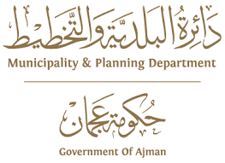
 |  | 
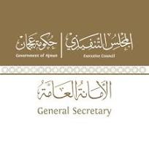 | 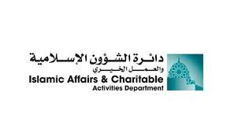 | 
 | 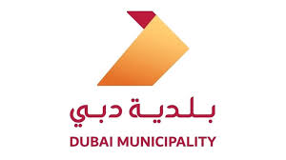 | 
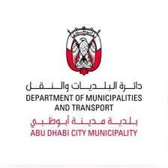 |  | 

Contact us
Address  : United Arab Emirates
📞 Phone : 00971547033643
📧 Email: info@brifma.com
- Website: www.brifma.com

