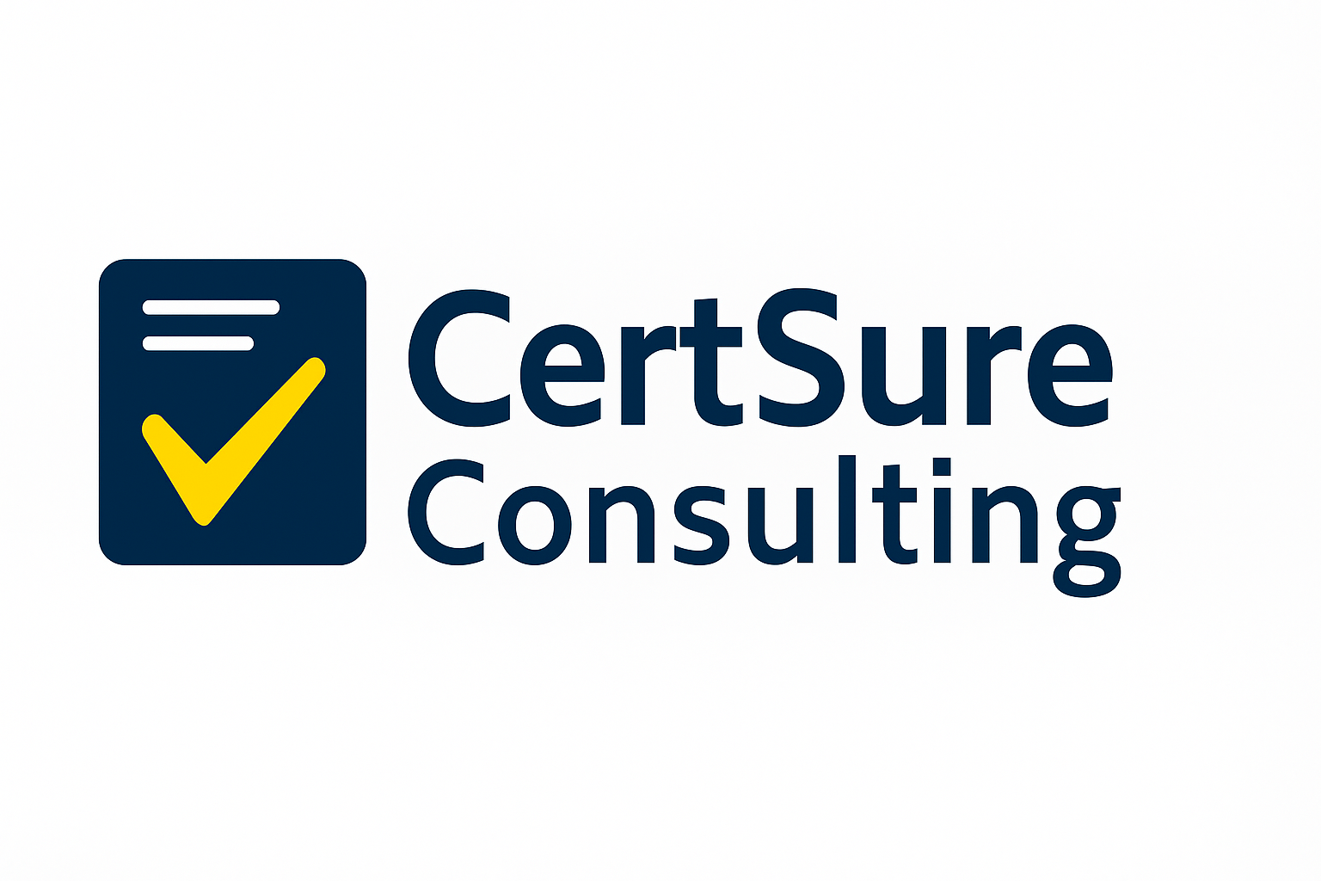
Citations

1. Sales growth (15–20%)
International Trade Centre study: “Companies that implemented ISO 9001 saw an average increase in sales of 15–20%.”
Source: Cyber Consultancy Services (CCS Risk) – “What is the Return on Investment (ROI) for achieving ISO 9001?” ccsrisk.com

2. Cost savings (3–5%)
American Society for Quality: “Companies that implemented ISO 9001 saw an average reduction in costs of 3.49%, resulting in a positive ROI.”
Source: CCS Risk – “What is the Return on Investment (ROI) for achieving ISO 9001?” ccsrisk.com

3. Faster market access
“Some Request for Tender (RFT), Invitations to Tender (ITT) and Pre-Qualification Questionnaire (PQQ) documents specify that a business must be ISO 9001 certified.”
Source: Amtivo – “5 Ways ISO 9001 Can Help Businesses Win More Tenders” amtivo.com

4. Higher customer retention
“Risk mitigation: satisfied customers are less likely to raise issues, leading to fewer complaints, returns and disputes.”
Source: ISO Quality Solutions Ltd – “The significance of customer satisfaction in ISO 9001” ISO QSL

5. Payback in 1–3 years
Meta-analysis of 92 ISO 9001 ROI studies: “The financial payback from ISO 9001 certification can typically be realised within 1–3 years.”
Source: Business-Benefits.org – Business Benefits repository business-benefits.org

