

Shop 3/19 Gerrale Street Cronulla 2230. Phone number: (02) 9527 1942
Il Gusto Set Menu: $55 per person

Entrée: To share
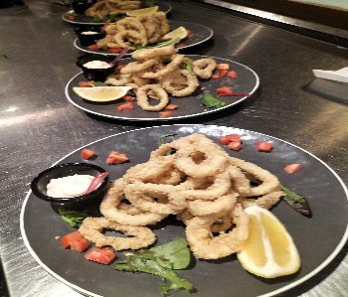
- Salt and pepper calamari: Calamari dusted in sea salt, pepper, and cornflour, shallow fried and served with fresh lemon and roasted garlic aioli.

- Italian Salad: Salad of lettuce, olives, Spanish
Onions, Tomatoes, cucumber, drizzled with extra virgin olive oil and lemon dressing.

Mains to share
- Pizzas
  - Italian: Pepperoni, mushroom, olives, oregano.

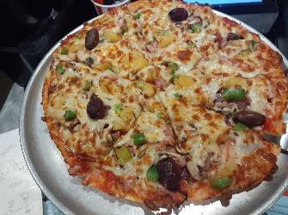
  - Vegetarian: Mushroom, capsicum, onion, pineapple, Sundried-tomatoes, shallots, olives.

  - Supreme: Ham, Bacon, Pepperoni, Cabanossi, Onion, mushroom, capsicum, Pineapple, Olives.

- Pastas
  - Linguine Prawns: Long thin pasta pan tossed with lemon zest, tiger prawns, bacon, garlic, chili, in extra virgin olive oil.

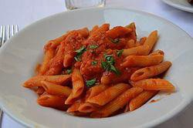
  - Penne Arabiata: onion, bacon shallots, garlic, chili, infused with white wine in a napolitana sauce.

  - Fettuccini Chicken Bosciola: Flat ribbon egg pasta, chicken, mushrooms, bacon, hint of garlic in a white wine cream sauce.

Please advise if there are any allergies or dietary requirements.

