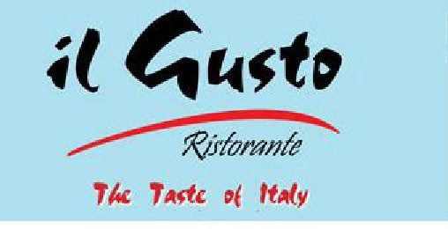

Shop 3/19 Gerrale Street Cronulla 2230. Phone number: (02) 9527 1942
Il Gusto Set Menu 2 $45 per person

Entrée: To share
- Garlic Bread

- Italian Salad: Salad of lettuce, olives, Spanish
Onions, Tomatoes, cucumber, drizzled with extra virgin olive oil and lemon dressing.

Mains to share
- Pizzas
  - Italian: Pepperoni, mushroom, olives, oregano.

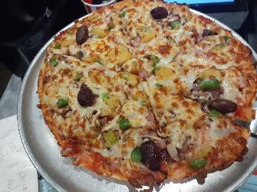
  - Vegetarian: Mushroom, capsicum, onion, pineapple, Sundried-tomatoes, shallots, olives.

  - Supreme: Ham, Bacon, Pepperoni, Cabanossi, Onion, mushroom, capsicum, Pineapple, Olives.

- Pastas
  - Ravioli Milano: Pillow shaped pasta, pan tossed with bacon, sun dried tomatoes, hint of chilli and garlic in a prima vera (pink sauce)

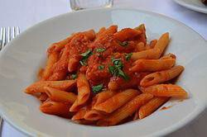
  - Penne Arabiata: onion, bacon shallots, garlic, chili, infused with white wine in a napolitana sauce.

  - Fettuccini Chicken Bosciola: Flat ribbon egg pasta, chicken, mushrooms, bacon, hint of garlic in a white wine cream sauce.

Please advise if there are any allergies or dietary requirements.

