4K School Supply List 2026-2027
SUPPLY LIST
1 Backpack
2 glue sticks (large size)
1 child size Fiskars scissors (for a right hander or left hander)
1 pkg. washable markers (8 basic colors with Pink & Grey)
2 dry erase markers (any color)
1 pack of twistable colored pencils
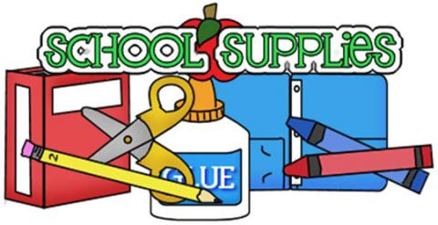
1 box of Kleenex
Art shirt
Sleep mat
1 folder
1 glue bottle
2 large tubs of Clorox wipes
2 bottles of juice
1 pair gym shoes that will remain at school for gym class

On the first day, please bring a zip-lock bag containing a pair of underwear, socks, shirt, and pants for your child; please write your child’s name on the bag.

**Please put their name on all school items including jacket, boots, snow-pants, etc.**

Each child will be assigned at least two weeks during the year when they are the “Star” and have a “Show and Tell” day. During those weeks students are responsible for providing the morning snack for the class.

4K School Supply List 2026-2027
SUPPLY LIST
1 Backpack
2 glue sticks (large size)
1 child size Fiskars scissors (for a right hander or left hander)
1 pkg. washable markers (8 basic colors with Pink & Grey)
2 dry erase markers (any color)
1 pack of twistable colored pencils
1 box of Kleenex
Art shirt
Sleep mat
1 folder
1 glue bottle
2 large tubs of Clorox wipes
2 bottles of juice
1 pair gym shoes that will remain at school for gym class

On the first day, please bring a zip-lock bag containing a pair of underwear, socks, shirt, and pants for your child; please write your child’s name on the bag.

**Please put their name on all school items including jacket, boots, snow-pants, etc.**

Each child will be assigned at least two weeks during the year when they are the “Star” and have a “Show and Tell” day. During those weeks students are responsible for providing the morning snack for the class

