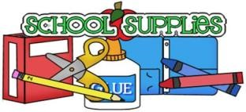**Zion Wayside 3K 2025-2026**

**SUPPLY LIST**

Backpack (no wheels)

4 Glue Sticks (standard size)

1 Child Size Fiskars Scissors (for a right hander or left hander)

1. Pkg. Washable Markers (8 basic colors only)
2. Dry Erase Markers (any color)

1 Box of 8 Basic Color Crayons

1 Box of Kleenex

Art shirt

Sleep Mat

Optional- blanket & soft item to hold such as stuffed animal

1 Plastic Black Folder with 2 Pockets

1. Glue Bottle
2. Large Tubs of Clorox Wipes

1 Watercolors

1 Junior Composition Notebook (Wide-ruled)

1 Box of Standard Size Pencils

1 Clipboard (brown)

1 School Box (to hold glue sticks, crayons, markers and scissors)

Gym shoes (stay at school)

Water Bottle (stay at school- sent home Fridays to wash)

On the first day, **please bring a zip-lock bag containing 2 pairs of underwear, socks, shirt, and pants for your child**; please write your child’s name on the bag.

**Please put their name on all school items including shoes, jacket, boots, etc.**