OPTO 2025 Abstract Template

**Alexandra Smith**1**, Charles Brown**1**, Aleksander Nowak**2,*

*1. Max-Planck-Institut für Quantenoptik, Hans-Kopfermann-Str.1, 85748 Garching, Germany*

*2. Wrocław University of Science and Technology, Wybrzeze Wyspianskiego 27, 50-370 Wrocław, Poland*

Corresponding author: *aleksander.nowak@pwr.edu.pl

This is a template for the one-page extended abstract submission for OPTO 2025. While this document is provided in Microsoft Word, **the final submission must be uploaded in PDF format.** The paper should be in A4 size (210 mm x 297 mm) with 2.5 cm margins on all sides (top, bottom, left, and right). Use only 10 pt Times New Roman font (regular, bold, or italic) for the text. Include all equations, figures, drawings, and references within the one-page limit and avoid adding page numbers. Please be concise and highlight the novel aspects of your work. Simple equations should be integrated into the text, while more complex ones should be centred and numbered. Please maintain 6 pt distance between numbered equations and the text.

$E=mc^{2}$ (1)

Figures should be relevant, centred, and placed as close as possible to their first mention in the text. Figures can be in grayscale or colour and should be in readable resolution. The spacing between the end of the text paragraph and the figure should be set to 6 pt.

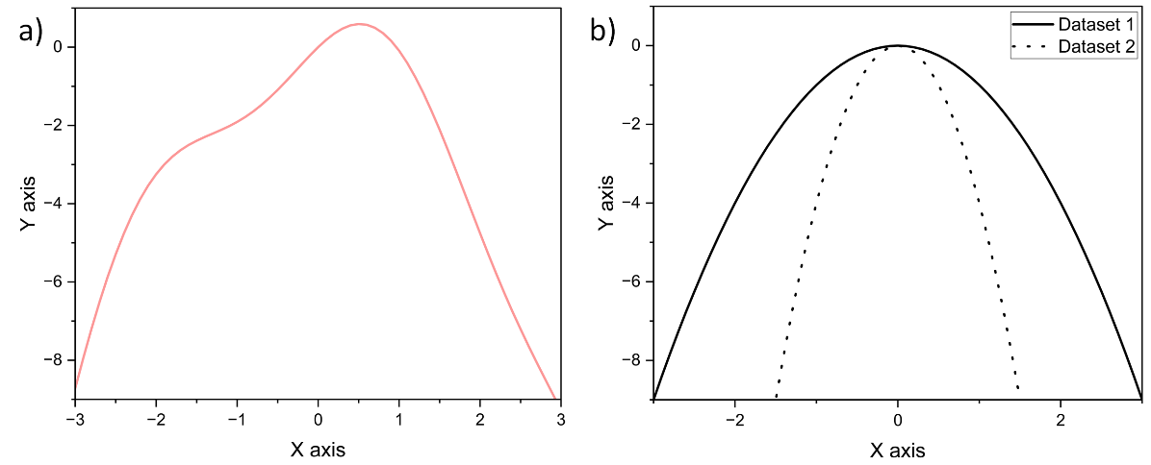

**Fig. 1 (a)** The abbreviation “Fig.” (for figure) should appear first, followed by the figure number, a period, and then the figure caption. **(b)** Captions should be centered beneath the figures in an 8-point font, indented 1 cm on both sides, and justified on both the left and right. The spacing between the figure caption and the continuation of the text should be 6 pt.

Tables should be centred and placed as close as possible to their first mention in the text. The text in the table should be 8 pt. The table caption should be 8 pt and placed directly above the table with spacing of 6 pt between the preceding text. Similarly, the distance of 6 pt should be kept between the end of the table and the next paragraph.

**Table 1.** Selected properties of dry air and water in standard temperature and pressure.

|  |  |  |  |
| --- | --- | --- | --- |
| Material | Density (g/cm3) | Molar mass (g/mol) | Refractive index (-) |
| Dry air | 1.293 | 28.97 | 1.00 |
| Water | 0.997 | 18.02 | 1.33 |

References should be listed at the end of the paper in the order they are cited within the text. Use 8 pt font, and align the references to the left. The suggested reference format is provided below. In the main text, references should be cited by a number in square brackets [1], placed before any commas or periods [2]. When citing two references together, separate them with a comma [2,3]. For three or more consecutive references, use a range indicated by a dash [1–3].

**Funding and acknowledgements.** Funding information and acknowledgements should be 8 pt type, regular text.

**References**

[1] S. Ghimire and D. A. Reis. “High-harmonic generation from solids”. Nat. Phys. 15, 10–16 (2019). For journal articles, authors are listed first, followed by the article’s full title in quotes, the journal’s title abbreviation, the volume number in bold, page number, and the year in parentheses.

[2] G. P. Agrawal, *Nonlinear Fiber Optics*, 3rd. ed., (Academic Press, Boston, 2001). For citation of a book as a whole: authors, followed by title in italics, and publisher, city, and year in parenthesis.

[3] G. P. Agrawal, *Nonlinear Fiber Optics,* chapter 2, 3rd. ed., (Academic Press, Boston, 2001 For citation of a book chapter, authors are listed first, followed by book title in italics, chapter number/name, publisher, city, and year in parenthesis.