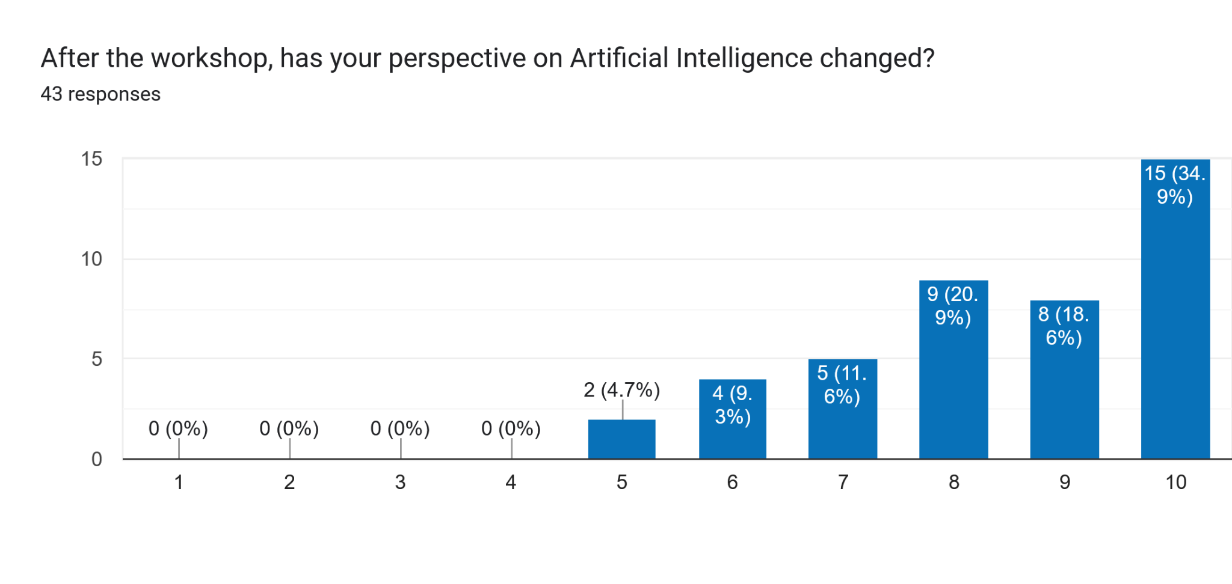

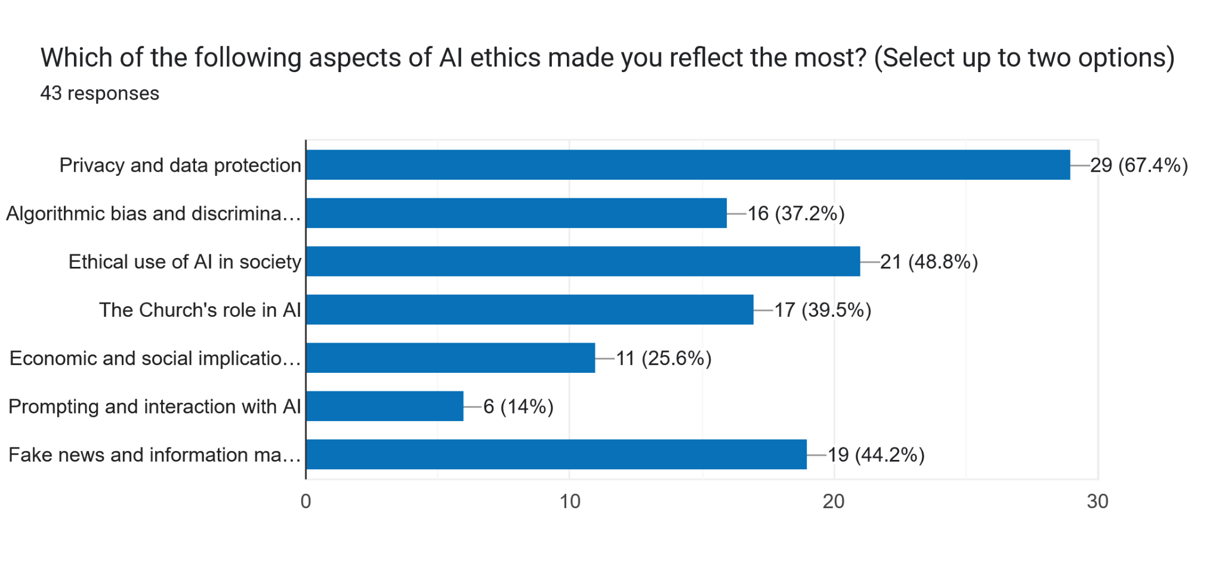

Can you describe an idea or concept that changed your perspective on AI?
43 responses
That is AI depends on data and by so remain human centred
Algorithm and bias
Through this workshop l have come to discover that AI is not magic and therefore we need to use it wisely
It works on predictions, probability and is data and culturally biased
That there is a digital space that stores all your inputs on AI Tools even fter the prompt has been cleared from your device. This lead me to think about being cautious of the information I feed my Al tool with.
Ethical use of AI
Responsible use of AI for evangelization
Fake news and information manipulation.
Yes. The fact that the church can play a big role using Ai to educate the people
The fact that you could lose your way of thinking if you rely solely on Ai
AI's predictive approach
That answers from AI are not 100% reliable
That AI is predictive rather than fact base
The importance of critical thinking and the need to shape the moral imagination of younger generations.
AI can be generative
The reality to live with Ai for generations yet to come, and the reality to accept it usage and ethically use it to advance God's creation.
How AI models are trained using my data.
It was interesting to learn that AI uses algorithms and probability to generate responses. I came to know that AI has been used to harm people and cause atrocities.
That AI need human intervention /data to produce an authentic information
AI cannot not replace human presence in all circumstances
The geopolitics of AI
AI responses are predictive than they are real
Data collections
Data processing
The biases, impacts and manipulation of information.
As a journalist, I came in thinking AI was a tool that saves time. What changed is that I now see it as a tool to help make my work better so I need to be intentional about how to use it, what to delegate to it, and carefully analyze whatever edits it makes to my writing and when to override it when necessary because it is never factual.
The AI system is not racist, but the society can be
I was using AI without being conscious of the biases and discrimination it contained
The fact the human person and dignity should be at the centre of AI
There is more to it than we see and know
Ai now becoming a cognitive Digital society
The concept of Verification if information from AI
Human dignity
The fact that your privacy and security can be compromised based on the information you feed into an AI tool
The data one submits to AI determines the results the AI produces.
Reliability of information
The various school of thought on prompts
That AI has come to stay with us but man must control it. It should not override human intelligence. It is good but could impose much threats to the human race.
Critical thinking
AI shaping the world, who shapes AI
How people create fake news to tarnish the image of other peoples
Use of AI to generate real life scenarios that are concerning but turning out to be false
Different feedback of same prompt by ChatGPT

