Welcome to Chapter 10:
Treatment Planning, Clinical Assessment, Intake,
Consent, and Documentation.

Chapter 10 Introduction
In this chapter, we will explore the professional and clinical responsibilities involved in preparing for safe and effective massage therapy sessions.

Massage therapy begins long before physical contact occurs. Proper intake procedures, communication, assessment, informed consent, documentation, and treatment planning are all essential parts of professional massage therapy practice.

Learning Objectives

By the end of this chapter, students should
be able to:

- Explain the purpose of treatment
planning and documentation

- Demonstrate proper intake and
communication skills

- Identify contraindications and red flag
conditions

- Develop appropriate treatment plans

  - Complete SOAP note documentation

  - Demonstrate professional clinical conduct

Clinical Reasoning

Proper assessment leads to a solid treatment plan that leads to effective treatment with positive results.

Massage therapists must evaluate:

- Tissue condition

  - Pain presentation • Contraindications • Client goals













    - Stress levels • Safety considerations
Massage therapy should never become a routine sequence performed the same way for every client.

Documentation and Intake
Documentation helps:

- Protect the therapist legally
- Support continuity of care
- Track client progress
- Improve communication
The intake process identifies:
- Health history
- Contraindications
- Medications
- Client expectations
“If it is not documented, it did not happen.”

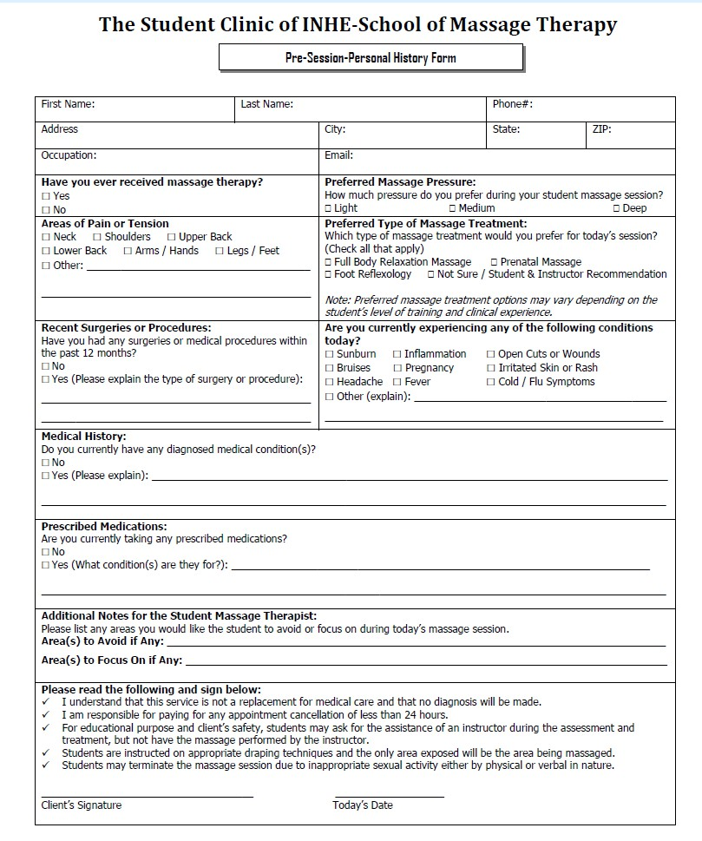

Pre-Session Intake History Form

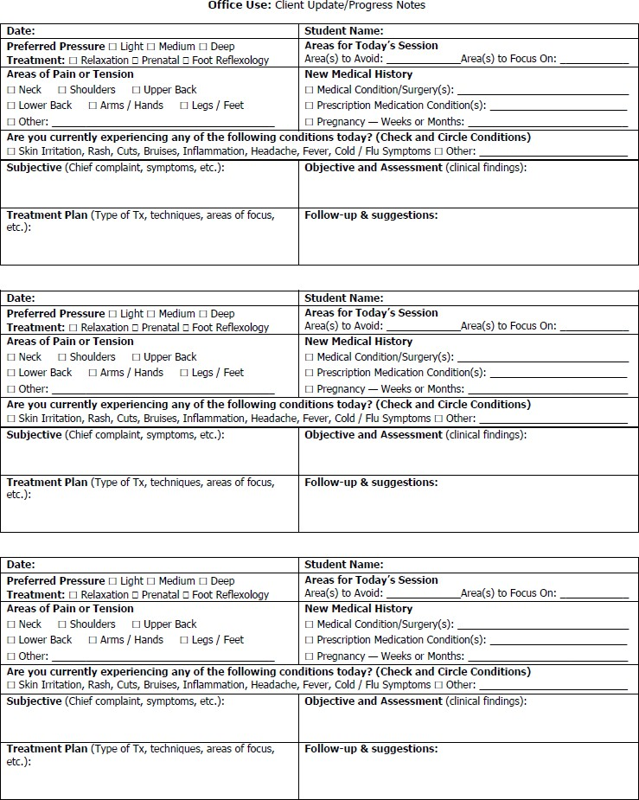

Intake History Form-Back Section

Effective Communication and Rapport
Professional communication helps establish:
- Trust
- Comfort
- Safety
- Professionalism
- Therapeutic rapport

Therapists should:
- Greet clients professionally
- Listen actively
- Maintain eye contact
- Explain procedures clearly



Proper Client Greeting

Students should greet clients professionally:

“Hi, my name is . I will be your student massage therapist for today.”

Then ask:
“Have you been here before?”

This helps determine whether new paperwork or updated forms are
needed.



New and Returning
Clients








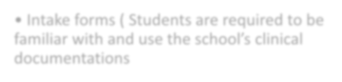





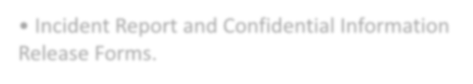


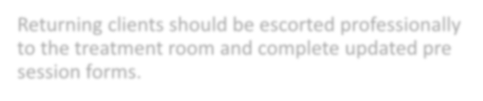


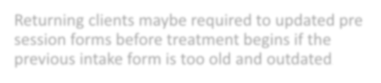

New clients should receive:

  - Pre Session Intake Form
  - Intake forms ( Students are required to be familiar with and use the school’s clinical documentations
Other used forms based on specific situations are:
  - Incident Report and Confidential Information
Release Forms.
Returning clients should be escorted professionally to the treatment room and complete updated pre session forms.
Returning clients maybe required to updated pre session forms before treatment begins if the previous intake form is too old and outdated.


Confidentiality and Reception
Area Professionalism

All confidential discussions must occur inside the treatment room and never in the reception area.
Students should:

  - Avoid discussing clients publicly

  - Remain professional

  - Avoid unnecessary conversations in
reception areas


Health Update Before Treatment

Students should ask:

“Is there anything that I should know about your health today that could be
a contraindication for massage or require specific considerations or
modifications during the session?”

This helps identify:
- Injuries
- Illness
- Medication changes
- Pregnancy
- Areas requiring modifications



Draping and Positioning Instructions

Before leaving the room, students should explain preparation instructions clearly.

Example:

“Before I step out for you to get ready, I would like for you to disrobe to your comfort level, lie face down on the table, cover yourself with the top sheet, and place your face in the face rest. Do you have any questions?”

Students should say:

Re Entering the Treatment Room
“I will give you a couple of minutes and knock on the door before entering to make sure you are ready.”

Students must:

- Always knock before entering and announce
by saying the client’s name.

- Respect privacy

  - Maintain professional boundaries

Therapists should:

  - Check pressure

Communication During the Session
  - Explain position changes

  - Discuss comfort levels

  - Maintain professional tone

Example:

“Is the pressure comfortable for you in this area?”

Therapists should avoid:

    - Political debates

Topics to Avoid
  - Inappropriate jokes

  - Offensive language

  - Discussing other clients

    - Excessive personal sharing

The focus should remain on the client’s
comfort and therapeutic goals.

Trauma Informed
Care

Clients should feel:
      - Safe
      - Respected
      - Heard
      - Comfortable
Therapists should:
      - Obtain ongoing consent
      - Respect boundaries
      - Explain procedures clearly
      - Maintain professional draping


Informed Consent

Clients should understand:
  - Treatment goals
  - Techniques used
  - Possible risks (localized or general contraindications)
  - Expected benefits
  - Students have the rights to obtain the instructors advise if needed
Clients always have the right to stop or modify treatment.

Scope of Practice
Massage therapists may:
    - Perform massage therapy
    - Provide stretching
    - Use hydrotherapy applications

Massage therapists may NOT:
    - Diagnose diseases
    - Prescribe medications
    - Perform surgery
    - Perform psychotherapy

Check with State's licensure regulations of which he/she is licensed to practice massage therapy.

Massage may need to be postponed, or areas avoided if clients present with:

      - Fever

      - Infection

Red Flags and
Contraindications
  - Severe inflammation

  - Chest pain (life-threatening medical emergency).

    - Suspected DVT (Deep Vein Thrombosis)

    - Recent fractures

    - Neurological symptoms

Pain assessment evaluates:

    - Severity

Pain Assessment
- Location

- Duration

- Aggravating factors

  - Relieving factors

The OPPQRST system may be used during assessment.

O (Onset): When did the symptom or pain start? Was it sudden or gradual? What were you doing when it began?

P (Provocation/Palliation): What makes the symptom or pain worse? What makes it better?

OPPQRST
System
Q (Quality): Can you describe what the pain or symptom feels like? (e.g., sharp, dull, crushing, throbbing, aching).

R (Region/Radiation): Where exactly is the pain located? Does it move or spread to any other areas of the body?

S (Severity): How bad is the symptom on a scale from 0 to 10 (where 0 is no pain and 10 is the worst imaginable)?

T (Time): How long has the episode been going on? Is it continuous, or does it come and go?

Massage therapists should observe:

Forward head posture

Postural and Functional Assessment

Rounded shoulders

Pelvic imbalance

Gait abnormalities

Movement restrictions

  - Muscle guarding

Treatment Planning
Treatment plans should consider:
- Client goals
- Health status
- Contraindications
- Assessment findings
- Tissue condition

Treatment plans may include:
- Techniques selected
- Session length
- Home care recommendations

SOAP Notes
SOAP documentation includes:

S = Subjective O = Objective
A = Assessment P = Plan

SOAP notes help maintain professional documentation and continuity of care.

Students are required to write the post-session notes. SOAP notes may be inspected by the clinic supervisor. Students may ask the clinic supervisor for assistance with proper terminology related to clinical procedures.

HIPAA and Confidentiality
Massage therapists must:
- Protect client privacy
- Store records securely
- Avoid discussing with clients publicly
- Use secure electronic systems

Confidentiality may only be broken when legally required.

Professional Appearance and Dress Code
Students must:
- Wear clean black scrubs
- Maintain good hygiene
- Avoid strong scents
- Keep nails trimmed
- Wear appropriate shoes
- Maintain professional appearance

Code of Conduct
Students are expected to:
- Demonstrate professionalism
- Respect confidentiality
- Maintain professional boundaries
- Communicate respectfully

Students may not attend clinic under the influence of drugs or alcohol.

24 hours’ notice are required for clinical absences.

Students with acute or highly contagious diseases must not attend clinic.

Classroom and Clinical Preparation
Lecture days require:
- Top and bottom black scrubs.
- One set of clean twin sheets

Clinical days require:
- Top and bottom black scrubs.
- Three sets of clean twin sheets
- Folded linens
- Required supplies

Unprepared students may receive an absence.

Healthcare Communication and Referrals
Massage therapists may communicate with:
- Physicians
- Chiropractors
- Physical therapists
- Occupational therapists
- Nurses
- Mental health professionals

Client authorization is generally required before sharing records.

Clinical Case Studies
Students should learn to identify:
  - Contraindications
  - Treatment goals
  - Pressure modifications
  - Home care recommendations
  - Reassessment needs

Examples include:
  - Office related neck tension
  - Elderly clients
  - Athlete recovery

Chapter Summary
Effective treatment planning combines:
- Communication
- Assessment
- Documentation
- Ethics
- Professionalism
- Clinical reasoning

Professional communication and informed consent are essential parts of
safe massage therapy practice.

Closing

This concludes Chapter 10: Treatment Planning, Clinical Assessment, Intake, Consent, and Documentation.
Please continue reviewing your study materials, SOAP note procedures, intake forms, contraindications, and clinic policies as you prepare for clinical practice and examinations.

Chapter 10 Knowledge Check

The following questions are designed to help reinforce important
concepts related to:
- treatment planning
- client communication
- contraindications
- documentation
- professionalism
- clinical procedures
Choose the best answer for each question.

Knowledge Check
Which of the following is considered part of the treatment planning process?
A. Performing surgery
B. Client assessment and documentation
C. Prescribing medications
D. Diagnosing diseases

Correct Answer:
B. Client assessment and documentation

Knowledge Check
Why is documentation important in massage therapy?
- It replaces treatment planning
- It helps track client progress and provides legal protection
- It allows therapists to diagnose conditions
- It eliminates the need for intake forms

Knowledge Check
Which of the following should occur in the treatment room and not in the reception area?
A. Scheduling appointments
B. Discussing confidential client health information
C. Greeting clients
D. Providing towels and linens

Knowledge Check
What should a student say before leaving the treatment room for the client to prepare?
A. “Please wait here until I return.”
B. “Remove all clothing.”
C. “Disrobe to your comfort level, cover yourself with the top sheet, and place your face in the face rest.”
D. “Lie however you feel comfortable.”

Knowledge Check

Which of the following is part of professional communication during a
massage session?
A. Discussing political opinions
B. Checking pressure and comfort levels
C. Discussing other clients
D. Excessive personal sharing

Knowledge Check
Which of the following is considered outside the massage therapist’s
scope of practice?
A. Providing stretching
B. Using hydrotherapy applications
C. Diagnosing diseases
D. Performing massage therapy

Knowledge Check
Which condition may require massage treatment to be postponed?
A. Mild muscle tightness
B. Fever and infection
C. Dry skin
D. Mild stress

Knowledge Check
In the OPPQRST system, what does the letter “Q” represent?
A. Quantity
B. Quickness
C. Quality
D. Questioning

Knowledge Check
What does SOAP documentation stand for?
A. Safety, Observation, Analysis, Prevention
B. Subjective, Objective, Assessment, Plan
C. Stretching, Observation, Application, Procedure
D. Subjective, Organization, Assessment, Prevention

Knowledge Check

Which of the following is part of the school’s dress code policy?
A. Open toed sandals
B. Strong scented perfume
C. Clean black scrubs
D. Artificial nails

Thank You and Congratulations
Thank you for taking the time


Congratulations on completing Chapter 10:
Treatment Planning, Clinical Assessment, Intake, Consent, and Documentation.
to review this important chapter on professional massage therapy procedures, communication, clinical documentation, and client care.


The concepts presented in this chapter are essential components of safe, ethical, and effective massage therapy practice.
As you continue your training, remember that professionalism, communication, assessment skills, and proper documentation are just as important as hands on treatment techniques.


Thank you for your dedication and commitment to becoming a professional massage therapist.
Institute of Natural Health & Education
INHE School of Massage Therapy

- B. Client assessment and documentation
- B. It helps track client progress and provides legal protection
- B. Discussing confidential client health information
- C. “Disrobe to your comfort level, cover yourself with the top sheet, and place your face in the face rest.”
- B. Checking pressure and comfort levels
- C. Diagnosing diseases
- B. Fever and infection
- C. Quality
- B. Subjective, Objective, Assessment, Plan
- C. Clean black scrubs

