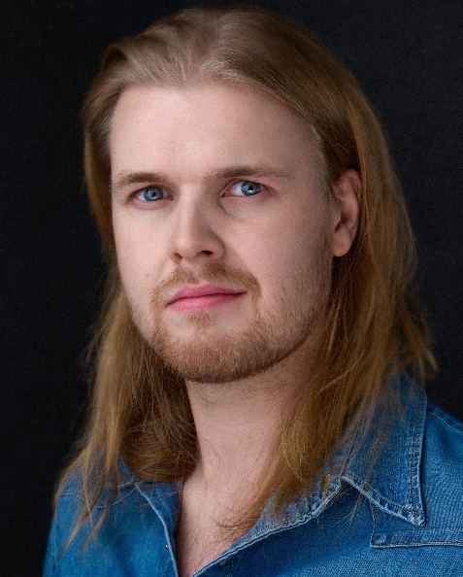
Joakim Carlsson
Hair: Blond
Eyes: Blue
Age: 31 (range 22-35)
Ethnicity: Scandinavian
Body type: Normal, Athletic
Height: 194cm (6’4”)
Chest: 111 cm
Waist: 99 cm
Hips: 112cm
Shoe size: 45

Email: joakimcarlssonfilm@gmail.com
Phone: +46739-357944

FILMS
Lillafaster Linda (2025) Sabina Renck
The Pirate Bay (2025) Jens Sjögren, Patrik Gyllström
Hell of a Date (2024) Prime Video + Milad Avaz
Omättlig (2024) Nova Raask
The Wanderer (2023) Ezekiel Schmiedl
Tasty (2022) Ina Wecken
The replacement (2023) Jonathan Hodapp
Language barrier (2023) Siddharth Kbir Singh

Theatre

Vart ska staden ligga? (2024) Martin Rossing
Oknyttens karta (2025) Michaela Granberg
Den stora premiären (2025) Filip Ivarsson

TRAINING
Acting for film program Prague Film School
Acting for film Course w/Amy Huck
Meisner Technique Course w/Brian Caspe
Stanislavski Technique Course w/Howard Lotker
Physical acting Technique Course w/Petra Johansson
Commedia dell’arte Masterclass w/ Petra Johansson
Voice Technique Course w/Marc Cram
Improv Technique Course w/Daniel Brown
Comedy writing Course w/Steen Agro
Combat acting Agency A.R.G.O
Dialogical acting with inner partner Course w/Howard Lotker
Directing Actors FAMU
Actors/Director Workshop GEST w/Gary Whitaker
Actors on stage Ljudaborgs kulturförening
Testfilmning/Actor’s techniques Masterclass w/ Pär Brundin
Acting Intensive Adam Findley

Other skills
Sport Dance Music
Martial Arts Swing Singing
Swimming Waltz Drums
Windsurfing Cha-cha Guitar
Sailing Salsa
Mountaineering Polka
Skiing Foxtrot
Yoga Blues
Archery Bugg
Horse Riding
Hunting
Diving
Parachuting
Enduro
Racing

Licensed Languages
Firearm Swedish
Hunting English
Car Spanish (medium)
Diving
Forklift
Boat

