Egypt’s National Dialogue: Towards a Political Opening?
Mohammed Moussa

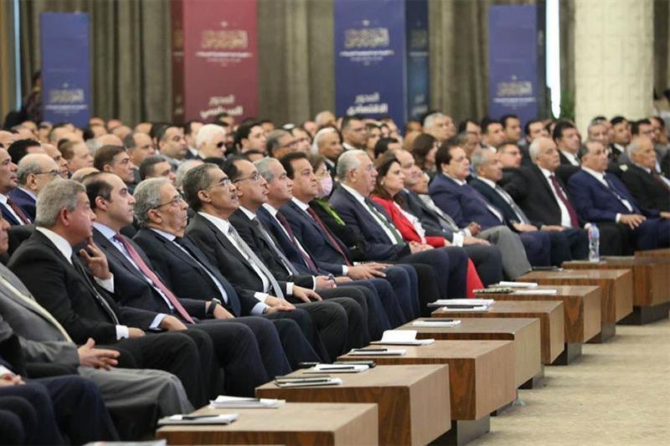

About the Author
Mohammed Moussa
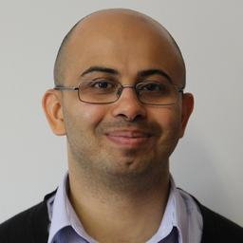
Mohammed Moussa is an assistant professor in the Department of Political Science and International Relations at Istanbul Sabahattin Zaim University. He was a Postdoctoral Research Fellow at Tokyo University of Foreign Studies. Mohammed completed his doctorate at the University of Exeter. His publications include a monograph on the political thought of Shaykh Muhammad al-Ghazali (2015) and articles in Journal of North African Studies, Journal of Arab & Muslim Media Research, Protest and Annals of Japan Association for Middle East Studies.

Abstract
Egypt’s vaunted national dialogue (al-hiwar al-watani) announced by President al-Sisi at the annual family iftar banquet in April 2022 sent a signal to the opposition and observers about the apparent readiness of the government to create a political opening. The regime through the presidency-affiliated National Training Academy and later the national dialogue’s board of trustees set about formulating its rules of conduct, choice of participants, topics of discussion and format of the proceedings. This policy brief examines the launching of Egypt’s recent national dialogue and the interactions between the regime and the opposition. It begins by highlighting the main processes and motives behind the creation of such a forum, based on the claim to establish a ‘new republic,’ and the existence of interlocking organisations from the presidency to the National Training Academy to the national dialogue’s board of trustees. Egypt’s opposition participated in this ostensible political opening with the consequence of revealing a lack of unity among these actors and the rise or entrenchment of divisions. In addition, despite the commitment to an open atmosphere of deliberation, the board of trustees decided that the issues of constitution, national security and foreign policy would not be discussed in the national dialogue. However, the disappearance of taboo subjects soon followed the start of Israel’s war on Gaza in October 2023. This event has led to the rolling back of these limits and the national dialogue’s shift to the intertwined concerns of national security and foreign policy. The policy brief concludes with a section on recommendations to a range of Egyptian stakeholders from political parties to civil society organisations on the necessity and the means of effecting genuine political reform.

Introduction
The very public display of meetings among Egyptian political figures, both pro-regime and opposition, in the vaunted national dialogue (al-hiwar al-watani) somewhat interrupted the routinisation of politics with its to and fro between the presidency, government and parliament. Since President Abdel Fattah al-Sisi came into office in 2014, the launching of a forum that is ostensibly open to most political groups to discuss most political issues has been a welcome development. Far from unsettling the typical course of executive’s decision-making, however, yet another mechanism has been added to its apparatus, formal and informal, that filters up policy recommendations to the executive. Participation of the opposition has unsurprisingly not translated into accountability. The national dialogue appears not to be a forum for state-opposition dialogue but rather a series of meetings among various politicians about a predetermined list of themes on a ‘horizontal’ plane followed by recommendations to be forwarded onto the presidency in a ‘vertical’ process. An open-ended state-opposition engagement about Egypt’s economic, social and political problems is conspicuously absent. Such an engagement could contribute to the addressing the issues of popular legitimacy, transparency, society-wide acceptance, ‘legal engineering’ and political reform surrounding the national dialogue. And moves towards an ethos of stakeholding could also be engendered among political actors and citizens in the wider society for the interdependent, though separate, processes of democratisation and state-building working towards a ‘new republic.’

A political opening towards a ‘new republic’?
Political openings are rare occurrences in Egypt in the last decade and half. Curiosities were therefore piqued when President Abdelfattah al-Sisi announced the intention to launch a ‘national dialogue’ at the annual family iftar banquet on 26 April 2022 in front of opposition leaders. From Hamdeen Sabahi to the late George Ishak, these were apparently approached beforehand to ensure their presence before this call. What were the motives and goals for a national dialogue? Needless to say, scepticism among both observers and opposition actors was not in short supply. A mix of problems, including worsening economic problems, Western pressure and leverage for further foreign loans, to name only a handful, were suggested at the time. What is interesting in the public declarations surrounding the national dialogue was the matter-of-fact acknowledgement that it sought to address Egypt’s political and economic problems. Whether the then anticipated forum was intended to be a source of policy-making ideas for the government or simply window-dressing to defuse social tensions, al-Sisi took a calculated gamble to establish an ostentatiously public forum that risked involving democrats and revolutionaries. Even the appearance of opposition politicians in such an event could stir up interest among politically engaged activists and citizens about the paucity of political pluralism in other political institutions.
However, the executive, both the presidency and government cabinet, ensured that the national dialogue’s participants and agenda were predetermined in advance with little risk of unwelcome surprises. For it took just over a year, from al-Sisi’s iftar call for this political opening in April 2022, for the first national dialogue meeting to occur on 3 May 2023. During this period, the format, procedures and institutions of the forum were planned and finalised. A path was thus smoothed for a direct engagement not between the state and opposition but among participants, pro-regime and opposition, for the purpose of formulating recommendations to be directly passed onto the presidency. Political parties were considered the ostensible beneficiaries of an alternative process to the parliament with access to the decision-making arena situated within the state-led human development agenda centred on Hayah Karimah (Decent Life) project.
The national dialogue, however, appears to be an instance of the Egyptian presidency having set up yet another institution with a mandate to propose policies. Formalising tendencies have included the creation of a variety of organisations for mobilising and implementing government policies in ways that blur the lines between civil society organisations and the state. Preparations for the national dialogue followed this path with the presidency-affiliated National Training Academy, with its mission of promoting human development in Egypt, initially responsible for launching and coordinating the forum to ensure its representative and inclusive participation. A board of trustees was soon established and given authority over the forum to formulate its rules of conduct, choice of participants, topics of discussion and format of the proceedings. Moreover, the selections of Diaa Rashwan, a veteran journalist, as head of the board of trustees and the general coordinator, and Mahmoud Fawzy as head of the technical secretariat showcase the prominent role of journalists in this process. Both Rashwan and Fawzy occupy senior positions in the regulation of the Egyptian media in the State Information Service (chairman) and the Supreme Council of Media Regulation (secretary-general) respectively. These institutions are closely affiliated with the office of president and extend the executive’s scope of ability to act upon a much wider range of social, cultural and political activities.
Moreover, the institutional hierarchy of the national dialogue betrays unequivocally top-down political relations with minimal interference from dissenting figures or groups. Since the founding of a board of trustees to manage the forum, the National Training Academy in Giza provided the setting for its first meeting on 5 July 2022 at the behest of its head and for subsequent board and committee meetings. In that opening meeting, Rashwan singled out two groups for exclusion from participation in the dialogue: the Muslim Brotherhood and those who rejected the 2014 constitution. The national dialogue’s opponents were seemingly also the regime’s opponents. Participation had its limits. While the National Training Academy provided the institutional umbrella for the national dialogue, the board of trustees, already mentioned above, set about finalising its rules, the list of participants, discussion topics and format. A 25-article code of conduct governing the behaviour of the chosen participants was agreed on by the trustees early on in the process. The code stipulates that:
The success of the dialogue is the responsibility of all participants and to achieve this goal all participants should refrain from turning the dialogue into a forum for scoring goals or settling personal and partisan accounts… the primary job of participants is to find common ground among themselves as well as observe objectivity, transparency and neutrality throughout the debates.
While the “success,” the outcome, of national dialogue rests on those participating in it, carrying this burden on their shoulders, the authority to make the rules and set up the format for the forum were not so democratically distributed among them. Further, the conduct of the participants in the proceedings was supposed to rise above “personal and partisan accounts” in what perhaps amounts to the depoliticising of the opposition.
In yet another demonstration of the board of trustees’ exercise of authority, they decided that three themes or axes would be discussed by the participants with a total 19 committees divided with five for politics, eight for the economy and six for society. By September 2022, the board of trustees had seemingly concluded the national dialogue’s committees, subcommittees and members through a procedure that involved their examination of 550 nominees that were put forward by political parties. Despite the flurry of activity that formed the rules and committees for the forum at an early stage, in the summer and autumn of 2022, the first meeting of the national dialogue convened on 3 May 2023. President al-Sisi’s video message at the meeting conveyed the message in a populist mood that differences of opinion, visions and proposals would not only be tolerated but be perceived to positively contribute to the outcome in the quest to shape “our new republic” (gomhuriyyatna l-gadida). Here the tensions between the uniformity demanded by the dialogue’s code and Sisi’s welcome of diversity, that “A difference of opinion does not spoil the cause of the nation,” portend to a more structural challenge: institutional rulemaking can seemingly take on a life of their own despite the best of avowed intentions.
The national dialogue between May and August 2023 had ostensibly served its purpose of making recommendations to the presidency. Its proceedings featured 44 sessions on the political, economic and social axes involving 65 political parties and more than 7,000 participants. Out of the 19 committees originally planned, the forum published a report in August 2023 containing recommendations from 13 committees on the axes of politics, the economy and society. Close interconnections between the national dialogue and the government defined the relations of these institutions as part of an expanding network of organisations that continues to blur the divisions within the state and between civil society and the state. At the apex or centre of this initiative of establishing a national front stands the presidency and its wide-ranging executive powers that are delegated to the cabinet. Through al-Sisi’s authority, the national dialogue’s recommendations have become government policies. An expanding role of the national dialogue in its no less publicised “second round” in 2024 witnessed a high of level of coordination between the cabinet led by Prime Minister Mustafa Madbouly and the board of trustees. This is also borne out by Rashwan’s proactive role in reviewing the implementation of the forum’s recommendations evinced by the meeting with Madbouly in spring 2024 against the backdrop of Sisi ordering the government to do so.

What about the opposition?
As noted above, participation had its limits according to the logic of exclusion of perceived threats to national unity directly translated from the government to the national dialogue. Although the forum is institutionally separate from the presidency, much of its emphases and priorities reflect government policies. The consequent participation of the various Egyptian political actors, admittedly most groups with few exceptions, also demonstrates the presidency and cabinet’s interests, if not influence, in the unfolding of the national dialogue’s processes. What were the responses of opposition figures and movements to the overtures made by President al-Sisi and the board of trustees charged with organising the forum? To begin with, the call for the national dialogue was made before major opposition figures at a public event. It appears to have been a carefully choreographed ceremony and signalled not only Sisi’s apparent willingness to directly engage with his political rivals but also the opposition’s receptiveness to a political opening. Instead of a headlong rush to participate in the proposed dialogue, Hamdeen Sabahi and other politicians laid down preconditions for joining it, namely the release of a number of political prisoners.
The Egyptian opposition in its current composition has a track record of political coordination, through the formation of the Civil Democratic Movement in 2017, united around the goal of a civilian state, Nonetheless, this front, mainly a mix of liberals and socialists, has not been able to garner popular support or electoral success. Common expectations revolving the cautious anticipation of a political opening were present among the senior leaders and politicians in the Civil Democratic Movement: Khalid Dawud (former Constitutionalist Party leader), Farid Zahran (Egyptian Social Democratic Party head), Medhat al-Zahed (Socialist Popular Alliance Party head) expressed the necessity for democracy, however tempered in tone, for media freedoms, a legitimate role for the opposition and political, judicial and constitutional changes respectively. The wish for modification to the existing constitution was similarly expressed by the Wafd leader Abdel Sanad Yamama, whose party is not a member of the Civil Democratic Movement, prior to the organising and launching of the national dialogue. A vaguely articulated consensus on loosening political limitations at the formal (i.e. constitution) and informal (i.e. political activism) levels can be discerned across the Egyptian political spectrum. Even when Rashwan assertively declared that there would be “no red lines” in the national dialogue just before its first meeting, he noted the exclusion of the discussion topics of the constitution, national security and foreign policy. Exclusive decision-making mechanisms have marked the formation of the forum through a series of interlocking organisations from the presidency to the National Training Academy to the board of trustees. Tensions between the opposing dynamics of top-down management and inclusive participation, not mutually exclusive of course, have severely circumscribed the efficacy of the opposition to impact the wider Egyptian political context. Outside the national dialogue, tense political rivalries within the Civil Democratic Movement have come to the surface at certain flashpoints. The most recent presidential election in winter 2023 revealed a clash between two competing sides on whether to boycott or participate in the polls following the alleged obstacles experienced by the Karama Party’s former head with disagreements even in the former that culminated in Egyptian Social Democratic Party’s Farid Zahran running as a candidate. Rather than elections spurring a unity of purpose among the ranks of the opposition, they seem to have exacerbated the divisions between the two chief trends of the Nasserists and the liberals.
In a recent twist, following a period of exile, Amr Hamzawy, a renowned scholar and one-time political party founder, was appointed in February 2025 to the board of trustees. This move has sent yet another signal that the Egyptian government appears to be interested in creating a climate of pluralism with former regime opponents that involves them at a decision-making level. Despite this and other acts of reconciliation, the tactic of “legal engineering,” noted by Hamzawy himself, continues unabated conflating peaceful, even democratic, political activity with terrorism. For the problem of prisoners of conscience demonstrates the simultaneous undermining of the government reaching out to the opposition and the inefficacy of the opposition in pushing for change. Although there was a spate of presidential pardons of prisoners surrounding the national dialogue, key figures such as Abdel Moneim Aboul Fotouh have spent time in prison and he received a 15-year sentence immediately after its announcement in spring 2022. The matter of prisoners of conscience seems to stubbornly persist and Sabahi, who endorsed the national dialogue, issued a direct appeal in January 2025 to al-Sisi to release such detainees.
Not so taboo national security
The existence of taboo subjects in the national dialogue’s proceedings were laid down from the outset by Rashwan in his capacity as the head of the board of trustees. Rashwan announced that he and his fellow board members had agreed, it was mentioned previously, not to add the constitution, foreign policy and national security to the national dialogue’s agenda. Official deliberations among the selected participants were restricted to the broad axes of politics, the economy and society but spelled out in more detail in the formation of subcommittees dedicated to specific issues. The committee in charge of running the national dialogue played a key role in managing the remit of this forum while attempting to reach out to opposition actors and to allay their concerns about the government’s commitment to a genuine political opening. Making certain matters taboo certainly underscores among whom and where the power to drive the national dialogue’s proceedings was located. Events since October 2023 next door to Egypt in Gaza, however, would soon necessitate an abrupt shift in rolling back these limits on the forum’s list of discussion topics.
The government’s perception of a grave threat to national security in a twist of irony has propelled the issue of national security among the board of trustees and the participants of the national dialogue. The former, announced Rashwan on 30 June 2024, would work towards a framework for the discussion of national security and foreign policy. Such a reversal in the national dialogue’s remit seems to follow and accompany President al-Sisi’s public position that even sensitive subjects can be raised with national security and foreign policy treated as priorities against the backdrop of the prospect of the expulsion of Palestinians from the Gaza Strip and the destruction of the Palestinian cause. Top-down political relations have largely determined the national dialogue’s boundaries of acceptable deliberations aligning its board of trustees with the presidency and the cabinet. Prime Minister Madbouly expressed the government’s expectation when he said “We want the National Dialogue to help the government to explore public opinion on these challenges, including Israel’s plan to relocate the Palestinians to Egypt” while it held two sessions by 11 February 2025 concerning Israel’s war in Gaza and its plan to expel Palestinians from the territory. Previous constraints on the national dialogue have been considerably loosened since its first meeting in May 2023 and the political scope of this forum has evolved in response to events in Egypt and the wider Arab world. The widely reported genocide in Gaza has sparked a search for popular support of the government’s foreign policy under immense pressure from Israel through an organisation that was originally conceived at the official level to build bridges between the government and the opposition.
Policy Recommendations
A slight political opening was opened for political parties in Egypt with President al-Sisi’s stated intention of launching a national dialogue in April 2022 followed by its first meeting in May 2023. Structural challenges within the new institution, however, plagued its formation, development and outcomes. Top-down political relations have enabled the national dialogue to achieve an official unity of purpose and yet also prevented it from being fully inclusive at the decision-making level. The ongoing national dialogue is an institutional answer to Sisi’s calls for Egypt to develop into a “new republic” and a “modern democratic state.” In addition, the meetings, discussions and coverage of this forum not only occur against the backdrop of domestic and foreign crises from a spiralling economic crisis to Russia’s war on Ukraine to Israel’s genocide in Gaza but are explicit responses to these challenges. The following policy recommendations for the national dialogue may serve to further augment state-opposition coordination towards a genuine political opening and these can be implemented by a range of stakeholders including, but not limited to, political parties, civil society organisations and state actors:
- Increase popular legitimacy of the national dialogue through the introduction of elections for the positions on the board of trustees and committee members. This procedure of electing board members can be carried out either using elections in which citizens can cast their votes for nominated candidates or by members of a popular assembly who are elected by the wider public.
- Promote transparency of the board of trustees’ deliberations by opening these to journalists and live broadcasts every time it convenes. Although this recommendation would not be entirely without precedent for the board’s first meeting was indeed aired live, the mandatory stipulation of media’s free and unrestrained access to its deliberations can become the ‘normal’ play of bottom-up political relations. Further, the minutes of these deliberations could be published and be made available online. Such moves would not only create a desirable distance between the executive, consisting of the presidency and cabinet, and those in charge of the national dialogue but it would contribute to an atmosphere of accountability and trust between the latter and the general public.
- Increase society-wide acceptance of the national dialogue’s recommendations using referenda before the government adopts them as policies. Citizens would have the opportunity to vote on potential government policies and agendas on a specific basis and thereby generate a collective identity of being stakeholders in a political scene that risks alienating ordinary people or making them feel apathetic.
- Reduce the numbers of prisoners of conscience in a general amnesty for allegations or convictions of political activities that did not involve the causing of any casualties or destruction of property. This act would contribute to lessening the legal engineering currently in place that proscribes various peaceful types of oppositional activity and mistakenly conflates them with terrorism. Releasing prisoners of conscience and allowing them to resume political activities could have salutary effects on the formation of a genuine democratic and pluralist national front in the face of Israel’s relentless genocide in Gaza.
- Extend political reforms from the formal sphere, i.e. laws and constitution, to the informal sphere to allow political groups to organise and mobilise without any physical or procedural obstacles. Within and outside the national dialogue, debating the issue of security sector reform would be a step in the right direction to raise professional standards in law enforcement agencies. Moreover, the objectionable political role of security institutions should be jointly highlighted and problematised by politicians and civil society organisations.
- Increase cooperation among opposition political parties to work towards a unity of purpose. Regular meetings among political party representatives about specific issues can contribute to a consensus that serves as the launchpad for bargaining and negotiation with the government. Broad agreement within the opposition has the potential to create and reinforce inter-ideological cooperation among different groups with competing ideologies such as socialism, liberalism and Islamism. Additionally, the frequent interaction through meetings dedicated to specific issues can cut across the lines of the ‘systemic’ and ‘anti-systemic’ opposition to lower the barriers of coordinated activism that involves both top-down and bottom-up tactics.
- Establish forums focusing on political reform to increase the awareness of the general public. Civil society organisations and political parties can work together to hold workshops that feature experts, activists and members of the general public to discuss the necessity, purpose and details of political reform in Egypt. This activity can also contribute to lowering the barriers of coordination between top-down and bottom-up tactics through enhancing the political education of not only ordinary citizens but also the systemic political parties to enable the latter to sustain closer links with the former.

Demos TunisiaDemos Tunisia is a forum for scholars, activists, practitioners, and decision-makers to engage in activities, conversations, workshops, teaching, conferences and debates that are geared towards the promotion of sustainable democracy and democratic sustainability.
Its normative mantra is that solutions to the challenges for fledgling democracies in Tunisia and the wider Arab World must derive from the locale. Solutions will not come from overseas. They are continuously honed through ever-evolving skills of democratic learning and unlearning. Such pedagogic democratic processes represent dynamic interactions of inclusive, collective, local, global (cross-regional), new and old synergies invested into the healthy innovation and flourishing of good government at the levels of attitudes, values, thought, practice and institutions.

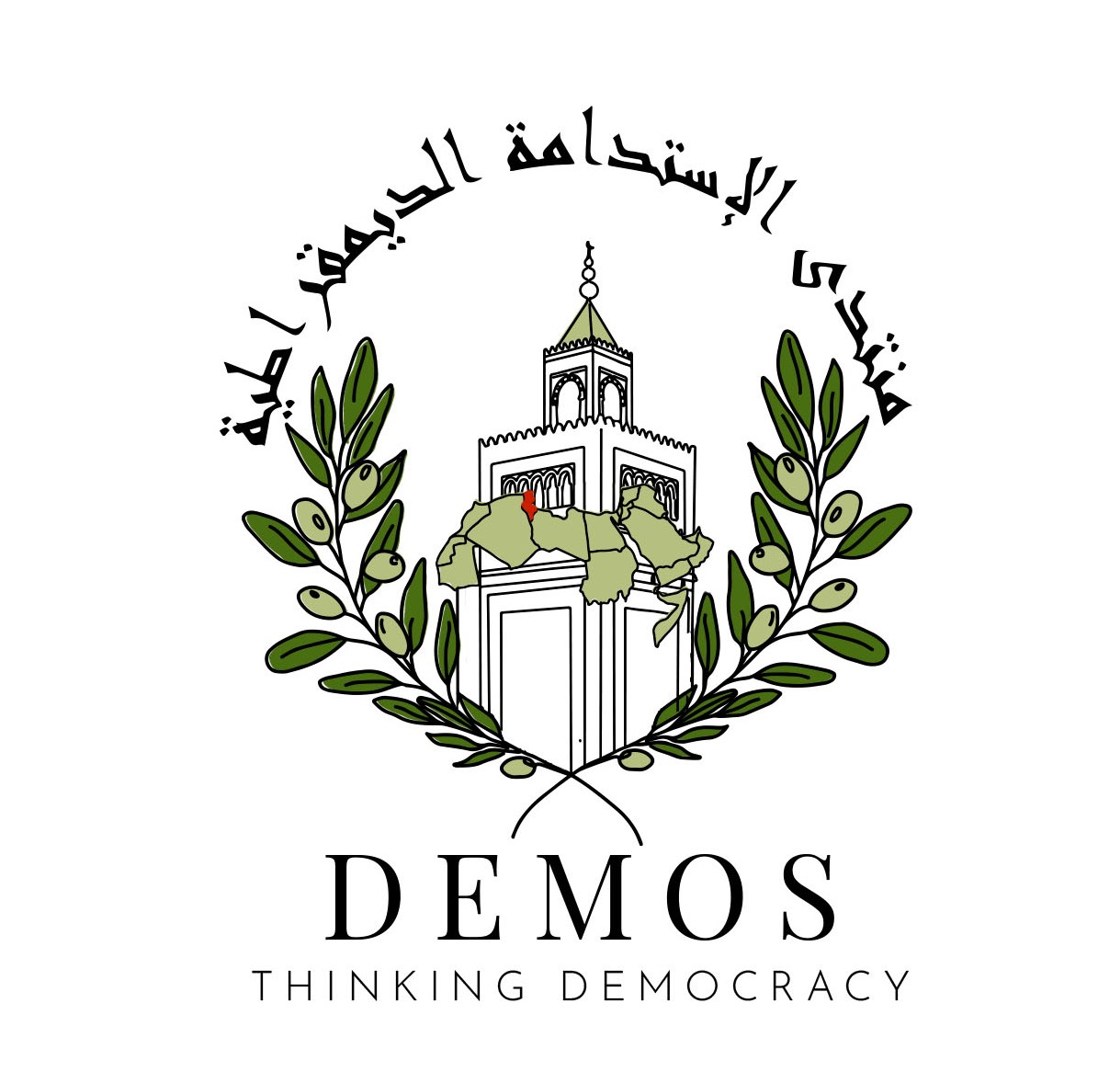

Ahmed al-Tantawi was sentenced in February 2024 for one year, plus given a five-year ban from running in an election, for the impermissible printing of electoral papers in his attempt to gather enough signatures to run for president in the 2023 presidential elections. “Egypt: Tantawi Arrested in Court to Serve a Prison Sentence for Challenging President Sisi in 2024 Elections,”Cairo Institute for Human Rights Studies, accessed 13 April 2025, https://www.hrw.org/news/2024/06/04/egypt-opposition-leader-imprisoned.
Amr Hamzawy, “Authoritarian Narratives and Practices in Egypt,”in Struggles for Political Change in the Arab World: Regimes, Oppositions, and External Actors after the Spring, eds. Lisa Blaydes, Amr Hamzawy and Hesham Sallam (Ann Arbour: University of Michigan Press, 2022), 38-40.

