MAY Night Sky – Meteor shower (Aquarids)
This month look southward low in the pre-dawn sky, as the Earth’s solar orbit intersects, over ten days, with debris though to be the trail left by Halley’s Comet as it travels on its 76-year retrograde elliptical orbit around the Sun.
The first recorded of observation of this comet was in 467 BC. It will come closest to the Sun in 2134.

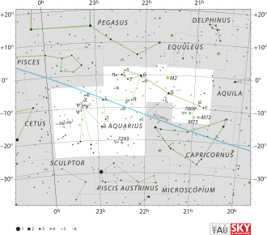

e Aqu (Aquarids) – Possibly up to 40 meteors per hour may be observed if the weather conditions and location are favourable. The mass loss of dust due to solar heat ejection has affected the comets orbit. In 1986 the spacecraft Giotto recorded the water vapour loss of 80%.
(RA 336° dec 0°).
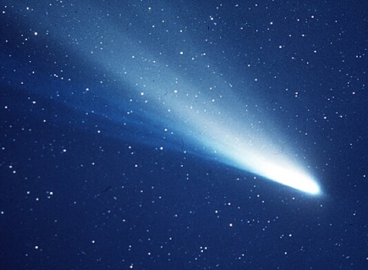

MAY ‘26 Newsletter.docx

