MARCH Night Sky – Jupiter cont. and the total Lunar Eclipse (Blood Moon)
Early this month (Saturday 3rd March) the Earth and consequently the Moon`s solar orbital positions, place them in an almost straight line of sight with the Sun. This effectively causes the Earth’s shadow to obscure the direct sunlight to the Moon, leaving the Earth`s atmosphere to refractively illuminate our satellite`s surface with a dim red hue lasting up to an hour. There are usually about half a dozen partial lunar eclipses each year.

Note: The next Total lunar eclipse (observable in the UK) will not be until the year 2090.

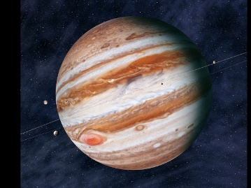 Jupiter (cont. from January

The stripped atmospheric cloud bands indicate the diverse turbulent nature that dominates the conditions there.
Planetary rotation takes about 10 hours and the mass is estimated to be twice that of the combined sum of all the other solar system bodies.

The Great Red Spot is a counter rotating variable sized, anticyclonic high pressure region which has been observed since the 17th century.

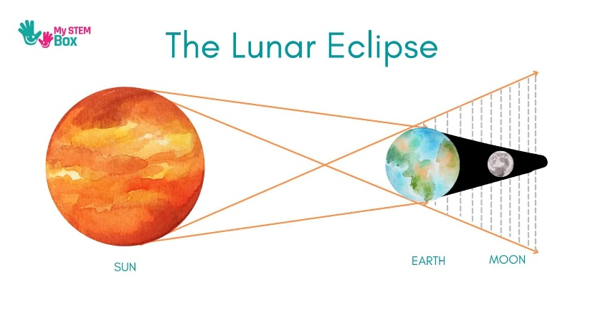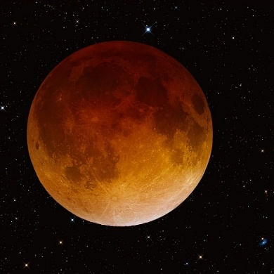

MARCH‘26 Newsletter.docx

