FEBRUARY Night Sky – Jupiter (The Hunter) and the molecular gas cloud M42,
This month we may concentrate on the largest planet in our Solar System, weather permitting as it will be visible throughout the night travelling from east to west, in the region of the constellation Gemini.

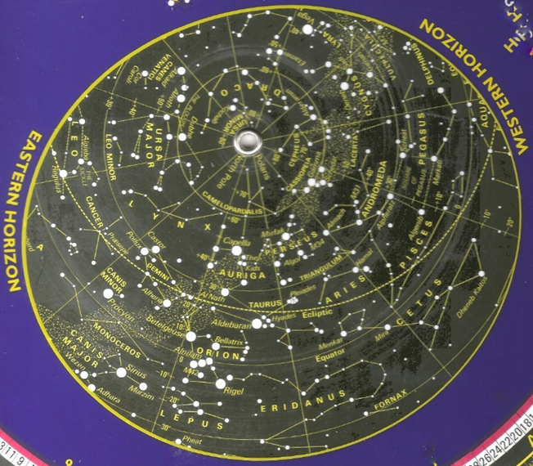

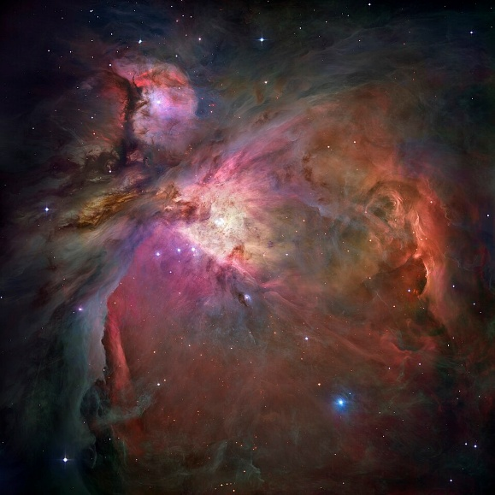
Orion Nebula M42
Jupiter - The largest planet, having an equatorial diameter of around 143,000 km and a mass 25x that of the Earth (318 x greater). It has (current count), 97 satellite moons, the largest four being Callisto, Europa, Ganymede and Io, each of which are individually of similar size to the planet Mercury.

The fast axial rotation of this planet takes about 10 hours to complete, with a mass is estimated to be 2.5 times the combined sum of all the other Solar System bodies.

Stripy atmospheric cloud bands indicate the diverse and turbulent nature that dominate the planets weather conditions there.

Orion Nebular M42 NGC1976 - This can be found just below the centre star in Orion`s belt and is a bright gas cloud where new stars are believed to be forming. Its distance from us is about 1,340 light years.

FEBRUARY ‘26 Newsletter.docx

