NOVEMBER Night Sky – Jupiter & Northern Taurids
Twice a year the Earth’s orbit intersects with the debris track left by the comet 2P/Enocke, which may provide us with the chance to see some spectacular shooting stars also, this month, the largest planet in the Solar System, Jupiter, may be seen in the west-south-west after midnight.

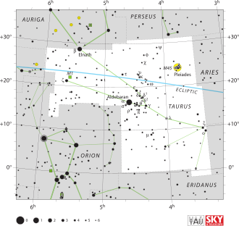

JUPITER – the largest planet in the Solar system. May have a solid core which is covered with liquid hydrogen together with a substantial, turbulent gaseous atmosphere. Two very prominent atmospheric bands straddle the planets equatorial region and may be observed. One of which contains a substantial red-orange circulating storm (Great Red Spot). It’s size is about 3x that of our Earth and has been viewed since 1831, It is believed to be anticyclonic.

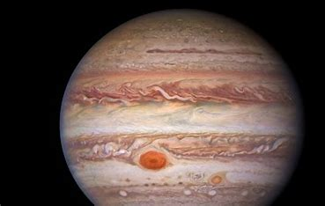

TAURID meteor showers. These have two radiant points and are thought to be to be associated with either the Encke comet and /or the asteroid 2004 TG 10. (RA 03h 50m dec +22° N and 14° N).

NOVEMBER `25 Newsletter.docx

