DECEMBER Night Sky – Gemini (the Twins – Castor & Pollux) and the meteor shower – Geminids plus Comet C/2025.
This month could be a good time, weather permitting, to seek out the Gemini constellation by looking due south after midnight.

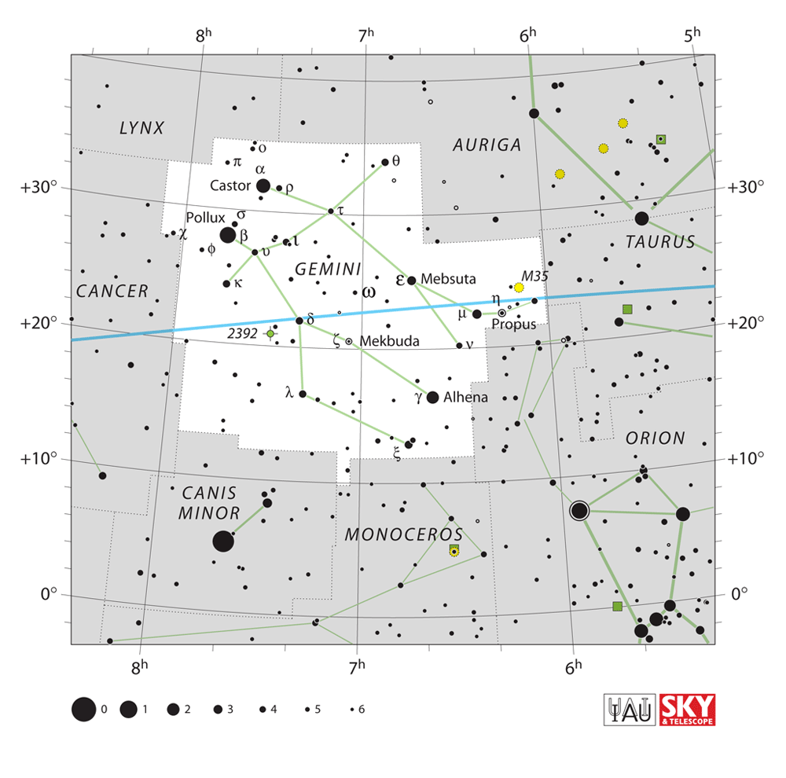
Castor α Gem – Is actually a sextuplet star system composed of 3 binary pairs around 49 ly away. The lagest and brightest is αlpha Gem a which is spec.type A 1V + dM 1e and has a red dwarf companion.
(RA 07h 36m dec +31° 53´ )

Pollux β Gem – Yellow-orange giant star spec.type K0 III which is 34 light-years away, which has about 2x mass, 9x radius and 38x luminosity of our Sun. (RA 07h 45m dec +28° 0´)

Geminids – In optimum weather conditions this annual shower has been known to provid more than 80 meteors per hour between 4th ~ 20th Dec. These are thought to be fragments left by the passing of asteroid 3200 Phaethon. (Radiant RA 07h 28’ dec +32°).

Comet 2025 - 3I/ATLAS (Asteroid Terrestrial-impact Last Alert System) – Access by an instrument / telescope, larger than 8” dia. could have enable the viewing of this comet as it passed through our solar system (Milky Way) at the end of last month. However, gravitational interactions with our Sun are now believed to have started the beginning of this comet’s nucleus fragmentation.

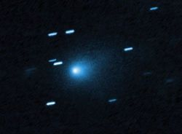

DECEMBER ’25 Newsletter.docs

