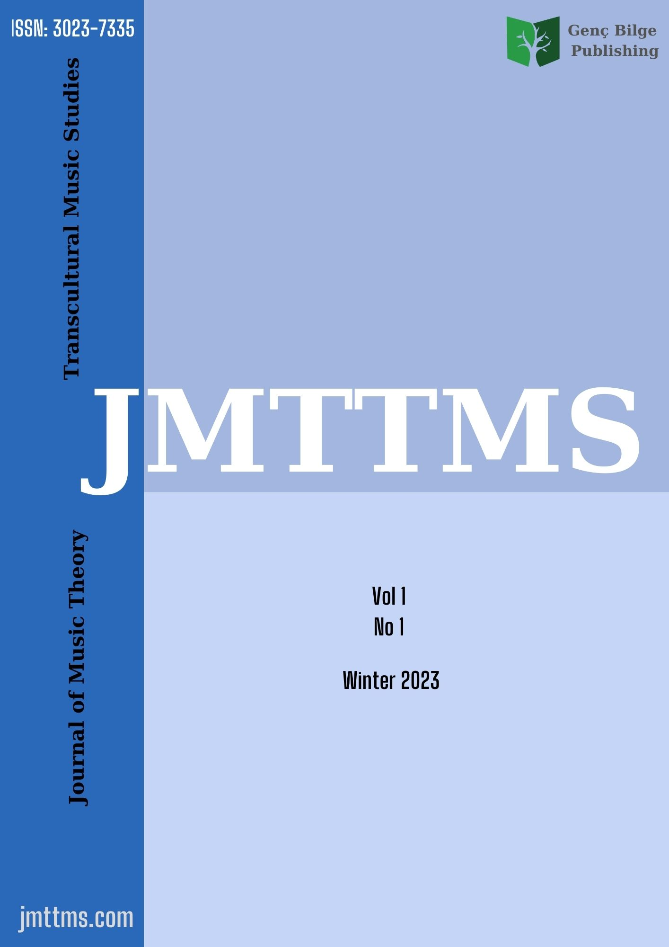
Journal of Music Theory and Transcultural Music Studies (JMTTMS)
ISSN: 3023-7335
Copyright Transfer Agreement Form
Journal of Music Theory and Transcultural Music Studies (JMTTMS in short)
Corresponding Author
Title of Manuscript
Address:
Telephone No: |  |  |  | E-mail
Co-Author Information
Co-Author |  |  | E-mail |  |  | Affiliations
The author(s) warrant that the manuscript submitted is his/her/their own original research. All participated authors in this work take public responsibility and have approved that the manuscript has not been sent any other journal for publication. All matter included in the manuscript does not violate any existing copyright rules and any intellectual property rights of any person or entity. The manuscript meets ethical standards applicable to the research discipline.
I/We (my co-authors) indemnify JMTTMS and the editors of the Journal and hold them harmless from any loss, expense or damage occasioned by a claim or suit by a third party for copyright infringement, or any suit arising out of any breach of the foregoing warranties as a result of publication of my/our article. The undersigned with the consent of all the authors, hereby transfer, to the extent that there is copyright to be transferred, the exclusive copyright interest in the above-cited manuscript, in this and all subsequent editions of this manuscript, and in derivatives, translations or ancillaries, in English and in foreign translations, in all formats and media of expression now known or later developed, including electronic, to JMTTMS.
Sign Here For Copyright Transfer
Print Authorized (Corresponding Author) Name and Title/Signature
Name and Title/Signature
Name and Title/Signature
Name and Title/Signature

