## Environmental Services Value Study of the Carrying Capacity and Economic Value of the Biosystem of the Grupo Nameless Tourist Complex located in the properties called Fraction II North Lot (Chemuyil), Fraction II South Lot 2 (Chemuyilito), Fraction 9, adjacent to Fraction 2 South (Chemuyilito) and Xcacel-Xcacelito Protected Area.

## by Dr. Linda M. AMBROSIE, PhD, CPA, August 2021

# Carrying Capacity – Main Findings

The carrying capacity of a natural system refers to the ability of a system to support one or more human activities at a given level before negative environmental impacts become irreversible. Although the term is broad and covers a variety of different concepts, they are related by the idea that systems, whether economic, social, or coastal ecological, such as mangroves, dunes, beaches, seagrasses, and reefs, have certain limits or thresholds. Because of the complexity, there are several ways to measure carrying capacity, either interconnected or integrated with various elements, but here the calculation is done separately to illustrate each of the individual effects. The types of carrying capacity that have been studied are physical, ecological, social and economic carrying capacity (Macleod & Cooper, 2005). Each is addressed and measured starting with the ecosystem characteristics of the study area, the area it covers, and its carrying capacity limits. Each measure is supported and documented by numerous recent academic studies that support the conclusions obtained. In the area called Fraction II North Lot (Chemuyil), Fraction II South Lot 2 (Chemuyilito), Fraction 9, adjacent to Fraction 2 South (Chemuyilito) (hereinafter referred to as the "**Grupo Nameless Tourist Complex**") and the Xcacel Protected Area, the conclusions of the calculations highlight the following:

- Physical-Social Carrying Capacity (tourism): The projected number of users (employees and tourists) of the Grupo Nameless Tourist Complex is three to six times higher than the physical-social capacity of the site.

- Ecological Carrying Capacity: The ecosystem services provided by the terrestrial and marine biosystems of the 130.7-hectare Grupo Nameless Tourist Complex combined with the Federal Maritime Zone **prior to any construction is USD 48.6 million**. Due to the clearing, construction of buildings and roads, containment walls, **damage** to the coastal zone, an ecosystem **value of USD 13.5 million in environmental services was lost**. This leaves a **balance of USD 35.1 million** of biosystem services, and that is without accounting for the important environmental service that sea turtles provide to the area, which is reciprocal, that is, the environmental services that the area provides to the sea turtles.

- Economic-social benefits (workers): The northern zone of Quintana Roo went from 28,165 rooms in 1994 to 107,128 rooms in 2019. By June 2021, due to the large hotels in operation, the number of rooms rose to 115,132 rooms of which 75% are in all-inclusive resorts and 85% in five stars (luxury category). As the demand is relatively inelastic, there is a certain number of tourists can be attracted to the area, more hotels will compete for the same clients by offering ever lower rates, especially now with the pandemic.

- Social impact (direct effects) Contrary to the statements made by Grupo Nameless Tourist Complex, it is estimated that the Complex, most certainly an all-inclusive resort, will employ at most 700 to 800 people, 70 to 80% fewer than the 2,600 employees declared.

- Social impact (indirect effects): Although the employment multiplier for the area is estimated at two (i.e., for every direct job another indirect job is created in the local community), only another 700 people will benefit, totaling between 1,400 and 1,600 people in all. This is 50% less than stated even when including both indirect and direct effects.

- Human resources (tax effects and work precarity): In addition, employees are hired through outsourcing companies to reduce employee salaries which decreases payroll tax collection, and to facilitate layoffs without benefits in periods of economic contraction.

The conclusion of the detailed calculations using three carrying capacity methods demonstrates that the Grupo Nameless Tourism Complex **will not have a positive economic, social or environmental outcome**. Following are the explanation and details behind these conclusions starting with the physical carrying capacity for tourists, then the monetization of the ecological services, and the real but limited employment benefits considering the over-construction of all-inclusive resorts in northern Quintana Roo.

# Physical carrying capacity and social carrying capacity (tourists)

Physical carrying capacity is a measure of the spatial or physical limitations of an area and is often expressed as the number of units, such as the number of tourists in the case of a resort, that a given area can physically serve or accommodate. Social carrying capacity is even more precise as it measures tolerance to overcrowding. In terms of tourist, it is the maximum visitor density at which recreationists still feel comfortable and uncrowded.

Other methods serve to measure one or more of the different environmental services including support, regulation, provisioning and cultural services. Support is the supporting ecological structures and functions that are essential for the provisioning of ecosystem services. Regulation is the maintenance of ecological processes (biogeochemical cycles) and support systems for human well-being. Provisioning is the supply of natural resources and raw materials, equally important for human well-being. Finally, cultural services serve to enhance human emotional, psychological, and cognitive well-being, which includes recreation services, i.e., opportunities for rest, refreshment, and recreation (Blue Ocean, n.d.). With that last in mind, Florida Parks (DEP, 2018) conducted a detailed study on user density that allowed for the best human experience while protecting a fragile coastal environment. Considering that the two coastal areas, the one in the site-specific study of the Tourism Complex Grupo Nameless, and Quintana Roo in general, share the same geology, have similar ecosystems, and the same economic characteristics, the results of the Florida Parks study can be reliably translated here. Based on these reliable measurements, Table 1 details the measurements of the Tourist Complex Grupo Nameless which includes a spa-golf club, 1,320 hotel rooms, 20 rooms built over the water on wooden piles (called palafittes) and two sun decks. **Use will exceed by three to six times** the physical and social carrying capacity of the **area where most of the tourists and employees will be located**.

Table 1: Physical and social carrying capacity in the coastal zone



Source: Ambrosie based on DEP, 2018 and measures provided in the environmental impact assessment Resolution: S.G.P.A.-DGIRA.-DIA.-0598/02.

The calculation of guests is based on the proposed investment of 1,300 rooms, a number that was later corrected to 1,320 by the authorities and recorded in document DIA-0598/02. All-inclusive resorts in the area tend to have an average annual occupancy of 70% with two people per room on average (Ambrosie, 2021). The 1,320 double rooms (excluding the 20 palafittes) with 70% occupancy at the Grupo Nameless Resort, translates into 1,840 tourists to occupy the resort with the vast majority on the vulnerable coastal strip that includes the Federal Maritime Terrestrial Zone. According to the measurements of the carrying capacity, the number of users allowed is 300 to 600 users maximum (see above Table 1, rows titled Beach and Swimming). Considering the limits to avoid overcrowding and irreversible ecosystem damage, the Tourism Complex Grupo Nameless **will be three to six times higher than the maximum** physical and social carrying capacity.

It is important to highlight three key variables in the calculation: activities, rotation and location. The maximum load considers the most common activities such as leisure, water recreation, and walking. Regarding the rotation throughout the day, the table shows that at any time (morning or afternoon), **the maximum capacity is 150 to 300 people at a point in time**, and therefore with a **rotation of two times (one group in the morning followed by another group in the afternoon, for example)** the maximum per day with two rotations allows for 300 to 600 per day to avoid overcrowding and negatively impacting ecosystem resilience. As for the exact location, the guests will spend most of their time in the most fragile area, which is the coastal zone. Therefore, the calculation of the physical and social carrying capacity must focus on the coastal zone, although it is obvious that the entire construction will have a much greater impact in addition to these two hectares. Hence the importance of the following ecological and economic carrying capacity to properly capture the broader impact.

# Ecosystem Valuation and Monetization

This calculation of ecological carrying capacity is more complex and important than the physical-social capacity because of its broader and long-term implications for the community and the state. Here we measure the ecological services provided by the different biomes found not only in the 130.7 hectares of land, but also the 34 hectares in the maritime zone between the Federal Zone and the mouths of the coves (SGPA, 2002). In the area studied, reefs are found not only inside the coves, but also at a short distance from the mouths. Excluding the mouth-reef area, the total Zofemat-marine area is 164 hectares. Because of species interactions between the different biomes, it is necessary to consider the combined and interconnected terrestrial and maritime zones.

While recognizing the important non-human services of these vital ecosystems, the measurement here considers mainly the essential services for humans which are support, regulation, provisioning and culture. Services are measured in US dollars at the 2021 exchange rate with a social discount rate of 3% over 50 years (see Desarrollo Turístico Ecotur, 2001; Fideicomiso-Chemuyil, 2019; Promotora Ecotur, 2001). The 50-year period includes the authorization period requested by Grupo Nameless in the environmental impact assessments. The discount rate is used to subtract the monetized value of the future amount (over 50 years) from the present. Combining the indicated measurements (see Annex for surface areas detailed by biome), academic studies of the services provided within the different biomes found on the property of the proposed Grupo Nameless Tourist Complex, and the **discount rate over 50 years, we arrive at a current value of USD 48.6 million**. The **damages caused to date** have a value of more than **USD 13.5 million** mainly due to the clearing of the dune and the modification of the beach that not only reduces the surface area for turtle nesting (not considered in the amounts) but for the vital protection provided by the dune and the beach to the entire coastal zone. This leaves a **net value of ecosystem services at a current value of USD 35.1 million**. But this calculation of the ecological carrying capacity does not account for the bi-directional value of sea turtles (value of turtles to the zone and from the zone to the turtle population), nor the problem of beach erosion outlined, measured and contemplated in the environmental impact assessment 2019 (Fideicomiso-Chemuyil, 2019), nor is included here the valuable services of greenhouse gas absorption. In essence, the net amount here of **USD 35.1 million is very conservative**.

Following are the details, calculations and sources to arrive at **full ecosystem services (Table 2) but now reduced by 25% due to the construction undertaken**, the calculation of which is presented in Table 3.

Table 2: Economic valuation of the full ecosystem services of the lots comprising 131 hectares of the Grupo Nameless Tourist Complex and also the coastal zone of the Federal Maritime Zone (Zofemat) with an additional 33 hectares.



Table 3: Economic valuation of damages and impact of construction initiated by the Grupo Nameless Tourist Complex



## A special note regarding sea turtles

Again, the above calculation does not include the value of the area to the turtles, nor the value of the turtles to the area. It has been widely documented (e.g., Lutz & Musick, 2017) the high sensitivity of turtles to human presence. Also specialized maps document, including within Chemuyilto cove, the unique importance of the area for turtle nesting:

Map 1: Turtle presence in the Grupo Nameless Tourist Complex zone and surroundings.

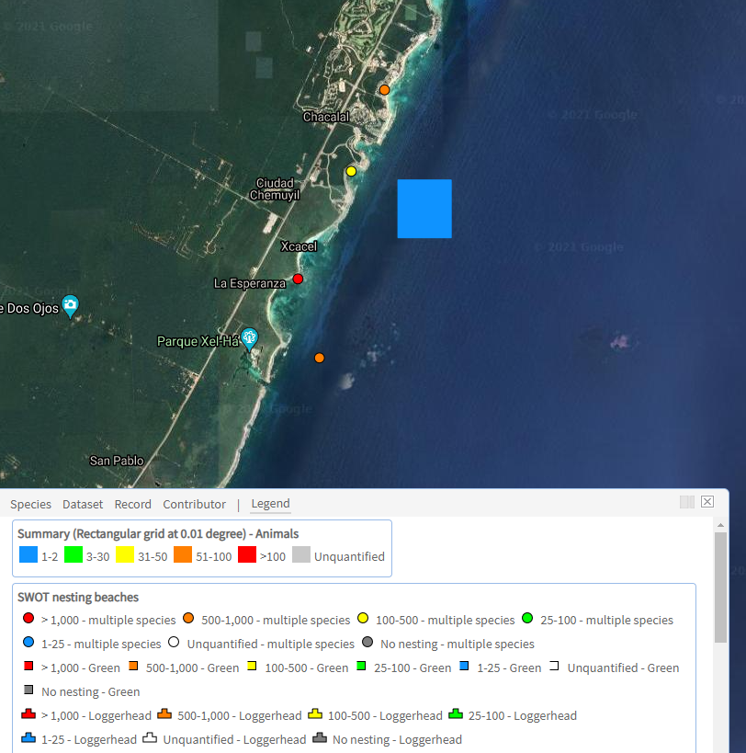

Source: OBIS-Seamap, 2021

Considering the importance of this coastal zone for sea turtles, studies have estimated the economic value of turtles for their direct use (provisioning and recreational) as well as their indirect importance in supporting ecosystem services. For example, turtles play an important role in reef health through their consumption of sponges (the only sponge predator) that compete for reef space with corals (Teelucksingh et al., 2010). Another example is the green turtle (Chelonia mydas) that feeds mainly on seagrasses (Zostera marina) which ensure the health of the seagrasses that serve to stabilize the soil to prevent erosion and provide transparent waters as well as habitat for other species.

Table 4: Use values that humans derive from sea turtles

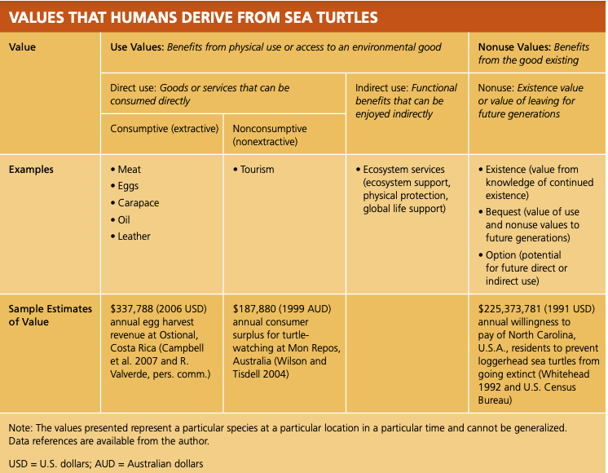

Source: Gjertsen, 2011

In summary, an appropriate amount, not estimated here, must be added to the calculation of ecosystem services from the 165 ha of land and sea area of Grupo Nameless Tourist Complex for the important benefits that sea turtles provide not only to the maintenance of reefs and seagrasses, but also to the beach and dune that benefit from nesting nutrients (Teelucksingh et al., 2010).

# Economic Benefits – Oversupply and Underemployment

To verify the claims in the 2001 environmental impact assessment about hotel supply and job creation provided by Grupo Nameless Tourist Complex (Desarrollo Turístico Ecotur, 2001), of which no updates have been provided since 2001, below in graph form are the number of rooms available as of May 2021 in northern Quintana Roo state (Tulum north to Costa Mujeres) and then the actual job creation is calculated based on recent studies and true figures.

## Supply

Over the last few decades, the number of all-inclusive resorts and the number of rooms have grown steadily as the following graphs demonstrate.

Graph 1 Growth in number of rooms in northern QR and the increase in the deluxe category

|  |  |
| --- | --- |
|  |  |

(Ambrosie, 2021 from DataTur-SecTur, n.d.; SEDETUR-several years, 2021)

Since 1994, the number of hotels increased 2.64 times and the number of rooms increased 2.80 times, i.e., the average hotel increased from 219 rooms per hotel to 248, a 13% increase in the size of hotel complexes in general. But the number of rooms in the 5* luxury hotel category increased by 615% from 9,000 rooms in thirty-three 5-star hotels to 76,000 rooms in 236 resort complexes by 2019. Just since 2002, the number of available rooms has increased by 100% and mostly in the area between Playa del Carmen and Tulum where the Grupo Nameless Tourist Complex is located.

The number of rooms in large luxury resorts (almost exclusively All-Inclusive) increased from 10,000 rooms in 1994 to 76,000 rooms in the 5-star category, 70% of the hotel supply by the end of 2019. Despite the pandemic, the number of large all-inclusive resorts and the number of rooms on offer continues to grow in two main areas: Costa Mujeres (Isla Mujeres) and the Riviera Maya (Solidaridad and Tulum the location of the Grupo Nameless Tourist Complex), both zones increasing between 3,000 and 4,000 rooms each in the period between May 2019 and May 2021 as the table below demonstrates:

Table 5: Room increase 2019 to 2021 in Riviera Maya and Costa Mujeres

|  |  |  |  |  |
| --- | --- | --- | --- | --- |
| Year, month of May | Isla Mujeres (in particular Costa Mujeres) | Municipalities of Solidaridad and Tulum | Rooms added per year increase from previous year) |  |
| 2019 | 4,950 | 46,969 |  |  |
| 2020 | 6,896 | 48,200 | = +3,177 (6.7%) |  |
| 2021 | 8,316 | 50,822 | = +4,042 (8.4%) | = +7,219 (15.4%) |

(Source: Sedetur – several years, n.d.2018 to May 2021)

In short, the Solidaridad-Tulum area has 25% more rooms than stated in the 2019 environmental impact assessment (Fideicomiso-Chemuyil, 2019, p. 1096 in pdf copy) and already over-densified with demand beginning to slow even prior to the onset of the pandemic (RLB, 2021). Also, the region is overly dependent on the US market (70% to 80% of the international tourists) that is hyper-sensitive to risk. Considering the excessive number of rooms on offer with flat or decreasing demand, a rate war will be triggered leading to a trajectory like that of the Acapulco area. Even the Nameless Group itself recognizes the saturation. The real beneficial owner, José Carlos Azcárraga Andrade, recently announced that he is focusing his hotel investments outside of Mexico, mainly in the Dominican Republic and this despite the significant debts that Grupo Nameless has accumulated (Ramírez-Tamayo, 2020).

## Employment

The calculation in the environmental impact assessments estimates 1,400 workers in construction and then 2,600 employees working in operations. From the hospitality studies it can be concluded that these figures are inflated.

Table 6: INFLATED CALCULATION PRESENTED IN Desarrollo Turístico Ecotur, 2001, p. 330

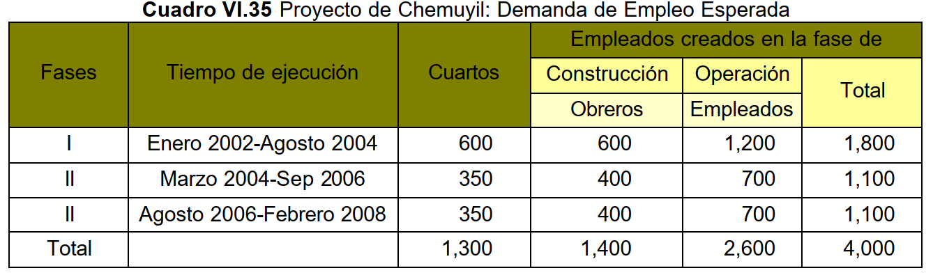

### Inconsistencies:

1. Number of employees: Even though in the same document the authors note that "for each occupied room, on average, one worker is employed", the **number in the above calculation is inflated to two**. But even a staff-to-room ratio of one for an all-inclusive hotel in an emerging economy is too high. In QR, the staff-to-room ratio is at most 0.75 employees per occupied room in the all-inclusive resorts, even those in the deluxe category. This staff-to-room-ratio with the average annual occupancy is combined to estimate the total number of employees. The average occupancy at all-inclusive resorts in the Riviera Maya area was over 70% for many years and increased to 82%[1] in 2018 and 2019 (SEDETUR, 2019, 2020), but was declining according to international reports (RLB, 2019, 2021) prior to the pandemic. With 70% to 80% occupancy and 0.75 employees per occupied room, the total number of employees is a **maximum of 700 to 800[2] employees, 70% less than the figure indicated**.

2. Origin of employees: It should be noted that it is unlikely that so many workers come from the local community. Therefore, the assumption that the local community will automatically benefit is false due to the different skills required in the different positions.

3. Indirect employment: Although the employment multiplier for the area is estimated at two (i.e., for every direct job another indirect job is created in the local community), only another 700 people at most will benefit, totaling between 1,400 and 1,600 people in all. **That is still 50% less than stated even when including both indirect and direct effects**.

3. Wages and social security: Not only will the Nameless Group Tourist Complex employ much fewer personnel, but all the **hotels outsource to lower the wage base** which is detrimental to the worker both economically and in terms of **access to social services**. Outsourcing helps the hotel to **pay less payroll taxes which impacts state revenue** and, in times of economic contraction such as the pandemic, **facilitates the drastic reduction of personnel** without the hotel looking directly responsible and affecting its reputation negatively. In March 2020, Quintana Roo in total numbers laid off 60,000 hospitality workers, the largest number of layoffs in the Republic. This was only discovered and calculated thanks to intrepid reporters (see Felix, 2020).

# Conclusion

The proposed Grupo Nameless Tourist Complex **will not meet any of the economic and social objectives**, much less the protection of biodiversity and their important services to human wellbeing. The reality, clearly demonstrated by updated data and studies, is that there are **currently more than 40,000 hotel rooms in the Playa del Carmen - Tulum corridor** (and more than 100,000 rooms in the whole of Quintana Roo’s northern zone) with decreasing occupancy every year. Grupo Nameless Tourist Complex will add a **maximum of 700 to 800 positions**, and the proposed resort has **at least triple the number of rooms for the physical and social carrying capacity**. The construction undertaken has already lowered the ecosystem services by 25% leaving a **net value of USD 35.1 million instead of USD 46.6 million**. Of the three ways of calculating carrying capacity, none demonstrates that the project will result in a positive outcome.

# References

Alcorn, J. cited in Godoy, R., Lubowski, R., & Markandya, A. (1993). A method for the economic valuation of non-timber tropical forest products. Economic Botany, 47(3), 220–233. <https://doi.org/10.1007/BF02862288>

Ambrosie, L. M. (2015). Sun & Sea Tourism: Fantasy and Finance of the All-Inclusive Industry. Cambridge Scholars Publishing. https://doi.org/978-1-4438-7804-3

Ambrosie, L. M. (2016). Turismo de Sol y Playa: Fantasia y Finanzas de la industria Todo-Incluido (Electronic). KDP.

Ambrosie, L. M. (2021). Turismo en Quintana Roo: de recaudación positiva a recaudación negativa con deudas sociales y ambientales: lecciones para otros destinos. In E. Cardenas (Ed.), Politicas Turisticas en Mexico. Colegio de Jalisco.

Barbier, E. B., & Strand, I. (1998). Valuing mangrove-fishery linkages. A case study of Campeche, Mexico. Environmental and Resource Economics, 12(2), 151–166. https://doi.org/10.1023/A:1008248003520

Blue Ocean. (n.d.). BlueValue. Harte Research Group,Texas A&M Corpus Cristi. Retrieved July 15, 2021, from <https://www.bluevalue.org/>

Cabrera, M. A., Seijo, J. C., Pérez, E., & Pérez, J. E. (1998). Economic values of ecological services from a Mangrove ecosystem. In Intercoast Network. https://www.researchgate.net/publication/235230828_Economic_values_of_ecological_services_from_a_Mangrove_ecosystem

Camacho-Valdez, V., Ruiz-Luna, A., Ghermandi, A., & Nunes, P. A. L. D. (2013). Valuation of ecosystem services provided by coastal wetlands in northwest Mexico. Ocean and Coastal Management, 78, 1–11. https://doi.org/10.1016/j.ocecoaman.2013.02.017

CONABIO. (n.d.). Ecosistemas de México. Biodiversidad Mexicana. Retrieved July 20, 2021, from https://www.biodiversidad.gob.mx/ecosistemas/ecosismex

CONABIO. (2008). Capital Natural de México: Políticas Públicas y Perspectivas de Sustentabilidad (J. Sarukhán (ed.); Vol III). CONABIO.

DEP. (2018). Recreational Carrying Capacity Guidelines. <https://floridadep.gov/parks/ogt/documents/recreational-carrying-capacity-guidelines>

Fideicomiso-Chemuyil. (2019). Obras Complementarias para el desarrollo de Servicios Turisticos (p. 1220). DGIRA.

Desarrollo Turístico Ecotur. (2001). Manifestación de Impacto Ambiental Modalidad Particular de “Desarrollo Turítistico Ecotur SA de CV” (p. 409). Desarrollo Turístico Ecotur Promotora Ecotur SA de CV.

Gjertsen, H. (2011). What’s a Turtle Worth? — The State of the World’s Sea Turtles. In State of the World’s Sea Turtles. https://www.seaturtlestatus.org/articles/2019/5/1/whats-a-turtle-worth

Lutz, P. L., & Musick, J. A. (2017). The biology of sea turtles. [Volume I].

OBIS-Seamap. (2021). The State of the World’s Sea Turtles. OBIS-Seamap. https://seamap.env.duke.edu/swot

Desarrollo Turístico Ecotur. (2001). *Manifestación de Impacto Ambiental Modalidad Particular de “Desarrollo Turítistico Ecotur SA de CV”* (p. 409). Desarrollo Turístico Ecotur Promotora Ecotur SA de CV.

Fideicomiso-Chemuyil. (2019). Obras Complementarias para el desarrollo de Servicios Turisticos de “Desarrollo Turítistico Ecotur SA de CV” (p. 1220).

Promotora Ecotur. (2001). Manifestación de impacto ambiental modalidad particular.

RLB. (2019). Latin American and Caribbean Hotels Monitor - Americas. Rider, Levett, Bucknall.

RLB. (2021). Latin America and Caribbean Hotels Monitor -Americas. In *Rider, Levett, Bucknall*. https://www.rlb.com/americas/insight/latin-america-caribbean-hotels-monitor/

SEDETUR. (2019). Indicadores Turísticos - Dic 2018. https://sedeturqroo.gob.mx/ARCHIVOS/indicadores/Indicador-Tur-Dic-2018.pdf

SEDETUR. (2020). Indicadores Turísticos - Dic 2019. https://sedeturqroo.gob.mx/ARCHIVOS/indicadores/Indicador-Tur-Dic-2019.pdf

Promotora Ecotur. (2001). Manifestación de impacto ambiental modalidad particular.

SGPA. (2002). S.G.P.A.-DGIRA.-DIA.-0598/02 (p. 41). SEMARNAT, Subsecretaría de Gestión para la Protección Ambiental.

SGPA. (2002). Resolutivo S.G.P.A.-DGIRA.-DIA.-0599/02 (p. 52). SEMARNAT, Subsecretaría de Gestión para la Protección Ambiental.

Teelucksingh, S., Eckert, S., & A.L.D. Nunes, P. (2010). Marine Turtles, Ecosystem Services and Human Welfare in the Marine Ecosystems of the Caribbean Sea: A Discussion of Key Methodologies. Études Caribéennes, 15. https://doi.org/10.4000/etudescaribeennes.10990

## ANNEX – DETAILED CALCULATION OF BIOMES AND SURFACE AREAS

SURFACE AREAS DECLARED, FAUNA AND FLORA OUTLINED IN 0598/02

| 0598/02 | Concepto | metros | en metros 2 | hectárea |
| --- | --- | --- | --- | --- |
| p. 6 | Campo de golf, lago, vialidades |  | 132,963 | 13.30 |
|  | Casa Club con spa |  | 21,631 | 2.16 |
|  | Estacionamiento |  | 2,376 | 0.24 |
|  | Campo, casa, parking = 11.87% de la superficie |  | = 156,970 | 15.70 |
|  | Superficie total - 100% |  | 1,322,409 | 132.24 |
| p. 10 | Manta freática |  | 2.9 a 3.20 | m de profundidad |
| p. 11 | Fauna amenazada, rara y bajo protección |  |  |  |
|  | Aguililla gris |  | Protección especial |  |
| p. 15 | Tortugas Blanca (Chelonia mydas) |  |  |  |
|  | Tortugas caguama (Careta careta) |  |  |  |
| p. 12 | Selva baja subcaducifolia |  |  | 47.40 |
|  | Selva baja superennifolia |  |  | 31.97 |
|  | Mangle chaparro |  |  | 5.22 |
|  | Mangle franja |  |  | 0.15 |
|  | Mangle mixto |  |  | 9.27 |
|  | Humedal Rhizophora |  |  | 3.03 |
|  | Humedal Rhizo-Cano_Laguncularia |  |  | 6.24 |
|  | Corchal |  |  | 0.22 |
|  | Saibal |  |  | 0.29 |
|  | Ecotono |  |  | 2.51 |
|  |  |  |  | 106.29 |
| p. 14 | Caleta Chemuyililto boca | 500.1 |  |  |
|  | Caleta de Chemuyilito hacia continente | 296.0 | 148,030 | 14.80 |
|  | Chemuyililto Litoral rocas carbonatadas norte | 233.9 |  |  |
|  | Chemuyililto Litoral rocas carbonatadas sur | 486.0 |  |  |
|  | Chemuyililto Playa arenosa | 182.9 |  |  |
|  | Caleta Chemuyil boca | 422.1 |  |  |
|  | Caleta Chemuyil hacia continente | 461.1 | 194,599 | 19.46 |
|  | Chemuyil Litoral rocas carbonatadas norte | 961.0 |  |  |
|  | Chemuyil Litoral rocas carbonatadas sur | 949.0 |  |  |
|  | Chemuyil Playa arenosa | 279.2 |  |  |
|  | Total, metros líneal del mar | 3092.0 |  |  |
|  | Zona Federal Marítima profundidad, metros | 20 | 61,841 | 6.18 |

1. The 82% was the occupancy boom and no doubt after the pandemic, it will take many years, if ever, for occupancy to reach that figure.
2. The calculation is 1,320 rooms times 82% occupancy times .75 jobs per occupied room = 811 jobs.