**Risks From Oil & Gas Production**

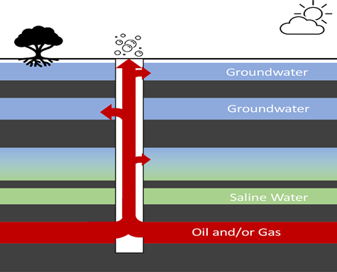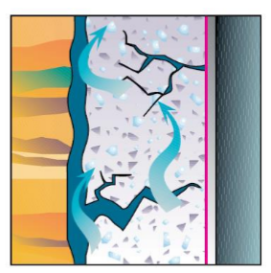**Cement Failure**. Multiple issues can contribute to cement failure. For instance, cement may shrink over time. This is particularly likely if the water content in the cement is too high, which causes the cement to lose water while setting (Dusseault et al. 2000). This can cause a micro -annulus problem to develop between the cement and the borehole and/or casing. Schematic below is a visual representation of cement shrinkage.

Cross-sectional schematic of an unplugged abandoned well acting as a subsurface leakage pathway connecting oil and gas reservoirs to aquifers and the ground surface. The dark gray zones represent lower permeability layers that act as barriers for vertical flow of groundwater and oil and gas. Groundwater is defined here as protected water of sufficient quality to be used for drinking, agriculture, industrial, or other uses. The red zone represents the formation containing oil and/or gas (and water) from which oil/gas will migrate upward due to buoyancy. As the oil/gas migrates upward, it can leak into aquifers and cause groundwater contamination or emit gases to the atmosphere. Plugged wells can also act as leakage pathways if the plugging was performed inadequately or the plug deteriorates.

Pennsylvania is estimated to have between 300,000 and 750,000 orphaned and abandoned oil and gas wells, with the state's Department of Environmental Protection (DEP) having identified over 27,000 of them so far.

These wells pose environmental and safety risks by releasing climate-warming methane and other toxic chemicals, but efforts are underway to locate and plug them, supported by federal funding from the Infrastructure Investment and Jobs Act.

**The Problems:**

**Numbers** Pennsylvania has the most orphaned and abandoned wells of any state in the nation, with hundreds of thousands likely remaining undiscovered.

**Safety Risks** Abandoned and orphaned wells in Pennsylvania pose hazards by leaking harmful substances like methane, a potent greenhouse gas contributing to climate change and posing risks of explosion. They also **leak other toxins** such as **benzene** and [**hydrogen sulfide**](https://www.google.com/search?client=firefox-b-1-d&cs=0&sca_esv=8e23599b05dcda53&q=hydrogen+sulfide&sa=X&ved=2ahUKEwivlKr1zqaPAxX5SzABHTrbFwAQxccNegQIAxAC&mstk=AUtExfDe-XTR2_7TBdnuAv1NKfeTHO5kriWbGyxWItJ1UwYFQ1CZIBCv4xkjG--DPpDelzNXpiSPPI13nWG8Coya3s52eMQQwHQv4LPAcxhX1a8ovJQmL35FncCO5gZVIJSQpcU&csui=3) into the **groundwater**, which can contaminate drinking water sources and threaten public health.

**Specific Hazards**

**Methane Emissions:** Leaking wells can release methane into groundwater.

**Toxic Contamination:** Wells can leak various hazardous substances into the groundwater.

[**Hydrogen Sulfide**](https://www.google.com/search?client=firefox-b-1-d&cs=0&sca_esv=8e23599b05dcda53&q=Hydrogen+Sulfide&sa=X&ved=2ahUKEwivlKr1zqaPAxX5SzABHTrbFwAQxccNegQIFhAB&mstk=AUtExfDe-XTR2_7TBdnuAv1NKfeTHO5kriWbGyxWItJ1UwYFQ1CZIBCv4xkjG--DPpDelzNXpiSPPI13nWG8Coya3s52eMQQwHQv4LPAcxhX1a8ovJQmL35FncCO5gZVIJSQpcU&csui=3)**:** A toxic gas with a characteristic rotten egg smell, also found in natural gas and oil deposits.

**Other chemicals:** Including arsenic and other substances from the well's infrastructure or the reservoir itself.

**Water and Soil Pollution:** Contaminants from leaking wells can seep into groundwater, contaminating drinking water supplies and pollute the surrounding soil.

**Structural Degradation & Leaks** Over time, the well casing and sealants can deteriorate, leading to further leaks of oil, gas, and fluids, as well as structural collapse. Leaks can lead to explosions, especially when gas migrates into homes and basements, posing a significant risk to human life and property.

**Undocumented wells:** The majority of abandoned wells are undocumented because Pennsylvania did not require permits for new wells until the mid-1950s. Many companies that originally drilled the wells are long gone, leaving no one responsible for plugging them.

**Growing numbers:** In addition to the "orphaned" wells abandoned before 1985, the number of abandoned wells continues to grow. A "culture of non-compliance" among some conventional drillers and inadequate enforcement means that even modern wells are sometimes not plugged after production ceases.

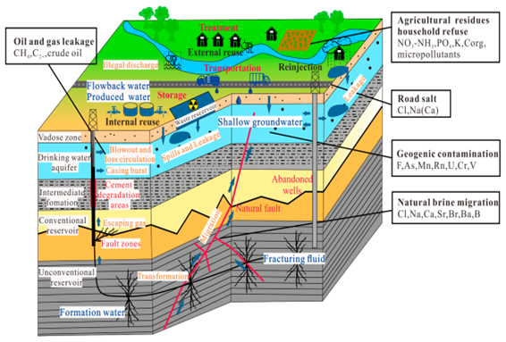**Additional Risks To Groundwater Contamination:**

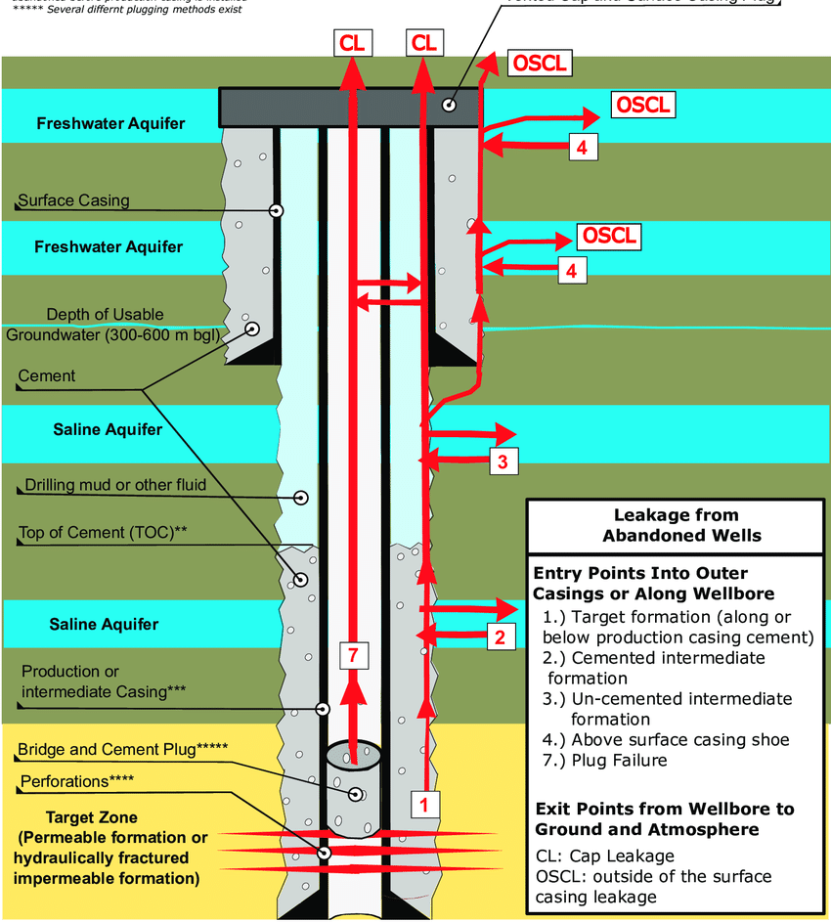**Wellbore Schematic**