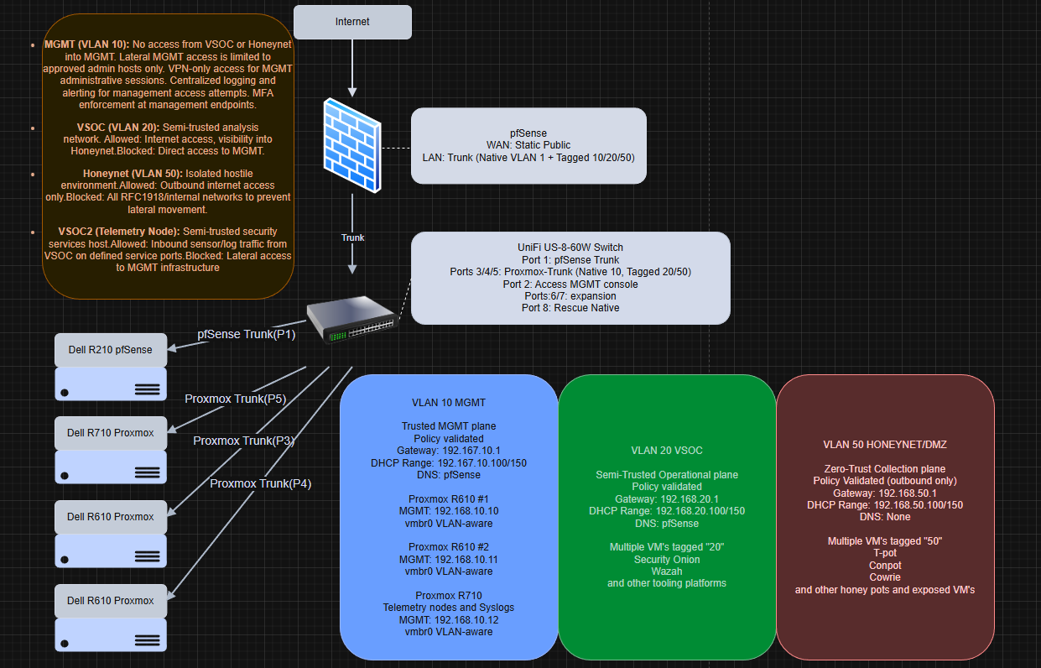

I built a security-focused home lab to practice SOC workflows safely. This architecture allows me to manage resources locally and remotely, analyze real time threats in a real-world environment, and reverse engineer/dissect malicious code. This project is part of a larger research project that will be published in mid-2026.
Mission:
My goal was to segment the environment with VLANs, make routing/firewalling centralized in pfSense, and run workloads on Proxmox—while keeping a safe rollback path so I wouldn’t lock myself out mid-build.
Execution:
I used pfSense to create VLAN interfaces for MGMT/VSOC/Honeynet, then configured a UniFi switch with access profiles and trunks. I validated each VLAN with a test client before plugging in servers. On Proxmox I used a single VLAN-aware bridge and tagged VM NICs per network. After proving connectivity, I tightened policy: VSOC can reach the Honeynet and the internet but is blocked from MGMT, and the Honeynet is blocked from RFC1918 (private IP’s) to prevent lateral movement. I also captured backups of pfSense and UniFi configurations at a stable checkpoint and created Proxmox templates.

Result:
I ended up with a stable SOC-style architecture: a protected management plane, an analysis network with controlled visibility into the honeynet, and a contained hostile zone. It’s now a platform I can extend with Zeek/Suricata/Wireshark and centralized logging on a dedicated ‘VSOC2’ node.

AAR (after action report):
The biggest takeaway was consistently having a rollback point to fall back to. I locked myself out more than once and it was frustrating. Through trial and error, I refined a build, validate, snapshot/backup methodology of architecture.

