FOR IMMEDIATE RELEASE
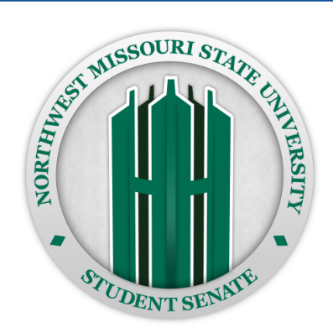

CONTACT INFORMATION:
Biff Winkleman, Publicity Chair
Maryville NWMSU Student Senate
(660) 582-5555, fax (660) 562-5555
biff@nwmissouri.edu

NORTHWEST MISSOURI STATE UNIVERSITY STUDENT SENATE HOSTS HEALTH SCREENING EVENT FOR LOCAL SENIORS

MARYVILLE, MO — To support the health and well-being of local seniors, the Northwest’s Student Senate is proud to announce a community health initiative. The Student Senate will be sponsoring a blood pressure check and cholesterol screening event on Friday, April 12, 2024, from 2 p.m. to 4 p.m. The event will take place at Hy-Vee, located at 1217 S Main St., Maryville, Mo.

The initiative, part of the University’s longstanding Maryville Outreach Program, aims to provide crucial health services to seniors in the area. Recognizing the importance of early detection in maintaining good health, the Student Senate is offering these screenings free of charge.

In addition to the blood pressure checks and cholesterol screenings, nurses may provide other tests requiring lab work at affordable rates. Along with the free and affordable services, Aramark will be catering the event with coffee.

Northwest’s Student Senate, a student-led organization dedicated to promoting student issues across campus, has been actively involved in community outreach since 2006 through the Maryville Outreach Program. This initiative underscores the Student Senate’s commitment to fostering stronger ties between the university and the local community.

Seniors interested in participating in the health screening event are encouraged to register before their screening and the Aramark coffee. For more information about the event, please contact Northwest’s Student Senate.

###

