A New York Elementary Teacher’s Recollection of 9/11

Jennifer Bennett, an 3rd grade school teacher in New York City, was under a mile away when The World Trade Center was under attack on Sept. 11, 2001.
Jennifer was introducing multiplication to her young students when an administrator informed her of the attack.
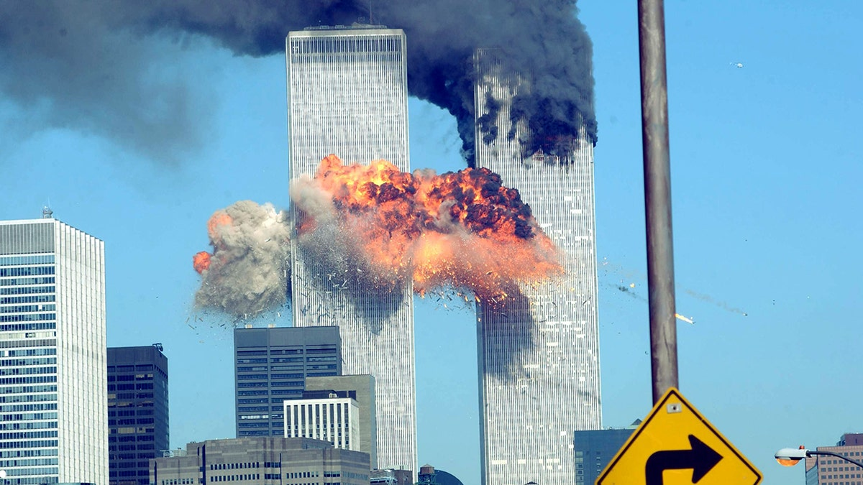
The World Trade Center after the second plane hit on Sept. 11, 2001, in New York City. (Spencer Platt/Getty Images)
Despite the chaos outside, she made a conscious decision not to burden her students with the grim reality. Jennifer persevered through the school day teaching the students and shielding them from the impending panic to the best of her ability.
“I didn’t want to put my students through what many others were going through at the time,” she explained. “However, I wasn’t able to completely shield them from the tragedy.”
Starting at around 8:30 a.m., parents began pulling their children out of school and continued to throughout the day.
At 10 a.m., Jennifer heard the sound of the South Tower falling. “I—I felt my heart sink.”
Then around 10:30 a.m., Jennifer heard the sound of the North Tower falling. Jennifer started to tear up as students became curious about what was going on. Jennifer kept her composure and did her best to change the subject distracting students from their thoughts.
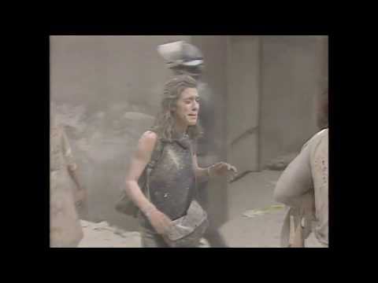
She recalled one parent who caught her attention by walking inside the classroom completely covered in debris from the Towers falling.
Around 11 o’clock when the students were eating lunch in the cafeteria, she gathered with other teachers to watch the news.
“It was completely silent. Nobody said anything. We all just listened to the news and sat there in shock after learning about the Pentagon and Pennsylvania plane crashes.”
By the end of the day, Jennifer found herself with only half her students remaining in class.

