FOR IMMEDIATE RELEASE

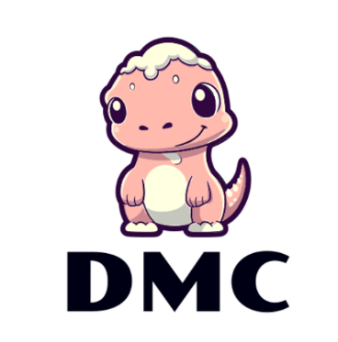
CONTACT INFORMATION:
Dakota Michele, Publicity Chair
Dakota Michele Clothing
(402) 000-0001
dmc@marketing.com

DMC DONATES CLOTHING TO NWMSU CAREER CLOSET

Lincoln, NE — To support the growing number of college students preparing for job interviews and career fairs as the summer approaches, the CEO of Dakota Michelle Clothing, who is an alumnus of Northwest Missouri State University, has decided to donate any overstock of their professional attire to NWSMU Career Closet.
DMC, an emerging and upscale business dedicated to crafting sustainable and affordable formal attire, has a mission to support students nationwide in launching and advancing their careers. DMC donates clothing to institutions like NWMSU, facilitated by their practice of offering discounts to individuals who send in their professional attire. They then reuse the fabric to create new pieces to donate or donate the piece entirely if it arrives in good condition. This innovative approach not only promotes sustainability but also ensures that students have access to quality clothing for their professional endeavors.
The NWMSU Career Closet is a valuable resource designed to assist students with preparing for job interviews and career fairs. Available to NWMSU students at no cost, the Career Closet offers a variety of clothing and accessories essential for professional attire. The closet is open Monday through Friday from 2 to 4 p.m. on the 1st floor of The Station. Students can make appointments for alternate times if they are unable to visit during the Career Closet’s regular operating hours.
DMC encourages individuals to send in any clothing or fabric to their address at 2425 Sustain St, Maryville, MO, 64468. Alternatively, if you prefer to donate directly to NWMSU, donations can be accepted at the Career Services office in Administration Building 130 on the NWMSU campus. All clothing should be neatly hung and ready to wear.
XXX

