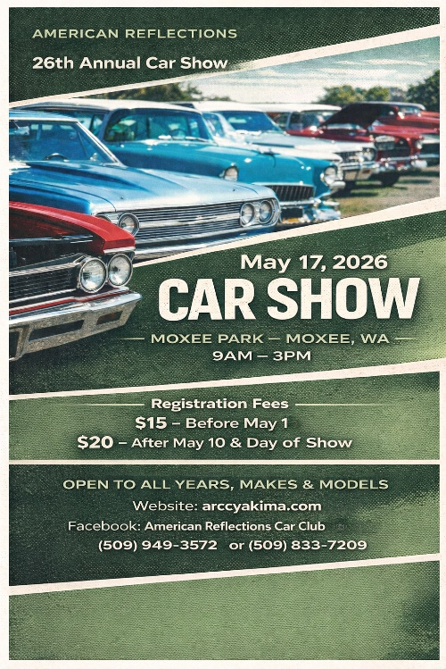
26th Annual Open Car Show
Sunday, May 17th, 2026
Moxee Park at 9:00 AM – 3:00 PM

Registration before May 1: $15.00
After May 10 and at the show: $20.00.

LIABILITY: Signature below indicates the release and discharge of the organizer, committee members and city of Moxee from all known and unknown damages, injuries, losses or claims to my vehicle, its occupants, and myself. I also give American Reflections permission to photograph my vehicle and use it in future advertisements & publications

First Name____________________ Last Name_____________________
Mailing Address_______________________________________________
City_____________________ State_____________ Zip_______________
Phone Number_________________ Email_________________________
Vehicle______________________________ Year____________________
Car Club______________________________________________________
Signature_____________________________________ Date___________
Registration Number:_______________ (Assigned by Club)

Please make checks payable to : "The American Reflections Car Club"
American Reflections P.O. Box 11377, Yakima, WA. 98909



Questions or concerns?
Facebook.com/ARCCYakima

T: 509-949-3572 / 509-833-7209
Instagram.com/american.reflections
E: Info@arccyakima.com
ARCCYakima.com

