J& M TECHNOLOGIES LIMITED

rAInge Sensor

Quick Start Guide

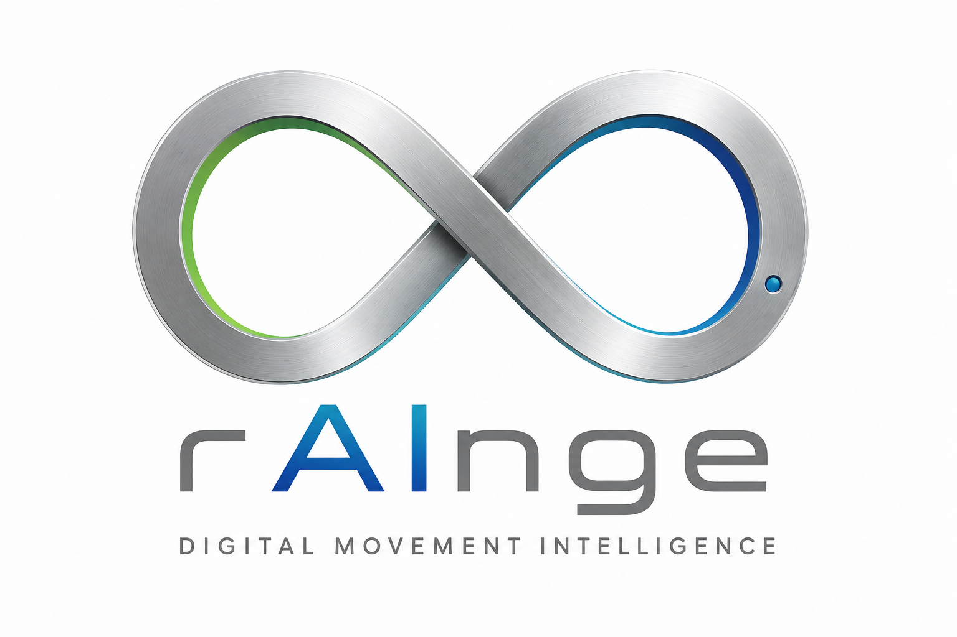

Charging Your Sensor

- Insert the standard USB-A end of the cable into any conventional USB charging adapter block (not supplied in kit).
- Connect the small USB-C male adapter carefully into the female power input receiver slot located own the underside of the black sensor unit.
- Look at the LED light on the front of the sensor and make sure it is showing the right colour.
Figure 1: Charging, Connectivity & LED codes
Red Light Battery needs charging
Steady Blue Light: Battery is charging
Green Light (On Lifting): Device is awake and operational
Green light flashing Sensor connected to phone

Mandatory: You must have an active network connection (Wi-Fi or cellular wireless data) to upload data

Before starting rehabilitation exercises, the sensor must pair with the smartphone via Bluetooth. This provides an encrypted, direct link to transfer movement data accurately.
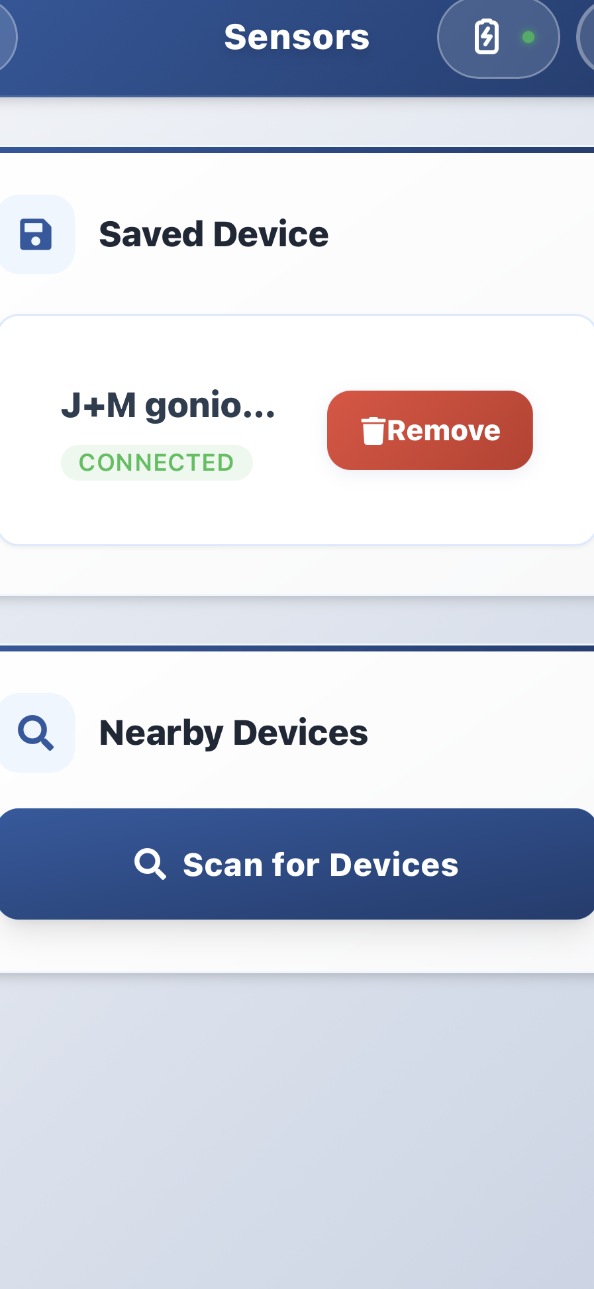

Pairing the Sensor with your App

1

- Enable Bluetooth: Make sure Bluetooth on your phone is turned ON
- Open the App Open the mobile app home screen and enter the "Sensors" dashboard page. Click "Search Sensor”
- Wake the Sensor: Pick up the sensor . This will wake the unit from low-power sleep mode to active state. The LED indicator will immediately flash green. Make sure the sensor is NOT plugged in to charger
- Select Sensor: identify the sensor device and click connect
- Two-Factor Authorization: An encrypted 4-digit mobile verification authentication code will be sent to your phone. Type this authorization verification number into the prompt on the App connection security.

If pairing fails, confirm that the sensor is NOT currently connected to a power cord charger. Bring the smartphone closer (within 30 centimeters) and if necessary please restart the app.
Fitting your sensor to the arm

Correct attachment position and alignment on your limb are essential for accurate measurement.

Fitting Guidelines
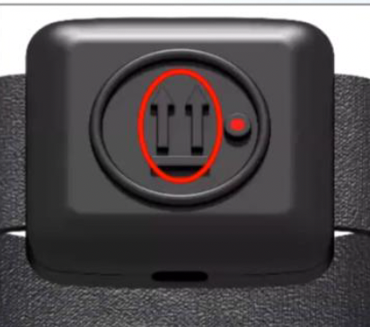

Direct Skin Contact Required:
Fasten the silicone strap directly around the bare skin surface of your arm. Do not position or wrap the band over shirts, sleeve materials, or fabric as this can cause the sensor to slip and cause measurement errors.

Proper Orientation:
Ensure the embossed arrows on the outer plastic casing are pointing directly UPWARD toward your head. The USB-C power insertion opening must face downward toward your wrist. The sensor should be placed the side of the arm facing out to the side

Figure 2 Correct orientation

System Calibration

Before you begin the exercises the sensor must be calibrated to allow it to know its position in space. This will be done twice: once at the start of the exercises and secondly before the External Rotation exercises.

- Assume the Home Position: Stand up straight. Let both arms hang loosely at your sides.
- Launch Calibration via Mobile App: From the application primary menu screen, press "Exercises" Select "Start Exercise Session”. (Figure 3)
- Select the side: Tap either "Left Arm" or "Right Arm" on the screen map to specify which side is being measured.
- Initiate Recording Gesture: Click the button marked "Record Gesture", then press "I Understand”.(Figure 4) A 5-second countdown timer will appear on screen. Remain still until the countdown has finished
- Avatar Synchronization: Watch the digital avatar model complete a simple arm elevation demonstration. (Figure 5) Copy the movement repeatedly at your own pace. Continue until prompt indicates that calibration is complete

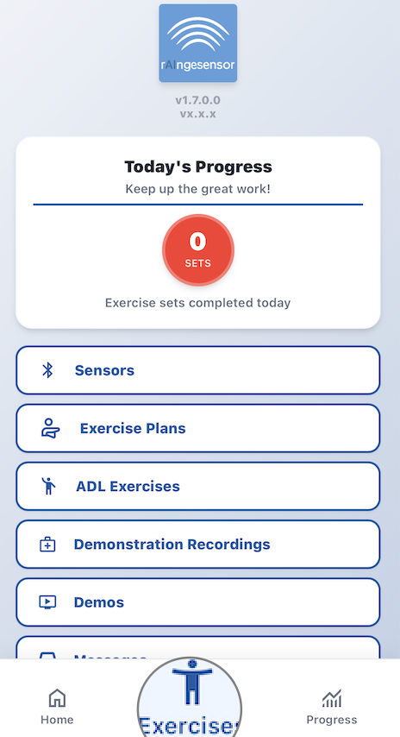
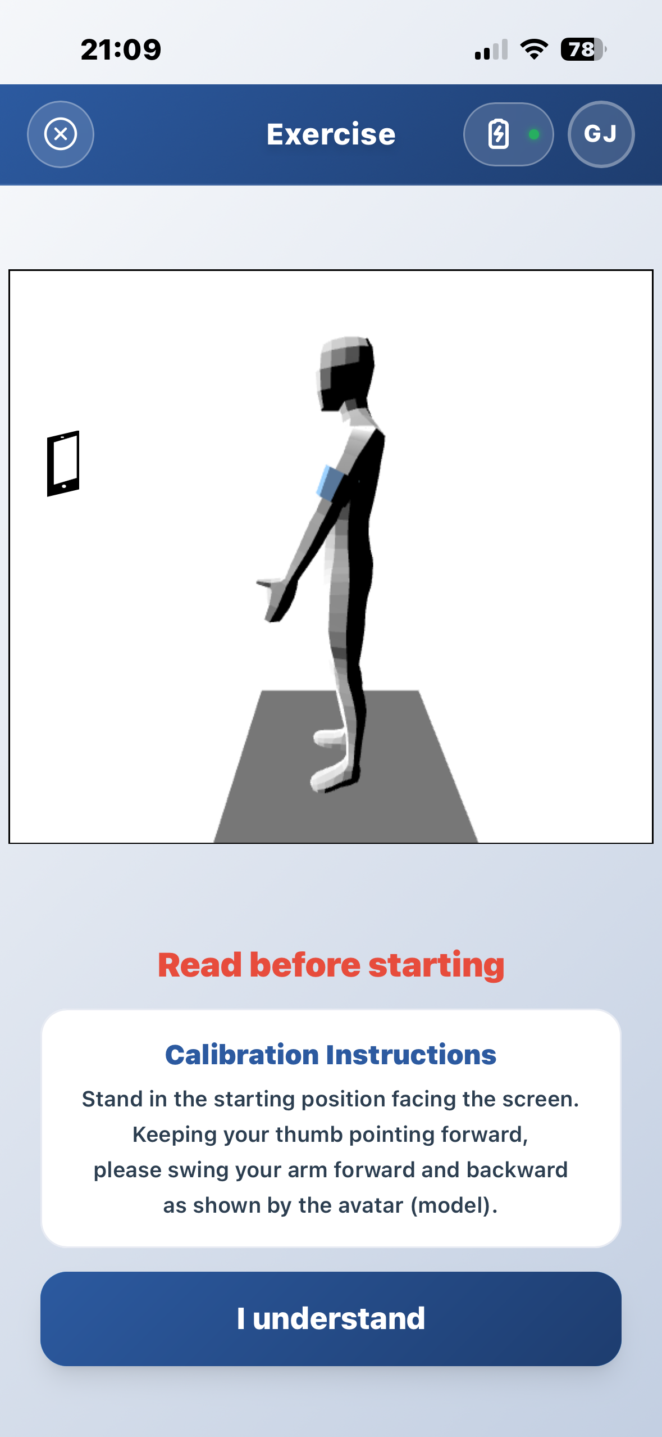
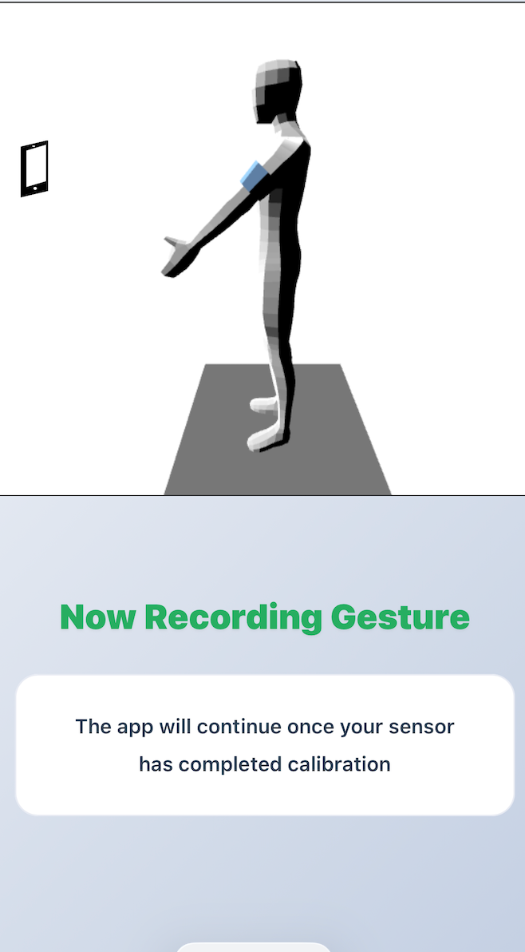

Figure 5

Figure 3

Core exercises:

Forward Flexion

Forward Flexion measures your ability to raise your arm forward and upward in front of your body.

Instructions

- Stand in the default home position,
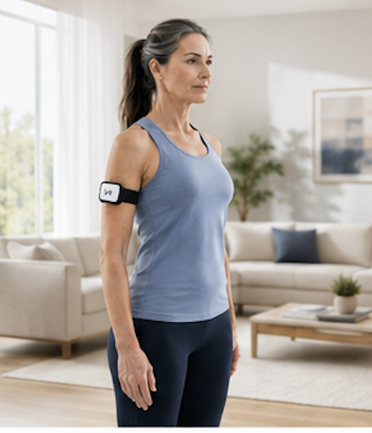
- Take your arm forward and up toward the ceiling, keeping your elbow straight with your thumb facing forward. Ensure the movement stays within a narrow forward path. Lower arm back to starting point.

Figure 4
- Repeat the exercise until the counter shows you have completed the exercise five times.
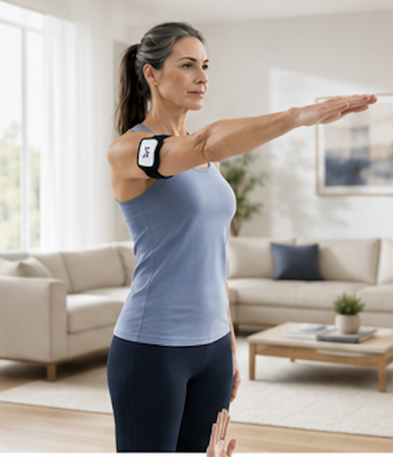
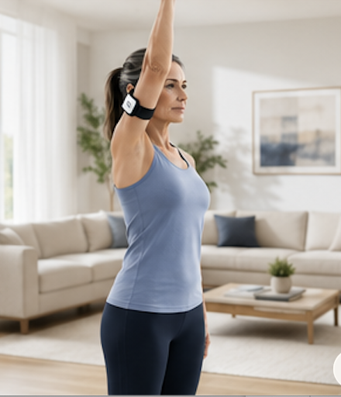
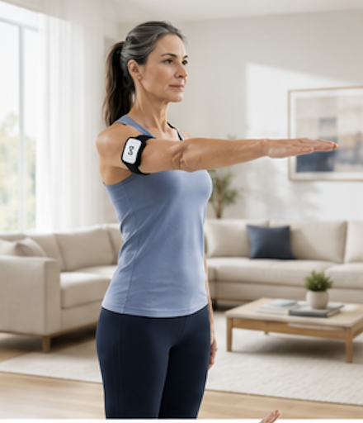
- Perform the movements at a normal pace.

Abduction
Abduction measures your ability to lift your arm out sideways overhead

Instructions

- Stand in the default home position.
- Point your thumb out sideways and lift your arm out to the side and up overhead. Keep your elbow straight and return to the start position.
- Repeat the exercise until the counter shows you have completed the exercise five times.
- Perform the movements at a normal pace.

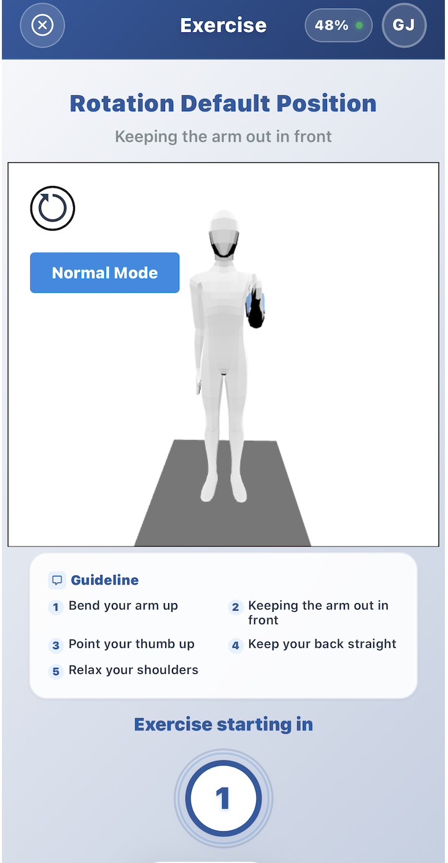
External Rotation

External rotation measure your ability to rotate the arm out sideways.
Another calibration movement needs to be done before these exercises can be undertaken

Calibration
Hold your arm with elbow bent to 90 degrees with fingers pointing forward and thumb pointing upwards. Keep still in this position until calibration is complete.

Instructions
- Start the exercise with the arm in the same position as during the calibration gesture.
- When prompted to start the exercises, swing the arm out sideways. It is important to keep the elbow tucked tightly into the side of the body as the arm is swung out sideways. Return to the start position.
- Repeat the exercise until the counter shows you have completed the exercise five times.
- Perform movements at a normal pace.

Pain Score Documentation & Cloud Synchronization

When the session concludes, the app automatically opens the "How are you feeling?" questionnaire pane. Select the score (0 to 10 scale) that represents the maximum pain level experienced during your movements with 0 being ‘No Pain’ and 10 being the ‘worst pain you can imagine’
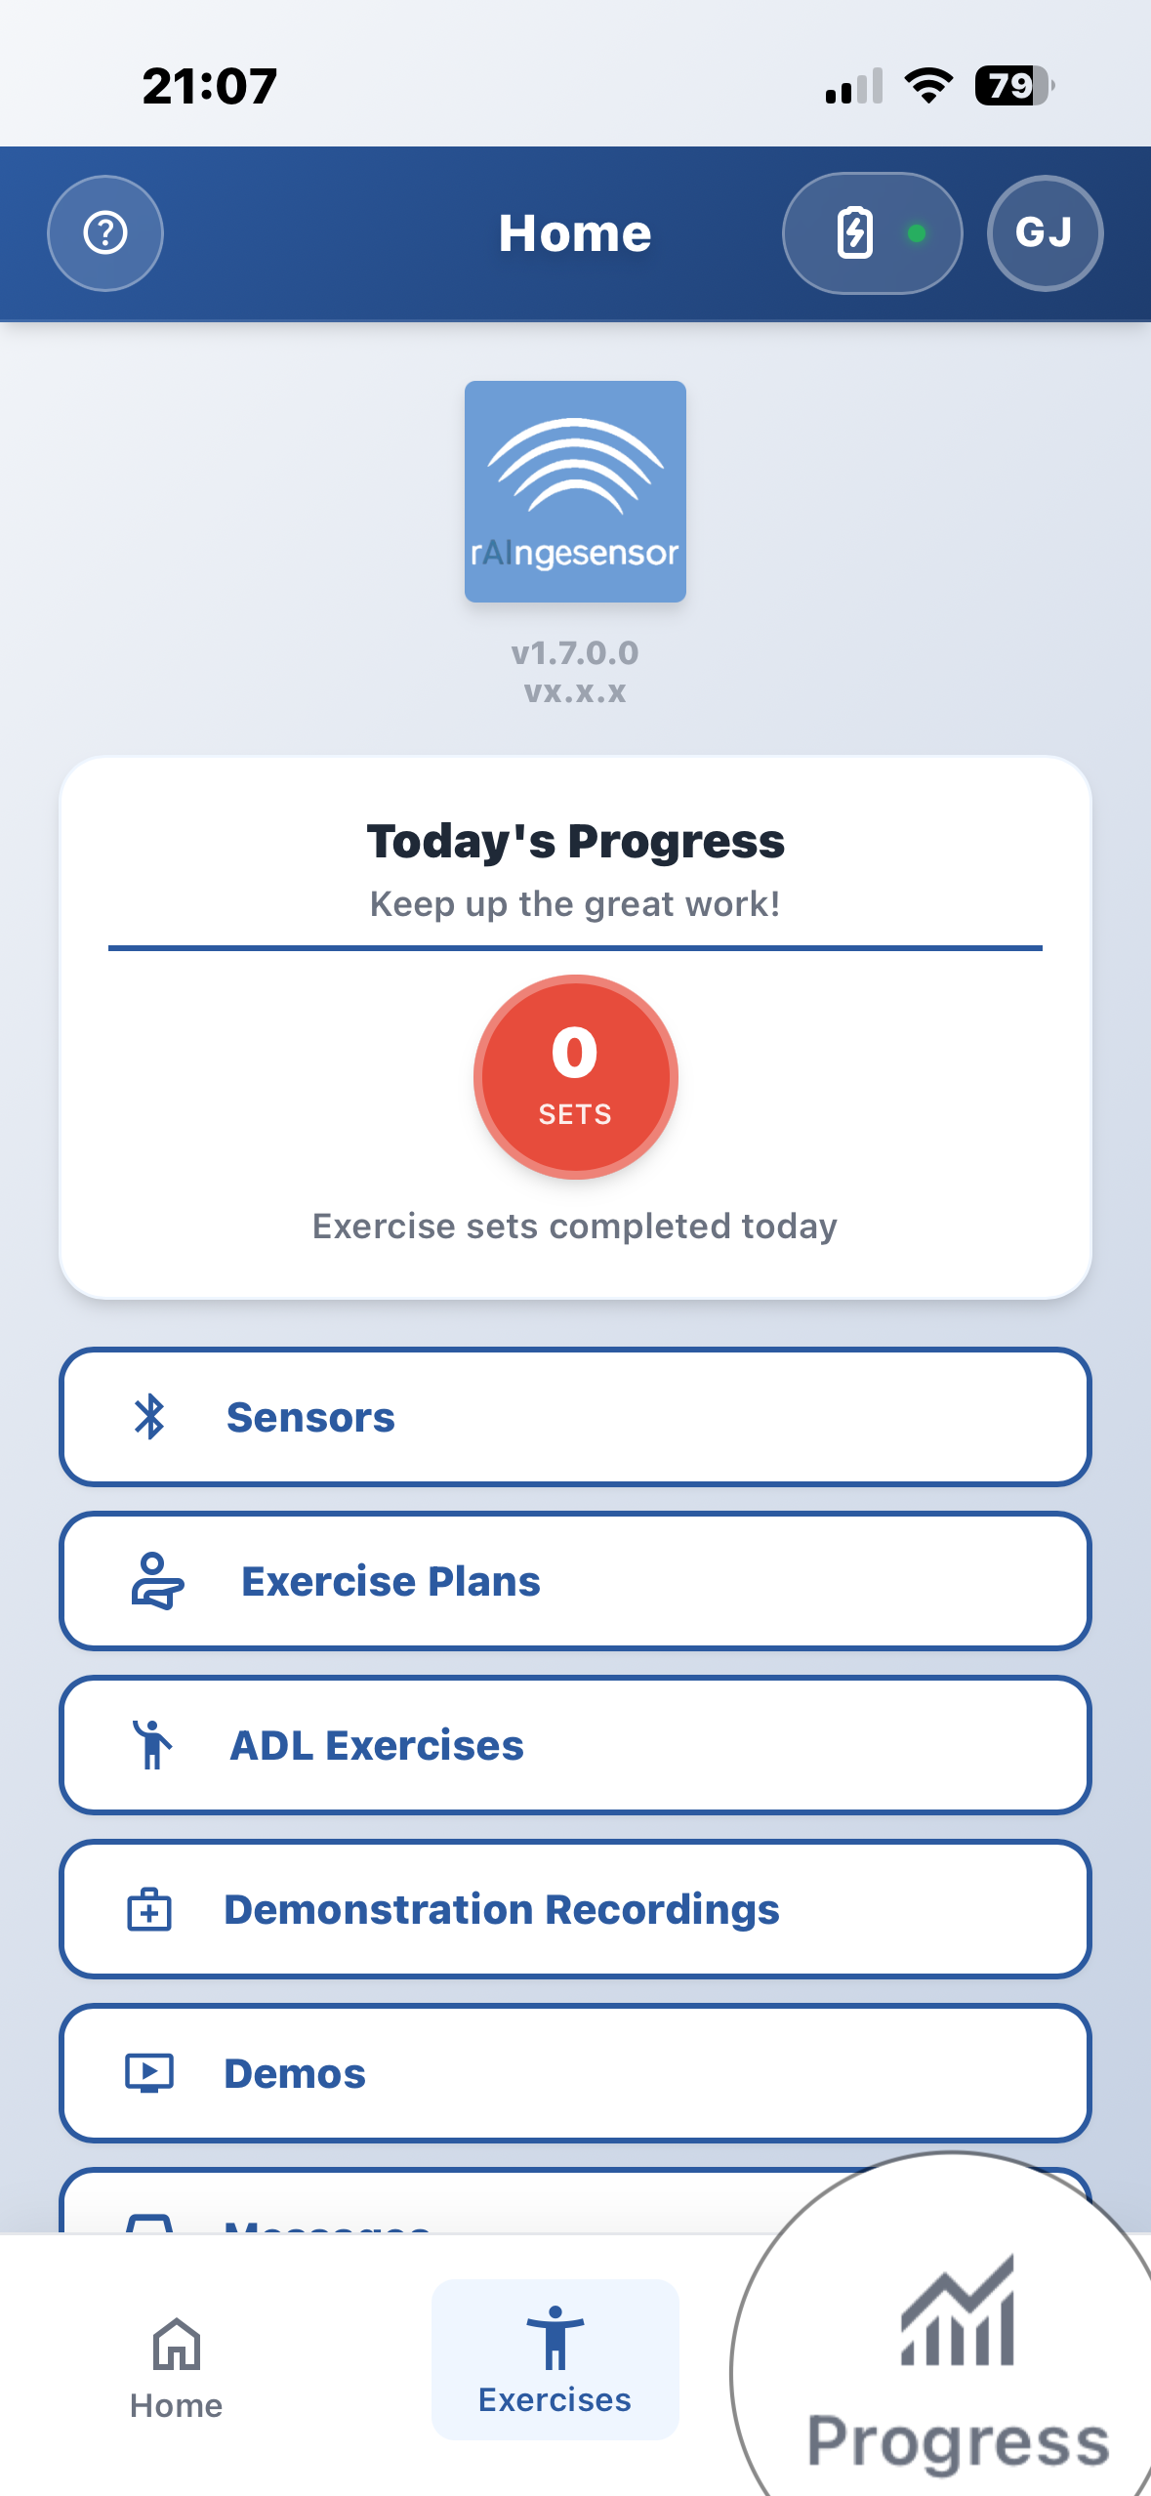
After selecting your score, press the "Save Session" button.

Progress charts
You can view your progress on the progress charts at the
bottom of the home screen

Contact

If you have further questions or need help please contact

us on info@raingesensor.com

