West kallada case study

Author: Sneha E T

Introduction

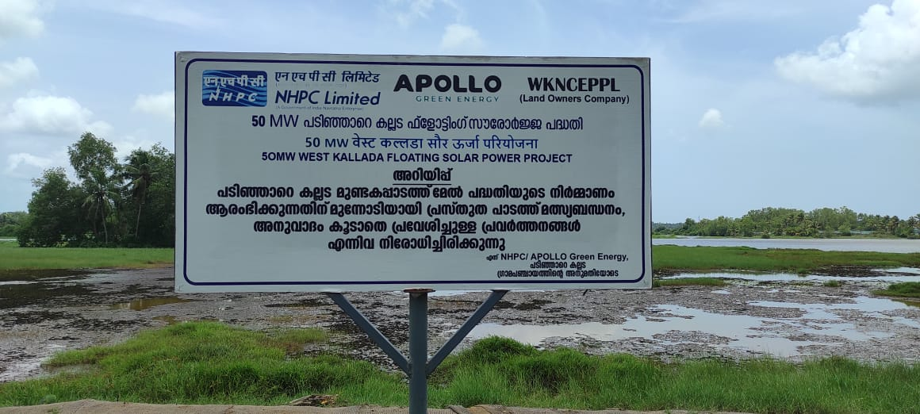

Floating solar is emerging as a critical growth segment within renewable energy. By utilizing water surfaces, these projects avoid large-scale land use while enhancing efficiency through the natural cooling effect of reservoirs. They also reduce evaporation, improve system longevity, and enable dual use of water bodies without disturbing ecological balance.

The West Kallada Floating Solar Project is a landmark renewable energy initiative in the Kollam district of Kerala,The 50 MW floating solar plant is a collaboration involving NHPC, a Navratna enterprise, and West Kallada Non-Conventional Energy Promoters Pvt. Ltd. (WKNCEPPL), which represents the local landowners. Around 300 acres of water-logged, uncultivated paddy fields in West Kallada were reserved for the project.The West Kallada project will generate renewable power in an environmentally responsible manner, ensuring minimal land impact while creating long-term benefits for local communities.

Plant Capacity : 50 MW Location : West kallada
Developer : Apollo Green Energy Limited (AGEL) with NHPC

Power Purchase : 3.04 Rs per unit Current Status & Timeline : Under construction
Grid Connectivity : Power to be evacuated to 110 kV Kundara - Chavara feeder.
Viability Gap Funding : Kerala Government provided assistance (VGF) for evacuation infrastructure.

Scheduled Commissioning : 18 months from PPA signing

2.Project Location&Land acquisition

Project Location | Coordinates
West Kallada, Kollam, Kerala, India[ | 9.0136 latitude and 76.6020 longitude

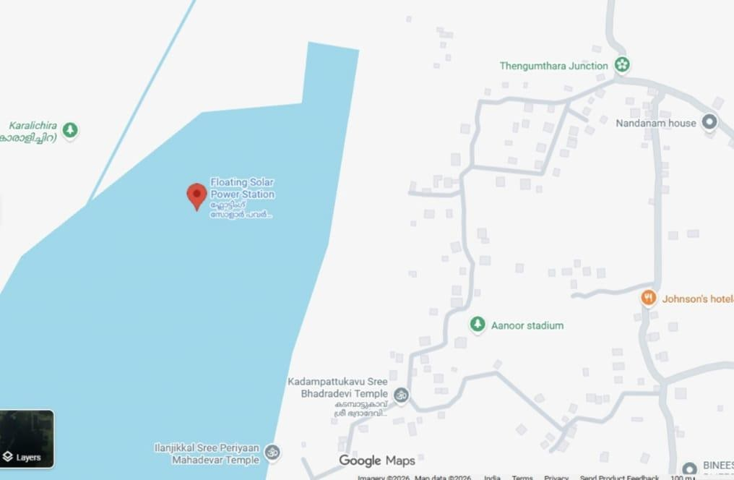
Spread over 340 acres of land at Mundakapadam, it is the largest floating solar project in the State.NHPC has already taken around 291 acres of land from M/s WKNCEPPL for the project.In the case of tower installation for power evacuation

Land Ownership& Revenue sharing

A company named West Kallada Non-Conventional Energy Promoters Pvt Ltd (WKNCEPPL) was registered on behalf of land owners and right to use of the land for setting up the Solar Plant has been handed over to the Company by different land owners. As per the MoU signed between NHPC and WKNCEPPL, NHPC will share 3% of the revenue generated from the project lieu of lease rental to WKNCEPPL which in turn distribute the same to respective land owners.The panchayat took the initiative to establish floating solar includes around 400 property owners. The NHPC will generate electricity here and the KSEB will buy it from them.

Grid Connectivity

The power generated from the 50MW West Kallada floating solar PV project may be evacuated through LILOing the existing 110 kV Kundara - Chavara feeder.The LILO ing point is 1.1 km away from the switchyard of the Solar Plant. As per the load flow analysis, 50 MW solar power injection reduces the load on existing 220kV Kayamkulam, Sasthamkotta and Kundara substations.The power injection results in voltage profile improvement in all related buses and reduction of power loss in the system by nearly 1.33 MW. The line and transformer loading under all contingency scenarios are found to be within the limits.

4.Tariff Rate

Kerala State Electricity Board Ltd sought approval from the Kerala State Electricity Regulatory Commission for a power purchase agreement (PPA) with NHPC Ltd. to procure electricity from a 50 MW floating solar power plant in NHPC Ltd. to procure electricity from a 50 MW floating solar power plant in West Kallada, Kollam District.

determination regulations and Section 86 of the Electricity Act 2003, emphasized Kerala’s commitment to renewable energy targets.The NHPC will generate electricity here and the KSEB will buy it from them.The levelised tariff is 3.04 for 25 Years.KSEB Ltd decided in the meeting held on12.06.2024, they will procure power from NHPC West Kallada 50MW Floating Solar project at a rate of Rs. 3.04/unit

PPA provisions

Contract Period: 25 years from Commercial Operation Date (COD). Capacity Utilization Factor (CUF):
  - Minimum: 19%

  - Maximum: 25%

Penalty Clause: 25% of tariff payable for generation below minimum CUF Excess Generation: Purchased by KSEBL at 75% of PPA tariff

Benefits
- The shadow in the reservoir will be comparatively low and hence the available power generation time in the floating solar will be more than that of land based PV plants.

- Floating plants if used in the cooling reservoirs will have the advantage of less water evaporation and the better utilization of the available space.

- The efficiency of the plant is directly related to the cleanliness of the modules
. The PV modules can be easily cleaned in floating plants . Also the reservoir water can be used for cooling of the modules which in turn increases the efficiency .

Funding Support and Grants
- Central Financial Assistance (CFA)
  - Provided by Ministry of New and Renewable Energy (MNRE)

  - Eligible amount:
₹20 lakh per MW or 30% of park cost, whichever is lower

  - For this project:
Maximum CFA eligible: ₹7.63 Crore

- Viability Gap Funding (VGF)
  - Sanctioned by Government of Kerala

  - Amount: ₹11.83 Crore

9.EPC COST(inCr)

Supply of plant and equipment | 210.11
Installation, testing & commissioning | 13.86
O&M for 5 years | 6.50
Plant & equipment for park development | 17.15
All respect for development of solar park | 8.29
Comprehensive O&M including all approval, permits, licence, testing, calibration etc. | 3.8
Total EPC | 259.72

10.Challenges

- Maintenance: Accessing and maintaining the solar panels on water can be more challenging than traditional land-based installations. Specialized equipment and procedures are needed.
- Environmental Impact: Proper environmental assessments are necessary to ensure that the project doesn’t harm aquatic ecosystems or interfere with local wildlife.
- Installation Costs: The initial investment in floating solar can be higher than ground based solar due to the cost of materials, anchoring systems, and installation and precise grid integration.

Financial cost analysis

Plant capacity | 50 MW
Land area | 300 acre
CUF | 20
Tariff rate | 3.04 per unit
Gross Revenue | 26 crore/year
Epc Cost | - crore

12.Replicability of the project

Kuttanad, covering Alappuzha, Kottayam, and Pathanamthitta districts, is one of the most suitable regions, as it has extensive low-lying paddy fields and calm

backwaters ideal for floating solar installations, along with landownership patterns that support community-based, revenue-sharing models.The Chalakudy river basin and floodplains in Thrissur and Ernakulam also offer high potential due to frequent flooding and proximity to grid infrastructure. The peripheral regions of Vembanad Lake, such as Vaikom, Cherthala, and Kumarakom, provide calm water surfaces suitable for floating solar, subject to environmental and navigation clearances. Irrigation reservoirs in Palakkad, including Malampuzha and Meenkara, allow moderate-scale replication. Overall, the West Kallada model can be effectively replicated across flood-prone and waterlogged regions of Kerala, enabling sustainable expansion of renewable energy with minimal land-use conflict and strong local benefits.

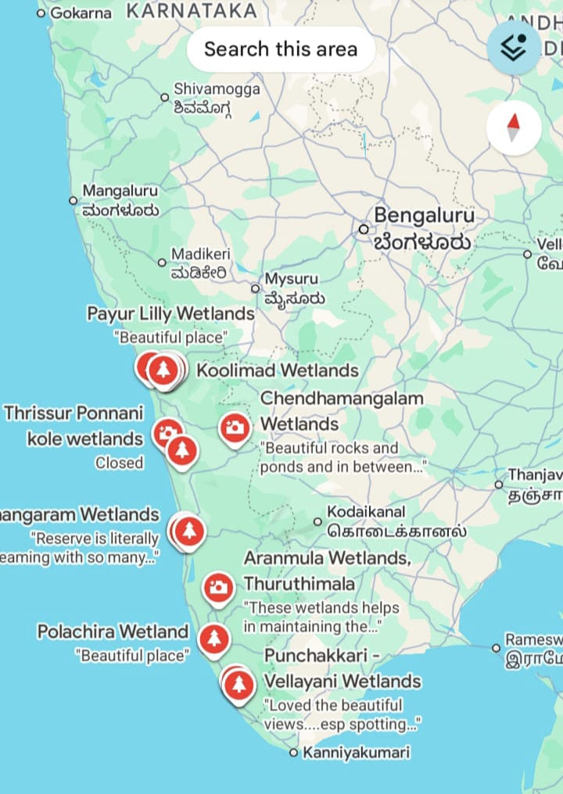

13. Without Battery storage per acre Revenue

CUF | Per acre revenue
0.22 | 9.8 lakhs/acre/year
0.19 | - lakhs/acre/year

14.With Battery storage
This petition, presented under KSERC’s tariff Prosumers with solar and energy storage systems receive a higher Feed-in Tariff for energy injected during designated peak hours. During peak hours feed in tariff is 7.5rs per unit.
A. Total Generation | 87.60 MU
B. BESS Capex | 103.4 Cr
C. Energy to BESS | 16.45 MU
C. Energy to Grid | 71.15 MU
D. Peak Tariff | ₹7.5
E. Revenue generated | 53.36 Cr

Conclusion

The West Kallada Floating Solar Project represents a significant step toward sustainable energy generation in Kerala. With a capacity of 50 MW, the project leverages waterlogged areas, minimizing land use conflicts while providing clean, renewable power. The collaboration between NHPC and local landowners.
through WKNCEPPL ensures fair revenue sharing, promoting community participation. Financially, the project is structured with EPC support from Apollo Green Energy Ltd, a viable PPA with KSEBL, and government assistance to enhance feasibility. Once operational, it will contribute substantially to Kerala’s renewable energy targets, reduce dependence on fossil fuels, and set a model for similar floating solar initiatives across India.

