A Report on Site Visit to West kallada floating solar Power Plant

Submitted by

Sneha E T

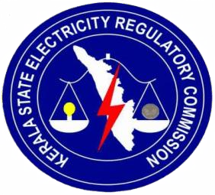

Kerala State Electricity Regulatory Commission
Thiruvananthapuram
Kerala February 2026
ABSTRACT

We have visited West kallada floating solar power plant in Kollam, Kerala. The primary objective was to evaluate the project's current construction status and gather technical data regarding the design and implementation of large scale floating solar photovoltaic (FSPV) systems. The project is being developed by NHPC Ltd as part of the Ultra Mega Renewable Energy Power Park (UMREPP) scheme. The project represents a significant change in land use optimization, utilizing approximately 300 acres of water logged areas formerly uncultivated paddy fields that remain under private ownership. The visit helped bridge the gap between theoretical knowledge and practical application, enhancing understanding complexities of large-scale floating PV deployment on private, non arable water bodies.

Contents

- Introduction

- West kallada floating solar project

  - Working

- Technical specification

  - Solar modules and its arrangement

  - Inverter

  - Power Evacuation

- Current status

- Implementation & Partnerships

- Project location and Land acquisition
- Tariff Rate
- Benefits

- Financial cost analysis

Chapter 1 Introduction
As part of our internship programme, a site visit was conducted to the visited West kallada floating solar power plant in Kollam, on 10 February 2026, which is one of the most important floating power generation facilities in the state of Kerala. The West Kallada Floating Solar Project is a landmark renewable energy initiative in the Kollam district of Kerala,The 50 MW floating solar plant is a collaboration involving NHPC, a Navratna enterprise, and West Kallada Non Conventional Energy Promoters Pvt. Ltd. (WKNCEPPL), which represents the local landowners. Around 300 acres of water-logged, uncultivated paddy fields in West Kallada were reserved for the project.The West Kallada project will generate renewable power in an environmentally responsible manner, ensuring minimal land impact while creating long-term benefits for local communities.
Floating solar has gained traction in India as a sustainable energy solution, primarily because it serves as a renewable energy source in areas with land scarcity. In such areas, since floating solar power plants are installed on waterbodies, the land can be used for other purposes such as farming or construction. Land unavailability and delays in land acquisition being major hurdles to scaling up solar power in India floating solar plants have emerged as a viable and practical solution.
During the site visit to the West Kallada Floating Solar Power Plant, it was observed that the project is currently in the foundational stages of physical execution. Primary on-site activities are concentrated on the anchoring and leveling processes, which are critical for ensuring the structural integrity and stability of the floating arrays against the waterlogged terrain. Simultaneously, significant progress is being made in the switchyard implementation, marking a transition toward establishing the electrical infrastructure necessary for grid connectivity.

Chapter 2

West kallada floating solar Project

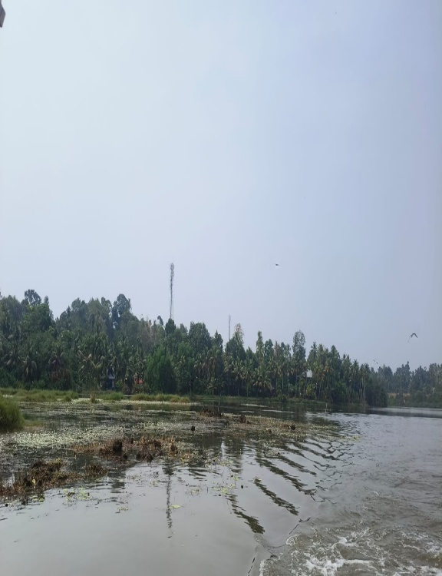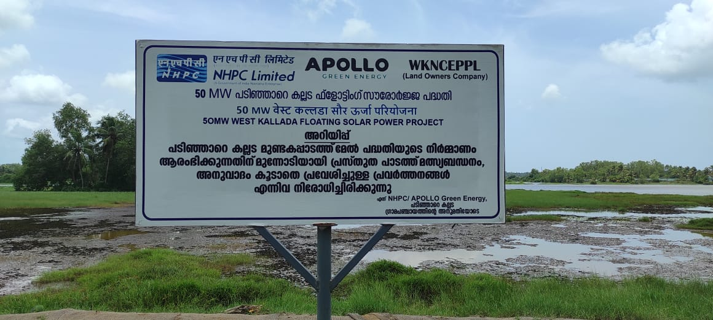
Fig 2.1 : Site for west kallada project

The West Kallada Floating Solar Project is a landmark renewable energy initiative located at Mundakapadam in the Kollam district of Kerala. As the largest floating solar project in the state, it utilizes approximately 300 acres of waterlogged, uncultivated paddy fields to generate clean power. This innovative project is a collaborative effort between NHPC and West Kallada Non-Conventional Energy Promoters Pvt. Ltd. (WKNCEPPL), which represents around 400 local landowners. By placing solar panels on the water's surface, the project avoids large-scale land use conflicts while benefiting from the natural cooling effect of the reservoir, which enhances the efficiency of the panels. Furthermore, the installation helps reduce water evaporation and provides long-term environmental and economic benefits to the local community through a unique revenue-sharing model. This sustainable model is considered highly replicable for other flood-prone and waterlogged regions across Kerala.

2.1 Working

The West Kallada Floating Solar Project operates through a sophisticated conversion and evacuation process designed to transform solar energy into high-voltage grid electricity. The system begins with approximately 1.10 lakh modules, each with a 590-Watt peak, organized into specific array configurations. These modules are connected in strings of 28 in series, with two such strings paired in parallel to feed into a String Combiner Box (SCB). The SCB outputs roughly 1200 V DC to an inverter, which converts the power to 660 V AC. This AC output is then directed to an Inverter Duty Transformer (IDT); specifically, two inverters feed into one IDT (utilizing two primaries and one secondary) to step the voltage up to 33 KV.Across the water body, six barge locations or stations facilitate this initial collection before the power is cabled to the Main Control Room (MCR). At the MCR, HT switchgear panels consolidate the inputs into two main outputs that connect to individual 31.5 MVA power transformers. These transformers perform a final step-up from 33 KV to 110 KV. The electricity is then managed through a 110 KV switchyard featuring two incoming and two outgoing bays. Finally, the power is evacuated via a 1.2 km LILO (Line In-Line Out) connection to the existing Kundara-Chavara 110 KV line, utilizing a 7-tower evacuation system.

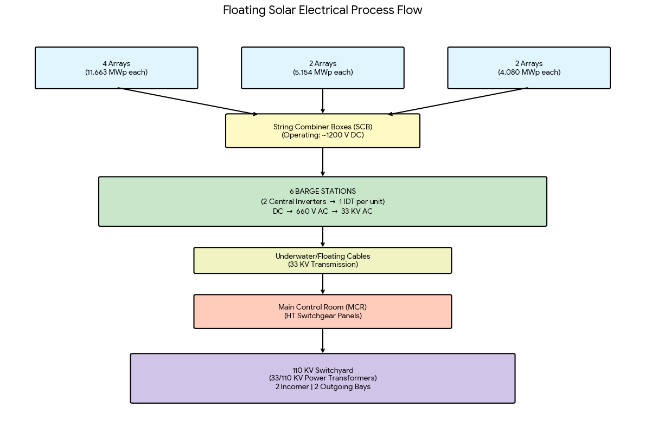
Chapter 3

Technical Specifications

Solar modules and its arrangement

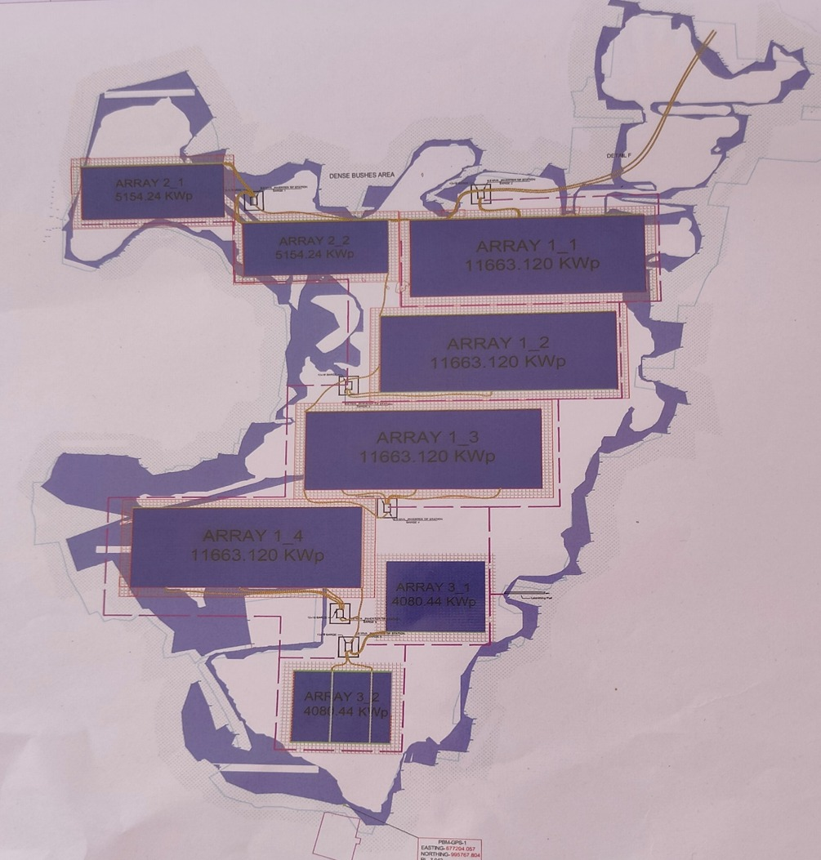

The West Kallada Floating Solar Project features a highly structured technical design aimed at maximizing energy efficiency on a water surface. The system is built around a total DC capacity of 65 MWp, which is distributed across eight specific array configurations consisting of four 11.663 MWp arrays, two 5.154 MWp arrays, and two 4.080 MWp arrays. This massive setup utilizes approximately 1.10 lakh solar modules, each providing a peak rating of 590 Watts.The modules are organized into strings where 28 modules are connected in series. Two such strings are then connected in parallel to form a single input for a String Combiner Box

3.2 Inverters

The process begins at the floating arrays, where DC power is aggregated into String Combiner Boxes (SCB) with an approximate output of 1200 V DC. This power is then fed into inverters—specifically ten 4.4 MVA units and two 3.3 MVA unit which convert the DC input into 660 V AC.

3.3 Power Evacuation

To facilitate transmission, this low-voltage AC is directed to Inverter Duty Transformers (IDT), with two inverters typically feeding a single transformer. The project employs five 8.8 MVA and one 6.6 MVA IDTs to step the voltage up to 33 KV for cable transmission from six barge locations to the Main Control Room (MCR). At the MCR, HT switchgear panels consolidate these inputs into two 31.5 MVA power transformers, which perform the final step-up from 33 KV to 110 KV. Finally, the energy is transmitted through a 110 KV switchyard and evacuated into the KSEB network via a 1.2 km LILO connection on the Kundara-Chavara line.

4. Current status
Current operations are primarily focused on site preparation and foundational stability. While site leveling is underway, there is still some ambiguity regarding the final location of the substation. Meanwhile various sizes of pontoons the floating blocks designed to support both solar arrays and walkways have been delivered to the site. To secure these structures, anchoring and mooring piling works are ready to commence using specialized barges. These submerged foundations are engineered to withstand significant lateral shear and uplift forces, though they must first be verified for axial load capacity before the PV arrays can be mounted.Simultaneously, the Mooring and Dynamic Tensioning systems are being deployed for station-keeping. By employing mechanical winches to manage high-tensile mooring lines, the system ensures the solar panels remain stable despite changing environmental conditions. This dynamic setup prevents the arrays from being pulled too tight as water levels rise and protects them from "grounding" or hitting the bottom when water levels.
5. Implementation & Partnerships

- Implementation: West Kallada floating solar project is being developed and implemented by NHPC Ltd.NHPC is also responsible for overall execution including signing the power purchase agreement.
- Revenue Sharing: Landowners and the panchayat are set to receive 3% of the profit from the power generated.
- Executing Agency: The EPC contract was recently awarded to Apollo Green Energy Ltd, with
- Power purchaser: The Kerla State Electricity board will purchase electricity generated at a tariff of RS.3.04 per unit under a long term agreement.
- Land management:The water body and surrounding land are leased for 25 years through WKNCEPL.

6.Project location and Land acquisition

Spread over 340 acres of land at Mundakapadam, it is the largest floating solar project in the State.NHPC has already taken around 291 acres of land from M/s WKNCEPPL for the project.

7.Tariff Rate

Kerala State Electricity Board Ltd sought approval from the Kerala State Electricity Regulatory Commission for a power purchase agreement (PPA) with NHPC Ltd. to procure electricity from a 50 MW floating solar power plant in West Kallada, Kollam District. This petition, presented under KSERC’s tariff determination regulations and Section 86 of the Electricity Act 2003, emphasized Kerala’s commitment to renewable energy targets.The NHPC will generate electricity here and the KSEB will buy it from them.The levelised tariff is 3.04 for 25 Years.KSEB Ltd decided in the meeting held on12.06.2024, they will procure power from NHPC West Kallada 50MW Floating Solar project at a rate of Rs. 3.04/unit.

Contract Period: 25 years from Commercial Operation Date (COD). Capacity Utilization Factor (CUF):
  - Minimum: 19%

  - Maximum: 25%

Penalty Clause: 25% of tariff payable for generation below minimum CUF Excess Generation: Purchased by KSEBL at 75% of PPA tariff.
8.Benefits
1. Boosting Efficiency with Cooler Environments
The unique placement of floating solar panels over water ensures a natural cooling effect. This helps reduce the operating temperature of the photovoltaic cells, which increases energy output significantly. For the West Kallada project, this efficiency is reflected in a net anticipated annual energy of 99.909 million units and a Capacity Utilization Factor (CUF) of 22.79%.
2. Water Resource Management
A standout feature of floating solar panels is their ability to conserve water. By covering large areas of water bodies specifically 291.68 acres in this project these installations drastically reduce water evaporation. This safeguards essential water reserves for agriculture, drinking, and industrial use
3. A Green Footprint for the Planet
Floating solar projects champion sustainability by minimizing carbon emissions and reducing dependency on fossil fuels. These projects protect biodiversity by eliminating the need for large-scale land alterations, as seen here where the 50 MW capacity is generated entirely over water. This allows terrestrial ecosystems to thrive undisturbed while providing a 25-year source of clean

9. Financial cost analysis
9.1 EPC COST ( in crores)

Supply of plant and equipment | 210.11
Installation, testing & commissioning | 13.86
O&M for 5 years | 6.50
Plant & equipment for park development | 17.15
All respect for development of solar park | 8.29
Comprehensive O&M including all approval, permits, license, testing, calibration etc. | 3.8
Total EPC | 259.72

9.2 Funding Support and Grants
- Central Financial Assistance (CFA)
  - Provided by Ministry of New and Renewable Energy (MNRE)

  - Eligible amount:
₹20 lakh per MW or 30% of park cost, whichever is lower

  - For this project:
Maximum CFA eligible: ₹7.63 Crore

- Viability Gap Funding (VGF)
  - Sanctioned by Government of Kerala

  - Amount: ₹11.83 Crore

9.3 Annual revenue generation
- Capacity of the plant : 50 MW
- CUF :22.79
- Annual energy yield : 99.909 MU
- Total revenue generated:30 crores
- Pay back period :8 years

10.Challenges

- Maintenance is difficult
Since FSPV plants are installed on the water surface rather than on land, it is relatively difficult to deal with O&M issues in such conditions. There are certain parts like anchoring and mooring that lie inside the water and are required to be inspected on a regular basis to ensure the plant’s stability.
- Installation Costs
Floating solar typically has a higher Investment cost than ground based solar due to the specialized materials, complex anchoring systems, and the need for precise grid integration. Accessing and maintaining the solar panels on water can be more challenging than traditional land based installations.

11.Conclusion
The West Kallada Floating Solar Project marks a transformative milestone in Kerala's renewable energy sector, effectively addressing regional land scarcity by repurposing approximately 300 acres of waterlogged, uncultivated paddy fields into a productive 50 MW clean energy facility. This strategic partnership between NHPC Ltd and West Kallada Non-Conventional Energy Promoters Pvt. Ltd. (WKNCEPPL) demonstrates an optimized land-use strategy that incorporates a sustainable 3% revenue-sharing model for local landowners. Furthermore, the installation facilitates essential water resource management by significantly reducing evaporation rates.From a technical perspective, the project utilizes the natural cooling properties of the water body to enhance photovoltaic efficiency, targeting a net annual energy yield of 99.909 million units with a 22.79% Capacity Utilization Factor (CUF). The project's economic viability is underpinned by a 25-year Power Purchase Agreement (PPA) with KSEB at a tariff of Rs. 3.04/unit and a projected payback period of eight years.

