Online Shopping
A Project Report Submitted in partial fulfillment of the
Requirements for the award of the Degree of

Master of Computer Application

BY

xxxxxxxxxxxxxxxx

xxxxxxxxxxxxxxxxx

Department of Computer Science Doranda College, Ranchi
2023


ACKNOWLEDGEMENT

A task or project cannot be completed alone. It requires the effort of many individuals. I take this opportunity to thank all those who helped me complete this project.

I would like to express my sincere thanks to xxxxxxxxxxxxxxx who helped a lot in offered various prompt suggestions during this project timely and properly finished.

I express my sincere gratitude to xxxxxxxxxxxxxxxxx
giving us the opportunity to undergo this project. I further thank his for lending a helping hand when it comes to solving my problems related to the project. This project would not have been possible without his valuable time and support.

I am also thanks to other xxxxxxxxxxxxxxxx for helping me in the preparation of the project.

I can’t forget to thanks my friends who are very helpful to me directly or indirectly during development of this project.

At the end I also want to pay my heartiest thanks to the whole family of out sponsoring organization that always seem prompt to help and create a friendly environment.

Name : xxxxxxxxxx
Roll No.: xxxxxxxxx

DECLARATION

This is to declare that this project report titled Online grocery has been developed by me along with other project members for the major project of final semester of Master of Computer Application, xxxxxxxxxxxx

I declare that this project is my own work by the best of my knowledge and belief. This project has never been submitted to any University or Institute for the partial fulfillment of the award of any degree or diploma.

Name :xxxxxxxx
Roll no.:xxxxxxxxx

CERTIFICATE OF ORIGINALITY

This is to certify that the project report entitled Online grocery Submitted to Doranda College, Ranchi in partial fulfillment of the requirement for the award of the degree of Master of Computer Application (MCA), is an original work carried out by Mr./ Ms. xxxxxxxxx Roll
No.: xxxxxxxxxxxxxx
The matter embodied in this project is a genuine work done by the student and has not been submitted whether to this University or to any other University / Institute for the fulfillment of the requirement of any course of study.

Signature of the Student Signature of the guide

Name xxxxxxxxxxx

Roll no:xxxxxxxxxX

(Internal Examiner) (External Examiner1) (ExternalExaminer2)

Topic | Index | Page No
1. Introduction |  | 1
2. Tools used |  | 2
3.System analysis and design |  | 3-12
4. Feasibility study |  | 13-17
5.Development of software |  | 18-20  21
6. Design of the system |  | 22-24
7. Data flow diagram -DFD |  | 25-28
8. Workflow with digram |  | 29-112
9. Coding and screenshot |  | 113-117

- Testing
- Limitation of the project

- Feature of project
- Scope of project
- Bibliography
118

119-120

121

122-123

INTRODUCTION
In today’s tech world most consumers are looking online for information that will help them make smarter purchasing decisions. In fact, according to the e-commerce Foundation, 88% of consumers will research product information before they make a purchase online or in the store. This buying behaviour trend emphasizes the importance of a website for today’s businesses.
Hence in any business website serves as that “home base” where they can send customers when they want to make a purchase or learn more about a particular product or service they offer.

For this project we have chosen the topic “Online grocery system”. Now days, people often order their grocery products through online mode. Here in this website visitors can come and browse the products and their prices. If they are willing to purchase anything then they have to register first and only after login they can add the products in their cart.

Tools used

  - FRONT END TOOLS :

- HTML
- CSS
- JavaScript
- JQUERY
- DREAMWEAVER
- ADOBE PHOTOSHOP

  - DATA BASE : MYSQL

  - SERVER : WAMP SERVER

  - LANGUAGE : PHP

System analysis and design

A System is the collection of interrelated components that works together to archive some common objective and system analysis is the specification as what the system required to do. It is a management technique which helps us in designing a new system or improving an existing system.
A system analyst should have various skills to effectively carry out the job specifically. These skills can be divided into two categories. These are interpersonal skills and technical skills interface of the analyst with people in business. They are useful in establishing trust, resolving conflict, and communication information. Technical skills on the other hand, focus on the procedures and techniques for operations analysis, system analyst and computer science.

The interpersonal skills which are relevant to systems work are following:-
- Communication:- Communication is not just reports, telephonic conversations, and interview. It is people talking, listening, felling, and reacting to one another, their experience and reaction. Some indicators of one another, their experience and reaction to the, their experience and reactions. Some indicator of climate of closed communication is defensive memos, excessive correspondence, and failure to speak up for fear of being identified. Therefore, opening communication channels are a must for system development.
- Understanding:- Identified problems and assessing their remedies is one of the attributes of good system analyst. A system analyst should have the grasp of company goals and objective.

- Teaching:- A system analyst should educate people in the use of computer systems, selling the system to the user and giving the support when needed.
- Selling: - a system analyst should have selling ideas and promoting innovations in problem solving using computer.
For system analysis we know that we operate in a dynamic environment where way of life is.

To construct a system the following key elements must be considered:-
- Outputs and inputs:- A major objective of a system is to produce an output that has value to its user. Whatever the nature of the output (goods, services, or information), it must be in line with the expectations of the intended user. Inputs are the elements (material, human recourses, information) that enter the system for processing. Output is the outcome of processing. A system feeds on input to produce output in much the same way that a business brings in human, financial, and material resources to produce goods and services. Output is a first step in specifying the nature, amount, and regularity of the input needed to operate a system. Input and processing design follow.

Input
Standard of
Human re
Transformation
Services
Management Control
Compare Output

Processing Output

- The processor(s):- The processor is the element of a system that involves the actual transformation of input into output. It is the operational component of a system. Processor may modify the input totally or partially, depending on the specifications of the output.
- Control:- The control elements guide the system. It is the decision- making subsystem that controls the pattern of activities governing input, processing, and output. In an organization context, management of the bank as a decision-making body controls the inflow, handling, and outflow of activities that affect the welfare of the business. In a computer system, the operating system and accompanying software influence the behavior of the system.
- Feedback:- Feedback may be positive or negative, routine or informational. Positive feedback reinforces the performance of the system. It is routine in nature. Negative feedback generally provides the controller with information for action. In system analysis, feedback is important in different

ways. During analysis, the user may be told that the problems in a given application verify his/her initial concerns and justify the need for change. Another form of feedback comes after the system is implemented. The user informs the analyst about the performance of the new installation. This feedback often results in enhancements to meet the user’s requirements.
- Environment:- The environment is the “ supersystem ” within which library operates. It is the source of external elements that impinge on the system. In fact, it often determines how a system must function such that the Bank’s environment, consisting of customers and others.
- Boundaries and Interface:- A system should be defined by its boundaries –the limits that identify its components, process, and interrelationships when it interfaces with another system.
There are generally eight types of System analysis technique:-
- Requirement technique:- Requirement determination is generally done through Extensive study of the system includes the understanding of the goal. Process And constraints of the system for which information are designed. Several Forms are also designed and illustrated in the text of system analysis. There are no straight

forward algorithms to elicit the requirement from the user. It is an iterative process, which the analyst use while interviewing several user groups. It is art rather than science.
- Diagramatic technique:- Data flow document flow diagrams represent perhaps most the most widely used diagramming technique of the system analyst. The document flow diagram graphically represents the various documents that flow across the system.: the information carried by the paper document must be generated and proceed by proposed information system.
- Data flow diagram(DFD):- Data flow diagram is a powerful diagram that can be used to document the information flow. It also presents itself to be broken down in top down fashion .At the top level ,data flow are represented at the very abstract aggregated level .Each component of the data flow is further broken down to different levels, so that at each level. We have just a few entities to concatenate on , DFD have developed a representation scheme to represent data store. Process(where some changes are made to system) and

entities(the player in the game) and the actual information flows.
- Data Dictionary:- Another powerful tool that is extensively used in system analysis in the data dictionary. DDs provides a detailed reference to every data item—the different names by which the item is represented in different program modules, different data structure used to represent the item in different modules. The module where the date item is generated ,where it is stored destroyed
.In essence it provides a quick snapshot of every data item is generated ,where it is stored and destroyed .In essence it provides a quick snapshot of every date item is used by the information system. In essence it provides a quick snapshot of every data item used by the information system .It is very useful for conceltency checks. System modification and completeness checking. While these techniques are general in nature and by the analyst in the different stages of the system life-cycle the following are specific to some of the steps of the system life-cycle.

- Feasibility Report:- A typical structure of the feasibility report will be under a preamble that sets the stage for the project followed by goals statement that quantity precisely the goals of the proposed information system. This is followed by a short narrative that describe in unambiguous yet jargon free Language the present system. This is understandable to any intelligent person not necessary a computer professional or a even a computer literate .the proposal alternative are then describe once again in a reasonably jagran free language .Bing a feasibility study the alternative are unlikely to be detailed to the full extent. Until full system is developed in its entirety, the full detail are unlikely to be known. Yet we can’t go ahead with the final system without doing a feasibly analyses. The detail of the system to be built may bum ford gradually from understood by the user as well as analyst. Based on ‘sketchy’ design of the proposed alternatives, an order of magnitude cost benefit study is preferred. The end-user decides a particular alternative that is worked out in

detail for further implementation. The detail design phase starts here.

- Detailed design:- The detailed specifications are worked out followed by hardware/software plan. This constitutes system designs which once again need to be whetted by the user. Once this is done detailed system design starts. Effectively the analysis phase ends here and the design phase begins. It may involve substantial effort on the part of technical system analyst, hardware, software, communication specialists etc. a major component of the detailed system design is the database design actual coding is undertaken after the database design is completed.
- Database Design: - DBMS permits efficient storage and manipulation of data files they do not cater to the structuring of the database themselves .There is the need for the right abstraction of data into the database so that any update/query operation captures the sprit of the data stored in the database. Normalization is used which leads

to the decomposition in such a way that no information is lost due to processing of data. Database theory details further degrees of normalization including 4NF and 5NF. While theoretically sound, such further refinement add (?) like , if, any, to data modeling real world data. Since our text is primarily on information system and not on database theory we will not further elaborate an advanced normalization.
- System implementation:- System implementation includes the detailed design of the process, their validation and thought checking. while the formal methods of proving program correctness are evolving ,they are still not useful to test out large commercial software to help information system planning .Many of the analysts use experimental version using what is known as “Parallel runs ”. Here both the current system and proposed new system are run in parallel for a specified time period and the current system is used to validate the purposed system.

Feasibility study

Feasibility is the determination of the whether or not a project is worth doing. The process followed in making this determination is called a feasibility study. These types of study determine if a project can and should be taken. Once it has been determination that a project a feasible, the analyst can go ahead and prepare the project specification which finalizes project requirements. Generally, feasibility studies are undertaken within tight time

constraints and normally culminate in a written and oral feasibility report . The contents and processed, postpone or cancel he project. Thus, since the Feasibility study may lead to the commitment of large resource, it becomes Necessary that it should be conducted competently and that no fundamental errors of judgment made.

Types of feasibility:-

Technical feasibility

  - Operational feasibility

Economical feasibility

  - Social feasibility

Management feasibility

  - Legal feasibility

Time feasibility

- Technical feasibility:- Technical feasibility involves determining whether or not a system can actually be constructed to solve the problem at end. This is considered with specifying equipment and software that will successfully satisfied the user requirement. The technical needs of the system may vary considerable ,but might include:-
- The facility to produce outputs in a given time.

- Response time under certain condition.

- Ability to process a certain volume of transaction at a particular Speed.
- Facility to communicate data to distant location.

- Operational feasibility:- Proposed projects are of course beneficial only if they can be turned into information system that will meet the organization’s operating requirement. Simply started, these tests of feasibility ask the system will work when developed and installed. There are there major barrier for implementation. It is related to human organizational and political aspects. The points to be considered are:-
- What change will be brought with the system?

- What organizational structures are distributed?

- What new skills will be required? Does the existing staff member have? These skills? If not, can they be trained in the due course of time?
- Economical feasibility:- Economic analysis is the most frequently used technique for evaluating the effectiveness of a proposed system. More commonly known as cost/benefit analysis the procedure is to determine the benefits and saving that are expected from a proposed system and compare them with cost. If benefit out

weights costs, a decision is taken to design and implementation the system.
- Social Feasibility: - Social Feasibility is a determination of whether a proposed project will be acceptable to the people or not. This determination Typical examines the probability of the project being accepted by group directly affected by the proposed system change.
- Management feasibility:- It is a determination of whether a proposed project will be acceptable to management. If management does not accept a project or gives a negligible support to it, the analyst will tend to view the project as a non-feasible one.
- Legal feasibility: - Legal feasibility is a determination of whether a proposed project infringes on known acts, Statutes, as well as any pending legislation. Although in some instance the project might appear sound, on closer investment it may be found to infringe on several legal areas.
- Time feasibility: - Time feasibility is a determination of whether a project can be implementing fully with in a

stipulated time frame .If a project takes too much time it is likely to be rejected.

Development of software

Software development may install purchased software or they may develop new, custom designed programs. The choice depends on the each option, the time available to develop software and the availability of programmers. Generally it has been observed that programmers are part

of permanent staff in a big organization. In smaller organization, without programmers, outside programming services may be hired or retained on a contractual basis. Programmers are also responsible for documenting the program, providing an explanation of how and why certain procedures are coded in specific ways. Documentations is essential to test the program and carry on maintenance once the application has been installed.
- User Management Assessment:- Evaluation of the attitudes of senior and user manager within the organization, as end-users.
- Development Performance: - Evaluation of the development process in accordance with such yardsticks as overall development time and effort, conformance to budgets and standards and other project management criteria. Maintenance is necessary to eliminate errors in the working system during its working life and to tune the system to any variations in its working environment. Often small system deficiencies are found as a system is brought into operations and changes are made to remove them. System planners must always plan for resource

availability to carry out these maintenance functions. The importance of maintenance is to continue to bring the new system to standards.

Design of the system

The design of an information system produces the details that clearly describe how a system will meet the requirements identified during system analysis. Systems specialists often refer to this stage as logical design, in contrast to the process of developing program software, which is referred to as physical design.
Development of the software:- Software development may install purchased software or they may develop new, custom designed programs. The choice depends on the each option, the time available to develop software and the availability of programmers. Generally it has been observed that programmers are part of permanent staff in a big organization. In smaller organization, without programmers, outside programming services may be hired or retained on a contractual basis. Programmers are also responsible for documenting the program, providing an

explanation of how and why certain procedures are coded in specific ways. Documentations is essential to test the program and carry on maintenance once the application has been installed.

Data flow diagram(DFD)

A data flow diagram is a graphical technique that

depicts information or data flow | and the | transforms | that
are applied as data move from | input to | output. A | DFD

therefore provides an indication of the transformation of data as it moves forward and it also depicts the functions that actually transform the data. The DFD is also called a bubble chart.
Following notations are used in DFD:-

This denotes an entity that is outside the system. It is not a part of the system and can be a machine, another software system, an organization or a person. This entity interacts with the system only

to the extent of providing some input to the system and receiving some outputs from the system.

This is a process or transform that receives the information received from the external entity, processes it or changes it in some way and then sends it to an external entity.

This arrow denotes a data object or the data item that is being sent either from one process to another or from an external entity to a process etc. It is essential to place an arrow on the data object because the direction of the arrow indicates the data flow. For example, in the figure above, data object A denotes information flow from external entity A to the system.

This represents a store or repository of data that is used by the software. This can be equated to a physical file or folder or notebook containing data that is used in manual systems.

PROCESS LOGIC OF THE PROJECT:-

Online Grocery shop

customer
Distributor
Crops
vendor
Cuss Search

Table

Cuss Search Weekly Report Monthly Report

Report

WORKFLOW WITH DIAGRAM
In every dynamic and interactive website database in the backend is the one of the important components. At the initial stage the database is designed by creating the ER- Diagram. Basically, here database is created to store the data for each customer and the details of the products of the store. Here the relation between the online grocery store and customers is one to many just like the relation between online grocery store and the products. But at a time, each customer can have one address only hence the relationship is one to one here.
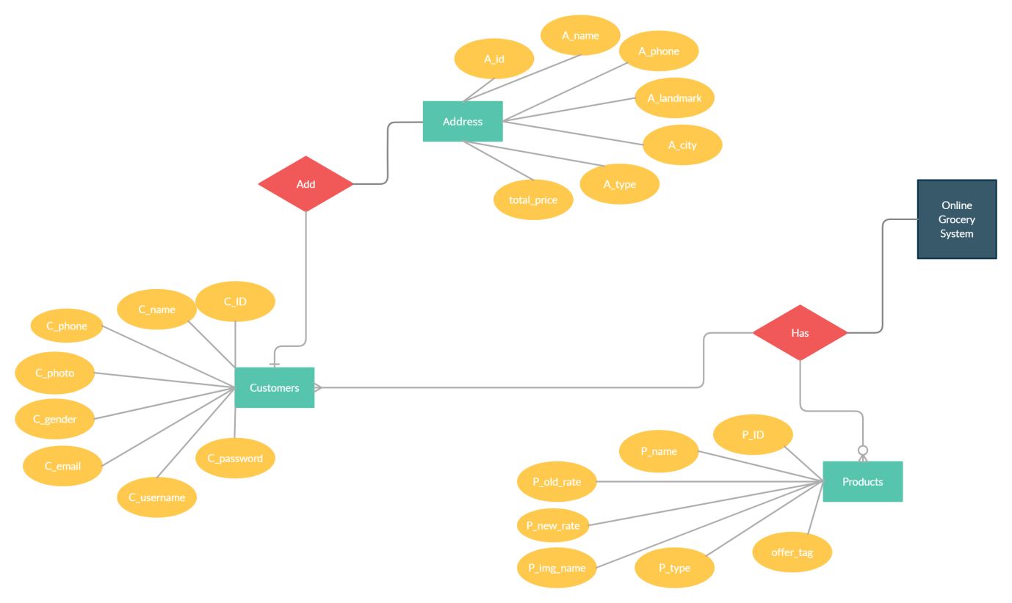
ER-Diagram of the online grocery store
Here, customers or visitors are the most important part of this kind of websites. The UI of the web application has been kept simple so that different types of users can use the website smoothly without any problems. Initially, the visitors or customers can browse in the

website but if they want to purchase something then they have to login. If they have not registered yet then they have to register themselves by providing details like name, phone number, email address etc.

]

Login Screen

HOME

OGIN/SIGNUP ME

LOGIN

LOGIN

NTER DETAIL
Login process flowchart

istration

HOME

OGIN/SIGNUP ME

SIGNUP

REGISTER

FIRM CAPT

NTER DETAIL
Registration process flowchart

Checkout billing details

CHECKOUT
REVIEW
ADD DETAILS

DELIVERY

ONFIRM CAPTC
Checkout and Billing process flowchart

CODING AND SCREEN SHOT
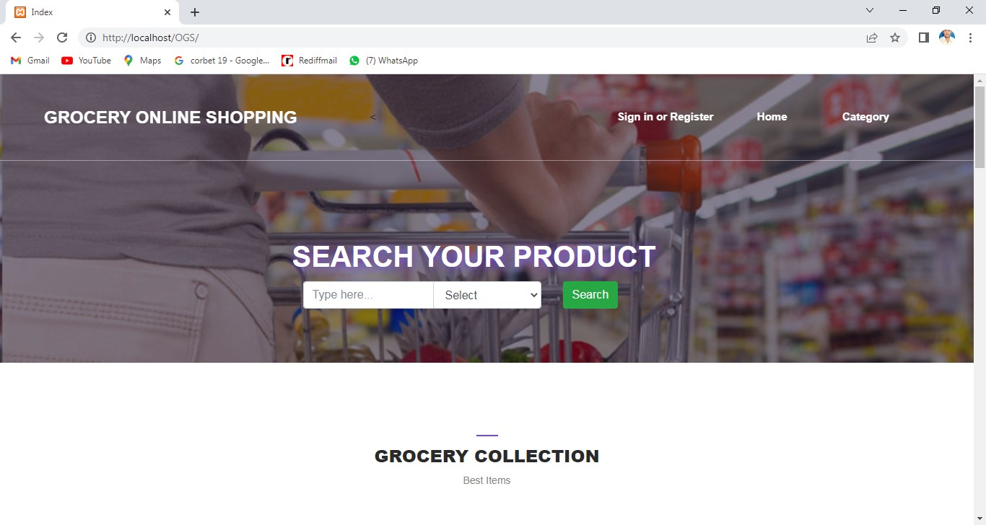

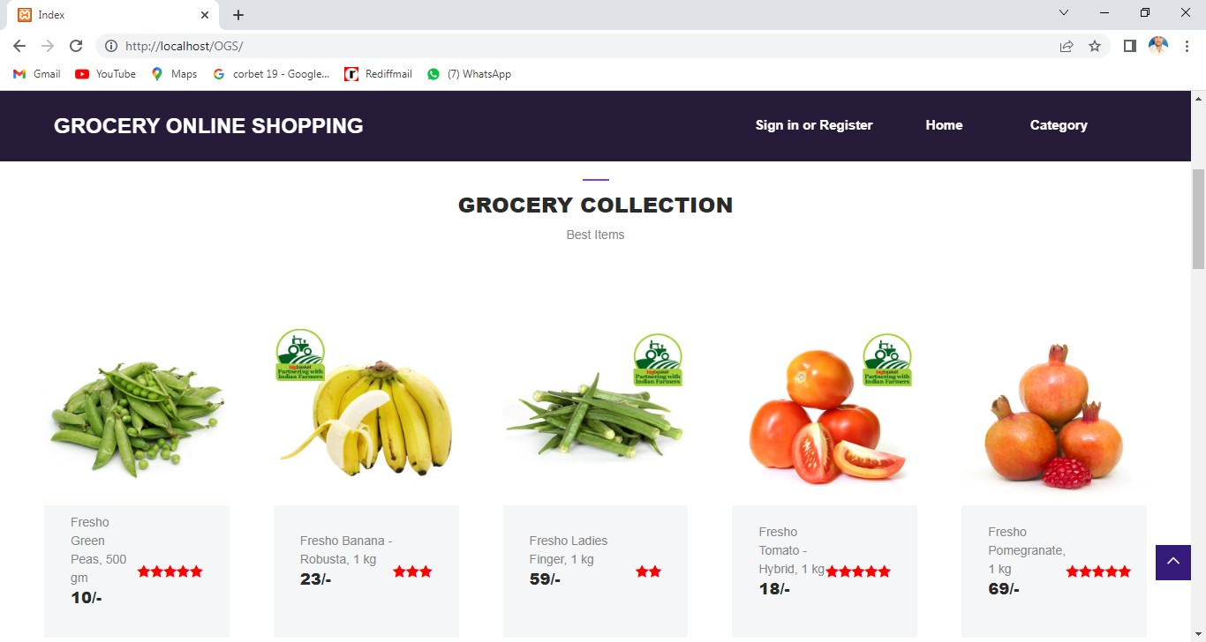

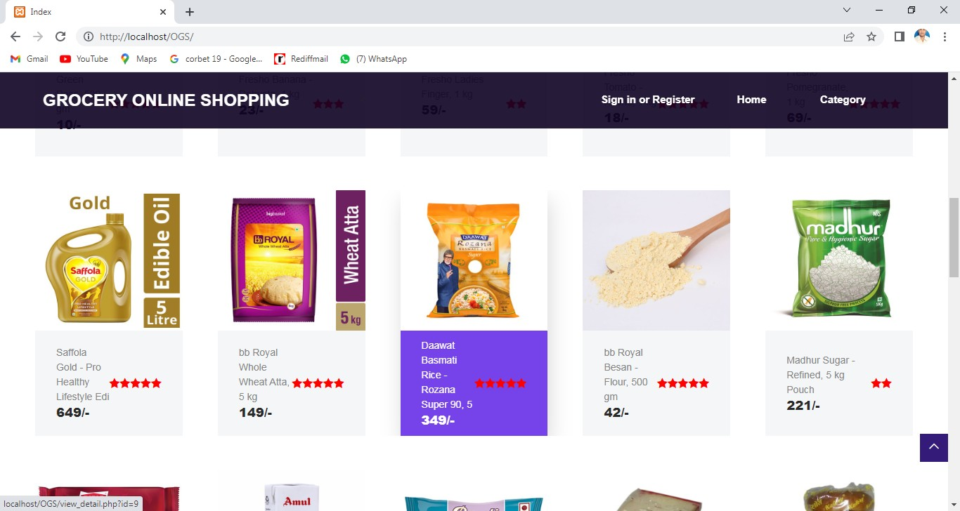

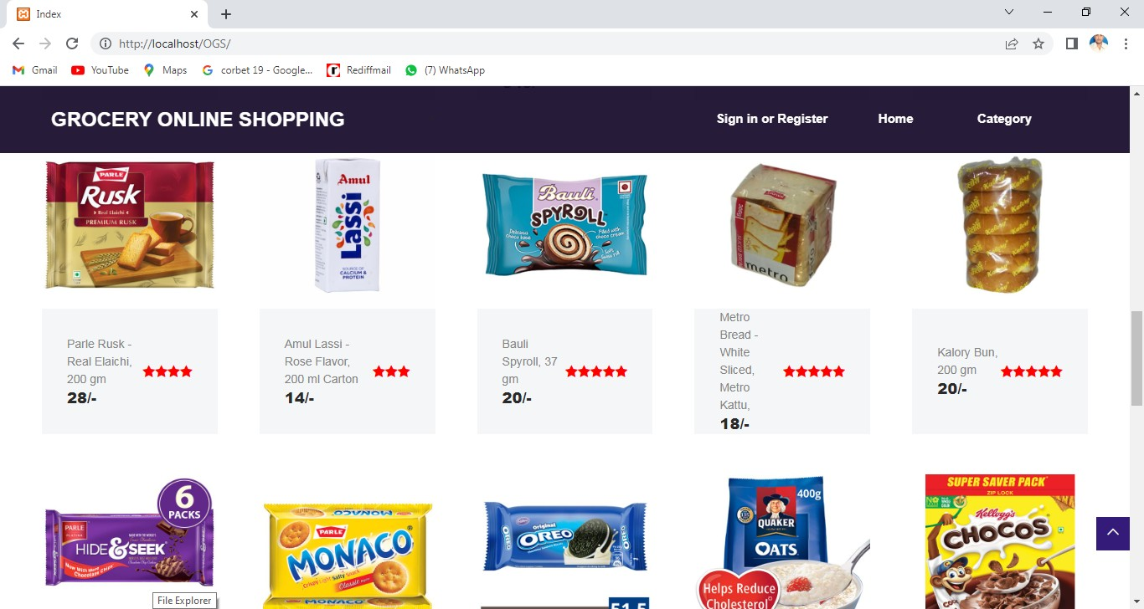

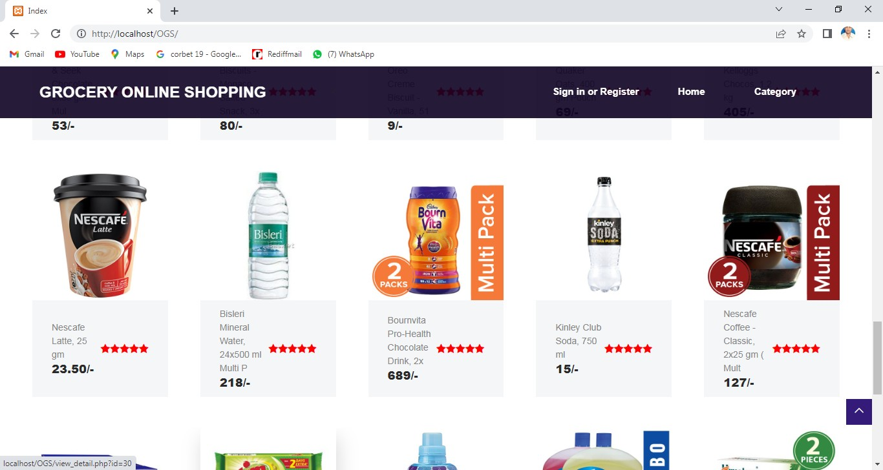

INDEX.PHP
<?php require_once"dbconfig.php";

?>
<!DOCTYPE html>
<html lang="en">

<head>
<meta charset="UTF-8">
<meta name="description" content="">
<meta http-equiv="X-UA-Compatible" content="IE=edge">
<meta name="viewport" content="width=device-width, initial-scale=1, shrink-to-fit=no">
<title>Index</title>

<link href="style.css" rel="stylesheet">

<link href="css/responsive/responsive.css" rel="stylesheet">

<script src="jquery.min.js"></script>
<script>
$(document).ready(function(){
$('#country').keyup(function(){ var query = $(this).val();
aler(query);
if(query != '')
{

$.ajax({
url:"searchinput.php", method:"POST", data:{query:query}, success:function(data)
{

$('#countryList').fadeIn();
$('#countryList').html(data);

}
});

}
});

$(document).on('click', 'li', function(){
$('#country').val($(this).text());
$('#countryList').fadeOut();

});

$('.navbar-light .dmenu').hover(function () {
$(this).find('.sm-menu').first().stop(true, true).slideDown(150);

}, function () {
$(this).find('.sm-menu').first().stop(true, true).slideUp(105)
});
});
</script>
</head>

<body>
<div id="preloader">
<div class="dorne-load"></div>
</div>

<header class="header_area" id="header">
<div class="container-fluid h-100">
<div class="row h-100">
<div class="col-12 h-100">
<nav class="h-100 navbar navbar-expand-lg">
<a class="navbar-brand" href="index.php">GROCERY ONLINE SHOPPING</a>

<button class="navbar-toggler" type="button" data- toggle="collapse" data-target="#dorneNav" aria-controls="dorneNav" aria- expanded="false" aria-label="Toggle navigation"><span class="fa fa- bars"></span></button>
<!-- Nav -->
<div class="collapse navbar-collapse" id="dorneNav">
<ul class="navbar-nav mr-auto" id="dorneMenu">
<li class="nav-item active">
<a class="nav-link" href="index.php"><span class="sr- only">(current)</span></a>

</li>
<li class="nav-item dropdown">
<
</li>

</ul>
<div class="dorne-signin-btn">
<?php if(isset($_SESSION['login']))
{

?><a class="nav-link" href="index.php">Home <span class="sr-only">(current)</span></a>

href="mycart.php">My Cart</a> href="category.php">Category</a>
<a class="nav-link"

<a class="nav-link"

<a class="nav-link" href="logout.php">Logout</a>

}

href="ragister.php">Sign in or Register</a>
<?php

else
{
?>
<a

<a class="nav-link" href="index.php">Home <span class="sr-only">(current)</span></a>
<a class="nav-link"
href="category.php">Category</a>

<?php
}

?>

</div>

</div>
</nav>
</div>
</div>
</div>
</header>
<section class="dorne-welcome-area bg-img bg-overlay" style="background- image: url(img/bg-img/hero-1.jpg);">
<div class="container h-100">
<div class="row h-100 align-items-center justify-content-center">
<div class="col-12 col-md-6"></br></br>
<div class="hero-content"></br></br></br></br></br>

<h1 style="color:white;font-weight:bold; text-shadow: 2px 2px 14px #7546E4;">SEARCH YOUR PRODUCT</h1>

</div>

<div class="container-fluid">
<div class="row">
<div class="col-lg-4">
<form class="form-inline" method="post" action="search_view.php">

<div class="form-group ">
<input type="text" class="form-control" name= "country" id="country" placeholder="Type here...">
</div>
</div><div class="col-lg-4">

<div class="form-group ">
<select class="form-control" name="category">
<option>Select</option>
<option value="FruitVegetables">Fruits & Vegetables</option>
<option value="FoodgrainsoilMasala">Foodgrains, oil & Masala</option>
<option value="BakerycakesDairy">Bakery, cakes & Dairy</option>
<option value="SnacksBrandedFoods">Snacks & Branded Foods</option>
<option value="Beverage">Beverage</option>
<option value="Cleaninghousehold">Cleaning & household</option>
</select>

</select>
</div>

</div>

<div class="col-lg-4">
<button type="submit" name="onsearch" id="search_click" class="btn btn- success ">Search</button></div>
</form>

</div>
</div>
<div id="countryList" style="background-color:yellow"></div>

</div>
</div>
</div>

</section>

<section class="dorne-features-destinations-area">
<div class="container-fluid">
<div class="row">
<div class="col-12">
<div class="section-heading dark text-center">
<span></span>
<h4>Grocery Collection</h4>
<p>Best Items</p>
</div>
</div>

</div>

<div class="row">
<div class="col-12">
<div class="features-slides owl-carousel">

category='FruitVegetables'");

<?php
$result=select("select * from items where

while($r=mysqli_fetch_array($result))
{

extract($r);
?>

<div class="single-features-area">
<a href="view_detail.php?id=<?=$itemid?>"><img src="admin/images/<?=$image?>" style="height:200px;width:400px">
<!-- Price -->
<div class="price-start">
</div>
<div class="feature-content d-flex align-items-center justify- content-between" style="height:150px">
<div class="feature-title">

<p><?=$Title?></p>

<h5><?=$price?>/-</h5></br>
</div>

<?php
for($i=1;$i<=$item_rating;$i++) : ?>

style="color:red" aria-hidden="true"></i>
<?php endfor; ?>
<i class="fa fa-star"

</div></a>
</div>

}

<?php

?>

</div>
</div>
</div></br></br>
<div class="row">
<div class="col-12">
<div class="features-slides owl-carousel">

<?php
$result=select("select * from items where category='FoodgrainsoilMasala'");
while($r=mysqli_fetch_array($result))
{

extract($r);
?>

<a href="view_detail.php?id=<?=$itemid?>"><div class="single-features-area">
<img src="admin/images/<?=$image?>" style="height:200px;width:400px">
<!-- Price -->

<div class="price-start">
</div>
<div class="feature-content d-flex align-items-center justify- content-between" style="height:150px">
<div class="feature-title">

<p><?=$Title?></p>

<h5><?=$price?>/-</h5>
</div>

<?php
for($i=1;$i<=$item_rating;$i++) : ?>

style="color:red" aria-hidden="true"></i>
<?php endfor; ?>

<i class="fa fa-star"

</div>
</div></a>

<?php
}
?>

</div>
</div>
</div></br></br>
<div class="row">
<div class="col-12">

<div class="features-slides owl-carousel">

category='BakerycakesDairy'");

<?php
$result=select("select * from items where

while($r=mysqli_fetch_array($result))
{

extract($r);
?>

<a href="view_detail.php?id=<?=$itemid?>"><div class="single-features-area">
<img src="admin/images/<?=$image?>" style="height:200px;width:400px">
<!-- Price -->
<div class="price-start">
</div>
<div class="feature-content d-flex align-items-center justify- content-between" style="height:150px">
<div class="feature-title">

<p><?=$Title?></p>

<h5><?=$price?>/-</h5>
</div>

<?php
for($i=1;$i<=$item_rating;$i++) : ?>

<i class="fa fa-star"
style="color:red" aria-hidden="true"></i>
<?php endfor; ?>

</div>
</div></a>
<?php
}
?>

</div>
</div>
</div></br></br>
<div class="row">
<div class="col-12">
<div class="features-slides owl-carousel">

<?php
$result=select("select * from items where category='SnacksBrandedFoods'");
while($r=mysqli_fetch_array($result))
{

extract($r);
?>

<a href="view_detail.php?id=<?=$itemid?>"><div class="single-features-area">
<img src="admin/images/<?=$image?>" style="height:200px;width:400px">
<!-- Price -->
<div class="price-start">
</div>
<div class="feature-content d-flex align-items-center justify- content-between" style="height:150px">

<div class="feature-title">
<p><?=$Title?></p>

<h5><?=$price?>/-</h5>
</div>

<?php
for($i=1;$i<=$item_rating;$i++) : ?>

style="color:red" aria-hidden="true"></i>
<?php endfor; ?>

<i class="fa fa-star"

</div>
</div></a>
<?php
}
?>

</div>
</div>
</div></br></br>
<div class="row">
<div class="col-12">
<div class="features-slides owl-carousel">

<?php

category='Beverage'");
$result=select("select * from items where

while($r=mysqli_fetch_array($result))
{

extract($r);
?>

<a href="view_detail.php?id=<?=$itemid?>"><div class="single-features-area">
<img src="admin/images/<?=$image?>" style="height:200px;width:400px">
<!-- Price -->
<div class="price-start">
</div>
<div class="feature-content d-flex align-items-center justify- content-between" style="height:150px">
<div class="feature-title">

<p><?=$Title?></p>

<h5><?=$price?>/-</h5>
</div>

<?php
for($i=1;$i<=$item_rating;$i++) : ?>

style="color:red" aria-hidden="true"></i>
<?php endfor; ?>

<i class="fa fa-star"

</div>
</div></a>

<?php

}
?>

</div>
</div>
</div></br></br>
<div class="row">
<div class="col-12">
<div class="features-slides owl-carousel">

category='Cleaninghousehold'");

<?php
$result=select("select * from items where

while($r=mysqli_fetch_array($result))
{

extract($r);
?>

<a href="view_detail.php?id=<?=$itemid?>"><div class="single-features-area">
<img src="admin/images/<?=$image?>" style="height:200px;width:400px">
<!-- Price -->
<div class="price-start">
</div>
<div class="feature-content d-flex align-items-center justify- content-between" style="height:150px">
<div class="feature-title">

<p><?=$Title?></p>

<h5><?=$price?>/-</h5>
</div>

<?php
for($i=1;$i<=$item_rating;$i++) : ?>

style="color:red" aria-hidden="true"></i>
<?php endfor; ?>

<i class="fa fa-star"

</div>
</div></a>

<?php
}
?>

</div>
</div>
</div></br></br>

</div>
</section>

<!-- ***** Clients Area Start ***** -->

<!-- ****** Footer Area Start ****** -->

<footer class="dorne-footer-area">
<div class="container-fluid">
<div class="row">
<div class="col-12 d-md-flex align-items-center justify-content- between">

<div class="footer-text">
<p>
Copyright &copy;<script>document.write(new Date().getFullYear());</script> All rights reserved | Final Year Project Made By Neha KUmari Doranda College,Ranchi</a>

</p>
</div>

</div>
</div>
</div>
</footer>
<!-- ****** Footer Area End ****** -->

<!-- jQuery-2.2.4 js -->
<script src="js/jquery/jquery-2.2.4.min.js"></script>
<!-- Popper js -->
<script src="js/bootstrap/popper.min.js"></script>
<!-- Bootstrap-4 js -->
<script src="js/bootstrap/bootstrap.min.js"></script>
<!-- All Plugins js -->
<script src="js/others/plugins.js"></script>
<!-- Active JS -->

<script src="js/active.js"></script>
</body>

</html>

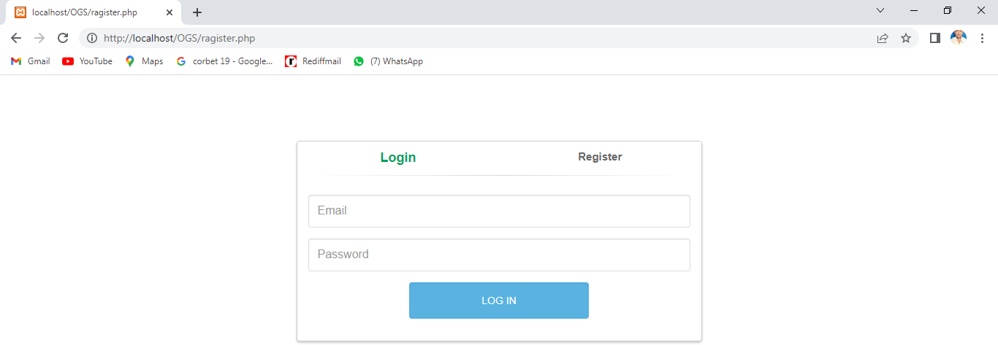

<link href="//maxcdn.bootstrapcdn.com/bootstrap/3.3.0/css/bootstrap.min.css" rel="stylesheet" id="bootstrap-css">
<script src="//maxcdn.bootstrapcdn.com/bootstrap/3.3.0/js/bootstrap.min.js"></script>
<script src="//code.jquery.com/jquery-1.11.1.min.js"></script>
<link href="css/ragister.css" rel="stylesheet">
<script>
$(function() {

$('#login-form-link').click(function(e) {
$("#login-form").delay(100).fadeIn(100);
$("#register-form").fadeOut(100);
$('#register-form-link').removeClass('active');
$(this).addClass('active'); e.preventDefault();
});
$('#register-form-link').click(function(e) {
$("#register-form").delay(100).fadeIn(100);
$("#login-form").fadeOut(100);
$('#login-form-link').removeClass('active');
$(this).addClass('active'); e.preventDefault();
});

});

</script>

<?php

require_once"dbconfig.php";
?>
<div class="container">
<div class="row">
<div class="col-md-6 col-md-offset-3">
<div class="panel panel-login">
<div class="panel-heading">
<div class="row">
<div class="col-xs-6">
<a href="#" class="active"

id="login-form-link">Login</a>

form-link">Register</a>

</div>
<div class="col-xs-6">
<a href="#" id="register-

</div>
</div>
<hr>
</div>
<div class="panel-body">
<div class="row">
<div class="col-lg-12">
<form id="login-form"

method="post" role="form" style="display: block;"> group">

<div class="form-

<input

type="text" name="email" id="username" tabindex="1" class="form-control" placeholder="Email" value="">

</div>

group">
<div class="form-

<input

type="password" name="password" id="password" tabindex="2" class="form- control" placeholder="Password">

</div>

group"> class="row">
class="col-sm-6 col-sm-offset-3">

<div class="form-

<div

<div

<input type="submit" name="login" id="login-submit" tabindex="4" class="form-control btn btn-login" value="Log In">

</div>
</div>
</div>

</form>
<form id="register-form" action="" method="post" role="form" style="display: none;">
<div class="form-
group">
<input
type="text" name="name" id="username" tabindex="1" class="form-control" placeholder="Username" value="">

group">
</div>
<div class="form-

<input

type="text" name="email" id="email" tabindex="1" class="form-control" placeholder="Email Address" value="">

group">
</div>
<div class="form-

<input

type="text" name="mobile" id="password" tabindex="2" class="form-control" placeholder="Mobile">

group">
</div>
<div class="form-

<input

type="password" name="password" id="confirm-password" tabindex="2" class="form-control" placeholder="Password">

group"> class="row">
class="col-sm-6 col-sm-offset-3">
</div>
<div class="form-

<div

<div

<input type="submit" name="register" id="register-submit" tabindex="4" class="form-control btn btn-register" value="Register Now">

</div>
</div>
</div>
</form>

<?php if(isset($_REQUEST['register']))
{

extract($_REQUEST);
$query="INSERT INTO `user`(`name`, `mobile`, `email`, `password`) values('$name','$mobile','$email','$password')";

if($n==1)
{
$n=iud($query);

}
else
{
echo"<script>alert('Register successfull'); window.location='ragister.php';
</script>";

echo"<script>alert('Something Wrong'); window.location='ragister.php';
</script>";

}
}

if(isset($_REQUEST['login']))
{

extract($_REQUEST);
$query="select * from user where email='$email' and password='$password'";
$login_data=select($query);
$n=mysqli_num_rows($login_data); if($n==1)
{

while($data=mysqli_fetch_array($login_data))
{
extract($data);

}

$_SESSION['userid']=$userid;
$_SESSION['login']="yes";

}
else
{

}

}
?>

header("location:index.php?id=".$_SESSION['userid']."");

echo"email or password is incorrect";

</div>
</div>
</div>
</div>
</div>
</div>

</div>

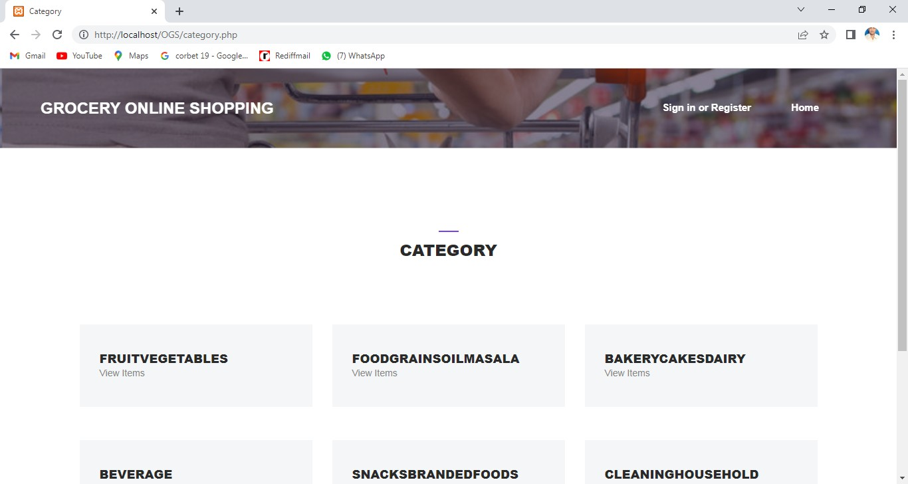

<?php require_once"dbconfig.php";
//$result=select("select * from items where itemid='".$_REQUEST['id']."'")
$result=select("SELECT DISTINCT category FROM items" );

?>
<!DOCTYPE html>
<html lang="en">

<head>
<meta charset="UTF-8">

<meta name="description" content="">
<meta http-equiv="X-UA-Compatible" content="IE=edge">
<meta name="viewport" content="width=device-width, initial-scale=1, shrink-to-fit=no">

<!-- Title -->
<title>Category</title>

<!-- Core Stylesheet -->
<link href="style.css" rel="stylesheet">

<!-- Responsive CSS -->
<link href="css/responsive/responsive.css" rel="stylesheet">

</head>

<body>
<!-- Preloader -->
<div id="preloader">
<div class="dorne-load"></div>
</div>

<!-- ***** Search Form Area ***** -->
<div class="dorne-search-form d-flex align-items-center">
<div class="container">
<div class="row">
<div class="col-12">
<div class="search-close-btn" id="closeBtn">

<i class="pe-7s-close-circle" aria-hidden="true"></i>
</div>
<form action="#" method="get">
<input type="search" name="caviarSearch" id="search" placeholder="Search Your Desire Destinations or Events">
<input type="submit" class="d-none" value="submit">
</form>
</div>
</div>
</div>
</div>

<!-- ***** Header Area Start ***** -->
<header class="header_area" id="header">
<div class="container-fluid h-100">
<div class="row h-100">
<div class="col-12 h-100">
<nav class="h-100 navbar navbar-expand-lg">
<a class="navbar-brand" href="index.php">GROCERY ONLINE SHOPPING</a>

<button class="navbar-toggler" type="button" data- toggle="collapse" data-target="#dorneNav" aria-controls="dorneNav" aria- expanded="false" aria-label="Toggle navigation"><span class="fa fa- bars"></span></button>
<!-- Nav -->
<div class="collapse navbar-collapse" id="dorneNav">
<ul class="navbar-nav mr-auto" id="dorneMenu">
<li class="nav-item">
<a class="nav-link" href="index.php"> <span class="sr- only">(current)</span></a>

</li>
<li class="nav-item">
<a class="nav-link" href="mycart.php"></a>
</li>

<li class="nav-item">
<a class="nav-link" href="logout.php"></a>
</li>
</ul>

<div class="dorne-signin-btn">
<?php if(isset($_SESSION['login']))
{

?><a class="nav-link" href="index.php">Home <span class="sr-only">(current)</span></a>

href="mycart.php">My Cart</a> href="mycart.php">Category</a>
<a class="nav-link"

<a class="nav-link"

<a class="nav-link" href="logout.php">Logout</a>

<?php
}
else
{

or Register</a>
?>
<a href="#">Sign in

<a class="nav-link"

href="index.php">Home <span class="sr-only">(current)</span></a>

<?php
}

?>

</div>

</div>
</nav>
</div>
</div>
</div>
</header>
<!-- ***** Header Area End ***** -->

<!-- ***** Breadcumb Area Start ***** -->
<div class="breadcumb-area bg-img bg-overlay" style="background-image: url(img/bg-img/hero-1.jpg)"></div>
</br>

<section class="dorne-listing-destinations-area section-padding-100-50">
<div class="container">

<div class="row">
<div class="col-12">
<div class="section-heading dark text-center">
<span></span>
<h4>Category</h4>
</div>
</div>
</div>
<div class="row">

<?php
while($r=mysqli_fetch_array($result))
{
?>

<div class="col-12 col-sm-6 col-lg-4">
<a href="cat_detail.php?cat=<?=$r[0]?>"><div class="single- features-area mb-50">
<!-- Price -->

<div class="feature-content d-flex align-items-center justify- content-between">
<div class="feature-title">
<h5><?=$r[0]?></h5>
<p>View Items</p>
</div>

</div>
</div></a>
</div><?php

}
?>
<!-- Single Features Area -->

</div>
</div>
</section>

<footer class="dorne-footer-area">
<div class="container-fluid">
<div class="row">
<div class="col-12 d-md-flex align-items-center justify-content- between">

<div class="footer-text">
<p>

Copyright &copy;<script>document.write(new Date().getFullYear());</script> All rights reserved | This Project is made by Shashank Kumar & Varunika Palsetty</a>

</p>
</div>

</div>
</div>
</div>
</footer>

<script src="js/jquery/jquery-2.2.4.min.js"></script>

<!-- Popper js -->
<script src="js/bootstrap/popper.min.js"></script>
<!-- Bootstrap-4 js -->
<script src="js/bootstrap/bootstrap.min.js"></script>
<!-- All Plugins js -->
<script src="js/others/plugins.js"></script>
<!-- Active JS -->
<script src="js/active.js"></script>
</body>

</html>

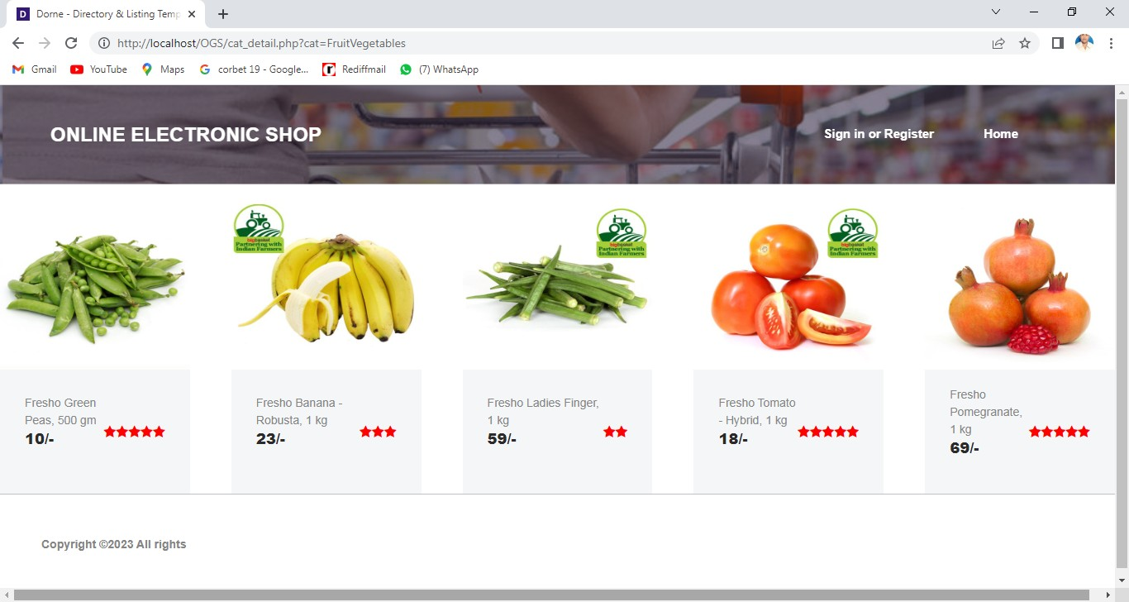

<?php require_once"dbconfig.php";
//$result=select("select * from items where itemid='".$_REQUEST['id']."'")

$q="SELECT * FROM items where category='".$_REQUEST['cat']."'";
$result=select($q);

?>
<!DOCTYPE html>
<html lang="en">

<head>
<meta charset="UTF-8">
<meta name="description" content="">
<meta http-equiv="X-UA-Compatible" content="IE=edge">
<meta name="viewport" content="width=device-width, initial-scale=1, shrink-to-fit=no">

<title>Dorne - Directory &amp; Listing Template | Listing</title>

<link rel="icon" href="img/core-img/favicon.ico">

<link href="style.css" rel="stylesheet">

<link href="css/responsive/responsive.css" rel="stylesheet">

</head>

<body>

<div id="preloader">
<div class="dorne-load"></div>
</div>

<div class="dorne-search-form d-flex align-items-center">
<div class="container">
<div class="row">
<div class="col-12">
<div class="search-close-btn" id="closeBtn">
<i class="pe-7s-close-circle" aria-hidden="true"></i>
</div>
<form action="#" method="get">
<input type="search" name="caviarSearch" id="search" placeholder="Search Your Desire Destinations or Events">
<input type="submit" class="d-none" value="submit">
</form>
</div>
</div>
</div>
</div>

<header class="header_area" id="header">
<div class="container-fluid h-100">
<div class="row h-100">
<div class="col-12 h-100">
<nav class="h-100 navbar navbar-expand-lg">

<a class="navbar-brand" href="index.php">ONLINE ELECTRONIC SHOP</a>

<button class="navbar-toggler" type="button" data- toggle="collapse" data-target="#dorneNav" aria-controls="dorneNav" aria- expanded="false" aria-label="Toggle navigation"><span class="fa fa- bars"></span></button>
<!-- Nav -->
<div class="collapse navbar-collapse" id="dorneNav">
<ul class="navbar-nav mr-auto" id="dorneMenu">
<li class="nav-item">
<a class="nav-link" href="index.php"> <span class="sr- only">(current)</span></a>
</li>
<li class="nav-item">
<a class="nav-link" href="mycart.php"></a>
</li>

<li class="nav-item">
<a class="nav-link" href="logout.php"></a>
</li>
</ul>

<div class="dorne-signin-btn">
<?php if(isset($_SESSION['login']))
{

?><a class="nav-link" href="index.php">Home <span class="sr-only">(current)</span></a>

href="mycart.php">My Cart</a> href="category.php">Category</a>
<a class="nav-link"

<a class="nav-link"

<a class="nav-link" href="logout.php">Logout</a>

or Register</a>

<?php
}
else
{

?>
<a href="#">Sign in

<a class="nav-link" href="index.php">Home <span class="sr-only">(current)</span></a>

<?php
}

?>

</div>

</div>
</nav>
</div>
</div>
</div>

</header>

<div class="breadcumb-area bg-img bg-overlay" style="background-image: url(img/bg-img/hero-1.jpg)"></div>
</br>

<div class="row">
<div class="col-12">
<div class="features-slides owl-carousel">

<?php while($r=mysqli_fetch_array($result))
{

extract($r);
?>

<div class="single-features-area">
<a href="view_detail.php?id=<?=$itemid?>"><img src="admin/images/<?=$image?>" style="height:200px;width:400px">
<!-- Price -->
<div class="price-start">
</div>
<div class="feature-content d-flex align-items-center justify- content-between" style="height:150px">
<div class="feature-title">

<p><?=$Title?></p>

<h5><?=$price?>/-</h5></br>
</div>

<?php
for($i=1;$i<=$item_rating;$i++) : ?>

style="color:red" aria-hidden="true"></i>
<?php endfor; ?>

<i class="fa fa-star"

</div></a>
</div>

}

<?php

?>

</div>
</div>
</div>

<footer class="dorne-footer-area">
<div class="container-fluid">
<div class="row">
<div class="col-12 d-md-flex align-items-center justify-content- between">

<div class="footer-text">
<p>

Copyright &copy;<script>document.write(new Date().getFullYear());</script> All rights
</p>
</div>

</div>
</div>
</div>
</footer>

<script src="js/jquery/jquery-2.2.4.min.js"></script>
<!-- Popper js -->
<script src="js/bootstrap/popper.min.js"></script>
<!-- Bootstrap-4 js -->
<script src="js/bootstrap/bootstrap.min.js"></script>
<!-- All Plugins js -->
<script src="js/others/plugins.js"></script>
<!-- Active JS -->
<script src="js/active.js"></script>
</body>

</html>

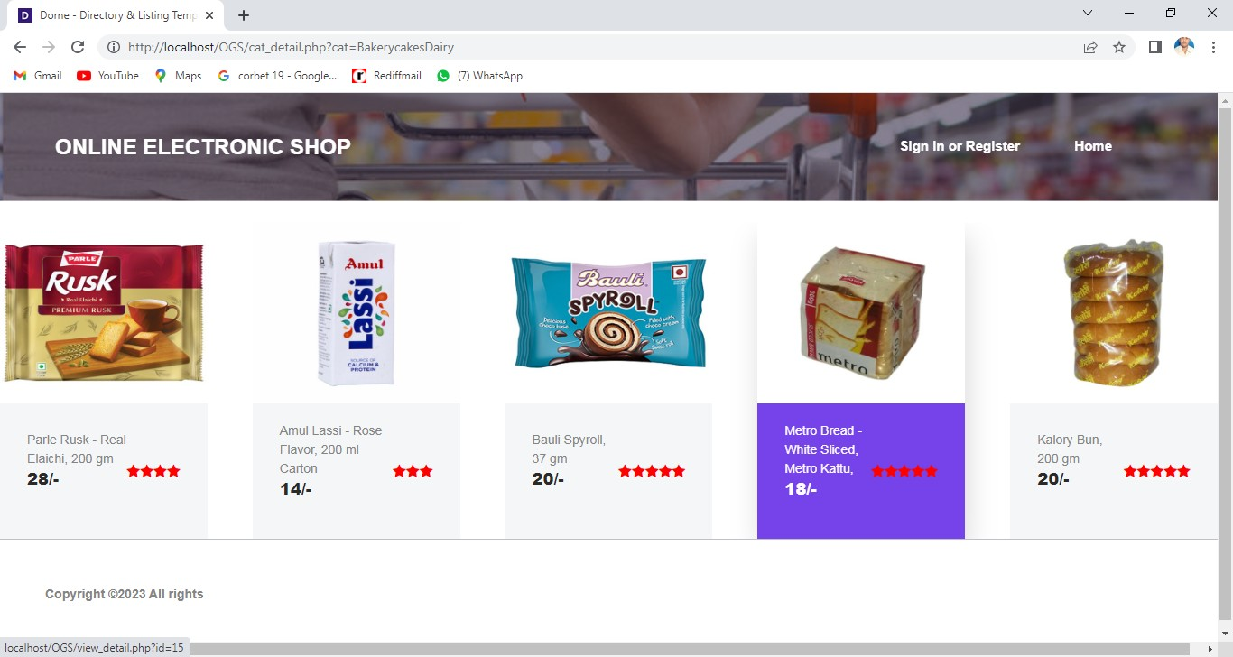

<?php require_once"dbconfig.php";
//$result=select("select * from items where itemid='".$_REQUEST['id']."'")
$result=select("SELECT DISTINCT category FROM items" );

?>
<!DOCTYPE html>
<html lang="en">

<head>
<meta charset="UTF-8">
<meta name="description" content="">
<meta http-equiv="X-UA-Compatible" content="IE=edge">
<meta name="viewport" content="width=device-width, initial-scale=1, shrink-to-fit=no">

<!-- Title -->
<title>Category</title>

<!-- Core Stylesheet -->
<link href="style.css" rel="stylesheet">

<!-- Responsive CSS -->
<link href="css/responsive/responsive.css" rel="stylesheet">

</head>

<body>
<!-- Preloader -->
<div id="preloader">
<div class="dorne-load"></div>
</div>

<!-- ***** Search Form Area ***** -->
<div class="dorne-search-form d-flex align-items-center">
<div class="container">
<div class="row">
<div class="col-12">
<div class="search-close-btn" id="closeBtn">
<i class="pe-7s-close-circle" aria-hidden="true"></i>
</div>
<form action="#" method="get">
<input type="search" name="caviarSearch" id="search" placeholder="Search Your Desire Destinations or Events">
<input type="submit" class="d-none" value="submit">

</form>
</div>
</div>
</div>
</div>

<!-- ***** Header Area Start ***** -->
<header class="header_area" id="header">
<div class="container-fluid h-100">
<div class="row h-100">
<div class="col-12 h-100">
<nav class="h-100 navbar navbar-expand-lg">
<a class="navbar-brand" href="index.php">GROCERY ONLINE SHOPPING</a>

<button class="navbar-toggler" type="button" data- toggle="collapse" data-target="#dorneNav" aria-controls="dorneNav" aria- expanded="false" aria-label="Toggle navigation"><span class="fa fa- bars"></span></button>
<!-- Nav -->
<div class="collapse navbar-collapse" id="dorneNav">
<ul class="navbar-nav mr-auto" id="dorneMenu">
<li class="nav-item">
<a class="nav-link" href="index.php"> <span class="sr- only">(current)</span></a>
</li>
<li class="nav-item">
<a class="nav-link" href="mycart.php"></a>
</li>

<li class="nav-item">
<a class="nav-link" href="logout.php"></a>
</li>
</ul>

<div class="dorne-signin-btn">
<?php if(isset($_SESSION['login']))
{

?><a class="nav-link" href="index.php">Home <span class="sr-only">(current)</span></a>

href="mycart.php">My Cart</a> href="mycart.php">Category</a>
<a class="nav-link"

<a class="nav-link"

<a class="nav-link" href="logout.php">Logout</a>

or Register</a>

<?php
}
else
{

?>
<a href="#">Sign in

<a class="nav-link" href="index.php">Home <span class="sr-only">(current)</span></a>

<?php
}

?>

</div>

</div>
</nav>
</div>
</div>
</div>
</header>
<!-- ***** Header Area End ***** -->

<!-- ***** Breadcumb Area Start ***** -->
<div class="breadcumb-area bg-img bg-overlay" style="background-image: url(img/bg-img/hero-1.jpg)"></div>
</br>

<section class="dorne-listing-destinations-area section-padding-100-50">
<div class="container">
<div class="row">
<div class="col-12">
<div class="section-heading dark text-center">
<span></span>
<h4>Category</h4>
</div>

</div>
</div>
<div class="row">

<?php
while($r=mysqli_fetch_array($result))
{
?>

<div class="col-12 col-sm-6 col-lg-4">
<a href="cat_detail.php?cat=<?=$r[0]?>"><div class="single- features-area mb-50">
<!-- Price -->

<div class="feature-content d-flex align-items-center justify- content-between">
<div class="feature-title">
<h5><?=$r[0]?></h5>
<p>View Items</p>
</div>

</div>
</div></a>
</div><?php
}
?>

<!-- Single Features Area -->

</div>
</div>

</section>

<footer class="dorne-footer-area">
<div class="container-fluid">
<div class="row">
<div class="col-12 d-md-flex align-items-center justify-content- between">

<div class="footer-text">
<p>

Copyright &copy;<script>document.write(new Date().getFullYear());</script> All rights reserved | This Project is made by Shashank Kumar & Varunika Palsetty</a>

</p>
</div>

</div>
</div>
</div>
</footer>

<script src="js/jquery/jquery-2.2.4.min.js"></script>
<!-- Popper js -->
<script src="js/bootstrap/popper.min.js"></script>
<!-- Bootstrap-4 js -->
<script src="js/bootstrap/bootstrap.min.js"></script>
<!-- All Plugins js -->
<script src="js/others/plugins.js"></script>

<!-- Active JS -->
<script src="js/active.js"></script>
</body>

</html>

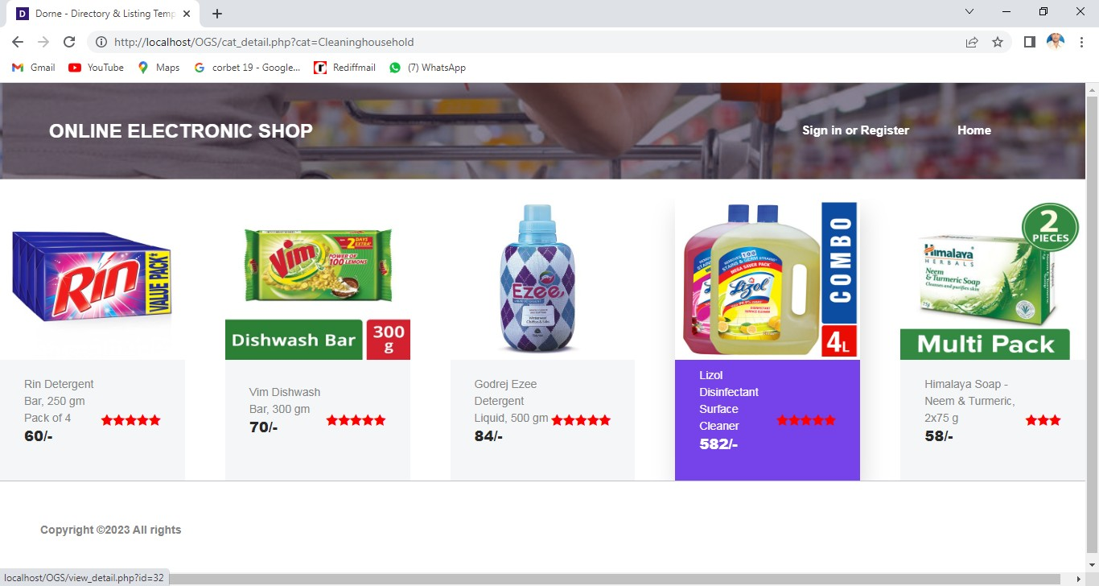

<?php require_once"dbconfig.php";
//$result=select("select * from items where itemid='".$_REQUEST['id']."'")
$result=select("SELECT DISTINCT category FROM items" );

?>
<!DOCTYPE html>
<html lang="en">

<head>

<meta charset="UTF-8">
<meta name="description" content="">
<meta http-equiv="X-UA-Compatible" content="IE=edge">
<meta name="viewport" content="width=device-width, initial-scale=1, shrink-to-fit=no">

<!-- Title -->
<title>Category</title>

<!-- Core Stylesheet -->
<link href="style.css" rel="stylesheet">

<!-- Responsive CSS -->
<link href="css/responsive/responsive.css" rel="stylesheet">

</head>

<body>
<!-- Preloader -->
<div id="preloader">
<div class="dorne-load"></div>
</div>

<!-- ***** Search Form Area ***** -->
<div class="dorne-search-form d-flex align-items-center">
<div class="container">
<div class="row">
<div class="col-12">

<div class="search-close-btn" id="closeBtn">
<i class="pe-7s-close-circle" aria-hidden="true"></i>
</div>
<form action="#" method="get">
<input type="search" name="caviarSearch" id="search" placeholder="Search Your Desire Destinations or Events">
<input type="submit" class="d-none" value="submit">
</form>
</div>
</div>
</div>
</div>

<!-- ***** Header Area Start ***** -->
<header class="header_area" id="header">
<div class="container-fluid h-100">
<div class="row h-100">
<div class="col-12 h-100">
<nav class="h-100 navbar navbar-expand-lg">
<a class="navbar-brand" href="index.php">GROCERY ONLINE SHOPPING</a>

<button class="navbar-toggler" type="button" data- toggle="collapse" data-target="#dorneNav" aria-controls="dorneNav" aria- expanded="false" aria-label="Toggle navigation"><span class="fa fa- bars"></span></button>
<!-- Nav -->
<div class="collapse navbar-collapse" id="dorneNav">
<ul class="navbar-nav mr-auto" id="dorneMenu">
<li class="nav-item">

<a class="nav-link" href="index.php"> <span class="sr- only">(current)</span></a>
</li>
<li class="nav-item">
<a class="nav-link" href="mycart.php"></a>
</li>

<li class="nav-item">
<a class="nav-link" href="logout.php"></a>
</li>
</ul>

<div class="dorne-signin-btn">
<?php if(isset($_SESSION['login']))
{

?><a class="nav-link" href="index.php">Home <span class="sr-only">(current)</span></a>

href="mycart.php">My Cart</a> href="mycart.php">Category</a>
<a class="nav-link"

<a class="nav-link"

<a class="nav-link" href="logout.php">Logout</a>

<?php
}
else

or Register</a>
{
?>
<a href="#">Sign in

<a class="nav-link" href="index.php">Home <span class="sr-only">(current)</span></a>

<?php
}

?>

</div>

</div>
</nav>
</div>
</div>
</div>
</header>
<!-- ***** Header Area End ***** -->

<!-- ***** Breadcumb Area Start ***** -->
<div class="breadcumb-area bg-img bg-overlay" style="background-image: url(img/bg-img/hero-1.jpg)"></div>
</br>

<section class="dorne-listing-destinations-area section-padding-100-50">

<div class="container">
<div class="row">
<div class="col-12">
<div class="section-heading dark text-center">
<span></span>
<h4>Category</h4>
</div>
</div>
</div>
<div class="row">

<?php
while($r=mysqli_fetch_array($result))
{
?>

<div class="col-12 col-sm-6 col-lg-4">
<a href="cat_detail.php?cat=<?=$r[0]?>"><div class="single- features-area mb-50">
<!-- Price -->

<div class="feature-content d-flex align-items-center justify- content-between">
<div class="feature-title">
<h5><?=$r[0]?></h5>
<p>View Items</p>
</div>

</div>
</div></a>

</div><?php
}
?>

<!-- Single Features Area -->

</div>
</div>
</section>

<footer class="dorne-footer-area">
<div class="container-fluid">
<div class="row">
<div class="col-12 d-md-flex align-items-center justify-content- between">

<div class="footer-text">
<p>

Copyright &copy;<script>document.write(new Date().getFullYear());</script> All rights reserved | This Project is made by Shashank Kumar & Varunika Palsetty</a>

</p>
</div>

</div>
</div>
</div>
</footer>

<script src="js/jquery/jquery-2.2.4.min.js"></script>
<!-- Popper js -->
<script src="js/bootstrap/popper.min.js"></script>
<!-- Bootstrap-4 js -->
<script src="js/bootstrap/bootstrap.min.js"></script>
<!-- All Plugins js -->
<script src="js/others/plugins.js"></script>
<!-- Active JS -->
<script src="js/active.js"></script>
</body>

</html>

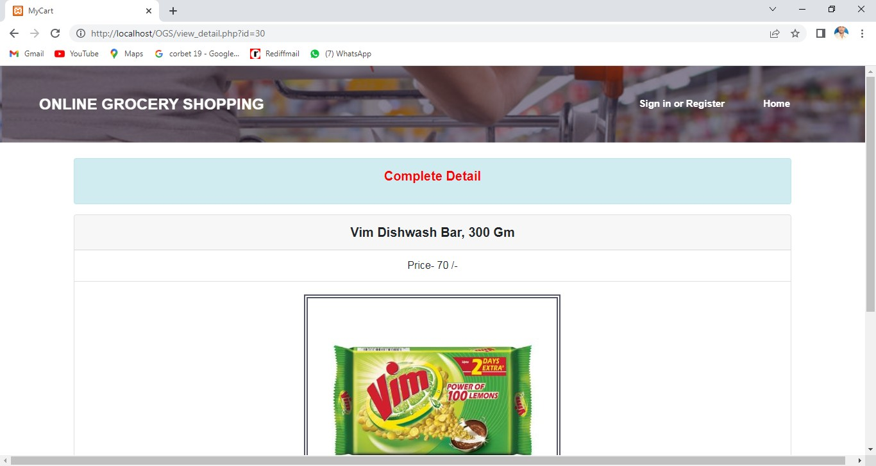

<?php require_once"dbconfig.php";
$result=select("select * from items where itemid='".$_REQUEST['id']."'")
?>
<!DOCTYPE html>
<html lang="en">

<head>
<meta charset="UTF-8">
<meta name="description" content="">
<meta http-equiv="X-UA-Compatible" content="IE=edge">
<meta name="viewport" content="width=device-width, initial-scale=1, shrink-to-fit=no">

<title>MyCart</title>
<!-- Core Stylesheet -->
<link href="style.css" rel="stylesheet">

<!-- Responsive CSS -->
<link href="css/responsive/responsive.css" rel="stylesheet">

</head>

<body>
<!-- Preloader -->
<div id="preloader">
<div class="dorne-load"></div>
</div>

<!-- ***** Search Form Area ***** -->
<div class="dorne-search-form d-flex align-items-center">
<div class="container">
<div class="row">
<div class="col-12">
<div class="search-close-btn" id="closeBtn">
<i class="pe-7s-close-circle" aria-hidden="true"></i>
</div>
<form action="#" method="get">
<input type="search" name="caviarSearch" id="search" placeholder="Search Your Desire Destinations or Events">
<input type="submit" class="d-none" value="submit">
</form>
</div>
</div>
</div>
</div>

<!-- ***** Header Area Start ***** -->
<header class="header_area" id="header">
<div class="container-fluid h-100">
<div class="row h-100">
<div class="col-12 h-100">
<nav class="h-100 navbar navbar-expand-lg">
<a class="navbar-brand" href="index.php">ONLINE GROCERY SHOPPING</a>

<button class="navbar-toggler" type="button" data- toggle="collapse" data-target="#dorneNav" aria-controls="dorneNav" aria- expanded="false" aria-label="Toggle navigation"><span class="fa fa- bars"></span></button>
<!-- Nav -->
<div class="collapse navbar-collapse" id="dorneNav">
<ul class="navbar-nav mr-auto" id="dorneMenu">
<li class="nav-item">
<a class="nav-link" href="index.php"> <span class="sr- only">(current)</span></a>
</li>
<li class="nav-item">
<a class="nav-link" href="mycart.php"></a>
</li>

<li class="nav-item">
<a class="nav-link" href="logout.php"></a>
</li>
</ul>

<div class="dorne-signin-btn">
<?php if(isset($_SESSION['login']))
{

?><a class="nav-link" href="index.php">Home <span class="sr-only">(current)</span></a>

href="mycart.php">My Cart</a> href="mycart.php">Category</a>
<a class="nav-link"

<a class="nav-link"

<a class="nav-link" href="logout.php">Logout</a>

}

href="ragister.php">Sign in or Register</a>

<?php

else
{
?>
<a

<a class="nav-link" href="index.php">Home <span class="sr-only">(current)</span></a>

<?php
}

?>

</div>

</div>
</nav>
</div>
</div>
</div>
</header>
<!-- ***** Header Area End ***** -->

<!-- ***** Breadcumb Area Start ***** -->
<div class="breadcumb-area bg-img bg-overlay" style="background-image: url(img/bg-img/hero-1.jpg)"></div>
</br>
<div class="row">
<div class="col-lg-1 text-center"></div>
<div class="col-lg-10 text-center">

<div class="alert alert-info" role="alert">
<p style="color:red;font-weight:bold;font-size:20px;">Complete Detail<p>
</div>
</div>

<div class="col-lg-1 text-center"></div>

</div><?php while($r=mysqli_fetch_array($result))
{

extract($r);
?>

<div class="row">
<div class="col-lg-1"></div>
<div class="col-lg-10">
<div class="card text-center">
<div class="card-header" style="font-weight:bold;font-size:20px">
<?=ucwords($Title)?>
</div>
<ul class="list-group list-group-flush">
<li class="list-group-item">Price- <?=$price?> /-</li>
</ul>

<div class="card-body">
<img src="admin/images/<?=$image?>" style="height:400px;max- width:95%;border:6px double #545565;">
<h5 class="card-title"><?=ucwords($discription)?></h5>
<form method="post">
<?php if(isset($_SESSION['login']))
{
?> <button name="cart" class="btn btn-primary">Add To Cart</button>
</div>
<input type="hidden" name="bookid" value=<?=$itemid?>>
<input type="hidden" name="userid" value=<?=$_SESSION['userid']?>>
<div class="card-footer text-muted">

<?php
}

else
{
?><a href="ragister.php" class="btn btn-primary">Add To Cart</a>

<?php
}
?>

<a href="index.php" class="btn btn-primary">Continue shopping</a>

</div>
</form>
<?php

if(isset($_REQUEST['cart']))
{

extract($_REQUEST);
$query= "INSERT INTO `cart`( `itemid`, `userid`) VALUES ('$bookid','$userid')";
$n=iud($query); if($n==1)
{

echo"<script>alert(' Successfull');
</script>";
}
else
{

echo"<script>alert('Something Wrong');

</script>";

}
}

?>
</div>

</div></div><?php
}
?>
<footer class="dorne-footer-area">
<div class="container-fluid">
<div class="row">
<div class="col-12 d-md-flex align-items-center justify-content- between">

<div class="footer-text">
<p>
Copyright &copy;<script>document.write(new Date().getFullYear());</script> All rights reserved | This Project is made by Shashank Kumar </a>
</p>
</div>

</div>
</div>
</div>
</footer>
<!-- ****** Footer Area End ****** -->

<!-- jQuery-2.2.4 js -->
<script src="js/jquery/jquery-2.2.4.min.js"></script>
<!-- Popper js -->
<script src="js/bootstrap/popper.min.js"></script>
<!-- Bootstrap-4 js -->
<script src="js/bootstrap/bootstrap.min.js"></script>
<!-- All Plugins js -->
<script src="js/others/plugins.js"></script>
<!-- Active JS -->
<script src="js/active.js"></script>
</body>

</html>

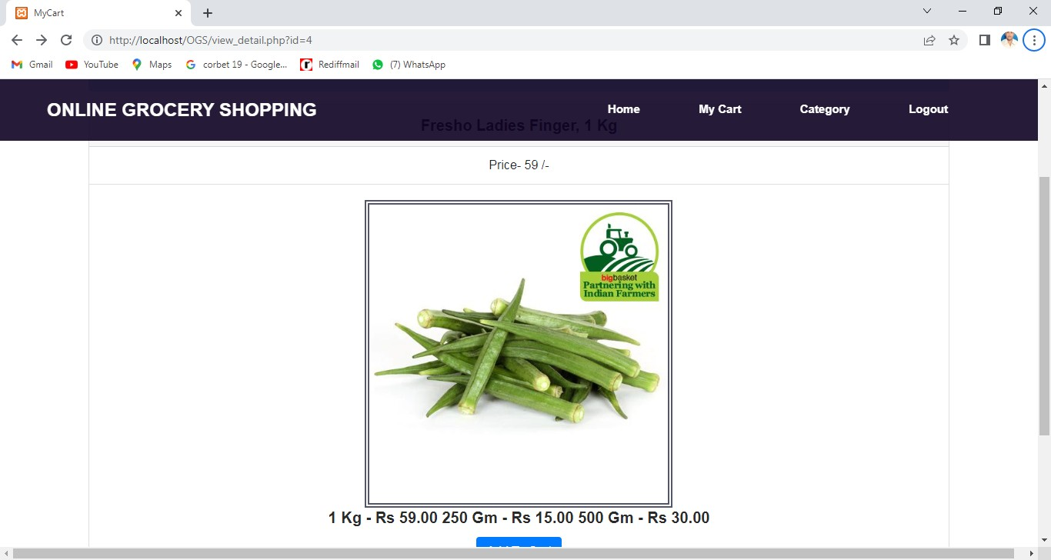

<?php require_once"dbconfig.php";

if(isset($_SESSION['login']))
{

}
else
{

}

header("location:ragister.php");

$result=select("SELECT * FROM cart
INNER JOIN items ON cart.itemid = items.itemid WHERE userid='".
$_SESSION['userid']."'");
$result1=select("SELECT sum(price) FROM cart
INNER JOIN items ON cart.itemid = items.itemid WHERE userid='".
$_SESSION['userid']."'");
$result2=select("select * from user where userid='".$_SESSION['userid']."'");

?>
<!DOCTYPE html>
<html lang="en">

<head>
<meta charset="UTF-8">
<meta name="description" content="">
<meta http-equiv="X-UA-Compatible" content="IE=edge">
<meta name="viewport" content="width=device-width, initial-scale=1, shrink-to-fit=no">

<title>My Cart</title>

<!-- Core Stylesheet -->
<link href="style.css" rel="stylesheet">

<!-- Responsive CSS -->
<link href="css/responsive/responsive.css" rel="stylesheet">

</head>

<body>
<!-- Preloader -->
<div id="preloader">
<div class="dorne-load"></div>
</div>

<!-- ***** Search Form Area ***** -->
<div class="dorne-search-form d-flex align-items-center">
<div class="container">
<div class="row">
<div class="col-12">
<div class="search-close-btn" id="closeBtn">
<i class="pe-7s-close-circle" aria-hidden="true"></i>
</div>
<form action="#" method="get">
<input type="search" name="caviarSearch" id="search" placeholder="Search Your Desire Destinations or Events">
<input type="submit" class="d-none" value="submit">

</form>
</div>
</div>
</div>
</div>

<!-- ***** Header Area Start ***** -->
<header class="header_area" id="header">
<div class="container-fluid h-100">
<div class="row h-100">
<div class="col-12 h-100">
<nav class="h-100 navbar navbar-expand-lg">
<a class="navbar-brand" href="index.php">ONLINE GROCERY SHOPPING</a>

<button class="navbar-toggler" type="button" data- toggle="collapse" data-target="#dorneNav" aria-controls="dorneNav" aria- expanded="false" aria-label="Toggle navigation"><span class="fa fa- bars"></span></button>
<!-- Nav -->
<div class="collapse navbar-collapse" id="dorneNav">
<ul class="navbar-nav mr-auto" id="dorneMenu">
<li class="nav-item">
<a class="nav-link" href="index.php"> <span class="sr- only">(current)</span></a>
</li>
<li class="nav-item">
<a class="nav-link" href="mycart.php"></a>
</li>

<li class="nav-item">
<a class="nav-link" href="logout.php"></a>
</li>
</ul>

<div class="dorne-signin-btn">
<?php if(isset($_SESSION['login']))
{

?><a class="nav-link" href="index.php">Home <span class="sr-only">(current)</span></a>

href="mycart.php">My Cart</a> href="category.php">Category</a>
<a class="nav-link"

<a class="nav-link"

<a class="nav-link" href="logout.php">Logout</a>

or Register</a>

<?php
}
else
{

?>
<a href="#">Sign in

<a class="nav-link" href="index.php">Home <span class="sr-only">(current)</span></a>

<?php
}

?>

</div>

</div>
</nav>
</div>
</div>
</div>
</header>

<div class="breadcumb-area bg-img bg-overlay" style="background-image: url(img/bg-img/hero-1.jpg)"></div>
</br>
<div class="container-fluid">
<div class="row">
<div class="col-lg-1 text-center"></div>
<div class="col-lg-10 text-center">

<div class="alert alert-light" role="alert">
<p style="color:red;font-weight:bold;font-size:20px;">My Cart Details<p>
</div>
</div>

<div class="col-lg-1 text-center"></div>

</div>
<div class="row">
<div class="col-lg-1"></div>
<div class="col-lg-10">
<div class="card text-center">

<table class="table">
<tr style="font-weight:bold">
<td> S.No.
</td>
<td>
Item Name
</td>
<td> Price
</td>
<td> Remove
</td>
</tr>
<?php
$n=1; while($p=mysqli_fetch_array($result))
{extract($p);
?>

<tr>
<td><?=$n?>.</td>
<td><?=ucwords($Title)?></td>
<td><?=$price?> /-</td>
<td><a href="myphp.php?dele=yes&id=<?=$cartid?>">
<span class="btn btn-danger">X</span>
</a></td>
<?php
$n++;
}

?>
</tr>
</table>
<div class="card-footer text-muted">
<?php while($t=mysqli_fetch_array($result1))
{extract($t);
?>
<a href="index.php" class="btn btn-danger" style="font-weight:bold">Total Price- <?=$t[0]?> /-</a>

<a href="payment1.php"><span class="btn btn- success">CheckOut</span></a>
<?php

}
?>

</div>
<div class="card-footer text-muted">
<a href="index.php" class="btn btn-primary">Continue shopping</a>

</div>
</div>

</div></div>
<footer class="dorne-footer-area">
<div class="container-fluid">
<div class="row">
<div class="col-12 d-md-flex align-items-center justify-content- between">

<div class="footer-text">
<p>
Copyright &copy;<script>document.write(new Date().getFullYear());</script> All rights reserved | This Project is made by Shashank Kumar & Varunika Palsetty</a>

</p>
</div>

</div>
</div>
</div>
</footer>

<!-- jQuery-2.2.4 js -->
<script src="js/jquery/jquery-2.2.4.min.js"></script>
<!-- Popper js -->
<script src="js/bootstrap/popper.min.js"></script>
<!-- Bootstrap-4 js -->

<script src="js/bootstrap/bootstrap.min.js"></script>
<!-- All Plugins js -->
<script src="js/others/plugins.js"></script>
<!-- Active JS -->
<script src="js/active.js"></script>
</body>

</html>

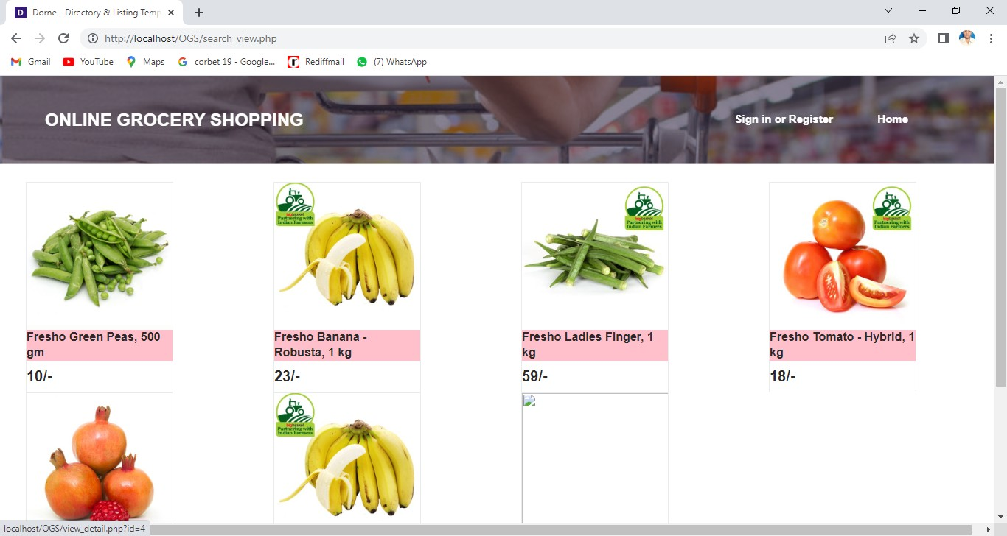

<?php require_once"dbconfig.php";

if(isset($_REQUEST['onsearch']))
{

extract($_REQUEST);

$result=select("SELECT * FROM `items` where Title like '%$country%' and category='$category'");
}
?>
<!DOCTYPE html>
<html lang="en">

<head>
<meta charset="UTF-8">
<meta name="description" content="">
<meta http-equiv="X-UA-Compatible" content="IE=edge">
<meta name="viewport" content="width=device-width, initial-scale=1, shrink-to-fit=no">

<title>Dorne - Directory &amp; Listing Template | Listing</title>

<!-- Favicon -->
<link rel="icon" href="img/core-img/favicon.ico">

<!-- Core Stylesheet -->
<link href="style.css" rel="stylesheet">

<!-- Responsive CSS -->
<link href="css/responsive/responsive.css" rel="stylesheet">

</head>

<body>
<!-- Preloader -->

<div id="preloader">
<div class="dorne-load"></div>
</div>

<div class="dorne-search-form d-flex align-items-center">
<div class="container">
<div class="row">
<div class="col-12">
<div class="search-close-btn" id="closeBtn">
<i class="pe-7s-close-circle" aria-hidden="true"></i>
</div>
<form action="#" method="get">
<input type="search" name="caviarSearch" id="search" placeholder="Search Your Desire Destinations or Events">
<input type="submit" class="d-none" value="submit">
</form>
</div>
</div>
</div>
</div>

<!-- ***** Header Area Start ***** -->
<header class="header_area" id="header">
<div class="container-fluid h-100">
<div class="row h-100">
<div class="col-12 h-100">
<nav class="h-100 navbar navbar-expand-lg">

<a class="navbar-brand" href="index.php">ONLINE GROCERY SHOPPING</a>

<button class="navbar-toggler" type="button" data- toggle="collapse" data-target="#dorneNav" aria-controls="dorneNav" aria- expanded="false" aria-label="Toggle navigation"><span class="fa fa- bars"></span></button>
<!-- Nav -->
<div class="collapse navbar-collapse" id="dorneNav">
<ul class="navbar-nav mr-auto" id="dorneMenu">
<li class="nav-item">
<a class="nav-link" href="index.php"> <span class="sr- only">(current)</span></a>
</li>
<li class="nav-item">
<a class="nav-link" href="mycart.php"></a>
</li>

<li class="nav-item">
<a class="nav-link" href="logout.php"></a>
</li>
</ul>

<div class="dorne-signin-btn">
<?php if(isset($_SESSION['login']))
{

?><a class="nav-link" href="index.php">Home <span class="sr-only">(current)</span></a>

href="mycart.php">My Cart</a> href="category.php">Category</a>
<a class="nav-link"

<a class="nav-link"

<a class="nav-link" href="logout.php">Logout</a>

or Register</a>

<?php
}
else
{

?>
<a href="#">Sign in

<a class="nav-link" href="index.php">Home <span class="sr-only">(current)</span></a>

<?php
}

?>

</div>

</div>
</nav>
</div>
</div>
</div>

</header>
<!-- ***** Header Area End ***** -->

<!-- ***** Breadcumb Area Start ***** -->
<div class="breadcumb-area bg-img bg-overlay" style="background-image: url(img/bg-img/hero-1.jpg)"></div>
</br>

<div class="row">
<div class="col-lg-12 " >

<div class="row" style="margin-left:20px">

<?php while($r=mysqli_fetch_array($result))
{

extract($r);
?>

<div class="col-lg-3 ">

<a href="view_detail.php?id=<?=$itemid?>"><div style="width:200px;" class="border well well-sm"><img src="admin/images/<?
=$image?>" style="height:200px;width:400px">
<!-- Price -->

<div class="feature-title"> color:pink"><?=$Title?></h6>
<h5><?=$price?>/-</h5>

<h6 style="background-

</div>

</div>
</a></div>

<?php
}
?>
</div>

</div>
</div></br>

<footer class="dorne-footer-area">
<div class="container-fluid">
<div class="row">
<div class="col-12 d-md-flex align-items-center justify-content- between">

<div class="footer-text">
<p>
Copyright &copy;<script>document.write(new Date().getFullYear());</script> All rights reserved | This Project is made by Shashank Kumar & Varunika Palsetty</a>
</p>
</div>

</div>
</div>
</div>
</footer>

<script src="js/jquery/jquery-2.2.4.min.js"></script>
<!-- Popper js -->
<script src="js/bootstrap/popper.min.js"></script>
<!-- Bootstrap-4 js -->
<script src="js/bootstrap/bootstrap.min.js"></script>
<!-- All Plugins js -->
<script src="js/others/plugins.js"></script>
<!-- Active JS -->
<script src="js/active.js"></script>
</body>

</html>

TESTING

In software development process, errors can be injected at any stages during development. No method is perfect for software testing and it is expected that some errors of the earlier phases will finally reaches to the coding phase. This is because most of the verification methods of earlier phases are manual. Hence the code developed during coding activity is likely to have some requirement errors and design errors, in addition to errors introduced during the coding activity.
During testing, the program to be tested is executed with a set of test cases, and the output of the program for the test cases is evaluated to determine if the program is performing as expected. From this it is clear that testing is used to find out errors rather than to tell the exact nature of the error. Also, the success of the testing process clearly depends upon the test cases used.

Testing is a complex process. In order to make the process simpler, the testing activities are broken into smaller activities. Due to this, for a project, incremental testing is generally performed. In incremental testing process, the system is broken into set of subsystems and these subsystems are tested separately before integrating them to form the system for system testing.

WHAT IS TESTING ?

By the definition of IEEE (Institute of Electrical and Electronics Engineers), testing is the process of analyzing a software item to detect the difference between existing and required conditions and to evaluate the features of the software items.
By the definition of Myers, testing is the process of analyzing a program with the intent of finding errors.

WHAT ARE TESTING FUNDAMENTALS?

There are three main testing fundamentals. That are as follows: -
- Error: The term error is used to refer to the discrepancy between computed, observed or measured value and the true or specified value. In other words, it is the difference between the actual output of software and the correct output.
- Fault: Fault is a condition that causes a system to fail in performing its required function.
- Failure: Failure is the inability of a system to perform a required function according to its specifications. A software failure occurs if the behavior of the software is different from the specified behavior.

SOFTWARE TESTING STRATEGIES

Testing is a set of activities that can be planned in advanced and conducted systematically. A strategy for software testing must accommodation low-level tests that are necessary to verify that a small source code segment has been correctly implemented as well as high- level tests that validate major system functions against customer requirements.
There are three types of testing strategies

  - Unit test
  - Integration test
  - Performance test

UNIT TESTING

Unit testing focuses verification efforts on the smallest unit of software design module. The unit test is always white box oriented. The tests that occur as part of unit testing are testing the module interface, examining the local data structures, testing the boundary conditions, execution all the independent paths and testing error-handling paths.

INTEGRATION TESTING

Integration testing is a systematic technique or construction the program structure while at the same time conducting tests to uncover errors associated with interfacing. Scope of testing summarizes the specific functional, performance, and internal design characteristics that are to be tested. It employs top-down testing and bottom-up testing methods for this case.

PERFORMANCE TESTING

Timing for both read and update transactions should be gathered to determine whether system functions are being performed in an acceptable timeframe.

MAINTAINANCE

Software will undoubtedly undergo change after it is delivered. Change will occur because errors have been encountered, because the software must be adapted to accommodate changes in its external environment (e.g., a change required because new operating system or peripheral device). Software can also undergo changes if the customer wants to add features based on functional or performance enhancement. The software maintenance phase may reapply each of the preceding software engineering life cycle steps to existing program rather than a new one.
Through maintenance is not considered a part of software development, it is a very important activity in the life of a software product. Usually, the total cost of maintenance phase is much higher than the development cost of the software. Normally the maintenance-to-develop cost ratio is suggested as 80:20,70:30 or 60:40.
Maintenance work is based on existing software, as compared to development work that creates new software. In other words, maintenance revolves around understanding the

existing software and maintainers spend most of their time trying to understand the software they have to modify. Understanding the software means that understanding not only the code but also the related documents. During the modification of the software, the effect the change has to be clearly understood by the maintainer. To test whether those aspect of the system that are not supposed to be modified are operating as they were before modification, regression testing is done. In regression testing, we use old test cause to test whether new errors have been introduced or not.
Thus, maintenance involves understanding the existing software, understanding the effect of changes, making the changes to both code and documents, testing the new parts and re testing the old parts that were not changed. In order to make the maintainer job easier, it is necessary to prepare some supporting documents during software development, makes maintenance the most costly activity in the life of software product.

Testing is always effective with a test plan. A test plan is a general document for the entire project that defines the scope, approach to be taken & the schedule of testing as well as identifies the test items for the entire testing process & the personnel responsible for the difficult activities of testing. Inputs for forming test plan are-
- Project plan
- Requirement document, &
- System design document
Project plan is needed to make sure that the test plan is consistent with the overall plan for project. Requirement document & the system design document are the document used for selecting the test units & deciding the approaches to be used during testing.

A TEST PLAN CONTAINS THE FOLLOWING

  - TEST UNIT SPECIFICATION : A test unit is a set of one or more modules, together with associated data, that are from single software & that are objects of testing. A test unit may be a module or a few modules or the entire software.
  - FEATURES TO BE TESTED : It includes all the software characteristics specified
or implied by the requirement or design documents. These may include functionality, performance, design constraints and attributes.
  - APPROACH FOR TESTING : It specifies the overall approach to be followed in
current project. The techniques that will be used to judge the testing effort should also

be specified. This is sometimes called testing criterion i.e., criterion for evaluating the set of test cases used in testing.
  - TEST DELIVERABLES : It should be specified in the test plan before the actual
testing begins. Deliverables could be a set of test cases that were used, detailed result of testing, test summary report, test log and data about the code coverage. Test summary report summarizes the results of testing activities.
  - SCHEDULE : It specifies the amount of time and effort to be spent on different
activities of testing.
  - PERSONAL ALLOCATION : It specifies the persons responsible for performing different activities.

LIMITATIONS OF THE PROJECT

While online grocery shopping has gained popularity and offers numerous benefits, it also has some limitations. Here are a few commonly encountered limitations of online grocery shops:

Limited product selection: Online grocery stores may not offer the same extensive range of products as physical supermarkets. Some specialized or niche items may be challenging to find online, leading to restricted choices for customers.

Quality control: Customers rely on online images and product descriptions when shopping for groceries, which may not accurately represent the actual quality of the products. There is a risk of receiving items that are not as fresh as desired, such as fruits, vegetables, or perishable goods.

Delivery issues: Online grocery shopping relies on timely and efficient delivery services. However, various factors like weather conditions, traffic, or logistical challenges can lead to delays or missed deliveries. This can be inconvenient for customers who depend on timely delivery to meet their meal planning or household needs.
Inability to inspect products: Unlike physical stores, online grocery shops do not allow customers to inspect or physically examine products before purchasing. Customers have to rely on product descriptions, images, and reviews, which may not always provide a complete picture of the item's quality or suitability for their needs.
Additional costs: Online grocery shopping often involves delivery fees or minimum order requirements. These additional costs can impact the overall affordability, especially for customers who prefer to purchase smaller quantities or have limited budgets.

Dependency on technology: Access to reliable internet connection and suitable devices is necessary for online grocery shopping. Individuals without internet access or those unfamiliar with online platforms may face barriers to using online grocery services effectively.
Lack of immediate gratification: Online grocery shopping typically requires waiting for the delivery, which can take several hours or even a few days. This delay may not be suitable for customers who prefer immediate gratification or need groceries urgently.

Returns and refunds: In case of product issues or dissatisfaction, returning or exchanging items can be more complicated and time-consuming with online grocery shopping compared to physical stores. The process may involve contacting customer support, arranging for pickups, or mailing the items back.

FEATURE OF PROJECT

Online grocery shops typically offer a range of features to enhance the convenience and efficiency of shopping for groceries online. Here are some common features you can find in online grocery shops:
- Product Catalog: Online grocery shops provide a comprehensive catalog of grocery items, including fruits, vegetables, dairy products, pantry staples, beverages, snacks, and more. The

catalog is often categorized and searchable, making it easy for customers to find specific products.
- Search and Filtering: Online grocery shops allow users to search for specific products or filter items based on various criteria such as brand, price range, dietary restrictions, or organic preferences. This helps customers quickly find the products they are looking for.
- Personalized Recommendations: Many online grocery platforms utilize algorithms to provide personalized product recommendations based on customers' purchase history, preferences, and browsing behavior. These recommendations help customers discover new products or easily reorder their favorite items.
- Shopping Lists: Customers can create digital shopping lists on online grocery platforms, making it convenient to plan and organize their grocery purchases. Shopping lists can be saved for future use and easily modified as needed.
- Deals and Discounts: Online grocery shops often highlight special deals, discounts, or promotional offers to attract customers. These can include discounts on specific products, bundle offers, loyalty programs, or coupon codes.
- User Reviews and Ratings: Customers can read and contribute to user reviews and ratings for products. This helps in assessing the quality and suitability of products based on the experiences of other customers.

- Delivery Options: Online grocery shops offer various delivery options to suit customers' preferences. This can include home delivery within a specified time window, express delivery for urgent orders, or the option to pick up the order from a designated store location.
- Secure Payment: Online grocery platforms provide secure payment options, including credit/debit card payments, digital wallets, or cash-on-delivery. These platforms ensure the safety of customers' financial information during the transaction process.
- Order Tracking: Customers can track the status of their orders in real-time, allowing them to know when their groceries will be delivered. Order tracking provides transparency and helps customers plan their day accordingly.

- Customer Support: Online grocery shops typically have customer support channels such as email, live chat, or helpline numbers to assist customers with inquiries, order issues, or product-related questions.
These features aim to provide a convenient, efficient, and personalized shopping experience for customers, replicating many of the benefits of physical grocery stores while leveraging the advantages of online shopping.

SCOPE OF THE PROJECT

Online grocery shops typically offer a range of features to enhance the convenience and efficiency of shopping for groceries online. Here are some common features you can find in online grocery shops:
  - Product Catalog: Online grocery shops provide a comprehensive catalog of grocery items, including fruits, vegetables, dairy products, pantry staples, beverages, snacks, and more. The catalog is often categorized and searchable, making it easy for customers to find specific products.
  - Search and Filtering: Online grocery shops allow users to search for specific products or filter items based on various criteria such as brand, price range, dietary restrictions, or organic preferences. This helps customers quickly find the products they are looking for.
  - Personalized Recommendations: Many online grocery platforms utilize algorithms to provide personalized product recommendations based on customers' purchase history, preferences, and browsing behavior. These recommendations help customers discover new products or easily reorder their favorite items.
  - Shopping Lists: Customers can create digital shopping lists on online grocery platforms, making it convenient to plan and organize their grocery purchases. Shopping lists can be saved for future use and easily modified as needed.

  - Deals and Discounts: Online grocery shops often highlight special deals, discounts, or promotional offers to attract customers. These can include discounts on specific products, bundle offers, loyalty programs, or coupon codes.
  - User Reviews and Ratings: Customers can read and contribute to user reviews and ratings for products. This helps in assessing the quality and suitability of products based on the experiences of other customers.
  - Delivery Options: Online grocery shops offer various delivery options to suit customers' preferences. This can include home delivery within a specified time window, express delivery for urgent orders, or the option to pick up the order from a designated store location.
  - Secure Payment: Online grocery platforms provide secure payment options, including credit/debit card payments, digital wallets, or cash- on-delivery. These platforms ensure the safety of customers' financial information during the transaction process.
  - Order Tracking: Customers can track the status of their orders in real- time, allowing them to know when their groceries will be delivered. Order tracking provides transparency and helps customers plan their day accordingly.
  - Customer Support: Online grocery shops typically have customer support channels such as email, live chat, or helpline numbers to assist customers with inquiries, order issues, or product-related questions.

BIBLIOGRAPHY

    - Rudraksh Batra, Charul Shukla, Anil Kumar Bansal,”PHP Black Book” , DreamTech Press
    - An Introduction to Database Systems, Author’s name (Bipin C. Desai), Published by Galgotia Publications pvt. Ltd, 2002.

    - System of software engineering, Author’s name (roger s. pressman), Published by McGraw-Hill, 2002.
    - Software engineering, Author’s name (Bharat Bhushan Agrwal & Sumit Prakash), Published by Laxmi publication pvt. Ltd, 2000.
    - Software Engineering A Practioner’s Approach, Author’s name (Roger S. Pressman), Published by McGraw-Hill, 2001.
    - Analysis and Design of Information Systems, Author’s name(RAJARAMAN V.),Published by Prentice Hall of India (1991),New Delhi .
    - Beginning asp.net 2.0 and databases ,Wrox publication
    - Beginning asp.net 2.0 , Wrox publication

