The Forgotten Black Explorer of the American Frontier
By: Marc Silver
In the long shadow of the Lewis and Clark expedition, one figure remains largely overlooked. He wasn’t a soldier, a scientist, or a commissioned officer. He was an enslaved man named William York, the only Black member of William and Clark’s Corps of Discovery. From the muddy banks of the Missouri River to the crashing waves of the Pacific, York endured the same dangers, weathered the same hunger, and earned the same admiration as his white companions. Yet when the journey ended, the others returned as heroes while York returned as property.
Sadly, York’s name is barely mentioned in schoolbooks, but his story challenges the familiar image of the American frontier. He was both explorer and enslaved laborer, both indispensable and expendable. His life revealed the contradiction of a young nation built on liberty but sustained by slavery.
Still, the story of York doesn’t begin with the expedition but with the world that shaped him.
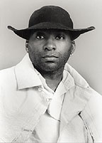
Early Life and Enslavement
William York was born into slavery around 1770, likely in Caroline County, Virginia, on the Clark family plantation. His parents, “Old York” and Rose, were among the many enslaved people who supported the wealth and comfort of the Clark household. When John Clark III died in 1799, his son William inherited York along with other “possessions.” The two had grown up together, and for much of their youth, the relationship was less master and servant than playmates. But adulthood and society hardened that bond. Clark became an officer, a landowner, and eventually one of America’s most famous explorers, while York remained his slave.
By the time Lewis and Clark began recruiting for the Corps of Discovery in 1803, York was in his early thirties, tall, broad-shouldered, and powerfully built. Years spent on Kentucky’s rough frontier had taught him to hunt, handle weapons, care for animals, and survive with limited supplies. These were practical skills the expedition would need in abundance. By any measure, his life had already been hard, and the frontier demanded even more of him.
York was also married. His wife was enslaved by another man near Louisville, Kentucky. Clark’s later letters suggest that York deeply missed her and begged to visit after the expedition. When her owner moved her to Mississippi, York’s connection to her was permanently severed. Her name has been lost to history, another piece of the human story erased by slavery’s record keeping.
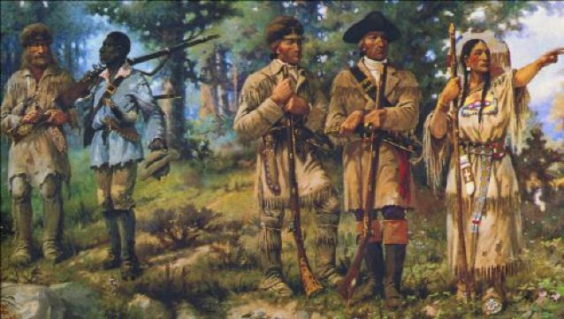
Joining the Corps of Discovery
to go. But his role soon grew far beyond that of a domestic servant. He was expected to pull oars, haul equipment, hunt, guard, and work alongside the enlisted men. His labor never seemed to end, and his endurance bordered on the impossible. The journals of Lewis and Clark rarely call him by name, referring to him simply as “my servant York,” yet his presence is felt throughout their pages.
As the journey began, no one, not even Clark, could have guessed how much York would endure.
The expedition left St. Louis in May 1804 with a small fleet of boats heading up the Missouri River. The men endured everything from scorching heat to freezing storms. Mosquitoes swarmed so thick they blackened the sky, and huge grizzly bears the men had never seen before charged at their camps. Through it all, York shared every hardship, rowing, hauling, and pushing forward when others faltered.
Clark recorded York’s strength and humor, noting that he was “of great service” to the party. His ability to hunt proved vital when rations ran low. During the bitter cold of the Dakota plains, York worked alongside soldiers to build shelters, hunt buffalo, and protect the camp. Despite his enslaved status, he was treated by many of the men as a comrade.
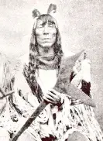
Encounters with Native Nations
York’s dark skin fascinated the Native nations the Corps met along the way. Among the Mandan and Hidatsa on the upper Missouri, some touched his arms, expecting the color to rub off. Others believed him to be imbued with spiritual power. Some tribes referred to him as “Big Medicine,” a term that reflected awe rather than mockery. His strength and calm demeanor left lasting impressions.
In one often retold story, York wrestled with a Mandan man in friendly competition and easily lifted his opponent over his shoulders to the delight of the crowd. For the expedition’s diplomatic aims, York’s presence was often an asset. His uniqueness became a form of cultural currency. Where Lewis and Clark sought trade or safe passage, York’s novelty helped open doors and spark goodwill.
But these moments also carried a painful irony. Among Native peoples, York experienced a level of curiosity and respect he rarely found in white society. He could not have missed the contrast. For a brief time on the trail, he was treated as a man of power rather than property.
Yet respect did not equal freedom.

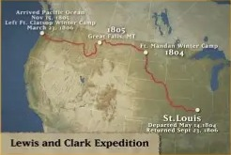
Life on the Expedition
The Corps of Discovery reached the Pacific Ocean in late 1805, nearly a year and a half after leaving St. Louis. Exhausted and hungry, they faced another decision: where to spend the winter. At Station Camp near the mouth of the Columbia River, the leaders called for a group discussion. Clark recorded that “every individual’s opinion was heard,” including those of Sacagawea and York.
It was an extraordinary moment, an enslaved man and a Native woman participating in a vote on equal footing with the white explorers. Whether it was a true democratic vote or simply an informal survey is debated, but it stands as a symbolic act that defied the rigid social lines of the early nineteenth century.
Throughout that long winter at Fort Clatsop, York continued to serve tirelessly. He hunted elk, helped build the fort, and kept watch in the miserable rain. Lewis noted that everyone suffered from “constant wetness,” yet York carried on without complaint. He had traveled thousands of miles and crossed mountains, fought off exhaustion, and somehow survived dangers that had claimed others. When the expedition finally returned in 1806, York had earned his share of glory. But freedom was not part of that reward.
What waited for York back home was not celebration but disappointment.
Conflict and Punishment After the Journey
Upon returning to St. Louis, each enlisted man received pay, land, and public recognition. York expected William Clark to grant him his freedom after the expedition, just as the other men received pay and land for their service. York received none of it, not the pay, not the land, and not the freedom he had earned.
Clark’s surviving letters show how their relationship deteriorated after the expedition. In 1808, he complained that York had become “insolent and sulky.” Clark’s response was brutal: “I gave him a severe trouncing,” he wrote to his brother Jonathan. He also admitted to hiring York out to “severe masters” in Kentucky as punishment.
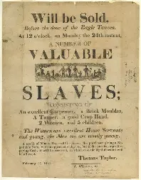
In another letter, Clark described having York jailed, “Caleboos’d,” in his words, for refusing to work. He accused York of laziness and self-importance, saying that freedom had “spoiled him.” Yet it’s clear from the letters that York’s so-called defiance was simply the desire to be treated as a man who had earned his liberty.
Years passed, but Clark’s grip on York’s life never loosened.
A later document from 1815 provides the last solid proof of York’s condition. It is a drayage agreement listing “Genl. Will: Clark’s slave (York)” as a driver for hire.
Time eventually buried York’s name beneath the fame of others.
Nearly ten years after helping chart a continent, York remained enslaved, hired out for labor, stripped of the respect he had earned on the frontier. Time eventually buried York’s name beneath the fame of others.
The Mystery of York’s Freedom and Fate
What became of York after that remains one of history’s unresolved questions. In 1832, William Clark told writer Washington Irving that he had freed York and given him a wagon and horses so he could start a freight business between Nashville and Richmond. According to Clark, York’s business failed, and he died of cholera shortly thereafter, allegedly regretting his freedom. Clark claimed York told him, “Damn this freedom.”
Historians view that story with skepticism. It exists only in Clark’s telling, nearly two decades after York disappears from official records. No manumission papers have ever surfaced, no records of a wagon business, and no burial site. The story reads less like truth and more like a man’s attempt to quiet his own guilt, or the questions he couldn’t silence.
Another legend tells a different ending. In the 1830s, a fur trader reported meeting an elderly Black man living among the Crow in the Rocky Mountains who said he had first come west with Lewis and Clark. Some believe this man was York, who might have escaped bondage and returned to the only world where he had once known dignity. There’s no proof either way. York’s trail simply fades, leaving behind silence and speculation.
Recognition came slowly, and when it did, from artists first.
Rediscovery and Legacy
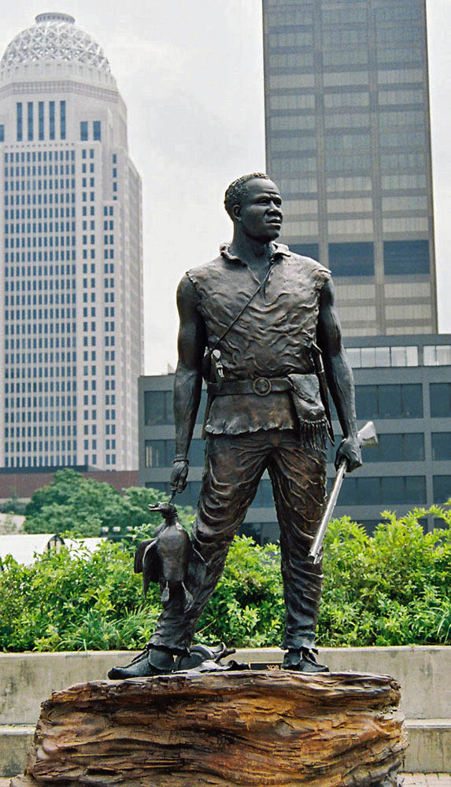
For nearly two centuries, York’s story remained buried under the fame of others. Lewis and Clark became symbols of courage and discovery, while York was reduced to a footnote. It wasn’t until the late twentieth century that historians and artists began to restore his place in history.
Today, several landmarks honor his name. “Yorks Islands,” located along the Missouri River, were officially recognized by the U.S. Board on Geographic Names in 2000. Clark had originally noted the site in his journals as “Yorks Islands,” a rare acknowledgment from the expedition leader. Another feature, “York’s Dry River,” appears in his notes near the Yellowstone, now identified as Custer Creek in Montana.
York has also found recognition in art and public memory. In 2003, sculptor Ed Hamilton unveiled a bronze statue of York in Louisville, Kentucky, his hometown, depicting him gazing westward toward the horizon. At Lewis & Clark College in Oregon, artist Alison Saar created York: Terra Incognita in 2010, a powerful bronze figure inscribed with the words “York’s dry river” carved across his back. In 2021, amid a national reckoning over monuments, an anonymous artist installed a bust of York atop a pedestal in Portland’s Mount Tabor Park, replacing a toppled statue of a colonial figure. The act was both protest and tribute, though the sculpture was later vandalized and removed.
Recognition has finally come from institutions once silent about York’s contributions. In 2001, the U.S. Army posthumously named York an Honorary Sergeant, formally acknowledging his service on the Corps of Discovery. That same year, the National Cowboy & Western Heritage Museum inducted him into its Hall of Great Westerners, placing him among the heroes of the American frontier.
For historians, York represents more than a side character in someone else’s story. He embodies the contradictions of a nation that prized liberty while practicing slavery, and the resilience of those who found dignity even within oppression. His life forces us to reconsider what it meant to be an explorer in early America.
For generations, his story went untold.
York’s Enduring Meaning
The frontier York helped map was a place of both discovery and dispossession. His journey west brushed against the ambitions of the young United States and the worlds of Native nations who saw him as something new, perhaps divine, perhaps dangerous. York himself left no written words, no diary, no letter. What survives are the observations of others, often filtered through the lens of ownership or novelty. Yet in those fragments, a portrait emerges of a man defined by endurance, curiosity, and quiet strength.
If Lewis and Clark opened the door to America’s western expansion, York reminds us of who was left standing outside it. He never gained the freedom he deserved, but his story has finally begun to move from the margins to the center of the American narrative. In his courage and humanity, we find the real story of the expedition, not only a triumph of discovery, but a mirror held up to a divided nation’s conscience.
References
Betts, Robert B. In Search of York: The Slave Who Went to the Pacific with Lewis and Clark. University Press of Colorado, 2000.
Lewis, Meriwether, and William Clark. The Journals of the Lewis and Clark Expedition. University of Nebraska Press.
Clark, William. Letters to Jonathan Clark, 1808–1809. Yale University Press, Dear Brother: Letters of William Clark to Jonathan Clark.
National Park Service. “York of the Corps of Discovery.” U.S. Department of the Interior.
Discover Lewis & Clark Project. “York: The Slave Who Went to the Pacific.”
Washington Irving. The Adventures of Captain Bonneville (1837).
Smithsonian Magazine. “York: The Forgotten Explorer of Lewis and Clark.”
National Cowboy & Western Heritage Museum. Hall of Great Westerners.
U.S. Army. Presidential Proclamation Honoring York (2001).
Alison Saar, York: Terra Incognita, Lewis & Clark College, Portland, Oregon.
Ed Hamilton, York, Louisville Belvedere, 2003.

