Why Tariffs Won’t Solve America’s Debt Problem
By Marc Silver
Politicians love simple answers to complex problems. Lately, tariffs have been pitched as one of those answers, a way to shrink America’s deficit and even begin paying down the national debt. It sounds appealing. Make foreign goods more expensive, collect the revenue, fix the books.
The problem is that the math doesn’t cooperate.
Deficit vs. Debt: Two Different Problems
Before looking at tariffs, it helps to separate two ideas that are often treated as interchangeable.
The annual deficit is how much more the federal government spends than it collects in a single year. Think of it like charging $5,000 to a credit card when you only earned $3,000. You’re $2,000 short for that year.
The national debt is the accumulated total of decades of those shortfalls. It’s the running balance after years of overspending.
They’re related, but they are not the same problem, and tariffs don’t meaningfully solve either one.
What Tariffs Actually Do
A tariff is a tax on imported goods. When companies bring products into the United States, they pay that tax to the government. In practice, those costs are usually passed along to consumers through higher prices.
Based on Congressional Budget Office projections and U.S. Treasury data, the current tariff structure is expected to generate roughly $230 billion per year on average over the next decade, assuming trade volumes remain relatively stable.
That’s real money. It just isn’t close to enough.
The Scale Problem
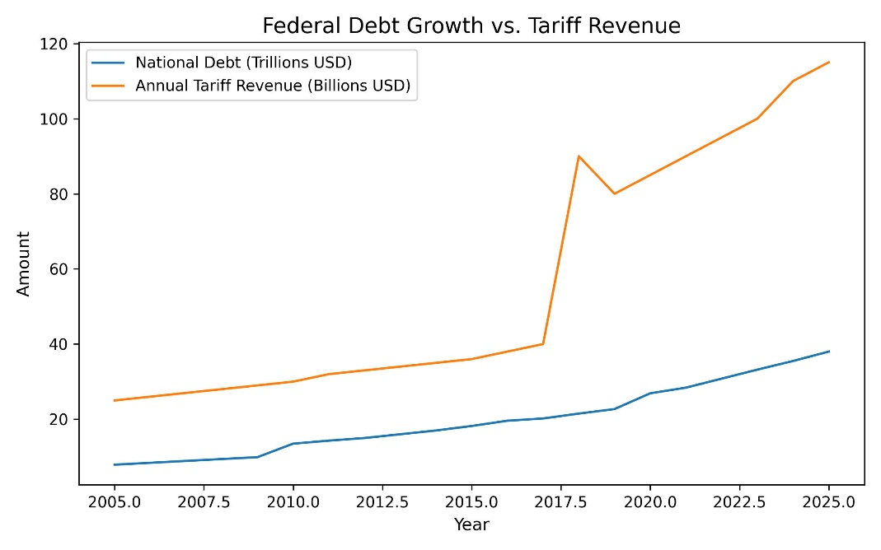
In 2026, the federal deficit is projected to reach roughly $1.7 trillion. Against that number, tariff revenue covers only about 13 to 14 percent of a single year’s overspending.
Put more plainly, for every dollar the government spends beyond its means, tariffs contribute about thirteen cents.
That gap is not a rounding error. It’s structural.
Debt Over Time Tells an Even Clearer Story
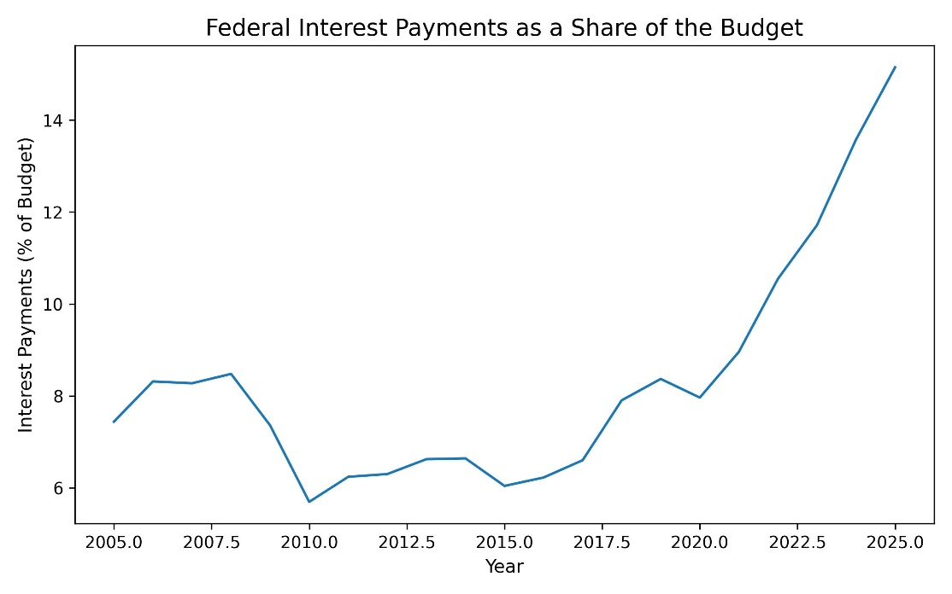
Looking at a single year understates the problem. The longer view is even less forgiving. The national debt now exceeds $38 trillion, according to Treasury data. Tariff revenue rises modestly after 2018, but it never meaningfully alters the trajectory of federal borrowing. Even if every dollar of tariff revenue were devoted exclusively to debt reduction, and even if no new debt were added, it would take more than 165 years to pay off the existing balance.
That scenario isn’t just optimistic. It’s unrealistic.
Tariff revenue also fluctuates. It depends on trade volumes, consumer demand, and how businesses restructure supply chains. As imports shift or decline, so does the revenue. Tariffs are not a stable foundation for fixing a long-term fiscal imbalance.
Why This Matters to You
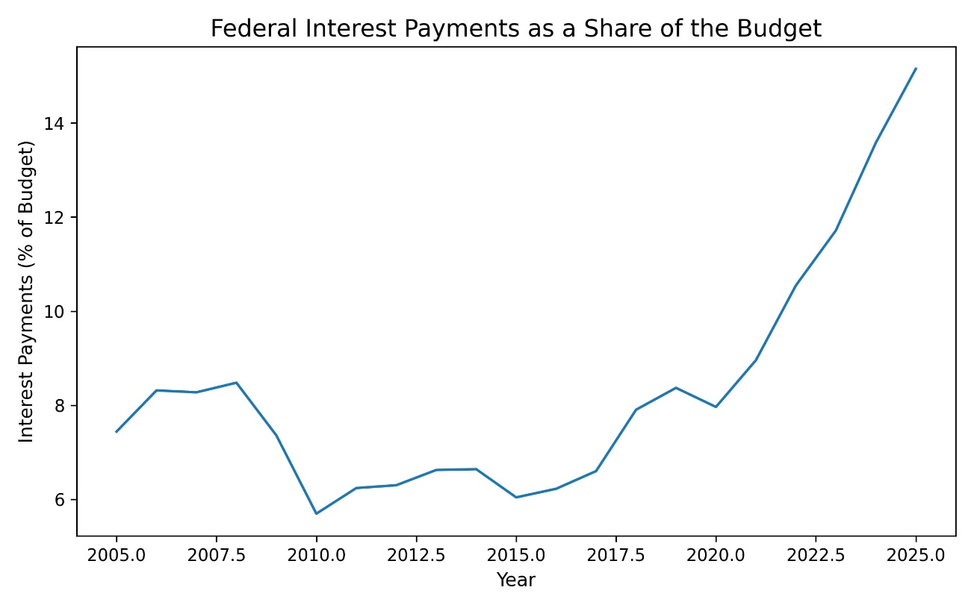
Debt isn’t an abstract concept. The government pays interest on it, just like any borrower.
For years, low interest rates kept this cost manageable. That period is over. As debt grows and rates rise, interest payments now consume a rapidly increasing share of the federal budget, approaching 15 percent of total spending. That money doesn’t fund roads, schools, or healthcare. It services past borrowing.
Interest is one of the few budget items that can’t be negotiated away. It gets paid first.
Tariffs also have a more immediate impact. While they generate revenue for the government, they function as a consumer tax in practice.
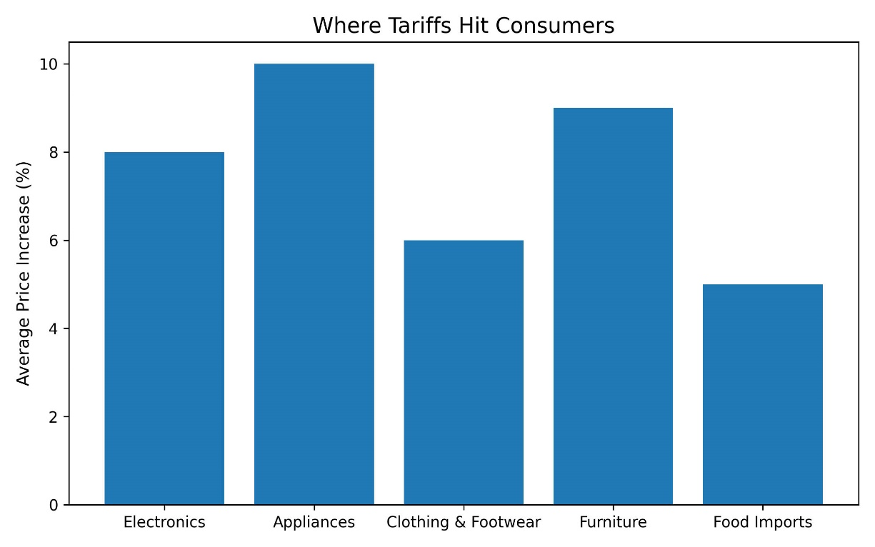
Higher import costs show up in electronics, appliances, furniture, clothing, and food. These aren’t luxury goods. They’re everyday purchases. The increases may look modest in isolation, but they compound across a household budget year after year.
What Tariffs Can and Can’t Do
Tariffs can influence trade behavior. They can protect specific industries. They can generate limited revenue.
What they cannot do is close a trillion-dollar annual gap between spending and revenue.
The numbers simply don’t allow it.
Any serious effort to address America’s debt problem has to confront the underlying mismatch between long-term spending commitments and tax receipts. That means economic growth, spending choices, entitlement reform, tax policy, or some combination of all four.
Tariffs may be politically convenient, but they are fiscally insufficient. The arithmetic is unforgiving, and it makes one thing clear: fixing America’s debt problem will require tools far larger and more structural than tariffs can ever provide.

References
Congressional Budget Office (CBO). The Budget and Economic Outlook: 2025 to 2035. Washington, DC: Congressional Budget Office.
Used for federal deficit projections, tariff revenue estimates, and long-term fiscal outlook.
Why Tariffs Won't Solve America…
Congressional Budget Office (CBO). Effects of Tariffs on the Federal Budget.
Supports estimates of annual tariff revenue and explains why tariff income fluctuates with trade volume and supply-chain behavior.
U.S. Department of the Treasury. Debt to the Penny.
Source for current national debt figures exceeding $38 trillion and historical debt accumulation data.
U.S. Department of the Treasury. Monthly Statement of the Public Debt.
Used for confirmation of debt servicing costs and interest payment trends.
Congressional Budget Office (CBO). Interest Costs on the Federal Debt.
Supports the claim that interest payments are approaching roughly 15 percent of total federal spending and are among the fastest-growing budget items.
Peterson Foundation. What Are Tariffs and How Do They Affect Consumers?
Used for explanations of how tariffs function as indirect consumer taxes and how costs are passed through to households.
Tax Policy Center. Who Really Pays Tariffs?
Supports discussion of tariff incidence, consumer price effects, and distributional impact.
Federal Reserve Bank of New York. Tariffs and Consumer Prices.
Empirical analysis of how tariffs affect prices of everyday goods such as appliances, electronics, and household items.

