Who Really Built the Space Toilet?
The Real Engineers Behind One of NASA’s Most Underrated Marvels
By Marc Silver
Sorry, Wolowitz Fans
Howard may have gone to space, but he didn’t design the throne.
One small leak for man. One giant plumbing disaster for the entire space station.
It made for great TV. But it also sparked a real question:
Who actually builds toilets for space missions?
Because somebody has to. And unlike Howard, they don’t get commercial breaks.
Let’s break it down, flush by flush.

The Early Years: Plastic Bags, Gravity, and Denial
When NASA launched the first manned missions into space, they weren’t thinking long-term about... waste. On Project Mercury, astronauts wore modified diapers. For Gemini and Apollo, things got marginally more sophisticated, meaning plastic bags, tape, and a great deal of awkward maneuvering.
The official NASA term? “Fecal containment system.” Unofficially? A very bad day at the office.
Buzz Aldrin once described the challenge of using these contraptions in microgravity with all the enthusiasm of someone filing their own tax audit.
Imagine trying to tape a bag to your backside, complete your business, seal the bag, and stow it, all while floating in a metal tube with no privacy.
No wonder space toilets became a top engineering priority.

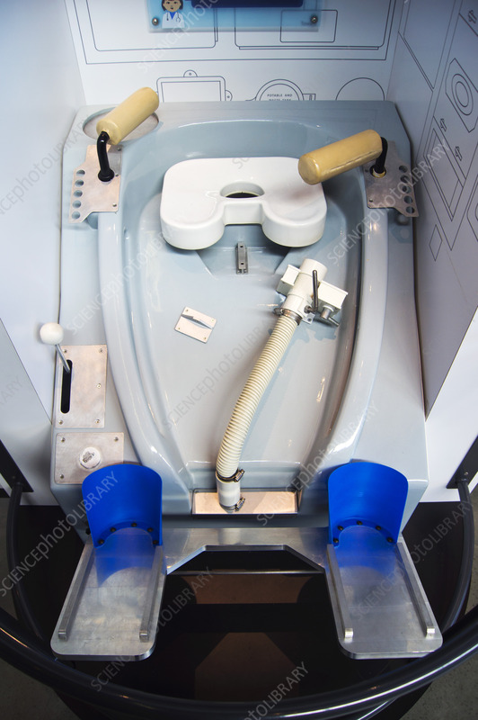
The Space Shuttle Toilet: Airflow, Fans, and Practice Runs
By the 1980s, engineers had a better grasp of what astronauts needed. Enter the Space Shuttle Waste Collection System, a $30 million air-suction toilet that relied on fans and airflow instead of gravity. It wasn’t perfect, but it was a massive leap forward (and far less humiliating than a roll of duct tape).
You could ace orbital mechanics and EVA prep, then fail the part where you aim at a 4-inch target with airflow suction and zero gravity working against you.
One NASA engineer summed it up like this:
"You're working in a place with no gravity, suction tubes, and one tiny target. You want to talk pressure? That’s pressure."

The International Space Station: Global Cooperation Meets Global Waste
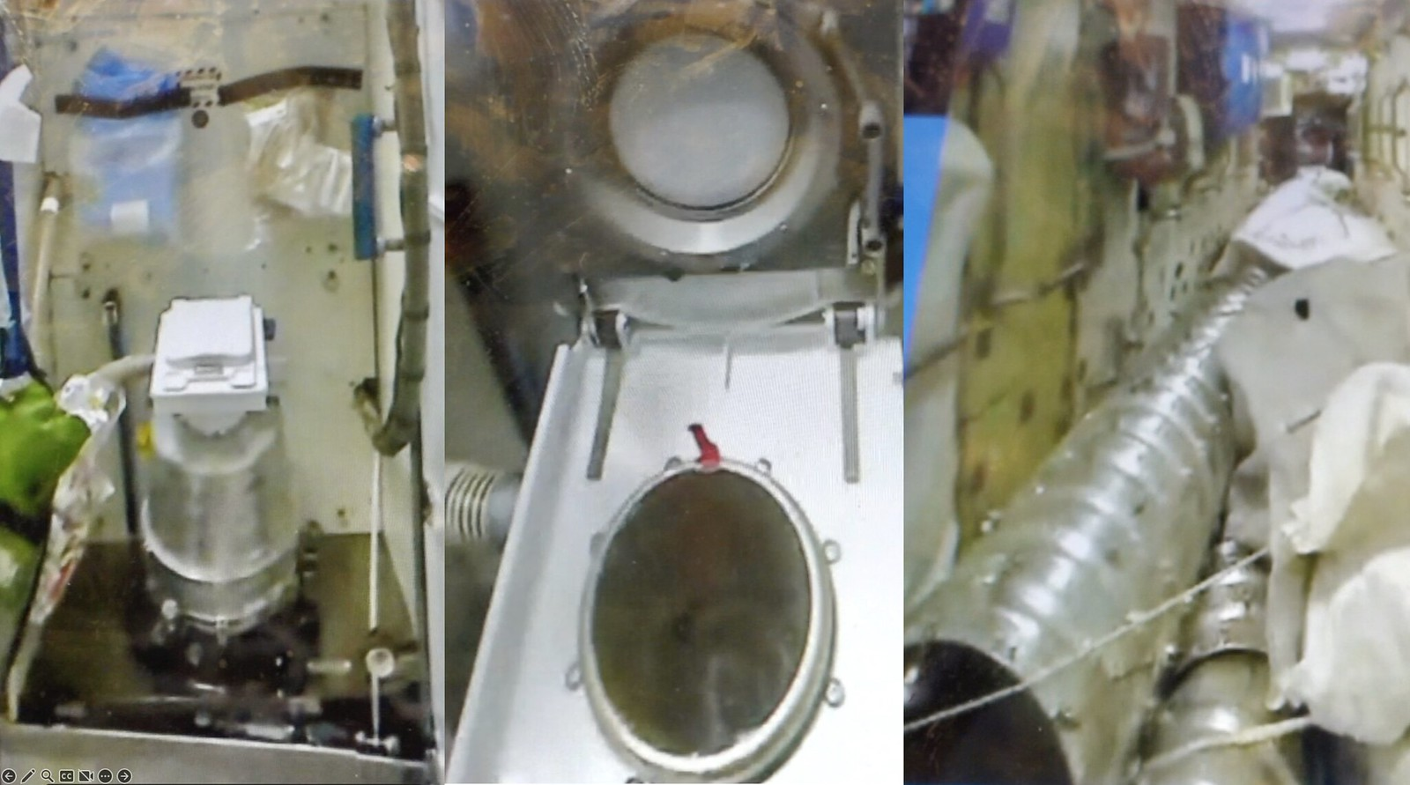
When the International Space Station launched, it needed a toilet that could handle long stays and multinational crews. The solution? Use what already worked.
Russia’s Energia Corporation had been running a reliable space toilet on the Mir station for years. NASA paid nearly $19 million to have a similar unit installed on the U.S. side of the ISS. It wasn’t about national pride; it was about practicality. The Russian design was proven. It used airflow, separation technology, and waste storage tanks that could be replaced mid-mission.
And no, it wasn’t Howard Wolowitz who drew the blueprints.

Real Engineers, Real Problems
NASA’s space toilet development has involved multiple agencies, contractors, and decades of iteration. Companies like Hamilton Standard (now part of Collins Aerospace) helped engineer the early life support and waste systems on the Shuttle. NASA’s Johnson Space Center led most of the R&D, and the work was anything but glamorous.
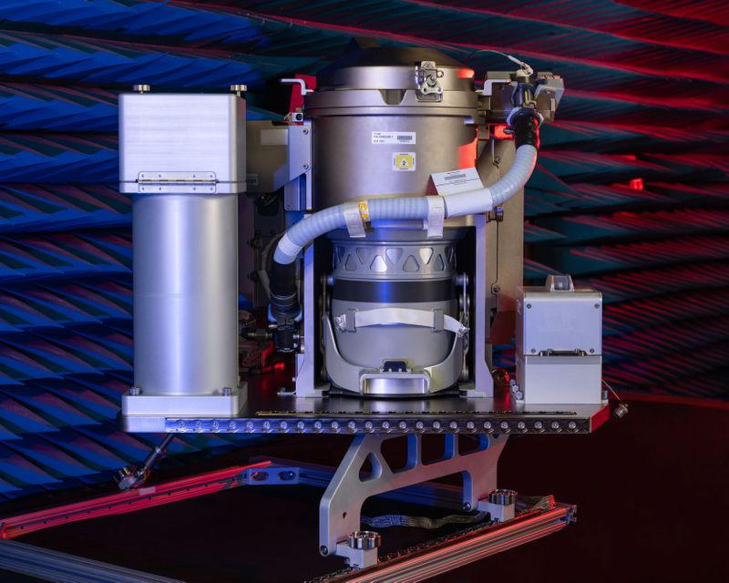
Every feature had to account for zero gravity, limited space, sanitation, and astronaut comfort. Even small oversights could mean clogged systems, hazardous spills, or weeks of unpleasant living conditions.
A real incident in 2008 involved a failing toilet pump, forcing astronauts to manually flush the system with hand tools. That’s the part they don’t show in the training videos. It wasn’t Wolowitz’s fault, but if it were, you can bet Sheldon would never have let him live it down.

Enter the UWMS: The Toilet of Tomorrow
In 2020, NASA introduced the Universal Waste Management System (UWMS), the next-gen model for missions to the Moon, Mars, and beyond. It’s smaller, more efficient, and finally optimized for female astronauts, who had long been underserved by earlier designs.
Key features include:
- Dual urine and fecal collection systems
- Advanced odor control and splash prevention
- Lightweight, modular construction for easier installation
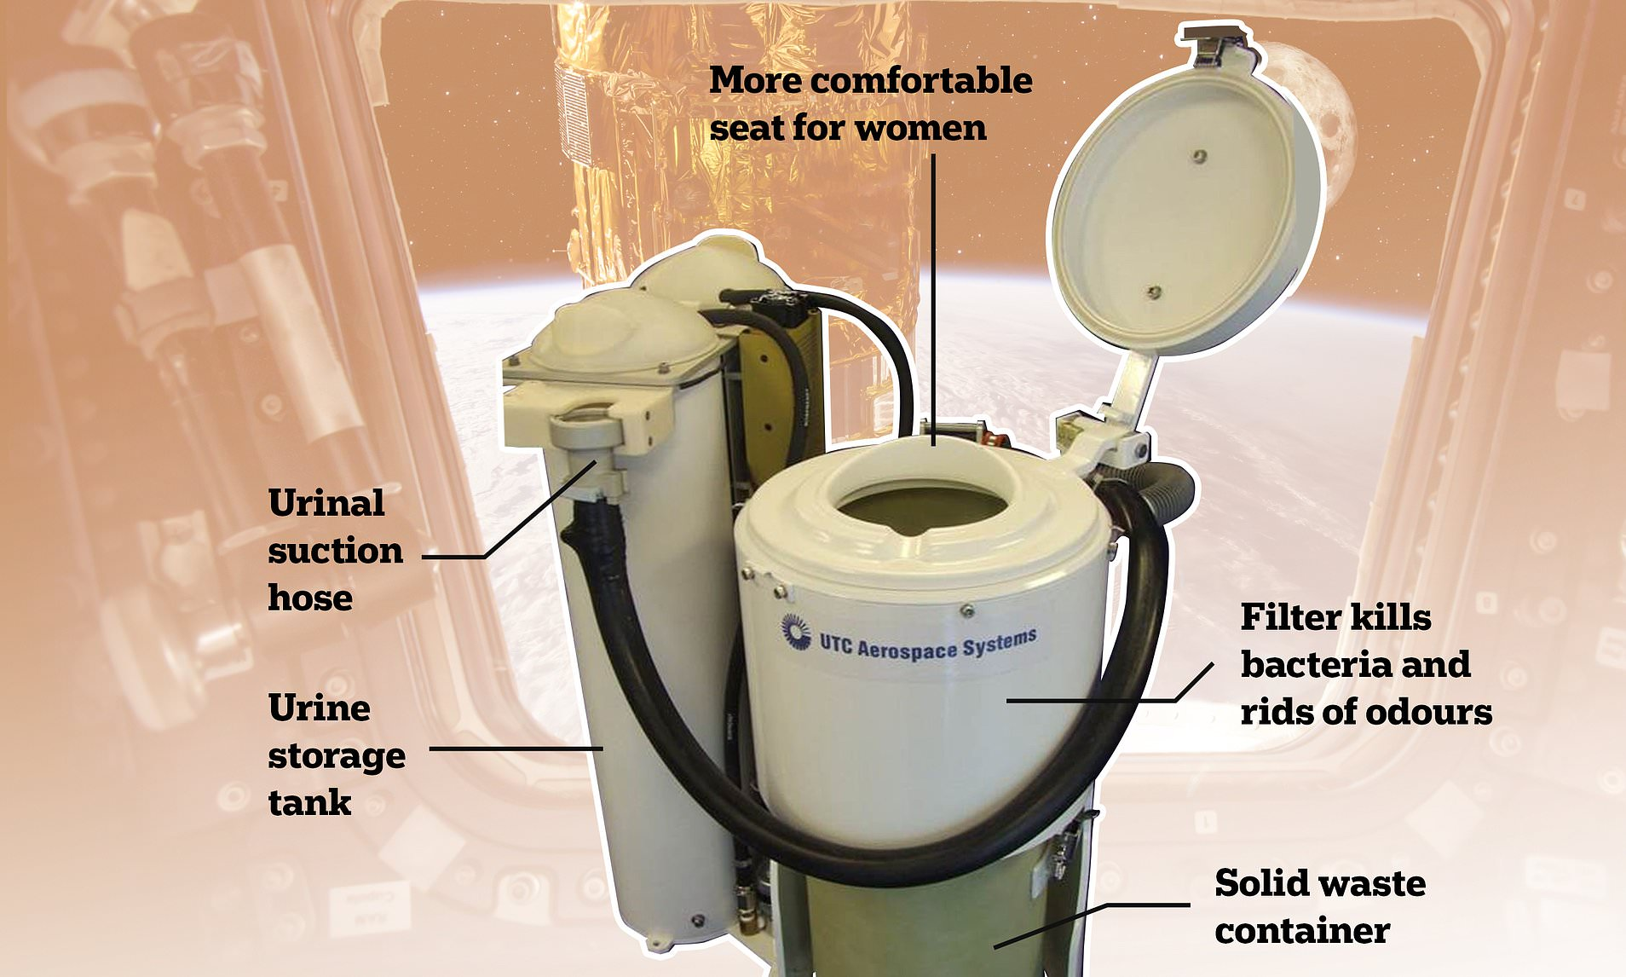
- Compatibility with water recycling systems that extract and purify urine.
As astronaut Jessica Meir put it: “It may sound silly, but this toilet really is a big deal.”
She’s right. In space, every ounce counts, and so does every drop.
The UWMS was developed by engineers at Collins Aerospace in partnership with NASA’s Exploration Systems Development Mission Directorate. It cost about $23 million, and yes, it works.

Wolowitz vs. The Real World
So, does Howard Wolowitz have a real-world counterpart? Not exactly. He’s an exaggerated composite of real NASA engineers, with a comedic twist. But the show's joke about his space toilet causing an orbital plumbing disaster isn't that far from the truth. Real space toilets have malfunctioned. Waste has escaped. Systems have broken.
The difference is, when something goes wrong on a real space toilet, a team of engineers, sometimes on two continents, spends days figuring out how to fix it without flooding the cabin. When it happens on The Big Bang Theory, it ends with a punchline.
That said, Wolowitz deserves credit. The show got a lot right. It highlighted the very real (and often underappreciated) contributions of engineers who work behind the scenes, building life support systems, designing backup plans, and yes, keeping astronauts from having very bad days in zero gravity.
Meet Rawand Rasheed: The Real Engineer Behind NASA’s Toilet Upgrade
Now, if you’re wondering whether there’s a real-life version of Howard Wolowitz—someone who actually did take the lead on designing NASA’s most advanced space toilet—look no further than Rawand Rasheed.

Rasheed, a systems engineer at Collins Aerospace, served as one of the lead engineers on the Universal Waste Management System (UWMS). His work helped bring NASA’s newest generation of space toilet to life, a unit designed for the International Space Station and future Moon missions under Artemis.
The UWMS had to meet some very real and very challenging goals:
- Reduce the toilet’s weight and footprint
- Improve accessibility for all astronauts, including women
- Enhance odor control and hygiene
- Work seamlessly with ISS water recycling systems
In a 2020 interview with Ars Technica, Rasheed explained that the UWMS was engineered with modularity in mind. Every component had to be serviceable in space. And like everything that flies, it had to be reliable, compact, and light.
So, while Howard Wolowitz had a disaster played for laughs, Rasheed and his team delivered a system that works quietly, cleanly, and consistently—arguably the greatest compliment a space toilet can receive.

Where Does It All Go?
Liquid waste on the ISS is processed through the station’s Water Recovery System—yes, astronauts drink purified urine. Solid waste, on the other hand, gets bagged and stored in airtight containers until it’s loaded into a cargo ship filled with trash. Once that ship is detached, it burns up upon re-entering Earth’s atmosphere—making your last trip to the toilet part of a fiery goodbye.
Final Flush: Let’s Give Credit Where It’s Due
So, who really built the space toilet?
- Not Howard Wolowitz.
- Not a lone genius in a lab coat.
- But hundreds of real engineers, mechanical, aerospace, chemical, who turned one of humanity’s most basic needs into a triumph of applied science.
They designed for pressure, temperature, airflow, hygiene, and storage. They figured out how to separate fluids from solids in a weightless vacuum. They even made it possible to drink yesterday’s waste water (after a bit of processing, thankfully).
In space, plumbing is rocket science.
So next time someone tells you Howard Wolowitz built the ISS toilet, feel free to smile. Then let them know it was actually built by a team of real engineers working under real constraints.
Because space exploration isn’t just about walking on the Moon.
It’s about flushing in orbit, and making sure the mess stays sealed.

References
- NASA History – Space Toilets and Waste Management Systems
NASA Glenn Research Center.
https://www.nasa.gov/feature/facts-about-space-toilets
- The $23 Million NASA Space Toilet Is Ready for Launch
NASA Press Release, September 2020.
https://www.nasa.gov/feature/new-space-toilet-prepares-for-launch-to-space-station
- Collins Aerospace: Universal Waste Management System
Collins Aerospace (Raytheon Technologies).
https://www.collinsaerospace.com/newsroom/Stories/2020/10/NASA-space-toilet
- International Space Station U.S. Segment Toilet Details
NASA Human Spaceflight: ISS Overview.
https://www.nasa.gov/mission_pages/station/structure/elements/node3.html
- Russian Space Toilet System (ASU) on the ISS
Russian Space Web by Anatoly Zak.
http://www.russianspaceweb.com/iss_assembly.html
- The History and Science of Toilets in Space
National Air and Space Museum, Smithsonian Institution.
https://airandspace.si.edu/stories/editorial/space-toilets
- Astronaut Training and Microgravity Toilet Use
Popular Mechanics, “This is How You Poop in Space,” by Joe Pappalardo, July 2015.
https://www.popularmechanics.com/space/a16744/pooping-in-space/
- Space Shuttle Waste Collection System Operations
NASA Technical Reports Server (NTRS).
https://ntrs.nasa.gov/citations/19850000317
- Astronaut Interviews on Life Aboard the ISS
NASA YouTube Channel – Jessica Meir and Christina Koch Interviews, 2020.
https://www.youtube.com/user/NASAtelevision

