When Phone Companies Made the Best Amplifiers
Story of The Western Electric Amplifiers
By: Marc Silver
I became interested in tube electronics back in 1968 when I had the opportunity to work at Stereo Mart in Tarzana, California. At the time, most people thought tube technology was dead and buried. But I was lucky enough to work for someone who thought differently. One day, he had me listen to a 35-watt-per-channel Dynaco Stereo 70 amp with its matching PAS-3 preamp driving a pair of Rectilinear III speakers. We compared it to a pair of SAE 150-watt solid-state separates. The SAE gear was impressive, but the Dynaco sounded more musical. That moment pulled me in.
Over the years, I built several different Dynakits and continued learning about tube gear and its roots. Eventually, I came across Western Electric tubes, widely regarded then and now as some of the best ever made. But it wasn’t until much later that I began to appreciate just how deep the Western Electric story went.

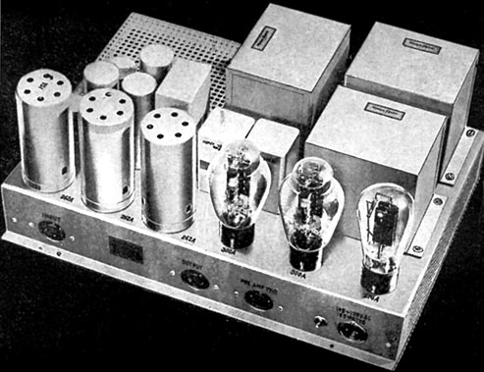
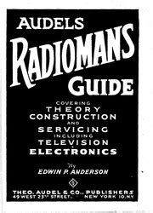
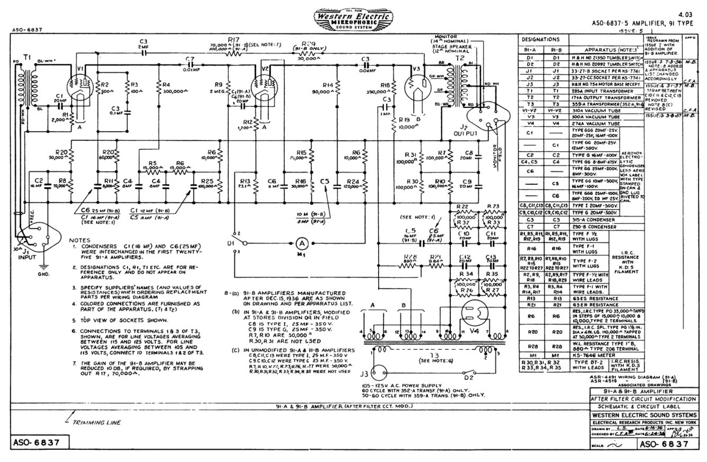
A technician friend named Steve Sweaney once loaned me a ratty old copy of the 1939 Audel's Radioman's Guide. He made a point to show me the schematic for a Western Electric 92A amplifier. He called it "pure engineering genius" and walked me through its design. That circuit was already 80 years old by then. Introduced around 1935, the Western Electric 92A was a 20-watt push-pull theater amplifier that used 42A pentode output tubes. Many people look at the pitures and believed it used 300Bs. While it wasn’t the origin of today’s single-ended triode designs, it helped set the stage for what came later. The 300B itself arrived a few years afterward and eventually became the heart of many high-end tube amps, especially in simpler, low-power SET circuits prized for their musicality.
Figure 1 Western Electric 92A Amplifier
Figure 3 Western Electric 300b Amplifier Schematic
Figure 2 Audel's Radioman's Guide.
Why Western Electric Wasn’t Playing Games
Western Electric wasn’t a boutique audio company. It was the engineering arm of AT&T, responsible for keeping the Bell System humming. When you picked up the phone in 1925 and asked for "long distance," your voice didn’t just float down the line. It was amplified by equipment Western Electric had designed and built, gear that was built to run 24/7, in dusty switch rooms and uncooled central offices, often on shaky rural power. If an amp failed, a whole region’s calls could go dead. Reliability wasn’t a goal; it was a mandate. That kind of pressure forged some extraordinary solutions.
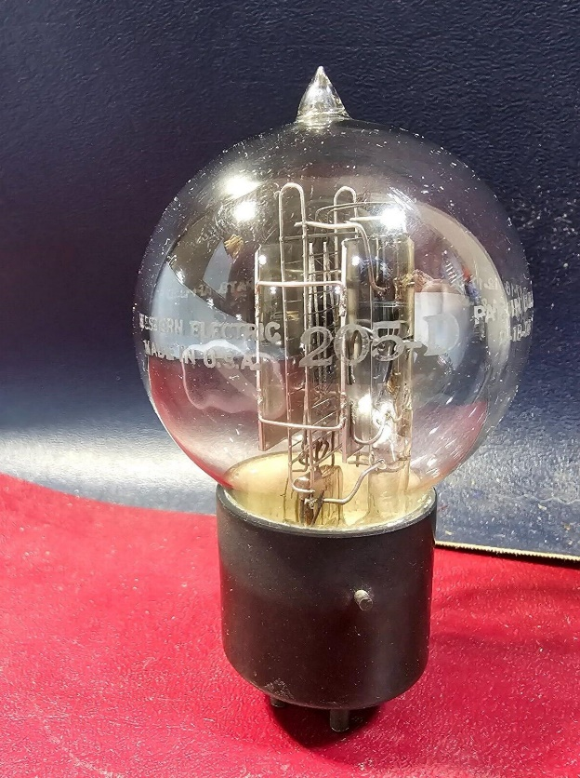
The 1920s: Making Something from (Almost) Nothing
Figure 4 Western Electric 205D triode tube
Take the Western Electric 32A from the early 1920s. It used a single 205D triode tube, essentially a lightbulb-shaped glass valve. Back then, rectifier tubes didn’t exist yet. So how did they power the amp? They used the same 205D audio tube to rectify the AC into DC. It’s like using your car’s engine to power your house.
Even bolder, they skipped the usual "ground everything" convention. Instead, the signal transformer was connected to the tube’s "virtual cathode," or the midpoint of the glowing filament. This made the circuit respond to the difference between the grid voltage and this midpoint voltage.
Today, we’d call it a differential amplifier. The benefit? It minimized the use of capacitors, then expensive and unreliable, and squeezed more performance out of the transformers. Smart, efficient design born of necessity.
The 1930s: Refining Genius, The 92A and Parallel Feed
By 1935, Western Electric had refined those early lessons into the now-legendary 92A amplifier, introducing what’s known as parallel feed coupling, or parafeed.
In earlier designs, the same transformer winding carried both the music signal and the DC power for the output tube. That mix caused cross-talk problems. The DC magnetized the transformer core, which led to distortion and forced designers to use huge iron cores to keep things from saturating. 
Western Electric split the duties:
- DC current ran through a separate choke or resistor.
- The audio signal passed through a coupling capacitor to the transformer.
That one architectural shift made a huge difference:
- Transformers got smaller and lighter.
- Frequency response improved across the board.
- Distortion dropped sharply.
- Exotic transformer core materials became viable because they weren’t being magnetized by DC.
The Output Stage: Harmony Through Balance
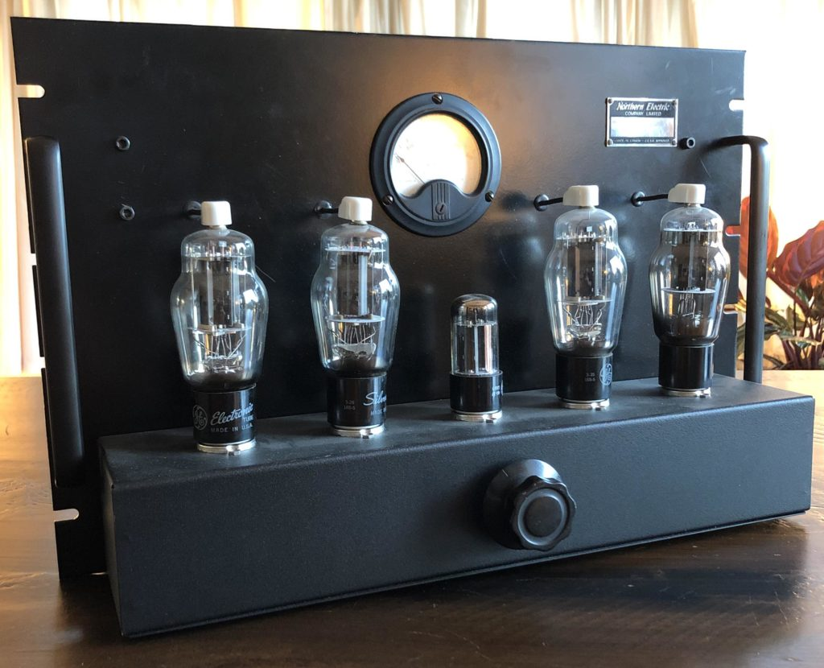
The 92A’s output stage used a push-pull pair of 300A triodes, the forerunners of the legendary 300B, with something Western Electric called a "Harmonic Balancer."
It wasn’t a brute-force global feedback loop. It was a built-in mechanism that sensed drift between the tubes, due to age or manufacturing variances, and corrected it automatically. A self-balancing circuit that kept the output clean and symmetrical for years without constant recalibration. This design modification closely resembles auto-bias circuits common today.
Hollywood's Roaring (Amplified) Twenties: The 43A Battleship
For something truly industrial, look at the 43A amplifier. This brute powered the earliest "talkie" films in the late 1920s. Back then, projectionists had to sync 78 RPM records with the movie reel, get it wrong, and the sound didn’t match the lips on screen.
The 43A was built to thrive in that chaos. Four huge 211E transmitter tubes ran over 1000 volts. It took up a full equipment rack and output just 20 watts. Overbuilt? Yes. But bulletproof. Later designs like the 86B and 92A shrank all that power into tabletop-sized chassis.
Why This Forgotten Tech Still Matters
You might think, “Cool history, but what’s it got to do with my Spotify playlist?” More than you’d think.
Western Electric solved problems modern tube designers still wrestle with:
- Transformer distortion? They solved it with parafeed.
- Power supply hum? They used precise capacitor ratios in the cathode leg to cancel it at the source, no fancy power conditioners needed.
They had no digital signal processors, no op-amps, no margin for error. Their solutions were simple, efficient, and deeply elegant. And many of them have been forgotten.
The Great Forgetting
So, what happened?
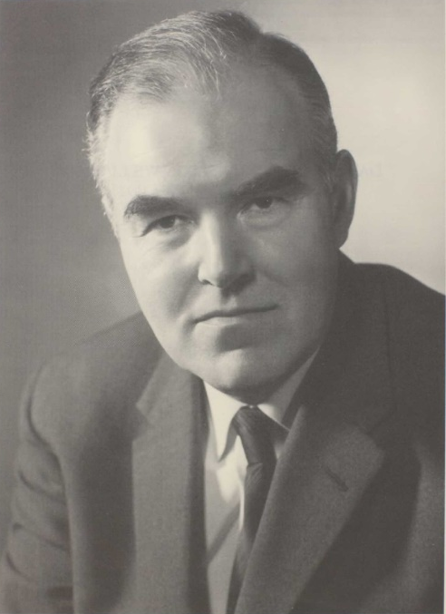
In 1947, British engineer D.T.N. Williamson published a simplified feedback amplifier design. It was easier to build, easier to explain, and performed well on paper. It became the default blueprint for a generation of amp builders.
But the rise of the Williamson design swept away an entire generation of nuanced circuit knowledge. By the time tube audio made a comeback in the 1990s, most of that earlier Western Electric wisdom had vanished, left buried in Bell System journals and forgotten textbooks.
Figure 5 D.T.N. Williamson
The Quiet Revival
Today, a small but passionate community of designers and DIY builders is rediscovering Western Electric’s circuit magic. These aren’t museum pieces, they’re functional, deeply musical amplifiers that offer something measurements can’t fully capture.
They sound real. They breathe. They handle complex music with ease and subtlety that some modern gear still struggles to match.
The Takeaway: What Western Electric Can Teach Us
Even if you never touch a soldering iron, the story of Western Electric amplifiers carries big lessons:
- Constraints Fuel Innovation: They didn’t have much to work with, and that made them smarter.
- Elegance Beats Overkill: Instead of brute force, they found the cleanest path.
- Knowledge Is Fragile: Decades of learning can disappear in a generation.
- Old Ideas Still Work: Signal integrity, power management, and hum rejection were solved, elegantly, almost a century ago. Maybe it’s time we listened.
The next time you stream a song or pick up a call, remember this: the sound didn’t get here by accident. It rode on the back of industrial amplifiers built not for prestige, but for perfection. Their creators didn’t seek the spotlight, but what they left behind was nothing short of hidden genius.
P.S. The rabbit hole is real. Online forums are full of folks building their own 92As, 86Bs, and even 43A replicas. Be warned: once you go down the WE blueprint trail, weekends start disappearing. And the sound? It just might keep you there.

