What Is a DAC and Why You Should Consider Upgrading Yours
By Marc Silver (Updated 2025)
You hear music every day that started life as numbers.
A CD. A streamed album from Spotify or Tidal. A music file on your phone. All of it exists first as digital data.
What comes out of your speakers is something else entirely.
It’s an analog signal, a continuously varying electrical waveform that your amplifier can boost and your speakers can turn into moving air in a room.
The part of your system that makes that transformation possible is called a DAC, a digital-to-analog converter.
You may never see it.
It may live inside your phone, your computer, your streamer, your amplifier, or your powered speakers.
But it’s there, working every time you press play.
In simple terms, a DAC is the translator between the digital world and the physical one.
Without it, digital audio would remain silent instructions, incapable of moving a speaker cone or filling a room with sound.

Plain English Definition
DAC (Digital-to-Analog Converter)
The part of an audio system that turns digital music data into an analog electrical signal your amplifier and speakers can use.

Why Digital Audio Needs a DAC at All
Digital audio is often described as ones and zeros. That description is accurate, but incomplete.
Those numbers don’t represent sound directly. They represent measurements of sound taken at specific moments in time. Digital audio is better thought of as a detailed set of instructions, not the thing itself.
Speakers don’t understand instructions.
They respond to voltage.
They need a smooth, continuously changing electrical signal to move back and forth and create sound waves in the air. A DAC’s job is to take those digital measurements and rebuild a continuous analog signal from them.
This step is unavoidable. Every digital playback system ever made uses a DAC somewhere in the chain.
Even the simplest Bluetooth speaker has one.
Even the cheapest phone has one.
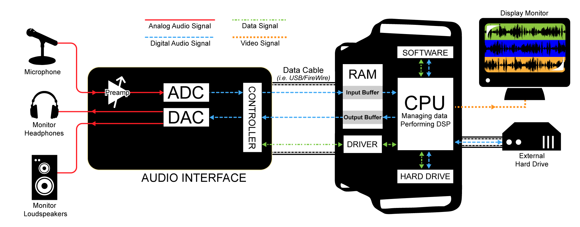
The difference is not whether a DAC exists, but how carefully that conversion is handled.
Why Early Digital Got a Bad Reputation
When compact discs were introduced in the 1980s, they were marketed as “perfect sound forever.” On paper, the numbers supported that claim.
In practice, many early CD players sounded thin or brittle compared to good analog systems of the time.
The problem wasn’t digital audio itself. It was execution.
Early DACs were limited by the technology available. Processing power was modest. Power supplies were often shared with noisy digital circuits. Analog output stages were treated as secondary concerns.
Engineers knew how to measure these devices. They were still learning how those designs behaved in real systems, in real rooms, over long listening sessions.
Many listeners concluded that digital itself was the problem. That perception lingered for years.
What changed wasn’t the concept of digital audio.
What changed was DAC design.
Better clocking, cleaner power, and more thoughtful analog stages transformed digital playback from a technical achievement into something genuinely musical.

Historical Note
Many early audiophiles didn’t abandon CDs because they disliked digital.
They added external DACs because they realized the weakest link wasn’t the disc. It was the conversion.

What a DAC Really Does, and Doesn’t Do
A DAC is not a tone control.
It doesn’t add bass or treble.
It doesn’t fix bad recordings or compensate for poor speaker placement.
What it does, when done well, is get out of the way.
A good DAC allows the rest of the system to work with cleaner, more accurate information. A compromised one can flatten dynamics, blur imaging, and make music feel less involving, even when everything else in the system is doing its job.
That’s why DAC quality matters.
It’s also why upgrading one can sometimes make a larger difference than people expect, even though the change is usually subtle rather than dramatic.

How a DAC Works (Without the Math)
Digital audio is a series of snapshots.
When sound is recorded digitally, the original analog waveform is measured thousands of times per second. Each measurement is stored as a number. During playback, a DAC uses those numbers to rebuild a smooth, continuous electrical signal that closely matches the original sound.
A common misconception is that digital audio produces a jagged, stair-step waveform.
That image is misleading.
A properly designed DAC does not output steps. It reconstructs a continuous signal by interpreting those measurements in time and amplitude.
Think of it less like connecting dots with straight lines and more like drawing a curve guided by precise reference points.

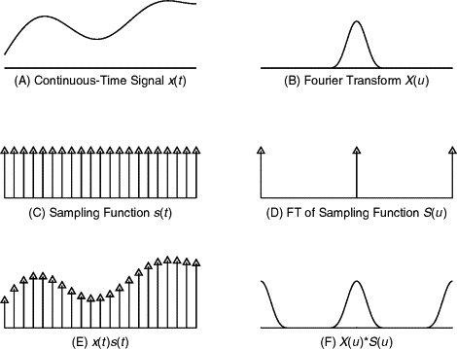
Plain English Definitions
Sampling Rate
How often the original sound was measured when it was converted into digital form. CD quality is 44.1kHz, meaning 44,100 measurements per second. High-resolution audio uses higher rates such as 96kHz or 192kHz.
Bit Depth
How much detail is captured in each measurement. CD quality is 16-bit. High-resolution audio typically uses 24-bit.
Analog Signal
A continuously changing electrical voltage that mirrors the shape of the original sound wave.

Timing Matters as Much as Accuracy
Getting the numbers right is only part of the job.
Getting them at the right time is just as important.
Digital playback depends on precise timing. If samples arrive slightly early or late, the reconstructed waveform loses coherence.
When timing errors occur, the result is rarely obvious distortion. Instead, music can lose focus. Imaging becomes vague. Space collapses.
Listeners often describe the effect as flat or uninvolving, even if they can’t point to a specific flaw.

Plain English Definition
Jitter
Small timing errors in digital playback that can blur detail, space, and imaging.

Why DACs Sound Different
Once digital data is converted, the signal is no longer digital.
It becomes a very small, delicate analog voltage. At that point, it is vulnerable.
Noise management, power supply quality, and analog output design all matter. Digital circuits generate electrical interference by nature. A well-designed DAC keeps that noise away from the analog stage. A less careful design allows it to leak through.
Power quality matters just as much. The conversion process and the output stage both depend on clean, stable power.
This is one reason DACs built into small devices often struggle to match dedicated units. They simply don’t have the space or resources to do everything well.

Plain English Definition
Analog Output Stage
The circuitry that prepares the converted signal for delivery to an amplifier. Its quality directly affects clarity, tone, and dynamics.

CALLOUT:
Two DACs can measure similarly and still sound different.
What happens after conversion matters as much as the conversion itself.

Built-In DACs vs External DACs
Every modern digital device includes a DAC. Phones, computers, streamers, televisions, and powered speakers all rely on one.
Many sound perfectly acceptable. Some sound very good.
The good news is that DAC technology has improved dramatically over the past two decades. Even budget implementations now achieve respectable performance. The gap between adequate and excellent has narrowed.
Design priority still matters.
In a phone or computer, the DAC must share space and power with processors, radios, and displays. Sound quality is important, but it competes with many other requirements.
An external DAC is built to do one job.
It has more space, cleaner power, and fewer compromises.
That focus can make an audible difference, particularly in revealing systems.
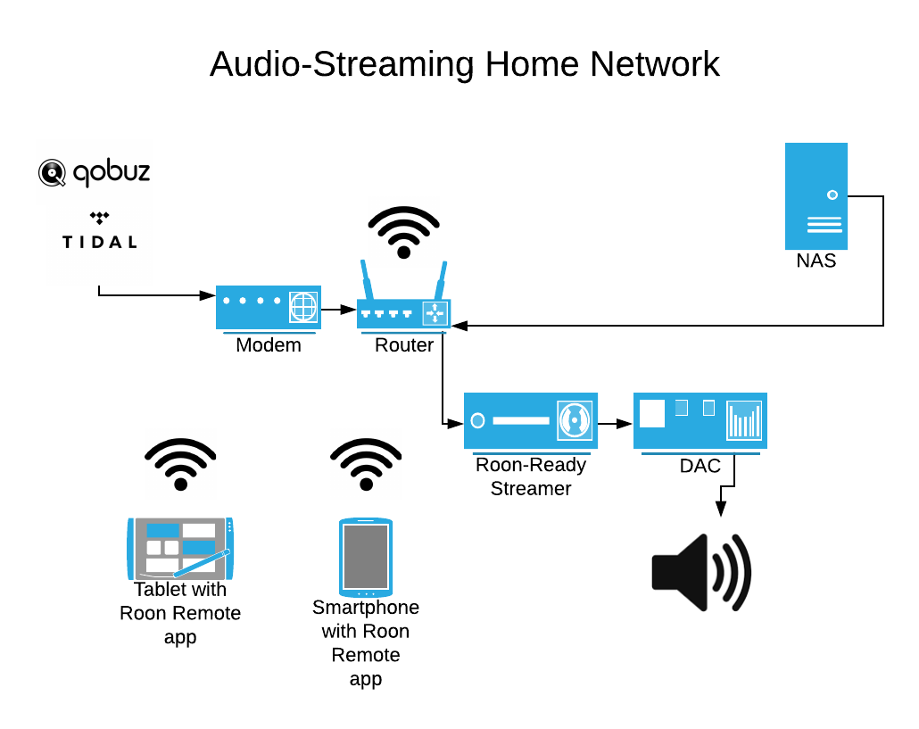
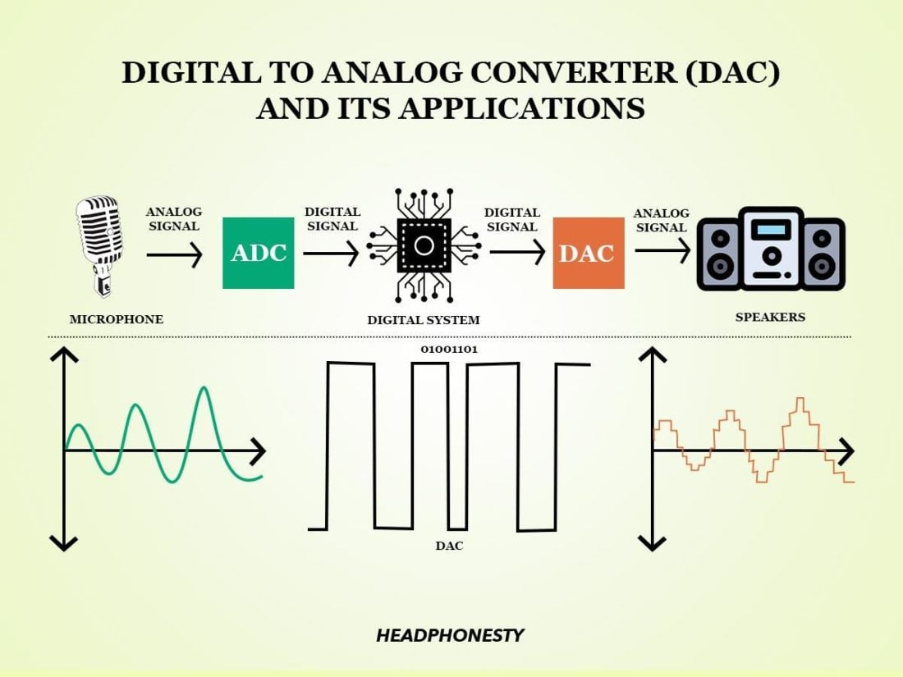
Plain English Comparison
Built-In DAC
Convenient and compact. Designed to be good enough within tight limits. Modern implementations have improved significantly and may be sufficient for many systems.
External DAC
Dedicated to one job, with more space, cleaner power, and fewer compromises.
Portable DAC / Headphone Amplifiers
Small USB devices, sometimes called dongles, that plug into phones or computers to provide better-than-built-in DAC performance. Popular for headphone listening and a practical first upgrade step.

When an External DAC Makes Sense
An external DAC is not automatically better. In some systems, adding one won’t change much. In others, it can be a meaningful upgrade.
It often makes sense if you use a phone or computer as a primary source for a quality system, rely on a basic headphone jack for line-level output, or find that digital playback sounds flat or fatiguing.
It also helps if the rest of your system is capable of revealing improvements.
It may not help if your speakers, room, or amplification are the limiting factors. This is not about chasing upgrades. It’s about identifying bottlenecks.
For headphone listeners, even a modest portable DAC and amplifier can make an immediate difference. Most phone and computer headphone outputs are designed for convenience, not quality.

Setup Checklist: Should You Consider a DAC Upgrade?
Am I listening primarily to digital sources such as streaming, computer audio, or digital files?
Does my current source rely on a basic or shared DAC?
Is my system resolving enough to reveal changes?
Do I hear glare, fatigue, or a lack of depth from digital playback?
If most of those answers are yes, a DAC upgrade is worth exploring.

Connecting a DAC: What Actually Matters
At a basic level, you send a digital signal from your source to the DAC, then an analog signal from the DAC to your amplifier or powered speakers.
That’s it.
USB has become the dominant connection for computer and streamer audio and is generally the most practical choice for modern systems.
Optical and coaxial connections can also work well when implemented properly. In most home systems, the audible differences between input types are small compared to the differences between DAC designs themselves.
For wireless listening, technologies such as aptX HD, LDAC, and AirPlay 2 have improved Bluetooth and Wi-Fi audio quality considerably. Even so, wireless transmission remains the weakest link, and a DAC is still required at the receiving end.

Plain English Definitions
USB Audio
A digital connection commonly used with computers and streamers. Now the most common DAC input.
Optical (Toslink)
A light-based digital connection that electrically isolates components. Useful for eliminating ground loops.
Coaxial Digital
An electrical digital connection often found on CD players and streamers.

CALLOUT:
Use a well-made cable of reasonable length.
Focus on the DAC, not the wire.

Choosing a DAC Without Chasing Specs
Specifications describe what a DAC can do, not how it will sound in your system.
A good DAC doesn’t impress by exaggeration. It makes music feel more natural and less tiring over time.
Be cautious of marketing claims around exotic processing, AI upsampling, or proprietary formats. These features may sound impressive but rarely correlate with better musical performance. Many formats once promoted as revolutionary have already faded from the market.
Build quality, reliability, sensible features, and system compatibility matter more than fashionable numbers.
If possible, listen in your own system. Short demonstrations can mislead. Long listening sessions reveal far more.

A Note on High-Resolution Audio
Streaming services now offer multiple quality tiers, from compressed audio to lossless CD-quality to high-resolution formats.
High-resolution audio can sound excellent. Even so, the improvement over well-implemented CD-quality playback is often subtle.
Focus first on good DAC implementation at standard resolutions before chasing higher numbers. A well-designed DAC playing CD-quality files will outperform a mediocre one playing high-resolution audio.

Final Thoughts
A DAC doesn’t define a system’s personality.
It defines how cleanly information crosses the boundary between digital and analog.
When that handoff is done well, the rest of the system has room to shine.
If your digital playback already sounds engaging, you may not need to change anything. If it feels brittle or uninvolving, a better DAC may be worth exploring.
The good news is that even affordable external DACs now offer performance that would have cost thousands of dollars two decades ago.
The challenge isn’t finding a good DAC.
It’s matching the right one to your system and listening priorities.
The best DACs don’t impress you at first listen.
They keep you listening longer.

