Western Australia Wine Region: A Sommelier's Guide
1. Region Overview
Geographic Location
Western Australia’s wine regions are concentrated in the state’s southwestern corner, spanning from the coastal Margaret River to the inland Great Southern region. The primary wine-producing areas include Margaret River, Great Southern, Swan Valley, Geographe, Blackwood Valley, Pemberton, and Manjimup. Margaret River, approximately 170 miles south of Perth, is the most internationally recognized.
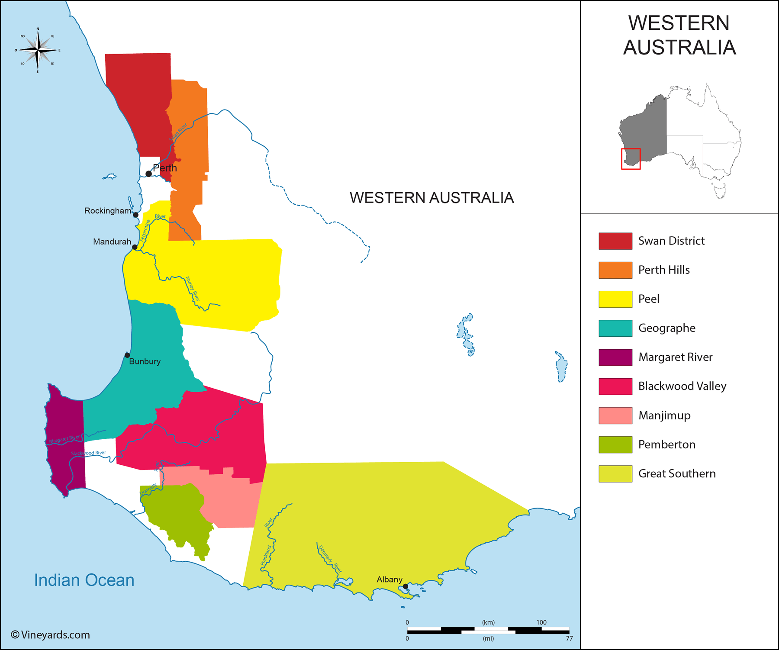
Climate and Terroir
Western Australia features a Mediterranean climate, with maritime influences from the Indian and Southern Oceans. Margaret River, in particular, benefits from consistent ocean breezes, resulting in long, even ripening seasons. The Great Southern region is more varied, with cool-climate zones in areas like Mount Barker and Denmark. Soils range from gravelly loam in Margaret River to ancient granite and laterite formations in the Great Southern, providing ideal conditions for a range of grape varieties.
Structural Organization
Western Australia is divided into several Geographic Indications (GIs), with Margaret River and Great Southern being the most prominent. Within Great Southern, there are five sub-regions: Albany, Denmark, Frankland River, Mount Barker, and Porongurup. Swan Valley, one of Australia’s oldest wine regions, is located closer to Perth.
Historical Context
Winemaking in Western Australia dates back to the 1830s in Swan Valley, though modern viticulture began in the 1960s with the development of Margaret River. Dr. John Gladstones’ research highlighted the region’s suitability for premium viticulture, leading to rapid expansion. Today, Western Australia produces less than 5% of the country’s total wine output but commands a significant share of premium wine exports.
Distinctive Features
Western Australia is known for its premium wines, particularly Margaret River’s Bordeaux-style blends and Great Southern’s cool-climate Riesling and Shiraz. The region’s commitment to sustainable viticulture and minimal-intervention winemaking further enhances its reputation.

2. Key Grape Varieties
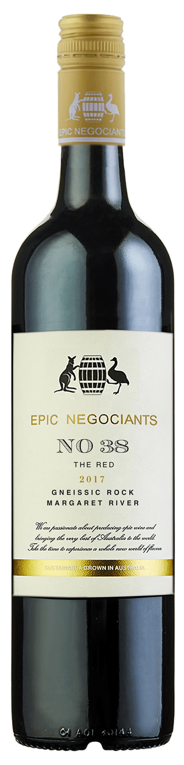
Primary Red Varieties
- Cabernet Sauvignon – Margaret River’s flagship red, producing structured, age-worthy wines with cassis, eucalyptus, and fine tannins.
- Shiraz – More prominent in Great Southern, where it exhibits cool-climate spice and elegance.
- Merlot – Often blended with Cabernet Sauvignon to produce Bordeaux-style wines.
Primary White Varieties
- Chardonnay – Margaret River’s cool-climate expression is characterized by minerality, citrus, and restrained oak influence.
- Sauvignon Blanc & Semillon – Often blended to create vibrant, structured white wines with high acidity.
- Riesling – A Great Southern specialty, known for its purity, lime-driven acidity, and longevity.

Indigenous/Regional Varieties
While no indigenous varieties exist, Western Australian expressions of Cabernet Sauvignon, Chardonnay, and Riesling are considered benchmarks within Australia.

Significance
Cabernet Sauvignon dominates Margaret River, while Shiraz and Riesling thrive in Great Southern. Sauvignon Blanc-Semillon blends also play a crucial role in defining the region’s white wine identity.

3. Wine Classification System
Quality Hierarchy
Western Australia follows the Australian GI system, with designated regions and sub-regions but no formal quality tiers.
Appellation Structure
- Western Australia GI – Covers all wine regions within the state.
- Margaret River GI – The most prestigious designation, focusing on premium wines.
- Great Southern GI – Includes five sub-regions, each with distinctive styles.
- Swan District GI – Includes Swan Valley, known for fortified wines and early harvest styles.
Special Classifications
- Iconic Cabernet Sauvignon & Chardonnay – Recognized for consistent excellence, though not formally classified.
Sub-Regional Distinctions
- Margaret River – Best known for Cabernet Sauvignon and Chardonnay.
- Great Southern – Produces top-tier Shiraz and Riesling.
- Swan Valley – Historically focused on fortified wines but diversifying.

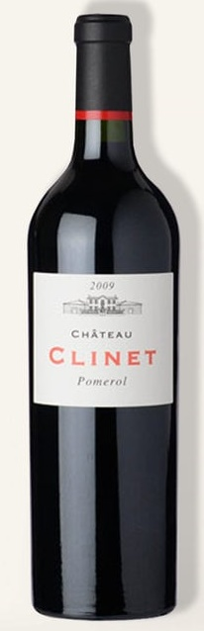
4. Notable Wine Styles
Bordeaux-Style Red Blends
- Classification Level: Margaret River GI
- Composition: Cabernet Sauvignon, Merlot, Cabernet Franc, Malbec, Petit Verdot
- Production Method: Oak aging in French barrels
- Aging Requirements: Typically 12–24 months in oak
- Alcohol Content: 13.5–15%
- Organoleptic Profile: Blackcurrant, cedar, tobacco, fine tannins
Chardonnay
- Classification Level: Margaret River GI
- Composition: 100% Chardonnay
- Production Method: Fermentation in oak or stainless steel
- Aging Requirements: Typically 9–12 months in oak
- Alcohol Content: 12.5–14%
- Organoleptic Profile: Citrus, stone fruit, minerality, integrated oak
Riesling
- Classification Level: Great Southern GI
- Composition: 100% Riesling
- Production Method: Stainless steel fermentation
- Aging Requirements: Typically aged in bottle
- Alcohol Content: 11–12.5%
- Organoleptic Profile: Lime, floral, high acidity, mineral-driven

5. Additional Context
Recent Developments
Western Australian wineries continue to refine their expressions of Chardonnay and Cabernet Sauvignon, with increasing emphasis on organic and biodynamic viticulture.
Historical Evolution
Margaret River’s wine industry has developed from an experimental region in the 1960s to a globally recognized producer of fine wine.
Food Pairing Notes
- Cabernet Sauvignon – Red meats, aged cheeses, roasted vegetables.
- Chardonnay – Seafood, poultry, creamy pasta dishes.
- Riesling – Thai cuisine, shellfish, spicy foods.
Producer Information
- Vasse Felix – One of Margaret River’s pioneering wineries, known for structured Cabernet Sauvignon.
- Leeuwin Estate – Celebrated for its ‘Art Series’ Chardonnay.
- Cullen Wines – Biodynamic producer of exceptional Cabernet blends.
- Howard Park Wines – Leading Great Southern winery producing Riesling and Shiraz.

6. Key Takeaways for Sommeliers
- Western Australia is renowned for its premium wines, particularly in Margaret River and Great Southern.
- Cabernet Sauvignon and Chardonnay are the benchmark varieties of Margaret River.
- Great Southern excels in cool-climate Shiraz and Riesling.
- Sauvignon Blanc-Semillon blends are a key regional specialty.
- Sustainability and biodynamic practices are increasingly shaping the region’s production.

7. Citations and References
- Wine Australia, 2023. https://www.wineaustralia.com/
- Halliday Wine Companion, 2023. https://www.winecompanion.com.au/
- Margaret River Wine Association, 2023. https://margaretriver.wine/
- Australian Wine Research Institute, 2023. https://www.awri.com.au/
- Great Southern Wine, 2023. https://greatsouthernwine.org.au/

