Volcanic Islands and Living Geology
How Hawaii Continues to Grow
By Marc Silver

A Landscape in Motion
If you’ve ever wanted to see the Earth building itself in real time, Hawaii is where you go. These islands are still forming, still rising from the sea, and still changing, sometimes dramatically, right before our eyes.
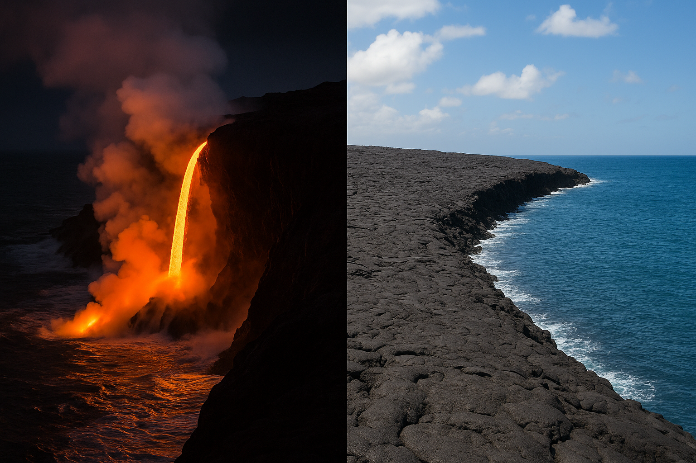
Figure 1 Side-by-Side Image of Lava Entering the Sea
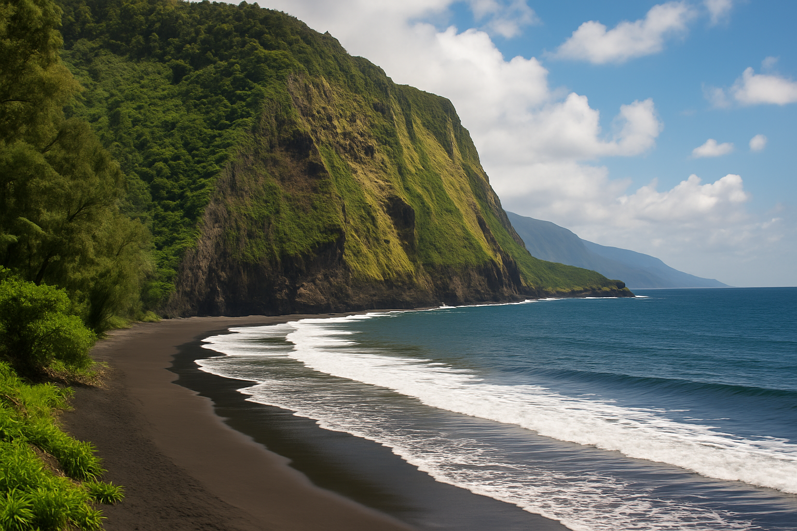
For cruise guests arriving by water, the view is more than just scenic. It’s geologic. Sheer cliffs, black sand beaches, and steaming volcanic slopes all tell a story. They’re not just part of a tropical vacation; they’re proof that our planet never stops moving.
Figure 2 black sand beaches
How did this remote chain of islands come to be? Why is the Big Island still bubbling with lava, while others seem quiet and calm? And what does it mean that Hawaii is still growing?
Let’s take a closer look.

The Hotspot That Started It All
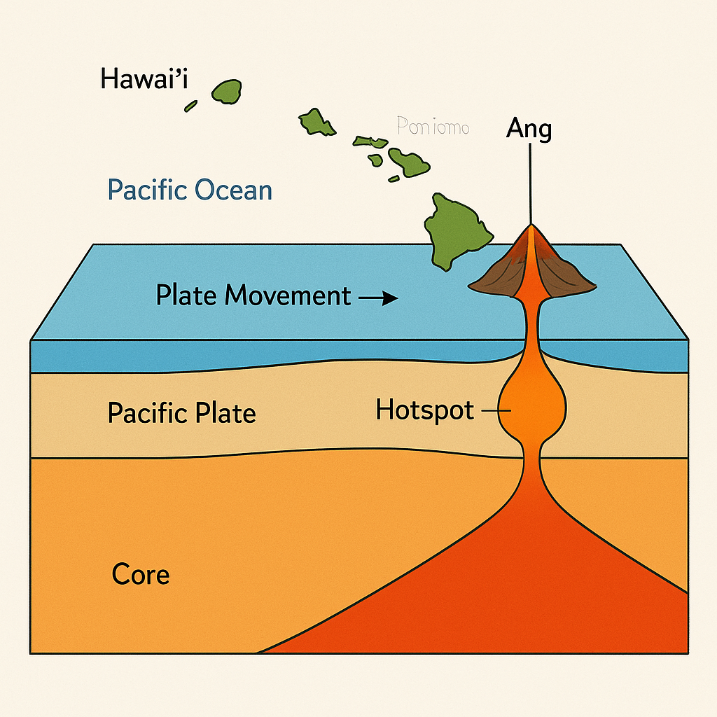
The key to Hawaii’s existence lies deep underground, beneath the crust of the Pacific Ocean. About 1,800 miles beneath your feet is a fixed plume of superheated rock known as the Hawaiian hotspot.
This hotspot doesn’t move. But the tectonic plate above it, the Pacific Plate, drifts northwestward, about 3 to 4 inches a year. That slow movement is enough to create an entire chain of islands. Here’s how:
Figure 3 Hot Spot
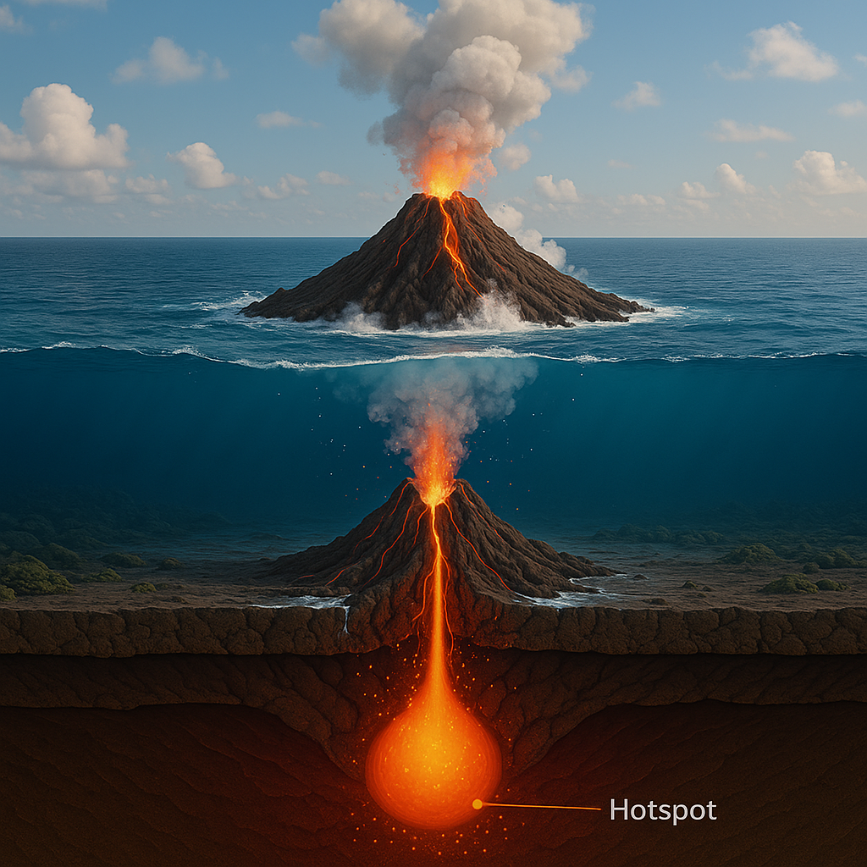
Every time the plate shifts over the hotspot, the intense heat melts a hole through the crust, forming a new volcano. That volcano gradually builds up through underwater eruptions until it breaks the surface and becomes an island.
Figure 4 The volcano emerges from the sea floor.
Eventually, the plate carries that island away from the hotspot. The volcano goes extinct, the island cools and erodes, and a new island begins forming behind it.
That’s why the Hawaiian Islands stretch in a northwest-to-southeast arc across the Pacific. It’s a geologic time-lapse: the farther northwest you go, the older the island. Kaua‘i is around 5 million years old. The Big Island? Less than a million, and still growing.

The Big Island: Hawaii’s Youngest Sibling
The Island of Hawai‘i, often simply called the Big Island, is the youngest and largest in the chain. It’s also the most volcanically active. Two of its volcanoes, Mauna Loa and Kīlauea, have erupted in recent memory. A third, Hualālai, last erupted in 1801 and is considered dormant, not extinct.
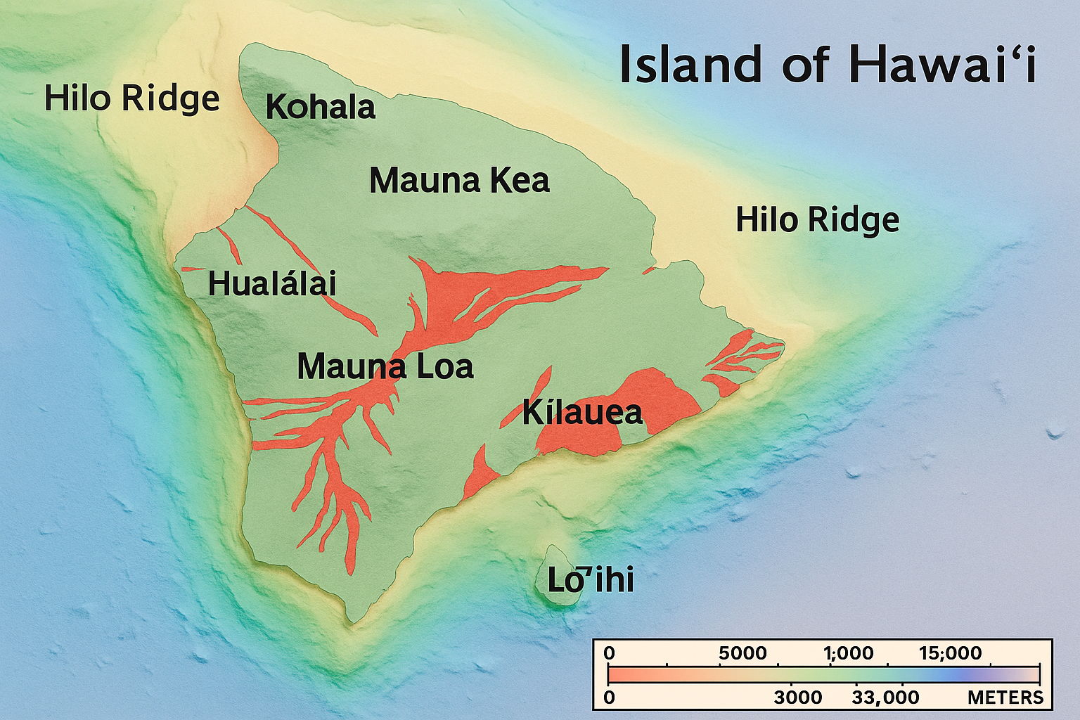
Mauna Loa is the largest volcano on Earth by volume. It covers over 5,000 square miles and rises more than 33,500 feet from its base on the seafloor to its summit, taller than Mount Everest if measured that way.
Figure 5 Big Island Lava flows
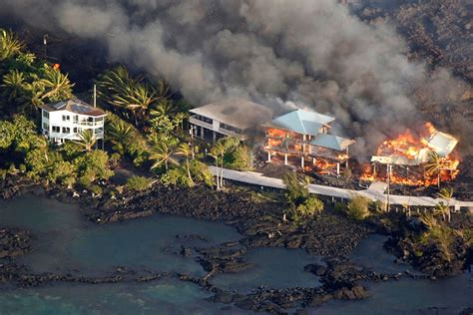
Kīlauea, though smaller, is far more active. Between 1983 and 2018, it erupted nearly nonstop, reshaping parts of the island and adding hundreds of acres of new land to Hawaii’s southeastern coast. Its 2018 eruption was particularly dramatic, fissures opened in residential neighborhoods, lava fountains shot hundreds of feet in the air, and entire subdivisions were wiped off the map.
Figure 6 Kīlauea 2018 Eruption
Despite the destruction, this wasn’t unusual. It’s how the Big Island was built. And it’s still happening.

How Lava Makes Land
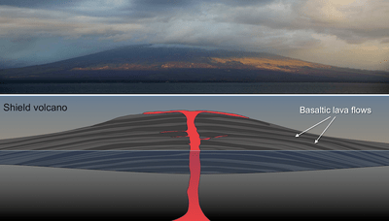
Lava may look like pure chaos, but it follows a surprisingly orderly process. When magma from deep underground erupts at the surface, it cools and hardens into volcanic rock. Over time, repeated eruptions layer these rocks higher and wider until a massive volcanic structure is formed.
Figure 7 Hawai'i's shield volcanoe
There are different types of lava, but the kind found in Hawaii, called pāhoehoe and ‘a‘ā, is low in viscosity, which means it flows easily. That gives Hawaiian volcanoes their broad, gently sloping shapes, called shield volcanoes.
They’re very different from the steep, explosive cones you might associate with places like Mount St. Helens or Vesuvius.
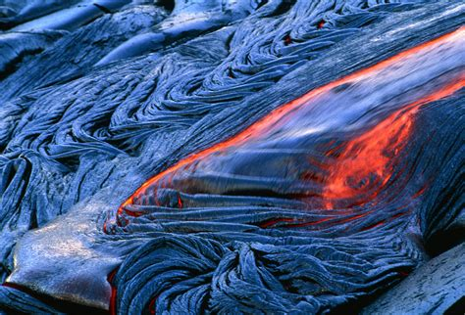
Pāhoehoe flows like hot syrup. It creates smooth, ropey surfaces. ‘A‘ā is thicker and chunkier, forming jagged, broken fields. Both can travel great distances, and when they reach the sea, they cool instantly, creating dramatic plumes of steam and expanding the coastline, inch by inch.
Figure 8 Pāhoehoe flows

Yes, land is literally being born here.
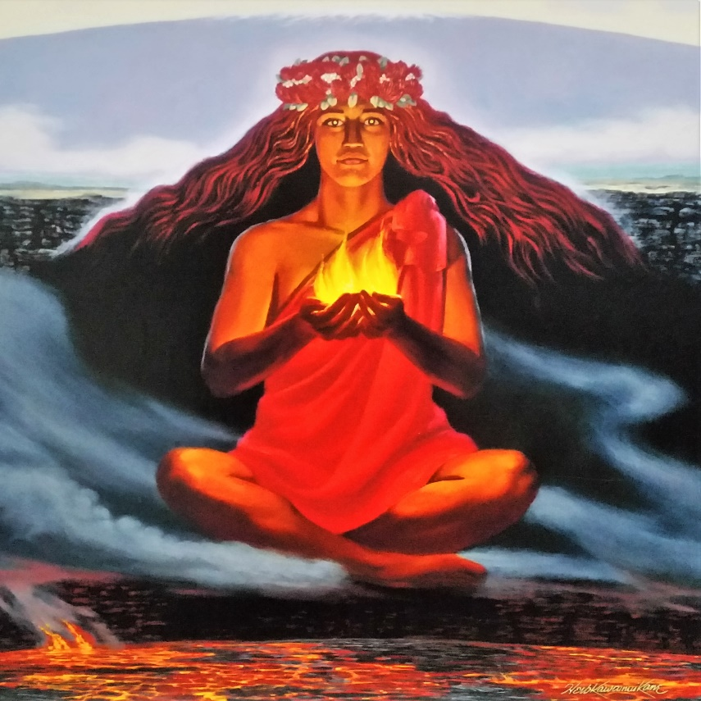
Kīlauea: Hawaii’s Fiery Heartbeat
Of all the volcanoes in Hawaii, Kīlauea is the one most tourists know by name. It’s also central to Native Hawaiian mythology. According to tradition, Kīlauea is home to Pele, the goddess of fire and volcanoes. Her moods, it’s said, dictate the rhythm of eruptions, fury when angered, quiet when at peace.
Science gives us a more measured explanation. Kīlauea sits directly over the hotspot. Its shallow magma chamber and open plumbing system make it particularly prone to frequent, effusive eruptions, meaning lots of lava, not so much explosive ash.
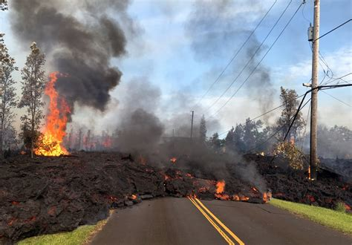
When Kīlauea erupts, lava can flow for miles, covering roads and structures but often doing so slowly enough for people to evacuate. That’s part of why scientists love studying it: it offers rare access to live volcanic processes with relatively low risk.
Figure 9 Hawaii Kilauea Volcano Eruption
It’s not always predictable, though. The 2018 eruption surprised everyone with its ferocity. Ground cracked open in the Leilani Estates subdivision, and lava fountains reached 300 feet. When the activity finally stopped, over 700 homes were gone, but new land had formed.

Life on a Living Island
So, what’s it like to live on a growing, rumbling island?
It’s complicated.
For many residents of the Big Island, volcanic activity is part of life. People build homes on land that didn’t exist a generation ago. Roads wind through lava fields. Steam vents dot backyards. Real estate maps come with lava hazard zones.
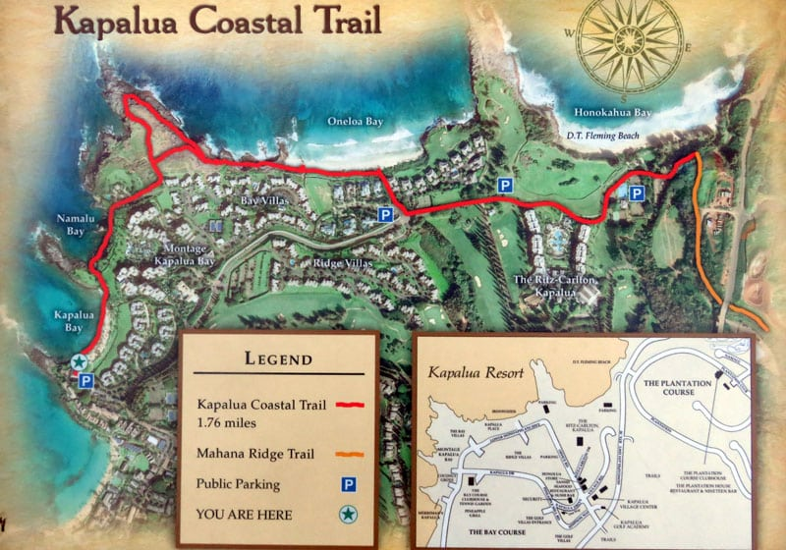
There’s risk, yes, but also opportunity. Volcanic soils are rich and fertile. They support lush rainforests, world-class coffee farms, and rare ecosystems. The volcano also powers geothermal energy plants, tapping into Earth’s internal heat.
Figure 10 Kapalua Coastal Trail
Tourism thrives too. Visitors flock to Volcanoes National Park to hike craters, watch lava glow at night, or walk through ancient lava tubes. It’s one of the only places on Earth where you can watch an island building itself.

Lo‘ihi: The Island You Can’t Visit, Yet
Just off the southeast coast of the Big Island, about 20 miles out and nearly a mile beneath the surface, something’s happening.
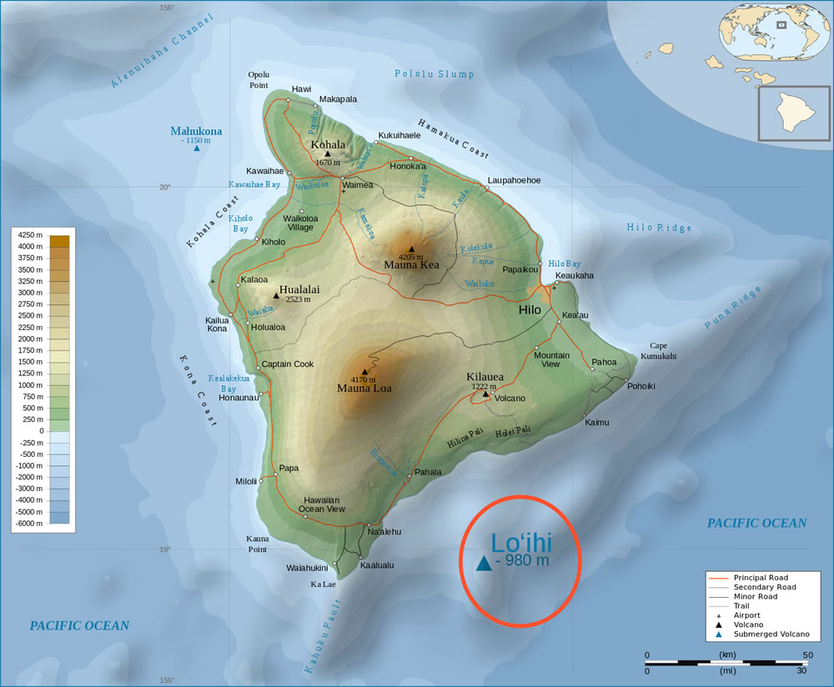
A new volcano is rising from the ocean floor. It’s called Lo‘ihi (pronounced low-ee-hee), and it’s the next island in the Hawaiian chain.
Lo‘ihi is about 10,000 feet tall already, but still about 3,000 feet shy of the surface. It’s erupting slowly, building up lava flows that someday, maybe 10,000 to 100,000 years from now, will break through the waves.
Scientists monitor it closely, using underwater sensors and remote submersibles. If you’ve ever wondered what Hawaii looked like before it broke the surface, Lo‘ihi is your time machine.

The Role of Erosion and Time
While new islands are forming, older ones are fading. Kaua‘i, Ni‘ihau, and the atolls to the northwest are slowly eroding. Their volcanic peaks are worn down by wind, rain, and time. Coral reefs grow around them, eventually turning them into flat islands or submerged seamounts.
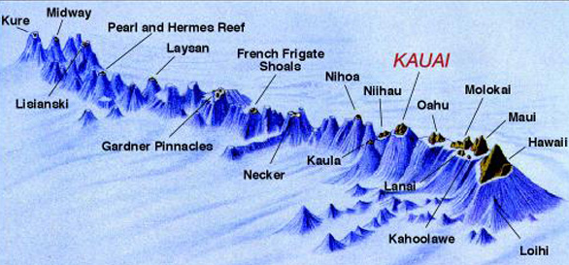
Figure 11 Hawaiian-Emperor seamount chain
This is the natural lifecycle of a volcanic island. Birth, growth, decline, and eventual submergence. But it takes millions of years.
In fact, the Hawaiian chain is just the visible tip of a much longer underwater chain called the Hawaiian-Emperor seamount chain. It stretches over 3,600 miles, reaching almost to Russia. These are ancient islands that have long since sunk beneath the waves. The remaining Hawaiian-Emperor seamount chain, stretching from Kure Atoll (just west of Midway) in the northwest to the Big Island of Hawai‘i in the southeast, is approximately 1,500 miles long.
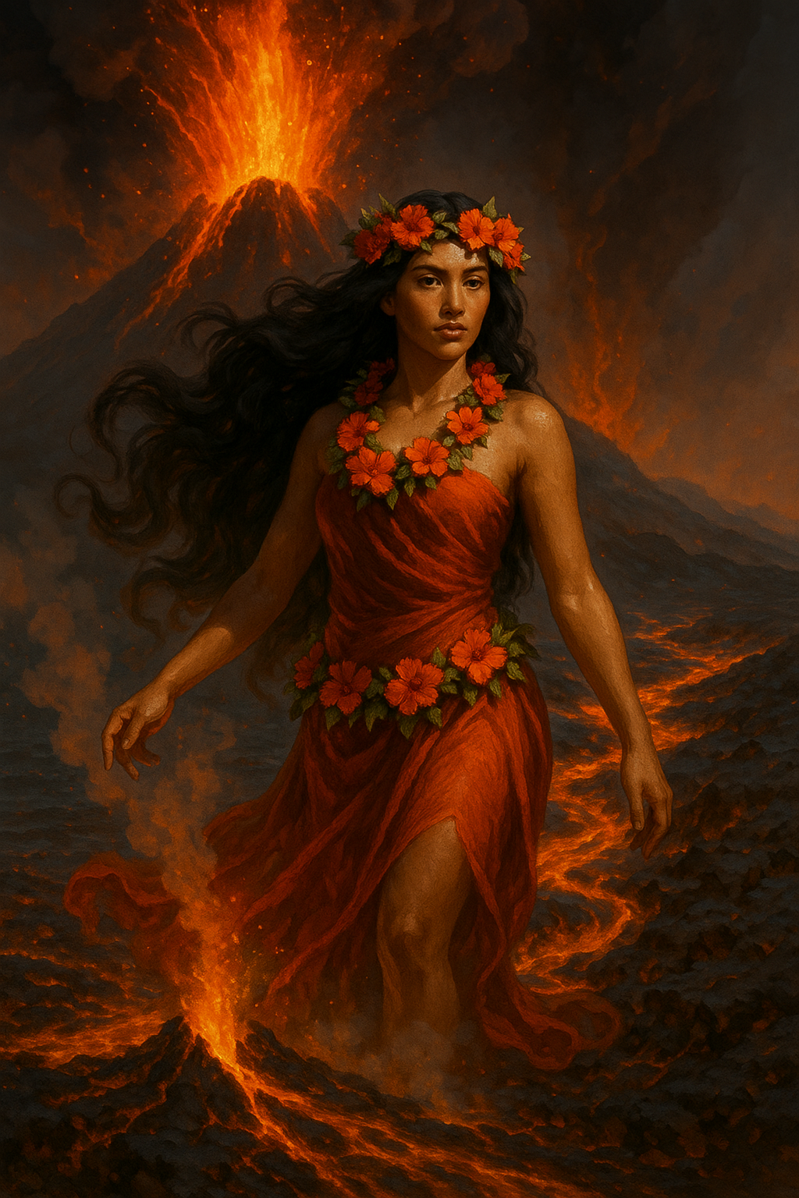
Figure 12 Pele, the fire goddess
A Culture Rooted in the Volcano
Hawaiian culture is deeply tied to its volcanic origins. The land is sacred, and volcanoes are seen not just as physical forces but as spiritual beings.
Pele, the fire goddess, isn’t just a myth, she’s part of daily life. Many locals leave offerings near lava flows or at Halemaʻumaʻu Crater to show respect. There are stories of travelers who took home lava rocks and later mailed them back after experiencing a string of bad luck, said to be Pele’s curse.
Traditional chants and hula often reference volcanoes, lava, and fire. They celebrate not just the beauty but the power of the islands.
Even modern scientists in Hawaii often speak with reverence. It’s hard not to, when the ground itself breathes and flows.

What the Future Holds
Will Hawaii keep growing? Yes.
As long as the hotspot beneath the Pacific Plate remains active, and there’s no reason to believe it won’t, new islands will form. The Big Island will continue expanding southeastward. Eventually, Lo‘ihi will join the chain.
Over millennia, the current islands will erode and sink, becoming reefs or seamounts. But new peaks will rise behind them. It’s a conveyor belt of island creation, running slowly but surely beneath the Pacific.
In the near future, scientists expect more eruptions from Kīlauea and Mauna Loa. Monitoring systems are better than ever, giving residents and visitors warning when activity increases. But predicting the exact moment of an eruption? That remains elusive.
Still, Hawaii’s future is written in lava.

Seeing It with Your Own Eyes
As a guest in Hawaii, you’re in a rare position. You get to witness this living geology up close. When you see a steaming vent, or a lava field stretching to the ocean, you’re not looking at history. You’re looking at a process.
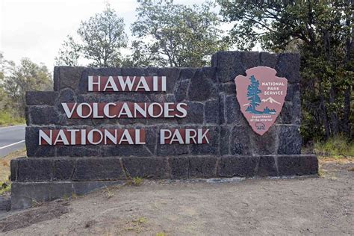
If you have the chance to visit Volcanoes National Park, take it. Walk across a cooled crater. Peer into a lava lake. Stand in a rainforest that wouldn’t exist if not for ancient flows.
All the signs are there, those deep black cliffs, the steam at the shoreline, the contrast between desolate lava and lush growth just beyond.
It’s one thing to read about geology. It’s another to sail right past it.

Final Thoughts: Islands Still Becoming
We think of islands as fixed places on a map, but Hawaii is a reminder that nothing in nature is truly still. These islands are always changing, always reshaping, always renewing.
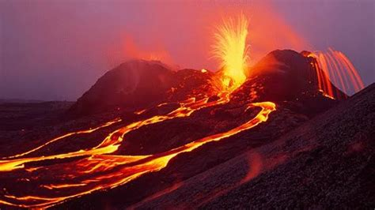
Some places show you the past. Hawaii shows you the present, and a little glimpse of the future.
Figure 13 volcanoes national park hawaii
Whether you’re drawn to the science, the stories, or the spectacle, one thing is certain: you’ve come to a place where the Earth is still making decisions. It’s still building. Still moving.
And you’re lucky enough to see it while it happens.

References & Further Exploration
(Because curious friends ask: "Where can I learn more?")
- Wilson, W. H. (1998). Indigenous Language Recovery: Lessons from Hawaiian.
- Pukui, M. K., & Elbert, S. H. (1986). Hawaiian Dictionary.
- Pukui, M. K., Haertig, E. W., & Lee, C. A. (1972). Nānā i ke Kumu (Look to the Source).
- Kimura, L. L. (1995). Hoʻoulu lahui aloha: To raise a beloved nation.
- Silva, N. K. (2004). Aloha Betrayed: Native Hawaiian Resistance.
- Kameʻeleihiwa, L. (1992). Native Land and Foreign Desires.
- Warner, S. L. (2001). The Movement to Revitalize Hawaiian Language.
- Goodyear-Kaʻōpua, N. (2013). The Seeds We Planted.
Hope in action:
- Trask, H. K. (1999). From a Native Daughter.
Unfiltered truth: Haunani-Kay
Bonus: Living Sources (Beyond Books)
Because language lives in people, not just pages:
- Ōiwi TV (Hawaiian-language news channel): Watch kids report weather in ʻŌlelo Hawaiʻi. Instant joy.
- Hawaiian Music Legends: Listen to Kealiʻi Reichel or Kalani Peʻa. Their lyrics? Masterclasses in poetic Hawaiian.
- Ship’s Cultural Ambassador: (Psst, ask them about their ʻohana! Real stories > textbooks.)

