Vintage Turntable Tweaks: Unlocking Hidden Performance in Classic Decks
By Marc Silver

The Mechanical Soul
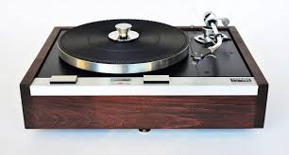
There’s something hypnotic about a vintage turntable in motion. The platter spins, the tonearm arcs gracefully across the groove, and music becomes mechanical poetry. These machines were built when engineering precision and craftsmanship mattered more than cost optimization, and names like Thorens, Linn, Dual, Technics, and Garrard still command respect decades later.
But age takes its toll. Bearings dry out, belts harden, and contact points corrode. A full restoration can be rewarding, but it’s often expensive and unnecessary. With patience and a handful of well-chosen tweaks, you can reclaim much of your deck’s original magic. The key is to tackle vinyl’s four great enemies: resonance, vibration, friction, and electrical noise.
Figure 1 Thorens TD125 / SME 3009 Turntable

Start with the Basics
Before trying fancy modifications, make sure your table’s foundation is solid. Every improvement depends on proper setup.
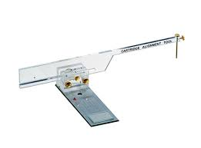
Cartridge Alignment
Even a half-millimeter of misalignment can cause audible distortion and accelerated stylus wear. Use a Baerwald or Stevenson protractor under bright light to align the cartridge precisely. I’ve been using the same Dennison Metal Protractor for over fifty years, but affordable versions are widely available online, from about $6 to $200.

Tracking Force
Figure 2 Pro-Ject Alignment Protractor
Never trust the tonearm’s dial. Springs fatigue with age, and calibration drifts. A digital stylus gauge, even a cheap one, is cheap insurance. Place it directly on the platter surface, lower the stylus onto the pad, and verify your tracking force matches the cartridge specification.
Figure 3 Digital Stylus Force Gauge
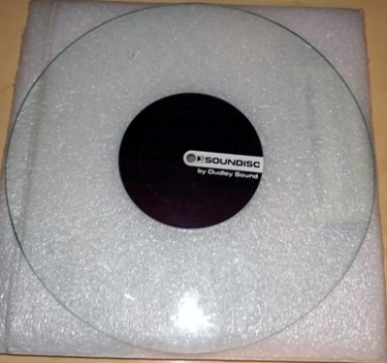
Anti-Skate
Anti-skate is a bit controversial, but it works. I use a glass platter, though a record with a blank side works fine. Watch how the arm behaves. If it drifts outward, anti-skate is too high; if it slides inward, too low. Adjust until it floats motionless midway across the disc.
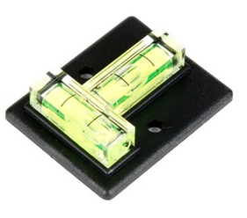
Level the Deck
A perfectly level platter ensures correct tracking force and balanced suspension. Set a spirit level directly on the platter and adjust the feet until the bubble remains centered as you rotate the platter. Inexpensive but essential tools, under $10, can be found online.
Figure 4 Glass Platter with Blank Groove for Anti-Skate Testing

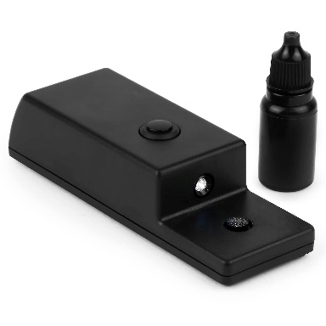
Stylus Health
Figure 5VPI Cross-Check Spirit

Inspect your stylus under magnification. A chipped or bent diamond can destroy records in minutes. Replace it if you’re unsure. To clean, use a soft brush or mascara wand. Avoid alcohol, it can weaken the adhesive securing the diamond. I use a digital ultrasonic cleaner, but any gentle method works.

Clean Electrical Contacts
Figure 6 Hudson Ultrasonic Stylus Cleaner
Dirty connectors rob life and clarity. Clean every contact, RCA plugs, headshell pins, cartridge leads, and ground lugs, with DeoxIT D5 or DeoxIT Gold. Apply with a cotton swab or micro-brush. Even oxidation invisible to the eye can add hiss or dull the highs.

Taming Resonance and Vibration
This is where most classic turntables hide their biggest potential. Vibrations muddy bass and smear detail; eliminating them makes music open up.

Platter and Bearing Maintenance
Clean out old oil and grime from the bearing assembly using 99 % isopropyl alcohol. Avoid leaving lint or fibers behind. Lubricate the spindle with one or two drops of light oil (Zoom Spout or sewing-machine oil). Too much lubricant can attract dust and slow rotation. A quiet, steady platter means cleaner bass and better pitch stability.

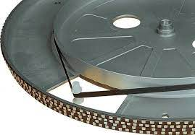
Belt Drive Optimization
Old belts stretch, glaze, or harden, transmitting motor noise to the platter. Replacing the belt is one of the cheapest and highest-impact upgrades you can make, usually $10–20. Always order the correct size; a belt that’s too tight or too loose degrades speed accuracy. Clean the pulley and platter rim with alcohol to improve grip.

Motor Isolation
Aging rubber grommets lose elasticity, letting vibration travel into the plinth. Replace them with Sorbothane or neoprene mounts in the 40–50 Shore A durometer range. You can also experiment with small pieces of Blu-Tack on the motor housing, sometimes it damps vibration; sometimes it overdamps. Listen critically after each tweak and remove anything that doesn’t improve sound.

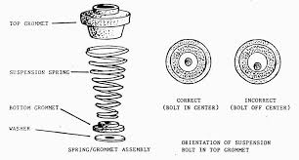
Suspension Systems
Suspended-sub-chassis tables like Thorens and Linn models rely on properly tuned springs to isolate the platter and arm. Clean the springs and dust covers, apply a touch of graphite powder for lubrication, and adjust the height so the sub-chassis bounces freely at about 3–5 Hz, one or two smooth oscillations when pressed gently. Be patient; an out-of-tune suspension can sound worse than none at all.
For Linn LP12 owners: if you’re unsure, have a specialist do it. Those suspensions can be temperamental and easy to mis-adjust.
Figure 7 Thorens Sub-chassis Spring Assembly

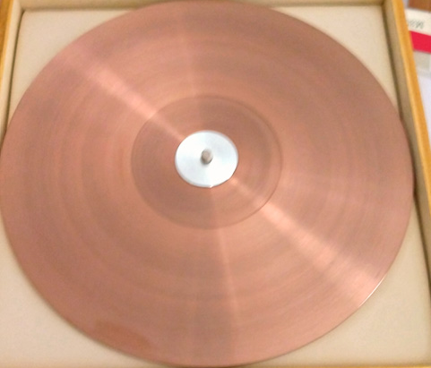

Platter Mats – More Than a Slipcover
The mat is the interface between record and platter. It shapes how energy is absorbed or reflected. Hardened stock rubber mats can blur transients and increase static. Swapping materials changes tonal character:
- Rubber – Excellent damping but can sound slightly dull.
- Cork – Adds openness and reduces static.
- Leather – Warmer, with strong grip and controlled bass.
- Composite (cork-rubber or acrylic blends) – Balances damping and liveliness.
Experiment freely. Mat changes are reversible and often reveal immediate differences.

Tonearm Refinements
The tonearm is your cartridge’s vehicle. Tiny adjustments here can transform clarity and focus.

Cartridge and Arm Matching
Matching cartridge compliance to tonearm mass is critical.
- Low-mass arms pair best with high-compliance cartridges.
- High-mass arms (often S-shaped) work better with low-compliance designs.
When compliance and mass are mismatched, bass becomes loose or treble edgy. Many online calculators can help you find the resonance frequency; aim for 8–12 Hz.

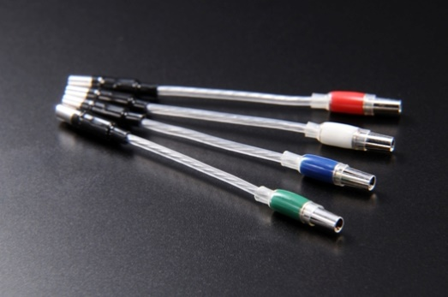
Headshells and Wiring
Stock headshells often resonate and color the sound. Replace lightweight factory models with better-damped options such as the Audio-Technica AT-HS6 (around $35). Clean and tighten all contacts. I’m fond of silver-Litz headshell wires, they offer superb conductivity without harshness.
Technics SL-1200 owners should check tonearm wiring; internal leads can corrode or break over decades.
Figure 87 Furutech’s La Source 101 headshell leads

Armtube Damping
Apply one-inch strips of Dynamat or similar damping material along the lower third of the tonearm. Add one strip at a time, testing as you go. Stop when improvements plateau, too much damping can dull transients. A small piece of Blu-Tack between cartridge and headshell can also tame micro-resonance.

Bearing and Cueing Mechanisms
If your tonearm bearings feel rough, clean them carefully with an alcohol-dampened watchmaker’s swab. Lubricate with a grain-of-rice amount of Moebius 8000 oil. Never flood the bearing. For sluggish cueing mechanisms, refill with 300,000 cSt silicone damping fluid (available from KAB USA and others). Smooth tonearm motion ensures accurate groove tracking and eliminates channel imbalance.

Electrical and Signal Path Upgrades
Your cartridge outputs a signal measured in microvolts, easily corrupted by interference or corrosion. Clean wiring pays big dividends.

Grounding
Before touching anything, check with a multimeter to ensure the chassis isn’t live. Then establish a solid ground path from the turntable to your preamp. Many vintage decks benefit from an extra ground wire tied directly to the tonearm base or motor housing. A stable ground eliminates hum and protects sensitive electronics.

Interconnect Cables
Factory RCA cables often have high capacitance and brittle shielding. Replace them with low-capacitance designs such as Blue Jeans LC-1 (≈ 12 pF/ft). Keep runs short, and avoid cheap “audiophile” cables that emphasize fashion over function.

Cartridge Loading
Moving-magnet cartridges are particularly sensitive to electrical loading. Check your cartridge’s specifications, e.g., a Shure M97xE wants around 200 pF capacitance and 47 kΩ resistance. If your phono preamp allows, experiment with loading plugs or capacitance settings. Proper loading tightens bass and smooths treble extension.

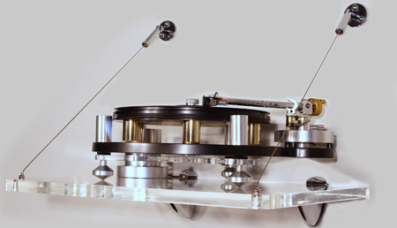
Isolation: The Final Frontier
Think of your turntable as a vibration microscope, it detects what you can’t feel. Isolation makes a bigger difference than many realize.
Placement
Never place your table on the same surface as speakers or subwoofers. Low-frequency feedback can cause “howling” or rumble. Avoid HVAC vents, doorways, or floors that flex underfoot.
Figure 8 Audio Suspension ASU-100
Support Solutions
Different budgets offer different isolation strategies:
- Sorbothane feet (~ $15) – Good entry-level damping when weight-matched.
- DIY sandbox (~ $10) – A shallow box filled with 2 inches of sand provides excellent energy absorption.
- Granite slab + pucks (~ $40) – Attractive and stable.
- Wall-mounted shelf ($100 +) – Bolted into studs, it isolates better than any surface stand.
Add mass and damping wherever possible; even concrete pavers can improve focus.

Budget vs. Impact
If you’re working within limits (and who isn’t?), here’s where to make your investment go the furthest. In order of value for the dollar:
- Belt replacement ($15) – ★★★★★ priority and impact. If your belt is stretched out nothing else matters,
- Bearing cleaning and lubrication (free) – ★★★★☆. Friction is not your friend!
- DeoxIT contact cleaning ($20) – ★★★★☆. Not a big spend but well worth the expense and should be used everywhere in your system.
- Sorbothane feet / isolation ($15) – ★★★☆☆. System resonance will cloud the sonic image, so I love this tweek.
- Low-capacitance cables ($40) – ★★★☆☆. I have to admit I have spent many hundreds on my cables throughout my system. Your cable investment needs to match your system investment. If you have many thousands invested in your system, spend accordingly on the cable infra-structure.
- Aftermarket headshell ($35) – ★★★☆☆. If your tonearm allows it, this is something to consider.
- Wall shelf ($120 +) – Effective but diminishing returns per dollar. In some cases this is a floor issue more than a system issue.

Listening Tests and Validation
Don’t rely on vague impressions. Use familiar recordings that expose specific frequency ranges. Dire Straits – “Money for Nothing” → bass punch.
- Norah Jones – “Don’t Know Why” → midrange clarity.
- Diana Krall – “Peel Me a Grape” → treble texture and vocal sibilance.
*I need to comment, my recommendations are based on albums I use. But I am also a in my 70s.:

A strobe disc or RPM app can verify speed accuracy. But ultimately, trust your ears: the real question is whether the music breathes, whether it feels alive rather than mechanical.
Listen for:
- Bass: Tighter, less boomy.
- Midrange: More presence and transparency.
- Highs: Smooth yet detailed.
- Soundstage: Deeper, more stable.

Myth-Busting
Save your money on:
- Green-edge markers (no measurable effect).
- Cable elevators (pure placebo outside labs).
- “Quantum” dots or stickers (fiction).
- Demagnetizers for vinyl (useless). (Interesting enough they do work on CDs)
No gimmick can replace careful setup and good maintenance.

The Tweaker’s Toolbox
- Digital stylus gauge (~ $25)
- Protractor (Baerwald / Stevenson) ($12.00 - $300)
- Spirit level ($8 - $$$)
- Contact cleaner (DeoxIT D5 / Gold $8.75 - $29.95)
- 99 % isopropyl alcohol (Cheap)
- Sewing-machine or synthetic bearing oil ($9 - $30)
- Screwdrivers / hex keys
- Blu-Tack or modeling clay ($6.99)
- Sorbothane feet or pucks ($10 - $50)
- Stroboscope disc ($10 - $100)
- Magnifying glass ($8 +)
And the two essentials that can’t be bought: patience and critical ears.

Respecting the Classics
These machines survived four or five decades because their engineering was brilliant. Restoring them isn’t about gimmicks or modernization, it’s about respect.
Start with the fundamentals: a new belt, clean bearing, proper leveling. Build from there methodically, listening after each step. Done right, these tweaks don’t alter the soul of your turntable, they reveal it.
When you cue up a favorite record and hear that first piano note rendered with lifelike depth, you’ll remember why these decks endure.
They let the music shine. And that’s the real reward, hearing your classic table sing again, alive and renewed.

