Victoria Wine Regions

1. Region Overview
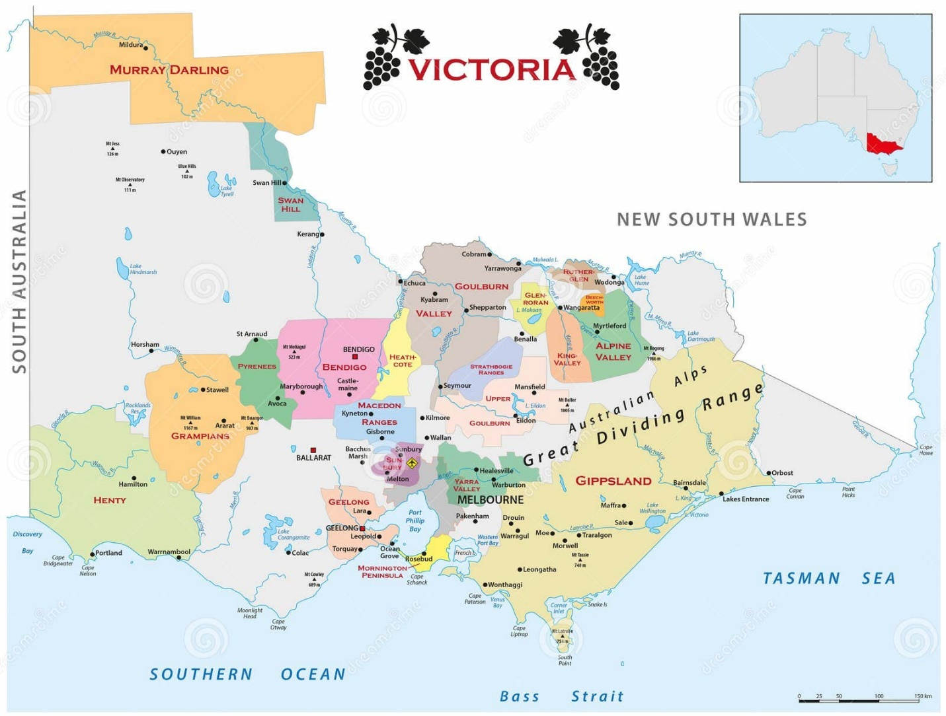
Victoria, located in southeastern Australia, is a state of remarkable viticultural diversity, spanning cool coastal zones, alpine foothills, and sun-drenched inland plains. With over 800 wineries and 21 designated wine regions, Victoria is celebrated for its eclectic styles—from elegant cool-climate Pinot Noir and Chardonnay to opulent fortified wines. Key regions include Yarra Valley, Mornington Peninsula, Grampians, Heathcote, Rutherglen, and Macedon Ranges. The state’s varied terroirs—volcanic soils, ancient riverbeds, and granite outcrops—coupled with a climate ranging from maritime to continental, enable Victoria to produce wines of both finesse and intensity.

2. Key Grape Varieties
Primary Red Varieties:
- Pinot Noir: Flagship of Yarra Valley and Mornington Peninsula, offering red cherry, earth, and silky tannins.
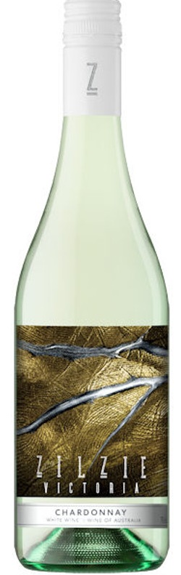
- Shiraz: Bold in Heathcote (ironstone soils, black pepper, plum) and structured in Grampians (violets, spice).
- Cabernet Sauvignon: Thrives in Pyrenees, with cassis and mint notes.
Primary White Varieties:
- Chardonnay: Lean and mineral-driven in Macedon Ranges, richer in Mornington Peninsula.
- Riesling: Bright and floral in Henty (southwestern Victoria).
Heritage/Notable Varieties:
- Muscat and Topaque (formerly Tokay): Legendary fortified wines from Rutherglen, with raisin, toffee, and spice.
- Nebbiolo and Sangiovese: Emerging in King Valley and Beechworth, reflecting Italian immigrant influence.

3. Wine Classification System
Victoria adheres to Australia’s Geographical Indication (GI) system:
- Key GIs:
  - Yarra Valley: Sub-regions like Upper Yarra (cooler, higher elevation) and Lower Yarra (warmer).
  - Rutherglen: Classifications for fortified wines (Rare, Grand, Classic).
  - Heathcote: Known for its Cambrian Greenstone soil strip.
- Standards: 85% of grapes must come from the stated GI; fortified wines follow strict aging protocols.

4. Notable Wine Styles
Yarra Valley Pinot Noir (GI)
- Composition: 100% Pinot Noir, often clones 115 and MV6.
- Production: Hand-harvested, whole-bunch fermentation, aged in French oak (20–30% new).
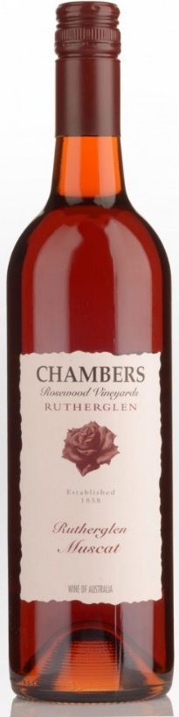
- Profile: Red cherry, sous-bois, and silky texture.
- Aging Potential: 5–10+ years.
Rutherglen Muscat (GI)
- Composition: 100% Muscat à Petits Grains.
- Production: Fortified with neutral grape spirit, aged in oak for decades.
- Profile: Raisin, caramel, and spice; classified as Rare (20+ years), Grand (5–20 years), Classic (younger).
Heathcote Shiraz (GI)
- Composition: 100% Shiraz, from Cambrian soils.
- Profile: Blackberry, licorice, and mineral grip.
- Comparison: Rivals Barossa’s power with more earthy restraint.

5. Additional Context
Recent Developments:
- Sustainability: Over 40% of vineyards are certified sustainable (e.g., Sustainable Winegrowing Victoria), with solar energy and water recycling initiatives.
- Climate Adaptation: Early harvesting in warmer zones; frost fans in Macedon Ranges.
Historical Context:
Victoria was Australia’s largest wine producer pre-1900s; phylloxera devastated vineyards, but 1970s pioneers like Dr. Bailey Carrodus (Yarra Yering) revived its reputation.
Food Pairings:
- Yarra Valley Chardonnay with roasted chicken or seafood.
- Rutherglen Muscat with blue cheese or sticky date pudding.
- Grampians Shiraz with slow-cooked lamb.
Key Producers:
De Bortoli (iconic Pinot Noir), Tahbilk (historic Marsanne), Best’s Wines (Grampians Shiraz), and Campbells (Rutherglen Muscat).
Takeaway for Sommeliers:
Victoria’s strength lies in its diversity—contrast coastal elegance (Mornington Peninsula) with inland power (Heathcote). Highlight Rutherglen’s fortified wines as globally unique treasures.
Final Thoughts:
A mosaic of climates and traditions, Victoria marries Old World charm with New World innovation, crafting wines that reflect its rugged landscapes and pioneering spirit.

Citations:
- Wine Victoria. Sustainability & Innovation Report. 2023.
- Halliday, J. Wine Atlas of Australia. 2022.
- “Rutherglen’s Liquid Gold.” Decanter, 2021.

