United States: The Pioneer of New World Wine
Region Overview
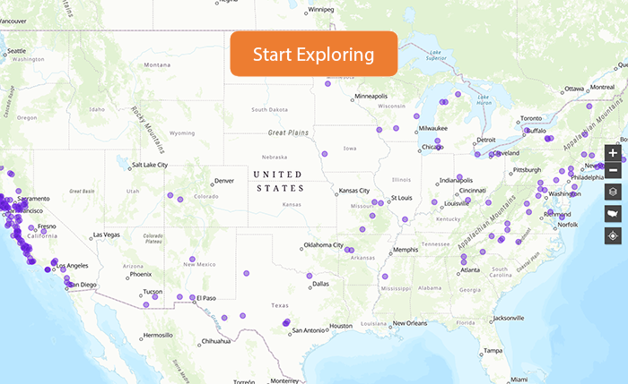
The United States is one of the world's most diverse and influential wine-producing countries. While California dominates production, wine is made in all 50 states, with notable regions in Oregon, Washington, New York, Texas, Virginia, Michigan, and Colorado. The country’s vast geography encompasses a range of climates, from the cool coastal influence of the Pacific Ocean to the arid deserts of the Southwest and the humid conditions of the East Coast. High-altitude vineyards in Colorado and emerging regions like Idaho and Missouri add further diversity.
The United States employs the American Viticultural Area (AVA) system, which defines wine-growing regions based on geographic and climatic factors rather than strict winemaking regulations. While the AVA system is comparable to European PDOs, it allows greater winemaker flexibility. The country is known for its innovation, embracing modern techniques while also drawing inspiration from Old World traditions. The influence of diverse immigrant winemaking communities has helped shape the U.S. into a global wine powerhouse.
Key Grape Varieties
- Primary Red Varieties:
  - Cabernet Sauvignon – The signature red of Napa Valley, producing full-bodied, age-worthy wines.
  - Pinot Noir – Thrives in Oregon’s Willamette Valley and California’s Sonoma Coast, yielding elegant, earthy expressions.
  - Zinfandel – A uniquely American variety with roots in Croatia, producing bold, fruit-forward wines, particularly in California.
  - Merlot – A softer, approachable red that excels in Washington State and California.
  - Petite Sirah – A distinctly Californian red producing deep, inky, structured wines.
  - Norton – A native American hybrid thriving in Missouri and Virginia.
- Primary White Varieties:
  - Chardonnay – The most widely planted white grape, offering styles from crisp and unoaked to rich and buttery.
  - Sauvignon Blanc – Found in Napa and Sonoma, known for bright acidity and tropical fruit flavors.
  - Riesling – A star in Washington State, Michigan, and New York’s Finger Lakes, producing both dry and sweet styles.
  - Koshu – An emerging variety gaining traction in experimental plantings.
Wine Classification System
The U.S. does not have a hierarchical appellation system like Europe but follows:
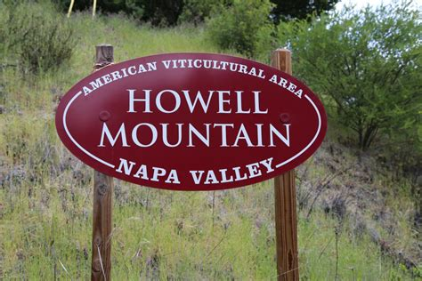
- American Viticultural Areas (AVAs): Defined by geographic boundaries rather than strict winemaking regulations. Some regions, such as Napa Valley, contain nested AVAs (e.g., Howell Mountain within Napa).
- Estate Bottled: Wines produced and bottled at the same estate where the grapes are grown.
- Varietal Labeling: At least 75% of the stated grape must be used in the wine.
- Regional Blends: Many wines, such as those from Oregon and Washington, are labeled by state or regional AVA.
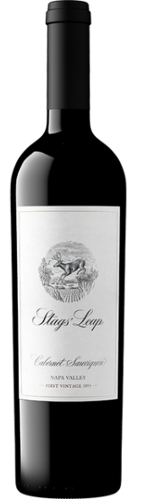
Notable Wine Styles
- Napa Valley Cabernet Sauvignon (Iconic Red)
  - Classification Level: AVA Napa Valley.
  - Composition: 100% Cabernet Sauvignon or blends with Merlot, Petit Verdot.
  - Production Method: Extended maceration, oak aging.
  - Aging Requirements: 12–24 months in oak.
  - Alcohol Content: 13.5–15.5% ABV.
  - Organoleptic Profile: Blackcurrant, cedar, graphite, and structured tannins.
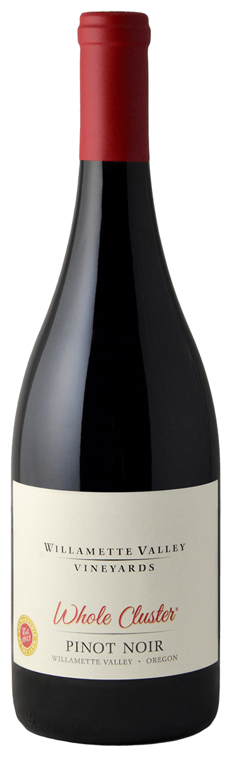
- Willamette Valley Pinot Noir (Elegant Red)
  - Classification Level: AVA Willamette Valley.
  - Composition: 100% Pinot Noir.
  - Production Method: Fermented in small batches, often aged in French oak.
  - Aging Requirements: 8–18 months in oak.
  - Alcohol Content: 12.5–14% ABV.
  - Organoleptic Profile: Red cherry, earth, forest floor, and silky tannins.
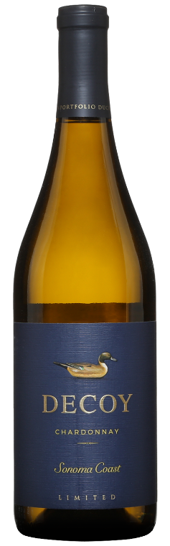
- Sonoma Chardonnay (Diverse Expressions)
  - Classification Level: AVA Sonoma County.
  - Composition: 100% Chardonnay.
  - Production Method: Stainless steel or barrel fermentation.
  - Aging Requirements: Varies by producer.
  - Alcohol Content: 12.5–14.5% ABV.
  - Organoleptic Profile: Green apple, lemon zest (unoaked); butter, vanilla (oaked).

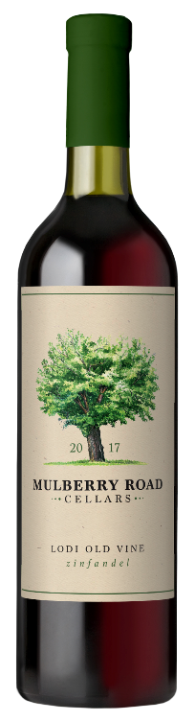
- Old Vine Zinfandel (California Heritage Wine)
  - Classification Level: AVA Lodi, Paso Robles, Sonoma County.
  - Composition: 100% Zinfandel.
  - Production Method: Extended maceration, aged in oak.
  - Aging Requirements: 12–18 months.
  - Alcohol Content: 14–16% ABV.
  - Organoleptic Profile: Ripe blackberry, plum, pepper spice, and jammy richness.
Additional Context
- Recent Developments: Growing focus on sustainability, organic, and biodynamic farming, as well as the rise of low-intervention natural winemaking.
- Historical Evolution: From early mission grape plantings in California to Prohibition’s setbacks, followed by Napa’s rise after the 1976 Judgment of Paris.
- Food Pairing Notes: Napa Cabernet Sauvignon pairs well with grilled steak; Oregon Pinot Noir complements salmon; Zinfandel is a classic match for barbecue.
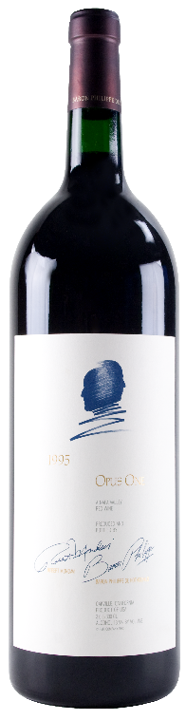
- Notable Producers:
  - Opus One (California) – A leading Napa Valley producer of Bordeaux-style blends.
  - Domaine Serene (Oregon) – A benchmark for Willamette Valley Pinot Noir.
  - Chateau Ste. Michelle (Washington) – The most recognized producer of Riesling in the U.S.
  - Turley Wine Cellars (California) – Renowned for its Old Vine Zinfandels.
Key Takeaways for Sommeliers
The U.S. wine industry’s flexibility and innovation make it a critical region for sommeliers. The diverse climate zones allow for an impressive variety of styles, from robust Napa Cabernets to the delicate Pinot Noirs of Oregon. Understanding the nested AVA system, regional differences, and the influence of Old World vs. New World winemaking approaches is key to mastering American wines.
Final Thoughts
As a leader in modern winemaking, the U.S. continues to push boundaries while maintaining respect for tradition. With its vast regional diversity, continued advancements in sustainable viticulture, and its influence on global wine trends, the country remains a dominant force in the world of wine.

